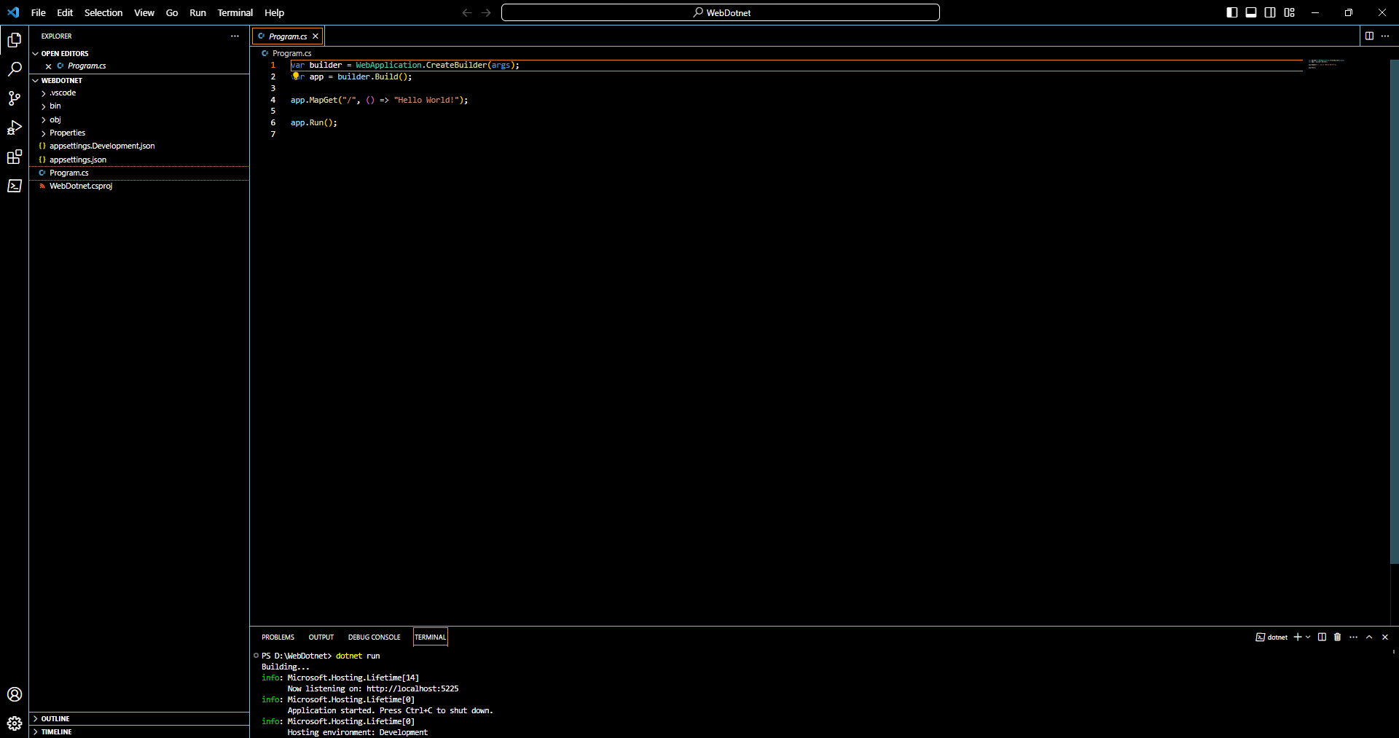Bài 1:

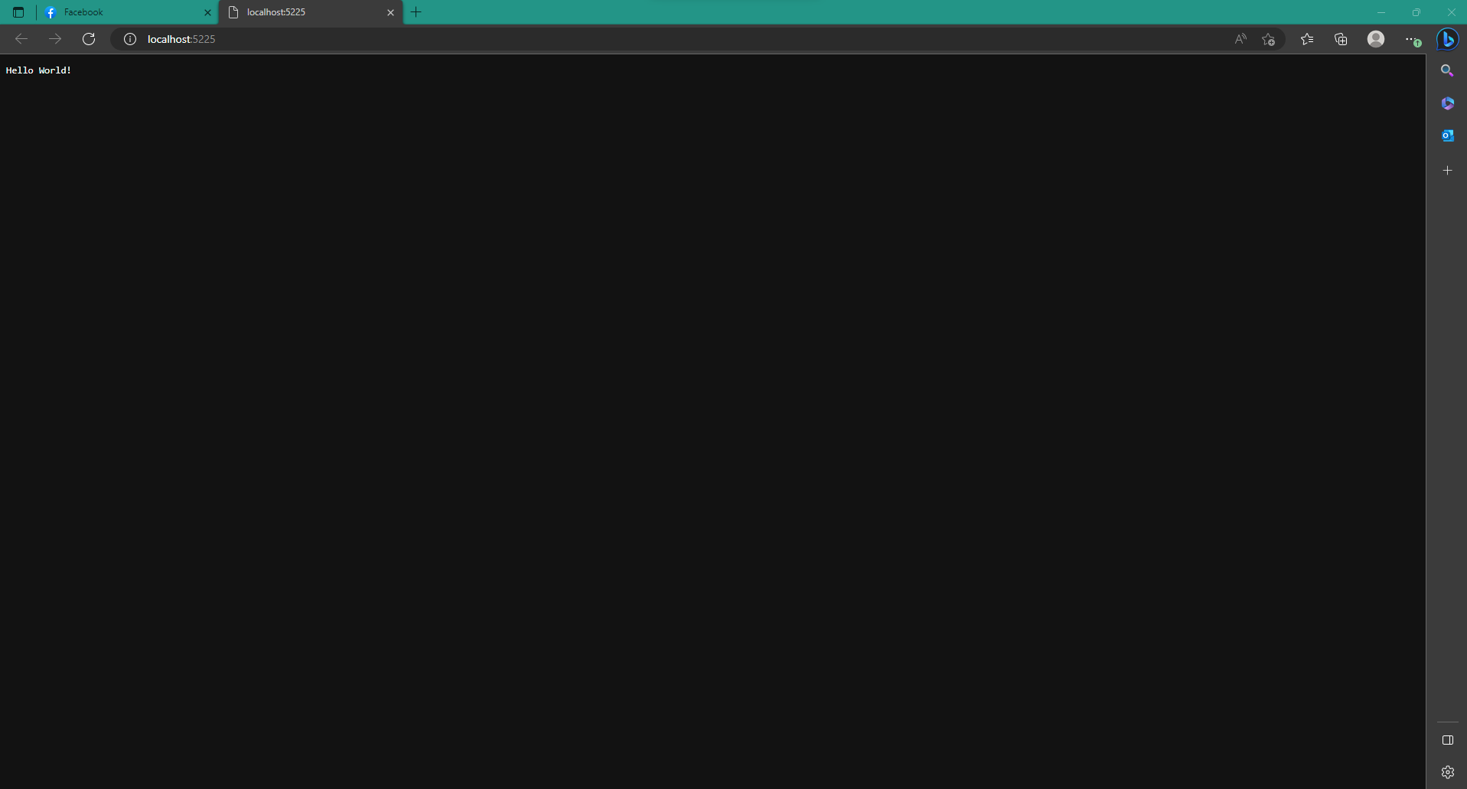

Bài 2:

Admin page:

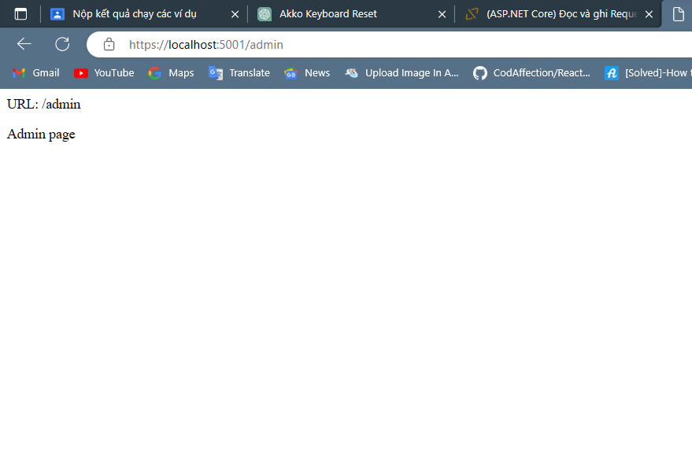

Admin/Product:

Admin/User:

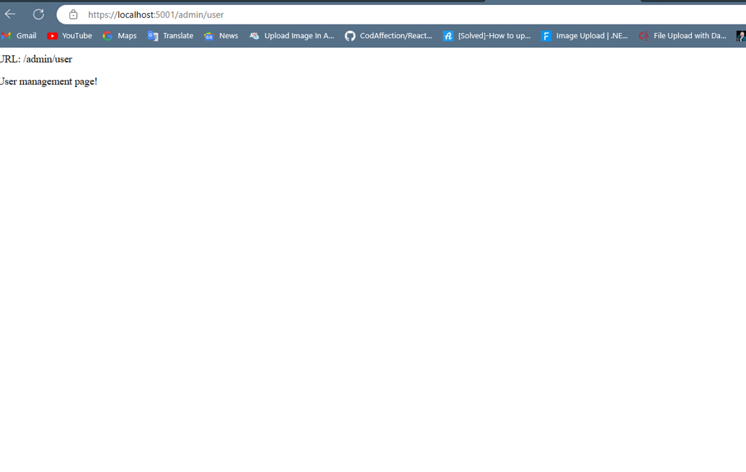

Bài 3:

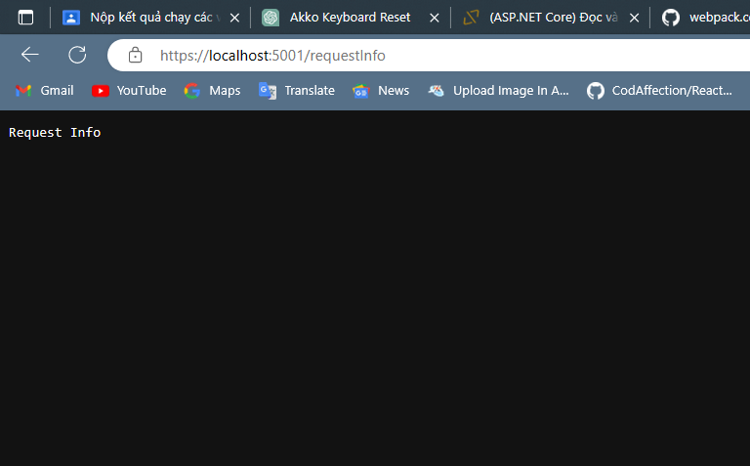

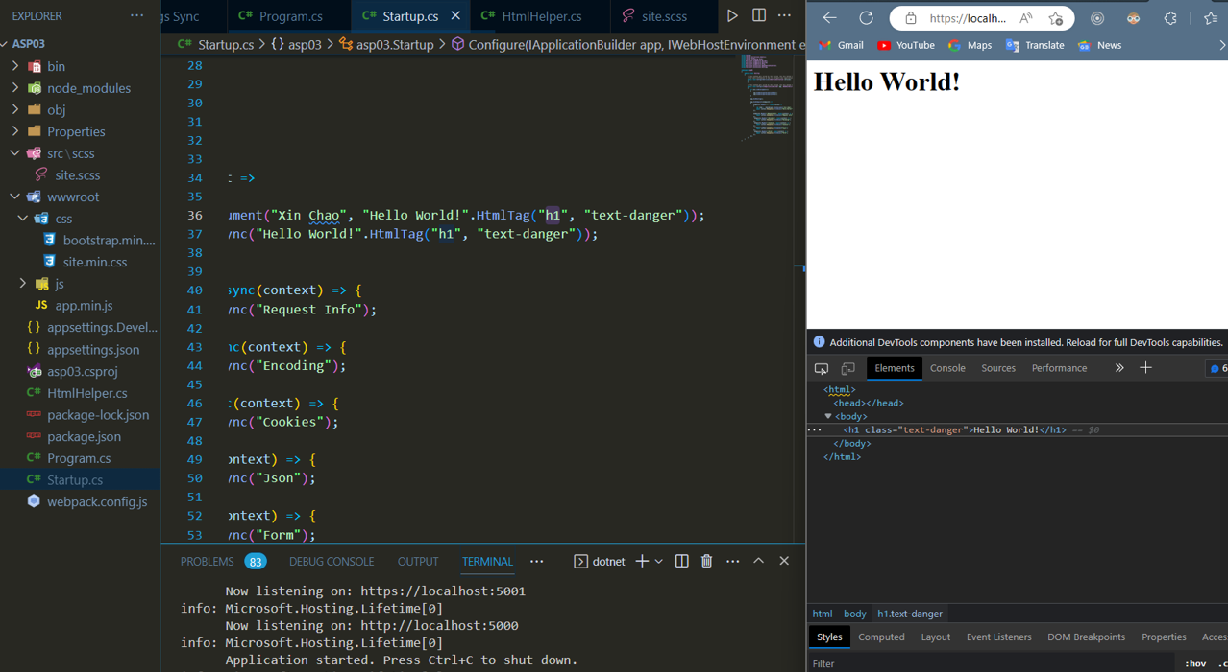

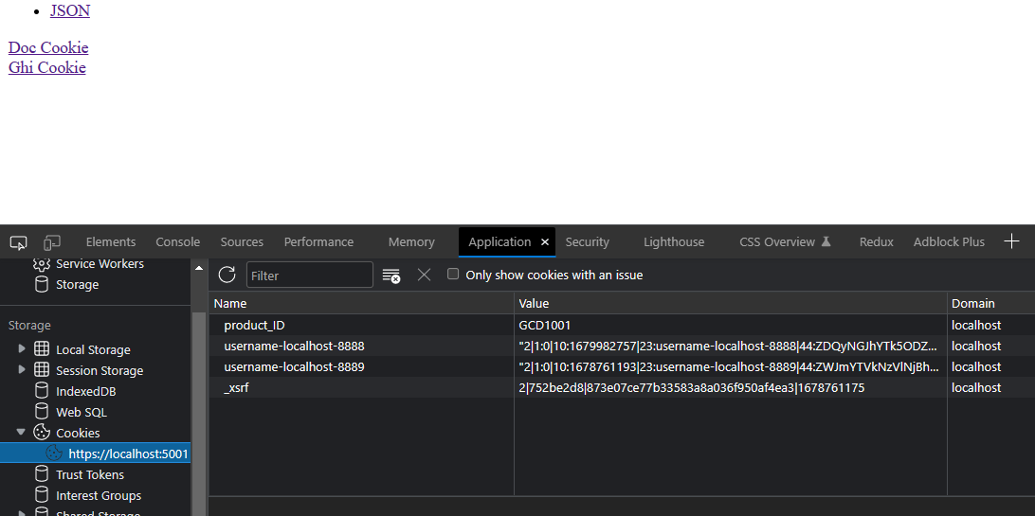

Đọc cookies:

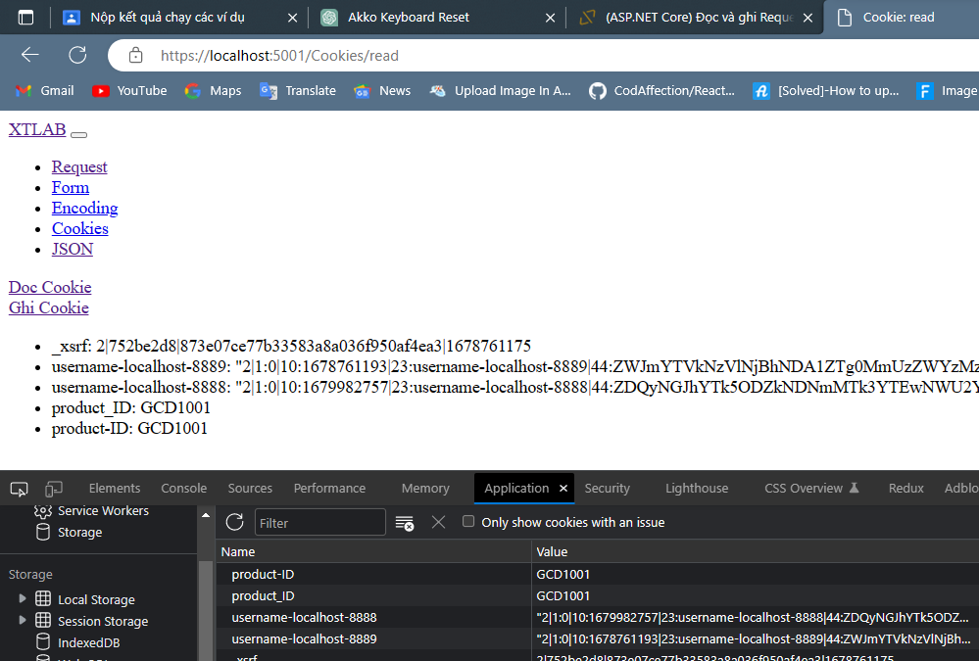

Form:

