International students should not pay higher tuition fees than domestic students. This is because there is an unfair in finance as well as mentality between the domestic students and the foreign ones. For example, abroad students, in some cases, find the sense of disrespect of the school’s principals to them, which probably causes the bad mood in studying or some kind of depression. Moreover, that the tuition fees for international students is dramatically fluctuated with a slight increase annually can cause problematic difficulty for abroad students to pay, which also probably leads the misunderstanding in the scale of wealthy between foreign students and the domestic ones. (Ontario-Post-Secondary Student, 2015). However, if the equality in tuition fees is showed, the leaders of many schools can not have any profits from international education, which can be considered a serious problem.

International students should pay higher tuition fees than domestic students. This is because there is the incompatibility in knowledge-acquiring ability in foreign students. For example, Britain students who are studying in England easily understand their language lessons than French students or Chinese students when every other student-evaluated element is considered equality, which mean there will be a considerable attempt going with costs from teachers in order to make them fulfill the knowledge of the lesson. However, the unfair in the fees, with a little chance, make the leaders of schools and colleagues more “oriented to the health, social sciences and humanities programs that they tend to avoid.” ( Usher, 2015).

***Task 9***

1.

 Checked

2.

Checked

3.

?

***Task 11***

1. APA/ Yes
2. APA/ the citation emphasizes the date that the 2 authors named …. has found the evidence.
3. MLA/ No comma between the authors name and the date.
4. MLA/ Because the author name is already mentioned in the sentence.

***Task 8***

1. 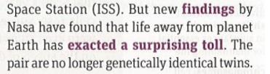
2. 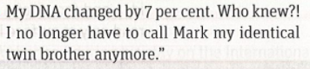
3. 
4. 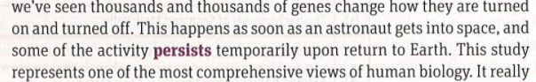-> Continuously
5. 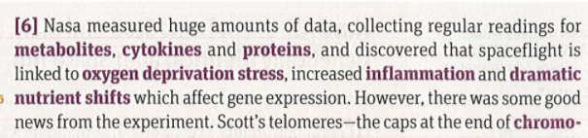

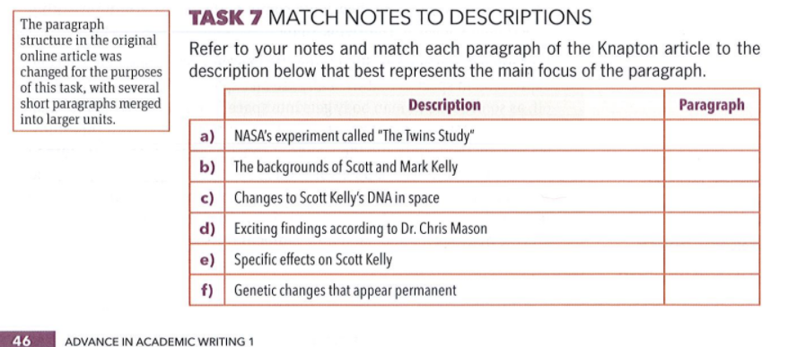

A4 b1 c2 d5 e6 f3

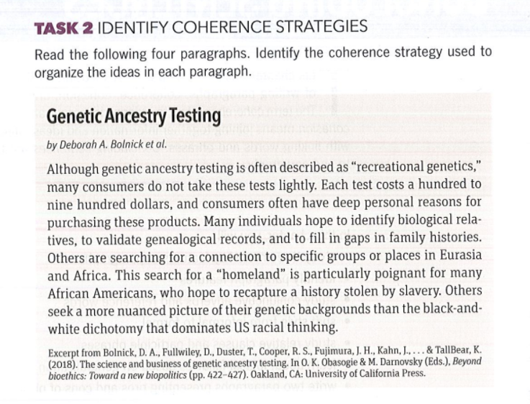

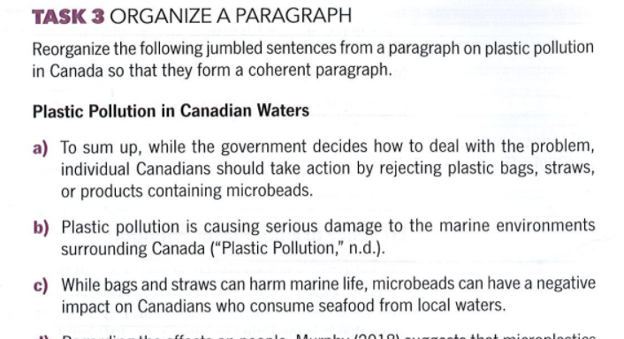

1b 2e 3c 4d 5g 6f 7a

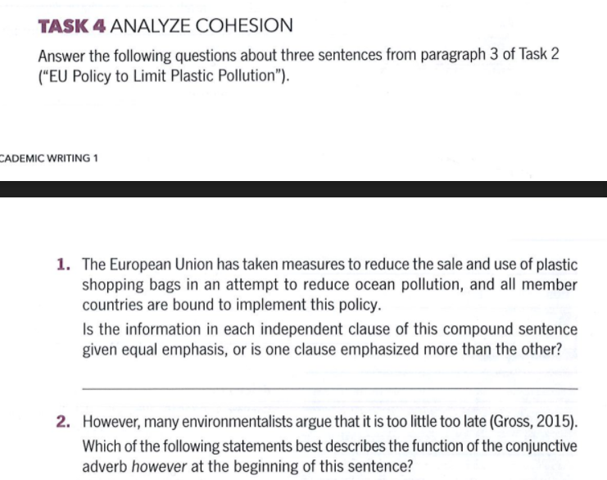

1. The latter clause emphasized more than the other
2. Constrast
3. T T F F

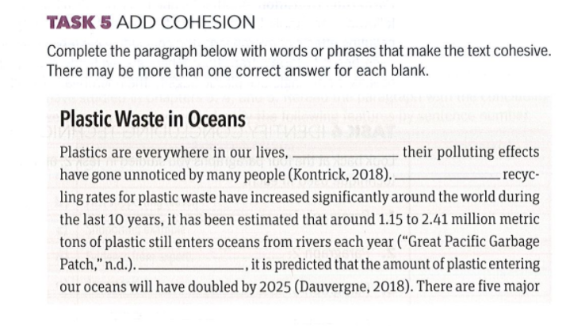

Yet, although, moreover, while, the smallest of waste.

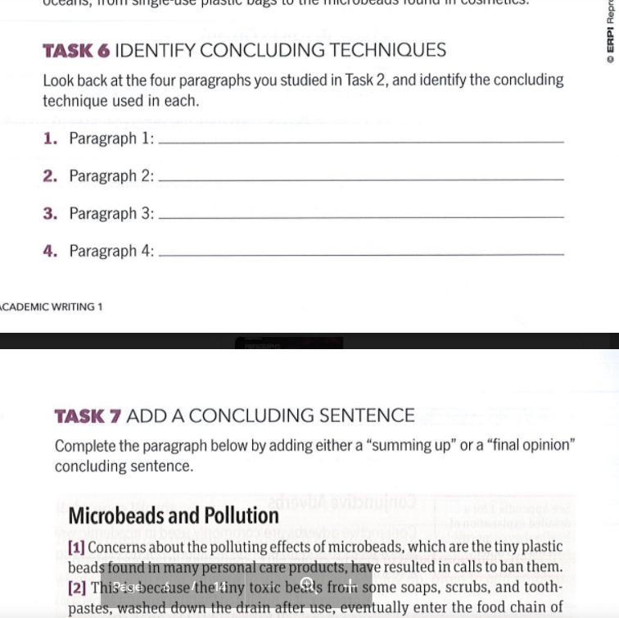

T2/70 T3/70 T4/1,2 T2,3/73 T7

Task2/70

1. Not sure. Because the student has already paid for the website with essay, which mean he/she possessed the website legally. However, the essays are not written by him, which means he is not the real owner of the essays.
2. Not sure. The ideas in the essay first is possessed by the student but not by the tutor. Plagiarism is counted in this situation when the tutor rewrote the essay with improving and is about to use that essay in the future. However, if the rewrote essay is used by the student with help from tutor, that situation is not counted as plagiarism.
3. Same as question 2.
4. Same as question 2.
5. Not plagiarism. It’s just a re-use method.
6. Plagiarism. The incorrect citation format can lead to plagiarism.
7. Plagiarism. Paraphrasing is just changing the sentences format but not the meaning of them.
8. Not plagiarism. The historical dates are widely known and are not possessed by anyone.

Task 3/73

1. Academic writing, skill, students, because most instructors assess, written assignment, there is a little doubt that, is more difficult for international students, however; academic English is also a new, student whose first language is not Eng, they too have … to learn.

* Patchwriting, writer does not have many changes in vocabulary and grammar.

1. Important, all students, writing assignments, international student, English.

* Paraphrase, writer changed all the grammar and vocabulary with keeping some main subject in the paragraph.

Task 4

1. [APA] According to Aitchison, the aim of all psycholinguists is: "to find

out about the structures and processes which underlie a human's ability to

speak and understand language" (Aitchison, 2007).

1. [APA] The aim of all psycholinguists is: "to find

out about the structures and processes which underlie a human's ability to

speak and understand language" (Aitchison, 2007).

t2/105__ t6,7/p108,109

t2/105

1. Pulping
2. Cupping
3. Harvesting
4. Milling
5. Fermenting
6. Brewing
7. Grinding

T7/108,109

1. T
2. F
3. F
4. F
5. T

The process reveals how a coffee cup is made from planting the seed to enjoying the cup of coffee.

1. Steadily increased
2. Small fall
3. Stabilized
4. Peaked
5. Gradually rose by

Academic writing is a standard used in academic environment. Academic writing mostly aims to the promotion in logic as well as ability to present the meaning of academic document. For example, IELTS is created for evaluating writing’s ability of candidates.

T5,6/120

T5

1. The language of exemplification in two sentences has different purpose. The first one is used to exemplify for an action while the second one is used to exemplify for the main object name AI.
2. Exemplify for the statement.
3. 2

T6

1. Is
2. Is performed by
3. Is performed by / For instance,
4. Which are
5. Namely ( such as )

[1] As we live our lives whother as a parent or child, spouse or partner,

relativ

that we can be in what we are doing. We want to live up to all expectations:

those of others and of ourselves. Our basic goals include making a decent

= living, enjoying our work careers, making our loved ones proud, and taking

care of the well-being of our families in relative security and material comfort.

But at the very least, we wish to stay out of trouble, not get fired, avoid being

sued, not harm others, and certainly not end up in jail. Basically, we hope to

fulfill our responsibilities both at work and at home, while living a good life

- with no major regrets.

Open with Google Docs ger, we presumably try to be the best

[2] We have many motivations to achieve these goals, including feelings of

loyalty, love, responsibility, self-worth, and self-satisfaction. But along the

way and on a daily basis, as we attempt to fulfill our life objectives, we inevit-

ably face ethical dilemmas that need to be resolved. Sometimes we simply

s don't realize we are facing ethical dilemmas, and make decisions we realize

only in hindsight should have been handled differently. In other cases we

might realize there are potential ethical implications to our actions but

we decide to ignore them, either consciously or subconsciously. Often, this

is because we choose to do what will help us achieve what we want, rather

o than what we know we ought to do. Either way, there are going to be potential

implications as a result of our actions or inaction, both for ourselves and for

others, throughout our lives.

[3] Just like everyone else, I have faced and continue to face ethical dilemmas.

I still vividly remember being in junior high school and sitting in my math-

ematics class. Just after class ended I opened one of the textbooks that had

been left on the desk. I discovered that a 20 dollar bill had been left inside

the textbook. Thoughts immediately crossed my mind. Should I keep it?

What would I buy with it? What about the other student who had forgotten

about his or her money? Why did the other student leave a 20 dollar bill in

o a textbook in the first place? Twenty dollars was a lot of money for a teenager