**1.Data input/collection**

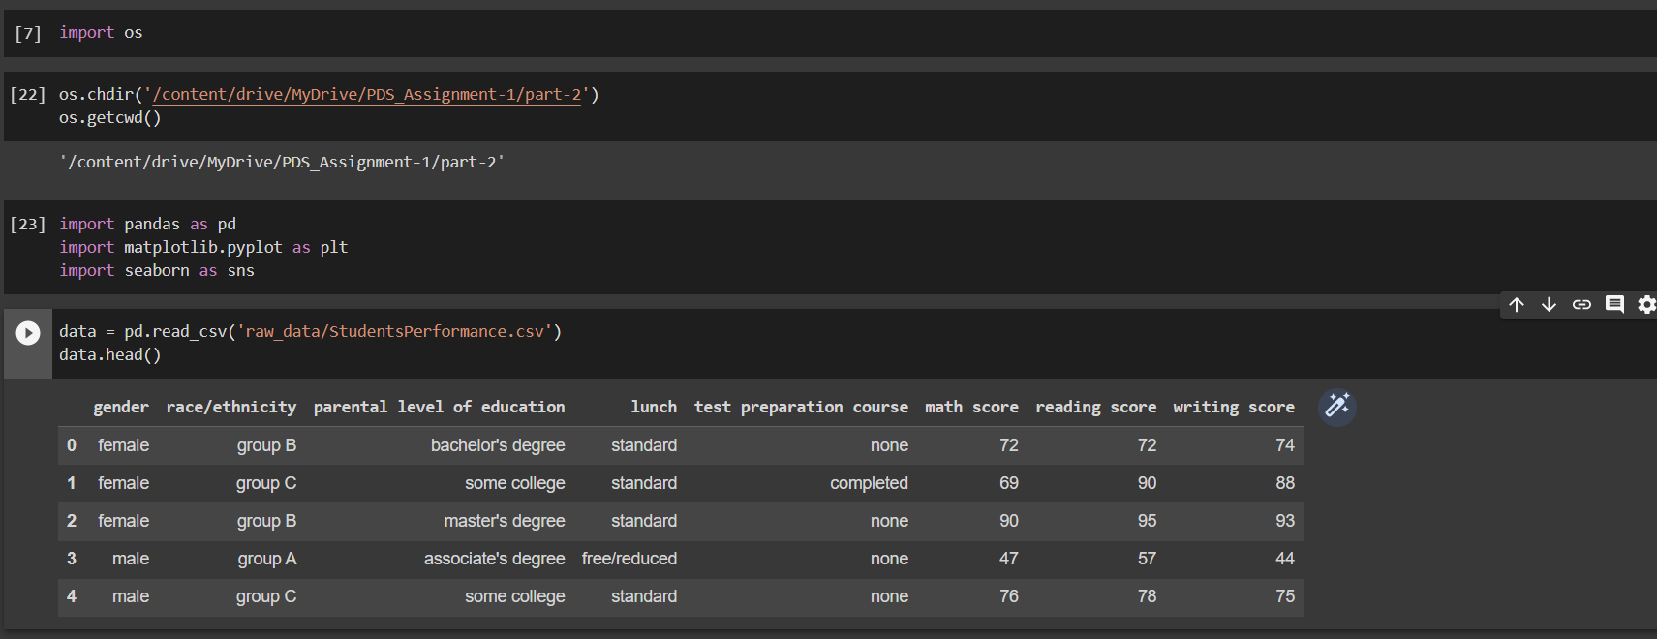

loaded the StudentsPerformance.csv file in a python environment using ***pandas*** library.

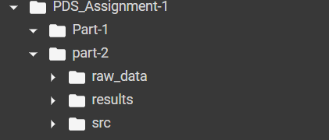

**2. Data processing**

Since the data doesn’t have any null values and data types are correct didn’t make any refinements to the data.

**3. Data analysis**

**a)**

b)

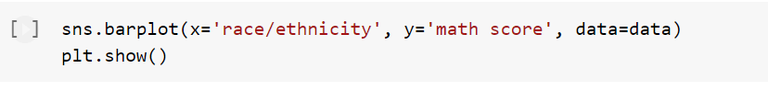

c)



This violin part used visualize the parental education and reading score.

d)

This visualization can help identify whether there is a correlation between math scores writing scores and reading scores.

e)

This visualization can help identify whether there is a difference in test scores between students whose parents have different levels of education.

the folder structure looks like this after ***data analysis*** stage.