

**CLOTHING WEBSITES PROJECT**

|  |  |
| --- | --- |
|  | **Group 6** |
| Group members | * Nguyễn Tuấn Thành - SE151308 * Bùi Duy Thái - SE151309 * Nguyễn Thị Mỹ Chi – SE140113 |
| Supervisor | vanttt |

Table of Contents

**A.** **Introduction:** 2

*1.* *Project Information* 2

*2.* *Introduction* 2

**B.** **A case study** 2

**C.** **A database design** 2

*C.1 Database Diagram* 2

*C.2 ERD* 3

**D.** **System design** 4

*D.1 MVC Model 2* 4

*D.2 Use Case Diagram* 5

*D.3 Class diagram* 6

*D.4 Sequence Diagram – Login* 7

*D.5 Sequence Diagram – Remove Cart Item* 8

*D.6 Sequence diagram – Add to Cart* 9

*D.7 Sequence Diagram – Logout* 9

**E.** **Screen design** 9

**F.** **Conclusion** 13

*F.1 Pros* 13

*F.2 Cons* 14

*F.3 Learned when development of this application* 14

**G.** **References** 14

1. **Introduction:**
2. *Project Information*

* Project name : Clothing websites
* Product Type: desktop app
* Start Date: 4/7/2021
* End Date: 12/7/2021

1. *Introduction*

In this document, we wrote this website to want to introduce people to a more handy site about sitting at home that can also make purchases. Due to the stressful situation in our country because of Covid, this website can be convenient for everyone at home to also buy goods.

This website is available for both purchasers and admins to use.

1. **A case study**

* The website has functions for admin:
* Login and Logout functions.
* Add new product to website.
* Edit information product on website.
* Remove the product from website.
* The website has functions for user:
* Sign up account (for guest).
* Login, Logout function (for user).
* View all available products on website.
* Search product on website.
* Add products to cart.
* Remove products from cart.

1. **A database design**

*C.1 Database Diagram*

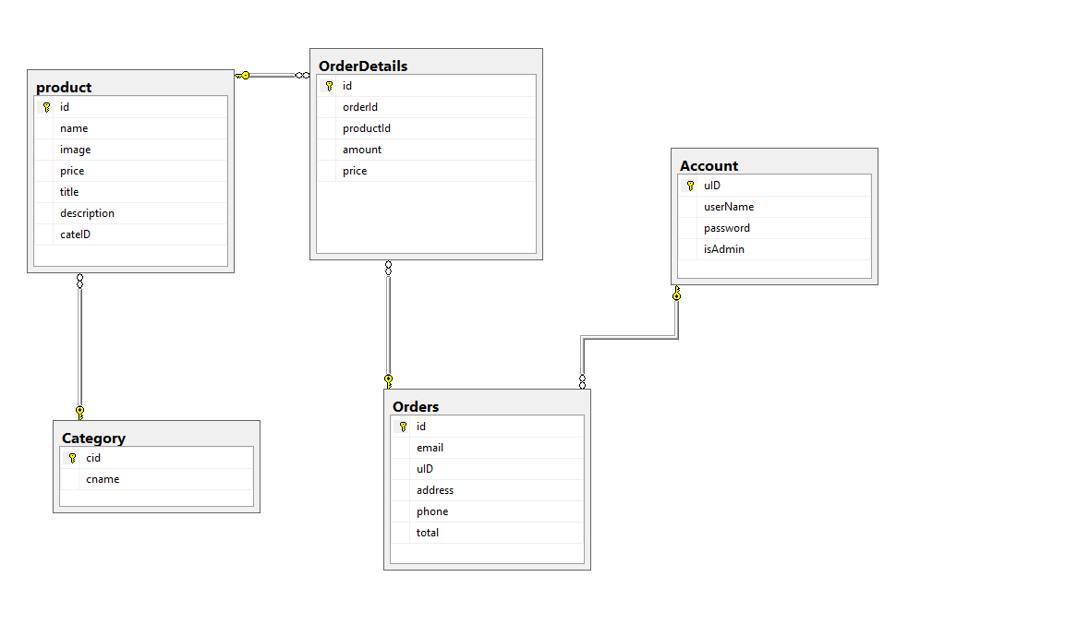

*C.2 ERD*

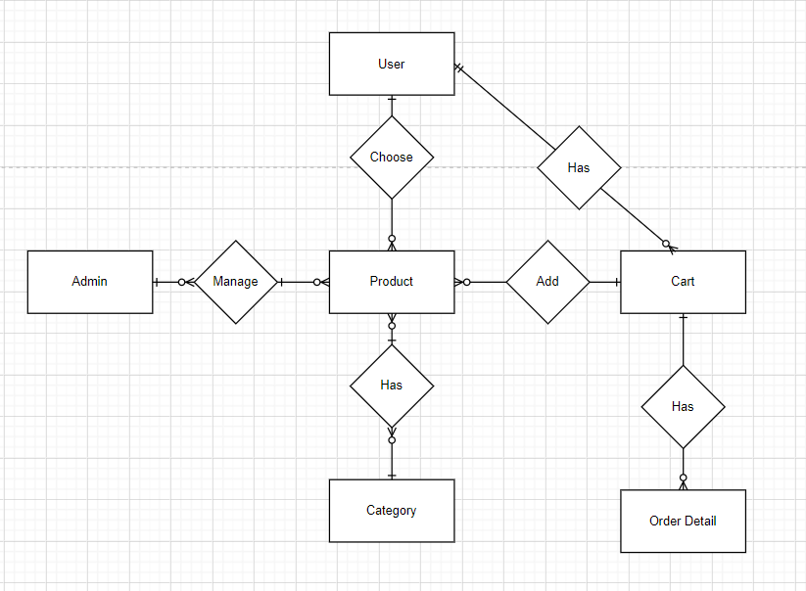

1. **System design**

*D.1 MVC Model 2*

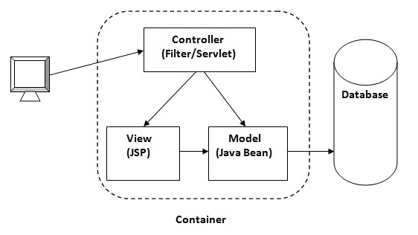

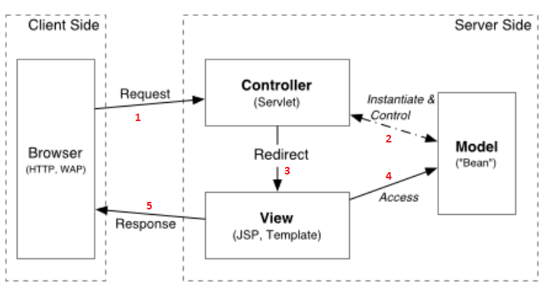

* Our web application is built using Javascript and Bootstrap 4. We have implemented MVC Model 2 architecture to design the system for this web application.
* To run this project, we use Tomcat 8 included in Netbeans to make the development process easier.
* For more details, we use JavaBean and Web Service as Model, HTML / Servlet / JSP as View, and finally servlet as Controller.

*D.2 Use Case Diagram*

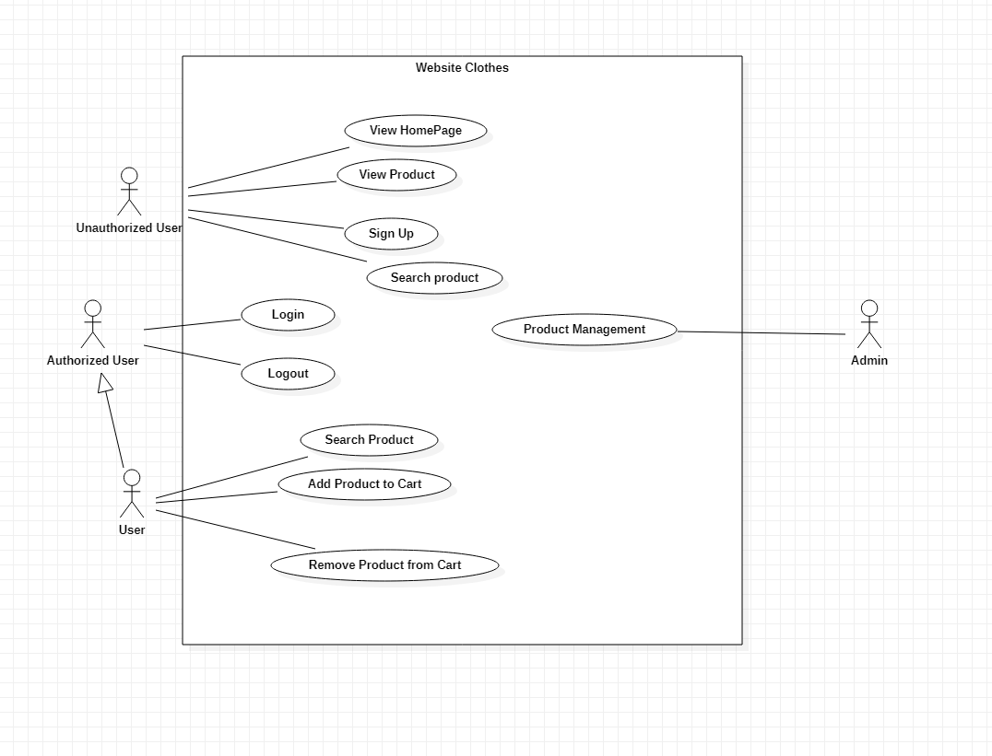

*D.3 Class diagram*

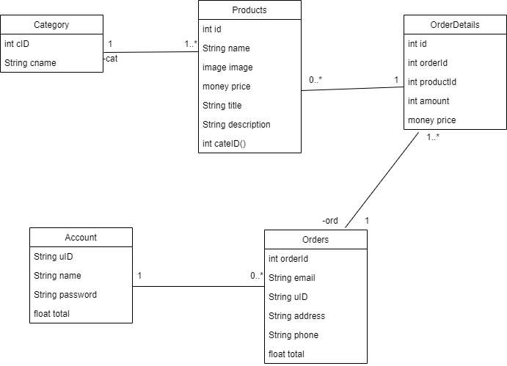

*D.4 Sequence Diagram – Login*

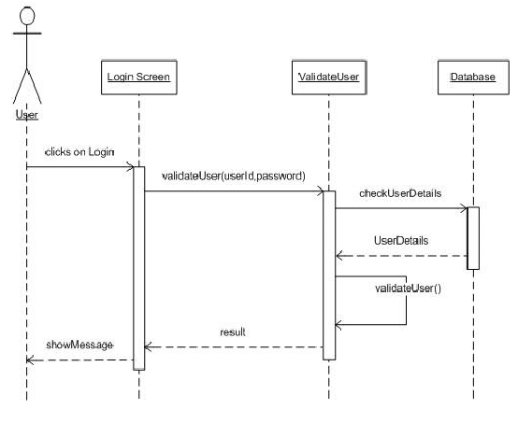

## *D.5 Sequence Diagram – Remove Cart Item*

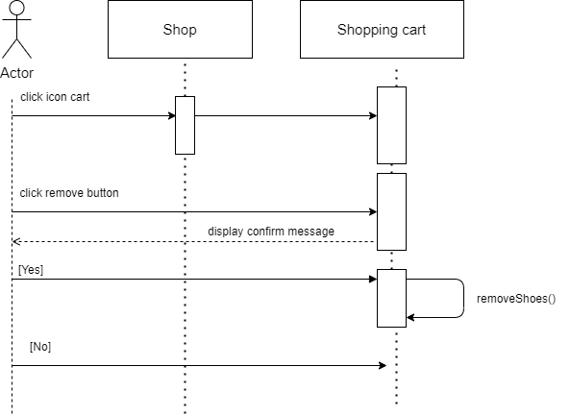

## *D.6 Sequence diagram – Add to Cart*

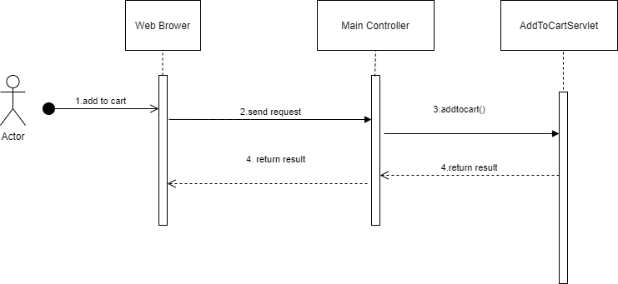

## *D.7 Sequence Diagram – Logout*

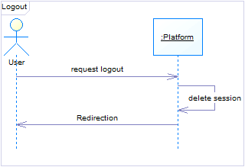

1. **Screen design**

* Home Page (For admin, user and guest).

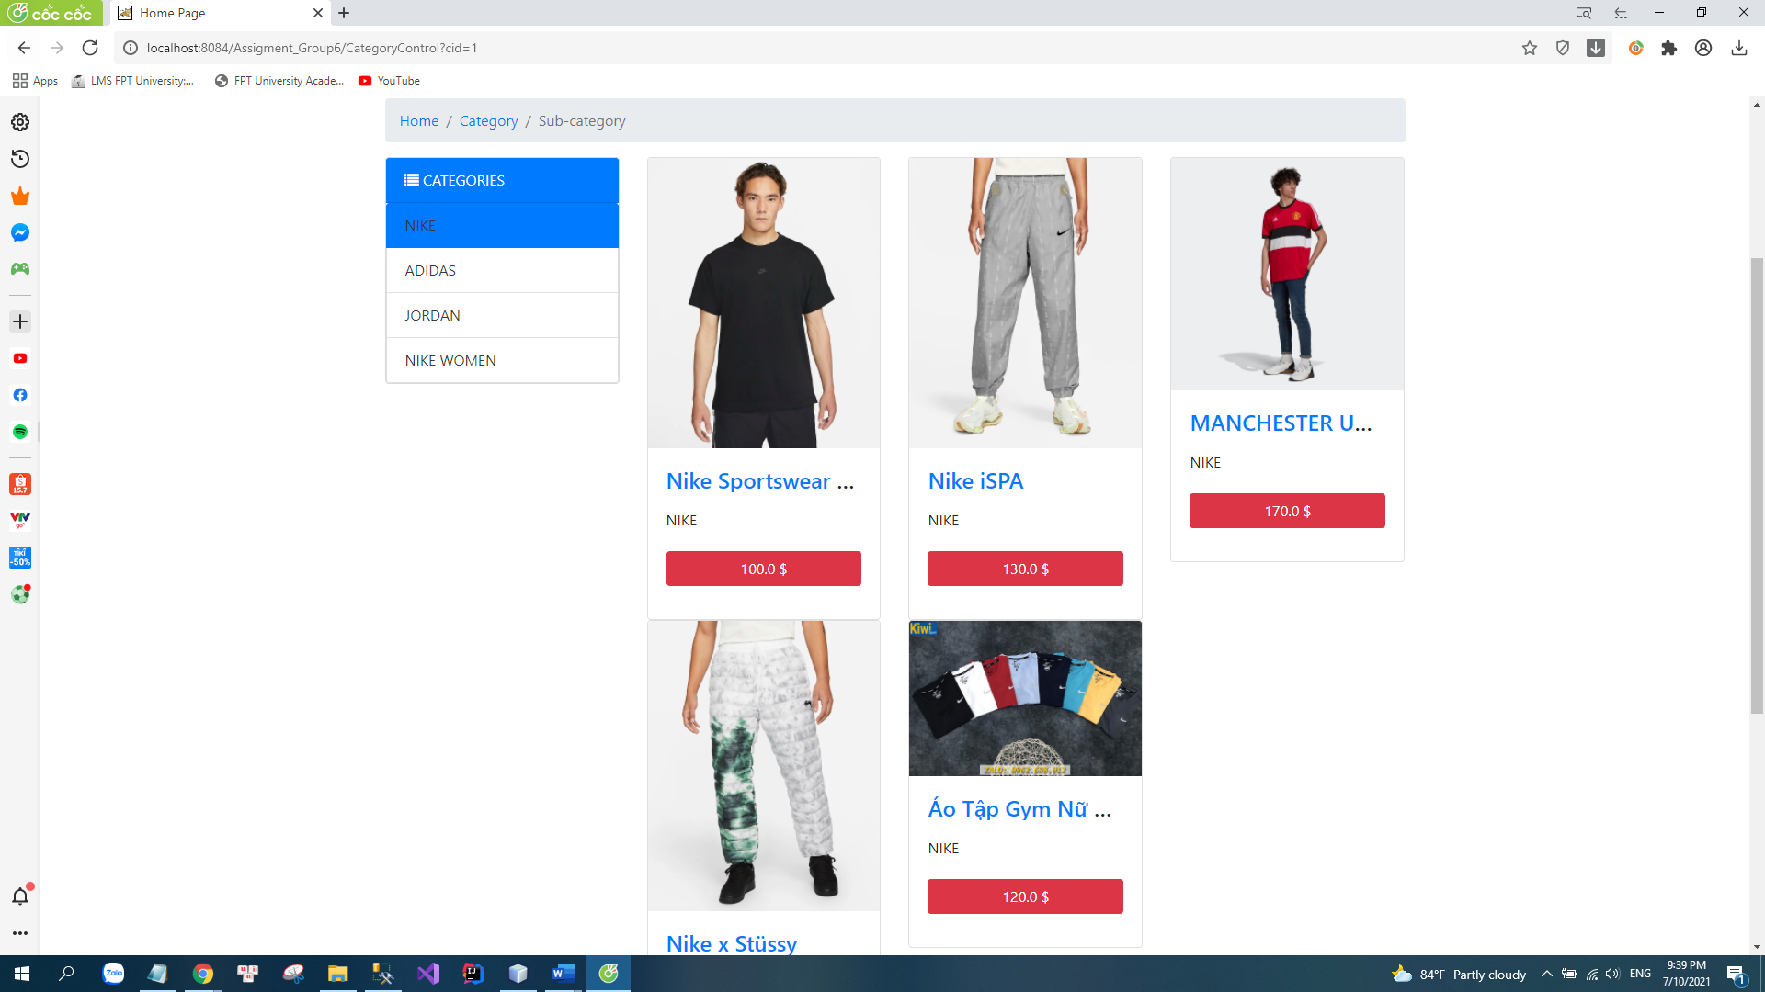

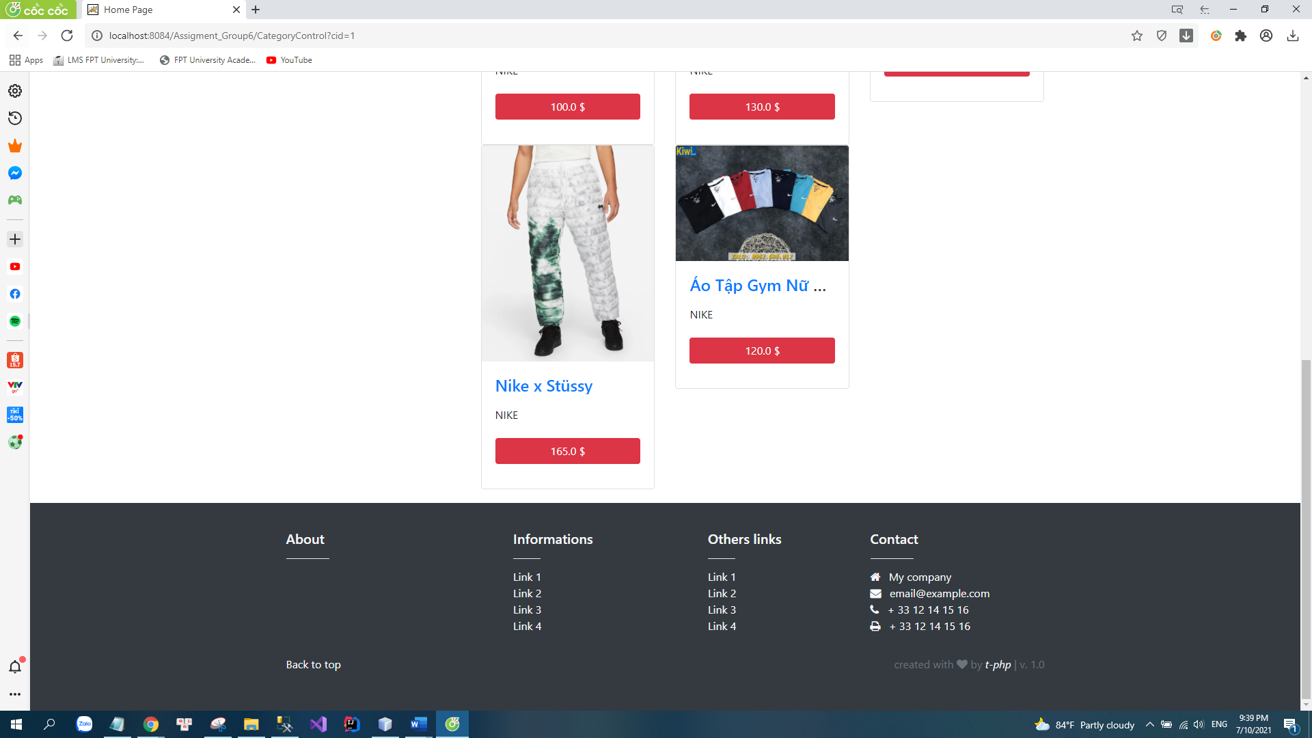

* Sign Up (for guest)

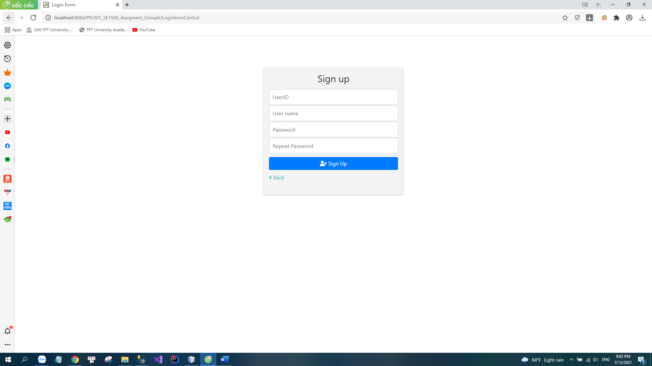

* Add To Cart(for User)

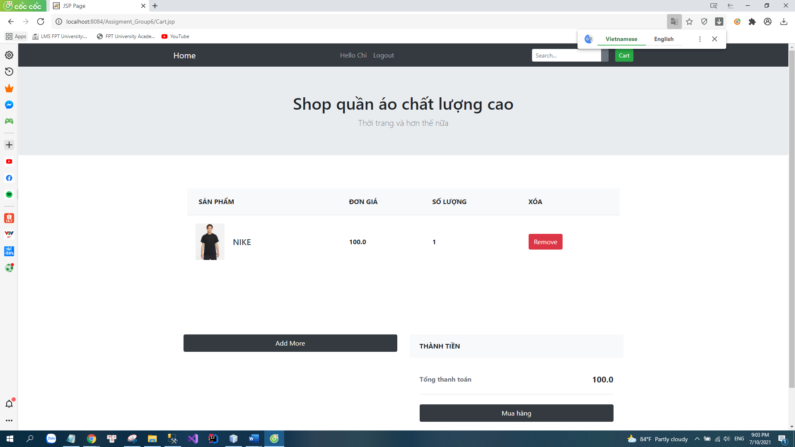

* Remove Product (for User)

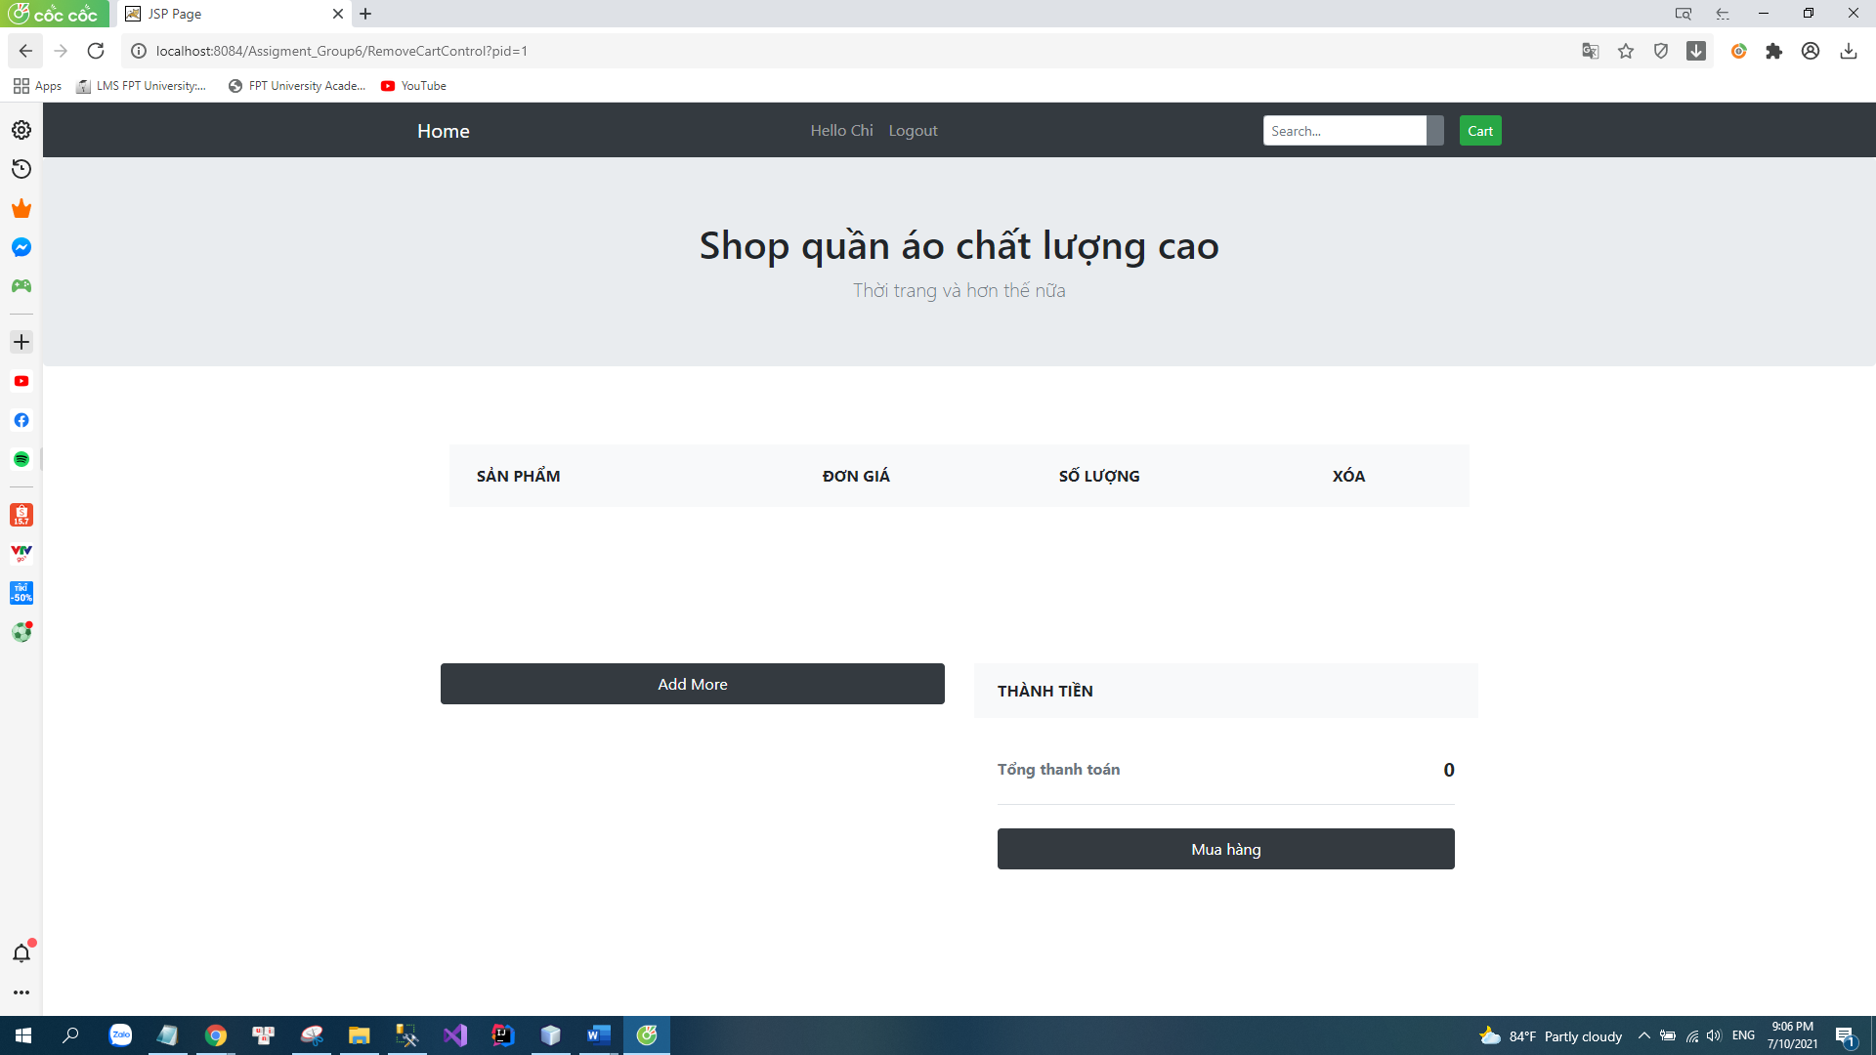

* Manage Product (for Admin)

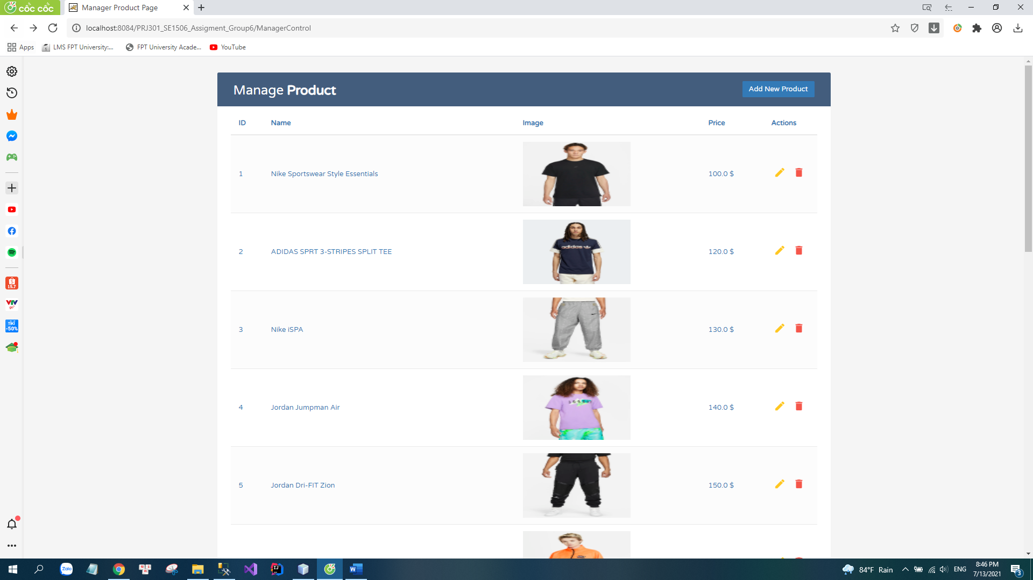

* Add new Product (for admin)

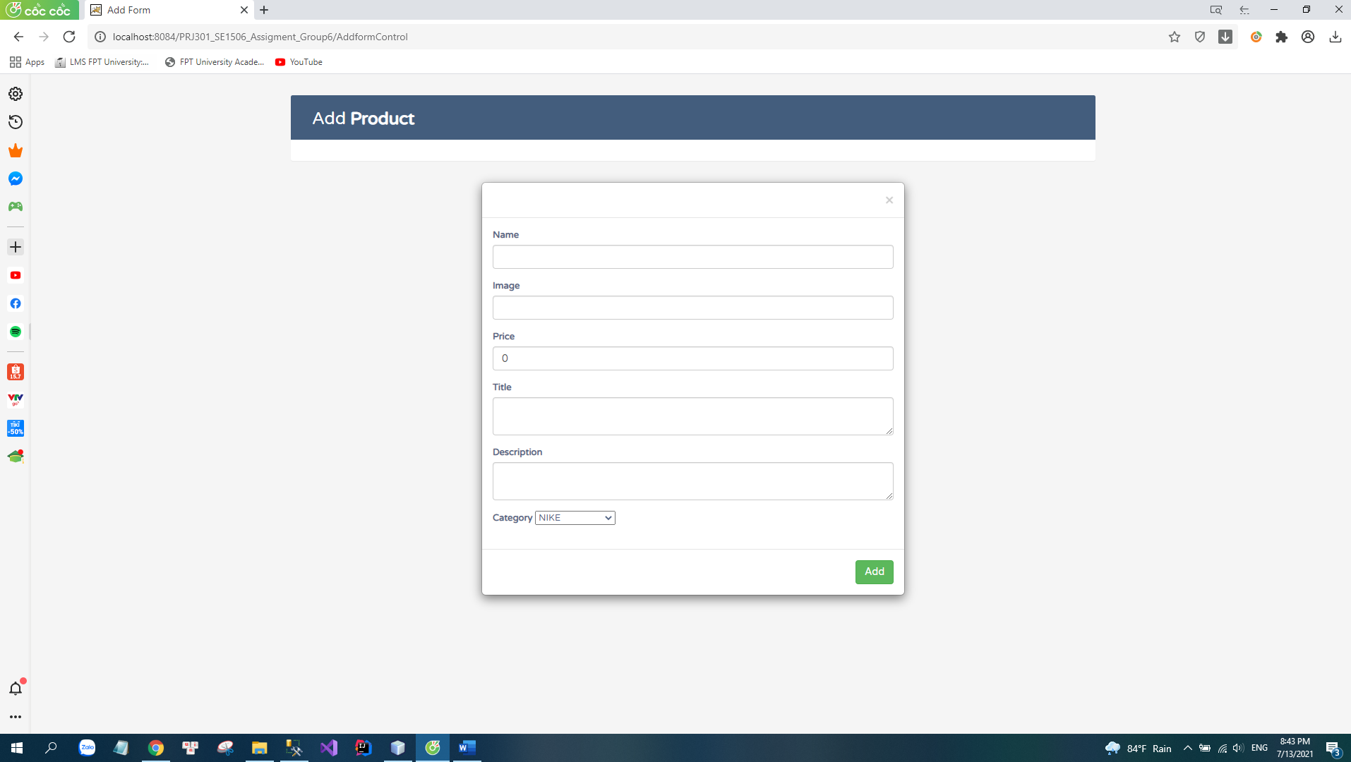  
- Edit Product (for admin)

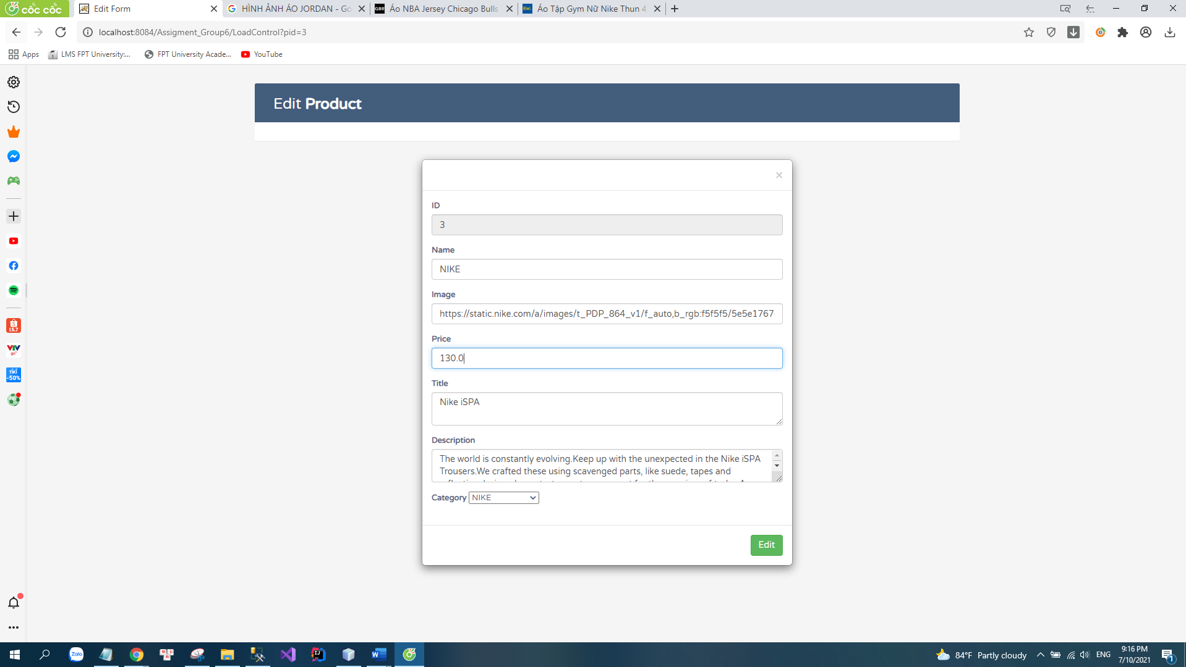

1. **Conclusion**

*F.1 Pros*

* Simple design and easy to use for user.
* Have many basic functions.
* Easy to maintain.
* Easy to extend.
* Easy to test.

## *F.2 Cons*

* Functionality is not well.
* We need to write controller code. If we change the controller code, we need to recompile the class and redeploy the applications.
* The website does not have a check out function for customers.

## *F.3 Learned when development of this application*

* Know how to make a sales website.
* Teamwork skill.
* Better understanding of MVC model 2.

1. **References**

[1]<https://drive.google.com/drive/u/0/folders/14RXTkcE6649eKoDHTc4ILG6X2w6jU9lD?fbclid=IwAR1EigX4TMlONDALHQa83wSkk0_eaSex9GaJr2xOuNxm8-ArufuxA3IqQyU>

[2]https://www.youtube.com/watch?v=kXrq6IiXdzo&list=PLpwmCwTvwxMEV0ScloeXYyNUgSPrTtszE&index=46