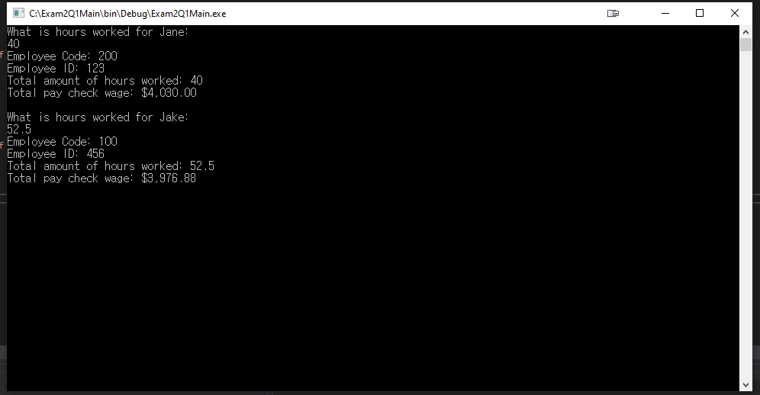

using System;

using System.Collections.Generic;

using System.Linq;

using System.Runtime.Remoting.Channels;

using System.Text;

using System.Threading.Tasks;

using Exam2Q1DLL;

namespace Exam2Q1Main

{

    class Program

    {

        static void Main(string[] args)

        {

            decimal hourWorked;

            decimal wage;

            string question = "What is hours worked for ";

            Staff jane = new FullTimeStaff(123);

            Console.WriteLine(question + "Jane:");

            hourWorked = Convert.ToDecimal(Console.ReadLine());

            wage = jane.CalWage(hourWorked);

            Console.WriteLine($"Employee Code: {jane.EmployeeCode} \nEmployee ID: {jane.EmployeeID} \nTotal amount of hours worked: {hourWorked} \nTotal pay check wage: {(wage.ToString("C"))} \n");

            Staff jake = new PartTimeStaff(456);

            Console.WriteLine(question + "Jake:");

            hourWorked = Convert.ToDecimal(Console.ReadLine());

            wage = jake.CalWage(hourWorked);

            Console.WriteLine($"Employee Code: {jake.EmployeeCode} \nEmployee ID: {jake.EmployeeID} \nTotal amount of hours worked: {hourWorked} \nTotal pay check wage: {(wage.ToString("C"))} \n");

            Console.ReadLine();

        }

    }

}

namespace Exam2Q1DLL

{

    public abstract class Staff

    {

        public abstract decimal CalWage(decimal totalHourWorked);

        public int EmployeeCode { get; set; }

        public int EmployeeID { get; set; }

    }

}

using System;

namespace Exam2Q1DLL

{

    public class FullTimeStaff : Staff

    {

        public FullTimeStaff(int employeeID)

        {

            EmployeeCode = 200;

            EmployeeID = employeeID;

        }

        public override decimal CalWage(decimal totalHourWorked)

        {

            decimal payRate = 100.75m;

            decimal pay = Math.Round(payRate \* totalHourWorked, 2);

            return pay;

        }

    }

}

using System;

namespace Exam2Q1DLL

{

    public class PartTimeStaff : Staff

    {

        public PartTimeStaff(int employeeID)

        {

            EmployeeCode = 100;

            EmployeeID = employeeID;

        }

        public override decimal CalWage(decimal totalHourWorked)

        {

            decimal payRate = 75.75m;

            decimal pay = Math.Round(payRate \* totalHourWorked, 2);

            return pay;

        }

    }

}