Details of your portfolio
PD URL site (*Compulsory to fill up for milestone 2 and 3):
https://painghtetzan.github.io/myportfolio/
Name of your portfolio:
Paing Htet Zan Portfolio
Your Logo:

Describe your target audience:
Target audiences are employesr. This portfolio is made in purpose to show case practical skills of mines.

Describe your brand story/ purpose:
My design theme is simple and joyful. Show each section clearly with unique animations.
Design brief
Colour scheme & Colour palette:
Which colour scheme you have selected for your website? Analogues? Complementary? Triadic? Monochromatic? What are the colours in your colour palette?
Complementary.

Typography:
What is the fonts type used?
Courgette, cursive

Theme:
Minimalistic? Contemporary? Fantasy? Sci-fi?
Fantasy

Layout/ Arrangement:
How will you arrange the multimodal composition in a way that makes sense for your audience and your purpose? How might you arrange ideas and elements so that your composition is effective?
Minimally 3 tabs with 2 layers of navigation
Opening page

Home
About
Contact
Project

Low fidelity wireframe:
Insert your low-fidelity wireframe here. This can be photo of your sketches or digitally created low-fidelity wireframe using shapes. E.g.
t

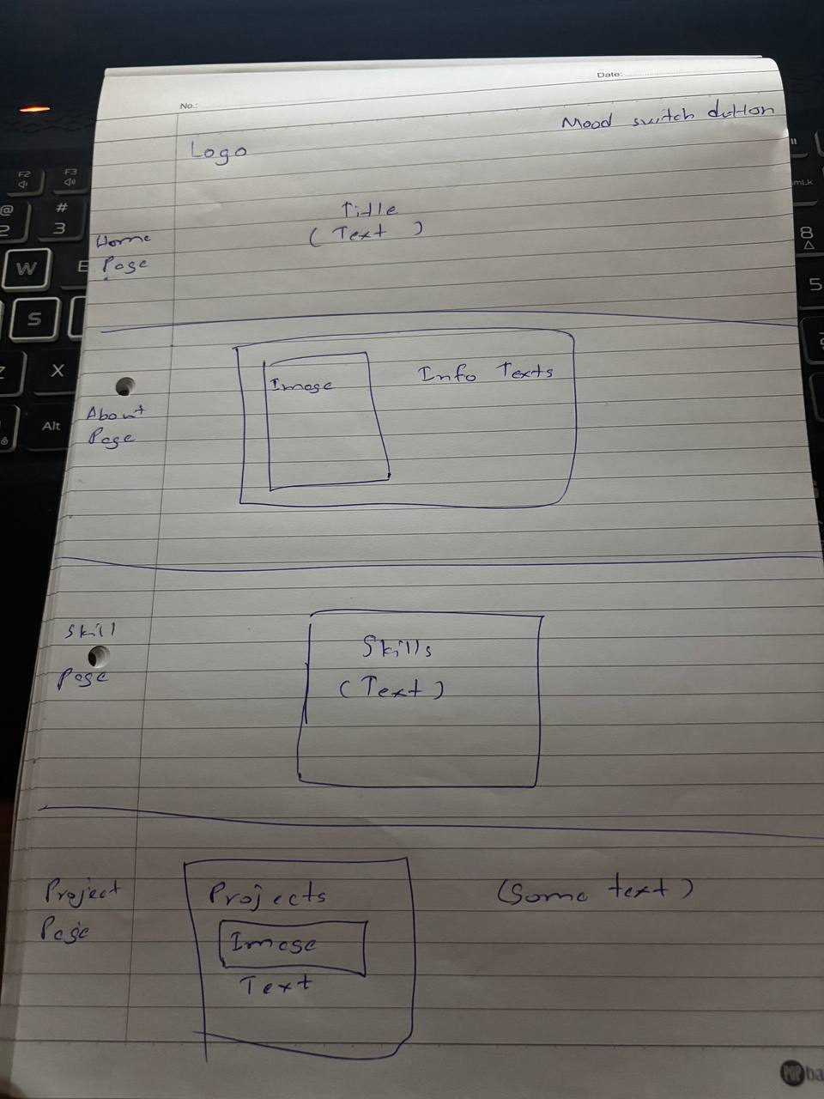
High fidelity wireframe (*Compulsory to fill up for milestone 2 and 3):
Insert your high-fidelity wireframe here. Full set of ALL the pages in JPEG or PDF format.
E.g.
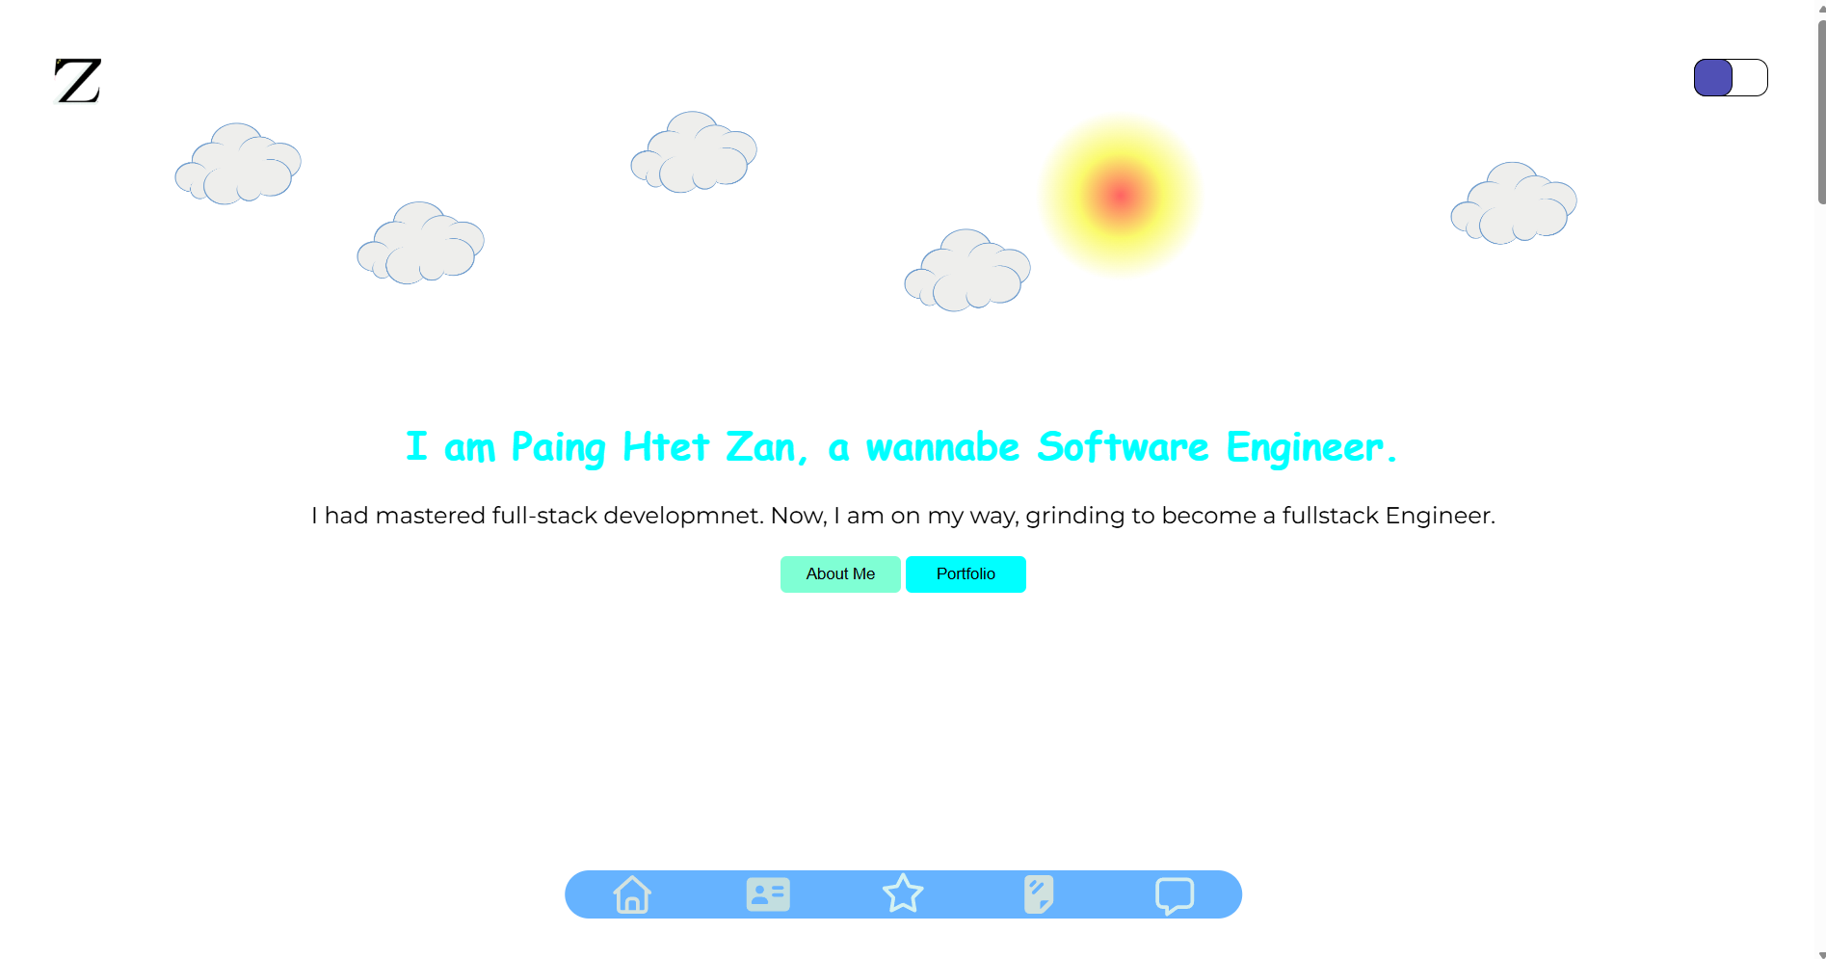
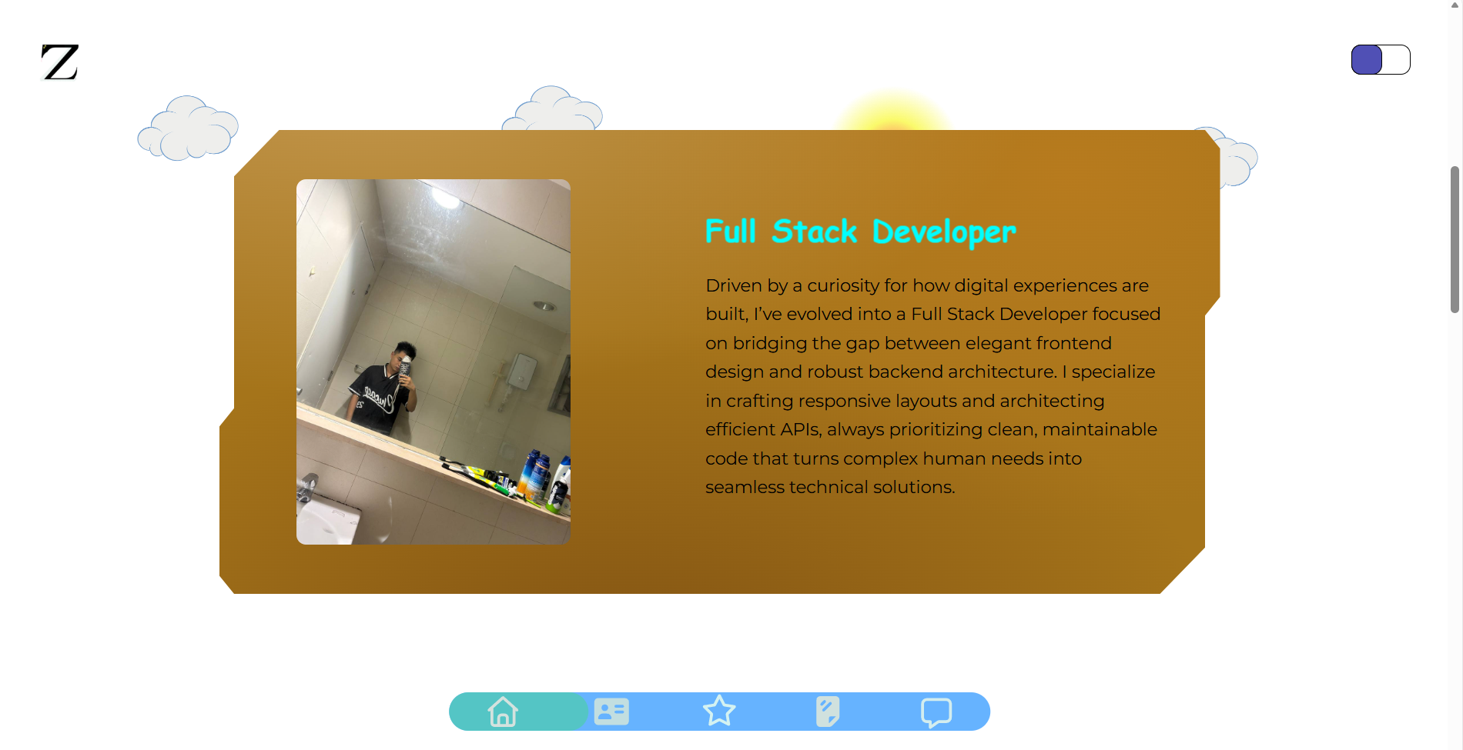

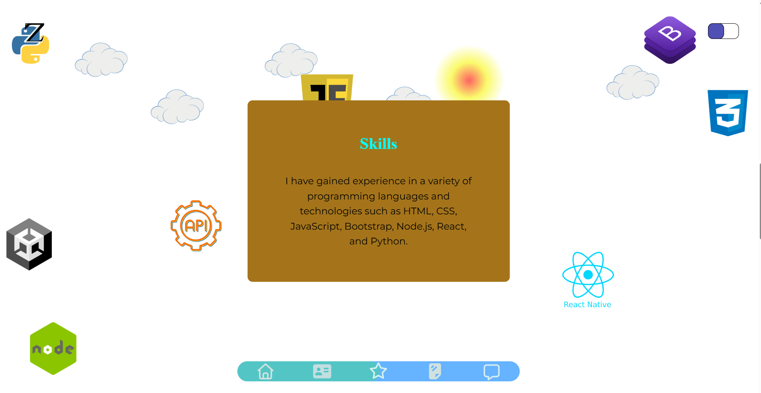
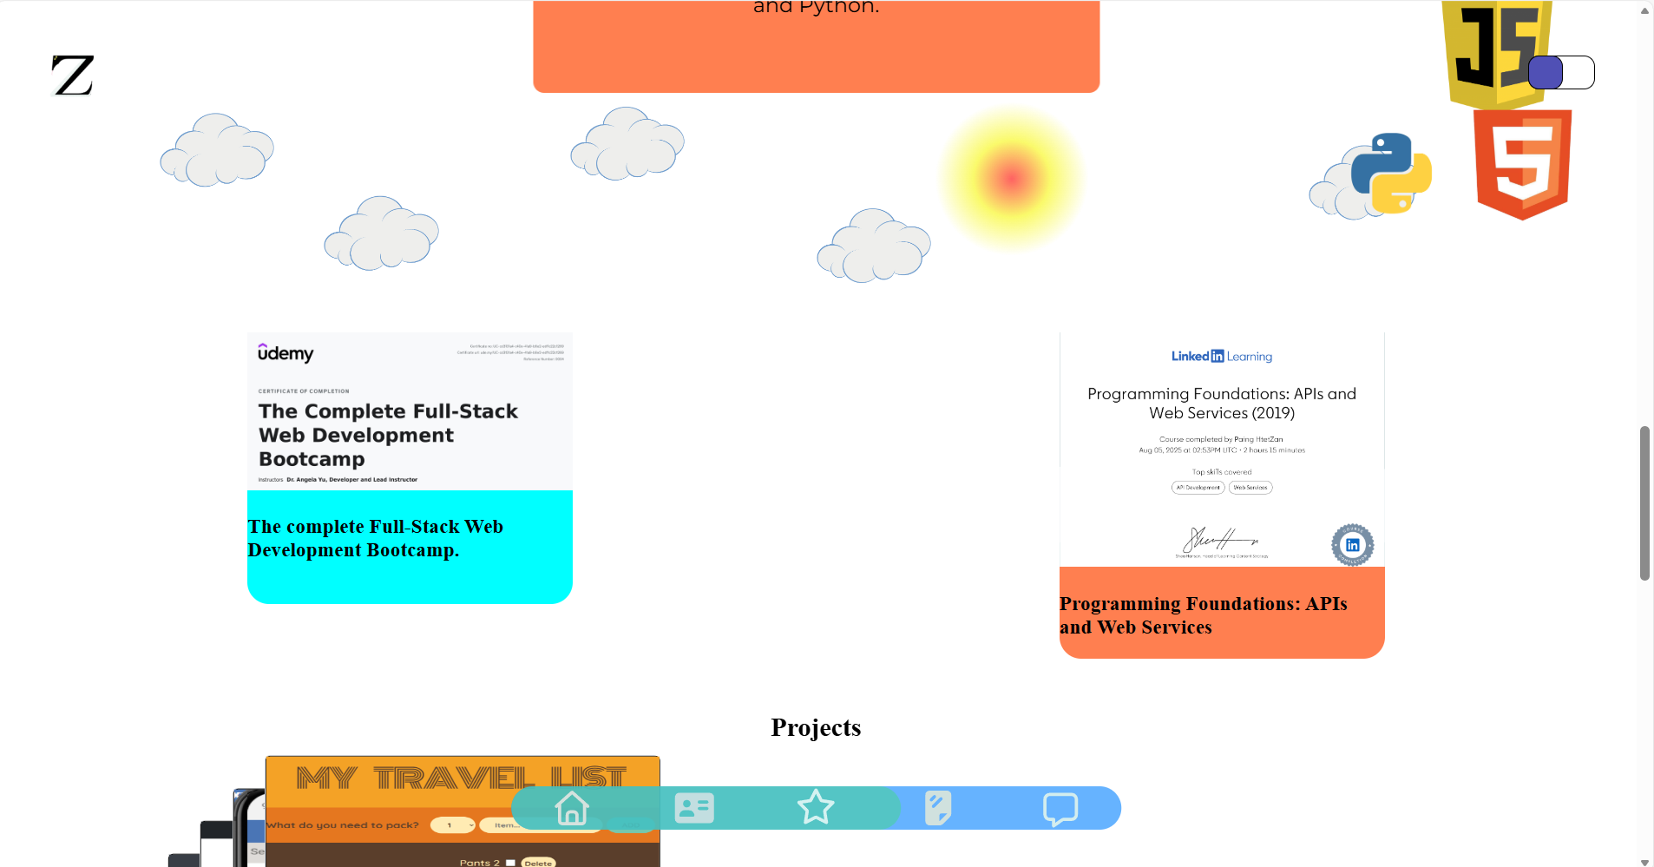
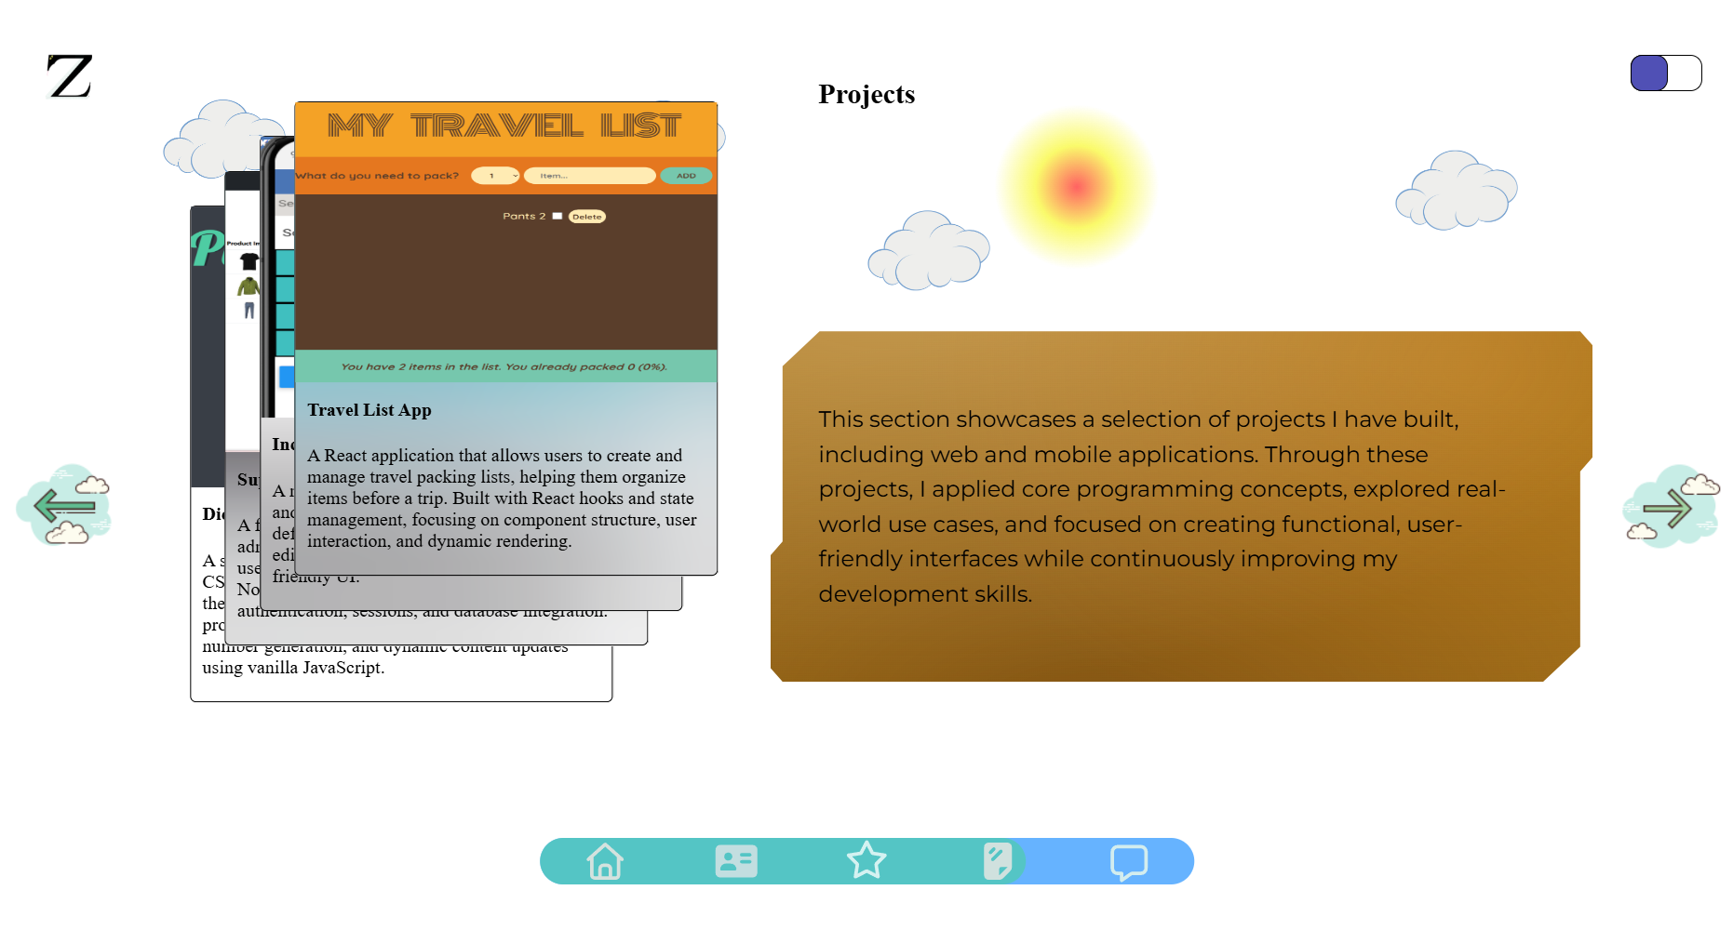
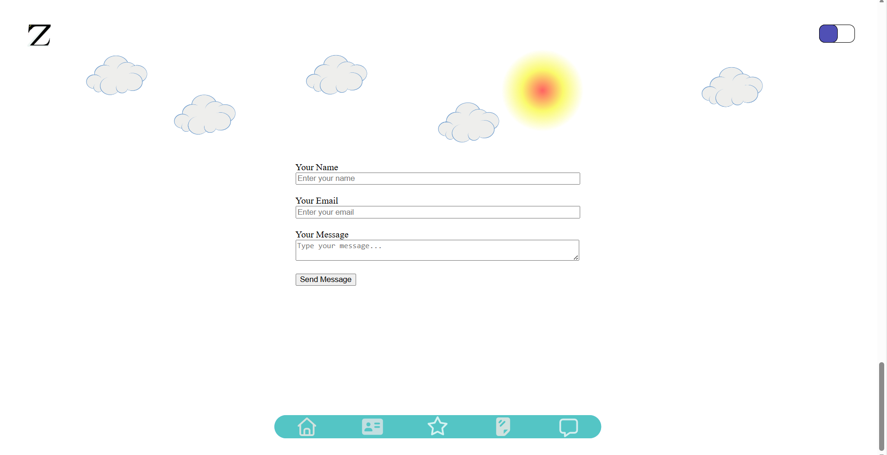
Link to your Prototype – Most likely on Figma (make sure your lecturer is given access to the site) (To fill up for milestone 2 and 3):

Reference sites (*Optional):

