**Kwin Map Prepartaion**

1. **Export Shp file from Geomedia file, (there are 9 files output and used (plotno shp only for matching)) these many data are exported by manually**

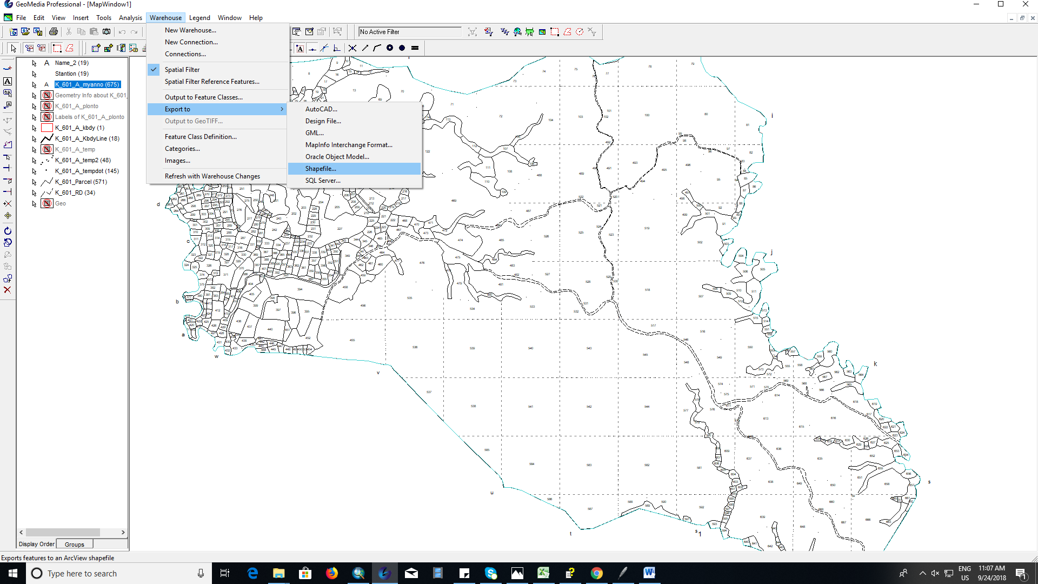

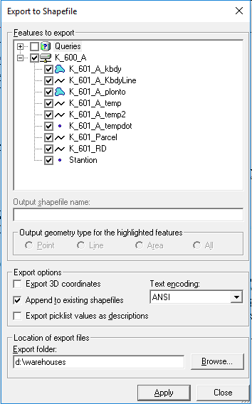

**After that Add field name as “ Kwin No “ in “K_601A__plotno.shp” file and write the name of the current file within each attribute table**

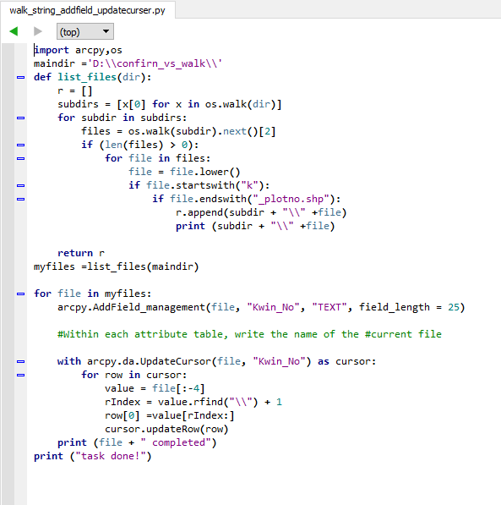

1. **Export AutoCad file of Myanmarannnotaion from Geomedia**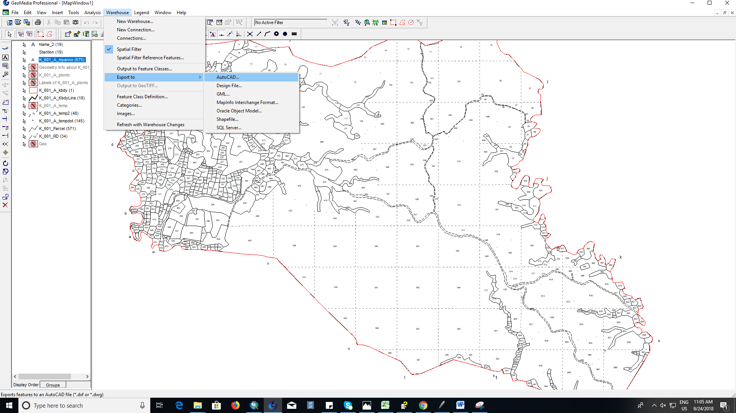

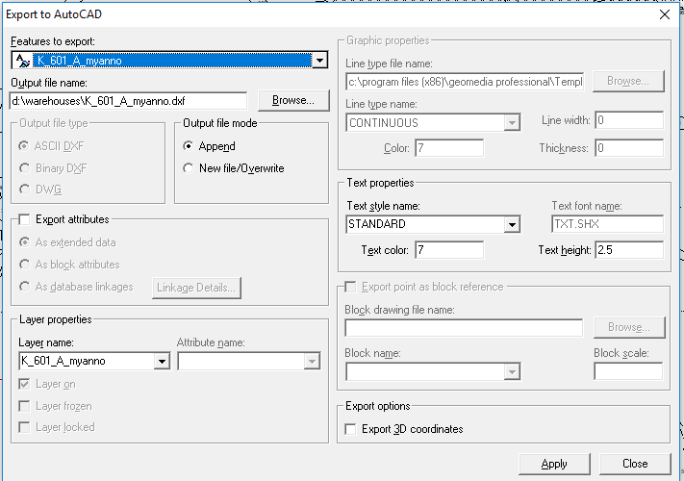

1. **Run Python script to change format of many AutoCAD file annotation to shape file to join with parcel kwin**

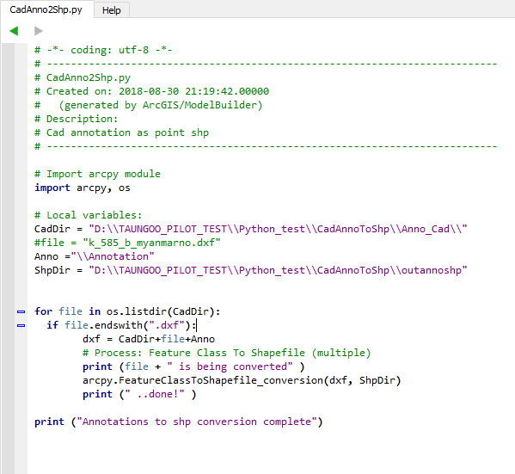

**The flollwing picture is the result of script anootation to shp conversion**

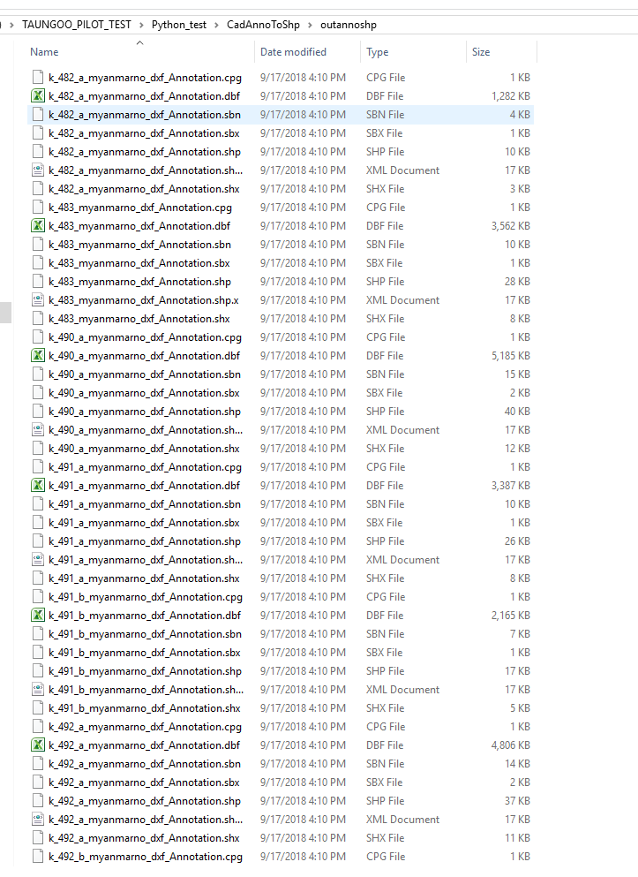

**Merging annotation shape point with python**

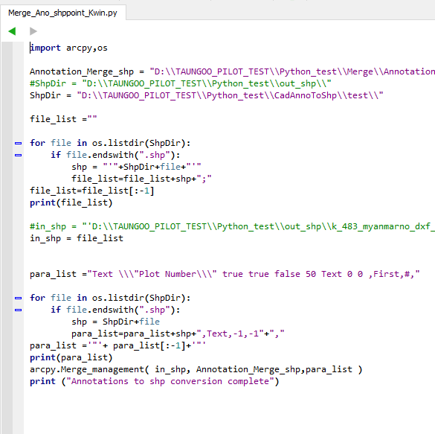

**Spatial join with kwin parcel (polygon) shp file and annotation shp (point)**

**Join option (Join_one_to_one)**

**Match optin (Contains)**

