Picture 1 : WORK ORDER

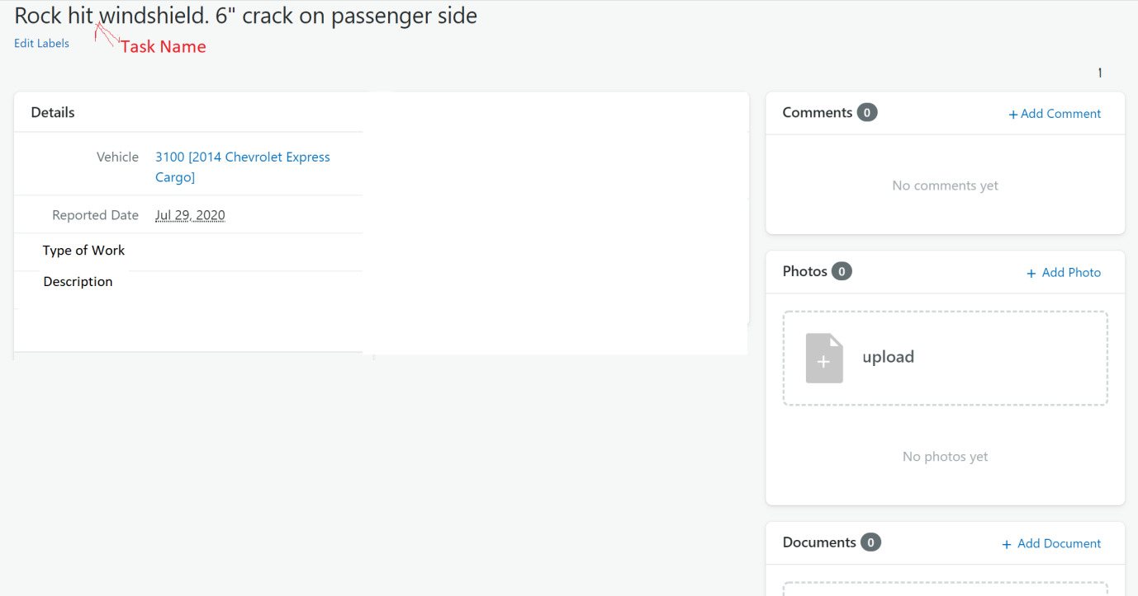

Picture 2: WORK DONE

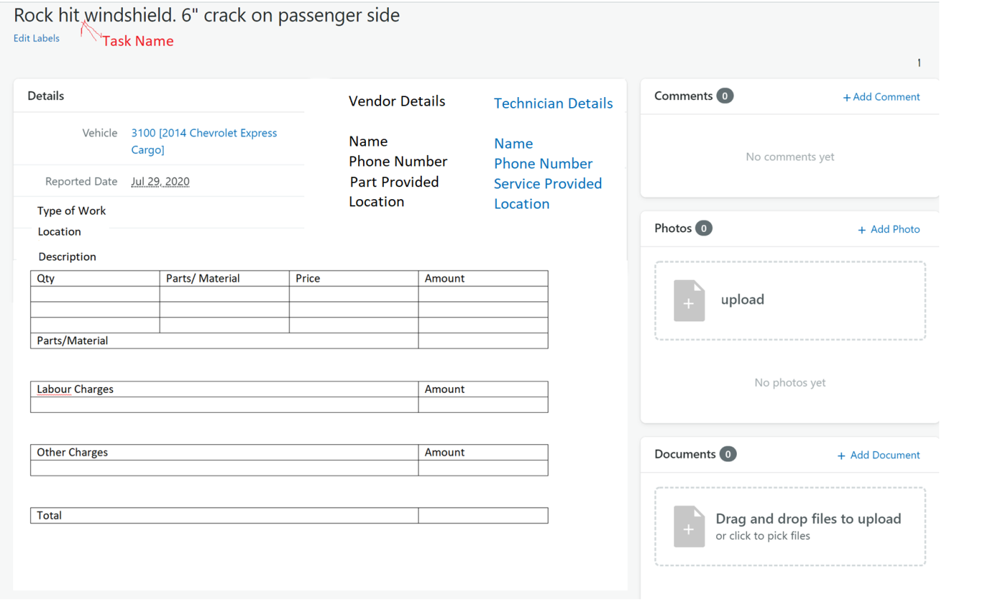

Picture 3: FUEL TRACKER

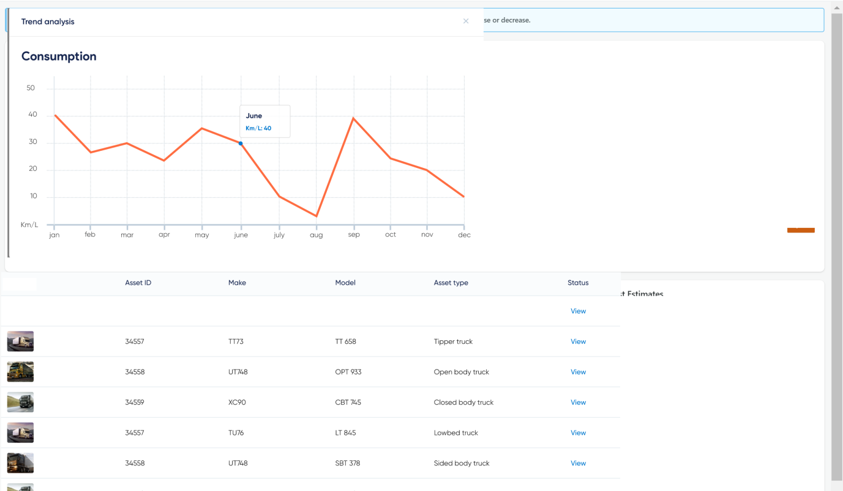

Picture 4: TRUCK CONNECT - TEMPLATE FOR VENDORS/TECHNICIANS/SERVICE PROVIDERS

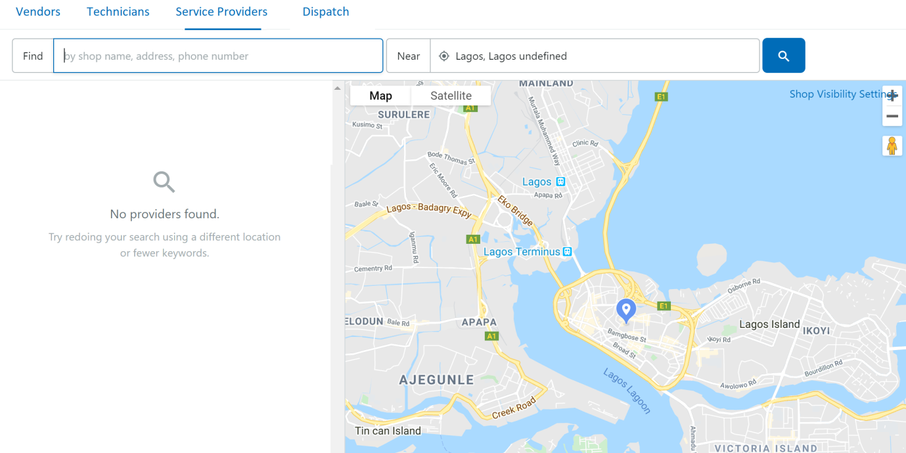

Picture 5: WHEN ANY ITEM IS CLICKED

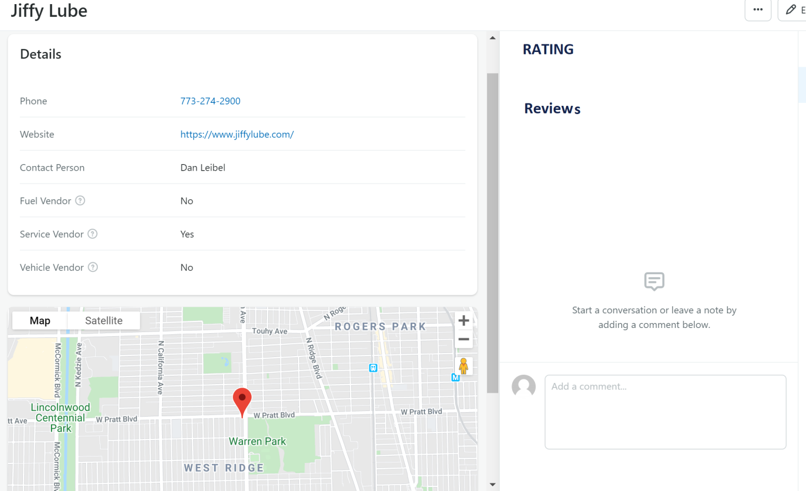

Picture 6: EXPENSE SHEET

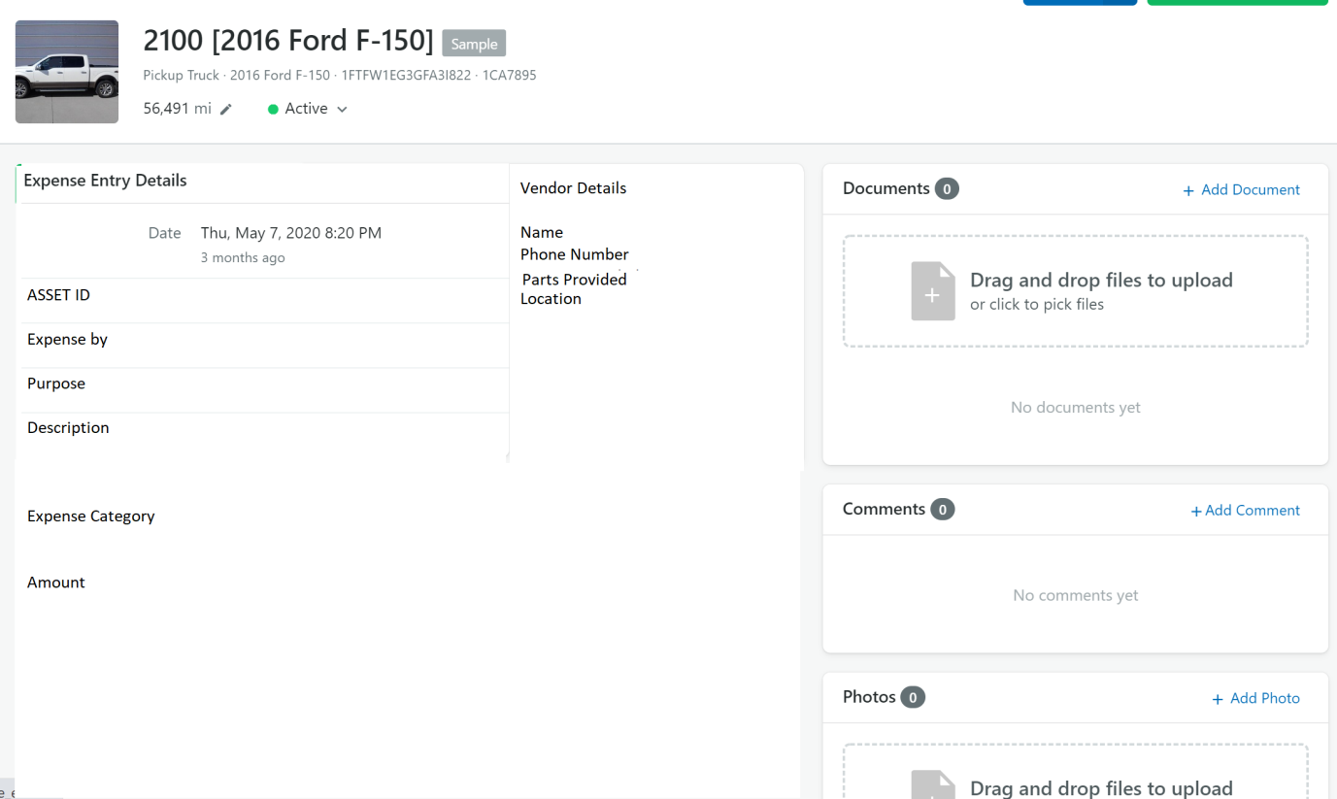

Picture 7: TRIP REPORT

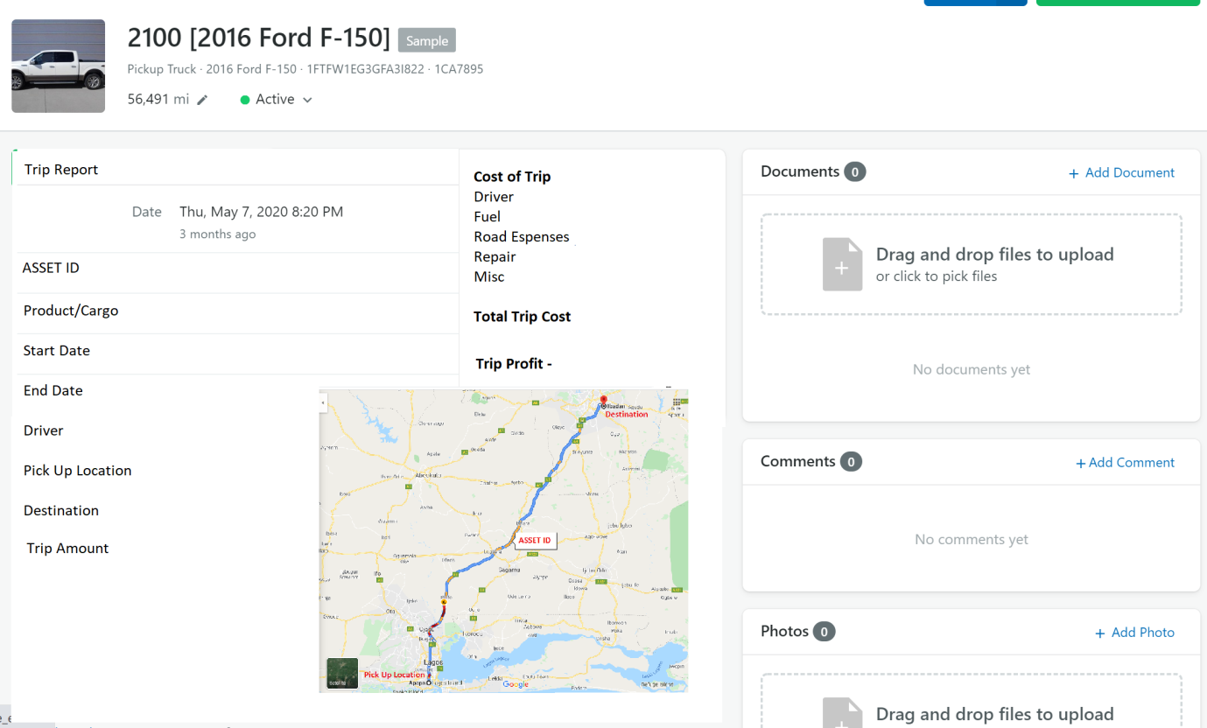

Picture 8: DOCUMENT MANAGER

`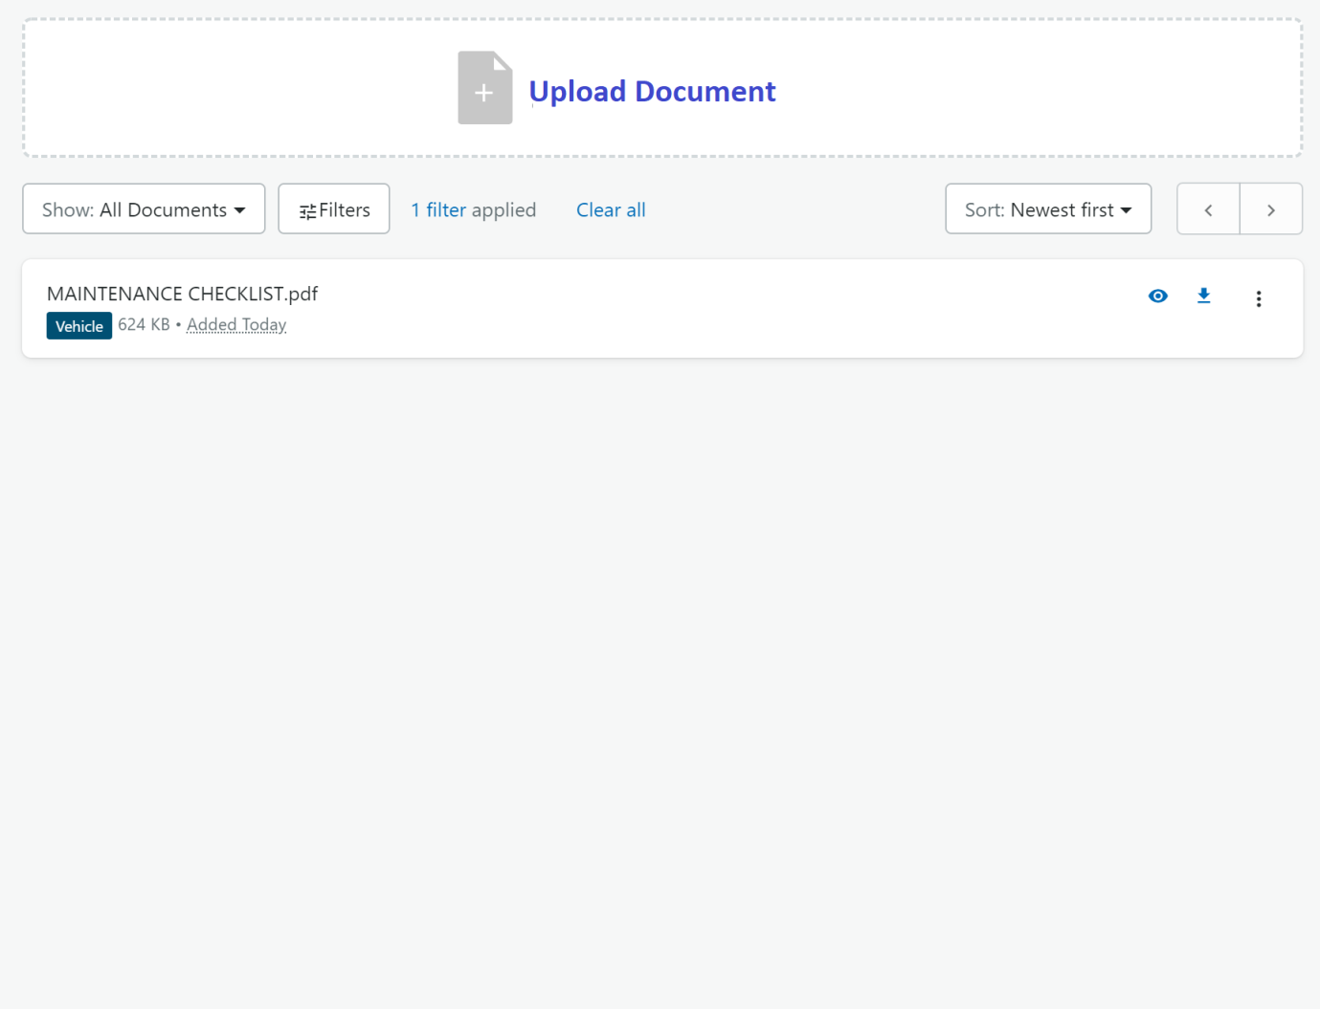

Picture 9: ASSETS OVERVIEW

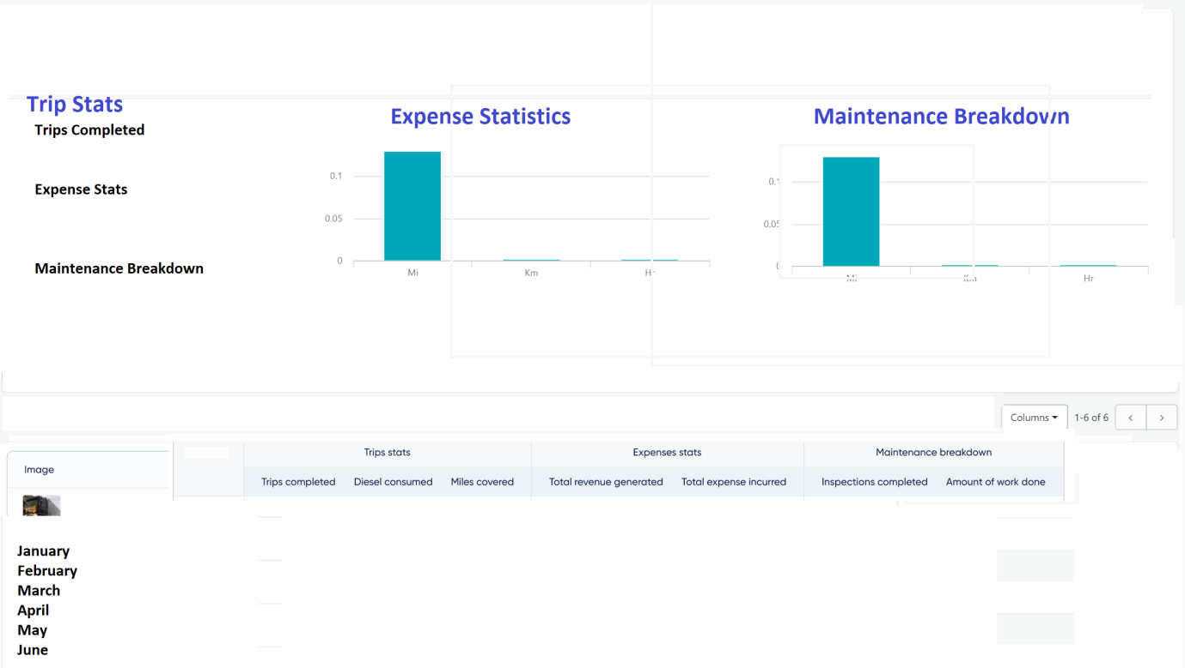

Picture 10: FINANCIAL PLAN

