|  |  |  |
| --- | --- | --- |
|  | Pimpri Chinchwad Education Trust’s  **Pimpri Chinchwad College of Engineering**  An Autonomous Institute  (Permanently affiliated to Savitribai Phule Pune University) |  |
| SEMESTER-IV |
| Assignment 5 | | |

**Assignment 5: SQL Grouping and database views**

**Database Schema (Banking System)**

**Customers**

**customer_id (INT, PRIMARY KEY)**

**name (VARCHAR)**

**dob (DATE)**

**city (VARCHAR)**

**account_type (VARCHAR)**

**Accounts**

**account_id (INT, PRIMARY KEY)**

**customer_id (INT, FOREIGN KEY REFERENCES Customers(customer_id))**

**balance (DECIMAL)**

**account_type (VARCHAR)**

**branch_id (INT, FOREIGN KEY REFERENCES Branches(branch_id))**

**Transactions**

**transaction_id (INT, PRIMARY KEY)**

**account_id (INT, FOREIGN KEY REFERENCES Accounts(account_id))**

**amount (DECIMAL)**

**transaction_type (VARCHAR) -- ('Deposit', 'Withdrawal', 'Transfer')**

**transaction_date (DATE)**

**Branches**

**branch_id (INT, PRIMARY KEY)**

**branch_name (VARCHAR)**

**city (VARCHAR)**

**Loans**

**loan_id (INT, PRIMARY KEY)**

**customer_id (INT, FOREIGN KEY REFERENCES Customers(customer_id))**

**amount (DECIMAL)**

**loan_type (VARCHAR) -- ('Home', 'Car', 'Personal')**

**status (VARCHAR) -- ('Approved', 'Pending', 'Rejected')**

**Solve following queries :**

1. Retrieve the total balance for each account type.

SELECT account_type, SUM(balance) AS total_balance

FROM Accounts_180

GROUP BY account_type;

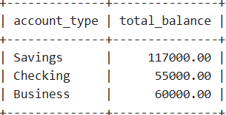

1. Count the number of accounts in each branch.

SELECT branch_id, COUNT(account_id) AS total_accounts

FROM Accounts_180

GROUP BY branch_id;

1. Find the number of customers in each city.

SELECT city, COUNT(customer_id) AS total_customers

FROM Customers_180

GROUP BY city;

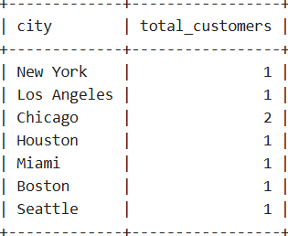

1. Show the number of loans approved per loan type.

SELECT loan_type, COUNT(loan_id) AS approved_loans

FROM Loans_180

WHERE status = 'Approved'

GROUP BY loan_type;

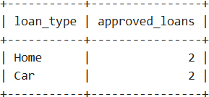

1. Find the total number of transactions for each transaction type.

SELECT transaction_type, COUNT(transaction_id) AS total_transactions

FROM Transactions_180

GROUP BY transaction_type;

1. Show the customers who do not have a loan.

**SELECT c.customer_id, c.name**

**FROM Customers_180 c**

**LEFT JOIN Loans_180 l ON c.customer_id = l.customer_id**

**WHERE l.loan_id IS NULL;**

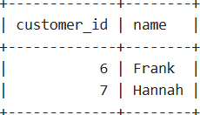

1. Retrieve customers who have accounts in more than one branch.

**SELECT customer_id, COUNT(DISTINCT branch_id) AS branch_count**

**FROM Accounts_180**

**GROUP BY customer_id**

**HAVING COUNT(DISTINCT branch_id) > 1;**

1. Find all accounts that have not had any deposits in the last 3 months.

SELECT a.account_id

FROM Accounts_180 a

LEFT JOIN Transactions_180 t ON a.account_id = t.account_id

AND t.transaction_type = 'Deposit'

AND t.transaction_date >= CURRENT_DATE - INTERVAL 3 MONTH

WHERE t.transaction_id IS NULL;

1. Display the account types where the total balance is below ₹25,000.

**SELECT account_type, SUM(balance) AS total_balance**

**FROM Accounts_180**

**GROUP BY account_type**

**HAVING SUM(balance) < 25000;**

**-------> Empty Set**

1. Find the total balance per account type where the balance is above ₹50,000.

**SELECT account_type, SUM(balance) AS total_balance**

**FROM Accounts_180**

**GROUP BY account_type**

**HAVING SUM(balance) > 50000;**

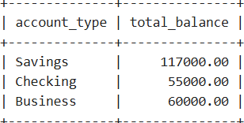

1. Retrieve the count of transactions made on dates where more than 5 transactions occurred.

**SELECT transaction_date, COUNT(transaction_id) AS total_transactions**

**FROM Transactions_180**

**GROUP BY transaction_date**

**HAVING COUNT(transaction_id) > 5;**

**------> Empty Set**

1. Find the top 3 transaction days with the highest total transaction amount.

SELECT transaction_date, SUM(amount) AS total_amount

FROM Transactions_180

GROUP BY transaction_date

ORDER BY total_amount DESC

LIMIT 3;

1. Find customers who have a loan but no account in the bank.

SELECT l.customer_id, c.name

FROM Loans_180 l

LEFT JOIN Accounts_180 a ON l.customer_id = a.customer_id

JOIN Customers_180 c ON l.customer_id = c.customer_id

WHERE a.account_id IS NULL;

