|  |  |  |
| --- | --- | --- |
|  | Pimpri Chinchwad Education Trust’s  **Pimpri Chinchwad College of Engineering**  An Autonomous Institute  (Permanently affiliated to Savitribai Phule Pune University) |  |
| SEMESTER-IV |
| Assignment 6 | | |

Assignment 6

Consider the following database schema for an E-commerce system:

**Tables:**

Customers (customer_id, name, email, city)

Orders (order_id, customer_id, order_date, total_amount) Products (product_id, product_name, category, price)

Order_Items (order_item_id, order_id, product_id, quantity, subtotal) Sellers (seller_id, seller_name, city)

**Solve following SQL Queries:**

1. Retrieve all customers along with their corresponding orders (including customers who haven't ordered).  
     
   SQL Query:  
   SELECT c.customer_id, c.name, o.order_id, o.order_date, o.total_amount  
   FROM Customers_180 c  
   LEFT JOIN Orders_180 o ON c.customer_id = o.customer_id;  
     
   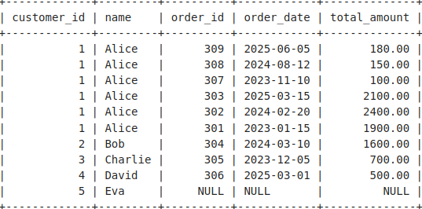
2. List all orders along with the product names and their quantities.  
     
   SQL Query:  
   SELECT o.order_id, p.product_name, oi.quantity  
   FROM Orders_180 o  
   JOIN Order_Items_180 oi ON o.order_id = oi.order_id  
   JOIN Products_180 p ON oi.product_id = p.product_id;  
     
   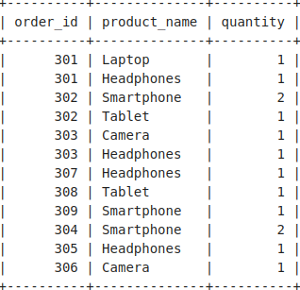
3. Find the total number of orders placed by each customer.  
     
   SQL Query:  
   SELECT c.customer_id, c.name, COUNT(o.order_id) AS total_orders  
   FROM Customers_180 c  
   LEFT JOIN Orders_180 o ON c.customer_id = o.customer_id  
   GROUP BY c.customer_id, c.name;  
     
   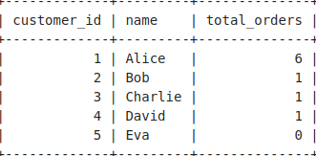
4. Find the total number of products available in each category.  
     
   SQL Query:  
   SELECT category, COUNT(product_id) AS total_products  
   FROM Products_180  
   GROUP BY category;

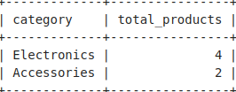

1. Retrieve the order details, including customer name and total amount, for all orders placed in the last 30 days.  
     
   SQL Query:  
   SELECT o.order_id, c.name, o.total_amount  
   FROM Orders_180 o  
   JOIN Customers_180 c ON o.customer_id = c.customer_id  
   WHERE o.order_date >= CURRENT_DATE - INTERVAL '30 days';

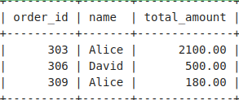

1. Retrieve the names of sellers who sell a specific product (e.g., "Laptop").  
     
   SQL Query:  
   SELECT DISTINCT s.seller_name  
   FROM Sellers_180 s  
   JOIN Product_Sellers_180 ps ON s.seller_id = ps.seller_id  
   JOIN Products_180 p ON ps.product_id = p.product_id  
   WHERE p.product_name = 'Laptop';

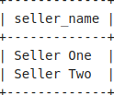

1. Show all customers who have never placed an order.  
     
   SQL Query:  
   SELECT c.customer_id, c.name  
   FROM Customers_180 c  
   LEFT JOIN Orders_180 o ON c.customer_id = o.customer_id  
   WHERE o.order_id IS NULL;

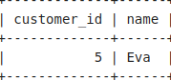

1. 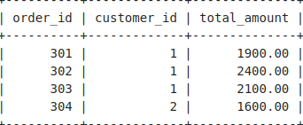Retrieve details of orders where the total amount is greater than the average order total.( solve suing subquery)  
     
   SQL Query:  
   SELECT order_id, customer_id, total_amount  
   FROM Orders_180  
   WHERE total_amount > (SELECT AVG(total_amount) FROM Orders_180);
2. 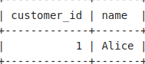Find customers who have placed at least two orders.  
     
   SQL Query:  
   SELECT c.customer_id, c.name  
   FROM Customers_180 c  
   JOIN Orders_180 o ON c.customer_id = o.customer_id  
   GROUP BY c.customer_id, c.name  
   HAVING COUNT(o.order_id) >= 2;
3. Find the top 3 most ordered products based on quantity sold.  
     
   SQL Query:  
   SELECT p.product_name, SUM(oi.quantity) AS total_quantity  
   FROM Products_180 p  
   JOIN Order_Items_180 oi ON p.product_id = oi.product_id  
   GROUP BY p.product_name  
   ORDER BY total_quantity DESC  
   LIMIT 3;

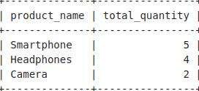

1. Display the product names that are sold by multiple sellers.  
     
   SQL Query:  
   SELECT p.product_name  
   FROM Products_180 p  
   JOIN Product_Sellers_180 ps ON p.product_id = ps.product_id  
   GROUP BY p.product_name  
   HAVING COUNT(DISTINCT ps.seller_id) > 1;

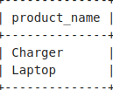

1. Retrieve sellers who have never sold any product.  
     
   SQL Query:  
   SELECT s.seller_id, s.seller_name  
   FROM Sellers_180 s  
   LEFT JOIN Product_Sellers_180 ps ON s.seller_id = ps.seller_id  
   WHERE ps.product_id IS NULL;

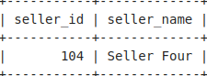

1. Find all products that have never been ordered.  
     
   SQL Query:  
   SELECT p.product_id, p.product_name  
   FROM Products_180 p  
   LEFT JOIN Order_Items_180 oi ON p.product_id = oi.product_id  
   WHERE oi.order_item_id IS NULL;

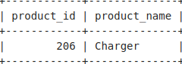

14. Retrieve the names of customers who have placed the highest number of orders.  
  
SQL Query:  
SELECT c.name  
FROM Customers_180 c  
JOIN Orders_180 o ON c.customer_id = o.customer_id  
GROUP BY c.customer_id, c.name  
HAVING COUNT(o.order_id) = (  
 SELECT MAX(order_count)  
 FROM (  
 SELECT COUNT(order_id) AS order_count  
 FROM Orders_180  
 GROUP BY customer_id

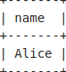

15. Find all customers who have ordered more than 5 different products.  
  
SQL Query:  
SELECT c.customer_id, c.name  
FROM Customers_180 c  
JOIN Orders_180 o ON c.customer_id = o.customer_id  
JOIN Order_Items_180 oi ON o.order_id = oi.order_id  
GROUP BY c.customer_id, c.name  
HAVING COUNT(DISTINCT oi.product_id) > 5;

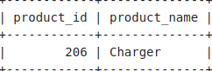

16. Find products that are sold by at least two different sellers but have never been ordered.  
  
SQL Query:  
SELECT p.product_id, p.product_name  
FROM Products_180 p  
JOIN Product_Sellers_180 ps ON p.product_id = ps.product_id  
GROUP BY p.product_id, p.product_name  
HAVING COUNT(DISTINCT ps.seller_id) > 1  
AND NOT EXISTS (  
 SELECT 1  
 FROM Order_Items_180 oi  
 WHERE oi.product_id = p.product_id  
);

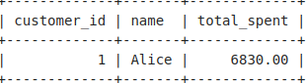

17.Find the customer who has spent the most money overall.

SQL Query:  
SELECT c.customer_id, c.name, SUM(o.total_amount) AS total_spent  
FROM Customers_180 c  
JOIN Orders_180 o ON c.customer_id = o.customer_id  
GROUP BY c.customer_id, c.name  
ORDER BY total_spent DESC  
LIMIT 1;

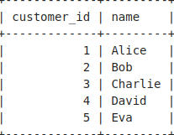

18. Find all customers who have either placed an order or live in the same city as a seller.

(Hint: Use UNION to combine customers who placed orders and those in seller cities.)  
  
SQL Query:  
SELECT DISTINCT customer_id, name  
FROM Customers_180  
WHERE customer_id IN (SELECT DISTINCT customer_id FROM Orders_180)

UNION  
SELECT DISTINCT customer_id, name  
FROM Customers_180  
WHERE city IN (SELECT DISTINCT city FROM Sellers_180);

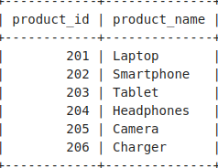

19. Retrieve all products that are either in stock with at least one seller or have been ordered at least once.  
  
SQL Query:  
SELECT DISTINCT p.product_id, p.product_name  
FROM Products_180 p  
WHERE p.product_id IN (SELECT DISTINCT product_id FROM Product_Sellers_180)  
UNION  
SELECT DISTINCT p.product_id, p.product_name  
FROM Products_180 p  
WHERE p.product_id IN (SELECT DISTINCT product_id FROM Order_Items_180);

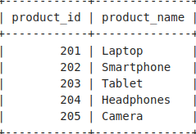

20. Retrieve products that have been both ordered and are currently in stock.  
  
SQL Query:  
SELECT p.product_id, p.product_name  
FROM Products_180 p  
WHERE p.product_id IN (SELECT product_id FROM Order_Items_180)  
INTERSECT  
SELECT p.product_id, p.product_name  
FROM Products_180 p  
WHERE p.product_id IN (SELECT product_id FROM Product_Sellers_180);

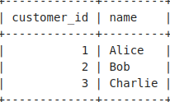

21. Find customers who have both placed an order and live in a city where a seller is located.  
  
SQL Query:  
SELECT c.customer_id, c.name  
FROM Customers_180 c  
WHERE c.customer_id IN (SELECT DISTINCT customer_id FROM Orders_180)  
INTERSECT

SELECT c.customer_id, c.name  
FROM Customers_180 c  
WHERE c.city IN (SELECT DISTINCT city FROM Sellers_180);

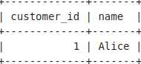

22. Retrieve all customers who have placed at least one order in each year available in the database.  
  
SQL Query:  
SELECT customer_id, name  
FROM Customers_180 c  
WHERE NOT EXISTS (  
 SELECT DISTINCT EXTRACT(YEAR FROM o.order_date) AS year  
 FROM Orders_180 o  
 WHERE NOT EXISTS (  
 SELECT 1  
 FROM Orders_180 o2  
 WHERE o2.customer_id = c.customer_id   
 AND EXTRACT(YEAR FROM o2.order_date) = EXTRACT(YEAR FROM o.order_date)  
 )  
);

→ Query 22 returns no output because no single customer has placed orders in every year present in the Orders table (2023, 2024, and 2025). The NOT EXISTS condition filters out any customer missing even one year, leading to an empty result set.