Name: Vivek Painjane

PRN: 123B1B280

Batch: D3

Assignment 10

Problem Statements:

Using Map-Reduce function comply the following requirements

1. Display the salary of employees department wise

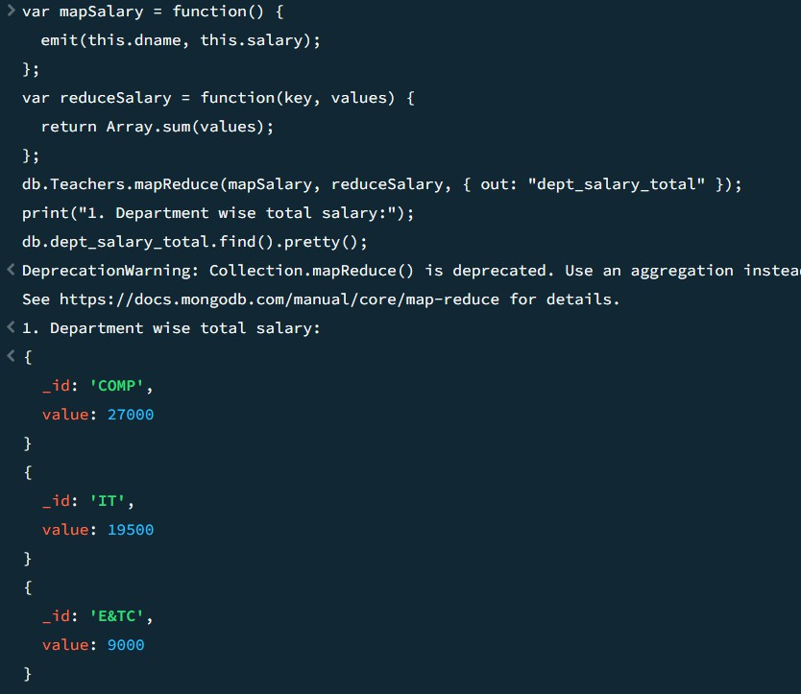

1. Display the count of employees department wise

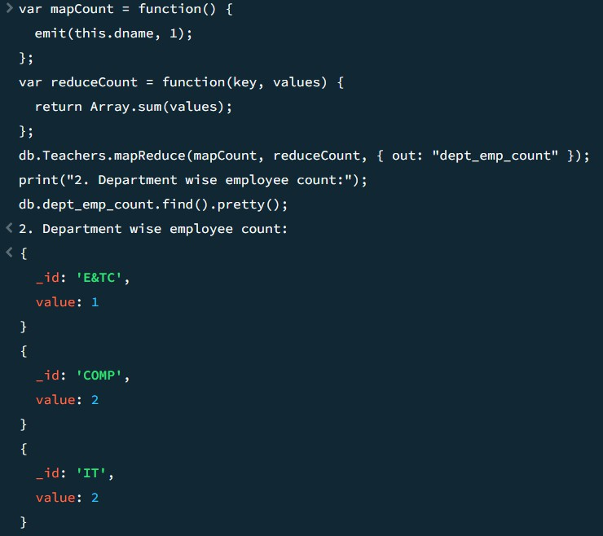

1. Consider the collection “Orders “ with the following types of doccuments

{

_id: ObjectId("50a8240b927d5d8b5891743c"), cust_id: "abc123",

status: 'A', price: 25,

}

Return the Total Price Per Customer

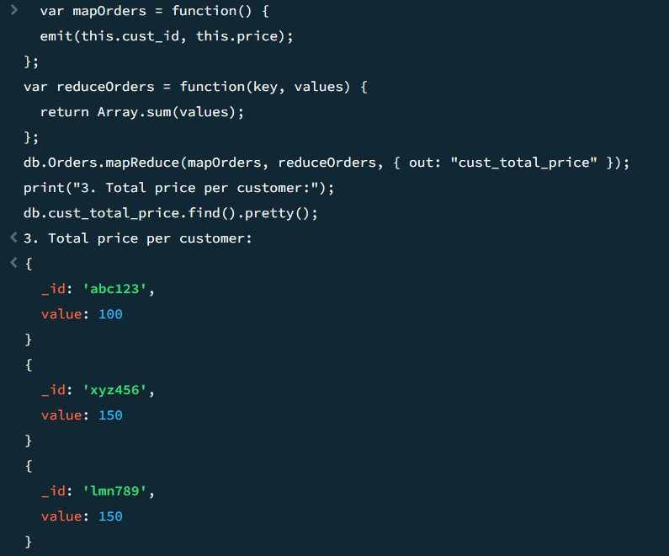

1. Display the total salatry of employees working in the computer department.

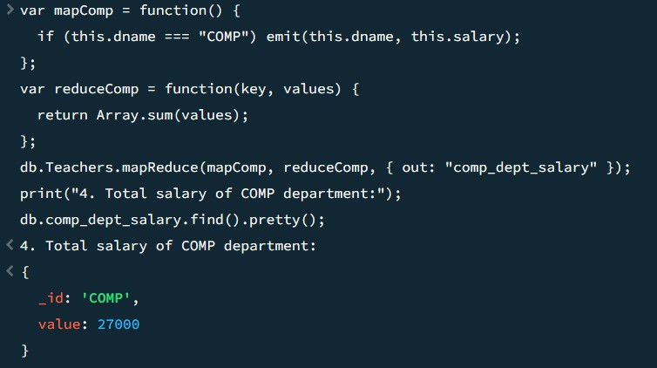

1. Consider each document in the zipcode collection has the following form:

{

"_id": "10280",

"city": "NEW YORK",

"state": "NY", "pop": 5574,

}

Return the city wise population of the cities in the NY state.

