|  |  |  |
| --- | --- | --- |
|  | Pimpri Chinchwad Education Trust’s  **Pimpri Chinchwad College of Engineering** An Autonomous Institute  (Permanently affiliated to Savitribai Phule Pune University) |  |
| SEMESTER-IV |
| Assignment 7 | | |

NAME : Vivek Painjane

PRN : 123B1B280

BATCH : D3

**Assignment 7 : Implement SQL queries to demonstrate the nested queries in SQL using MySql.** Consider the following database schema :

**Tables:**

**Students Table:**

CREATE TABLE Students (

StudentID INT PRIMARY KEY AUTO_INCREMENT,

Name VARCHAR(100) NOT NULL,

Age INT CHECK (Age >= 18), -- Students must be at least 18

DepartmentID INT,

CGPA DECIMAL(3,2) CHECK (CGPA BETWEEN 0 AND 10), -- CGPA should be between 0 and 10 FOREIGN KEY (DepartmentID) REFERENCES Departments(DepartmentID) ON DELETE SET NULL

);

**Departments Table:**

CREATE TABLE Departments (

DepartmentID INT PRIMARY KEY AUTO_INCREMENT,

DeptName VARCHAR(100) UNIQUE NOT NULL,

HOD VARCHAR(100) NOT NULL -- Name of the Head of Department

);

**Courses Table:**

CREATE TABLE Courses (

CourseID VARCHAR(10) PRIMARY KEY, -- Course codes like CSE101, ECE201

CourseName VARCHAR(100) NOT NULL,

DepartmentID INT,

FOREIGN KEY (DepartmentID) REFERENCES Departments(DepartmentID) ON DELETE CASCADE

);

**Enrollments Table:**

CREATE TABLE Enrollments (

EnrollmentID INT PRIMARY KEY AUTO_INCREMENT,

StudentID INT,

CourseID VARCHAR(10),

Marks INT CHECK (Marks BETWEEN 0 AND 100), -- Marks should be between 0 and 100

FOREIGN KEY (StudentID) REFERENCES Students(StudentID),

FOREIGN KEY (CourseID) REFERENCES Courses(CourseID),

UNIQUE (StudentID, CourseID) -- A student cannot enroll in the same course more than once

);

SOLUTION:-

CREATE TABLE Departments280 (

DepartmentID INT PRIMARY KEY AUTO_INCREMENT,

DeptName VARCHAR(100) UNIQUE NOT NULL,

HOD VARCHAR(100) NOT NULL

);

CREATE TABLE Students280 (

StudentID INT PRIMARY KEY AUTO_INCREMENT,

Name VARCHAR(100) NOT NULL,

Age INT,

DepartmentID INT,

CGPA DECIMAL(3,2),

FOREIGN KEY (DepartmentID) REFERENCES Departments280(DepartmentID) ON DELETE SET NULL,

CONSTRAINT Age_Check CHECK (Age >= 18),

CONSTRAINT CGPA_Check CHECK (CGPA BETWEEN 0 AND 10)

);

CREATE TABLE Courses280(

CourseID VARCHAR(10) PRIMARY KEY, -- Course codes like CSE101, ECE201

CourseName VARCHAR(100) NOT NULL,

DepartmentID INT,

FOREIGN KEY (DepartmentID) REFERENCES Departments280(DepartmentID) ON DELETE CASCADE

);

CREATE TABLE Enrollments280 (

EnrollmentID INT PRIMARY KEY AUTO_INCREMENT,

StudentID INT,

CourseID VARCHAR(10),

Marks INT CHECK (Marks BETWEEN 0 AND 100), -- Marks should be between 0 and 100

FOREIGN KEY (StudentID) REFERENCES Students280(StudentID),

FOREIGN KEY (CourseID) REFERENCES Courses280(CourseID),

UNIQUE (StudentID, CourseID) -- A student cannot enroll in the same course more than once

);

-- Insert data into Departments280

INSERT INTO Departments280 (DeptName, HOD) VALUES

('Computer Science', 'Dr. Smith'),

('Electronics', 'Dr. Johnson'),

('Mechanical', 'Dr. Brown'),

('Civil', 'Dr. White'),

('Chemical', 'Dr. Davis'),

('Biotechnology', 'Dr. Miller'),

('Aerospace', 'Dr. Wilson'),

('Automobile', 'Dr. Taylor'),

('IT', 'Dr. Anderson'),

('Artificial Intelligence', 'Dr. Thomas'),

('Data Science', 'Dr. Moore'),

('Robotics', 'Dr. Jackson'),

('Cyber Security', 'Dr. Harris'),

('Electrical', 'Dr. Martin'),

('Environmental', 'Dr. Lewis');

-- Insert data into Students280

INSERT INTO Students280 (Name, Age, DepartmentID, CGPA) VALUES

('Alice Johnson', 20, 1, 8.5),

('Bob Smith', 22, 2, 7.8),

('Charlie Brown', 21, 3, 9.2),

('David Wilson', 23, 4, 6.5),

('Emma Davis', 24, 5, 7.9),

('Frank Miller', 20, 6, 8.1),

('Grace Hall', 22, 7, 7.2),

('Hannah White', 19, 8, 9.5),

('Isaac King', 21, 9, 6.8),

('Jack Turner', 22, 10, 9.1),

('Kevin Adams', 24, 11, 5.9),

('Lily Baker', 23, 12, 8.9),

('Michael Scott', 21, 13, 7.0),

('Nancy Green', 20, NULL, 8.0), -- No department (For testing ON DELETE SET NULL)

('Oliver Wright', 23, 14, 9.7);

-- Insert data into Courses280

INSERT INTO Courses280 (CourseID, CourseName, DepartmentID) VALUES

('CSE101', 'Data Structures', 1),

('CSE102', 'Algorithms', 1),

('ECE201', 'Digital Circuits', 2),

('ME301', 'Thermodynamics', 3),

('CIV401', 'Structural Analysis', 4),

('CH501', 'Chemical Reactions', 5),

('BT601', 'Genetic Engineering', 6),

('AE701', 'Aerodynamics', 7),

('AU801', 'Automobile Engines', 8),

('IT901', 'Operating Systems', 9),

('AI101', 'Machine Learning', 10),

('DS201', 'Big Data Analytics', 11),

('ROB301', 'Robotic Vision', 12),

('CYB401', 'Network Security', 13),

('EE501', 'Power Systems', 14);

-- Insert data into Enrollments280

INSERT INTO Enrollments280 (StudentID, CourseID, Marks) VALUES

(1, 'CSE101', 90),

(1, 'CSE102', 85),

(2, 'ECE201', 78),

(3, 'ME301', 88),

(4, 'CIV401', 67),

(5, 'CH501', 45),

(6, 'BT601', 92), -- Highest marks in a course

(7, 'AE701', 81),

(8, 'AU801', 55),

(9, 'IT901', 61),

(10, 'AI101', 77),

(11, 'DS201', 83),

(12, 'ROB301', 49),

(13, 'CYB401', 39), -- Failed student (Marks < 40)

(14, 'EE501', 96); -- High score for highest marks query

SELECT * FROM Students280;

SELECT * FROM Departments280;

SELECT * FROM Courses280;

SELECT * FROM Enrollments280;

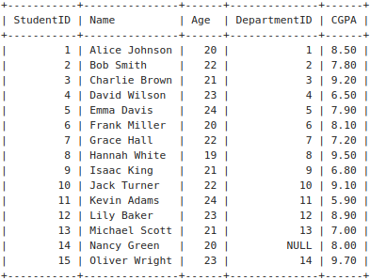

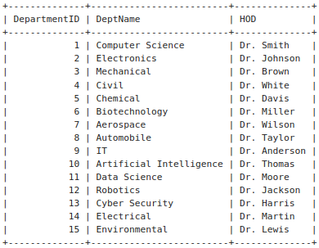

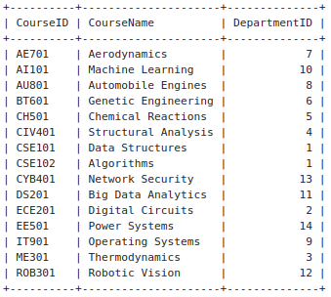

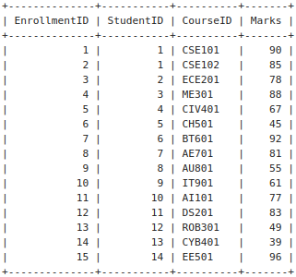

**Solve following SQL Queries:**

1. Find students who have a CGPA higher than the university average CGPA

SELECT * FROM Students280

WHERE CGPA > (SELECT AVG(CGPA)

FROM Students280);

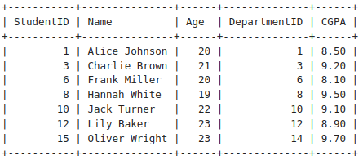

2. Find students who have never enrolled in any course

SELECT * FROM Students280

WHERE StudentID NOT IN (SELECT DISTINCT StudentID FROM Enrollments280);

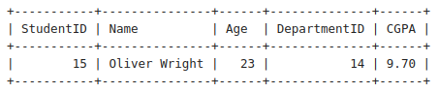

3. Get courses that have no students enrolled

SELECT * FROM Courses280

WHERE CourseID NOT IN (SELECT DISTINCT CourseID

FROM Enrollments280);

* 🡪 Empty Set

4. Get students enrolled in courses offered by the 'Computer Sci' department

SELECT DISTINCT s.*

FROM Students280 s

JOIN Enrollments280 e ON s.StudentID = e.StudentID

JOIN Courses280 c ON e.CourseID = c.CourseID

JOIN Departments280 d ON c.DepartmentID = d.DepartmentID

WHERE d.DeptName = 'Computer Science';

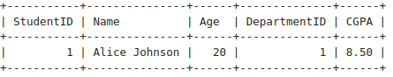

5. Find students who have the same age as the oldest student

SELECT * FROM Students280

WHERE Age = (SELECT MAX(Age)

FROM Students280);

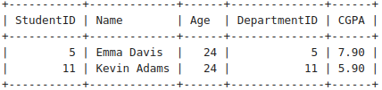

6. Retrieve courses where at least one student scored more than 85 marks

SELECT DISTINCT c.* FROM Courses280 c

JOIN Enrollments280 e ON c.CourseID = e.CourseID

WHERE e.Marks > 85;

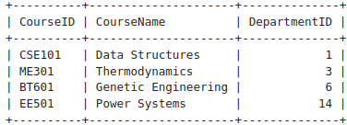

7. Find the highest CGPA in each department

SELECT DepartmentID, MAX(CGPA) AS Highest_CGPA

FROM Students280

GROUP BY DepartmentID;

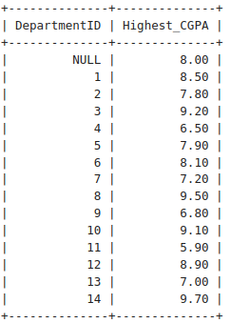

8. Get students who have enrolled in more than one course

SELECT StudentID

FROM Enrollments280

GROUP BY StudentID

HAVING COUNT(CourseID) > 1;

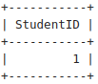

9. Get the department with the most students enrolled

SELECT d.DepartmentID, d.DeptName

FROM Departments280 d

JOIN Students280 s ON d.DepartmentID = s.DepartmentID

GROUP BY d.DepartmentID, d.DeptName

ORDER BY COUNT(s.StudentID) DESC;

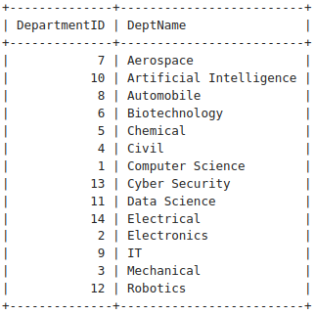

10. Find students who are not enrolled in any course

SELECT * FROM Students280

WHERE StudentID NOT IN (SELECT DISTINCT StudentID

FROM Enrollments280);



11. Retrieve students who scored below the average marks in their courses

SELECT e.StudentID, e.CourseID, e.Marks

FROM Enrollments280 e

WHERE e.Marks < (SELECT AVG(Marks)

FROM Enrollments280

WHERE CourseID = e.CourseID);

* Empty Set

12. Find the department where the highest CGPA student belongs

SELECT DepartmentID

FROM Students280

WHERE

CGPA = (SELECT MAX(CGPA)

FROM Students280);

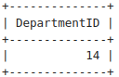

13. Find the department with the highest number of students enrolled

SELECT d.DepartmentID, d.DeptName

FROM Departments280 d

JOIN Students280 s ON d.DepartmentID = s.DepartmentID

GROUP BY d.DepartmentID, d.DeptName

ORDER BY COUNT(s.StudentID) DESC;



14. Get courses where the lowest score is higher than 70

SELECT c.* FROM Courses280 c

WHERE 70 < (SELECT MIN(Marks)

FROM Enrollments280

WHERE CourseID = c.CourseID);

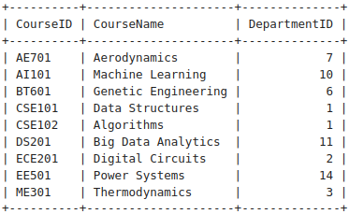

15. Retrieve students who have the same CGPA as 'Alice'

SELECT * FROM Students280

WHERE CGPA = (SELECT CGPA FROM Students280

WHERE Name = 'Alice Johnson');

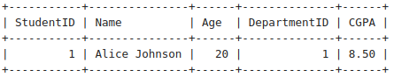

16. Get the course where the maximum number of students have enrolled

SELECT CourseID

FROM Enrollments280

GROUP BY CourseID

ORDER BY COUNT(StudentID)

DESC LIMIT 1;

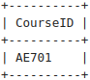

17. Find students who are enrolled in more than two courses

SELECT StudentID

FROM Enrollments280

GROUP BY StudentID

HAVING COUNT(CourseID) > 2;

* 🡪 Empty Set

18. Retrieve students who have scored the highest marks in any course

(Hint: Use Join along with nested quesries).

SELECT s.StudentID, s.Name, e.CourseID, e.Marks

FROM Students280 s

JOIN Enrollments280 e ON s.StudentID = e.StudentID

WHERE e.Marks = ( SELECT MAX(Marks) FROM Enrollments280 WHERE CourseID = e.CourseID);

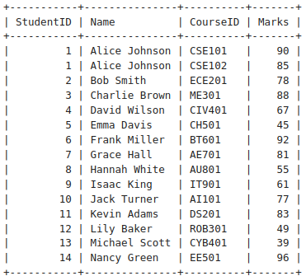

19. Get the department with the lowest average CGPA

SELECT DepartmentID

FROM Students280

GROUP BY DepartmentID

ORDER BY AVG(CGPA)

ASC LIMIT 1;

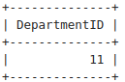

20. Find the course in which the maximum number of students have failed (Marks < 40)

SELECT CourseID

FROM Enrollments280

WHERE Marks < 40

GROUP BY CourseID

ORDER BY COUNT(*)

DESC LIMIT 1;

