A Mini Project Report
on
Automated Refund Processing using Agentic AI
Submitted in partial fulfilment of the requirements for the Major/Minor Data Science Program in the course Business Analytics
Submitted by
Pushkar Wagh – (PRN: 25030421030)
Navdeep Singh – (PRN: 25030421027)
Manbhavna khanna - (PRN: 25030422067)


Submitted to:
Dr. Bela Joglekar
Associate Professor
Symbiosis Artificial Intelligence Institute (SAII साई),
Symbiosis International (Deemed University), Pune 412115
Oct 2026

DECLARATION

We hereby declare that the Mini Project Report entitled
“Automated Refund Processing using Agentic AI” is submitted to Symbiosis Artificial Intelligence Institute (SAII साई),), Symbiosis International (Deemed University), Pune, in partial fulfilment of the requirements for the completion of Third semester in Bachelor of
Science (Artificial Intelligence) is a bonafide report of the work carried out
by us. The material contained in the report has not been submitted to any University or
Institution.

Navdeep Singh  (PRN: 25030421027) | Pushkar Wagh  (PRN: 25030421030) | Manbhavna Khanna  (PRN: 25030422067)

CERTIFICATE
This is to confirm that the Mini Project Report titled “Automated Refund Processing using Agentic AI”
submitted by Navdeep Singh (PRN: 25030421027), Pushkar Wagh (PRN: 25030421030) and Manbhavna Khanna (PRN: 25030422067) as record of the work carried out by them, is accepted as Report submission in partial fulfilment of the requirements for the completion of third semester in Bachelor of
Science (Artificial Intelligence)..

Internal Project Guides

Dr. Bela Joglekar | Dr. Pradnya Patil | Dr. Sahas V Swamy
Associate Professor | Assistant Professor | Assistant Professor

External Project Guides

Mr. Sushil Shinde | Mrs. Tarannum Syed | Mr. Yash Vaykar
Founder & CEO  Credenca Data Solutions Pvt. Ltd. | Manager - Service Delivery  Credenca Data Solutions Pvt. Ltd. | Data Scientist  Credenca Data Solutions Pvt. Ltd.

Table of Contents

Sl. No. | Content Title | Page
1 | Declaration | 1
2 | Certificate | 2
3 | Abstract | 4
4 | 1. Introduction | 5
5 | 2. Existing System and Problem Context | 5
6 | 3. Problem Statement, Objectives and Scope | 6
7 | 4. Conceptual Foundation and Related Approaches | 7
8 | 5. Proposed Solution Architecture | 8
9 | 6. LangGraph Workflow and Action Execution | 9
10 | 7. Data Model and Persistence Design | 10
11 | 8. Composite Dataset Strategy and Provenance | 12
12 | 9. Methodology and Feature Engineering | 14
13 | 10. Risk Scoring and Abuse Detection | 15
14 | 11. Expected-Cost Resolution | 16
15 | 12. Historical Analysis and Prevention Loop | 17
16 | 13. Technology Stack and Implementation | 18
17 | 14. Business Analytics and Interface Design | 19
18 | 15. Testing and Evaluation | 20
19 | 16. Results and Discussion | 22
20 | 17. Challenges, Limitations and Controls | 24
21 | 18. Future Scope and Roadmap | 24
22 | 19. Conclusion | 25
23 | Appendix A. API and Demonstration Guide | 26
24 | Appendix B. Glossary and Data Dictionary | 27
25 | References | 28

Abstract
Most of the e-commerce platforms already have procedures for verifying orders and processing refunds. The problem occurs when the verification text lacks clarity, or the image used is poor or not original, or the customer’s behavior appears suspicious. These signals usually undergo separate screening. In this project, we propose adding the decision-making layer to increase effectiveness of the refund process instead of replacing order fulfilment and payment processing systems.
The prototype verifies order and policy compliance, researches photo quality and authenticity (using aHash, pHash, ORB), examines complaint wording, and investigates customer’s activity in different periods such as 30, 90, and 180 days prior to the incident. The system is fed with 5 different patterns of misuse that result in claims and behavioral scores, which are used for cost-effectiveness analysis of available solutions. The LangGraph is managing the operations of 3 different agents: the backend solution is powered by FastAPI, Streamlit is providing interfacing capabilities for the customers and operation experts, while SQL helps storing data.
The industry review prompted modifications in numerous segments of the design. The claim interpreter now has the capability of verifying negation, and sentiment analysis is utilized strictly for product insight and service routing. ORB operates to locate additional cropped-image matches that were overlooked by two perceptual hashes. CLIP serves as an optional path, but it has not been tested using the real model weights.
No singular public source relates orders to grant outcomes with confirmed abuse labels and claim pictures. Hence tests use datasets exclusively for functions that their fields are useful for. Four datasets were used in the research: Olist, UCI Online Retail II, Amazon Reviews 2023, and INRIA Copydays alongside the labelled claim set of 60 sentences and synthetic customer profiles.
Every automated test executed successfully. Accuracy of the claim category in the case of the 60-sentence set grew from 0.45 using earlier keyword method up to 0.73 using negation-aware rules. ORB matched the extracted images that were not detected by aHash and pHash for Copydays-layout layout. These results are very limited since the public datasets have not undergone end-to-end evaluation yet.
Hence, the existing scores and cost indicators should be interpreted as prototype options and not precise indicators of financial damage or fraud.

Keywords: recording abuse, e-commerce, evidence intelligence, behavioral risk, expected-cost decision, LangGraph, Business Analytics, data provenance, human-in-the-loop

1. Introduction

1.1 Background
The standard refund process consists of requesting, retrieving, reviewing the order information, analyzing the policy, and executing a decision. The existence of this refund process is taken for granted. Therefore, this project only begins when the request appears and deals with cases where the text, image, or user's history can change the suggested step.
When deleting an item’s claim without any issues, only a small amount of examination is needed, while several claims with the same photo will need more attention. However, this information wouldn’t confirm that fraud is taking place in this case.

1.2 Project proposition
Project premise. We are not rebuilding refunds. The project adds an intelligence layer before the existing refund process chooses and executes an action.
The prototype contains five components of decision support which are checks of evidence, customer behavior characteristics, rules for claims and abuse, analysis of costs of solutions, and study of behavior associated with repeat products, suppliers, and policies. Interpretation is made possible by AI; however, eligibility information, firm rules, and restrictive conditions remain deterministic.

1.3 Business Analytics relevance
In case of a specific issue, the system indicates the cause of the recommendation. When analyzed over a period of time, the trend can point towards some goods, suppliers or regulations that often lead to refunds or additional reviews. The purpose of the project is to help the team understand what to focus their investigations on.

2. Existing System and Problem Context

2.1 Conventional refund process
The retailer system covers order lookup, qualification, refund creation, payment, case status, and alerts. The db.py file in this prototype provides basic implementations for these functionalities. The solution outputs an action recommendation and its trail before the action occurs in the external system.
Stage | What happens | Status in this project
1. Request intake | Collect the order ID, stated reason, description, amount and time. | Existing system
2. Context loading | Load the order, delivery status, earlier refunds, return window and blacklist result. | Represented by stubs
3. Policy gate | Check known eligibility rules and restrictions before scoring the claim. | Integrated as a deterministic gate
4. Intelligence assessment | Review the photo, claim wording, customer history and possible abuse patterns; compare eligible actions. | Added by this project
5. Resolution execution | Record the action to take: refund, request evidence or send the case for review. | Execution boundary only
6. Outcome and learning | Save the outcome so later product, vendor and policy patterns can be examined. | Existing inputs plus new analysis

2.2 Where conventional processing is insufficient
Established regulations are valuable for determining eligibility, but they do not clarify if the wording of the claim meets a explained reason or if a picture was taken again. In addition, the customer-level sum conceals the distinction between a bad current claim and continuity over several months. Lastly, the approve-or-deny methodology does not compare trade-offs with regards to request for proof or assignment of a case to a reviewer..
Gap in the current process | Practical effect | Question for the reviewer
Evidence treated as an attachment | A weak, inconsistent or reused photo can be accepted without a structured check. | Does the uploaded photo support the stated claim?
Customer history viewed in isolation | Patterns may only become visible across several claims and time windows. | Is this claim unusual for this customer?
Claim risk and customer behaviour conflated | A poor claim and a repeat pattern are different problems and can need different responses. | Where does the risk originate?
Binary decision logic | Automatic decline can frustrate legitimate customers; sending every case to review is expensive. | Which allowed action has the lowest expected total cost?
No feedback from aggregate patterns | Recurring product, vendor or policy issues may not feed back into case handling. | What recurring issue should the business act on?

3. Problem Statement, Objectives and Scope

3.1 Problem statement
The real problem, however, is that there is fragmentation. The claims information could be in one record, the evidence could be stored in an upload folder, the previous refunds could be available in the transaction table, and recurring product issues could be tracked in a dashboard. The reviewers have to reconstruct the case by themselves, with some similar cases possibly being treated differently.
The new layer collects those signals and provides the recommended action with minimum expense, while remaining inside the policy constraints and rules. It also captures all information and reasons for taking that action so the operator is able to follow the process, make inquiries, and resolve the case.

3.2 Objectives
Objective | How the prototype addresses it | What can be checked
Improve evidence usefulness | Validate files, measure image quality, match against stored evidence with aHash, pHash and ORB, and optionally compare photo and claim with CLIP. | Stored evidence record with quality and match methods; CLIP consistency is present only when enabled.
Model historical customer behaviour | Build rolling 30, 90 and 180-day counts, value ratio, repeated reasons and return-event exceptions. | Behaviour score, trust index and component values are available for inspection.
Detect recurring abuse patterns | Apply five deterministic rules: serial refunder, return abuse, fake defect pattern, refund farming and policy exploitation. | Pattern flags use named rules and tested thresholds.
Select a cost-aware resolution | Compare risk exposure, customer friction and handling cost for each eligible action. | The selected action includes a cost breakdown and reason.
Support business prevention | Aggregate refunds, review scores and claim sentiment into product and vendor snapshots and policy insights. | The insight log stores a baseline and a later outcome.
Preserve accountability | Keep hard constraints deterministic, and send failures and uncertainty to human review. | The trace records guardrail reasons and any reviewer action.

3.3 Scope and non-goal
The MVP includes incident assessment, behavioral specifications, claim-text processing, abuse policies, cost-based action selection, manual review, and historical operations. The application works with stubs at the refund-execution interface. It does not include checkout, payment settlement, inventory, shipping, or a complete retailer refund ledger.
Included in the MVP | Not implemented in this project
Claim and evidence analysis, customer behavioural features, negation-aware claim text, sentiment routing, abuse rules, expected-cost resolution, human review and historical insights. | Rebuilding cart, checkout, payment settlement, inventory, shipping or a full refund ledger.
Streamlit customer portal, operations console and management view on top of FastAPI and LangGraph. | Enterprise microservices, Kubernetes, event streaming, a vector database or a full MLOps stack.
Composite, provenance-aware evaluation data, a small hand-labelled claim set and independent synthetic customers. | Claiming that public datasets contain real, verified refund-fraud labels, which they do not.
Transparent score weights, thresholds and cost settings with component-level evaluation. | Claiming calibrated fraud probabilities or fully autonomous decisions.

4. Conceptual Foundation and Related Approaches

4.1 Transactional analytics and behavioral features

The data set UCI Online Retail II is comprised of two years of transaction records, where cancellation is indicated by invoice number beginning with “C” [2]. These instances can be used for validating the repeat purchase and timing features, but since they are not records for refund and do not prove exploitation; records are being considered as cancellation_proxy events.

4.2 Evidence intelligence and image-copy detection

The prototype analyzes each submitted picture by checking if the provided file is valid, estimating the quality of the image, and checking for coincidences with prior evidence. The hash methods of searching for similar images such as aHash and pHash are cheap techniques, but cropping can ruin them. The use of ORB features in combination with RANSAC provides some of those cropped coincidences that can be obtained [4]. It is also possible to compare pictures with the description of the claim using CLIP [14]. Amazon Reviews 2023 has provided text and ratings [3], where pictures from the catalog are not included in the refund evidence.
4.3 Agentic orchestration with deterministic controls
LangGraph is engaged in linking together decision-making stages, case driving, and supporting manual oversights. Therefore, it can be advantageous here because language processing is fluid, while policy verification and analyzing risk formulas need regular actions. These three agents can be optional as the main process can be carried out without specific LLM. The selected provider must offer conversational interface that is compatible with OpenAI.
4.4 Reliance on AI and human verification
An LLM has an ability to interpret a signal and generate a probability regarding a specific parameter but cannot get rid of one’s operation restrictions. To be precise, this happens owing to some reason codes, deterministic guardrails, limiting of scoring, actions logging and the possibility for manual verification. This approach fits the NIST AI Risk Management Framework emphasizing the need for identifying and managing risks through all the periods of AI system functioning [6].
4.5 Claim content, sentiment and image connection
The algorithm for keyword identification before has been open to be interfered with by negation of words and different synonyms, now it is able to investigate whether any negation phrases occur near the phrase denoting a claim category. For instance, the statement “the product is not ruined” wouldn’t

4.6 Design principles
- Employ rules when data is available, AI when judgment is necessary, and humans when the outcome is uncertain.
- Treat claim risk and behavioral risk as distinct signals and not as one mystery trust score.
- A risk score is useful as a priority indicator; it does not mean that a person has committed a crime now.
- A historical loop is not included in the real-time graph but only zooms to finish earlier claims as background information.
- Keep an account of the origin of the data and labels during each transformation step..

Proposed Solution Architecture
The architecture consists of four components: the current order and refund context; the intelligence checks introduced by this initiative; the action layer, which executes or documents the decision; and the historical views utilized by operations and management. The components are characterized by the disconnection between testing of recommendation logic and assumptions of using a production payment system.
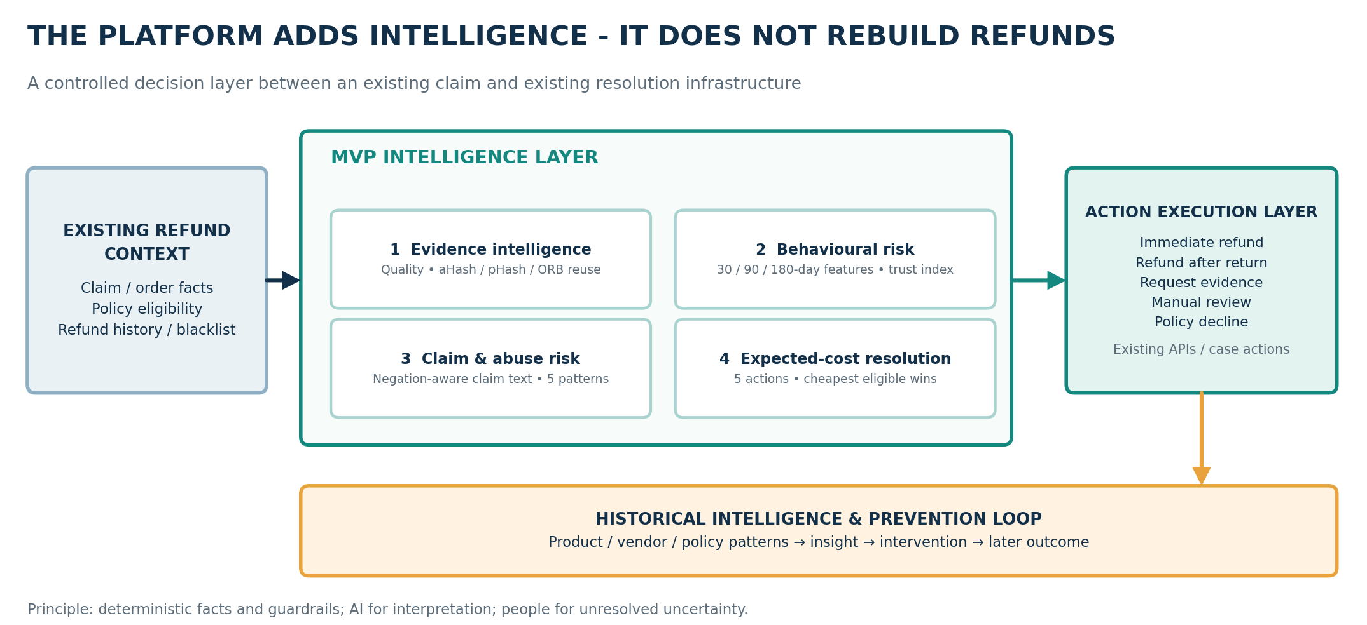
Figure 1. Platform architecture: the five intelligence contributions sit between the existing refund context and the existing execution layer.

5.1 Five MVP contributions
Contribution | Implemented behaviour | Why it may help
G1. Evidence Intelligence | Image quality, hash and local-feature reuse matching, claim-evidence consistency and an optional CLIP text-image check. | Image quality, duplicate-photo matching and claim/evidence comparison, with CLIP available as an optional check.
G2. Customer Behavioural Risk | Rolling 30, 90 and 180-day refund counts, value ratio, repeated reasons and return-event exceptions, combined into behavioural risk and a trust index. | Counts and value measures over 30, 90 and 180 days, plus repeated reasons and return exceptions.
G3. Claim & Abuse Risk | Negation-aware claim interpretation, evidence inconsistency, reuse and five named abuse patterns, combined into claim risk. | Negation-aware text rules, evidence flags and five fixed abuse patterns.
G4. Expected-Cost Resolution | Cost of each eligible action = risk exposure + customer friction + handling, with deterministic guardrails. | Cost comparison for each action that is still allowed by policy and the guardrails.
G5. Historical Intelligence & Prevention Loop | Product and vendor snapshots (refund rate, review score, sentiment), policy insights and an insight, intervention and outcome log. | Offline product/vendor snapshots and a log of insights, actions and later outcomes.

5.2 Architectural boundary
The existing version utilizes stubs for both order, policy, refund, review and notifications, referring to integration points rather than finished retailer integrations. This contribution represents the assessment carried out when the claim is received until the next decision is fulfilled.

LangGraph Workflow and Action Execution
This live graph connects 9 nodes from policy gate and feature builder, passing through evidence matching, three agents, risk synthesis, and action costing to the execution phase. When a guardrail is breached, a process can depart from normal path for manual review. The sequence of processes is shown in Figure 3. Note that historical batch jobs run separately from each live request.
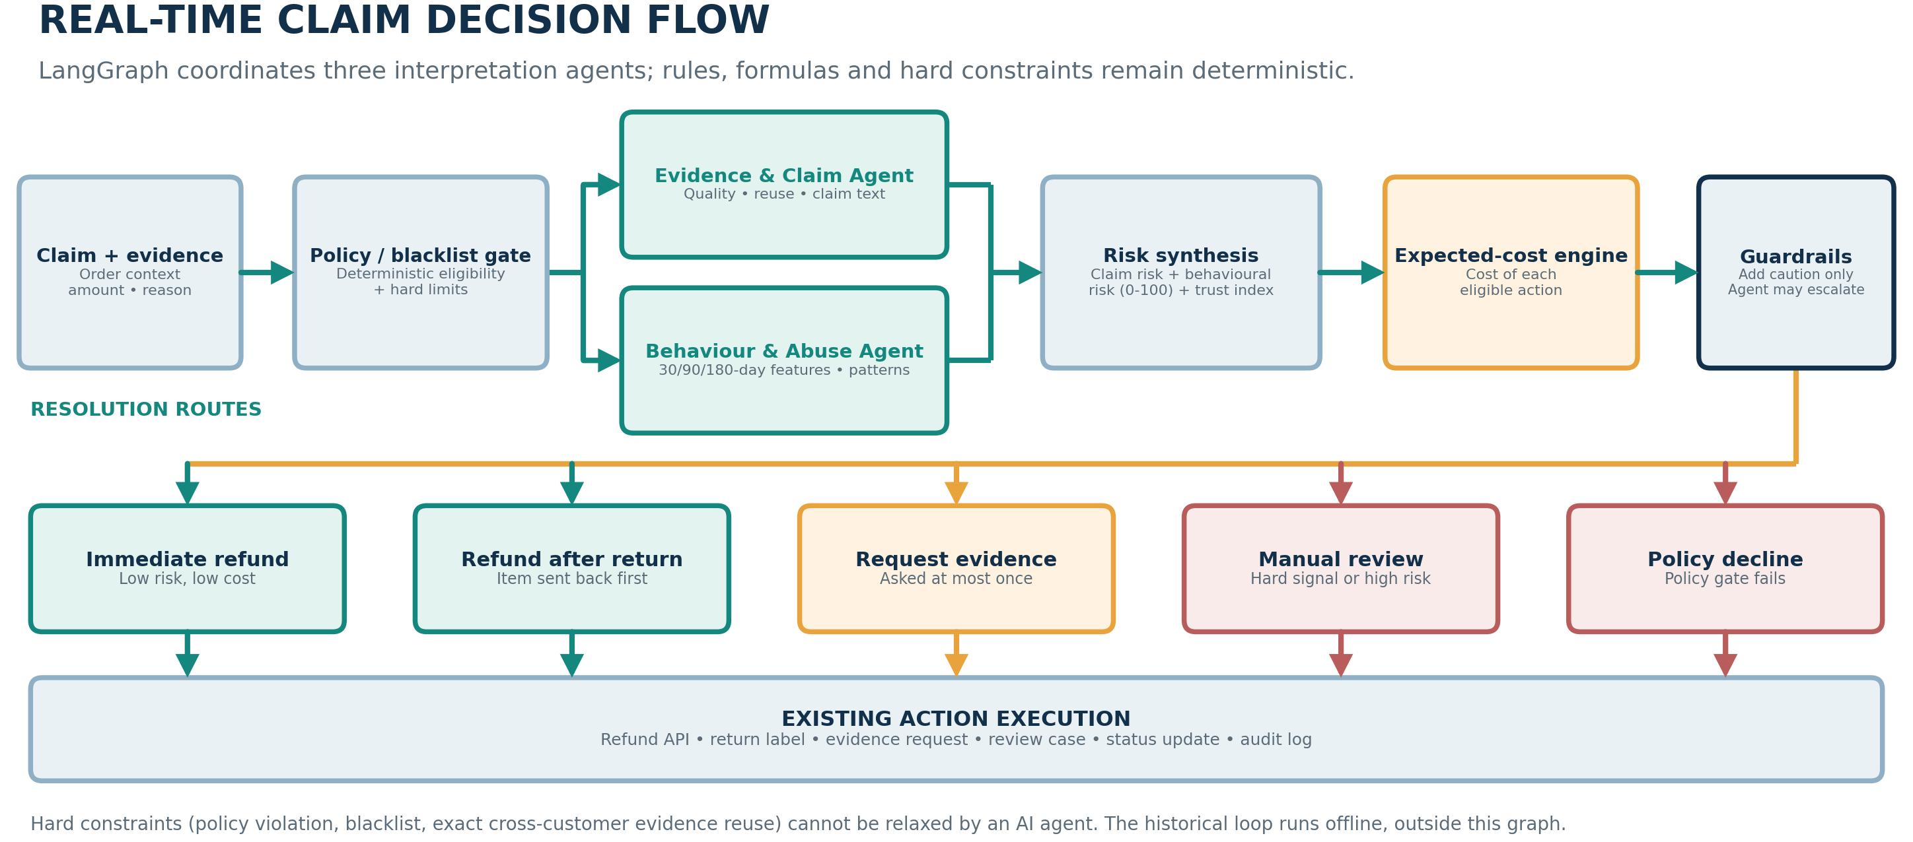
Figure 2. LangGraph decision flow with three agents, risk synthesis, expected-cost selection and five resolution routes.

6.1 Focused agent roles
System part | How it works | Main task | What it cannot change
Evidence & Claim Agent | LLM-assisted interpretation (optional) | Reads claim wording and evidence flags; may adjust claim risk by up to 10 points. | Cannot override file checks, exact cross-customer reuse or the policy gate, and cannot lower a hard signal.
Behaviour & Abuse Agent | LLM-assisted interpretation of deterministic signals | Explains customer history and the deterministic pattern flags. | Features and abuse rules set the baseline. The nudge is bounded at 10 points and never lowers a hard signal.
Resolution Reasoning Agent | LLM-assisted explanation | Explains the selected action and may escalate to a more cautious option. | Cannot choose a less cautious action than the cost engine, and cannot relax a guardrail.
Feature Builder / risk engines | Deterministic | Builds features and runs the risk, pattern, match and cost calculations. | Formulas and weights are constants that tests pin.
Policy / blacklist gate and guardrail | Deterministic | Applies the policy result and routes hard cases. | Policy failure means decline. Blacklist or exact evidence reuse across customers means manual review.

6.2 Graph state
The graph state records the information needed to justify a decision referred to in the claim, including the terms, policy outcomes, evidence match quality, behaviour characteristics, score formulas, abuses identified, costs related to the action in question, and the reason for the decision. This recording allows to examine an unexpected course of actions if, for instance, there is an actual run of a model under question. If parameters for an OpenAI-compatible supplier are set up as LLM_API_KEY, LLM_BASE_URL and LLM_MODEL, then the graph is able to invoke a model. Otherwise, deterministic methods allow continuing with the demo.
- Data Model and Persistence Design
The data model distinguishes between operational records and added risk and history records. For local runs, SQLite is standard, while PostgreSQL may be configured for a more permanent deployment solution. This storage path is intended to just be a prototype, not a declaration that production access controls, retention policies, or operational recovery have been carried out.
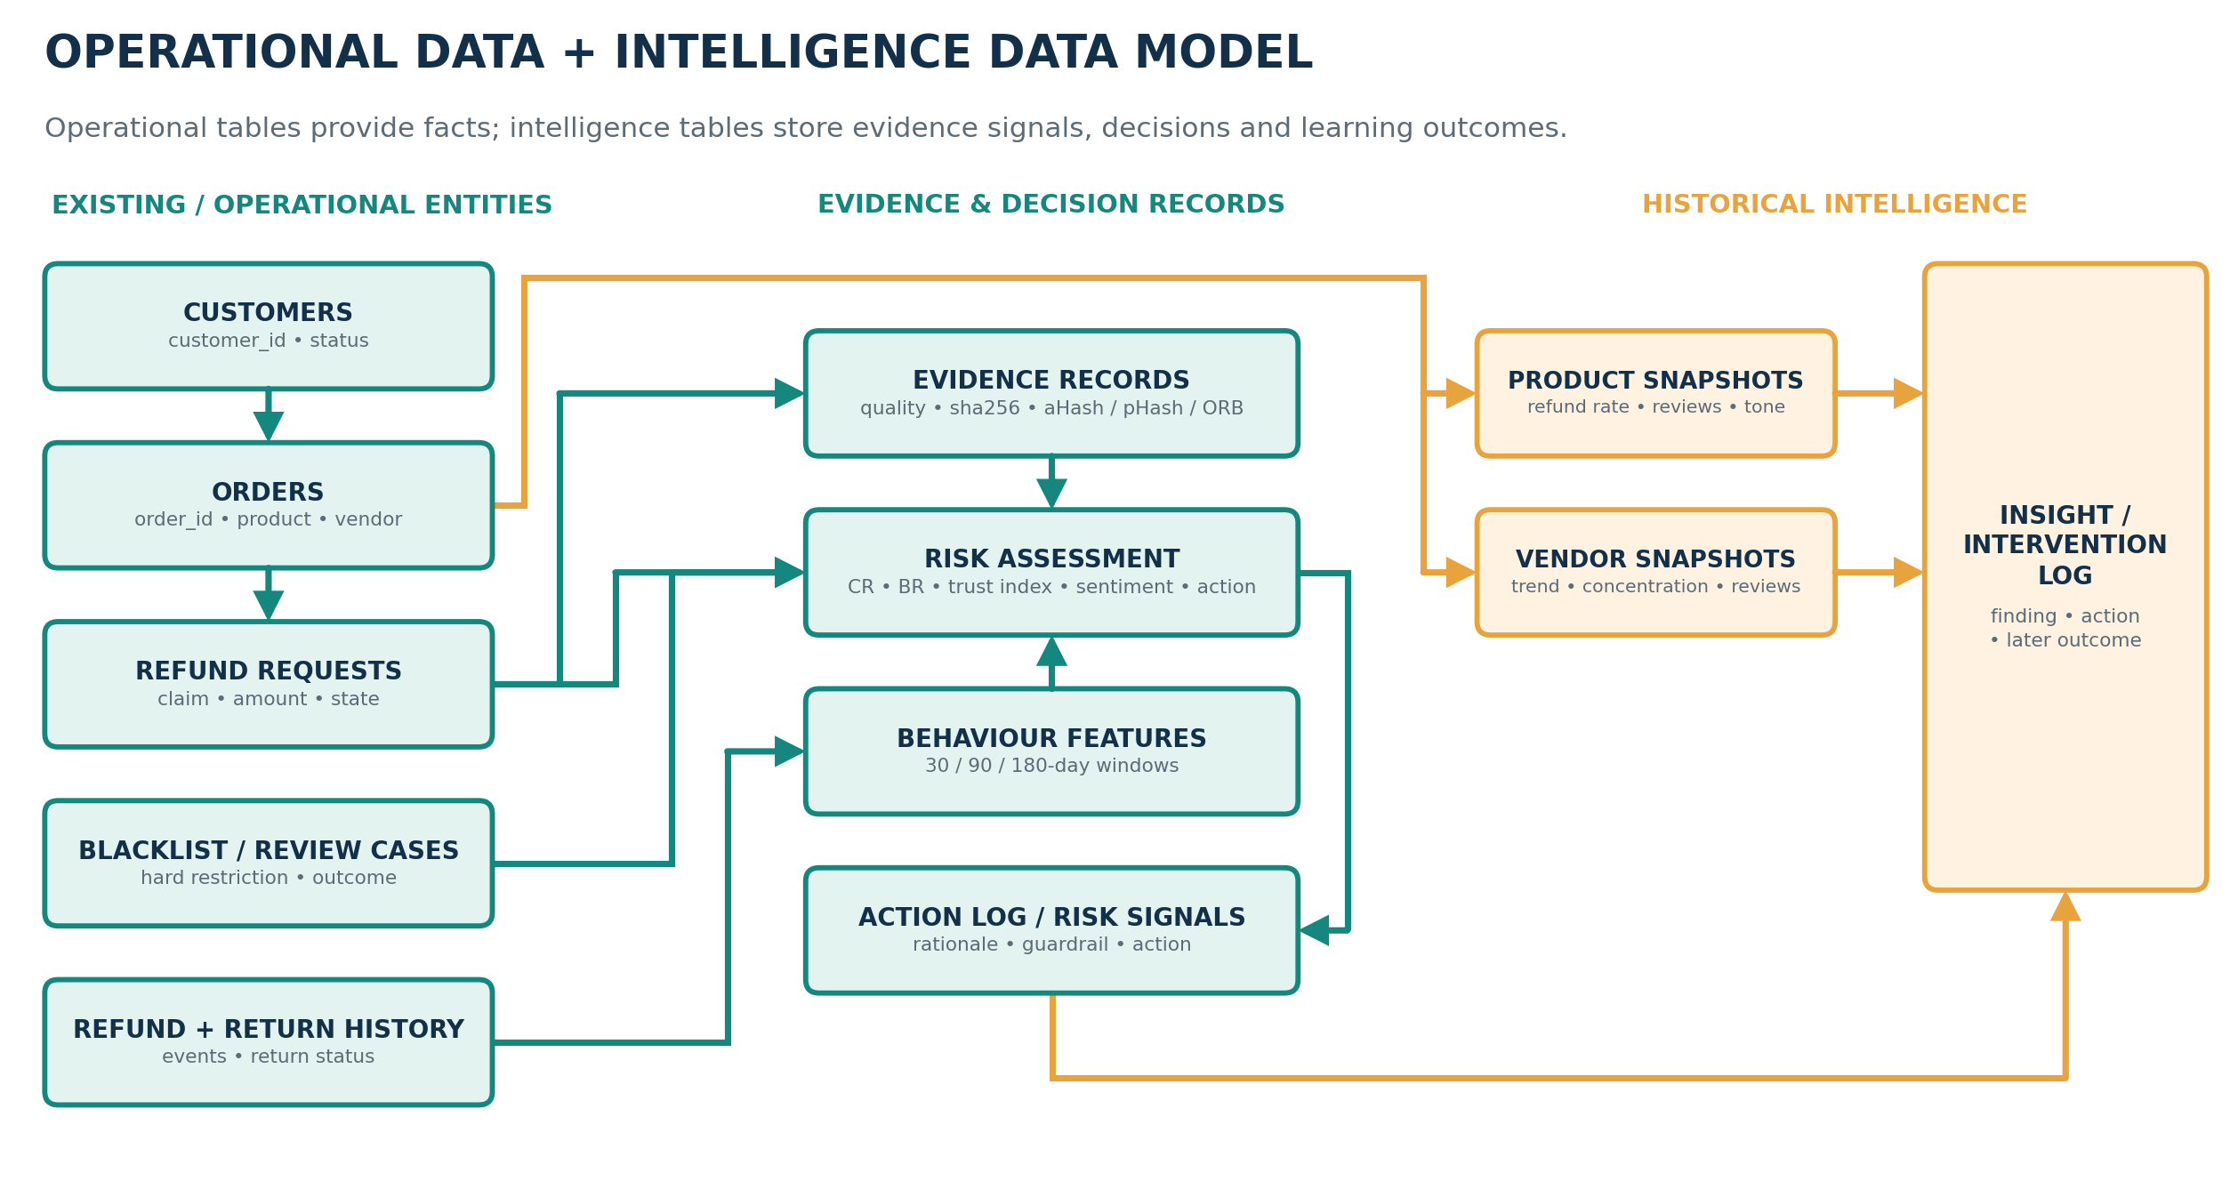
Figure 3. Logical data model: operational records feed evidence and risk records, and aggregate snapshots feed the prevention loop.
Record group | Representative fields | How the data is used
Customers | id, name, email, created_at | Identifies a customer and anchors the history features.
Orders | id, customer_id, product_id, vendor_id, category, amount, status, delivered_at | Supplies delivery and product context for policy checks and aggregation.
Policies | category, window_days, refundable, max_auto_amount | Stores the return window, refundability and auto-approval limit.
Refund Requests | id, order_id, reason, amount, status, risk, decision, sentiment | Stores the claim, assessment and current status.
Refund History / Returns | Past refunds; return events with status and time | Provides the history used by rolling features and return checks.
Blacklist / Review Cases | customer_id, reason; case status and outcome | Provides hard restrictions and the manual-review queue.
Evidence | id, claim_id, path, sha256, quality, hashes, ORB signature | Stores the uploaded photo and the signals used to compare it with past evidence.
Behaviour / Risk Profile | Rolling counts and values; behavior_risk, trust_index | Caches rolling features and the customer's risk profile.
Risk Signals / Action Log | kind and detail; action, detail and time | Explains flags and retains the decision trail.
Product / Vendor Snapshots | entity id, refund rate, review score, sentiment, outlier flags | Stores aggregated measures used to spot unusual patterns.
Insight Log | kind, entity, pattern, intervention, baseline metric, outcome | Links a historical finding to an intervention and later result.
Provenance / Labels / Reviews | source, file, original id, label origin; labels; review text | Keeps evaluation labels and data origin traceable.

Relationships and data minimisation
Several orders and lots can be identified by customers. A claim associated with its evidence, signals and actions. The results from different vendors and products are obtained by snapshots, while the data chronicling checklists and ex-post inspections are kept in logs.

Composite Dataset Strategy and Provenance
No public dataset containing orders, refunds, claims photos, confirmed abusers and customer history is currently available. Hence, instead of one consolidated source, we utilize multiple sources for different checks. In line with industrial studies, there is also used Olist's order-reviews file, a set of 60 sentences containing claims and synthetic customers. Because synthetic labels are generated independently of the threshold of the detector, this test doesn’t make a simple division into “abusive ” cases that the existing rules were made for.
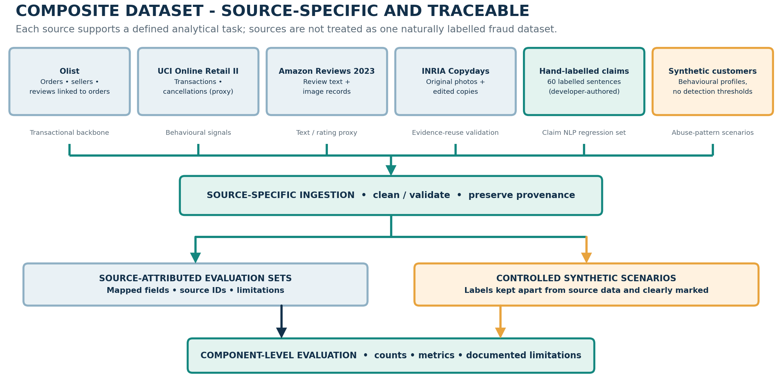
Figure 4. Composite dataset strategy: each source supports a defined task, and synthetic labels stay separate.

8.1 What each source can tell us
Source | What is available | Use in this project | What it cannot establish
Olist Brazilian E-Commerce [1] | About 100,000 orders from 2016-2018 with items, sellers, customers, products, delivery dates and an order-reviews file (score and comment) linked to real orders. | Uses orders and reviews for order context and product/vendor summaries, including review outliers. | No refunds or fraud labels. Review text is Portuguese, so the English rules are not evaluated on it. A bad review is not a refund claim.
UCI Online Retail II [2] | 1,067,371 transaction rows from a UK online retailer, 2009-2011, many of them wholesale. | Uses cancellations as behavioural proxies only; does not call them refunds or abuse. | A cancellation is not a confirmed refund and not fraud. There are no delivery dates, so timing patterns cannot fire.
Amazon Reviews 2023 [3] | Review text, ratings, item metadata and image URLs for one chosen category. | Uses review text and ratings to test text and sentiment components, not as refund claims. | Reviews are not refund claims, and review images are never stored as evidence. Licence terms must be checked before use.
INRIA Copydays [4] (DISC21 [5] as a larger alternative) | 157 original holiday photos with JPEG, crop and strong-edit variants. | Tests whether image matching detects known copies, crops and recompressed variants. | A matched-image benchmark does not represent the full range of photos submitted with real refund claims.
Hand-labelled claim set | 60 claim sentences labelled for reason category, text support and sentiment, covering plain, paraphrased, negated and hard cases. | Regression set for the claim-text rules and the sentiment lexicon. | These profiles are generated for controlled tests and do not estimate a real retailer’s abuse rate.
Synthetic customers | Customers drawn from behavioural profiles (normal, heavy genuine, serial refunder, refund farmer, policy exploiter, return abuser) using Poisson and Beta draws, plus an evidence-reuse scenario in which one customer re-uploads an edited photo of another. | Tests how the pipeline separates the profiles, with labels kept in a separate table. | The generator never references a detection threshold, so recall below 100% and false flags are expected. It shows no real-world fraud rate.

8.2 Source-to-schema mapping
Data area | Fields / records used | Outputs tested
Transactional and delivery context | order_id, customer_unique_id, status, purchase and delivery dates, item prices, seller, product category. | Builds rolling activity features and the values used in customer behavioural risk.
Repeat-customer behaviour | UCI customer ID, invoice dates, quantities, prices, cancellation invoices (as proxy events). | Uses linked order reviews for product/vendor aggregates and the text/sentiment checks.
Review text and images | Olist review score and comment linked by order_id; Amazon rating, title, text and image URLs. | Review-based product and vendor outliers, and text and sentiment test data.
Image reuse | Copydays originals and their JPEG, crop and strong variants. | Per-method recall and false-match rates, and the matching thresholds.
Abuse ground truth | Scenario ID, profile, generator seed, label and label origin for each synthetic entity. | Known profiles for pattern and decision evaluation.

8.3 Provenance and safe joining rules
Every loaded row contains information about its source, filename, original ID, and label source (the source may be real, presumed, or artificial). A log documents conversion of the fields and cleaning decisions. IDs remain within namespaces determined by the dataset’s type; unrelated data will not be merged simply because of similar names. Artificial labels are given only to artificial data. The assumptions used in modifying Olist and UCI to the prototype (return periods and auto-approval caps) are documented rather than treated as information obtained from the source data.
8.4 Reproducibility Testing
• Every dataset is associated with its formal page, citation, and access terms (docs/data_sources.md).
• Manifest shows the files that were utilized, the number of records, missing values, and cleaning choices. It contains what was in fact loaded.
• Raw data is stored in the data/raw folder and is ignored by git. The repository does not redistribute any dataset.
• Evaluation database is separate from the demo database with the seeds.
• Artificial scenarios use a fixed seed (7). There is a check to ensure that the generator does not refer to a detection threshold.

Methodology and Feature Engineering
The process begins with the source files but then finishes at the recorded decision stage, although evaluation is in itself separate. No one classifier was trained to label various types of data. In other words, the transactions support the behavioral features, the images support the matching of reuse, and the small claims conclude the text evaluation.
Step | What we do
1. Source acquisition | Download each source, note its version and checksum, and record the access date.
2. Validation and normalisation | Clean each file using rules suited to that source; count removed records rather than silently dropping them.
3. Source-aware mapping | Map only fields that exist in a source, keep IDs namespaced, and avoid unsupported cross-dataset joins.
4. Feature building | Calculate rolling refund-like counts, value ratios, repeated reasons, return exceptions and timing features.
5. Controlled scenario generation | Generate controlled behavioural profiles; store the profile label separately from detector output.
6. Real-time claim evaluation | Run the live claim graph and save the signals, costs and selected action.
7. Historical intelligence | Aggregate completed cases, store snapshots and compare later results with the baseline.
8. Evaluation and revision | Run each component evaluation, inspect errors and update rules or source mappings where justified.

Preprocessing controls
The dates conform to the ISO timestamps, numbers are checked for impossible values, while texts are kept intact. The dataset covers a number of years (approximately from 2009 until 2018), so the evaluation allows to assign to each record a certain date instead of presuming, as is common in most analytical works, that different datasets contain data of the same time period.

9.2 Features built from the source data
Feature group | Examples used | How it affects the assessment
Frequency | Refunds in the last 30, 90 and 180 days. | Frequency risk is the worst window against saturation points of 3, 5 and 8 refunds.
Rate | Refund value divided by purchase value over 180 days. | Saturates at 50% of purchase value.
Value | Near-limit refunds and refund value against the auto-approve limit. | Highlights exposure and refund farming, and is not proof of abuse.
Timing | Refunds filed in the last 20% of the return window. | Feeds the policy-exploitation rule.
Reason repetition | Largest count of one refund reason in 180 days. | Repeated reasons raise behavioural risk and saturate at 3.
Evidence | Image quality, sha256, aHash, pHash, ORB signature, reuse flags and optional CLIP consistency. | Feeds the evidence-inconsistency and reuse parts of claim risk.
Aggregate quality | Product and vendor refund rates, review scores and claim sentiment. | Points to concentrated drivers for operations or supplier follow-up.

Risk Scoring and Abuse Detection
Claim risk and behavioral risk feature a scale ranging from 0 to 100 while being equipped with a total trust index at the same time. Component weights and thresholds of those indexes are designed in intelligence.py file and portrayed in the corresponding tests. Though these elements of the prototype provide some level of insight into the choice made by the model, calibration was not carried out in order to obtain the representative data of refund cases present on the market today.

10.1 Claim Risk
Claim risk formula. CR = 0.30 × ClaimAmbiguity + 0.30 × EvidenceInconsistency + 0.20 × EvidenceReuse + 0.20 × AbusePatternStrength
ClaimThe highest ClaimAmbiguity corresponds to the case when there is no explanation, explanation is too vague or explanation contradicts the rationale. EvidenceInconsistent claim is rated at 65 for a claim with no photo of physical damage; otherwise Inconsistency is calculated from image quality (100 × (1 - quality)), or greater value found from the enabled CLIP compatibility check. EvidenceReuse is 100 if image has completely been submitted before by the separate customer; 70 if it is almost identical; 50 if it is from the same customer’s previous claim. Different forms of abuse generate at least 50 points to AbusePatternStrength with a limit of 100 total points.

10.2 Behavioural Risk
Behavioural risk formula. BR = 0.35 × Frequency + 0.25 × ValueRatio + 0.15 × RepeatReason + 0.15 × ReturnException + 0.10 × EvidenceReuse. Trust index = 100 − BR. A blacklist stays a separate hard signal.
The values of behavioral characteristics fall within the same range from 0 to 100. Frequency yields the highest figure of all. It shows 30-, 90- and 180-day peaks which are 3, 5, and 8 returns, respectively. The proportion of refunds and purchases is maxed out at 50%. Repeated reasons for returns and return exceptions are maxed out at 3 occurrences, whilst the history of reusing evidence is up to 2 flagged claims maxed out. The trust index should be used for ordering the review queue, as opposed to detecting misconduct.

10.3 Exposure risk in the cost model
Exposure risk formula. ExposureRisk = (0.6 × CR + 0.4 × BR) / 100. RiskExposure(action) = refund amount × ExposureRisk × the action exposure factor.
The project brief did not give any instructions on how to combine claim and behavioral risk; hence the present version of the system is operating at a 0.6/0.4 ratio. EXPOSURE_W controls this setting. Exposure risk is an input into the cost model and is not considered as the probability of fraud by the customer. There is an option of having an LLM working. In this case, the agent can change the CR or the BR by up to 10 points, provided, however, that the score would not be dropped below that of the hard signal.

10.4 Deterministic abuse patterns
Pattern name | Rule used by the prototype | Effect on the case
Serial refunder | At least 3 refunds in 30 days, or 4 in 90 days, or 7 in 180 days. | Raises the abuse signal and behavioural risk.
Return abuse | At least 2 late or missing return events in 180 days (needs return events). | Flag, and count as a return-event exception. No coverage on Olist or UCI.
Fake defect pattern | Defect-type claim with reused evidence, or at least 3 defect claims in 90 days with at least 2 weak or missing-evidence cases. | Flag as a repeated defect with weak evidence.
Refund farming | At least 3 refunds just under the auto-approve limit, or at least 4 refunds in 180 days with refund value at least 50% of purchases. | Flag clustering near the decision limit.
Policy exploitation | At least 3 refunds filed in the last 20% of the return window. | Flag late-window concentration.

10.5 Hard guardrails
The blacklisted claim case requires manual evaluation. Policy violation results in a denial of a case, which cannot be skipped by any authority. Clear proof is used on different clients and subsequently needs manual assessment. Proof can be requested just one time for the claim. Agents may escalate the matter, but will not be able to approve the risky claim..

Expected-Cost Resolution
As soon as a claim successfully clears the policy gateway, the system will analyze the alternatives available for proceeding. There are three elements associated with each alternative's cost: monetary risk, friction with customers and labor required. The cheapest option will be chosen unless the safeguard dictates a safer path.
Decision rule. ExpectedCost(action) = RiskExposure(action) + CustomerFrictionCost(action) + HandlingCost(action). The cheapest eligible action is selected, unless a guardrail requires more caution. Policy decline comes from the policy gate.
Available action | When it can be used | Cost trade-off in the prototype | Restriction
Immediate refund | Always eligible. | Exposure factor 1.00, no friction or handling cost, so it is cheapest when risk is low. | Never chosen when a guardrail applies.
Refund after return | There is an item to send back. | Exposure factor 0.20, friction 25 plus a share of the claim value, handling 40. | Used when risk is moderate and the item can be returned first.
Request evidence | Physical claim with evidence inconsistency of at least 30, asked at most once. | Exposure factor 0.15, friction 10 plus a share of the claim value, handling 10. | Not offered again after a resubmission.
Manual review | Always eligible. | Exposure factor 0.03, handling 100, small friction. | A reviewer sees the signals, costs and rationale.
Policy decline | Only when the deterministic policy gate fails. | Not priced. Taken directly from the gate. | No agent can override it.

Decision sequence
1. Take the policy gate and implement it on the authoritative policy order and the facts.
2. Create the features, match the evidence, interpret the claims text, and find abuse patterns.
3. Merge them into claim risk, behavioral risk, trust index, and exposure risk.
4. Assess all actions and select the least costly.
5. Exposure risk is only a proxy; cost matrix is only for demonstration, not for financial forecasting. COST_SCALE adjusts frictional and handling costs to the claim value and currency used by the deployment. In the fixture run, the default setting did not flag any of the synthetic abusers; 0.1 has flagged 55 out of 100. Thresholds and costs will have to be compared with actual claim figures and reviewed outcomes before use in production.
6. Implement the solution using the Action Execution Layer and keep a record of the decision trace.

11.2 Illustrative example

To exemplify, suppose a customer with no previous history lodged a claim of the physical damage without providing a photo. The risk of this claim is 19.5, behavioral risk of 25.6, trust index of 74.4, and exposure risk of 0.22. Now, based on the configured costs, the immediate refund would cost 394.9, refund-after-return 214.2, evidence request 149.5, and manual review 182.1. Therefore the system asks for the photo. Once the customer uploads the clear photo, evidence request is not applicable anymore. Updated costs are 184.3 for immediate refund, 182.6 for refund-after-return, and 186.3 for review.

12. Historical Analysis and Prevention Loop
To exemplify, suppose a customer with no previous history lodged a claim of the physical damage without providing a photo. The risk of this claim is 19.5, behavioral risk of 25.6, trust index of 74.4, and exposure risk of 0.22. Now, based on the configured costs, the immediate refund would cost 394.9, refund-after-return 214.2, evidence request 149.5, and manual review 182.1. Therefore the system asks for the photo. Once the customer uploads the clear photo, evidence request is not applicable anymore. Updated costs are 184.3 for immediate refund, 182.6 for refund-after-return, and 186.3 for review..
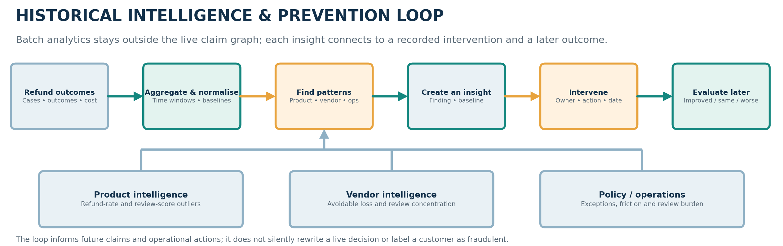
Figure 5. The historical loop links recurring patterns to interventions and later outcomes.

12.1 Three analytics lenses
Analysis view | Signal examined | Possible follow-up
Product Intelligence | Refund rate (outlier at 1.5 times the average with at least 3 refunds), top reasons, Olist review score and negative-review rate, and average claim sentiment. | Inspect descriptions, packaging or quality control, and trigger targeted checks.
Vendor Intelligence | Refund rate, expected avoidable loss and negative-review concentration by seller. | Ask the supplier for evidence and prioritise vendor review.
Policy / Operations Insight | Late-window refund share (flag at 25% with at least 5 refunds), abuse-pattern counts and review burden. | Clarify policy text, require evidence for late-window refunds and adjust review thresholds.
12.2 The Life Cycle of Intervention and Results
For each cycle, the batch job takes pictures of vendors and products, recording the pattern and the reference measure at the same time. The operator may be able to apply intervention, which may include asking for clearer pictures of defects or limiting the auto-acceptance of repeated patterns. In the following cycle, the new measure will be compared with the reference measure saved, and it will be noted whether the measure has improved, remained unchanged, or become worse. Each record connects observation with the business action and the following episode.
12.3 Operating metrics
• Risks of refund approvals and the accumulation of risks by product line, vendor, and type of policy;
• The frequency of the instances of manual review altering the initial path;
• Turnaround time and the ratio of the volume of low-risk claims processed;
• The ratio of true positives to false positives against a chosen reference;
• The impact of the intervention in comparison to some reference value measured cumulatively over several instances.

Technology Stack and Implementation
This is a little Python project instead of a service designed for production. There are five main modules that take care of storage, intelligence, graph orchestration, the API, and the interface based on Streamlit. Besides that, there are some scripting tools that contain demo information, run the evaluation, and make use of the API. The infrastructure is scaled and made simple to meet the needs of the present tests and demonstration.

Module / file | What it contains | Current role
db.py | SQL schema, stubs for surrounding systems, seed data, snapshot, insight and provenance records. | Keeps operational boundaries explicit.
intelligence.py | Contains the policy gate, feature logic, evidence matching, text/sentiment rules, formulas, agents, abuse rules, cost model and batch analysis. | All weights and thresholds are constants at the top, pinned by tests.
graph.py | Connects the real-time decision nodes and routes restricted or uncertain cases to review. | Coordinates the nine nodes and the execution route.
app.py | Provides the endpoints for claims, evidence, returns, review cases, business views and historical analysis. | Keeps the user interface separate from the decision logic.
streamlit_app.py | Presents the customer, operations and management screens; calls the API rather than duplicating decision logic. | Calls the API only.
demo.py, eval_data.py | Seeded demo scenarios, and the offline tooling for dataset ingestion, synthetic scenarios and evaluation. | Runs without an API key and uses its own evaluation database.
tests/ (3 files) | 44 tests: model and graph behaviour, evaluation tooling and an API journey. | Regression protection for formulas, guardrails and the evaluation rules.
requirements*.txt, .env.example, docker-compose.yml | Core dependencies, optional transformer and CLIP packages, a configuration template and a PostgreSQL container. | Optional backends need internet access to download model weights.

13.1 Technology choices
Layer | Technology | Why it is used
Language and analytics | Python, Pandas, NumPy | Data cleaning, feature building and transparent rules [12].
Orchestration | LangGraph | Stateful graph with deterministic and agentic nodes [11].
Service API | FastAPI | Typed request and response models with automatic API documentation [7].
User interface | Streamlit | Quick customer, operations and management screens in Python [8].
Image handling | Pillow, OpenCV (ORB), optional CLIP | aHash, pHash and ORB matching, plus an optional text-image check [13][14].
Storage | SQLite, optional PostgreSQL | Local execution with a relational path to production.
Testing | pytest | 44 tests for rules, routing, evaluation tooling and the API [9].
Model integration | Optional LLM and transformer backends | OpenAI-compatible agents, a zero-shot claim classifier and transformer sentiment, each with a fallback.

13.2 API surface
APIs allow accompanying of claims processing, uploading evidence, returning events, reviewing of cases and the overview of business operations, management, products, vendors, policies and abuses in addition to providing about historical events. The endpoints for the process build photos, utilize interventions and compare outputs.
14. Business Analytics and Interface Design
The system or interface is built according to the operations that people have to do. For example, the claimant can file a request and check its status; the operator can look through the evidence, costs and reasons before accepting the review; the manager can be provided with a common overview of the products, vendors and policies.
Screen | Main user | What is shown | Question it helps answer
Customer Portal | Customer / claimant | New refund request (order, reason, description, amount, photo) and claim status. | What do I need to submit, and where is my claim?
Operations Console | Refund analyst / support team | Review queue with exposure risk, decision, status and priority-care flag; case detail with claim risk, behavioural risk, trust index, cost table, flags, evidence image and a resolve button. | Which cases need me now, and why did the system choose this route?
Management View | Operations lead / business manager | Tabs for refund and abuse, product, vendor, policy and operations, and the prevention loop, with priority-care counts and average claim sentiment. | Where are refund loss and friction concentrated, and what should change?

14.1 Core KPI catalogue
Metric | Definition / calculation | Business use
Avoidable refund exposure | Risk-weighted refund value (amount × exposure risk) for new claims, grouped by product and vendor. | Prioritise high-value, high-risk areas, and compare trends with care.
Manual review rate | Share of claims routed to manual review. | Balance protection against reviewer workload.
False-review rate | Share of reviewed claims later judged legitimate. | Reduce friction for honest customers.
Safe auto-resolution rate | Share of eligible low-risk claims resolved without review or reversal. | Track efficiency without ignoring later outcomes.
Time to resolution | Elapsed time from claim creation to its final state. | Find delays in evidence collection and review.
Evidence-reuse precision / recall | Correct matches over predicted matches, and over known duplicate pairs. | Tune the matching thresholds and the false-match risk.
Product/vendor intervention outcome | Metric after an intervention compared with the baseline snapshot. | Check whether the action changed the targeted pattern.
Priority-care claims | Claims with sentiment at or below -0.5 and a trust index of at least 60, where the action adds friction or declines. | Route unhappy but trustworthy customers to care outreach. Never used as a fraud signal.
Average claim sentiment | Mean sentiment score of claim text, overall and per product. | Product insight and service quality. Lexicon sentiment is weak on factual complaints.

14.2 Principle of Visual Reporting

The chart must serve the purpose of answering a business question and not just act as a filler. The visual views focus on prioritizing the case by highlighting whether refund exposure or efforts are concentrated in the right area and if the product, vendor or working policy needs to be addressed. The historical dashboard also indicates whether interventions made a difference in the metric being affected.

15. Testing and Evaluation

The complete test involves calculating formulas, weighing, determining the guardrails, and analyzing the routing, different scenarios, and API behavior. The test run has 44 completed tests, and the evaluation utilities also assess if all datasets included the required fields before conducting a particular experiment. Passing these tests proves that the implementation path works properly, but does not guarantee that fraud detection will work properly in the real world.

15.1 Functional scenario matrix
Test area | Scenario / method | Expected behaviour | Recorded result / status
Normal eligible claim | Good customer, damaged mixer, clear photo. | Immediate refund (claim risk 0, behavioural risk 0, trust index 100). | Selected action, risk components and rationale.
Serial refunder | 7 refunds in 60 days, all just under the limit and filed late in the window. | Manual review (CR 20.0, BR 90.0) with serial refunder, return abuse, refund farming and policy exploitation flags. | Pattern flags and cost table.
New account, high value | New account, Rs 18,000 phone, blurry photo. | Manual review (CR 11.1, evidence confidence 63.1) with high-value flags. | Flags and cost table.
Evidence reuse | Another customer re-uploads an earlier customer's photo. | Manual review by guardrail, matched by aHash, pHash and ORB. | Match methods and matched claim.
No photo | Physical damage claim without a photo. | Request evidence (CR 19.5, BR 25.6). | Evidence flag and costs.
Resubmission | The same claim after the photo arrives. | Refund after return (request evidence is no longer offered). | New decision and costs.
Outside return window | Grocery claim 6 days after delivery, window 2 days. | Policy decline, with no agent override. | Policy violation and guardrail reason.
Negated claim text | Reason is damaged but the text says the item is not damaged. | Ambiguity raised and the flag claim_negated_by_text is set. | Interpreter flags and the backend used.
Sentiment isolation | Very negative claim text. | cx_priority may be set, but no score, cost or decision changes (test). | Sentiment label and cx_priority.
Cropped photo reuse | A cropped copy of another customer's photo. | Detected by ORB where the hashes miss it. | Match methods.
Graph failure | An error inside the graph. | Manual-review fallback, never a silent approval. | Fallback event.
Historical loop isolation | The batch loop runs. | Snapshots and insights update outside the graph, and later claims get context only (test). | Snapshot, baseline, intervention and outcome log.

15.2 Component-level data evaluation
Component | Evaluation input | Result and caveat
Policy gate on real Olist orders | Check the deterministic gate against real order timestamps, with an assumed policy and synthetic claim timing. | Orders, checks and agreement rate.
Behaviour and abuse rules on UCI | Run the features and rules on UCI cancellation customers (unlabelled, return-like proxy). | Flag counts and rates, behavioural-risk percentiles. Not precision or recall.
Evidence reuse on Copydays | Use original-to-variant ground truth to measure each matching method by transformation type. | Recall and false-match rate per method (aHash, pHash, ORB) and for the combined rule.
Synthetic customers | Draw customers from independent behavioural profiles and run them through the graph. | Pattern recall per profile, false flags on legitimate profiles, and classifier and decision metrics by cost scale.
Claim text and sentiment | Score the rules (and a transformer when enabled) against the labelled set, with the old substring matcher as a baseline. | Category accuracy, macro-F1, negation, paraphrase and hard-case accuracy, and sentiment accuracy.
Olist reviews linked to orders | Link reviews to real orders and compute score distributions and outliers. | Reviews, link rate, score distribution, product and vendor outliers.
Amazon reviews text proxy | Compare the sign of the sentiment with the star rating on a chosen category. | Agreement of sentiment with rating (a weak label).

15.3 Metrics and formulas
In the case of labelled instances, precision is defined as TP/(TP+FP), recall is defined as TP/(TP+FN), and F1 score is computed as 2 × precision × recall/(precision + recall). Image matching uses the idea of comparing an identified pair with the platform's valid pairs. The review rate and the resolution time are presented separately, as they indicate the procedure, rather than efficiency of a single classifier.
There are dissimilarities between datasets: while one contains transactions, another comprises reviews and so on, the manual set uses claim sentences. As a result, measuring accuracy for all groups is not entirely correct.
Measure | Meaning | How to interpret it
Abuse-rule detection | Pattern recall and false-flag rate per profile | Check each synthetic profile against its target pattern, and look at false flags on legitimate profiles.
Evidence reuse | Recall and false-match rate per method and transformation | Show that hashes fail on crops while ORB catches them, and what the false-match cost is.
Claim text | Category accuracy, negation accuracy, unsupported-claim precision and recall | Compare the rules with the old substring matcher, and note that the labelled set is not independent.
Decision routing | Decision as a classifier at several cost scales | Show that outcomes depend on the cost scale, so set it from real claim sizes.
Operational effect | Review rate, false-review rate, priority-care claims | Track protection and customer friction together.
Historical loop | Snapshot completeness, intervention outcome against baseline | Include sample size, because before-and-after movement is not causal proof.

16. Results and Discussion

16.1 Implementation outcome
The present build links up the claim intake to the processes of checking evidence, behavior but not behavior characteristics, limitations, and cost comparison, as well as keeping a record of actions taken. A narrower evidence base was put together for this report because it is based on 44 completed tests, some pieces from public websites, and the 60-sentence labeled dataset. The actual public documents have to be obtained and processed with the help of the program python eval_data.py because they were inaccessible in the evaluation environment [10].
Evaluation case | Observed result | Interpretation
Automated tests | 44 tests pass (model, graph, evaluation tooling and an API journey). | The decision logic and the evaluation rules are pinned by tests.
Claim text rules | On the 60 labelled sentences, category accuracy rises from 0.45 (substring matcher) to 0.73 (negation-aware rules). Negation cases go from 0.09 to 0.64, and hard paraphrases stay at 0.21. | Negation handling is a real gain. Hard paraphrases are what a transformer should fix, and that is not yet measured.
Sentiment | The VADER lexicon reaches a three-class accuracy of 0.40 and a recall of 0.22 for negative text on the labelled set. | Lexicon sentiment is weak on factual complaints, so it is used for routing only.
Image matching | On the Copydays-layout fixture (6 pairs), aHash and pHash recall on crops is 0.0, while ORB and the combined rule reach 1.0, with no false matches at the operating thresholds. | ORB catches crops that hashes miss. Real Copydays and product photos must confirm the thresholds.
Synthetic abusers | The pattern flags catch 56 of 100 synthetic abusers, with 1 false flag among 40 legitimate customers (precision 0.98, recall 0.56). | The rules miss many abusers once the generator does not mirror them. Whether the thresholds suit real behaviour is unknown.
Decision and cost scale | At the default cost scale the decision flags none of the abusers. At a scale of 0.1 it flags 55, with 4 false flags. | The cost matrix needs a scale taken from real claim sizes.
Policy gate | On 35 Olist-layout orders the gate agrees with its reference in all 210 checks. | This validates the implementation on real timestamps, not the realism of the policy.
Olist reviews link | All 33 fixture reviews link to orders, and 2 of them carry comment text. | The link works. Text analysis of Portuguese reviews is not evaluated.

16.2 Response to industry review feedback
The industry review brought forth five explicit implementation modifications and offered more recommendations pertaining to the dataset and evaluation strategy. The table below reveals the reaction concerning every point, which includes efforts done but not recorded on actual data yet.
Review feedback | Change in the repository | Status of the evidence | Where to verify it
Claim text misses negation and paraphrase; use a transformer | Negation-aware phrase rules are the default; CLAIM_NLP=transformer enables the optional zero-shot path with rule fallback. | Rules done and measured. Transformer written but not run with real weights. | interpret_claim; accuracy 0.45 to 0.73 on the labelled set
Add a text-image consistency check (CLIP) | Optional IMAGE_TEXT=clip path compares claim text with the photo; evidence inconsistency uses the worse signal. | Written and tested with a stand-in model. Real CLIP not run. | test_text_image_  consistency_hook
Use sentiment for service routing, not fraud | VADER supports service priority and product summaries. It does not affect fraud risk or the decision. | Done. Lexicon is weak on factual complaints (accuracy 0.40). | test_sentiment_  never_changes_  risk_or_decision
Average hash misses cropped images | aHash, pHash and ORB are combined; match_methods records which method detected a candidate pair. | Done. Thresholds calibrated on synthetic images and to be rechecked on real photos. | Crop recall on fixtures: hashes 0.0, ORB 1.0
Use the Olist reviews file, linked to real orders | Olist order reviews are mapped into source_reviews and used for product/vendor summaries; real-file evaluation remains pending. | Done in code and fixture tests. Not run on the real file. | test_olist_  reviews_are_  linked_to_  real_orders
Create a small manually labelled test set | A 60-sentence developer-authored set exists; the planned 200-review sheet still needs independent team labels. | Set exists but is developer-authored. Team labelling still to do. | data/  manual_claims_  labelled.csv
Keep the synthetic generator independent of the detection rules | Profiles use Poisson and Beta draws and do not refer to the detection thresholds; tests enforce this separation. | Done and test-enforced. Recall below 100% is now visible. | test_generator_is_independent_of_the_detection_rules
Run the evaluation on the real datasets | The script is ready for the real paths, but the complete public files have not yet been processed. | Not done yet. The real files were not available in the build environment. | docs/pipeline_smoke_run.md (fixtures only)

16.3 Demonstration findings
The demo version that got the seed can perform six stories without the API key. The legitimate claim with a proper image results in reimbursement without delay; too much reimbursement activity as well as re-utilization of image of various clients leads to manual review. The newly created account, detailed about expensive phone but with blurred image, gets to manual review as well. In another case, the system requests proof when a claim on physical damage does not have any photo and provides reimbursement after the image is uploaded. A grocery late claim is rejected due to means of the policy. The particular routes depend on features, setup rate and security measures; the high score in itself does not trigger manual review.

16.4 What is not claimed
Constraints of the present evaluation. The prototype has not been interfaced with the working refund and payment systems of a merchant in question, and no overall public datasets have been assessed yet. The transformer and CLIP ways have not been applied with true model weights. The developer who produced the rules also authored the 60-sentence claim set. Scores, costs, and thresholds still await independent labels.

17. Challenges, Limitations and Controls
Coverage of the data: The sources mentioned do not correlate with orders, refunds, uploaded images of claims and labeled abuse verified. Thus, each data set will be utilized for the independent experiments instead of taking them as a single refund representative sample.
Events proxy: Cancellations by UCI or negative reviews on products cannot be considered as positive refunds or fraud. These events are not utilized except as a part of specific behavioral, sentiment or aggregate checks described.
Cross-source identity: Customer IDs have a connection to their source. The two data sets can never be connected by some common names or weak connections, as this would lead to customer history, which cannot be supported by the evidence.
Matching of images: Perceptual hashes cannot find cropped copies while local-feature matching may also show false coincidences. Current thresholds were tested using fixtures and require real images to be checked independently.
Model backends and claim text: Rules that take into account negation improve labeled instances, but it is still difficult to paraphrase them. VADER can also misinterpret the messages. The implementation of CLIP and transformer have never been tested on real model weights.
Independence of assessment. The 60-sentence set was developed by the designer of the rules. Thus, the set has more of a use for regression purposes than for assessing the precision of the score. The simulated generator does not employ thresholds of detectors in this case, but its patterns do not give away the real prevalence of refund fraud.
Weights and costs of actions. The different scores as well as the costs scale are but prototypes in this instance. In this case study, when the COST_SCALE is not set, none of the synthetic fraudsters is flagged, but after turning it to 0.1, 55 out of 100 fraudsters are caught. This sensitivity should be checked against the actual claims and winning outcomes.
Responsible usage. The risk score does not confirm that the person has behaved unethically. Any operational test should measure the frequency of false reviews, check all appropriate categories, where due data and permissions are available, and provide an opportunity for the reviewer to pay attention to the recommendation.

17.1 Monitoring during a pilot
In the course of a pilot, monitor the false-review rate, overturn rate, time taken to resolve issue, and action chosen at all COST_SCALE levels. Compare these with baseline values and assess differences by category prior to any rule changes. Small sample sizes may make comparison by percentages ineffective – show both counts and percentages. Use initial results as indication for further examination, not as conclusive proof..

Future Scope and Roadmap
In the following step, you need to find out the capabilities of the prototype based on the original data and independent examples. Developing more models or making production connections before doing this would only lead to bigger systems without eliminating the key question of whether the metrics and task costs turn into effective decisions.
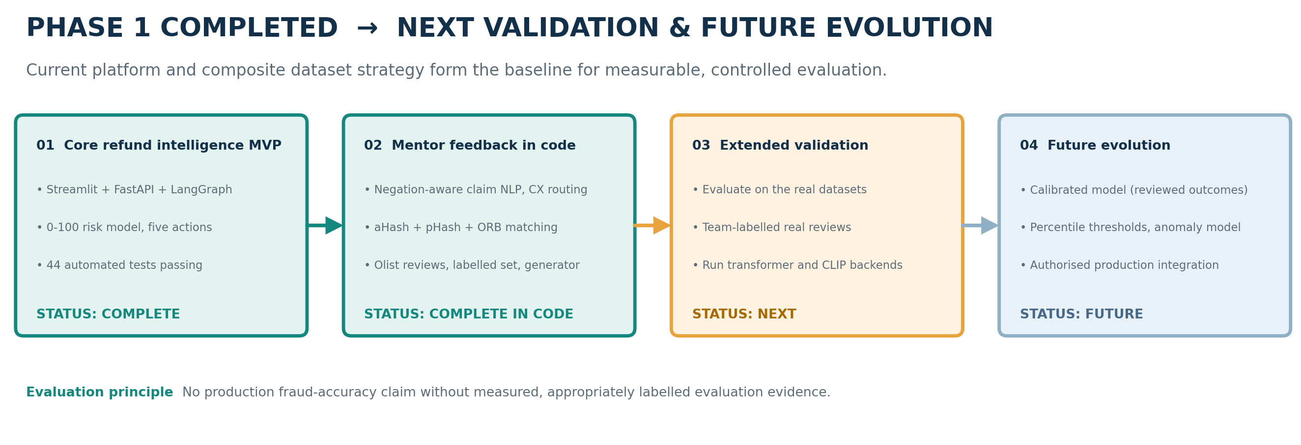
Figure 6. Completed core platform and composite dataset strategy, followed by validation and future evolution.

Stage | Work to complete | What is needed / how to check
Near-term validation | Download the real datasets, run python eval_data.py all, and publish the generated manifest and evaluation report. | Dataset files, recorded checksums and a clean-environment run.
Near-term validation | Confirm the aHash, pHash and ORB thresholds on Copydays and real product photos. | Real photo samples and a review of false matches.
Phase 2 | Run the transformer claim classifier (multilingual for Olist) and CLIP with real weights, and compare them with the rules. | Model access, and the team-labelled real-review set for an independent test.
Phase 2 | Recalibrate the abuse thresholds with percentile-based rules, add an anomaly model for comparison and move towards calibrated probabilities. | Reviewed outcomes and enough trusted labels.
Advanced research | Graph-based detection of coordinated abuse across customers and shared evidence. | Reliable entity linkage and a privacy review.
Production integration | Replace the stubs with authorised retailer APIs, durable case management, access control and monitoring. | Security and privacy assessment and business-owner approval.

Proposed implementation sequence
Download the four public sources and, after obtaining versions and checksums, make sure to run `python eval_data.py all`.
Run the complete test suite as well as demo in a new environment and save the outputs for your teammate to verify the process.
Ask two teammates to get 200 actual reviews labeled. Ensure to keep this set apart from developer-generated sets from rule-building.
Run both the transformer and the CLIP paths with actual model weights and compare the results with the current rules.
Make sure to go back to where the thresholds and COST_SCALE have been obtained and check the actual claims versus ruled outcomes while finalizing the recommendation algorithm.

19. Conclusion
The project introduces a series of decision tests in connection to an existing refund process. It combines the evidence provided, the customer's latest activities, five rule-driven patterns of abuse, and the expense involved in the next steps to provide a basis for explaining the decision.
The tests provide a more limited conclusion that is in line with the goal of running the rule paths as expected, while the decision trace allows tracking the decision taken. At the same time, the tests do not show any real-world precision, recall, or savings. In order to address these issues, individual claims need to be used in their brand-new experimental settings.
In conclusion, testing on default cost has not been productive due to an absence of cases of misconduct indicated in the system.
Independently validating the process comes next: utilizing the existing sources; keeping the IDs of the sources separately; tagging a new sample of claims; and computing the costs with the help of the reviewed results. After this, analyzing the chosen option against the baseline is possible, and only in case of success is it doable.
In one sentence: The project is representation of a refund decision layer that checks proofs and behavior, compares possible ways to go with the respect incurred costs, and identifies the activities that may repeat themselves in the future.

Appendix A. API and Demonstration Guide
Appendix A provides an overview of key API routes and local commands in tabular format. The precise format of the request and response is available in the repository README as well as at `/docs` when the API is operational.
Task | Route / command | Purpose
Create claim | POST /claims | Create a claim and run the decision graph.
Return event | POST /claims/{id}/return | Record a return as received, late or missing.
Submit evidence | POST /claims/{id}/evidence | Attach a photo and re-run the assessment.
Inspect claim | GET /claims/{id}; GET /claims/{id}/evidence-image | Read the state, risk signals, costs and photo.
Operations review | GET /reviews; POST /reviews/{case_id}/resolve | List open cases and record the reviewer outcome.
Business views | GET /insights/operations, /management, /products, /vendors, /policy, /abuse | Operational and aggregate intelligence views.
Historical loop | POST /historical/run; GET /historical/snapshots/{kind}; GET /historical/insights | Build snapshots and list insights.
Interventions | POST /historical/insights/{id}/apply; POST /historical/insights/{id}/evaluate | Apply an intervention and compare it with the baseline.
Local demo | python demo.py | Run seeded stories without an API key.
Backend | uvicorn app:app --reload | Start the API and the interactive docs at /docs.
Frontend | streamlit run streamlit_app.py | Start the user interface.
Automated checks | pytest -q | Run the 44 tests.
Evaluation | python eval_data.py all --olist DIR --uci FILE ... | Ingest the datasets and generate the manifest and the evaluation report.
Labelling sheet | python eval_data.py labelling-sheet --n 200 | Export real reviews for teammates to label.

A.1 Recommended reviewer walkthrough
1. Access a basic normal claim and examine the selected action along with the reasoning trace.
2. Access the claim that does not have any photographic evidence included, display the evidence request, and subsequently add a photograph followed by the new result.
3. Access the story of the serial-refunder story and check the abuse patterns that were activated.
4. Display a hard guardrail: re-download the image used by a different customer, or the image that belongs to a blacklisted customer.
5. Access the Operations Console, and close a review case while showing the outcome.
6. Start the historical loop in the Management View, and show the snapshots, insights, intervention, and the result.

Appendix B. Glossary and Data Dictionary
Term | Meaning in this report
Claim Risk (CR) | Current claim risk, 0-100, from ambiguity, evidence inconsistency, evidence reuse and abuse-pattern strength.
Behavioural Risk (BR) | Customer-history risk, 0-100, from frequency, value ratio, repeated reasons, return exceptions and evidence-reuse history. A blacklist is a hard signal outside the formula.
Trust index | 100 minus behavioural risk. A supporting index, never proof of wrongdoing.
Exposure risk | (0.6 × CR + 0.4 × BR) / 100, a normalised proxy used in the cost model, not a calibrated probability.
Expected cost | Risk exposure plus customer friction plus handling cost for an action.
Guardrail | A deterministic condition that overrides normal routing and only adds caution.
Evidence reuse | An exact (sha256) or near-duplicate (aHash, pHash, ORB) match with earlier evidence.
Synthetic profile | A generated customer drawn from a behavioural profile and labelled only in eval_labels.
Source provenance | The record of source, file, original ID and label origin for each loaded row.
Historical Intelligence & Prevention Loop | Offline aggregation of refund patterns into snapshots, insights, interventions and later outcomes.
Human-in-the-loop (HITL) | A reviewer handles cases that are ambiguous, restricted or unsafe to resolve automatically.
Existing action layer | The system boundary that executes refund, return, evidence-request, case and status actions.

B.1 Core risk variable definitions
Variable | Scale | Definition used in the code
ClaimAmbiguity | 0-100 | Clarity of the claim text and its consistency with the claimed reason.
EvidenceInconsistency | 0-100 | 65 for a physical claim without a photo, otherwise 100 × (1 − image quality), or the CLIP mismatch if that is worse.
EvidenceReuse | 0-100 | 100 for an exact copy of another customer's photo, 70 for a near-duplicate, 50 for the customer's own earlier claim.
AbusePatternStrength | 0-100 | 50 per detected pattern, capped at 100.
Frequency / ValueRatio / RepeatReason / ReturnException / ReuseHistory | 0-100 each | Behavioural components that saturate at 3, 5 and 8 refunds, a 50% value ratio, 3 repeats, 3 exceptions and 2 flagged claims.
Sentiment | -1 to 1 | Tone of the claim text, used for routing only. Labelled negative at or below -0.35.
Expected cost(action) | Configured cost scale | Risk exposure plus friction plus handling for an action.

References

[1] Olist and collaborators. (2021). Brazilian E-Commerce Public Dataset by Olist. Kaggle. https://www.kaggle.com/datasets/olistbr/brazilian-ecommerce (Accessed 11 October 2026).
[2] Chen, D. (2012). Online Retail II [Dataset]. UCI Machine Learning Repository. https://doi.org/10.24432/C5CG6D. https://archive.ics.uci.edu/dataset/502/online+retail+ii (Accessed 11 October 2026).
[3] Hou, Y., Li, J., He, Z., Yan, A., Chen, X., & McAuley, J. (2024). Bridging Language and Items for Retrieval and Recommendation. arXiv:2403.03952. Amazon Reviews'23 dataset documentation: https://amazon-reviews-2023.github.io/ (Accessed 11 October 2026).
[4] Jégou, H., Douze, M., & Schmid, C. (2008). Hamming Embedding and Weak Geometric Consistency for Large Scale Image Search. Proceedings of the 10th European Conference on Computer Vision. INRIA Copydays dataset: https://lear.inrialpes.fr/~jegou/data.php.html (Accessed 11 October 2026).
[5] Meta AI. (2022, June 14). DISC21: Dataset for the Image Similarity Challenge 2021. https://ai.meta.com/datasets/disc21-dataset/ (Accessed 11 October 2026).
[6] Tabassi, E. (2023). Artificial Intelligence Risk Management Framework (AI RMF 1.0). NIST AI 100-1. National Institute of Standards and Technology. https://doi.org/10.6028/NIST.AI.100-1.
[7] FastAPI. (n.d.). FastAPI documentation. https://fastapi.tiangolo.com/ (Accessed 11 October 2026).
[8] Streamlit. (n.d.). Streamlit documentation: multipage applications and app development. https://docs.streamlit.io/ (Accessed 11 October 2026).
[9] pytest development team. (n.d.). pytest documentation. https://docs.pytest.org/en/stable/ (Accessed 11 October 2026).
[10] Painsparc. (2026). Refund Intelligence: Intelligent Refund Risk & Resolution Platform (source code repository and README). https://github.com/painsparc/refund-intelligence (Accessed 22 October 2026).
[11] LangChain AI. (n.d.). LangGraph overview: stateful orchestration, deterministic steps and human-in-the-loop. https://langchain-ai.github.io/langgraph/tutorials/introduction/ (Accessed 11 October 2026).
[12] Python Software Foundation. (n.d.). Python documentation. https://docs.python.org/3/ (Accessed 11 October 2026).
[13] Rublee, E., Rabaud, V., Konolige, K., & Bradski, G. (2011). ORB: An efficient alternative to SIFT or SURF. 2011 International Conference on Computer Vision, 2564-2571. IEEE.
[14] Radford, A., Kim, J. W., Hallacy, C., Ramesh, A., Sastry, G., Askell, A., Mishkin, P., Clark, J., Krueger, G., & Sutskever, I. (2021). Learning transferable visual models from natural language supervision. Proceedings of the 38th International Conference on Machine Learning, PMLR 139, 8748-8763.
[15] Hutto, C. J., & Gilbert, E. (2014). VADER: A parsimonious rule-based model for sentiment analysis of social media text. Proceedings of the International AAAI Conference on Web and Social Media, 8(1), 216-225.
[16] Yin, W., Hay, J., & Roth, D. (2019). Benchmarking zero-shot text classification: Datasets, evaluation and entailment approach. Proceedings of EMNLP-IJCNLP 2019, 3914-3923.
[17] Fischler, M. A., & Bolles, R. C. (1981). Random sample consensus: A paradigm for model fitting with applications to image analysis and automated cartography. Communications of the ACM, 24(6), 381-395.

