POKHARA UNIVERSITY

Faculty of Science and Technology

School of Engineering



Project On

PROJECT MANAGEMENT SYSTEM

Subject: Advance Programming in JAVA

Submitted by: Submitted to:

Name: Pairavee Kiran Bhattarai Department of Software Engineering

Roll no: 47 Sushant Poudel

Program: Software

Abstract

Human resource difficulties face all businesses, large and small. Because every organization has different project management needs, we create custom project management solutions that are tailored to your needs. This is intended to aid strategic planning and guarantee that your firm has the appropriate degree of human resources to meet your long-term objectives. This approach will help you to better manage your resources in the long run.

Introduction

Everything has been digitized in our age of ever-increasing technology. The human workforce has grown as a result of the abundance of job options. As a result, a system that can handle the data of such a vast number of people in a company is required. Because of its user-friendly design, this project makes the process of keeping records easier. The "POJECT MANAGEMENT SYSTEM" was created to address the issues that plagued the previous manual system. This program is designed to eliminate, and in some cases, decrease, the problems that the current system has to eliminate data entry mistakes, the software is kept as simple as possible. When inputting incorrect data, it also displays an error notice. The user doesn’t require any formal expertise to operate this system. The admin will be able to add new employees to this project. Employee data may also be seen and printed by the administrator. Admins can also remove

Below are the important concepts on which the work has been done and with the support of these

I was able to work on my project.

NET BEANS- NetBeans is a Java-based integrated development environment (IDE). NetBeans enables the creation of applications using a set of modular software components known as modules. NetBeans is compatible with Windows, Mac OS X, Linux, and Solaris. It also allows other programming languages to be extended. In addition to Java programming, Third-party developers can expand NetBeans-based applications, including the NetBeans IDE.

JAVA- High-level, Object-Oriented programming language which help programmers to run their applications efficiently. JAVA is the programming language which comes into our minds when we talk about android application. By using JAVA as a programming language, programmer can develop any type of android application easily. JAVA also provides many libraries which also helps in making efficient android application. Swing is a Java GUI widget toolkit. It's part of Oracle's Java Foundation Classes (JFC), which provides an API for creating graphical-user-interfaces for Java program.

SWING- Swing is a Java GUI widget toolkit. It's part of Oracle's Java Foundation Classes (JFC), which provides an API for creating-graphical-user-interfaces for Java program. Swing was created to give a more advanced collection of graphical user interface components than the previous Abstract Window Toolkit (AWT). Swing offers a pluggable look and feel that allows applications to have a look &feel that is unconnected to the underlying platform, as well as a look & feel that emulates the look & feel of numerous platforms.

SQL- SQL (Structured Query Language) is a computer language that is used to manage data in a relational database management system (RDBMS) or for stream processing in a relational data stream management system (RDSMS). It's especially beneficial for dealing with structured data, or data that has relationships between entities and variables.

IMPLEMENTATIONS AND RESULT

Following are the screens of the Employee Management System where you can see all the features of this system in use and you can also see the GUI of the system:

1. 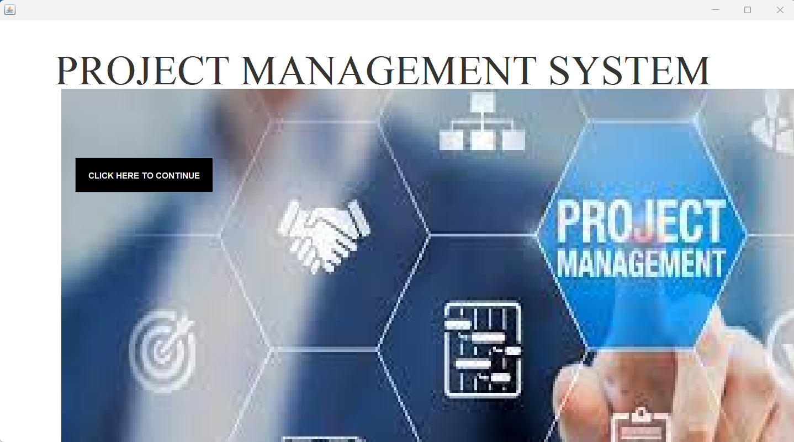Splash – This is the very first page.

2. Login frame – This is the login frame of this system where user have to enter the required credentials to have access for the main dashboard.

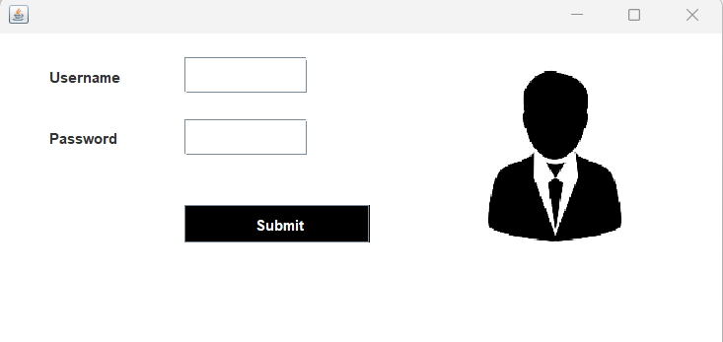

3. Main Dashboard – After login in, user is directed to the main dashboard of this system where user can perform various operations like adding a task, deleting a task is performed.

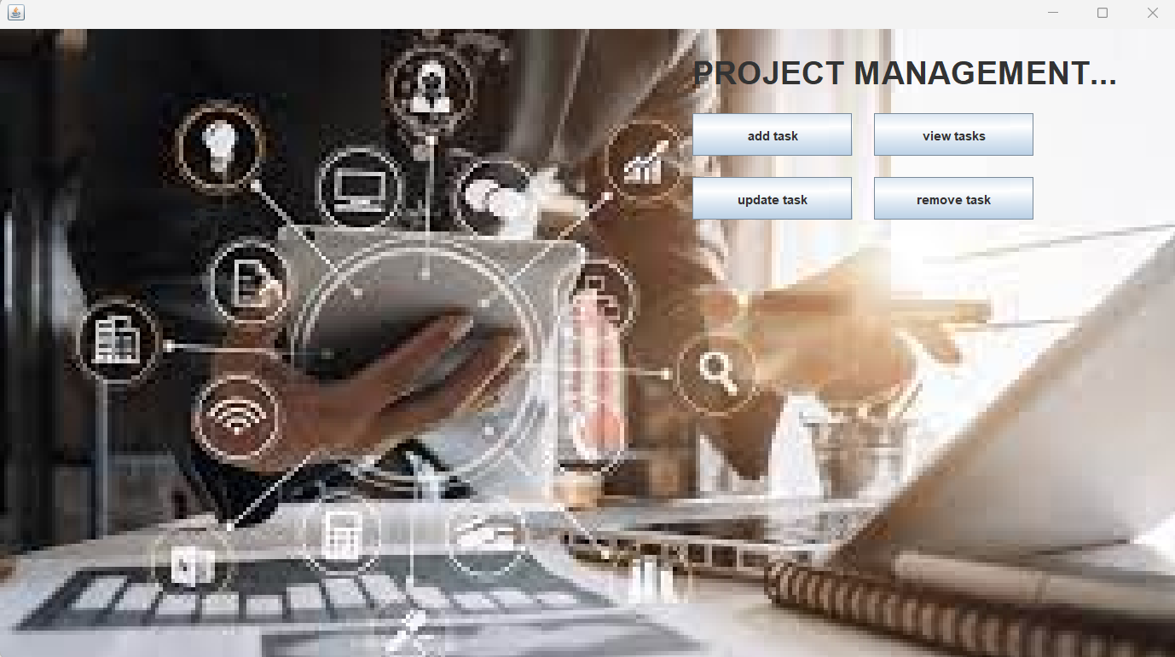

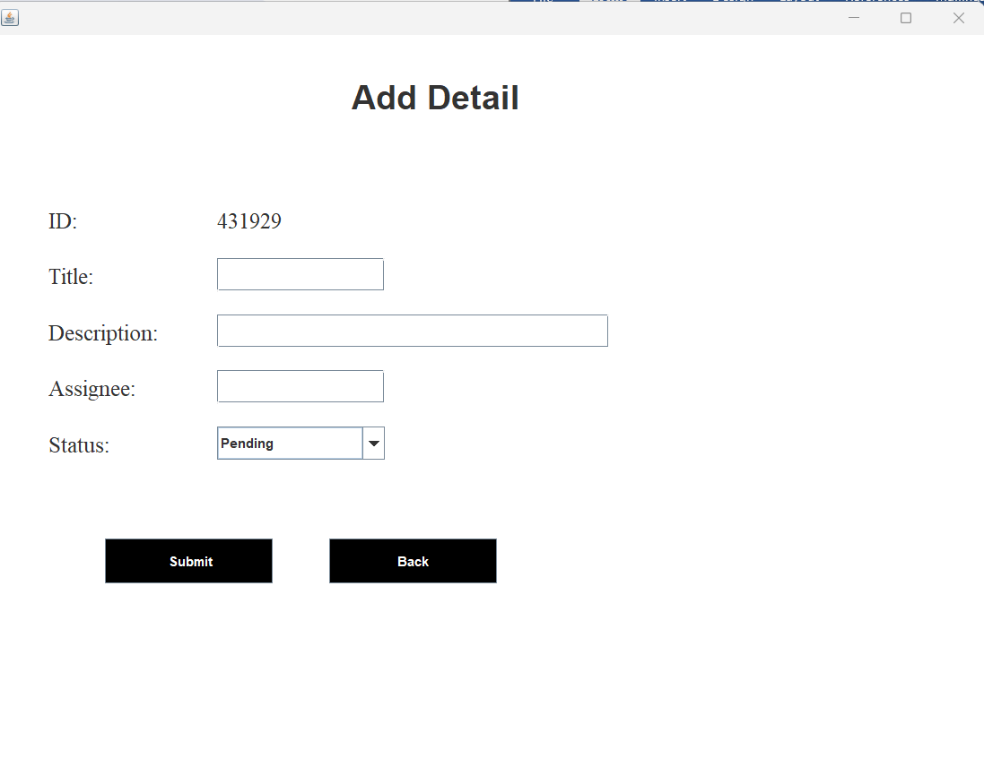4. Add task – Here user have to enter all the required credentials to add a new employee to the system.

5. View and update employee – In order to view and update task information, the user have to enter project ID.

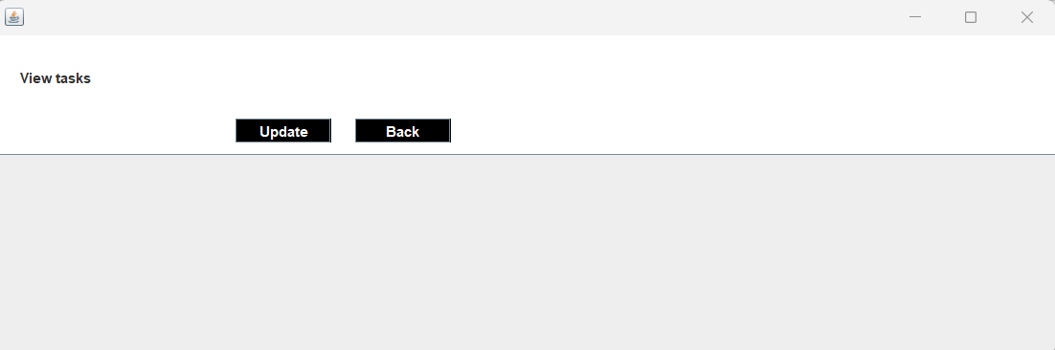

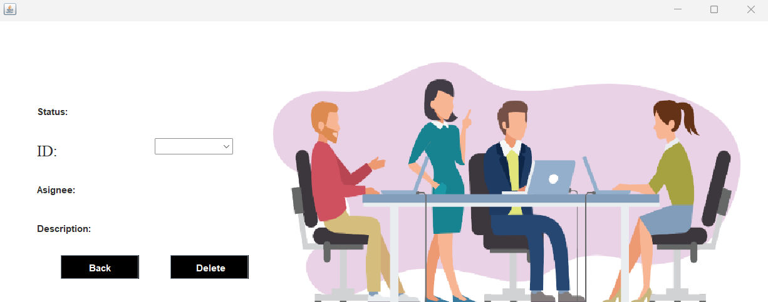6. Remove employee – User has to enter the project id in order to delete his information from the system.

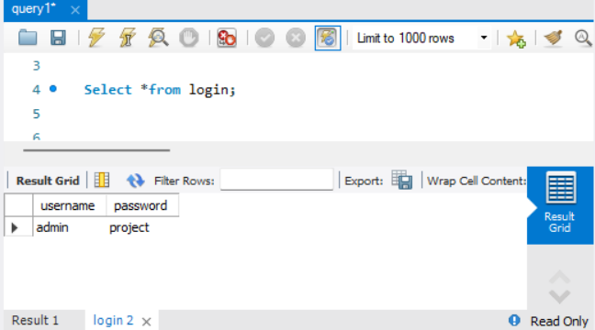7. Database – MYSQL Workbench is used to store data, to where the add task store data and the store data can be used for validation, view, update and deleting purpose.

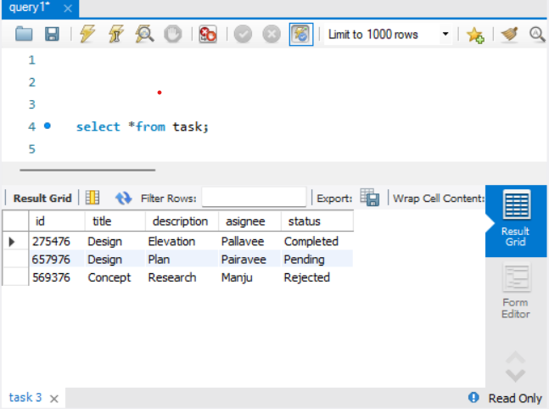

TESTING

|  |  |  |  |  |  |
| --- | --- | --- | --- | --- | --- |
| Test ID | Test-Purpose | Test-Condition | Expected-Output | Output | Remark |
| TC1 | Check Username & Password | If user details are not correct, display error message | Grant access to main dashboard. | Access granted to main dashboard | Test successful |
| TC2 | To add new user to the system | If user already exists, error message should be displayed. | New user should be added. | New user added successfully | Test successful |
| TC3 | To view existing task information | If task exists, then information should be displayed, else error message should be displayed. | Information should be displayed. | Information displayed. | Test successful |
| TC4 | To remove an task | If task exists, then Task should be removed else error message should be displayed. | Information should be remove. | Information removed successfully. | Test successful |
| TC5 | To update an task | If task exists, then Task should be updated else error message should be displayed. | Information should be updated. | Information update successfully | Test successful |

CONCLUSION

The goal of the initiative is to digitize personnel databases in businesses and provide administrators access to computers. Employees and administrators use software as an information system. The user can store his or her database safe and secure for an indefinite amount of time here. Adding, deleting, accessing, and changing project information is simple and easy using the Project Management System.

References

1. Code for Interview YouTube Channel (https://www.youtube.com/playlist?list=PL5BFcXE899zxVrWaO3Ul6ly2SVJMnJFOr)

2. Online Bank Account Management System

Website: http://www.slideshare.net (Collect some info for report documents)

3. Learning MYSQL, JavaScript, jQuery, PHP, HTML, CSS3,

Website: http://www.w3schools.com