Wago

User's Manual

Rev 0.3

Revision Sheet

Release No. | Date | Revision Description | Author
0.1 | 05/09/13 | Initial draft document. | Pawel Kowaliszyn
0.2 | 25/10/13 | Added machine state, spellcheck | Pawel Kowaliszyn
0.3 | 03/12/13 | Document Formatting | Pawel Kowaliszyn
0.4 | 16/12/13 | Added default module catalog | Pawel Kowaliszyn

Table of Contents
1.0 General Information 4
1.1 System overview 4
2.0 Build process 4
3.0 Configuration 4
3.1 Overview 4
3.2 Class property 5
3.3 Server instance properties 5
4.0 Run time 7
Appendix 1 8

1.0 General Information

1.1 System overview
Wago class is a tango interface for Wago 750 series controllers and couplers. It represents the device in tango control environment. Wago server communicates with hardware through Modbus device server. Physical Wago device consist of two basic elements controller/coupler and attached input/output modules. Because of variety of possible hardware configurations server is also configurable. Equivalent of I/O module within server is Logical Device. Wago server aggregates Logical Devices which are represented in tango control environment as dynamic attributes. Each logical device consist of logical channels(equivalents of physical module channels). If logical device has only one channel ts represented as scalar attribute, if more then its represented as spectrum attribute.

2.0 Build process
Wago server can be built as standalone server or with the Modbus device server integrated. When using standalone server user must start another process of Modbus device server and point reference to it in property.
To build standalone server go to projects SRC directory and type make. Compiled binary can be found under src/bin/<os_type>/
To build binary with Modbus device server integrated some adjustments must be done first. Work directory for integrated build is under src/Multiclass. It is necessary to edit makefile and set following variables:
- MODBUS_HOME variable pointing to directory where the source of Modbus device server is stored, and
- SERIAL_HOME should point to directory where sources of SeriallLine tango server are stored.
To build server type make. Compiled binary can be found under src/MultiClass/bin/<os_type>/.

3.0 Configuration

3.1 Overview
Wago device server needs to be configured to work. Configuration consists of two parts. Class property. called modulesCatalogue. Which describes all available physical modules which may be used with Wago device. This property is used for all instances of Wago server within the control system. It is created only once when registering first instance of Wago server.

3.2 Class property
First step is to create Wago class property called modulesCatalogue.
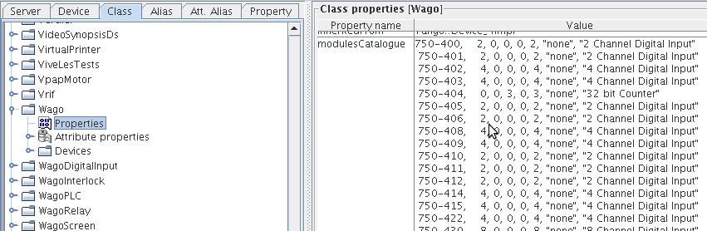Illustration 1: Wago server class property

This property is a list of known modules with parameters. It has following syntax: for each module, you must supply:
- module reference code
- number of digital inputs
- number of digital outputs
- number of word inputs
- number of word outputs
- number of logical channels (typically SSI32bits==2 words)
- -string for special module ("none","ssi","thc","thck",etc)
- -string for description
Example module catalog is attached in Appendix 1.

3.3 Server instance properties
Following server instance properties must be filled in tango server database.
- Config
- modbusDevName

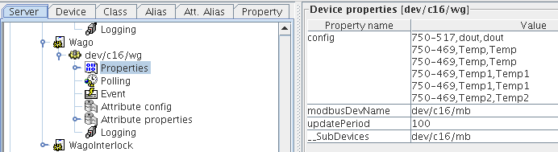Illustration 2: Wago server sample configuration

Attribute config has following syntax:

{Module code}, { name of logical channel 1}, { name of logical channel 2}, ….

Logical channels are representation for Input/Output channels in module. Logical channels names are also name for attributes representing values. For example:

750-469,Temp1,Temp2

This input will result in creation of two attributes in server representing channels of module named Temp1 and Temp2.
If the same name of logical channel appears more than once it will result in creation of vector attribute aggregating values marked by names. For example:

750-469,Temp, Temp
750-469,Temp, Temp

This configuration will result in creation of vector attribute Temp with 4 values, representing inputs of both modules.
Number Of names shall be less or equal to number of channels in module. Syntax allows omitting channels. For example:

750-469,, Temp

This will result in creation of one attribute Temp representing second channel of 469 module.

sModbusDevName is an attributes which indicates Modbus server which is an gateway for this server to a Wago box.

UpdatePeriod is additional parameter setting update period of internal cache (in ms). Default value is 1000ms

4.0 Run time
Wago server has three possible states:
- INIT
- FAULT
- RUNNING
Possible state transitions are shown in following diagram. If state is Fault additional information about last exception are added to status string.

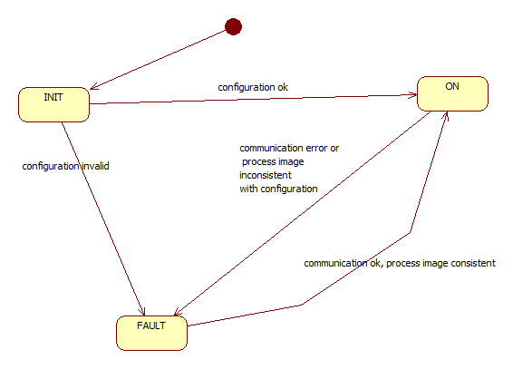Illustration 3: possible state transitions of server during run time

Appendix 1
In following appendix you can find sample moduleCatalogue.

750-400, 2, 0, 0, 0, 2, "none", "2 Channel Digital Input"
750-401, 2, 0, 0, 0, 2, "none", "2 Channel Digital Input"
750-402, 4, 0, 0, 0, 4, "none", "4 Channel Digital Input"
750-403, 4, 0, 0, 0, 4, "none", "4 Channel Digital Input"
750-404, 0, 0, 3, 0, 3, "none", "32 bit Counter"
750-405, 2, 0, 0, 0, 2, "none", "2 Channel Digital Input"
750-406, 2, 0, 0, 0, 2, "none", "2 Channel Digital Input"
750-408, 4, 0, 0, 0, 4, "none", "4 Channel Digital Input"
750-409, 4, 0, 0, 0, 4, "none", "4 Channel Digital Input"
750-410, 2, 0, 0, 0, 2, "none", "2 Channel Digital Input"
750-411, 2, 0, 0, 0, 2, "none", "2 Channel Digital Input"
750-412, 2, 0, 0, 0, 2, "none", "2 Channel Digital Input"
750-414, 4, 0, 0, 0, 4, "none", "4 Channel Digital Input"
750-415, 4, 0, 0, 0, 4, "none", "4 Channel Digital Input"
750-422, 4, 0, 0, 0, 4, "none", "4 Channel Digital Input"
750-430, 8, 0, 0, 0, 8, "none", "8 Channel Digital Input"
750-436, 8, 0, 0, 0, 8, "none", "8 Channel Digital Input"
750-485, 0, 0, 2, 0, 2, "fs4-20_13", "2 Channel 4/20mA Input"
750-501, 0, 2, 0, 0, 2, "none", "2 Channel Digital Output"
750-502, 0, 2, 0, 0, 2, "none", "2 Channel Digital Output"
750-504, 0, 4, 0, 0, 4, "none", "4 Channel Digital Output"
750-506, 4, 4, 0, 0, 4, "none", "2 Channel Digital Output"
750-507, 2, 2, 0, 0, 2, "none", "2 Channel Digital Output"
750-508, 2, 2, 0, 0, 2, "none", "2 Channel Digital Output"
750-509, 0, 2, 0, 0, 2, "none", "2 Channel Digital Output"
750-512, 0, 2, 0, 0, 2, "none", "2 Normally Open Relay Output"
750-513, 0, 2, 0, 0, 2, "none", "2 Normally Open Relay Output"
750-514, 0, 2, 0, 0, 2, "none", "2 Changeover Relay Output"
750-516, 0, 4, 0, 0, 4, "none", "4 Channel Digital Output"
750-517, 0, 2, 0, 0, 2, "none", "2 Changeover Relay Output"
750-519, 0, 4, 0, 0, 4, "none", "4 Channel Digital Output"
750-530, 0, 8, 0, 0, 8, "none", "8 Channel Digital Output"
750-531, 0, 4, 0, 0, 4, "none", "4 Channel Digital Output"
750-536, 0, 8, 0, 0, 8, "none", "8 Channel Digital Output"
750-452, 0, 0, 2, 0, 2, "fs20_13", "2 Channel 0/20mA Input"
750-454, 0, 0, 2, 0, 2, "fs4-20_13", "2 Channel 4/20mA Input"
750-456, 0, 0, 2, 0, 2, "fs10_13", "2 Channel +-10V Differential Input"
750-457, 0, 0, 4, 0, 4, "fs10_13", "4 Channel +-10V Input"
750-461, 0, 0, 2, 0, 2, "thc", "2 Channel PT100 Input"
750-462, 0, 0, 2, 0, 2, "thc", "2 Channel Thermocouple Input"
750-465, 0, 0, 2, 0, 2, "fs20_13", "2 Channel 0/20mA Input"
750-466, 0, 0, 2, 0, 2, "fs4-20_13", "2 Channel 4/20mA Input"
750-467, 0, 0, 2, 0, 2, "fs10_13", "2 Channel 0/10V Input"
750-468, 0, 0, 4, 0, 4, "fs10_13", "4 Channel 0/10V Input"
750-469, 0, 0, 2, 0, 2, "thc", "2 Channel Ktype Thermocouple Input"
750-472, 0, 0, 2, 0, 2, "fs20", "2 Channel 0/20mA 16bit Input"
750-474, 0, 0, 2, 0, 2, "fs4-20", "2 Channel 4/20mA 16bit Input"
750-476, 0, 0, 2, 0, 2, "fs10", "2 Channel +-10V Input"
750-477, 0, 0, 2, 0, 2, "fs20", "2 Channel 0/10V Differential Input"
750-478, 0, 0, 2, 0, 2, "fs10", "2 Channel 0/10V Input"
750-479, 0, 0, 2, 0, 2, "fs10_14", "2 Channel +-10V Input"
750-492, 0, 0, 2, 0, 2, "fs4-20_13", "2 Channel 4/20mA Differential Input"
750-550, 0, 0, 0, 2, 2, "fs10", "2 Channel 0/10V Output"
750-552, 0, 0, 0, 2, 2, "fs20", "2 Channel 0/20mA Output"
750-554, 0, 0, 0, 2, 2, "fs4-20", "2 Channel 4/20mA Output"
750-556, 0, 0, 0, 2, 2, "fs10", "2 Channel +-10V Output"
750-557, 0, 0, 0, 4, 4, "fs10", "4 Channel +-10V Output"
750-562-UP, 0, 0, 0, 2, 2, "fs10", "2 Channel 0/ 10V 16bit Output"
750-562, 0, 0, 0, 2, 2, "fs10", "2 Channel +-10V 16bit Output"
750-630, 0, 0, 2, 0, 1, "ssi24","24 bit SSI encoder"
750-630-24, 0, 0, 2, 0, 1, "ssi24","24 bit SSI encoder"
750-630-32, 0, 0, 2, 0, 1, "ssi32","32 bit SSI encoder"
750-637, 0, 0, 4, 4, 2, "637", "32 bit Incremental encoder"
750-653, 0, 0, 2, 2, 1, "653", "RS485 Serial Interface"
750-1417, 8, 0, 0, 0, 8, "none", "8 Channel Digital Input"
750-1515, 0, 8, 0, 0, 8, "none", "8 Channel Digital Output"
750-459, 0, 0, 4, 0, 4, "fs10_13", "4 Channel Channel 0/10V Input"

