WagoInterlock

User's Manual

Rev 0.1

Revision Sheet

Release No. | Date | Revision Description | Author
0.1 | 12/10/13 | Initial draft document | Pawel Kowaliszyn

Table of Contents
1.0 General Information 4
1.1 System overview 4
2.0 Build process 5
3.0 Configuration 5
3.1 Overview 5
3.2 Server instance properties 5
4.0 Run time 7

1.0 General Information

1.1 System overview
WagoInterlock is device server for interfacing Wago 750 controller series based interlocks to tango control system. The whole tango solution consists of three device servers.
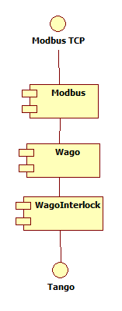Illustration 1: Interlock server stack

Modbus – server responsible for handling Modbus protocol communication.
Wago – Represnts the Wago device in the control system. Provides access to process image and ISG protocol.
WagoInterlock – Represents the interlock instance within Wago wago controller.

The actual Interlock is defined within the software running on Wago controller. It is identified by name and id number. It may have multiple digital or analog inputs and one digital output. Interlock is described by configuration which defines inputs used for triggering, trigger thresholds and output of the interlock. One Wago box can handle multiple interlock instances.

2.0 Build process
Interlock device server can be built as standalone server or with the Wago and Modbus device server integrated. When using standalone interlock device server user must start separate Wago device server and point reference to it in property.
To build standalone server go to projects SRC directory and type make. Compiled binary can be found under src/bin/<os_type>/
To build binary with Wago and Modbus device servers integrated some adjustments must be done first. Work directory for integrated build is under src/Multiclass. It is necessary to edit Makefile and set following variables:
- MODBUS_HOME variable pointing to directory where the source of Modbus device server is stored.
- WAGO_HOME variable needs to point to directory where Wago device server source is stored.
- SERIAL_HOME needs to point where SerialLine device server sources are stored.
To build server type make. Compiled binary can be found under src/MultiClass/bin/<os_type>/.

3.0 Configuration

3.1 Overview
The server stack needs to be set up for proper work. Interlock server setup is explained in this part. For Wago device server configuration description check Wago User's manual document.
As mentioned before actual interlock is defined within software running in Wago Box. Server is capable of handling interlock existing in Wago device, identified by it's name. Server can also create a new instance of interlock within Wago device with given name and configuration. Configuration of interlock must be consistent with inerlock instance with given name existing in Wago device, otherwise server will stay in FAULT state.

3.2 Server instance properties'
To configure WagoInterlock server following server attributes must be filled.

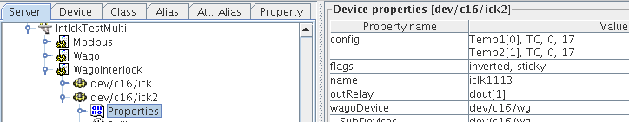Illustration 2: Wago server class property.

Property name is a name of interlock instance in Wago device. This is the element witch software uses to recognize interlock belonging to this device server.

outRelay is a name of related attribute of Wago server which serves as a digital output of the interlock. The related Wago device channel must be digital output.
Property config describes input channels of the interlock. It has following syntax:
<chan1> <type> [<min> <max>] {<chflag> ... }
<chan2> <type> [<min> <max>] {<chflag> ... }
...
<chanN> <type> [<min> <max>] {<chflag> ... }

<chanX> – is a name of attribute in wago server representing corresponding channel. Channel syntax allows scalar attributes and vector attributes for example Temp1[2] means second element of Temp1 vector attribute. Temp[0:2] would mean three input channels connected to three first elements of vector attribute Temp.
<type> Channel types supported: IB(Binary Input), OB (Binary Output), IW (Word Input), OW (Word Output), TC (ThermoCouple), IV (Voltage Input), OV (Voltage Output)
<min> <max> values are required for word (analog) values, This values are low and high boundaries for input values outside which interlock will be triggered.
<chflag> Channel flags: inverted, sticky.Inverted is used only for binary channels, value of input is inverted before further processing. Sticky means that interlock stays in alarm state even if values of inputs return back below alarm levels.

Example:
lightin OB inverted # output driving the pneumatics
fldin OB inverted # fluo detector pneumatics
flsw[1] IB
supply,IV,4,6 #5V power supply monitor

Property flags holds the interlock configuration flags. Supported flag values are:
- digital
- output
- unsigned
- sticky
- inverted
- disabled
- noforce
Multiple values are allowed separated with ",".
Property wagoDevice is an name of Wago tango server which this server shall use to access Wago box.

4.0 Run time
The task of this class is to interface Wago ISG interlock into Tango control environment. Communication with Wago hardware is done via Wago server (drawing 1) with use of ISG protocol. After start interlock server downloads the list of existing interlocks within Wago controller device. Next step is finding the instance with the same name as one given in server property. Next step is comparison of configuration given in property and parameters of interlock stored inside Wago device. If configurations are coherent sever goes to ON state and continues monitoring status of this interlock instance. If configurations are not coherent sever stays in FAULT state.
If interlock configured in server does not exist inside Wago box or configurations are not coherent. User may use UpdateConfig command to create instance and configure it as its described in properties. UpdateConfig procedure first checks if interlock instance with name given by property already exist inside Wago box. If it is found it will be deleted, and after that new instance is created

WagoInterlock has following possible states:
- ON
- FAULT
- ALARM
- UNKNOWN

Possible state transitions are shown in following drawing. In case of Fault state additional error information are added to Status string.

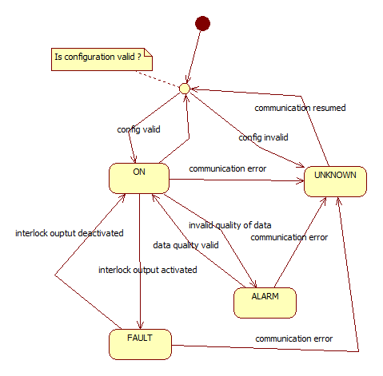Illustration 3: possible sever state transitions during run time

