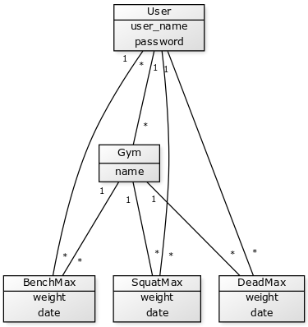

Sovelluksen tietokantakaavio

[User|user_name; password], [Gym| name], [DeadMax| weight; date], [SquatMax| weight; date], [BenchMax| weight; date], [User]1-*[DeadMax], [User]1-*[SquatMax], [User]1-*[BenchMax], [User]*-*[Gym], [Gym]1-*[DeadMax], [Gym]1-*[SquatMax], [Gym]1-*[BenchMax]

