DESIGN AND IMPLEMENTATION SMART BANDAGE TECHNOLOGY FOR WOUND MONITORING

DIDAN DANA RAFIQ

UNIVERSITI TEKNOLOGI MALAYSIA

PSZ 19:16 (Pind. 1/13)

UNIVERSITI TEKNOLOGI MALAYSIA

DECLARATION OF THESIS / UNDERGRADUATE PROJECT REPORT AND COPYRIGHT

Author’s full name :

Date of Birth :

Title :

Academic Session :

I declare that this thesis is classified as:

|  |  |  |
| --- | --- | --- |
|  | CONFIDENTIAL | (Contains confidential information under the Official Secret Act 1972)* |
|  |  |  |
|  | RESTRICTED | (Contains restricted information as specified by the organization where research was done)* |
|  |  |  |
| ✓ | OPEN ACCESS | I agree that my thesis to be published as online open access (full text) |

1. I acknowledged that Universiti Teknologi Malaysia reserves the right as follows:
2. The thesis is the property of Universiti Teknologi Malaysia
3. The Library of Universiti Teknologi Malaysia has the right to make copies for the purpose of research only.
4. The Library has the right to make copies of the thesis for academic exchange.

|  |  |  |  |  |
| --- | --- | --- | --- | --- |
|  |  |  | Certified by: Mr. Ako Abubakir Jaafer |  |
|  |  |  |  |  |
|  |  |  |  |  |
|  |  |  |  |  |
|  | SIGNATURE OF STUDENT |  | SIGNATURE OF SUPERVISOR |  |
|  |  |  |  |  |
|  | QU201SEBB006 |  | Mr. Ako Abubakir Jaafer |  |
|  | **MATRIC NUMBER** |  | **NAME OF SUPERVISOR** |  |
|  |  |  |  |  |
|  | Date: 20th JANUARY 2024 |  | Date: 20th JANUARY 2024 |  |

NOTES : If the thesis is CONFIDENTIAL or RESTRICTED, please attach with the letter from the organization with period and reasons for confidentiality or restriction

“I hereby declare that we have read this thesis and in my

opinion this thesis is sufficient in term of scope and quality for the

award of the degree of Bachelor of Biomedical Engineering.”

|  |  |  |
| --- | --- | --- |
| Signature | : | ________________________________ |
| Name of Supervisor I | : | Mr. Ako Abubakir Jaafer |
| Date | : | 22 January 2024 |
|  |  |  |
|  |  |  |

DESIGN AND IMPLEMENTATION SMART BANDAGE TECHNOLOGY FOR WOUND MONITORING

DIDAN DANA RAFIQ

A thesis submitted in fulfilment of the

requirements for the award of the degree of

Bachelor of Biomedical engineering

School of Biomedical Engineering and Health Sciences

Faculty of Engineering

Universiti Teknologi Malaysia

JANUARY 2024

DECLARATION

I declare that this thesis entitled *“DESIGN AND IMPLEMENTATION SMART BANDAGE TECHNOLOGY FOR WOUND MONITORING”* is the result of my own research except as cited in the references. The proposal has not been accepted for any degree and is not concurrently submitted in candidature of any other degree.

|  |  |  |
| --- | --- | --- |
| Signature | : | .................................................... |
| Name | : | DIDAN DANA RAFIQ |
| Date | : | 20 January 2024 |
|  |  |  |
|  |  |  |

DEDICATION

This thesis is dedicated to my father, who taught me that the best kind of knowledge to have is that which is learned for its own sake. It is also dedicated to my mother, who taught me that even the largest task can be accomplished if it is done one step at a time.

ACKNOWLEDGEMENT

In preparing this thesis, I was in contact with many people, researchers, academicians, and practitioners. They have contributed towards my understanding and thoughts. In particular, I wish to express my sincere appreciation to my main thesis supervisor, Mr. Ako Abubakir Jaafer, for encouragement, guidance, critics and friendship. I am also very thankful to my head of department Dr. Dyari Hassan for their guidance, and advices. Without their continued support and interest, this thesis would not have been the same as presented here.

My fellow postgraduate student should also be recognised for their support. My sincere appreciation also extends to all my colleagues and others who have provided assistance at various occasions. Their views and tips are useful indeed. Unfortunately, it is not possible to list all of them in this limited space. I am grateful to all my family member.

ABSTRACT

The purpose of this study is to investigate the application of genetic algorithm (GA) in modelling linear and non-linear dynamic systems and develop an alternative model structure selection algorithm based on GA. Orthogonal least square (OLS), a gradient descent method was used as the benchmark for the proposed algorithm. A model structure selection based on modified genetic algorithm (MGA) has been proposed in this study to reduce problems of premature convergence in simple GA (SGA). The effect of different combinations of MGA operators on the performance of the developed model was studied and the effectiveness and shortcomings of MGA were highlighted. Results were compared between SGA, MGA and benchmark OLS method. It was discovered that with similar number of dynamic terms, in most cases, MGA performs better than SGA in terms of exploring potential solution and outperformed the OLS algorithm in terms of selected number of terms and predictive accuracy. In addition, the use of local search with MGA for fine-tuning the algorithm was also proposed and investigated, named as memetic algorithm (MA). Simulation results demonstrated that in most cases, MA is able to produce an adequate and parsimonious model that can satisfy the model validation tests with significant advantages over OLS, SGA and MGA methods. Furthermore, the case studies on identification of multivariable systems based on real experiment t al data from two systems namely a turbo alternator and a continuous stirred tank reactor showed that the proposed algorithm could be used as an alternative to adequately identify adequate and parsimonious models for those systems. Abstract must be bilingual. For a thesis written in Bahasa Melayu, the abstract must first be written in Bahasa Melayu and followed by the English translation. If the thesis is written in English, the abstract must be written in English and followed by the translation in Bahasa Melayu. The abstract should be brief, written in one paragraph and not exceed one (1) page. An abstract is different from synopsis or summary of a thesis. It should states the field of study, problem definition, methodology adopted, research process, results obtained and conclusion of the research. The abstract can be written using single or one and a half spacing. Example can be seen in Appendix 1 (Bahasa Melayu) and Appendix J (English).

ABSTRAK

Kajian ini dilakukan bertujuan mengkaji penggunaan algoritma genetik (GA)

dalam pemodelan sistem dinamik linear dan tak linear dan membangunkan kaedah alternatif bagi pcmilihan struktur model menggunakan GA. Algorithma kuasa dua terkecil ortogon (OLS), satu kaedah penurunan kecerunan digunakan sebagai bandingan bagi kaedah yang dicadangkan. Pcmilihan struktur model mengunakan kaedah algoritma genetik yang diubahsuai (MGA) dicadangkan dalam kajian ini bagi

mengurangkan masalah konvergens pramatang dalam algoritma genetik mudah (SGA). Kesan penggunaan gabungan operator MGA yang berbeza ke atas prestasi model yang terbentuk dikaji dan keberkesanan serta kekurangan MGA diu t arakan. Kajian simulasi dilakukan untuk membanding SGA, MGA dan OLS. Dengan meggunakan bilangan parametcr dinamik yang setara kajian ini mendapati, dalam kebanyakan kes, prestasi MGA adalah lebih baik daripada SGA dalam mencari penyelesaian yang berpotensi dan lebih berkebolehan daripada OLS dalam menentukan bilangan sebutan yang dipilih dan ketcpatan ramalan. Di samping itu, penggunaan carian tcmpatan dalam MGA untuk menambah baik algorithma tersebut dicadang dan dikaji, dinamai sebagai algoritma mcmetic (MA). Hasil simulasi menunjukkan, dalam kebanyakan kes, MA berkeupayaan menghasilkan model yang bersesuaian dan parsimoni dan mcmenuhi ujian pengsahihan model di samping mcmperolehi beberapa kelebihan dibandingkan dengan kaedah OLS, SGA dan MGA. Tambahan pula, kajian kes untuk sistcm berbilang pcmbolehubah menggunakan data eksperimental sebenar daripada dua sistem iaitu sistem pengulang-alik turbo dan reaktor teraduk berterusan menunjukkan algoritma ini boleh digunakan sebagai alternatif untuk mcmperolehi model termudah yang memadai bagi sistcm tersebut.

TABLE OF CONTENTS

|  |  |  |
| --- | --- | --- |
|  | TITLE | PAGE |

DECLARATION ii

DEDICATION iii

ACKNOWLEDGEMENT iv

ABSTRACT v

ABSTRAK vi

TABLE OF CONTENTS vii

LIST OF TABLES ix

LIST OF FIGURES x

LIST OF ABBREVIATIONS xi

CHAPTER 1 INTRODUCTION 1

1.1 Problem Background 1

1.2 Problem Statement 2

1.3 Problem Statement 2

1.4 Research Goal 2

1.4.1 Research Objectives 2

1.5 Captions 3

1.6 Quotation 4

1.7 Equation 4

CHAPTER 2 LITERATURE REVIEW 7

2.1 Introduction 7

2.1.1 State-of-the-Arts 8

2.2 Limitation 8

2.3 Research Gap 8

CHAPTER 3 RESEARCH METHODOLOGY 11

3.1 Introduction 11

3.1.1 Proposed Method 11

3.1.1.1 Research Activities 11

3.2 Tools and Platforms 12

3.3 Chapter Summary 12

CHAPTER 4 PROPOSED WORK 13

4.1 The Big Picture 13

4.2 Analytical Proofs 13

4.3 Result and Discussion 13

4.4 Chapter Summary 13

CHAPTER 5 CONCLUSION AND RECOMMENDATIONS 15

5.1 Research Outcomes 15

5.2 Contributions to Knowledge 15

5.3 Future Works 15

REFERENCES 17

LIST OF PUBLICATIONS 22

LIST OF TABLES

|  |  |  |
| --- | --- | --- |
| TABLE NO. | TITLE | PAGE |

Table ‎1.1 The role of statistical quality engineering tools and methodologies 4

Table ‎1.2 Basic ANN models used for control chart pattern recognition 4

Table ‎2.1 Regression analysis for the results of preliminary feature screening 7

Table ‎2.2 Estimated effects and regression coefficients for the recogniser's performance (reduced model) 7

Table ‎5.1 Example Repeated Header Table 15

LIST OF FIGURES

|  |  |  |
| --- | --- | --- |
| FIGURE NO. | TITLE | PAGE |

Figure ‎1.1 Trends leading to the problem using MZJ Formatting Method 3

Figure ‎1.2 Design and development phases of the proposed scheme (Muhamad, 2018) 3

Figure ‎2.1 Continuous variability reduction using SPC chart (Revelle and Harrington, 1992) 7

Figure ‎2.2 Typical fully developed patterns on Shewhart control chart (Cheng, 1989) 7

Figure ‎3.1 Example of Formatting Method 12

Figure ‎4.1 This is MZJ original idea 13

Figure ‎4.2 The method for hig performance formatting 14

# INTRODUCTION

## Problem Background

Modern healthcare has sought innovation and made great strides in medical technology. For a long time, an innovative solution for wound care management has been missing. "Healthcare-associated wound infections are a complicated issue that has a significant impact on patient morbidity and cost implications for healthcare organizations. The growing interest in cutting-edge infection prevention techniques and diagnosis methods has resulted in exploring the subject through the study" (The Development of Smart-Bandage Technologies - ProQuest, n.d.). Effective patient management is important for smooth communication and cooperation among healthcare providers in dynamic healthcare.

Nonetheless, traditional patient identification and data capturing methods include paper charts and pen recording, which could be faster. Besides, healthcare systems are getting more complex, and personalized types of care lead to other problems around improving workflows toward optimal patient outcomes. Major problems include correct identification of patients, people on the staff, and people visiting the health care institutions. It is essential to ensure that appropriate assistance reaches the correct people and avoid situations like drug errors, misdiagnosis, and bad results, amongst other scenarios. In addition, if there are no effective communication avenues between healthcare providers within a setting, it could lead to delays in treatment, misdiagnosis, and poor coordination of treatment services. There is a high demand for a more sophisticated system that would overcome the identified deficiencies of traditional identification techniques and enhance hospital communication and data management services. Here, that's why there's a "smart badge."

It is a kind of wearable a badge with wireless communication and modern technologies such as biosensors, NFC, and a radio frequency identification system. Technology that can provide real time vital sign monitoring, relevant and dynamic IDs, and EHR interoperability may revolutionize the healthcare industry. Smart badges can provide relevant information about a patient at the time of his admission in order to enhance patient safety, decision-making of doctors and nurses and quality of health care. Second, a smart bandage can also monitor wound recovery status by assessing the changing wound environment in different stages of healing. In this case, removing the bandages would not be necessary and would therefore eliminate the possibility of irritation of the wound. Moreover, this could allow the nurses and caregiver to work efficiently by decreasing the amount of time spent with one patient.

## Problem Statement

Despite the common use of traditional dressings, they have many limitations that prevent the effective wound management. However, one major disadvantage of hydrogels is that they are very unaccommodating to the various wound geometries and sizes. Consequently, the use of one-size-fits-all often produces poor conformability to the irregular wound surfaces resulting in inadequate coverage and also impaired healing. This disadvantage is especially observable in the complicated types of injuries or those that have contours differences.

In addition, conventional dressings can unintentionally impede the wound granulation as they lead to the formation of a damp environment suitable for bacterial colonization. However, some bandage materials are impermeable to the moisture and in this case forms favorable conditions for the growth of the infection causing microorganisms. This problem is even further aggravated in the case of bandages that require constant replacement since they distort the wound’s natural healing process and lead to an increased risk for many complications." (Levin et al., 2023).

These issues can only be handled by designing innovative bandages that focus on the adaptability, encourage optimal environments for healing, and incorporate active therapeutic components. Modern materials and technologies like smart textiles or bioactive coatings provide great possibilities to address the main drawbacks of the regular bandages. All these improvements are intended to change the field of wound treatment by increasing its effectiveness, minimizing the infection risks, and ensuring patient comfort in the course of recovery. The prospect of wound care is that it continues to develop, and as the researchers and healthcare providers delve into these breakthroughs, there are even better solutions for the patients. Therefor this project report attempts to answer these questions:

1. How the problem of traditional bandage can be solved by using smart bandages.
2. How smart bandage can be design and implemented.
3. How smart bandage can be tested and compared with traditional bandage.

## Research Objectives

1. To Study and investigate smart bandages and sensor device integration for personalized treatment.

2. To design and implement a smart bandage and smart bandage system.

3. To evaluate and compare the smart bandage with the traditional bandage.

## Scope of Research

Smart bandages have evolved as a promising option in wound care, providing continuous monitoring, personalized therapy, and enhanced patient interaction through advanced sensing technologies. The purpose of considering this issue is to determine the complexity of smart bandages. In particular, this matter focuses on the ability of these bandages for monitoring wound conditions, incorporation of modern materials, and promoting patient self-care. The inquiry seeks to dig deeper into such perspectives so as to enrich wound management practices as well as enhance understanding of the outcomes.

## Significance of Research

Use of smart bandages shows that the wound care field has made one of the latest developments that offers numerous advantages and answers to some difficulties met when using traditional wound care. It is important in terms of making improvements on wound care and patient outcomes as well as to the management in the healthcare division, patients, and caregivers’ because it looks into the fundamental issues and offers new techniques on improving general quality of care with wound.

The importance of this study lies in the potential of smart bandages to revolutionize the checking of wound conditions in real time. These bandages facilitate early mediation, minimizing complications and assisting the recuperating process by enabling persistent following crucial pointers such as disease, aggravation, and healing progress.

Overall, the significance of this research lies in its potential to transform the scene of wound care, advancing proactive and personalized approaches that enhance understanding outcomes, improve the effectiveness of healthcare delivery, and enable patients to require an active part in their healing preparation. By shedding light on the multifaceted benefits of smart bandages, this study contributes to advancing patient-centric care and forming the longer term of wound management practices.

# LITERATURE REVIEW

## Introduction

"The purpose of a literature review is to understand the existing research and debates relevant to a particular topic or area of study and to present that knowledge in the form of a written report" (Western Sydney University, 2017). The "Smart Bandage" stands at the crossing point of technological development and healthcare, encapsulating a convergence of remote communication, biosensors, NFC (Near Field Communication), RFID (Radio-Frequency Identification), and other cutting-edge components. This wearable identification holds a gigantic guarantee in revolutionizing the healthcare industry by advertising real-time crucial sign observing, versatile and energetic recognizable proof capabilities, and seamless electronic health record (EHR) interoperability.

In recent past, healthcare industry has faced difficulties to respond to an increasingly complex knowledge-based population. As such, incorporating intelligent and connected systems is necessary for quiet results optimization, resources distribution and relieving healthcare providers. Smart Bandage is a paramount achievement in this technological revolution depicting more holistic patient-oriented care. This is a wearable device that integrates various modern components for purposes of expanding monitoring of patient’s vital signs and establishing a continuous means for communication through digital health system between patients and healthcare providers.

The importance of “Smart Bandage” inside the healthcare cannot be overestimated. It provides a global perspective on silent care through the ability to observe critical signs in real time, with timely intervention for emergencies and early detection of deteriorating health condition. These wireless sensors incorporated in the bandage will also aid physicians to track a wound progression in real time. It will also assist in reducing paperwork by streamlining administrative processes, minimizing duplication of efforts and elevating patient data accuracy. This means more efficient health care service delivery, better understanding of safety, and ultimately better clinical results.

In summation, the "Smart Bandage" speaks to a pivotal progression in healthcare innovation, holding the potential to rethink the scene of understanding care. Through an in-depth investigation of its functionalities, applications, and suggestions, this examination contributes to the progressing talk encompassing this transformative advancement. It underscores its paramount significance for the healthcare industry.

### State-of-the-Arts

During the development stage of your project, it is critical to understand all of the precise aspects associated with your idea, from advantages to disadvantages as well. To get at the ideal design, compare yours to the current ones so that you may profit and develop your project with the fewest issues possible.

At the core of smart bandages are embedded sensors and microelectronics that enable continuous monitoring of crucial physiological parameters. These sensors can detect indicators such as temperature, pH levels, and moisture, providing healthcare professionals with valuable insights into the wound healing process. Smart bandages can be equipped with wireless connectivity, enabling remote monitoring of patients. Healthcare providers can access patient information in real-time, facilitating timely interventions and reducing the need for frequent clinic visits. This feature is particularly beneficial for people with chronic conditions or those who live in remote areas, enhancing access to quality healthcare.

Smart Bandages are really rare in the world, and even rare when it comes to our region, Kurdistan. Smart bandages represent the cutting edge of wound care technology, marking a critical departure from traditional bandages by incorporating progressed features that improve the monitoring and treatment of wounds. At the state-of-the-art level, these intelligent dressings are equipped with cutting-edge sensors, microelectronics, and materials designed to contribute to the healing process effectively.

This section will compare my smart bandage device with three case studies on progressed wound care technologies. The point is to assess the qualities and weaknesses of my device, emphasizing its one-of-a-kind features and identifying potential areas for improvement.

One outstanding difference between smart and traditional bandages is their monitoring capabilities. Traditional bandages basically serve the purpose of providing a protective barrier over wounds, offering limited experience in the healing progression. Smart bandages utilize sensors to continuously monitor key physiological parameters such as temperature, pH, and moisture levels at the wound location. This real-time information enables healthcare professionals to make informed decisions, leading to more personalized and effective treatment techniques. In addition, smart bandages could be more effective than traditional bandages for chronic wounds due to their advanced features and capabilities. For instance, in smart bandages, we have (Real-Time Monitoring, Automated Feedback Systems, and Optimized Healing) The combination of real-time checking and automated feedback contributes to an optimized healing environment for chronic wounds. The capacity to tailor treatment based on the particular needs of the wound can result in progressed results compared to a one-size-fits-all approach with traditional bandages. (Smart Bandages: The Future of Wound Care).

In the second case study, conducted by Mostafalu et al. (2018). a smart bandage was developed with embedded sensors for real-time wound monitoring. While their approach illustrates a commendable advance in remote patient care, my device exceeds expectations by incorporating more sensors, providing a comprehensive overview of the wound environment. In any case, a potential area for enhancement lies in optimizing the data analytics algorithm to guarantee more precise and significant experiences. One limitation of the second Case Study is the limited range of sensors, which may limit the depth of wound data assembled.

In conclusion, although in the previous paragraphs, we talked about some different cases of smart bandages, which might be similar to this project, the thing that makes smart bandages unique is that they are rare. In addition, the one thing that makes this project unique is that we have none of those in our region, Kurdistan, and nobody has attempted to create something like this before. Smart bandages provide real-time monitoring and tracking of PH levels in the wound and offer various benefits for healing wounds and potential well-being issues. The previous cases are prevalent gadgets offering comparative highlights.

Table1: Comparison table of the products

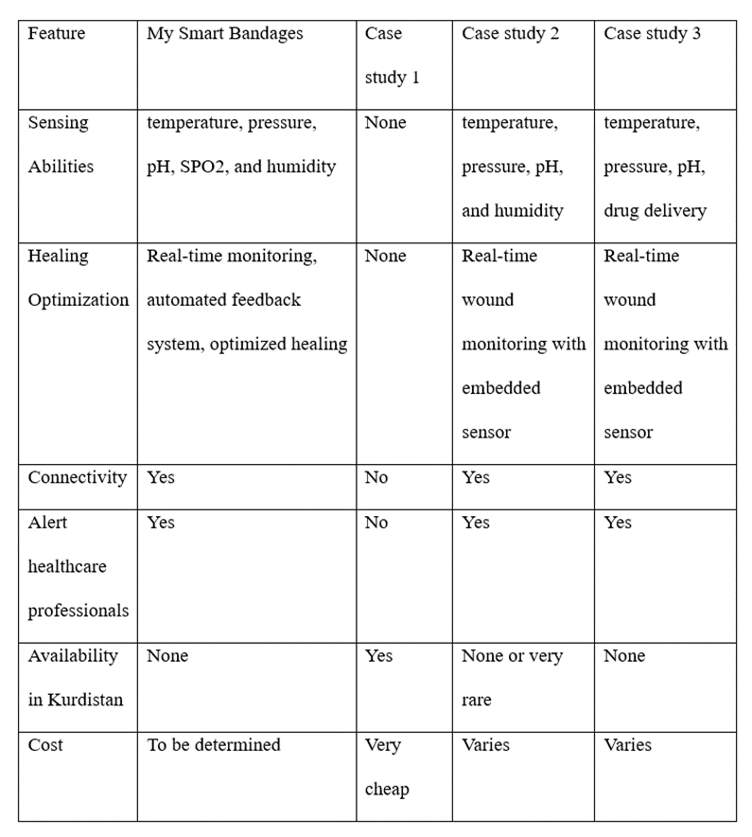

## Research Gap

Wounds, both acute and chronic, pose significant challenges to healthcare, regularly requiring meticulous care for optimal recovery. Chronic wounds, in particular, such as diabetic ulcers or pressure sores, present persistent healing hurdles. Smart bandages represent a groundbreaking solution by consistently merging technology and wound management. These intelligent dressings contain sensors that monitor key parameters like temperature and moisture, providing real-time information to healthcare providers. In chronic wound cases, the nonstop monitoring capability of smart bandages is transformative, permitting for early detection of complications and precise intervention. These high-tech dressings not only improve the healing process by creating an optimal environment but also reduce the burden on healthcare systems by minimizing the need for frequent check-ups. Embracing smart bandages is significant in progressing wound care, ensuring efficient and personalized treatment methodologies for both acute and chronic wounds.

One of the most essential things regarding the creation of a project is knowing and studying the gaps of the study. In recent years, the field of wound care has witnessed a paradigm shift with the appearance of smart bandages, checking a departure from ordinary wound management strategies. Smart bandages, equipped with advanced technologies such as sensors and wireless connectivity, offer real-time monitoring and data-driven experiences in the healing process. This move prompts a critical examination of the existing research gap between smart bandages and traditional bandages.

One critical disadvantage of traditional bandages lies in their passive nature. Once applied, they provide minimal data about the wound's status and cannot contribute to the recuperating handle effectively. This limitation has spurred the necessity for innovation, giving rise to the concept of smart bandages. Smart bandages incorporate advanced technologies such as sensors and microprocessors. Not at all like their passive counterparts, smart bandages can monitor key parameters of the wound environment, counting temperature, moisture levels, and bacterial presence. In addition, smart bandages enable patients to effectively engage in their healing process by permitting them to track their recovery progress through mobile applications or other digital platforms. This perspective is notably missing in traditional bandages, where patients stay passive recipients of care. This real-time data collection permits healthcare professionals to assess the healing progress more precisely and make informed decisions about treatment adjustments.

# RESEARCH METHODOLOGY

## Introduction

The research methodology focuses on the authenticity and provides scientifically valid findings. In addition to that, it provides a step-by-step arrangement which forms some sort of differentiation to keep the analysts on the course thereby making the strategy logical, effective and rational (Indeed Editorial Team, 2023). The flowchart helps in indicating the process being used and thus gives a succinct summary of how the project is to be conducted. The chapter also provides the activities of research on a chart to guide with the time for different tasks thus creating an organized timeline.

In addition, the applications and tools that are necessary for the project will be discussed. These constituents are very pivotal in the success of the smart bandage concept. The readers are able to adopt the plan offered, get an idea of when various elements will be developing and what means should be used to ensure that the project is successful. This chapter provides a good foundation for the subsequent phases whereby the smart bandage idea will be applied.

## Proposed Method

A flow chart is essential for any project as it provides an overview of the work completed currently. A flow chart provides a breakdown of the essential stages to understanding a problem and is a diagrammatic representation of the arrangement of a particular issue. Flowcharts provide a better overview of the process and can help you identify the essential flowchart:

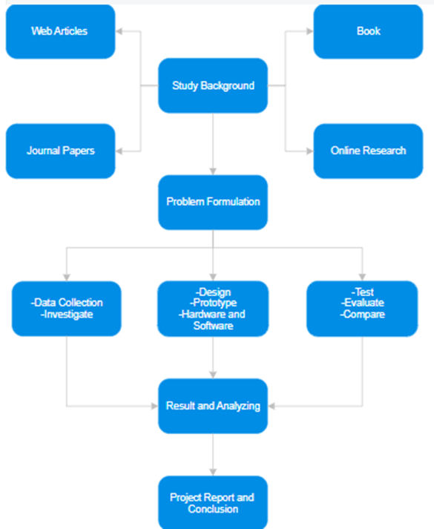

Figure 1: Project Flowchart

### Study Background

At this stage of the project process, a wide range of approach is taken to collect the relevant information from various sources such as articles; books; online searches and journal papers. The aim is to look into the topic at hand in great detail and be able to obtain the important lessons that will really add up to appreciable knowledge of the project.

### Design and Implementation

In this critical stage of the project, focusing on the detailed development and implementation of an innovative smart bandage. The creation of a hardware prototype and a software prototype is a critical milestone toward the realization of this venture.

### Testing

Thorough testing of the smart bandage will ensure its reliability and also user-friendliness as well. An expert in the relevant field will ensure unwavering reliability through a very meticulous assessment of its correctness in all the cases. Simultaneously, there are also plans to engage a patient for providing feedback in terms of practical applications and user experience via the intensive usability testing. For this reason, this dual evaluation will help in refining and improving the bandage and steers it to more practical efficacy in a clinical setting.

## Research Activities

Every project requires a Gantt chart. A Gantt chart is a time management tool that shows work performed over time in regard to the time permitted for the activity. The picture below shows the Gantt chart for this project based on the first 12 weeks of the academic year (APM, 2017, September 20).

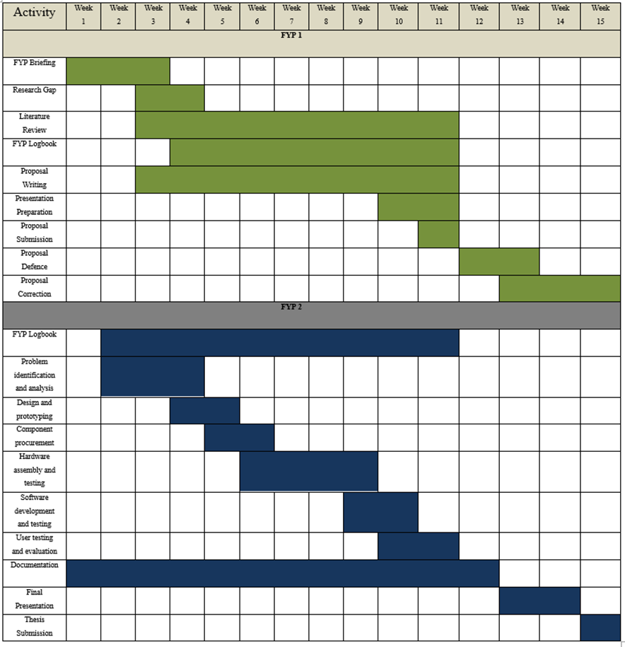 Figure 2: Gannt chart for our project

## Tools and Platforms

The proposed vision is improved on a smart patch for comprehensive health monitoring throughout the healing phase. The device is innovative and is made using Arduino microcontrollers and many different sensors, which offer real-time monitoring, and alert in case anything is unusual like the change in skin temperature or unusual pattern for wound healing. The second is a reliable communication system to pass information to a care giver, a doctor, and a worried person. Here are a few tools and platforms commonly utilized in the development of smart bandages:

### Hardware

1. 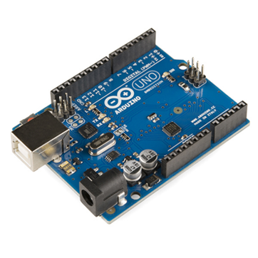Arduino: The Arduino board is the controller for gathering and handling sensor information.

Figure 3: Arduino

1. 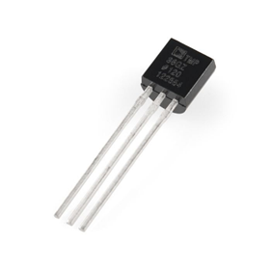Temperature Sensors: These sensors monitor the temperature of the wound, which can give insights into the healing process.

Figure 4: Temperature Sensor

1. 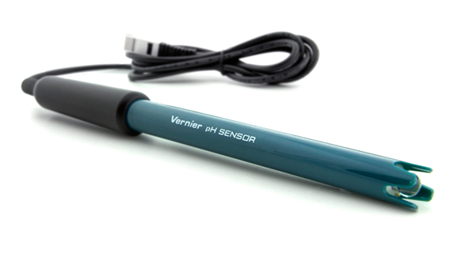Biological Sensors: Such as pH sensors to measure the acidity of the wound environment.

Figure 5: PH Sensor

1. 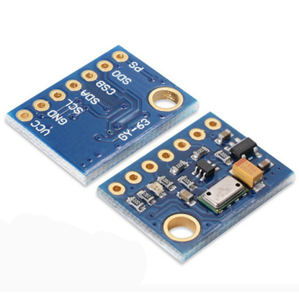Pressure Sensors: Utilized to identify changes in pressure, which can be characteristic of swelling or infection.

Figure 6: Pressure Sensor

1. 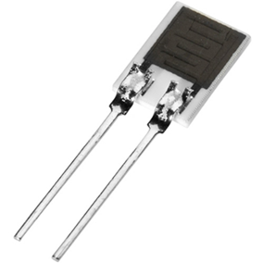Humidity sensor: measures moisture in the area of the wound and continuously provides information about the level of moisture at a given time.

Figure 7: Humidity Sensor

1. 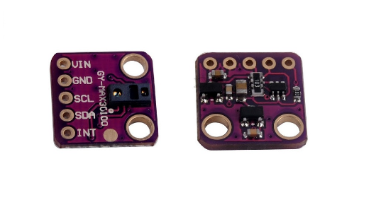SpO2: utilizing light absorption to measure oxygen levels in the blood.

Figure 8: SpO2 Sensor

1. Cellular Network: Integration with cellular networks for remote monitoring and data transmission.
2. Power Supply: Given the nature of bandages, flexible and small batteries are regularly essential to power the sensors and other components.

### Software

1. Arduino Platform: Employing the Arduino platform for coding the sensor.
2. Mobile App Development Platforms (Flutter): For making companion apps for users to monitor their wounds.
3. Stimulation: For creating Software and hardware prototypes like (Blender, Adobe XD).

At its core, the Arduino Uno microcontroller is the command center, sending out commands and receiving information from all over. Its programmable nature makes it adaptive, an essential quality in designing the smart bandage system to match each patient's and each wound's unique needs.

Temperature sensors provide real-time thermal measuring data, allowing detection of infections or inflammation at an early stage. This function is still the basis for early intervention, which prevents complications, speeds up healing. Acidity levels continue to be monitored with the addition of pH sensors, contributing to the analytical robustness. This fine-grained information improves our grasp of the setting for wounds, so that medical professionals can recognize problems before they arise and choose care approaches best suited to individual patients (Zhang et al., 2022).

Pressure sensors help reduce risks created by immobility because they monitor the pressure at the site of a wound and prevent things like pressure ulcers. With the addition of cellular network connectivity, for remote real-time monitoring comes the analytical leap. This interconnectivity boosts the system's capability, enabling medical personnel to access essential data speedily and make wise judgments swiftly (Philip Chung et al.,2013).

The design of power supply mechanisms assures the continuing workability of the smart bandage system, an important condition for maintaining continuous monitoring. Clinical proof culminates in mobile app development platforms, getting patients actively involved with their own care. This real-time data gives patients the opportunity to get involved and engage with healthcare providers in a more effective, patient-centered way for wound management (Andrew Myers, 2022).

# PROPOSED WORK

## Introduction

This chapter provides a detailed process for designing and prototyping a very smart bandage that is very innovative in nature. This transformative stage encompasses the merger of high technology, clinical knowledge, and also customer-focused concerns. The solutions to these challenges and the issues that arise when combining sensors, processing algorithms for data, and also advanced materials for optimal performance with comfort are discussed.

Further than the theory, however, by developing a physical prototype we get into the practical area. This voyage demonstrates the dedication to quality and engineering of a smart bandage that is in perfect harmony with the needs for medicine and also consumer perceptions. Experience the disentanglement of travelling from conception to completion, in formulating a change solution for wound care.

## Prototype Design

“The most significant benefit of prototyping is the fact that it comes up with final product model. It may be useful in attracting customers to commit themselves to the product even before any resource allocation on implementation procedures. You can find design mistakes and test their accuracy before moving into production.” (Simplilearn, 2023). The components lay out the prototype design of the "Design and Implementation of Smart Bandage Technology for Wound Monitoring". It illustrates how the parts come together in a whole that far exceeds traditional wound care techniques. Each component of the innovative solution is crucial-the Arduino Uno microcontroller, temperature sensors, pH sensors, pressure sensors, humidity sensor, SpO2 sensor, cellular network connectivity, power supply and mobile app development platforms.

### Hardware Prototype

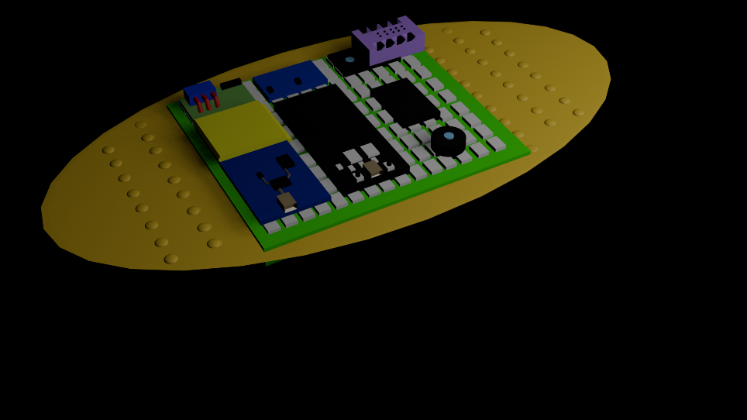

Figure 9: Hardware Prototype

### Software Prototype

Figure10: Home Page Figure11: Notifications

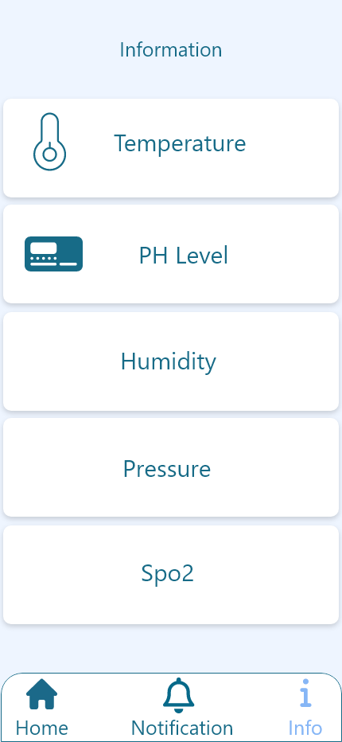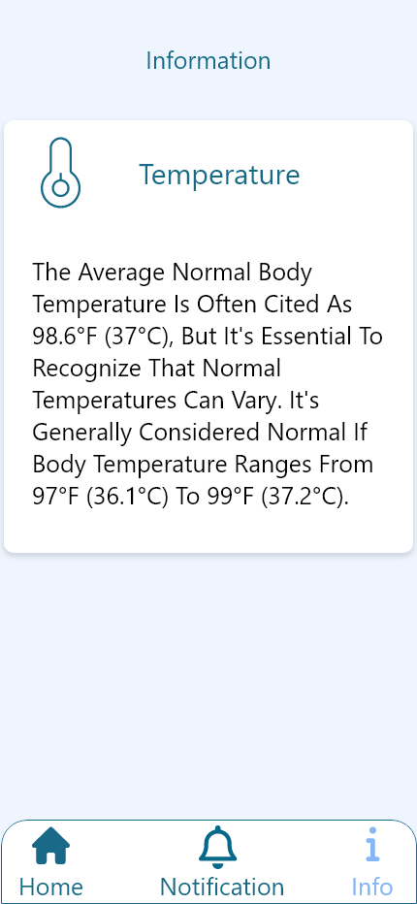

Figure12: Information about Sensors Figure13: Detailed Information

The project details are displayed by a mobile application, which is a software prototype. It shows individual sensor ratios at the application of smart bandage to the wound and notifies in case of any out-of-normality state at the wound site. The third part provides the standard deviation values for all the sensors.

### Process Design

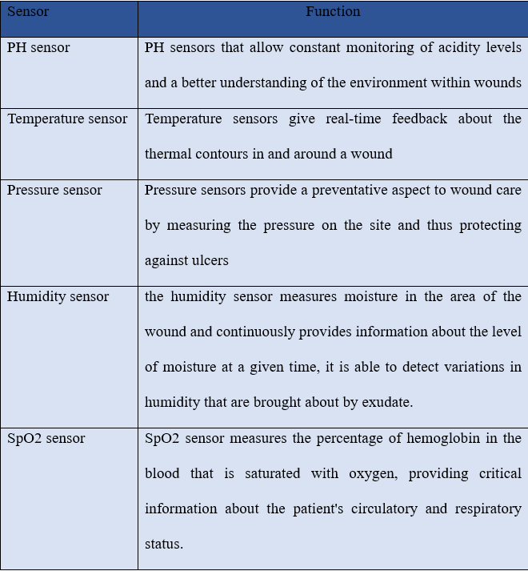 The incorporation of new components, including the Arduino Uno microcontroller, temperature sensors, pH sensors, pressure sensors, humidity sensor, SpO2 sensor, cellular network connectivity and power supply as well as mobile app development platforms that also offer Health make up the next generation in smart bandage wound monitoring system. This elegantly presents a comprehensive solution with greatly increased capabilities when compared to traditional technology.

Table 2: Sensors and Function

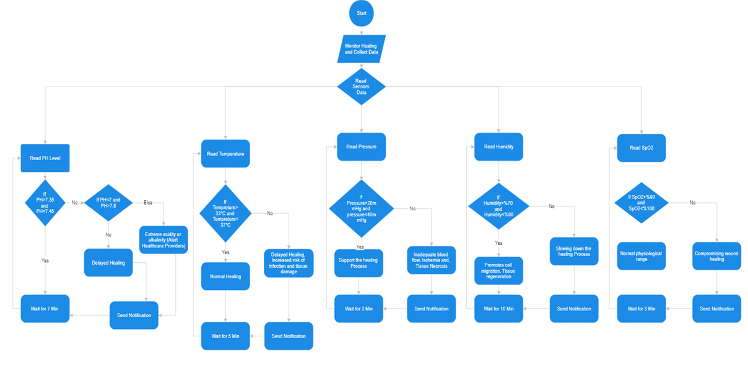 Figure14: Process Flowchart

This Flow chart is about how sensors work and how they send notifications, for the PH level the range should be between 7.35-7.45 for normal healing, but if does not it will delay the healing. In addition, if the pH level drops below 7.0 or rises above 7.8, the smart bandage alert healthcare providers or the wearer. because it is an extreme acidity or alkalinity.

The temperature of the smart bandage should be within the desired range for wound healing; ideally, it falls between 33°C and 37°C (or 91.4°F and 98.6°F). Any variations from this range will either promote or hinder the cellular activities that are core for the process of healing. In case the temperature would go below 33°C, it could also inhibit the enzymatic reactions and cellular metabolism that may delay healing and also increase the susceptibility to infectious complications. In contrast, a temperature above 37°C may lead to the inflammation, destruction of the tissue and also impair the normal healing process.

The ideal pressure that should be exerted by the smart bandage should sustain at such a level that the wound compression is achievable without causing any undue pain or tissue damage. Prescription pressure that is usually used (20-40 mm Hg for compression bandages) helps to enhance the blood flow and drainage system, reduce edema, as well as to support the healing process. Below the lower limit or above the upper limit may interfere with how the compression therapy functions. If the blood pressure is not high enough, inadequate perfusion results while if it is too great, it can lead to ischemia, tissue necrosis and others.

Therefore, the smart bandage should sustain an ideal moisture content roughly on the wound site to facilitate the intrinsic processes of healing. In general, wounds would do well with a slightly moist environment (about 70 to 90 % humidity) since it encourages the cell migration and tissue regrowth while also discouraging the formation of scabs. Should the humidity fall below this optimal range, it may result in an over-dry environment that will not enhance the wound healing and might even cause discomfort. On the contrary, when the humidity is above the set limit it could provide a very favourable environment for the bacterial multiplication and infection.

The smart bandage should perform the constant monitoring of oxygen saturation levels of the wearer, with its aim at maintaining this indicator within 95-100% limits, which is very typical for the physiological norm. SpO2 values below this range may be a sign of inadequate tissue oxygenation, which might impede the wound healing and overall condition. The smart bandage is expected to send an alert signal either to the healthcare providers or to the wearer of the device in order for them to find out what caused it and take appropriate interventions such as readjusting it, or addressing any respiratory issues if present.

## Result and Discussion

Thus far, the application of smart bandage technology for wound monitoring with essential elements including the Arduino Uno microcontroller, temperature sensors, pH sensors, pressure sensors, cellular network connectivity and mobile app development platforms, have indeed shown encouraging results. These data open the door to an in-depth review of this revolutionary form of wound care.

Temperature sensors, an important part of the system, have proved themselves to be quite effective in showing real-time thermal dynamics of wounds. The findings suggest that early detection of changes in temperature makes possible timely intervention by healthcare professionals, so they can tackle possible infections or inflammation immediately. This ability is of critical importance in preventing complications and promoting a rapid healing process

The incorporation of pH sensors in the smart bandage system has provided information on wound acidity levels. The ability to monitor pH levels continually enables healthcare providers to understand the wound environment in a more refined way, and can identify deviations and potential complications. These results highlight the importance of this feature, as its use allows us to develop interventions that are specifically targeted for each patient, making wound care much more precise.

Foundational components pressure sensors reduce the risk of immobility. These results show that theses sensors help to prevent pressure ulcers by monitoring pressure at the wound site. Such a preventive aspect fits in with the larger aim of improving patient outcomes and reducing the burden of secondary complications.

With cellular network connectivity, the smart bandage technology has been greatly broadened in terms of its capabilities. The results show that real-time remote monitoring is now achievable, providing healthcare professionals with up to the minute data. This connectivity increases the active nature of wound management, eliminating many repeats in-person visits and allowing intervention to be carried out at just the right moment.

The design of power supply mechanisms for the smart bandage system has allowed it to operate continuously. This trait is important to sustaining continuous monitoring, and the figures show that system continues producing high-quality and valuable data.

Incorporating mobile app development platforms enables patients to actively participate in their own care. The results indicate that patients can access real-time data, in effect cooperating with healthcare providers. It is part of a more patient-centered model of wound care, and fits in with the broader direction to personalized medicine.

## Limitations

Although the application of smart bandage technology for wound monitoring has much potential, it is necessary to recognize some limitations in order to have a more objective picture about its applicability. The following are notable constraints associated with the design and implementation, considering the specified components:

1. **Dependency on Cellular Network:**

Relying on a cellular network to monitor in real time makes the system more limited, especially when connectivity is poor. In areas with uneven network coverage, the efficiency of the system of smart bandages could be impaired. Data transmission might be delayed or the availability to health care professionals reduced.

1. **Power** **Consumption** **Challenges:**

Incorporation of different elements, including temperature sensors, pH sensors, pressure sensors and mobile app development platforms may result in higher power consumption. This presents a problem with the life of the power source, requiring frequent replacement or recharging of batteries. Especially when a stable power source is not available, power constraints may limit the continuous monitoring capability.

1. **Size and Comfort Considerations:**

Having a multitude of sensors combined with the necessary technology might make for a thicker design, at least on paper, which could affect how comfortable or easy to wear it would be. But this could prove too impractical for long-term use, especially if the bandage is inconveniently large or uncomfortable.

## Chapter Summary

This chapter provides powerful evidence demonstrating the effectiveness of the technology. Temperature sensors provide instantaneous thermal information, pH sensors increase understanding of the wound environment, pressure sensors reduce risks due to immobility, and cellular connectivity allows for continuous wireless monitoring from a distance. These power supply mechanisms make it so that functionality lasts forever. And mobile app platforms allow patients to take charge of their own care. The results attest to the ability of smart bandage technology to make a difference, revolutionizing wound monitoring with precision, efficiency and patient awareness.

# CONCLUSION AND RECOMMENDATIONS

## Research Outcomes

In the study, three major goals of using smart bandages were addressed. First, a study was done on smart bandages and sensor integration with the aim of improving individualized treatment. With the incorporation of sensors within the bandage, it would be possible to monitor in real-time wound conditions as well as patient health enabling directed and adaptive treatment approaches. This goal was to close the gap between standard wound care and new technology, emphasizing personalization of treatment.

Second, the study encompassed development and implementation of a smart bandage and its system. This goal was used to achieve the complete integration of sensors and smart technologies in the bandage, so that they would be easy for use and data transmission. The focus was on the creation of a practical and functional solution that could be readily implemented within clinical environments.

Lastly, the research comprised an analysis and a comparison of the smart bandage to traditional ones. This comparative analysis addressed the healing process, comfort of patients and general effectiveness among other factors. In other words, by offering comprehensive assessments, the research intended to shed light on the advantages and limitations of smart bandages in order to ensure that health care practices are based on rational choices. The results of this study add to the emerging field of personalized medicine and smart healthcare technologies, giving an encouraging direction for enhancing wound care and patient outcomes.

## Contributions to Knowledge

The use of Smart Bandage Technology for Wound Monitoring is an important addition to the current literature on healthcare, technology, and patient-management practices. This study goes beyond traditional perspective of wound care management and presents new solution that can elevate the level of patient monitoring and treatment by redefining the standards.

One of the major contributions is the integration of sophisticated sensor technology where temperature sensors, biological sensors and pressure sensors are incorporated into one smart bandage system. This combination sets a base for further research on the consolidation of multiple sensors in healthcare applications outside wound healing.

The use of cellular network connectivity to transmit real-time data from the smart bandage to care providers is an innovative move towards improving remote patient monitoring. This contribution paves the way for further research into safe and effective data transfer in healthcare and may affect the creation of other monitoring systems focusing on various health indicators.

The creation of mobile application interface convenient for users designed for the purpose of monitoring wounds is one of the signs that patient-centric healthcare solutions are evolving. Therefore, this research not only highlights the need to encourage patients to control their health data but also creates a background for other medical applications that use intuitive interfaces.

## Future Works

The application of the Smart Bandage Technology for Wound Monitoring has opened a number of very prospective directions in further research and development. To begin with, the most attractive point is the introduction of Artificial Intelligence (AI). AI algorithms can be used to interpret the large volumes of data that would have been collected by the smart bandages, thus giving predictions on wound healing trends. This would allow more preemptive and individualized treatment plans that will help maximize healthcare interventions.

Wearable devices may also be integrated into the future of smart bandage technology. Collaborating with the smart bandages, these devices can enable constant tracking of other vital signs and health parameters. The integration of sensors for heart rate or oxygen saturation would give a more detailed and whole picture of patients’ health.

REFERENCES

APM. (2017, September 20). What Is A Gantt Chart? | Definition & Examples | APM. https://www.apm.org.uk/resources/find-a-resource/gantt chart/#:~:text=A%20Gantt%20chart%20is%20a

Derakhshandeh, H., Kashaf, S. S., Aghabaglou, F., Ghanavati, I. O., & Tamayol, A. (2018). Smart Bandages: The Future of Wound Care. Trends in Biotechnology, 36(12), 1259–1274. https://doi.org/10.1016/j.tibtech.2018.07.007

Fabric-based pressure sensor array for decubitus ulcer monitoring. (2013, July 1). IEEE Conference Publication | IEEE Xplore. https://ieeexplore.ieee.org/document/6611045.

Farahani, M., & Shafiee, A. (2021). Wound Healing: From Passive to Smart Dressings. Advanced Healthcare Materials. https://typeset.io/papers/wound-healing-from-passive-to-smart-dressings-597hv9qeoo

Kassal, P., Kim, J., Kumar, R., de Araujo, W. R., Steinberg, I. M., Steinberg, M. D., & Wang, J. (2015). Smart bandage with wireless connectivity for uric acid biosensing as an indicator of wound status. Electrochemistry Communications, 56, 6–10.

https://www2.chemistry.msu.edu/courses/cem434/Case%20Study%2010_2016_smartbandage.pdf

Simplilearn. (2023, August 9). Prototyping in Design Thinking: Definition, Types & Benefits. Simplilearn.com. https://www.simplilearn.com/prototyping-in-design-thinking-article#:~:text=The%20most%20important%20advantage%20of,correctness%20before%20going%20into%20production.

The Development of Smart-bandage Technologies - ProQuest. (n.d.). Www.proquest.com. Retrieved November 10, 2023, from https://www.proquest.com/openview/90d9670de2da9e20c61db6c6ddadd1d7/1?pq-origsite=gscholar&cbl=2026366&diss=y

Levin, A., Gong, S., & Cheng, W. (2023). Wearable Smart Bandage-Based Bio-Sensors. Biosensors, 13(4), 462–462. https://doi.org/10.3390/bios13040462

Libretexts. (2021, April 14). 2.1: Basic microcontroller use for measurement and control. Engineering LibreTexts. https://eng.libretexts.org/Bookshelves/Biological_Engineering/Introduction_to_Biosystems_Engineering_(Holden_et_al.)/02%3A_Information_Technology_Sensors_and_Control_Systems/2.01%3A_Basic_Microcontroller_Use_for_Measurement_and_Control.

Mostafalu, P., Tamayol, A., Rahimi, R., Ochoa, M., Khalilpour, A., Kiaee, G., Yazdi, I. K., Bagherifard, S., Dokmeci, M. R., Ziaie, B., Sonkusale, S. R., & Khademhosseini, A. (2018). Smart Bandage for Monitoring and Treatment of Chronic Wounds. Small, 14(33), 1703509. https://doi.org/10.1002/smll.201703509

Tang, N., Zheng, Y., Jiang, X., Zhou, C., Jin, H., Jin, K., Wu, W., & Haick, H. (2021). Wearable sensors and systems for Wound Healing-Related PH and temperature detection. Micromachines, 12(4), 430. https://doi.org/10.3390/mi12040430.

Ucl. (2022, July 25). What is the significance of a flowchart? [UPDATED]. Culture Online. https://www.ucl.ac.uk/culture-online/case-studies/2021/jun/what-significance-flowchart#:~:text=A%20flowchart%20is%20a%20diagram,steps%20to%20solving%20the%20problem.

What Is Research Methodology and Why Is it Important? Indeed Career Guide. https://www.indeed.com/career-advice/career-development/research-methodology

Western Sydney University. (2017). Literature review purpose. https://www.westernsydney.edu.au/__data/assets/pdf_file/0006/1254786/Literature_review_purpose.pdf

Wireless smart bandage provides new insights on healing chronic wounds. (2022, November 24). EurekAlert! https://www.eurekalert.org/news-releases/971937.

Zhang, Z., Su, R., Han, F., Zheng, Z., Liu, Y., Zhou, X., Li, Q., Zhai, X., Wu, J., Pan, X., Pan, H., Guo, P., Li, Z., Liu, Z., & Zhao, X. (2022). A soft intelligent dressing with pH and temperature sensors for early detection of wound infection. RSC Advances, 12(6), 3243–3252. https://doi.org/10.1039/d1ra08375a.

Appendix A Mathematical Proofs

Appendix B Psuedo Code

Appendix C Time-series Results Long Long Long Long Long Long Long Long Long Long

LIST OF PUBLICATIONS