**CPSC 319 - Winter 2025**  
**PA-3: Binary Search Trees (BST) - Word Frequency Analysis**  
**Total Weight: 14% of Final Grade**

📌 **Student Information**

* **Full Name:** Thomas Boyko
* **UCID:** 30191728
* **Tutorial Section:** T06

**💡 Marking Criteria (Total: 50 Points)**

|  |  |  |
| --- | --- | --- |
| Section | Max Points | Score |
| 1. BST Implementation & Execution | 10 |  |
| 2. BST Traversal Implementation | 10 |  |
| 3. Word Frequency & Search Implementation | 10 |  |
| 4. File Handling & Input Processing | 5 |  |
| 5. BST Height Calculation | 5 |  |
| 6. Code Documentation & Readability | 5 |  |
| 7. Proper Citation of Sources | 3 |  |
| 8. AI/External Tool Usage Disclosure | 2 |  |
| Total Score | **50** |  |

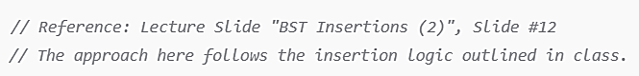



**📌 Submission Information**

**📁 File Submission Format**

* Submit all completed documents as a zipped folder:

PA-3--<Your Full Name-UCID-TUT>.zip

*(e.g.,* PA-3--JaneDoe-12345678-T01.zip *)*

* Upload via **D2L Dropbox** by **March 21, 2025 (Friday), 11:59 PM**.

**⏳ Late Submission Policy**

* **1 day late**: -10%
* **2 days late**: -20%
* **3 days late**: -30%
* **Beyond 3 days**: Requires documented exceptional circumstances.

**⚠️ Policy on Tool Usage**

* **Clearly document** any AI-assisted tools used.
* **Unauthorized AI automation = academic penalty.**

