Point #1: Check the Field’s size in Mobile view.
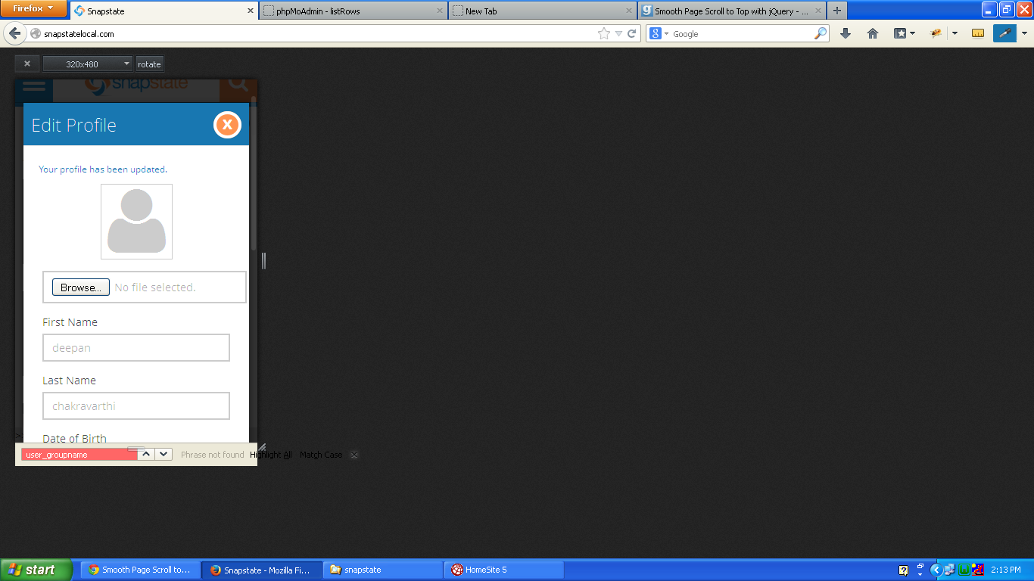

#2: Update the success message style.
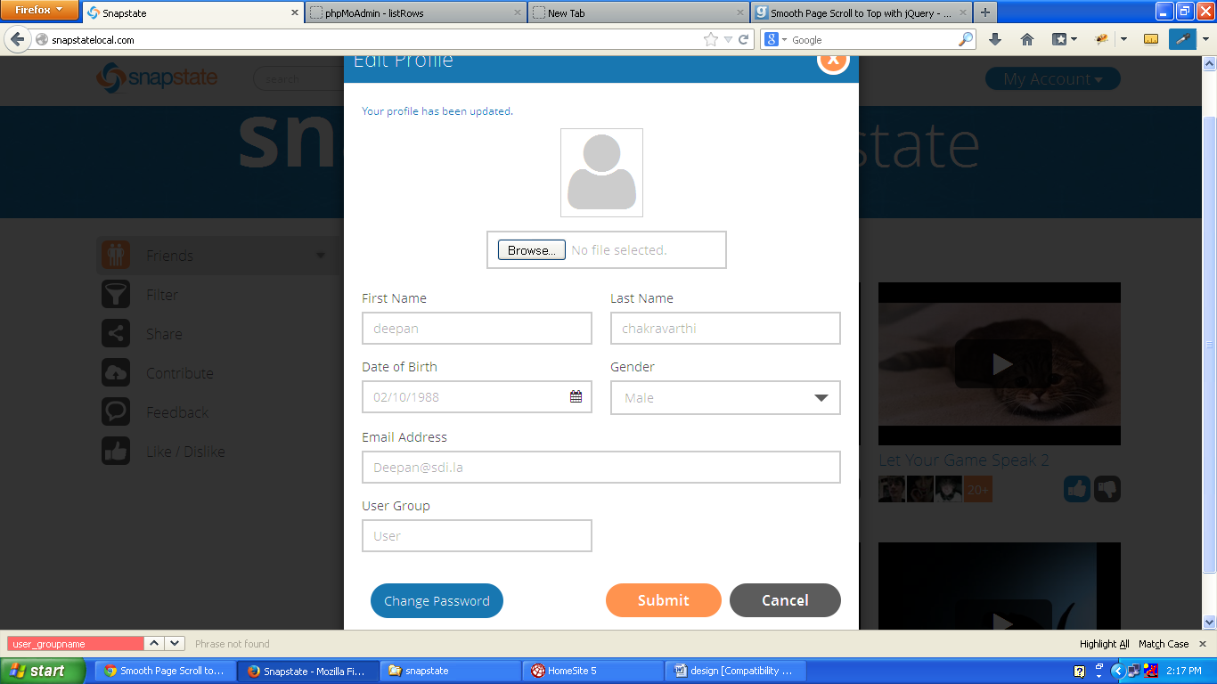

#3 Display the accepted file format hint for User Photo

#4 Need to change the no image – height & check the border line while uploading a new photo
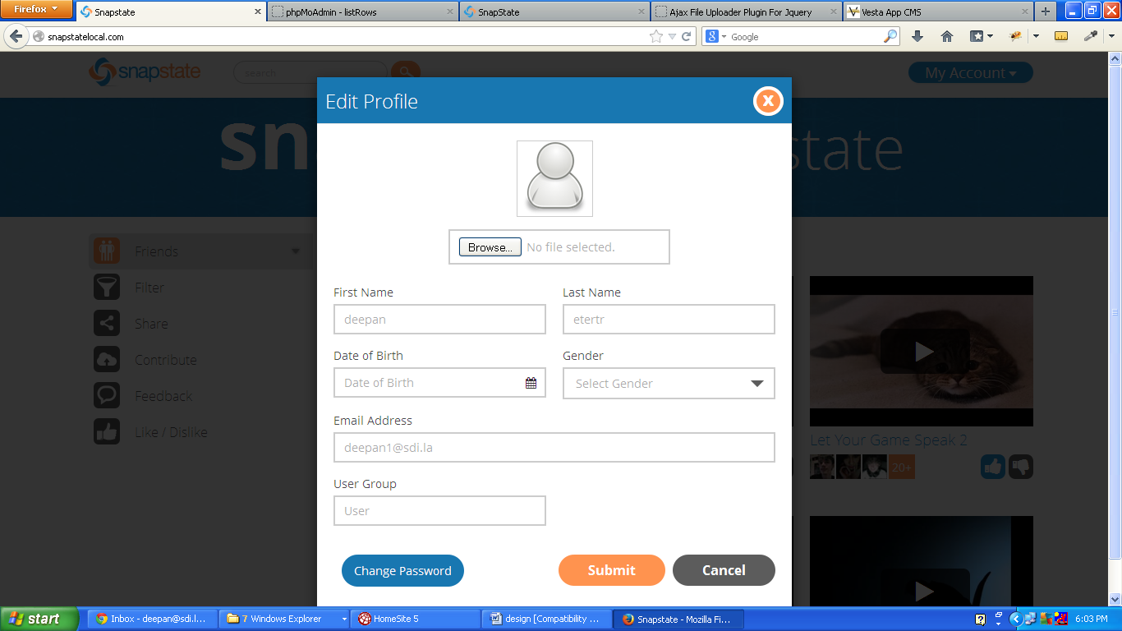

#5 Restrict Length
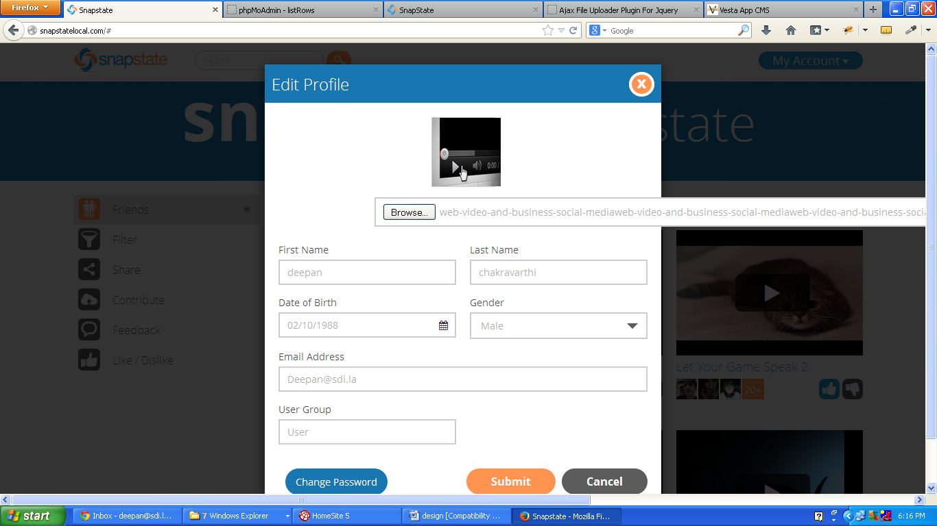

#6 Need to add dropdown menus for options under the FILTER

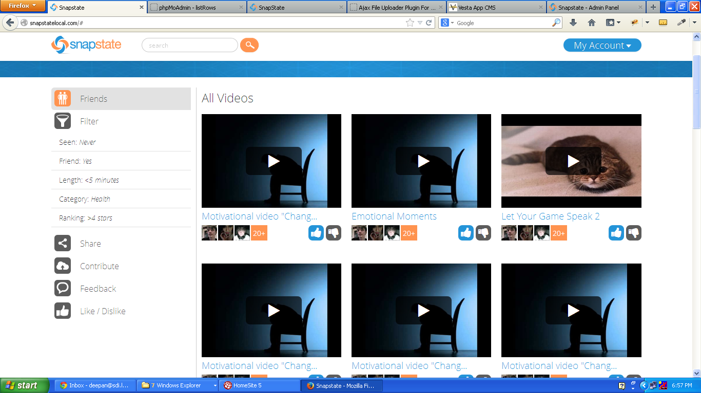

#7 Mobile view – Photo
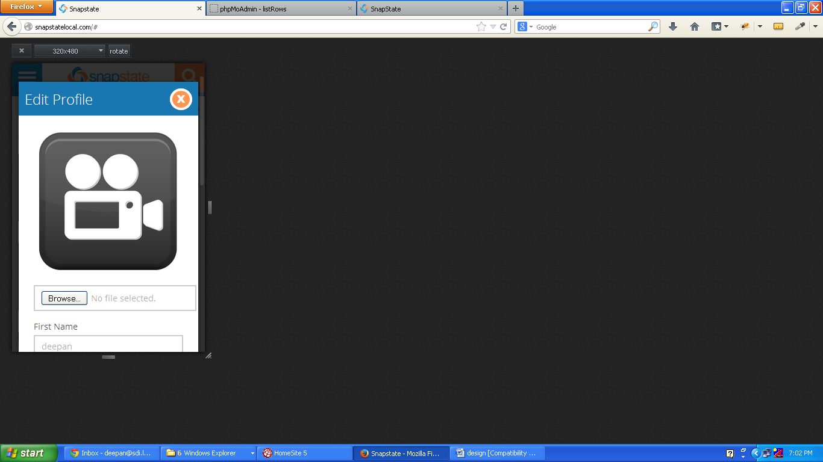

#8 check the placement of arrow
