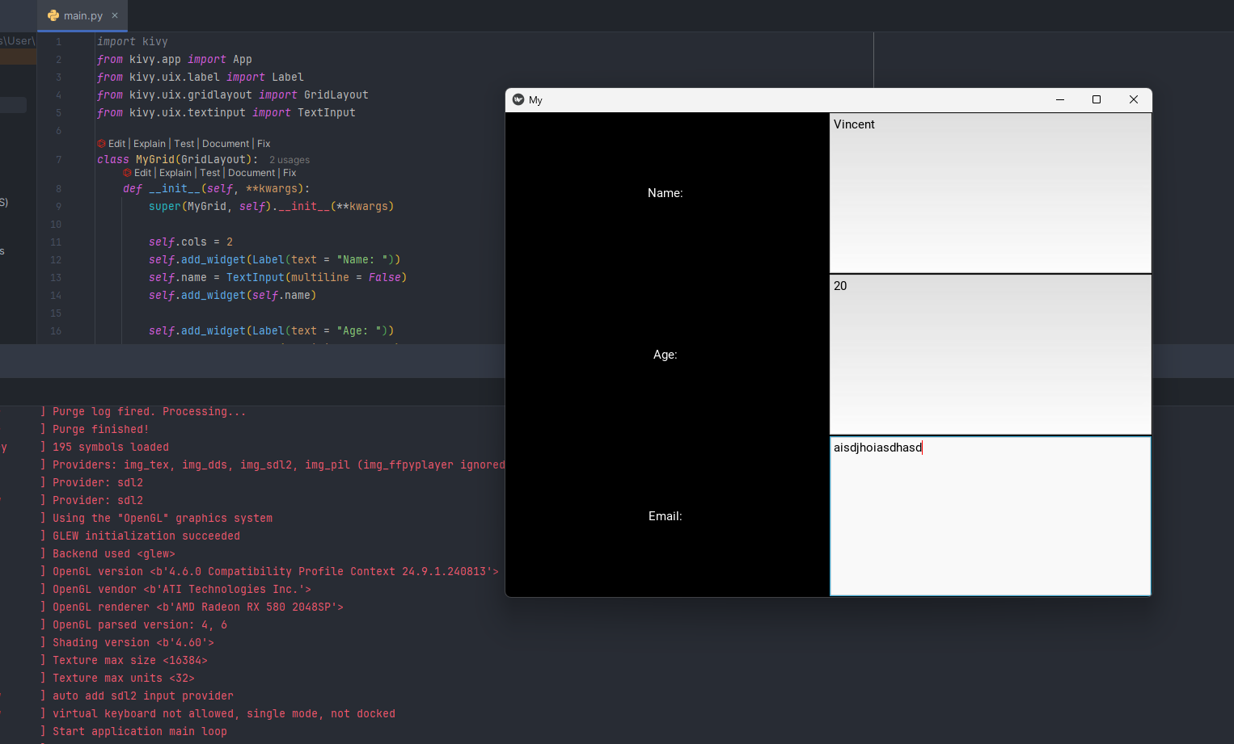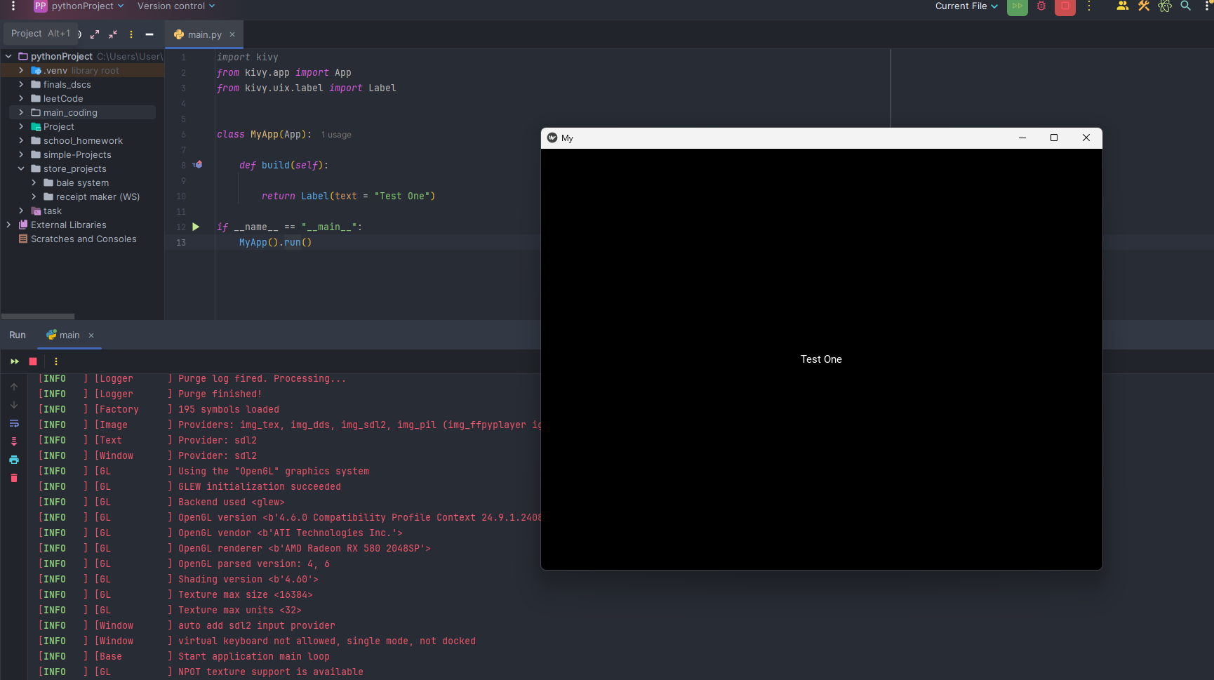# Documenting the first test for Kivy

# Playing around with label and input texts

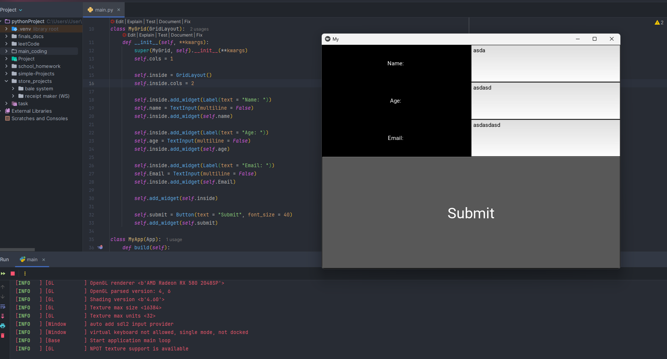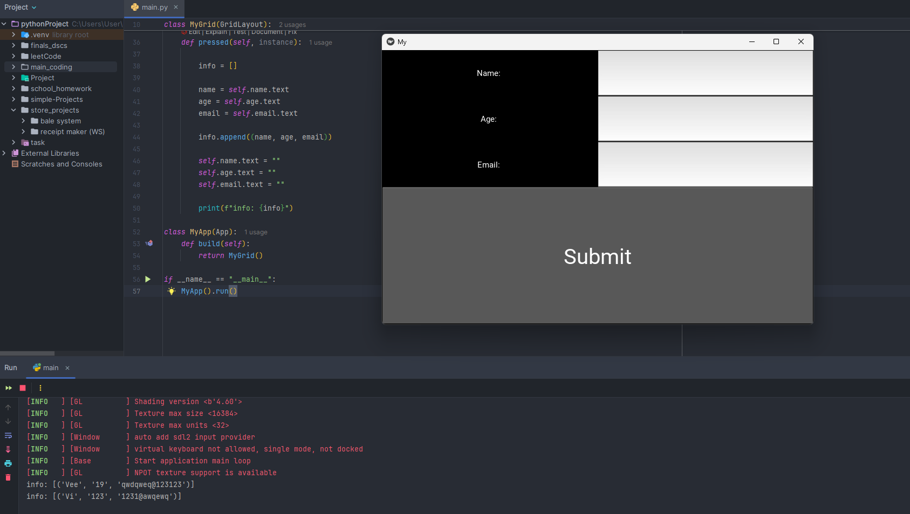# Just added a button

# Added thee function of a button and also binded it so that once the user pressed it the computer stores that data in a variable or list

[SOURCE CODE]:

*from* kivy.app *import* App  
*from* kivy.uix.label *import* Label  
*from* kivy.uix.gridlayout *import* GridLayout  
*from* kivy.uix.textinput *import* TextInput  
*from* kivy.uix.button *import* Button  
  
  
*class* MyGrid(GridLayout):  
 *def* __init__(*self*, **kwargs):  
 super(MyGrid, *self*).__init__(**kwargs)  
 *self*.cols = 1  
  
 *self*.inside = GridLayout()  
 *self*.inside.cols = 2  
  
 *self*.inside.add_widget(Label(text = "Name: "))  
 *self*.name = TextInput(multiline = *False*)  
 *self*.inside.add_widget(*self*.name)  
  
 *self*.inside.add_widget(Label(text = "Age: "))  
 *self*.age = TextInput(multiline = *False*)  
 *self*.inside.add_widget(*self*.age)  
  
 *self*.inside.add_widget(Label(text = "Email: "))  
 *self*.email = TextInput(multiline = *False*)  
 *self*.inside.add_widget(*self*.email)  
  
 *self*.add_widget(*self*.inside)  
  
 *self*.submit = Button(text = "Submit", font_size = 40)  
 *self*.submit.bind(on_press = *self*.pressed)  
 *self*.add_widget(*self*.submit)  
  
 *def* pressed(*self*, instance):  
  
 info = []  
  
 name = *self*.name.text  
 age = *self*.age.text  
 email = *self*.email.text  
  
 info.append((name, age, email))  
  
 *self*.name.text = ""  
 *self*.age.text = ""  
 *self*.email.text = ""  
  
 print(f"info: {info}")  
  
*class* MyApp(App):  
 *def* build(*self*):  
 *return* MyGrid()  
  
*if* __name__ == "__main__":  
 MyApp().run()