Database System Engineering and Distributed Backend Development
Course Code: 25CS13002E
ROLL NO:2520030177
NAME: P.HARINI
WEEK-1
Query 1: Create the database
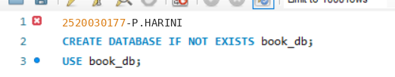
Output:

Query 2: Select the database:

Output:

Query 3: Create the books table
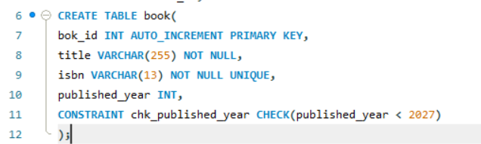
Output:

Query 4: Create the members table:
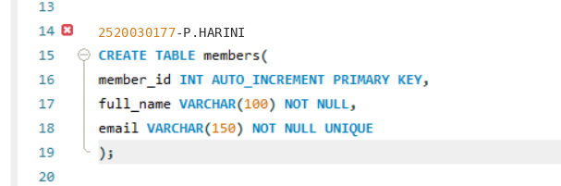
Output:

Query 5 (verification): Inspect the table structures:
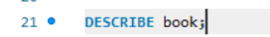
Output:
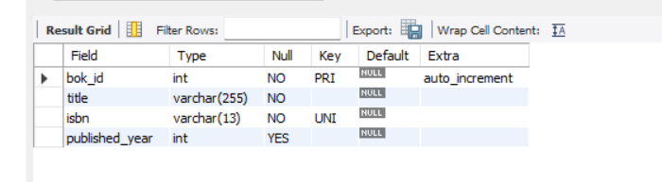

Query 6:
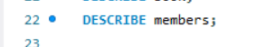
Output:
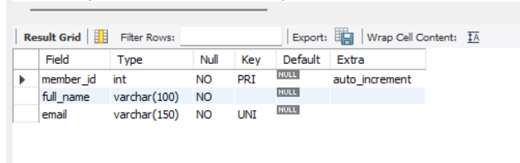

Query 7: Insert 3 books
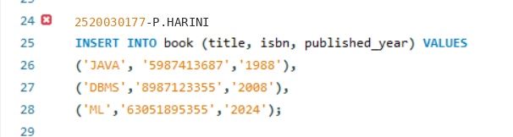
Output:

Query 8:
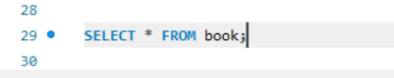
Output:
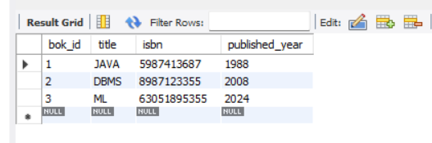

Query 7: Insert 3 members:
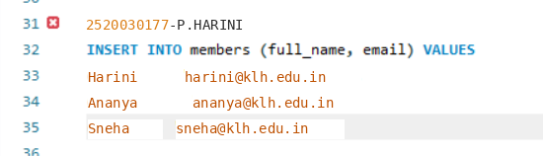
Output:

Query 8:
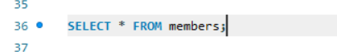
Output:
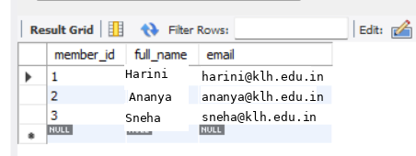

Query: Duplicate ISBN (UNIQUE violation):
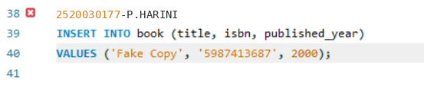
Output:

