1) SQL Schema:

CREATE TABLE STATEMENTS: Refer to videoPlayerSchema.sql file
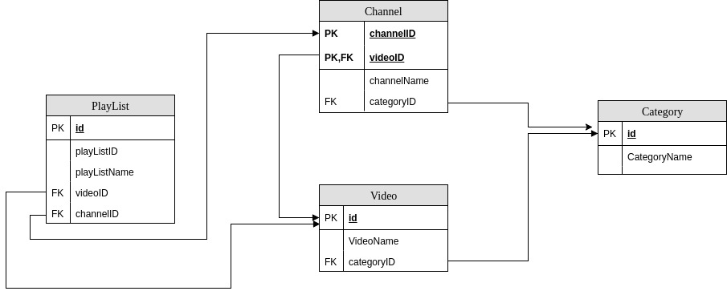

Channel has One to One relation with Category
Channel has One to Many relation with Video
Video has One to One relation with Category
PlayList has Many to Many relation with Video
PlayList has Many to One relation with Channel

2) Java Classes are present in the model package – Channel, PlayList, Category, Video. ( The classes are analogous to the sql tables).

3) This project has been developed keeping in mind about model/controller. Our model has the essential four tables – Category, PlayList,Channel,Video. We have another package called DataAccess. This contains the business logic to interact with database object and fetch data structuring them to satisfy requirements. We have Controller class that brings building blocks of models and data access module together. This class facilitates the flow of the application and controls it to get required output.

4) Refer Queries.sql file

5) Refer Queries.sql file

6) Refer Queries.sql file

7) Please run App.java .( The query logic is present in QueryLogic.java and the outputs are printed in Controller.java)

