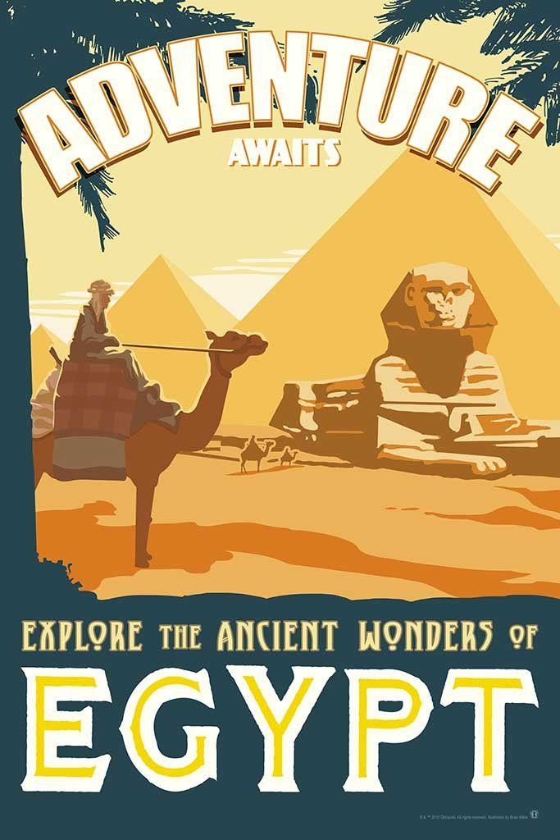

***Egypt Adventure***

Design by Nikita Lysiuk

For PC: Windows and Linux

**Rating:** T

**Game story:**

Archaeologist Piter Miller has been teaching history and archaeology for over 15 years. From time to time, the university also sends him on dangerous journeys to collect artifacts. One of these trips awaits our archaeologist in Egypt. He has already visited hundreds of temples, mines, and dungeons and has never seen anything out of the ordinary except for old ruined places that are only valuable to historians, but this trip will change Peter's view of the world. What can he expect in the ancient pyramid of Tutankhamun? Skeletons of dead Egyptians, mummies, bats and a lot of unknown mysticism after which Peter's life will no longer be before. Will Peter be able to find the artifact and not get lost forever in the pyramid?

**Game play:**

In Egypt Adventure, Peter will explore Tutankhamun's pyramid. The pyramid will consist of 3 floors where on the top floor he will be waiting for the biggest threat Tutankhamun himself, who will protect his crown for which the main character came. Given that this is Rougelike, each floor will be randomly generated, the location of rooms, monsters, chests and stairs to the next floor will be unique for each game session. Although Peter has never encountered mysticism before, all sorts of bandits have taught him that it's better to have a weapon with you, so he doesn't forget his revolver in the box under his bed. Also, the pyramid is dark and not everywhere torches are burning, so you have to be careful because who knows what is there in the dark. The player will have to explore the floors, find different things in the chests, fight off enemies and find the crown of Tutankhamun.

**Game flow:**

While exploring dungeons, the Player can search chests and pick up loot from dead enemies. From the very beginning, Peter will only have a revolver and a torch. But during the journey, he will notice various mystical creatures that use ancient magic that seems to not exist. The player will have to find various amulets, jewelry, and rings that the ancient Egyptians made to protect themselves from magical forces. Also, the torch is not eternal, you will need to find others to upgrade it, also, surprisingly or not, other tomb robbers left their resources after a horrible death in the pyramid, so Peter will be able to renew ammunition for the revolver.

**Character and Control:**

You will play an archaeologist who has visited more than one tomb. Peter's story is difficult. He had a family, but after the death of his son, his wife could not survive this loss and left Peter. After that, he became completely immersed in his work. First of all, the basic mechanics of movement (walking). Peter also has a revolver that he can shoot from, and it will also need to be reloaded. Peter can pick up items from the chest that will improve his characteristics or give him some shields.

**Main Gameplay Concepts and Platform Specific Features:**

**1. Core Gameplay Elements:** The player controls archaeologist Peter Miller as he explores Tutankhamun’s pyramid in search of an ancient artifact. This is a **roguelike** game with exploration and combat systems.

* **Genre:** Roguelike, Dungeon Crawler, Adventure game.
* **Core mechanics:** Exploring randomly generated levels, finding treasures, fighting enemies (mummies, skeletons, bats), and collecting weapons and items for survival.
* **Levels:** The game is divided into three levels, each representing a different floor of the pyramid. The player starts from the first floor and must work their way down to the final floor, where the main boss—Tutankhamun—awaits.

**2. Game Structure:**

* **Levels:** Each level is randomly generated with new rooms and challenges on every playthrough. The player must explore the dungeon, discover hidden rooms, and find loot and weapons.
* **Progression:** Each level ends when the player finds the stairs leading to the next floor. On the final floor, they must face Tutankhamun to complete the game.
* **Death System:** If the character dies, the game resets with newly generated levels and enemies.

**3. Unique Gameplay Elements:**

* **Random Generation:** Each game session offers unique, procedurally generated maps, enhancing replayability and increasing the challenge for players.
* **Light System:** The pyramid is mostly dark, and the player will use torches to light their path. The player's visibility is limited to areas lit by torches or other light sources. This adds a stealth element, as players may need to avoid enemies in dark areas.
* **Combat System:** Peter has limited ammunition for his revolver, requiring players to conserve bullets and find other means of defense.

**Game World**

**1. Pyramid of Tutankhamun (Main Setting):**

The gameplay takes place entirely within the mysterious and ancient **Pyramid of Tutankhamun**. The pyramid consists of **three distinct floors**, each with a unique atmosphere and set of challenges.

**2. Environments:**

* **Floor 1 (Entrance Halls):**

The first floor represents the **outer chambers** of the pyramid. It's filled with narrow corridors and small rooms. There are a few scattered light sources, but the player will often find themselves in near darkness, relying on torches to explore.

* **Floor 2 (Ancient Catacombs):**

The second floor is a **maze-like labyrinth** filled with tombs, traps, and forgotten burial chambers. This floor feels claustrophobic, with skeletons and mummies lurking in the shadows. The rooms are larger and more complex than the first floor, and the atmosphere is more oppressive, with constant danger lurking behind every corner.

* **Floor 3 (King's Chamber):**

The final floor is the **King’s Chamber**, where the ancient Pharaoh Tutankhamun guards his most prized artifact, his crown. This floor is grand and imposing, with larger rooms, elaborate traps, and mystic energy coursing through the air.

**3. Connection and Navigation:**

The game world is connected in a **linear** fashion, where each floor must be completed to advance to the next. The player will navigate through the pyramid by finding the stairs at the end of each floor, leading to the next level. There is no hub-style navigation; the game flows progressively from the entrance of the pyramid to the final showdown with Tutankhamun.

### **Interface**

**1. General Layout:** The game will be presented entirely in ASCII art within the console. The player will navigate the game world using simple key commands, such as arrow keys for movement and specific keys for actions like interacting with objects or accessing the inventory. The interface will focus on clarity and simplicity, while also reflecting the sense of mystery and danger inside the pyramid.

**2. Key Elements of the Interface:**

* **Game World View (Center of the Screen):**
* The main portion of the screen will display the current area of the pyramid the player is exploring. Rooms, enemies, and items will all be represented using ASCII characters. For example:
  + Walls: #
  + Doors: +
  + Peter: @
  + Enemies: M (for mummies) or S (for skeletons)
  + Chests: %
  + Torches: T

Only the areas lit by the player’s torch will be visible on the screen. Other parts of the pyramid will remain hidden in darkness, represented by “.”. As the player moves, areas they explore will light up, while others will fade into shadow.

* **Player Stats (Top or Bottom Bar):**
* The player's key stats will be displayed at the top or bottom of the screen in a status bar format, making it easy to monitor at all times:

**HP: 85/100 | SP: 50/50 | Ammo: 6/6 | Torch Time: 3:45**

* **HP (Health Points):** Shows the player's remaining health. This decreases when the player takes damage from enemies or traps.
* **SP (Shield Points):** If Peter picks up any relics or magical shields, SP will reflect the durability of his shield. When the shield is broken, only HP will take damage.
* **Ammo:** Displays how many bullets are left in Peter’s revolver. Since ammo is limited, this encourages strategic usage.
* **Torch Time:** This shows how much time is left for the current torch before it burns out. When the timer runs out, the area around the player becomes dark again unless they light a new torch.
* **Inventory (Side Panel or Toggle Screen):**

The inventory can either be displayed on the side of the screen or opened with a key (e.g., I). It will list all items Peter has found so far, including:

* **Relics:** Ancient artifacts Peter has discovered. These may have lore, buffs, or special abilities.
* **Additional Torches:** Extra torches the player can use when the current one burns out. These will be represented as "Torch x3" for example.
* **Special Items:** Any other key items that help in solving puzzles or progressing through the game, like keys or scrolls.

The inventory could look like this:

Inventory:

1. Revolver Ammo: 6

2. Torches: 2

3. Relic: Ancient Scarab

4. Relic: Tutankhamun's Ring

**Text Log / Notes (Bottom or Side Panel):**

A section of the interface will display **narrative text** such as notes, journal entries, or Peter's internal thoughts. This will help players piece together the story of the pyramid and Peter's journey. This text section will also show any messages from the game, such as:

“You found an old scroll! It describes a secret passage in the pyramid.”  
“The torch flickers... it might burn out soon.”

The text log will provide a sense of atmosphere and background lore, adding depth to the player's experience.

**Mechanics and Power-ups**

**Gameplay Mechanics:**

The core mechanics of the game revolve around exploration, combat, and survival. The player, controlling Peter Miller, must navigate through the randomly generated floors of Tutankhamun’s pyramid while facing various dangers and uncovering secrets. Here are the key gameplay mechanics:

* **Randomized Dungeon Layout:**
* Each game session generates a new, unique pyramid layout, with different room locations, enemy placements, and item spawns. This mechanic ensures that no two playthroughs are alike, encouraging replayability.
* **Combat:**
* The player uses Peter's revolver to defend himself from enemies such as mummies, skeletons, and bats. Ammo is limited, so the player must strategically decide when to fight and when to avoid confrontation.
* **Torch Mechanics and Darkness:**
* The pyramid is shrouded in darkness, and Peter must light torches to see his surroundings. The torch has a limited duration, and when it goes out, the player is left in darkness, making it harder to navigate and fight enemies. The player can find additional torches or fuel to extend their current one.
* **Exploration and Puzzles:**
* As Peter explores the pyramid, he will encounter chests containing relics, keys, and other important items. Some doors or areas will be locked or blocked, requiring the player to solve simple puzzles or find specific items to proceed.
* **Health and Shield Points:**
* Peter has both **HP (Health Points)** and **SP (Shield Points)**. HP represents his overall health, while SP represents a temporary shield that can be gained through collecting magical relics. Once the SP is depleted, Peter starts taking damage to his HP.
* **Relic Collection:**
* Throughout the game, Peter will find ancient relics that can offer different bonuses, such as increased movement speed, additional ammo, or special abilities like temporarily slowing down enemies.

**Power-ups:**

* **Health Potions:**
* Restores HP to Peter, allowing him to survive longer against the threats in the pyramid.
* **Shield Relics:**
* Special artifacts that grant SP (Shield Points). These protect Peter from damage until the shield is depleted. Once used, they provide temporary protection.
* **Ammo Pickups:**
* Peter's revolver has limited ammo. Collecting ammo pickups allows him to reload and continue defending himself from enemies.
* **Torch Refills:**
* These extend the duration of Peter’s torch or provide new torches to light the darkened hallways. Managing light is key to survival in the pyramid.
* **Special Relics:**
* Relics in the pyramid not only add to the story but provide bonuses when collected. These may increase Peter's abilities, such as improving his attack power, speed, or the duration of his torch. Some relics may even unlock special areas of the pyramid or reveal hidden lore.