Group 98

* commit cce8b1a119be447cb3ec4b1ece10c5381152a4d4 (HEAD -> main, origin/main, origin/HEAD)

| Author: pakaok <jaeseok.kim@griffithuni.edu.au>

| Date: Sun Sep 4 19:57:28 2022 +1000

|

| Structural & visual design done, Gantt chart Done

|

* commit 9555ed517dc653fab55baa7871707b68ea7af57e

| Author: pakaok <jaeseok.kim@griffithuni.edu.au>

| Date: Fri Sep 2 19:34:13 2022 +1000

|

| Functions, Data structures, Detailed Design in Software component && usercase diagram modified

|

* commit a0bb2cd78b65268917c9fca649d6574ef8454dcc

| Author: pakaok <jaeseok.kim@griffithuni.edu.au>

| Date: Wed Aug 31 17:27:15 2022 +1000

|

| Project plan done except for Gantt Chart

|

* commit 7ea94da5e2d3f57280c30f2d2dbf769d862eb60c

| Author: pakaok <jaeseok.kim@griffithuni.edu.au>

| Date: Tue Aug 30 22:08:45 2022 +1000

|

| Use case & Use case diagram & software design done

|

* commit afc1f6bca044165f1d486674a06d2e588d7361d9

| Author: pakaok <jaeseok.kim@griffithuni.edu.au>

| Date: Mon Aug 29 19:11:21 2022 +1000

|

| user&software requirements done

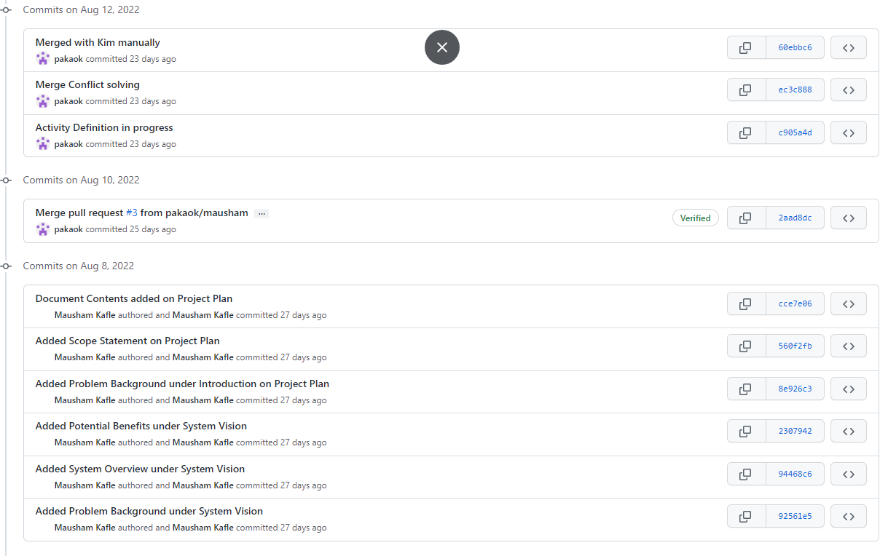

**Git log on cmd does not show above commits in picture, so its manually captured from github website**