VSB SKILL VAULT — ACTIVITY 3
Mini Web Application
CRUD-Based Web Application — Project Report
Student Management System
Submitted by: KAVIN P A
Roll Number: 922525118025
Department: CCE [Computer and Communication Engineering]
VSB Engineering College
September 2026

1. Project Overview
The Student Management System is a full-stack CRUD (Create, Read, Update, Delete) web application built for VSB Skill Vault Activity 3. It lets college staff maintain a searchable digital register of student enrollment records — adding new students, editing details, searching or filtering the roster, and removing records — through a clean web interface backed by a REST API.
The application follows the layered architecture recommended in the activity guidelines: a JavaScript frontend consumes a Django REST Framework API, which validates and persists data to an SQLite database through Django's ORM.

2. Problem Statement
Small departments and course coordinators often track student details in spreadsheets or paper registers. These are hard to search, easy to duplicate or corrupt, and offer no validation — a mistyped email or a duplicate roll number goes unnoticed until it causes a real problem. A lightweight, purpose-built web application solves this by centralizing records behind consistent validation, instant search/filter, and a REST API that other systems could integrate with later.

3. Objectives
- Implement full CRUD functionality for student records through a REST API.
- Enforce data integrity with validation on both the client and the server.
- Provide search (by name/roll number) and filtering (by department, year).
- Demonstrate clean separation between frontend, backend, and database layers.
- Cover the API with both automated tests and a manual Postman test suite.

4. Technology Stack
Layer | Technology | Purpose
Frontend | HTML5, CSS3, JavaScript (Fetch API) | User interface and API calls
Backend | Django 6.1 + Django REST Framework 3.18 | Server-side logic and REST endpoints
Database | SQLite | Persistent storage (db.sqlite3)
API testing | Postman | Manual endpoint verification
Automated testing | Django test runner (APITestCase) | Regression checks for the API
Version control | Git / GitHub | Source control and submission

5. System Architecture
The system is organized into clear layers. The browser loads a static frontend (served by Django) that talks to a REST API over HTTP. Django REST Framework routes each request to a ModelViewSet, which validates input through a serializer and reads/writes data via the Django ORM to SQLite.
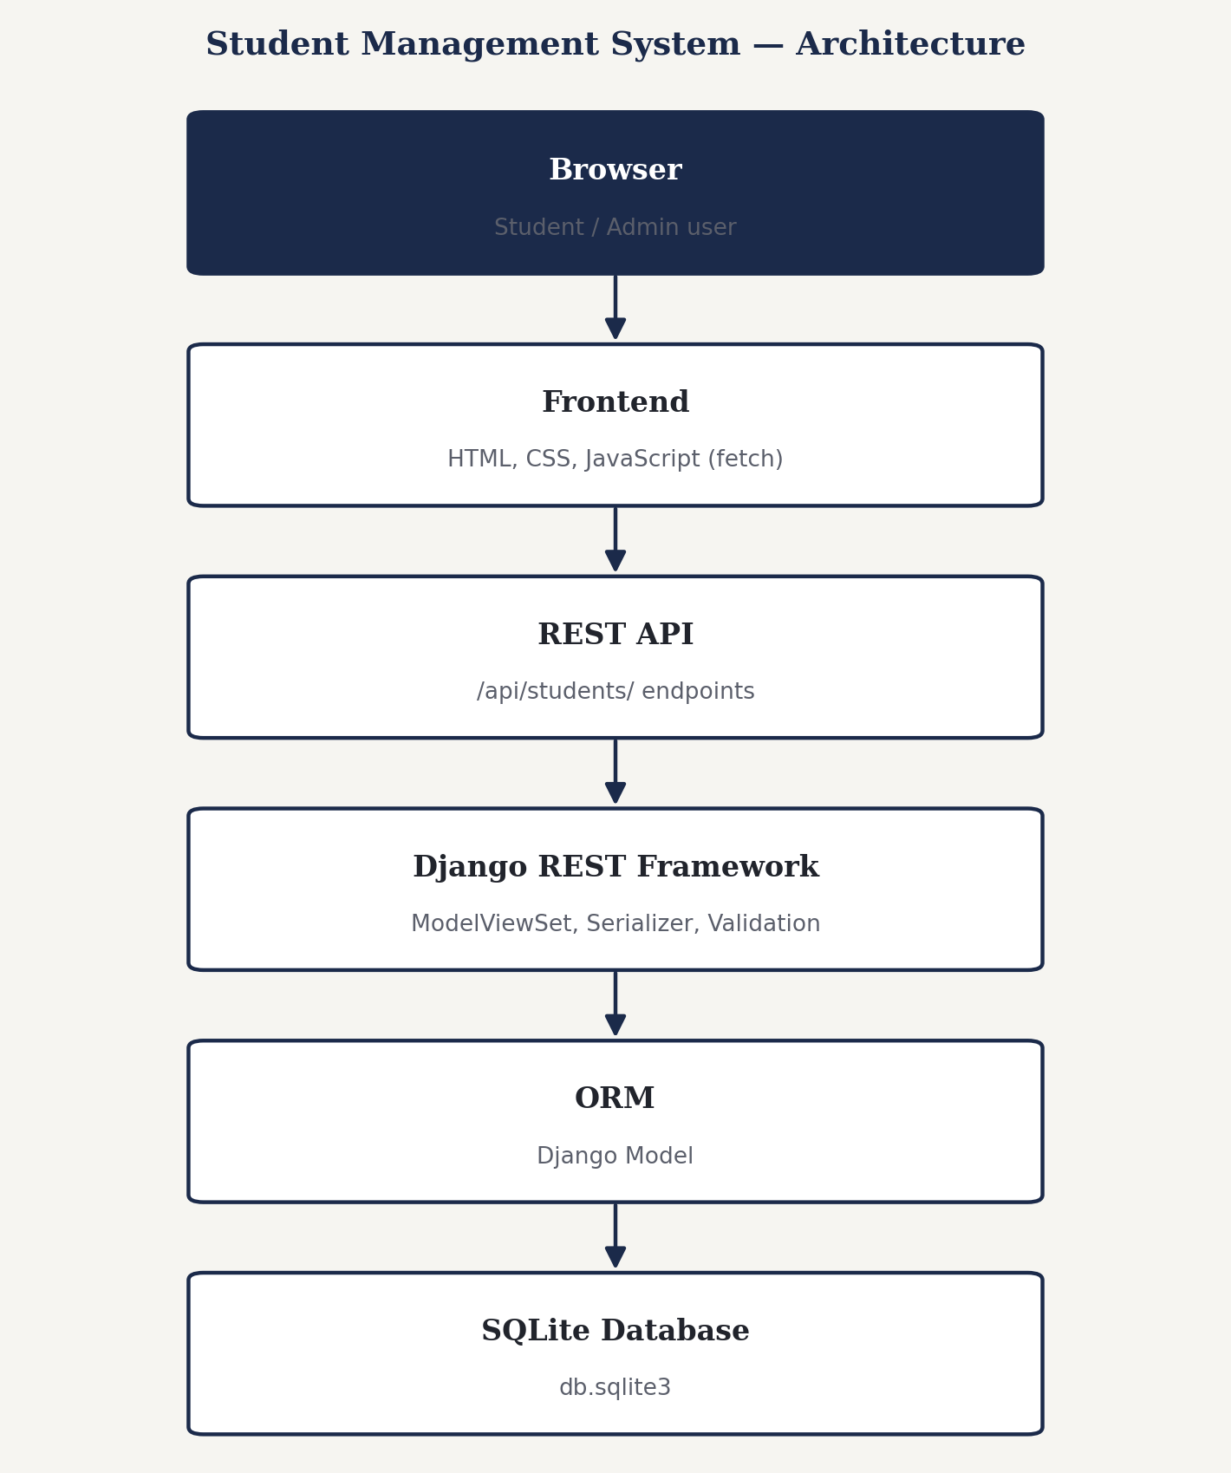
Figure 1 — Layered architecture of the Student Management System
Serving the frontend directly from Django (via STATICFILES_DIRS / TEMPLATES DIRS pointed at the frontend folder) means the whole application runs from a single command with no cross-origin requests to configure for normal use. django-cors-headers is still included so the API can be called from a separately-hosted frontend if the project is extended later.

6. Database Design
The system uses a single Student entity — there are no relationships to model, so no foreign keys are required. Two fields (roll_number, email) are constrained unique at both the database and serializer level.
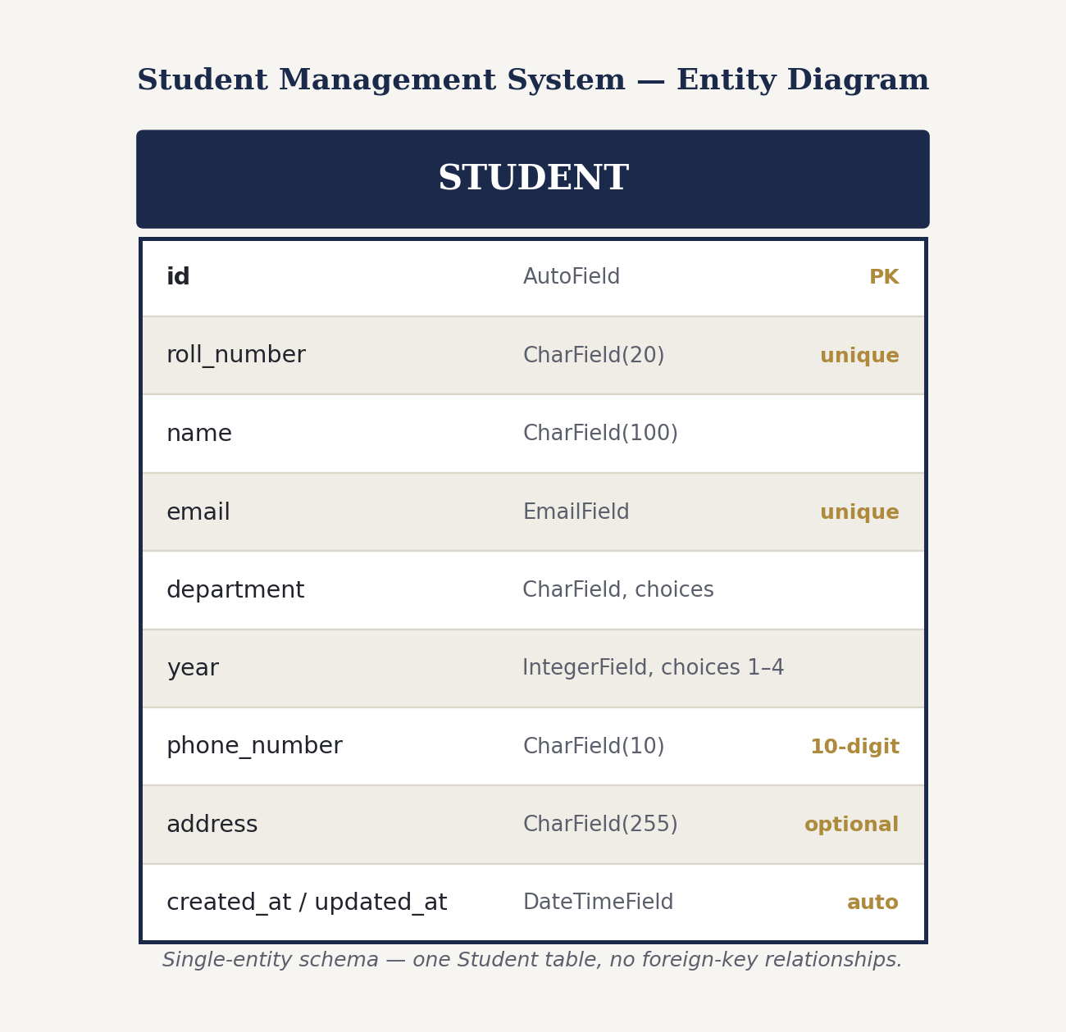
Figure 2 — Student entity and field constraints

7. User Interface
The interface is a single page: a header with live record/department counts, a toolbar for search and filtering, a data table listing every student, and a modal form used for both adding and editing a record.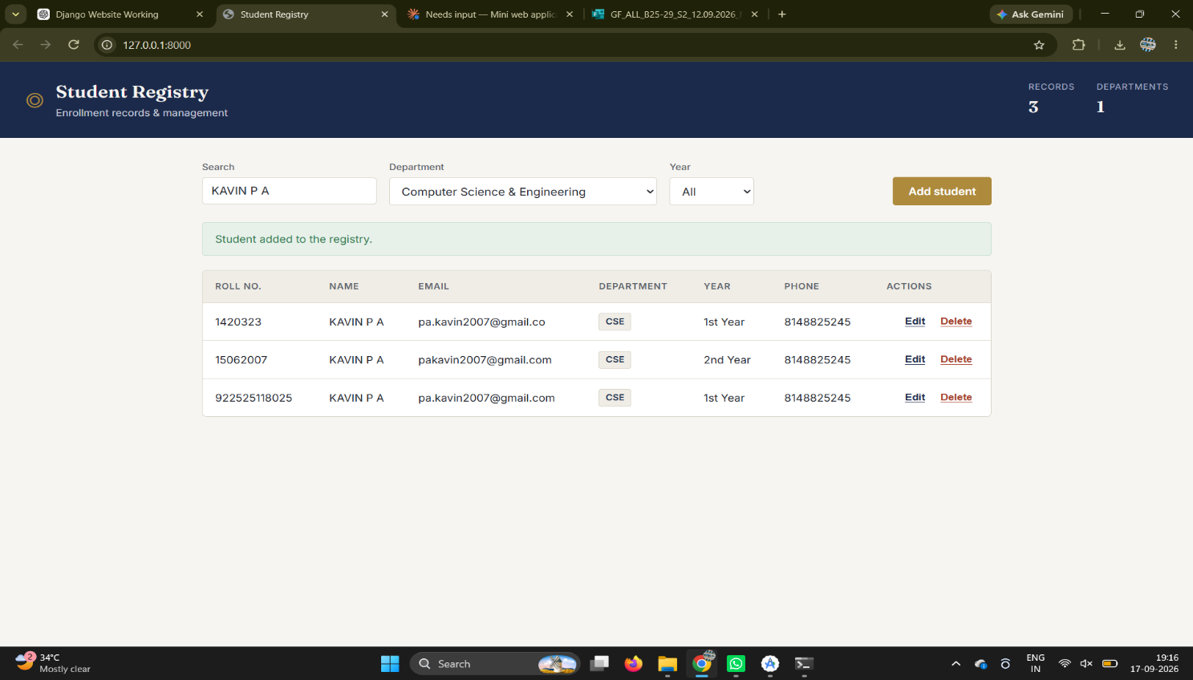

Figure 3 — Student list view, populated with sample records
The same page also includes an Add/Edit modal (opened via the “Add student” button or a row's Edit action) with inline validation messages, and a delete-confirmation dialog. Capture these two states from your own run — see Section 12 — and insert them here before submission, alongside this list view.

8. REST API Reference
Base URL: http://127.0.0.1:8000/api/students/
Operation | Method | Endpoint | Result
Create | POST | /students/ | New record created (201)
Read all | GET | /students/ | List of records (200); supports ?search=, ?department=, ?year=
Read one | GET | /students/{id}/ | Single record (200) or 404
Update | PUT | /students/{id}/ | Record replaced (200) or 404
Delete | DELETE | /students/{id}/ | Record removed (204) or 404

9. CRUD Implementation Details

Create
POST requests are handled by DRF's ModelViewSet.create(), which runs the payload through StudentSerializer for validation (required fields, uniqueness, format) before saving a new Student row.

Read
GET /students/ lists all records; get_queryset() layers on optional search/department/year filtering from query parameters using Q objects. GET /students/{id}/ returns a single record or a 404 if the id does not exist.

Update
PUT /students/{id}/ re-validates the full payload through the same serializer rules as Create, so a bad edit is rejected exactly like a bad creation.

Delete
DELETE /students/{id}/ removes the row and returns 204 No Content; deleting a non-existent id returns 404.

10. Validation Rules
Field | Client-side (browser) | Server-side (serializer)
roll_number | Required | Required, unique, normalized to uppercase
name | Required, min 2 chars | Required; letters/spaces/. ' - only
email | type="email" | Required, unique, valid email format
phone_number | pattern=\d{10} | Required, exactly 10 digits
department | Required, dropdown | Required, one of 6 defined choices
year | Required, dropdown | Required, one of 1–4
address | Optional | Optional
Server-side validation is authoritative: every rule above is enforced by Django REST Framework regardless of what the browser sends, so the API rejects bad data even if the frontend is bypassed (e.g. a direct Postman request).

11. Testing

11.1 Automated tests
Seven automated test cases (Django REST Framework's APITestCase) cover the API directly: creating a valid record, rejecting a duplicate roll number, rejecting an invalid phone number, listing and retrieving, updating, deleting, and search/filter. Run them with:
cd backend && python manage.py test
All 7 tests passed during development of this project. Re-run them after setup to confirm your environment.
Test | Verifies
test_create_student | Valid POST returns 201 and persists a row
test_duplicate_roll_number_rejected | Duplicate roll_number returns 400
test_invalid_phone_number_rejected | Non-10-digit phone returns 400
test_list_and_retrieve | GET list and GET by id return the right data
test_update_student | PUT updates and returns the new values
test_delete_student | DELETE removes the row and returns 204
test_search_filter | ?search= and ?department= narrow results correctly

11.2 Manual Postman testing
Import postman_collection.json (Postman → Import). It is organized into Create / Read / Update / Delete folders, each covering valid requests and edge cases. Fill in the Actual Result column below from your own run, and attach screenshots in your submission:
Case | Expected result | Actual result
Create — valid data | 201 Created, record returned | ____________
Create — missing fields | 400 Bad Request | ____________
Create — duplicate roll number | 400 Bad Request | ____________
Create — invalid phone number | 400 Bad Request | ____________
Read — empty database | 200 OK, empty list | ____________
Read — populated database | 200 OK, list of records | ____________
Update — valid id | 200 OK, updated record | ____________
Update — invalid id | 404 Not Found | ____________
Delete — valid id | 204 No Content | ____________
Delete — invalid id | 404 Not Found | ____________

12. Installation and Execution Steps
- Create and activate a virtual environment: python -m venv venv
- Install dependencies: cd backend && pip install -r requirements.txt
- Apply migrations: python manage.py migrate
- Run the server: python manage.py runserver
- Open http://127.0.0.1:8000/ in a browser — frontend and API are both served from here.
- Optional: python manage.py createsuperuser, then visit /admin/ for the built-in admin view.
Full details, including the Postman workflow, are in the project's README.md.

13. Design Decisions & Challenges
A few deliberate choices shaped this build:
- Single-origin frontend: the frontend is served by Django itself (STATICFILES_DIRS / TEMPLATES DIRS pointed at the frontend folder) rather than run on a separate dev server, so there is no CORS configuration required for normal use, and the whole app starts with one command.
- Duplicated validation, single source of truth: rules are checked in the browser for instant feedback, but the serializer re-checks everything server-side, so the API stays correct even if a request skips the UI entirely.
- Consistent roll numbers: roll_number is normalized to uppercase in the serializer, so ‘21cse045’ and ‘21CSE045’ are treated as the same student instead of silently creating duplicates.

14. Future Enhancements
- Authentication so only logged-in staff can add, edit, or delete records.
- Pagination for the student list once the roster grows large.
- CSV export of the current (filtered) roster.
- Bulk import of students from a spreadsheet.

15. Git Repository & Submission Reference
Item | Reference
Git repository | [insert your GitHub repository URL]
Demo video / link | [insert if required by the activity guidelines]
Activity | VSB Skill Vault — Activity 3, Mini Web Application (CRUD-Based Web Application)
Submission deadline | 17 September 2026, before 8:00 PM

