### Hazard assessment Template

|  |  |
| --- | --- |
| **Title** | Identify the Technical system being assessed |
| **Author** | Date and names of team conducting the assessment |
| **Current state of technical system** | Describe the current state of the technical system, with its existing controls/barriers/procedures in place. E.g. ‘Battery powered lawnmower for domestic use.’ |

**1 Architecture of the system**

Draw a diagram representing the architecture of the system. [1 page, hand drawn is acceptable. This could be an annotated photo, mindmap, workflow diagram, etc.]

**2 Risk matrix and scales adopted**

Use these unchanged.

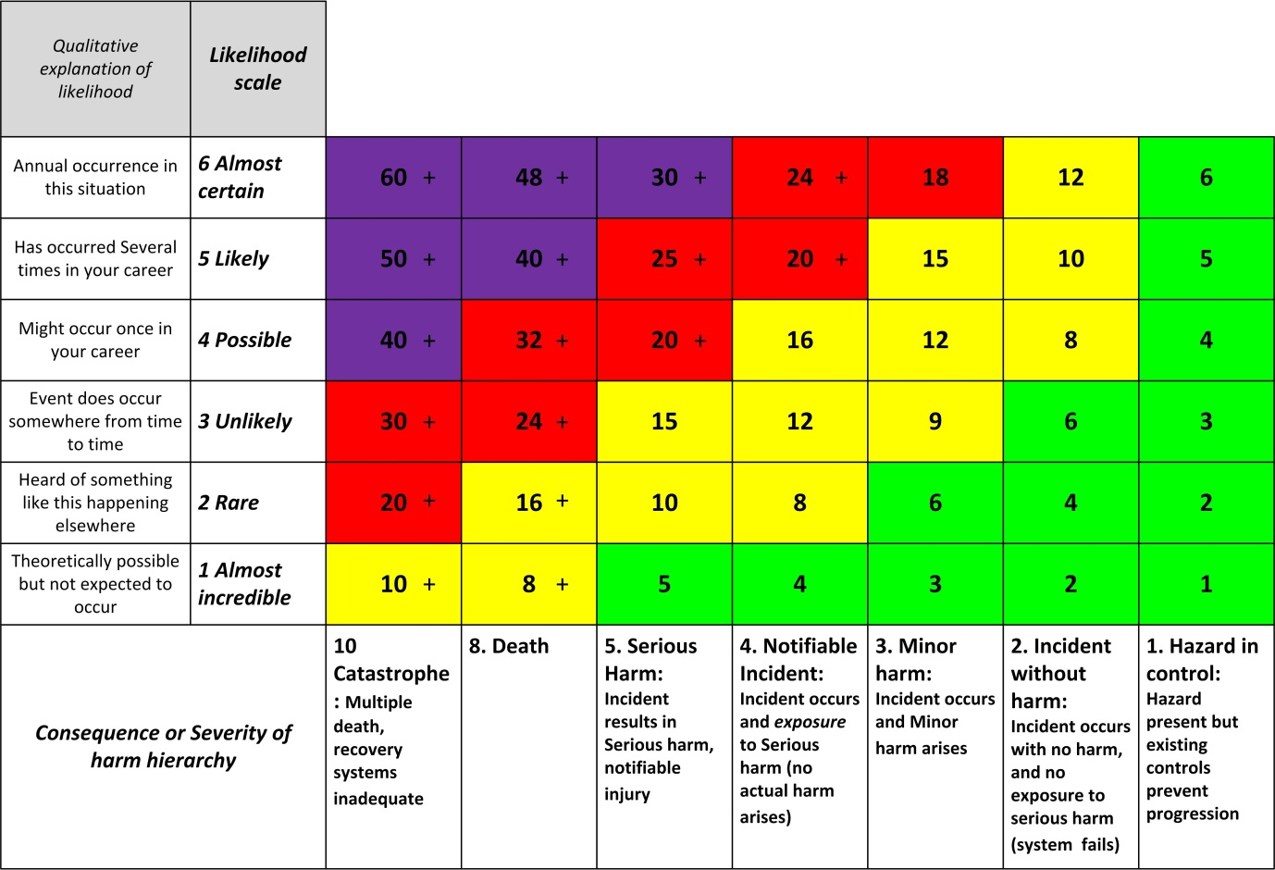

Try to get the analysis to the level where the HARM outcomes are linked to a root cause. Such as ‘Cut to hand from sharp edges’, ‘Hearing damage from cutting noise’, ‘Smoke & dust inhalation from substrate and disc’, ‘Amputation of fingers’, ‘Serious lacerationsfrom disc fragments’, ‘Burn from hot battery’, ‘Fire from battery or charger’.

**3 Risk register**

|  |  |  |  |  |  |  |  |  |  |  |  |  |
| --- | --- | --- | --- | --- | --- | --- | --- | --- | --- | --- | --- | --- |
|  |  | Risks of system in its CURRENT STATE, with its existing controls. | | | | | |  | Risks of system in its FUTURE STATE after these treatments. Insert any new threats caused by the treatments. | | | |
| Architecture level: Work-stream, project phase, hardware category, workstation | Specific hazard | Consequence (C), as per ‘Severity of harm’ scale  1. Hazard occurred  2. Incident with no harm  3. Incident and Minor harm  4. Incident and exposure to serious harm  5. Serious harm Occurs  8. Death  10. Catastrophe | Likelihood (L) of that harm consequence arising  6 Almost certain  5 Likely 4 Possible  3 Unlikely  2 Rare  1 Almost incredible | Risk = (C x L) | Treatment? Consider Preventative and Recovery mechanisms.  30 or higher Unacceptable risk.  18 or higher Urgent treatment.  8 or higher Consider treatment  7 or less No intervention necessary. | Action required by who? Resources required? | Monitoring required of efficacy of treatment? |  | Treated Consequence (C*) | Treated Likelihood (L*) | Residual Risk  (C* x L*) | Is this acceptable? What further action is required? |
| Car cabin compartment - Electrical Fire | Smoke inhalation | 5 | 3  Car Doors provide escape route | 15 | Install Smoke detector in battery compartment, for early warning | Designers, Mechanical, Electronic, Software | Car startup software to monitor state of Smoke detector |  | 3 | 2 | 6 | Risk reduced sufficiently |
|  |  |  |  |  |  |  |  |  |  |  |  |  |
|  |  |  |  |  |  |  |  |  |  |  |  |  |

### Appendix – optional

You may include up to two pages of other supporting material