Close Action
NAVAL WARFARE IN THE AGE OF NAPOLEON, 1793-1815
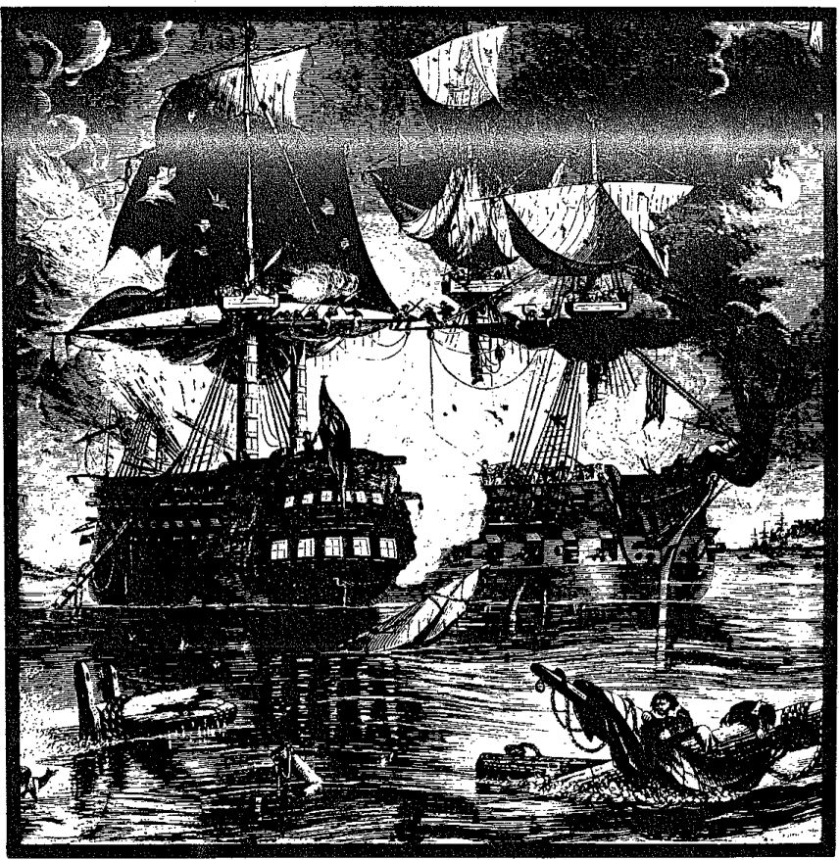
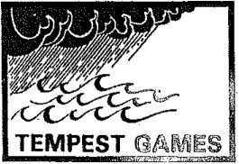
VERSION 6.1

CLOSE ACTION

VERSION 6.1
"...in case signals can not be clearly seen, no captain can do very wrong if he places his ship alongside that of an enemy."
- Vice Admiral Horatio Nelson

CREDITS
(Listed in Alphabetical Order)
DESIGN Mark A. Campbell DEVELOPMENT Mark Campbell, Chaim D. Kaufmann, Albert C. E. Parker
HISTORICAL RESEARCH Mark Campbell, Albert Parker
RULES EDITING Chaim Kaufmann, Albert Parker
DEVELOPMENT AID .... Thomas S. Ballou, Mark E. Hancock, John F. Kolb, Carl Nogueira, Eric S. Raymond
COMPUTER TECHNICAL SUPPORT Christopher Bell
PLAYTESTERS:
Thomas Ballou, Neil Calvert, Robert Cunningham, Web Ewell, Mark Hancock, George and Leo Kelepouris, John Kolb, Thomas Kinney, Tom Kusterer, Leonard Jeppe-Kroll, Seth Owen, Steve Payne, Peter Reese, Kelly Schmitz, Don E. Williams, and many others too numerous to individually mention.
SPECIAL THANKS:
The contributions of three men have been so important in the development and improvement of Close Action over the past decade that it is proper to single them out for special mention. In the age of Napoleon, naval officers of especial daring, courage and skill were called ’star-captains." The star-captains of CA are: Mark Hancock, who encouraged me to design CA and was instrumental in its early development; Albert Parker, who has constantly supported the side of historical realism; and Chaim Kaufmann, whose constant drive has been to make CA both accurate and playable ... his efforts have made CA more elegant yet less complex. Albert Parker and Chaim Kaufmann have also been invaluable as editors.
- owe these three a greater debt than I can ever repay. My particular thanks to them, and to the many other loyal and dedicated men who have helped improve CA.
Lastly, I must point out that, although CA has benefitted from the ideas and advice of others more than from my own efforts, any errors in these rules are naturally entirely my responsibility.
Copyright © 1991 by Tempest Games
All rights reserved.
TEMPEST GAMES
426 South St.
Plainville, MA 02762
CLOSE ACTION was written, edited, and typeset using the XyWrite ill+ word processor running on an IBM- compatible 386sx and a LaserJet III laser printer. Diagrams produced using Corel Draw 2.0. Printing by Flash Print of Pawtucket, Rl.

TABLE OF CONTENTS

- INTRODUCTION 2
- Overview 2
- Game Scale 3
- Physical Components 3
- Counters 4
- Log Sheet 4
- Sample Ship Log 6
- SEQUENCE OF PLAY 7
- Game-Turns 7
- Phases 7
- WEATHER PHASE 8
- Weather Aspects 8
- Wind Direction 8
- Wind Speed 8
- PLOT PHASE 9
- Plotting 9
- Crew Tasks 9
- MOVEMENT UNDER SAIL 10
- Movement Allowance 10
- Movement Plot Procedure 10
- Turning 11
- Acceleration and Deceleration 12
- Tacking and In Irons 13
- Sail Status 14
- Blocked Wind 15
- Drifting 15
- Illegal Moves 16
- MOVEMENT EXECUTION 16
- General Movement Procedure 16
- Turning Away While Adjacent 16
- Contested Hexes 17
- Bearing Off 18
- Collisions and Fouling 19
- Poor Maneuvering 19
- GUN FIRE AND MARINE FIRE 20
- Gun Fire - Choosing Targets 20
- Gun Fire - Field of Fire 20
- Gun Fire - Line of Sight 21
- Lower Deck Guns 22
- Gun Fire Resolution 23
- Ammunition 24
- Damage from Gun Fire 25
- Marine Fire 26
- BOARDING 27
- Boarding Parties 27
- Boarding Eligibility 27
- Boarding Procedure 27
- Reorganizing 28
- Operation of Captured Ships 29
- MAINTENANCE PHASE 30
- Grappling & Ungrappling 30
- Unfouling 30
- Fighting Fires 30
- Fire Damage and Explosion Effects 31
- Sinking Ships 31
- Repairs 32
- Other Actions 32
- CREW QUALITY AND MORALE 32
- Crew Quality, Skill and Morale 32
- Morale Checks 32
- Striking 33
- SIGNALLING 33
- Basic Signalling Rules 33
- Message Format and Contents 33
- Flagships 34
- SPECIAL MOVEMENT RULES 34
- Anchoring - General Rules 34
- Preparing to Anchor 35
- Anchoring 35
- Anchoring with Springs 36
- Warping 36
- Getting Under Way 36
- Towing 37
- Rowing 38
- Shallow Water and Land 38
- Casting the Lead 38
- Lightning Tack 38
- OPTIONAL RULES 39
- Pro-Rated Movement 39
- Surrendering 39
- Limited Intelligence 40
DESIGNER'S NOTES 40
GLOSSARY Inside Back Cover

I. INTRODUCTION
'The world has never seen a more impressive demonstration of the influence of sea power upon its history. Those far distant, storm-beaten ships, upon which the Grand Army never looked, stood between it and the dominion of the world*
W Alfred Thayer Mahan, The Influence of Seapower Upon the French Revolution and Empire
CLOSE ACTION (CA) is a realistic game system that recreates tactical naval combat during the wars of the French Revolution and Empire, better known as the Napoleonic era. During this quarter-century of nearly continuous warfare, the warships of France, Spain, the Netherlands, Denmark, Russia and the United States fought against the British Royal Navy for supremacy on all the seas of the world. Through calm and storm, wind and wave, the great wooden sailing ships of this era decided the fate of nations and empires. In a thousand actions large and small, the British navy time and again defeated the best that France and her allies could send to sea, creating in the process an empire 'on which the sun never set.'

I.A OVERVIEW
CA is a simultaneous movement game. At the beginning of each game-turn, all players plot their actions for that game-turn on ship logs. The plots are then revealed and executed simultaneously. As a ship captain, you will have three main things to concern you; seamanship, gunnery, and crew management. We'll give a brief overview of each, then conclude with some suggestions on how to learn the rules most quickly and effectively.
- A.1 Seamanship. To defeat the enemy, you must bring him to battle under conditions that give you an overall edge. In the age of sail, ships were dependent upon the variable winds for movement; tactical initiative generally rested with the side that held the upwind (windward) position from their enemies. Naval tactics were dominated by the struggle for this 'weather gauge' advantage, and 'seamanship' (the ability to maneuver a ship skillfully) was often the decisive factor in naval battles.
In general, smaller ships were more maneuverable than larger ones, but they were also more vulnerable in storms. Even among ships of the same general type and size, hull design and loading could cause significant differences in speed and agility. The amount of sail made a difference, too; more sail meant more speed, but also greater vulnerability to battle and storm damage.
The CA rules reflect all this. The amount of movement and maneuver you will be able to plot for your ships will vary a great deal, depending on wind speed, wind direction, and your ship’s size, speed rating, and the amount of sail carried. Speed and maneuverability will also be reduced by damage.
In general, you plot movement by specifying a sequence of actions (normally forward movements of one or more hexes and 60° turns) until you run out of movement points or the allowed number of turns. There are various other special moves for unusual situations (for example, certain small vessels can tack more quickly than other ships).
The core of the movement rules is sections V and VI. Bear in mind in studying these rules that large sailing warships were large objects with a great deal of inertia; most of the movement rules are designed to simulate the difficulties of maneuver in ships that, far from turning on a dime, sometimes required hundreds of yards to make significant changes in direction (assuming that the wind would allow a contemplated maneuver at all).
I.A.2 Combat. There are three possible forms of combat in CA - gun fire, marine fire, and boarding. While marine fire and boarding are occasionally useful, your guns are your ship’s main weapons. In sailing ships of this period guns mounted to be able to fire directly fore or aft (that is, over the bow or stern of the ship) were rare; the main weapon was the broadside, the massed destructive power of up to 70 side-firing cannon. Indeed, the bow and (especially) the stern were were particularly vulnerable to gunfire; thus the dream of every captain was to maneuver to 'cross the T,' or rake, the opponent, pouring a broadside into the enemy's bow or stern at short range without receiving any significant return fire. This was the epitome of good seamanship. Of course, there were many other less dramatic but equally effective ways to concentrate force against the enemy, and a rake will often place your ship out of position to support or be supported by the rest of your squadron. Like real naval warfare, teamwork is the key to Close Action multi-player games.
Naval guns came in two basic varieties. Large warships were usually equipped mostly with long guns. These cannon were effective out to about 1000 yards (13 hexes in CA); the shorter carronades, like shotguns, were quite effective at short ranges (around 300 to 400 yards, or 5 hexes in CA), but totally ineffective at longer ranges. None of these guns were rifled, and they were thus ridiculously inaccurate by modern standards; thus, if neither side was able to outmaneuver the other, historical battles generally degenerated into slugging matches. In the game, the range to target is the most important determinant of your chances to hit.
Your chances to hit are also affected by the quality of your crew, and are further modified by various other factors (whether you're anchored, dismasted, and so forth). You can elect to fire high (at the rigging) or low (at the hull); the former hurts your opponent's maneuver capacity more, while the latter is more likely to cut into his fighting strength.
There were several types of ammunition used in this period, including roundshot, grapeshot and chainshot. Unlike movement, gunnery fire isn't plotted, so you just choose what type of ammo to fire at the moment of shooting. Roundshot is the normal choice (it’s effective in the widest variety of situations), but grapeshot (particularly devastating against crew) and chainshot (against rigging) may prove useful.
i.A.3 Crew Management Your ship needs crew to operate it. There are two types of crew in CA - sailor crew sections and marine crew sections. Sailor crew sections can perform all crew functions except marine fire - fire the guns, set or take in sail, make repairs, anchor, and so forth. Marines can perform all crew functions except firing the ship's guns. In addition, they can perform marine fire, and are better at boarding than sailors. (Boarding was historically a usually unsuccessful tactic, but has been included because it was always a threat, and did sometimes succeed.)
The key statistics about your crew are its quantity (the number of crew boxes in each section), its quality (which can vary from "Elite’ to ’Demoralized,’ reflecting its state of training), and its morale, which quantifies how willing the men are to keep fighting. Quality has wide-ranging effects on your ship's gunfire and many other situations.
As your ship takes battle casualties, you may need to make hard decisions on how to allocate crew sections for maximum effectiveness.
I.A.4 How to Study the Rules. The rules come in two parts: the standard rules and a few optional rules. The standard rules comprise all the rules you need to know to play any CA scenario or tournament game.
There are a few optional rules which add some realism to the game system at the cost of additional complexity. Do not use these rules until you are familiar with the standard rules.
Chapter II of the rules covers the sequence of play for each game-turn, while chapters III (Weather), IV (Plot) V and VI (Movement), VII and VIII (Combat) and IX, X and XI (Maintenance) are arranged roughly in order of their appearance in the sequence of play. The one exception to this is chapter XII, Special Movement Rules. This chapter covers many movement rules which are used infrequently (such as anchoring, towing and rowing). It was deemed more logical to place them in a separate section, after the main body of the rules, rather than cluttering up the main movement rules.
The core of the rules is in chapters II through VI. Study those first. Chapters IV, V and VI are especially important, as they tell you how your ships move. Chapter VII covers the vast majority of the combat in CA; study it carefully. Chapter VIII (Boarding) covers the remaining type of combat; save this section for last, as boarding situations rarely arise.
CA uses a number of abbreviations to save space in the body of the rules. The glossary (see inside back cover) identifies all abbreviations, and also lists ail notations used to plot movement and other actions.

I.B GAME SCALE
1 hex » 75 yards.
1 game-turn = 3.33 minutes of real time.
1 crew box = 25 men.
1 movement pt. = 2/3 of a knot.
1 gun box = 45 pounds of broadside weight of shot (adjusted)
1 carronade box - 80 pounds of broadside weight of shot (adjusted)

I.C PHYSICAL COMPONENTS
1.C.1 Items Required. In order to play CA, you need this rule set, an appropriate playing surface and two dice. This edition of CA comes with the following components:
- The Rules booklet (this book).
- The Scenarios and Tournament rules booklet.
- Four cardstock sheets, in blue, red, green and yellow, on which are the tables needed to play CA.
- A 3-color glossy counter sheet, containing the informational counters used to play the game. These should be mounted on a cardboard backing and must be cut out before playing the game.
- Two blank ship Log sheets, containing three ship logs each.
- A Message form for multi-player games.
- A registration card to register you as an owner of CA.
- C.2 Items Not Included but Necessary. Close Action requires but does not currently include a playing board, two six-sided dice and at least two players.
LC.3 Mapboard. CA is primarily intended to be used with a mapboard gridded into regular hexagons. This hexgrid is used to determine movement, weapons ranges and ship positions. You must use the recommended mapboard in order to play the scenarios presented in the Scenario book, but any regular hexgrid will serve for 'design your own* scenarios.
I.C.4 Dice. At least two standard six-sided dice are required (more are useful). The dice are rolled either singly or in pairs: when rolling two dice, sum the spots to determine the final number.

l.D COUNTERS
I.D.1 Counter*. CA includes all the markers (called counters) needed to represent the ships and various information about the ships. Although all references in the rules are henceforth to the counters included, you may also play CA with miniature ships for greater visual appeal. If you use the CA counters, it is recommended that they be mounted on a hard cardboard backing before use. The following instructions describe how best to do that.
I.D.2 Mounting the Counter Sheet. The counter sheet included with CA should be mounted on a stiff piece of cardboard which has a smooth, preferably white surface on one side. This side will be the back side of the counter sheet. The side which will be attached to the counters may be either smooth or rough; it doesn't matter.
First liberally coat the rough side of the cardboard with rubber cement. Spread it around with the applicator until it forms a nice, smooth coat. Wait for a few seconds until it begins to skim over, then place the counter sheet down on top of the cardboard. Starting at the center, press down on the counter sheet until it is firmly bonded to the cardboard, Work outwards towards the sides, continuing to press down as you go, so as to avoid air pockets. After the counter sheet is firmly attached to the cardboard, let dry for about an hour.
- D.3 Cutting out the Counters. You will need a sharp X- Acto knife and a metal straightedge for this step. Take the straightedge and X-Acto knife and carefully and slowly scribe along the indicated counter edges. After scribing a few times, you can take the straightedge away and continue cutting slowly until you have cut entirely through the counter sheet and cardboard backing. Do all the cuts in a single direction (i.e., all the rows or all the columns) first. After this is complete do the other direction. When you make these cross cuts, be very gentle; avoid cutting entirely through the cardboard until you have scribed as many of the cross lines as possible, because the counters will now begin to fall to pieces, making the cutting more difficult. Do not hurry as you do this; if you do the counter edges tend to tear, producing an unsightly mess.
I.D.4 Counter types. There are two types of counters, ship counters and status counters.
I.D.5 Ship Counters. Each ship counter represents a single vessel. All ship counters occupy 2 hexes. CA includes 48 ship counters - 24 dark blue and 24 light blue. Each ship counter has a single letter (A-X) near the starboard bow of the ship. This letter is the identification code for that ship. Both the dark blue and light blue ship counters share the same ID letters; the sides can be distinguished by their different background colors.
FIGURE 1 - SHIP COUNTER
I.D.6 Status Counters. Other counters are necessary to represent the state of each ship during the course of a game. These are called status counters. CA includes 140 status counters.
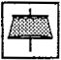
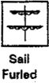
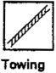
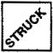
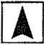
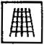
(MS)
Sall
Struck
Wind
Arrow
Men in Rigging
-2
Maneuver Sail
(for damage)
IN
IRONS
Obscured Broadside
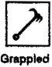

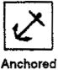

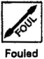
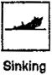
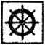
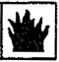
Dismasted
(PS)
Plain Sail (for damage)
Boarding Party
In Irons
Wheel
Shot Away
On Fire
CALM
Drift
DRIFT
Wind
Speed 0
FIGURE 2 - Status Counters
Dismasted

I.E LOG SHEET
I.E.1 Introduction. CA comes with blank log sheets, which you may photocopy as many times as you wish. Each log sheet has space to record all of the necessary information for three ships. Each ship is rated in two categories - damage boxes and other information. Damage boxes are indicated by square boxes on the log, while the rounded-comer boxes list other information.
I.E.2 Filling Out the Log. Before beginning play, a log must be filled out for each ship. All the information to be entered in the log may be found on the Ship Data Chart (SDC) or in the scenario order of battle (OB). Refer to figure 4 on the next page while reading the following descriptions.
I.E.2 Boxes. Each ship has a specific number of rigging, hull, crew, and gun boxes. The log has enough boxes of each type for the largest ship, but since most ships are smaller, some boxes of each type must be crossed out at the start of each scenario to show that they are not used.
I.E.4 RIGG (Rigging Sections). All ships have four rigging sections. The number of rigging boxes in each section reflects the ability of the masts, yards, sails and lines of the ship to absorb damage. Give your ship the correct number of boxes for each section. This information is specified in the ’RIGGING' column of the SDC.
EXAMPLE («ee Figure 4): The ship shown (a British 74) has 7 rigging boxes in rigging section 1, and 6 boxes in rigging sections 2, 3 and 4. The crossed-oirt boxes show battle damage suffered in a hypothetical battle.
I.E.5 HULL (Kull Sections). All ships have three hull sections. The number of boxes in each section reflects the ability of the ship's hull to absorb damage. Give each hull section the correct number of boxes, as specified in the ’HULL’ column of the SDC or OB. The small number in parentheses in the hull column of the SDC is the ship’s critical hit (CH) modifier. Place this number in the ’CH’ box to the right of the hull sections on the log.
EXAMPLE (tea Figure 4): The British 74 has 9 boxes in hull section 1 and 8 boxes in hull sections 2 and 3. The CH modifier is 0. The boxes are crossed out to show battle damage suffered in a hypothetical battle.
I.E.6 CREW (Crew Sections). All ships have four crew sections. The numbered crew sections (1-3) represent the ordinary seamen who comprised the majority of a ship's crew; they are called sailor crew sections (CS) in CA. The fourth CS, labelled ’M,’ represents the ship's marines and topmen and is referred to as the marine CS in CA. Al! of the ship's crew boxes belong to one of these four CS's, and the number in each section is shown in the ’CREW’ column of the SDC. Enter each section in the appropriate area on the log.
The small number in parentheses in the crew column of the SDC is entered in the box labeled ’P" on the log (see Vll.G.6 for more information on pumps).
- E.7 GUNNERY (Guns and Carronades). Two types of guns constituted the heavy artillery of a ship; tong guns (labeled 'GUNS’ on the log) and carronades (labeled O' on the log). Most ships have both types of guns, but some have only one or the other. The SDC shows the long guns in the *G’ column and carronades in the ’C’ column. The numbers given are the number of gun and carronade boxes on each broadside of the ship. The number in parentheses to the right of the ’C’ column are the lower- deck guns. These are a part of the ship’s long guns, unless the ship has no long guns, in which case they are part of the carronades. Lower-deck guns (LDGs) cannot fire in certain weather conditions (depending on the ship’s freeboard). Record the guns and carronades on the log by leaving the appropriate number of empty boxes, and crossing out the rest. Record LDGs by placing a dot in the center of the appropriate number of boxes.
EXAMPLE (we Figure 4): The British 74 has 16 guns and 4 carronades per broadside. Of the 16 guns, 10 are LOG, so a dot is placed in 10 gun boxes (some are crossed out to represent battle damage suffered during a hypothetical battle).
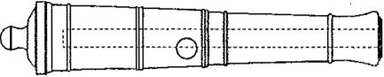
32-pdr. Long Gun

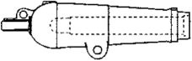
32-pdr. Carronade
FIGURE 3 - Long Gun and Carronade
I.E.8 Other Information. There are other boxes which must be filled out for each ship, although some of them might not be used in a particular battle.
I.E.9 Nat. Write the ship's nationality here (BR for British, FR for French, etc.).
I.E.10 Rate. Write the ship's rate here. This is the number of guns nominally carried (e.g., 74,120, etc.).
I.E.11 CQ and MR. if you are playing a scenario from the Scenario and Tournament Rules book or some other source, then the ship's CQ and MR will be given in the scenario's order of battle (08) section. If you are fighting a Tree build,' then the CQ and MR values will be part of your selection process for your ships, and you will know them. In either event, you should now enter the CQ letter (A-E) and the MR number (2-5) in the proper boxes at the top of the log.
I.E.12 Ship Name. If this is a scenario from th® Scenario and Tournament Rules book, the ship's name will be included in the scenario’s OB section. If fighting a Tree build’ scenario, select a suitable name for your ship. Enter the name in the ’SHIP NAME' box at the top of the log.
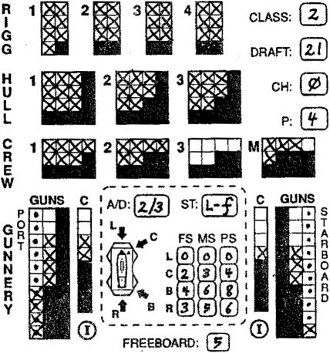
Nat. Rate CQ MR SHIP NAME ID
7? | B | 3 | KeMUN | X |
1
2
3
4
S
6
7
8
S
10
11
12
13
14
IS
16
17
18
IS
20 21 22 23 24 25
MOVE | SAILS | NOTES
_5L |  | fss-rt
$¥ |  | ?55 - H
1 |  | - ft
SiS I
rzs |  | 755 -M
1 sz
717 |  | RR-rt
7 |  | RK-K UT
 |  | RR-tf
i |  | TAS - M
 |  | PAS - At
— |  | A
(s] | Fu»L-rt | rtc
fsl
Zr) |  | re-m
 |  | MC
 |  | FoulsP
 |  | 3 fie
STKIKB^

LE.13 ID. Write the ship counter's ID letter (A-X) here.
I.E.14 Class. CA divides all sailing warships of the Napoleonic period into four types, or classes. The class number of a ship provides a broad indication of its hull form, tonnage, and height above the water - three interrelated measures which divided ships into general levels of performance. This value determines the ship's general movement characteristics. It is found under the "C:" line in either the SDC or OB. Enter this number in the box labeled "Class" at the upper right of the log. A few ships have a small superscripted number next to the class number; in this case the ship is of the class indicated by the larger number but it turns as a ship of the superscripted number. Enter both numbers in the class box.
I.E.15 Draft. This determines the depth of water the ship draws. It is found in the "D:‘ column in the OB or SDC.
I.E.1K Freeboard. This value determines how high the ship carries its LDGs (the higher, the better). It is found In the "Ft" column in the OB or SDC.
I.E.17 Movement, in the center of the ship log is a dashed-outline box. This box contains all the information necessary for determining the ship's movement. There are four invidual items within this dashed box. They are:
- Wind Facing Determination diagram. A small diagram of a ship, showing the wind facings.
- A/D. The Acceleration and Deceleration of the ship goes in this box. This is found by consulting the Speed Change Table on the red sheet.
- ST (Speed Type). The letters from the column labeled "ST* on the SDC are entered here.
- FS, MS, PS. The 12 boxes under these headings contain the ship’s current Movement Allowance for each sail state and wind facing. Consult the Movement Determination Table (MDT); cross-index with the ST and Wind Speed to determine these values (see V.A). Use a pencil to fill out this section, as the values in it change frequently (it's a good idea to use pencil throughout the log, but it's especially important here).

LF SAMPLE SHIP LOG
I.F.1 Sample Log. To provide you with a guideline on how the ship log is supposed to be used and filled out, a sample log’for a British 74 is provided here, completely filled out and ready for play. In addition, the damage absorbed, moves and other notes for a complete game are given to show how movement and other notations should be written.
FIGURE 4 - Sample Log (British 74)

EXAMPLE: A ship lows its second hull section and must ssnd mon to the pumps. The ship's pump value is 3, so it must send 3 crew boxes to the pumps. The following combinations are valid (assuming the ship has enough of each type of crew): 3 sailor crew boxes; 2 sailor crew boxes and 1 marine crew box; 1 sailor crew and 2 marine crew boxes; 3 marine crow boxes.
Vll.G.7 Crew Damage. If only one type of crew remains, then all c hits are automatically of that type. Otherwise roll one die on the proper line of the Crew Loss Table for each crew box which is lost. Use the top row of the table if firing low with roundshot; use the bottom row of the table for every other cause of crew loss (e.g„ firing high with any type of ammunition, firing low with chainshot or grapeshot, marine fire, and boarding combat).
VII.G.8 Sailor Losses. All sailor crew losses must come from the lowest-numbered sailor crew section.
- G.S Striking Due to Loss of Crew. A ship which has no crew available to freely assign (i.e., ail the crew is either crossed off or is dedicated to mandatory tasks such as fighting fires) immediately strikes.
- G.10 Gun Damage Location.
- Not a rake: Guns must be removed from the side of the target ship closest to the firing ship.
- Bow rakes: Gun losses are split evenly between the port and starboard broadsides. For odd boxes, roll-a die; 1-3 - port, 4-6 = starboard.
- Stern rakes: Since stem rakes cause double the number of gun losses indicated, half of the guns lost come off the port broadside, and half from the starboard side (there will always be an even number of guns lost because of the doubling).
VII.G.11 The Gun Loss Table. There are three types of gun boxes which can be lost: normal guns, lower-deck guns, and carronades. If a ship has only one type of gun box along a broadside, the box lost must obviously be of that type. However, if there is more than one type of gun box on the affected broadside, roll on the Gun Loss Table for each gun box lost to determine the type of gun box actually lost.
- Normal guns. If a ship has no normal guns, all normal gun losses become lower-deck gun losses.
- Lower-deck guns. If a ship has no lower-deck guns, all lower-deck gun losses become normal gun losses.
- Carronades. If there are no carronades remaining, carronade losses become lower-deck gun losses.
- If there are no gun boxes of any type on the affected broadside, mark out a hull box instead.
Vli.G.12 Critical Hits. In addition to damage taken according to the above rules, a ship may also suffer critical hits, if the gunnery DR is an unmoaified 6, then another DR is made immediately. If this second DR is < the CH number on the FGN row, a critical hit occurs.
- The CH chance is modified by the ship's CH modifier.
- If the second DR resulted in a CH, roll two dice and consult either the Hull or Rigging CHT; the Hull CHT if the firing ship was firing low or firing Grapeshot, or the Rigging CHT if the ship was firing high.
- All critical hits take effect at the end of the Combat Phase, unless otherwise noted.

Vll.H MARINE FIRE
VII.H.1 Who May Fire. Only marine sections may use marine fire, and they may fire only at adjacent ships. The orientation of the firing ship to the target ship is immaterial (see back cover of this book for field of fire diagram).
VILH.2 Target. The entire marine section must fire at one enemy ship, even if more than one target is available.
VII.H.3 Procedure. Count the number of marine boxes available at the beginning of the game-turn and roll one die on the Marine Fire Table (on the blue sheet), adding or subtracting the appropriate DRMs. The result is the number of crew boxes crossed off by the target ship. Roll on the Crew Loss Table for each box lost (unless the ship has only one type of crew remaining).
VILH.4 Die Roll Modifiers. The marine fire DRMs are all cumulative. One often misunderstood DRM is for firing from a larger class to a smaller. If the firing ship is larger than the target ship (class # < the target ship class #), the firing ship gets a -1 DRM, regardless of how much larger the firing ship is. Note that there is no modifier when firing from a smaller class to a larger.
EXAMPLE: A class 1 ship firing at a class 2, 3 or 4 ship would have a -1 DRM in all cases. A class 3 ship firing at a class 4 ship would also get a -1 DRM.
Vii.H.5 Marine Availability. A marine section may fire only if it has not been plotted to perform another task in the same game-turn. [Exception: Marines assigned to boarding parties or to repel boarders may fire.}
Vll.H.6 Simultaneity with Gunfire. Marine fire is simultaneous with gun fire. Therefore, marine crew losses inflicted by gun fire do not reduce the number of marine boxes which can use marine fire in the same turn.

HL WEATHER PHASE
7 cannot command winds and weather.’
M" Horatio Nelson
Changes In the direction and speed of the wind are quite common in most oceans, and had major tactical Implications In the age of sail. Every captain and admiral had to be prepared for the hazards and opportunities the wind might present.

IH.A WEATHER ASPECTS
III.A.1 Wind Direction and Speed. There are two elements to weather in CA: wind direction and wind speed.
IJI.A.2 Wind Direction. The wind direction (WD) at the beginning of every game is defined in each scenario or in the tournament rules. Orient the wind arrow to the correct direction using the wind rose (see Figure 5). The WD determines the Wind Facing (WF) of ail ships in the scenario; it may change in non-tournament games.
III.A.3 Wind Speed. The strength of the wind, or wind speed, is also defined at the beginning of each scenario or tournament game. The wind speed determines the movement characteristics of ships in each WF. A wind speed (WS) of 3 is a 'normal" or ‘average’ speed, at which most ships perform best, but the speed can range from 0 (calm) to 5 (tempest). Like WD, the WS can change in nontournament games.
III.A.4 Wind Change. During the Weather Phase of each game-turn, the Wind Speed and Wind Direction tables are consulted to determine if there is a change in the wind speed, wind direction, or both. As noted above, there is no wind change in tournament games.
ill.A.5 When Changes Take Effect. Any changes in wind speed or direction take effect in the Weather Phase of the next game-turn.
EXAMPLE: K a change in wind speed or direction is rolled on game-turn 2, the change takes effect on game-turn 3.
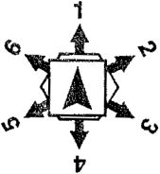
FIGURE 5 -
Wind Direction Rose

II!.B WIND DIRECTION
lll.B.1 Wind Direction Change Frequency. The WD change can be either oceanic (representing the steadier winds found far out to sea) or coastal (representing the more variable winds usually found near coastlines). The WD change frequency is specified in each scenario,
III.8.2 Wind Direction Change Procedure. Roll two dice and consult the appropriate column of the Wind Direction Table to see if the WD changes, if the WD does change, turn the wind arrow in the appropriate direction.
EXAMPLE (sac Figure 5): If the wind changes direction from WD 1 60° to the right, the wind would then be blowing In WD 2; If It changed direction 60° to the left, it wouid be blowing in WD 6.
Hi.8 3 Wind Direction in Wind Speed 0: Even if the wind speed falls to 0, continue rolling for wind direction change, and record any changes that occur. This is important, because if the wind increases to WS 1 or greater again, the wind direction will become useful again.
- C WIND SPEED
M.C.1 Wind Speed Change Frequency. The WS change can either be steady (representing trade winds, which did not vary much in velocity) or gusty (representing more variable winds). The WS change frequency is specified in each scenario.
III.C.2 Wind Speed Change Procedure. Roll two dice and consult the appropriate column of the Wind Speed Table to determine whether the wind speed changes. The Wind Speed may never go above 5 nor below 0: such results are treated as 'No Change.’
III.C.3 Losing Rigging In High Winds. The small numbers inside brackets at WS 4 and 5 on the MDT indicate that there is a chance of rigging loss at that combination of wind speed and sail state. Any ship carrying the amount of rigging for damage at that wind state must roll two dice each game-turn now. If the DR is < the bracketed number, the ship loses its current rigging section.
IH.C.4 Wind Speed Changing to Calm (WS 0). Unless a scenario begins at WS 1 or 2, the WS may never drop to 0. Treat all such results on the WS table as ’No Change."
III.C.5 Effects of Calm. Indicate the WS is 0 by placing the ’Cairn' counter on top of the Wind Direction (arrow) counter. Do not remove the wind direction counter: if the wind speed increases later, the wind direction will become necessary again.
III.C.6 Movement In Calm. The only type of movement allowed in a calm is rowing. Class 4 vessels may use rowing movement (see XII.H).
- MOVEMENT UNDER SAIL
’Nava] tactics, or the art of war at sea, is limited by the possibilities of navigation; and is therefore much less capable of that variety of stratagems which belongs to the hostility of armies'
M" David Steel, The Elements of Naval Tactics
During the period covered by CA, the only practical way tor a ship to move across the oceans of the world was to use the power of the wind. The following rules attempt to realistically recreate the behavior of square- rigged sailing warships.
- A MOVEMENT ALLOWANCE
V.A.1 Movement Allowance (MA). The MA of a ship is the maximum number of movement points (MP's) a ship may expend in the course of one game-turn. Each ship’s MA is determined anew during the Plot Phase of each game-turn. Within certain restrictions, the ship may use none, some, or all of its MA. MP’s may not be accumulated from game-turn to game-turn, nor may they be transferred from ship to ship.
V.A.2 Determining MA. The MA for a ship is determined by five factors:
- Speed Type. Each ship has one of six speed types (listed on the SDC or scenario). These are L-f (fast ship of the line (SOL]), L-s (slow SOL), F-f and F-s (fast and slow frigates), and C-f and C-s (fast and slow corvettes).
- Sail Status (Furl/D, FS, MS or PS). A ship may be at one of four possible sail states; Furl/D (ail sails furled, or ship entirely dismasted), FS (fighting sail), MS (maneuvering sail), or PS (plain sail). These represent different amounts of sail that a ship might have in use.
- Rigging damage. A ship loses the ability to move as it loses rigging. Rigging loss is measured in sections of rigging lost. For each rigging section lost, a ship usually (but not always) loses one MP in each WF.
- Wind Facing (WF). A sailing ship's movement is very much affected by its orientation to the wind, or facing. A ship can be in four possible wind facings. These are L (Luffing), C (Close-Hauled), B (Broad-reaching), and R (Running). Each ship must fully occupy two hexes, and must always point towards another hex. Ships may never lie along hex spines.
EXAMPLE (see Figure 6): The ships labeled "L¹, "C, 'B', and 'R⁻ show ships in those WF’s. These ships are all aligned correctly along Vie hex grid. The ships In gray are Incorrectly aligned.
- Wind Speed (0-5). The wind speed (WS) can vary from 0 (calm) to 5 (tempest). The wind speed affects ships differently, according to their size, sail state, and wind facing.
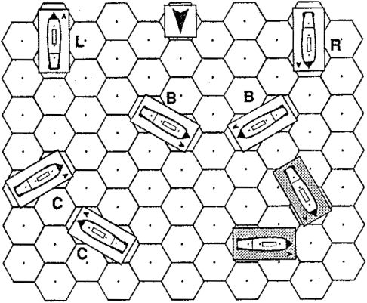
FIGURE 6 - Wind Facings

- A.3 Movement Determination Table. The Movement Determination Table (MDT) allows you to determine the ship’s MA in any possible situation. Cross-reference the ship’s speed type, WS, WF, rigging state, and number of rigging sections remaining on the MDT: the result is a number from 0 to S. This number is the ship's MA for that game-turn. Once determined, the MA does not change as the result of any actions taken by the ship during the game-turn. [Exception: Downwind Acceleration (see
- B.4).]
EXAMPLE (refer to MDT): A fast frigate (F-f) which is close-hauled (WF=C) at maneuvering sail (MS) in a moderate breeze (WS=3) and has 4 rigging sections remaining has an MA of 4. Assuming no deceleration or acceleration problems, the frigate could expend from 0 to 4 MP's in that game-turn. H could not expend more than 4 MP's even if it turns to WF B (where it would normally have an MA of 7).
- B MOVEMENT PLOT PROCEDURE
V.B.1 Plot Procedure. A ship may perform any one of three possible actions with each MP. Each action uses one MP. These actions, and the proper notations to mark them on the log, are:
- Move forward one hex (1). The ship is moved forward into the hex towards which its bow points. To move forward several hexes in a row, write ■#*, where # is the number of consecutive toward moves.
EXAMPLE (see Figure 7): Example A shows a ship
. moving one hex forward (notation of •I"). Example B shows a ship moving two hexes forward (notation of ’2‘).
- Turn to starboard (S), This indicates that the ship turns so that its bow faces to the right, compared to its previous course.
EXAMPLE («M Figure 7): Ships marked S are turning to starboard.
- Turn to port (P). This indicates that the ship turns so that its bow faces to the left, compared to its previous course.
EXAMPLE (see Figure 7): Ships marked P are turning to
port
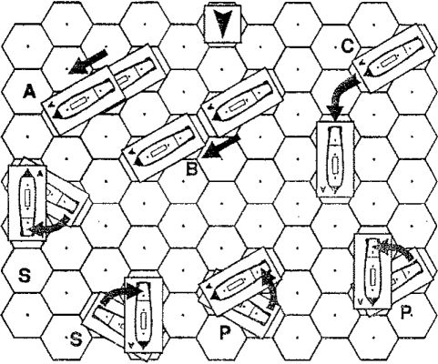
FIGURE 7 - Movement and Turning
Note to Figure 7: Example C shows a ship moving 1P1.

V.B.2 WF Restriction. The MA shown on the MOT for each WF is the maximum number of hexes forward a ship may move in that WF, even if the ship began the gameturn in a different WF with a higher MA. If a ship does move forward the maximum possible number of hexes in any WF, it may not move any further, even if it has MP’s remaining.
EXAMPLE (sea Figure 8, examples C and D): A fast SOL (L-f) which is broad reaching (WF=B) under fighting sail (FS) in a moderate breeze (WS-3) and which has all 4 rigging sections remaining has an MA of 4. If H turns to WF C (example C), it may move only 2 hexes In that direction as its MA for WF C (at FS and WS 3) is 2. Thus a move of P2 Is allowable (position 21), while P3 (position 22, in gray) is not. The same ship (example D) could also move PI SI (position 01), while P2S (position 02) is not allowed.
V.B.3 Turning into the Wind. A ship which turns into WF L must immediately stop, and may not move or turn for the remainder of the Movement Phase, even if it has MP's left. [Exception: Lightning Tack (see Xll.K).]
- B.4 Downwind Acceleration (from WF C to WF B). A ship which has an MA of at least 1 in WF C and which turns from WF C to WF B with its first MP in a game-turn receives one extra MP to use in that game-turn. This is an exception to V.A.3.
EXAMPLE (sm Figurs 8, example A): A fast SOL (movement type L-l) with all 4 rigging sections remaining at FS in WS 3 has a MA of 2 in WF C. Its maximum forward move is 2 (position Al): however, the ship could also move S2 (position A3). 82 is legal because the ship turns into WF B with its first MP, receiving one extra MP, for a total of 3. A move of 181 (position A2) is not legal; the ship does not gain an MP through downwind acceleration in this case because it did not turn into WF B with its first MP.
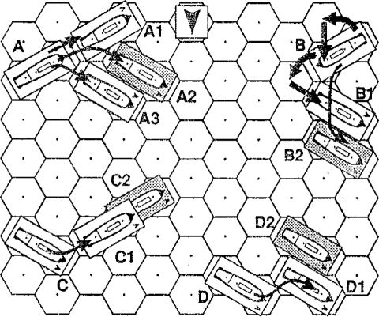
FIGURE 8 - Movement Examples

V.B.S MA of 0. A ship with an MA of 0 may never move forward, but may turn once in a game-turn, subject to the limitations of the turning rules (see V.C.9).
V.B.S Definition of Motionless. A ship is considered to be motionless if any of the following apply:
- The ship did not use at least one MP to move forward in the previous game-turn.
- The ship was grappled or fouled at any time in the previous game-turn, even only momentarily.
- The ship was involved in a collision at any time in the previous game-turn.
- C TURNING
V.C.1 Introduction. The maneuverability of a ship is determined primarily by its class. The class number of a ship is listed on the SDG and in each scenario in the column labeled "C:" Class 1, 2 and 3 ships may make up to two 60° turns per game-turn; Class 4 ships may may up to three 60° turns in each game-turn. Note that a few ships are rated for turning as one class less than their nominal class. Such ships have a small superscripted number next to their class number, like this: 3². These ships use the small number for purposes of turning, and the larger number for all other purposes.
V.C.2 Directions of Turns. A ship's maneuverability depends on whether the ship is turning in the same direction or opposite direction compared to its last previous turn.
EXAMPLE: A move of LSI followed by St would be a turn In the same direction; « move of LSI followed by PI would be a turn in the opposite direction.
- C.3 Turning In the Same Direction. Before making a 60° turn in the same direction as their last previous 60° turn - even if the two turns occur on different game-turns - a ship must move straight from 0 to 3 hexes, as determined by cross-indexing the ship's class with its plotted speed for the current game-turn (see the Turning Table on the red sheet). Note that hexes moved straight forward at the end of the previous game-turn do count towards the number that must be moved before being able to turn again. A notation of ‘0’ on the Turning Table means that ships may turn in the same direction as their last 60° turns without moving forward one hex.
EXAMPLE 1: The following ere legal plots tor class 1 ships;
Game-Turn 1: P3P1 | 381 | IP | 28
Game-Turn 2: — | 181 | IP | 8
while there are not:
Game-Turn 1: P2P1 | 381 | IP | 8
Game-Turn 2: — | SI | PI | 81
EXAMPLE L (see Figure 8, example B): A class 2 ship wants to turn as tightly as possible in the same direction using 4 and 5 MP's. Assuming the ship's move last gameturn was 3, it may turn to port immediately. Referring to the Turning Table on the red sheet, we see that class 2 ships using 4 MP's In a game-turn must only move 1 hex forward before turning in the same direction. At a speed of 5, however, the ship must move 2 hexes forward. Thus the tightest turns possible are:
4: PI PI (position B1: arrows show stem's movement)
5: P2P1 (position B2)

V.C.4 Tight Turns. A ship may never turn more than two times In consecutive movement points, even if these turns occur over different game-turns.
EXAMPLE: The following are legal plots for class 4 ships:
Game-Turn 1: | 18 | 88
Game-Turn 2: | 81 | 18
... while there are not:
Game-Turn 1: | 888 | 88 | 8
Game-Turn 2: | ■— | 8 | s
Game-Turn 3: | — | — | 8

- C.5 Turning In the Opposite Direction. Before making a 60° turn in the opposite direction to its last 60° turn - even if the two 60° turns occur on different game-turns - a ship must move at least one hex forward. This rule applies to all ships, regardless of class. [Exception: Reverse Tack (see V.E.3).]
EXAMPLE: The following plots are legal:
Game-Turn 1:  Game-Turn 2:  Game-Turn 3: | PI 8 3S  — IP | 381 P
... while these are not:  Game-Turn 1: | 2PS1 38 | 8
Game-Turn 2: | - PI | P

V.C.6 Fishtailing. To reemphasize an important concept, a ship which turns in one direction may never turn in the opposite direction with its next MP, even if the two MP's occur on different game-turns. Such a move is called f ishtailing,' after the motion of a fish’s tail, and is not allowed.
V.C.7 No Previous Turn. Ships which did not move forward or turn in the previous game-turn are assumed to have no 'previous 60° turn,' and thus may turn in either direction. However, if they use their first movement point to turn, they must immediately stop.
EXAMPLES: The following | plots are legal:
Game-Turn 1: | 0 0 0
Game-Turn 2: | 181P 2P S
... while these are not:
Game-Turn 1: | 0 0
Game-Turn 2: | SI PI P2

V.C.8 Executing a Turn. A ship turns by pivoting on its bow hex so that the bow turns in the direction plotted. Thus, as the ship's bow pivots 60°, the stern wilt swing into a new hex (see Figure 7, examples P and S).
V.C.9 MA of 0. A ship with an MA of 0 may still turn if it has any rigging remaining. Note: a section is 'remaining* so long as even one box in the section is not crossed out.
- 3-4 rigging sections remaining: A ship may automatically turn [Exceptions: Calm and In Irons]. This constitutes its entire move for that game-turn.
- 1-2 rigging sections remaining; A ship must plot for 2 consecutive game-turns to make one turn.
- Dismasted: A ship may not turn voluntarily unless it is anchored with springs, it may turn involuntarily while being towed or by partial drift (see V.H.6).
- Calm: A ship may not turn except by rowing (see XII.H).

V.D ACCELERATION AND DECELERATION
V.D.1 Introduction. Sailing ships could not immediately achieve full speed from a standing start in the amount of time covered by a game-turn. It took much more time to set the sails properly and gradually overcome the tremendous inertia of the ship. Similarly, sailing ships could not instantly slow from full speed to a dead stop. Rather, their momentum would carry them forward a distance. The following rules attempt to simulate this reality.
V.D.2 Speed Change Table. The Speed Change Table (see the red sheet) shows the amount by which each ship can accelerate or decelerate in a single game-turn.
EXAMPLE 1: Class 2 ships may accelerate by 2 MP's, and decelerate by 3. Thus a class 2 ship that moved IS (using 2 MP's) in the previous game-turn could use up to 4 MP's in the current game-turn (assuming its sail state and WF permitted it to do so).
EXAMPLE L A class 1 ship that used S MP's in the previous game-turn would have to use at least S MP's in the current game-turn (assuming its sail state and WF permitted it to do so), because it can only decelerate by 2.
V.D.3 Acceleration Reduction. The acceleration of a ship is reduced by one if the ship:
- bias only 1 or 2 rigging sections remaining.
- Is towing another ship.
EXAMPLE: A class 4 ship with only 2 rigging sections remaining and towing another ship (-2 to acceleration) can accelerate by 2 MP's per game-turn.
V.D.4 Minimum Acceleration. A ship’s acceleration may never be reduced to 0 (of course, it may be unable to move because its MA is 0).
EXAMPLE: A class 1 ship (acceleration of 2) has only 2 rigging sections remaining and Is towing another ship (-2 to acceleration); it can still accelerate by 1 per game-turn.
V.D.5 Exceptions to Deceleration Limit. Deceleration limits do not apply to a ship which must cease movement because it uses all allowable MP's in a WF (see V.B.2) or is involved in a collision (see VI E).
EXAMPLE: A class 1 ship (deceleration of 2) with speed type of L-f in WF B at PS at WS 3 has an MA of S. On game-turn 1 it moves 8, and finishes altering sail to MS. (maneuvering sail). On game-turn 2 it turns into WF C (S) and goes forward 3 - the maximum forward move allowable In WF C at MS. It has now finished its move, and has expended a total of 4 MP's. According to its deceleration it would have to move a minimum of S, but this is over-ridden by the maximum movement of the WF.
- D.6 Unfouled and Ungrappled Ships. Any ship which has just unfouled or ungrappled from another ship is considered motionless for all movement purposes. This is so even if the ship managed to untangle itself on the same game-turn on which it became fouled or grappled.
EXAMPLE: A Class 1 ship moves 5 hexes and collides and fouls with another ship during the Movement Phase of game-turn 1. It manages to immediately unfoul during the Maintenance Phase of game-turn 1. It would have a maximum MA of 2 on game-turn 2, due to acceleration limits.
V.D.7 Motionless Ships. A motionless ship is considered to have a speed of o for acceleration purposes.
EXAMPLE: A Class 1 ship turns P on game-turn 1. On game-turn 2, it would only have an MA of 2, since it only turned on the previous game-turn, and was thus motionless.
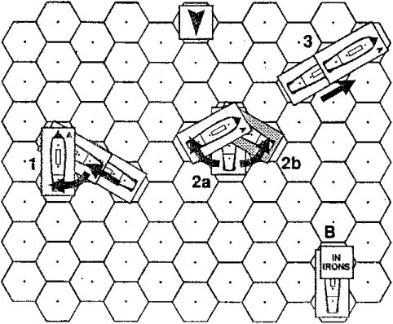
FIGURE 9 - Tacking

V.E TACKING AND M IRONS
V.E.1 Options In WF L A ship that turns into WF L must immediately stop, even if it has MP’s remaining in that game-turn, it may taka one of three actions on the next game-turn:
- Stay still (it would then be in irons).
- Continue turning in the same direction. This procedure of turning the ship’s bow across the wind is called tacking.
- Try to turn back in the opposite direction from which it just turned. This is called a reverse tack.
V.E.2 Tacking. A ship which turns into WF L and has at least three rigging sections remaining may continue turning in the same direction in the next game-turn, completing its tack (see V.G.9).
EXAMPLE (»o» Figure S): In position 1, the ship moves IS, turning into WF L, and Immediately steps for that gameturn. On the next game-turn it continues turning to starboard (position 2a), and cannot move any further in that game-turn. It has now tacked. On the next game-turn, it may move forward again: a move of t is shown (position 3). Remember that the ship must accelerate from 0.
V.E.3 Reverse Tack. A ship that turns into WF L would normally continue turning in the same direction, as described above; however, it may try to reverse its turn. This is called a reverse tack. It must roil a die on the in Irons Table If it rolls within the specified range, it may complete its turn as plotted; otherwise the attempt fails and the ship is in irons. This is the single exception to the rule that prohibits ships from turning in opposite directions in consecutive MP's.
EXAMPLE (••• Figure S): Position 2b (in gray) shows a ship perfoming a reverse tack after having moved 1S the previous game-turn (position 1).
- E.4 In Irons. Any ship that enters WF L and does not complete its tack in the next Movement Phase is in irons. [Exception: Anchored ships are never in irons.] [Exception: ships at a WS of 0 are never in irons.]
EXAMPLE (*•• Figure S, example B): M the ship moves
IS (position 1) and either does not tack (position 2a) or succeed in reversing tacking (2b), it would remain in WF L, and would be in irons.
V.E.5 Getting out of Irons. A ship in irons may not automatically turn out of irons. Instead, it plots a turn during the Plot Phase, then must roll on the In Irons Table to determine whether the plotted turn succeeds.
V.E.k In Irons Table. The ship roll a die. If the result is < the number shown on the In Irons Table, the ship succeeds in getting out of irons; the turn that was plotted for the ship immediately takes effect. The ship is turned 60° and is now in WF C.
Example: A Veteran (CQ=B) class 2 ship with ail rigging sections remaining at WS 3 tries to turn out of irons. It would have to roll a 1,2 or 3 to do so.
V.E.7 Continuing In Irons. A ship which fails to get out of irons may try again on the next game-turn. The ship may not turn or move at all until it succeeds. [Exception: ship may drift and may be towed out of irons.]

V.F SAIL STATUS
V.F.1 Introduction. A ship may be under one of four possible sail states - Furled/Dismasted (Furl/D), fighting sail (FS), maneuvering sail (MS) or plain sail (PS). The more sail a ship uses, the faster it moves, but the more easily damaged its rigging is.
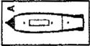
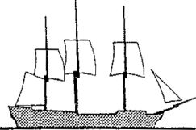
- F.2 Salls- Furled or Dismasted (Furl/D). 'Furled' sails are clewed up to the yards, and do not catch the wind; a dismasted ship has no masts remaining. In either case the ship has no sails spread, and cannot move. A ship can be in this state voluntarily, such as when anchored, or involuntarily, such as when dismasted by enemy gunfire.
FIGURE 10 - Ship at Fighting Sail
V.F.3 Fighting Sall (FS). This state represents a ship prepared for battle, with only enough sails spread to provide steerageway. A ship is able to use FS until it has lost all its rigging boxes (i.e., is dismasted). A ship at FS is represented by the ship counter alone, without any sail markers on it.
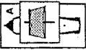
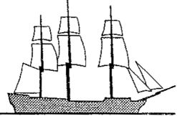
V.F.4 Maneuvering Sail (MS). This represents a ship with more sails unfurled than FS. Place one sail counter on the ship counter to indicate that the ship is at MS. A ship is able to use MS until it has lost its entire second rigging section,
FIGURE 11 - Ship at Maneuvering Sail
EXAMPLE (<«e Figure 4): A British 74 with a total of 25 rigging boxes (rigging = 7-6-S-6) may use MS until it loses its 13th rigging box.
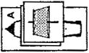
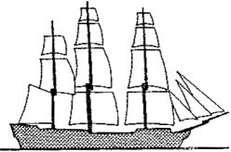
V.F.5 Plain Sail (PS). This represents a ship with most of its sails set. Place two sail markers on the ship counter to indicate that the ship is at PS. A ship is able to use PS until it has completely lost its first rigging section.
FIGURE 12 - Ship at Plain Sail
- F.6 Altering Sail. Ships may only change from one sail state to the next highest or lowest state. Legal changes are from Furl to FS (and vice-versa), from FS to MS (and vice-versa) and MS to PS (and vice-versa).
- A ship may change from FS to MS, or FS to Furl by writing the sail state that it is going to in the sail column of the log during the Plot Phase (see the sample log). One CS must be assigned to the task of changing sail state. It may do nothing else during that game-turn. Place a "Men in the Rigging" counter on the ship to indicate that it is altering sail. Note that a "lines jammed" critical hit cancels the plotted sail alteration.
- A ship may change from PS to MS (or MS to PS) by plotting in the sail column of the log for 2 consecutive game-turns. A ship that has plotted once must plot in the next game-turn as well; the change of sail state
cannot be suspended or reversed. [Exception: a •tines jammed* critical hit cancels the plotted sail alteration.] Two CS's must be assigned for each of two game-turns. The same sections need not be used each turn. A ship retains the MA of the sail state it is coming from until the change is complete. Place a •Men in the Rigging* counter on the ship to indicate that it is altering sail.
- F.7 Announcing Alteration of Sall. Changes of sail state must be announced during the Movement Phase, at the same time the ship's movement is announced. Place all ’Men in the Rigging* counters at this time.
- F.8 Green and Demoralized Ships. Green and Demoralized (CQ E and F) ships take one extra game-turn to change sail states. Thus a Green ship requires three game-turns to go from PS to MS, and two game-turns to go from MS to FS (and vice-versa).
- F.S Completion of Altering Sall. Sail changes do not take effect until the Sail Status portion of the appropriate Maintenance Phase. Until that time the ship uses the previous sail state for movement and damage.
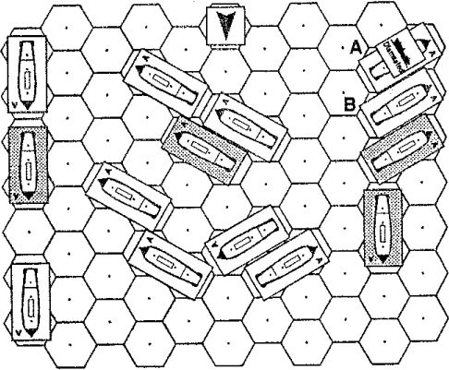
FIGURE 13 - Blocked Wind

V.G BLOCKED WIND
V.G.1 Introduction. When two sailing ships are close together, the one to windward of the other will block its wind and create a ‘shadow* of reduced wind strength.
- G.2 Definition. A ship's wind is blocked only if all the two hexes directly to windward of the ship are occupied by other ships at sail state FS or higher. A ship in WF C or B must have both hexes directly to windward occupied by other ships for its wind to be blocked, while a ship in WF L or R need only have the one hex directly to windward occupied.
EXAMPLE: In Figure 13, the shaded ships have their wind blocked. Note that dismasted ship A does not block the wind of ship B.
V.G.3 Movement Effect. A ship subject to blocked wind has its MA reduced by 1. A ship's MA may never be reduced to 0 by blocked wind, and therefore blocked wind is determined after all other modifications to a ship’s MA.
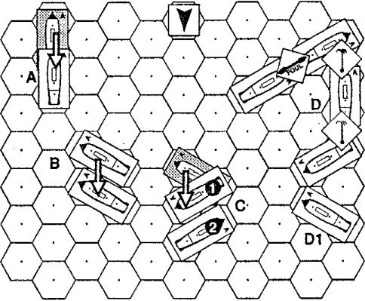
FIGURE 14 - Drifting

V.H DRIFTING
V.H.1 Which Ships Drift. A ship may which does not move forward in a game-turn may drift. Its chance to drift depends on its sail state and the wind speed; see the Drift Table (on the red sheet). Roll two dice. If the result is L the number shown in the Drift Table, the ship drifts.
EXAMPLE: A class 2 ship at MS in WS 3 does not move forward. On a DR 2: 3 with two dice, it drifts. If the ship was a class 4 ship, ft would drift on a DR L 6.
- H.2 Order of Drifting. Always check for drift in order from the most leeward ships to the most windward.
V.H.3 Groups of Ships. A group of ships which are grappled or fouled together always drift as a group, at the rate of the slowest-drifting ship of the group. Only one drift DR is made for the entire group.
EXAMPLE (see Figure 14, example 0): All four ships are grappled or fouled together, as shown. One ship Is at PS, another at MS, a third at FS and one at Furled. The ships check for drifting as if ail the ships were at Furled.
V.H.4 Drift Execution. A ship which drifts moves one hex directly to leeward, its WF does not change.
EXAMPLE (see Figure 14): Examples A and B show drift
V.H.5 Blocked Path. If a drifting ship has its path blocked by another ship, it cannot drift and therefore remains in its current location. [Exception: partial drift.] It may foul with the ship which is blocking its path unless either ship is dismasted, in which case fouling is impossible. Roll on the Collision Table to see if the ships are fouled.
V.H.6 Partial Drift. If a drifting ship is partially blocked (i.e„ its bow or stern hex can drift, but not the whole ship), then the part of the ship that may drift does so. The ship's WF will therefore change: this is an exception to V.H.5. Roll on the Collision Table to see if the ships are fouled. [Exception: fouled and grappled ships do not partially drift.]
EXAMPLE 1 (»•• Figure 14, example C): Ship 1 drifts, but is partially blocked by ship 2; thus ship 1 partially drifts to the position shown, pivoting on its stern to do so.
EXAMPLE 2 (see Figure 14, example D): The mass of grappled and fouled ships drifts, but Its path is blocked by ship DI. Since grappled and fouled ships cannot partially drift, the entire mass does not drift.

V.( ILLEGAL MOVES
V.1.1 Correction of Illegal Plots: If a player plots an illegal move, the move is executed up to the point of illegality. The illegal action and the remainder of the move is not executed.
Example: A class 1 ship plots PI PI. This is illegal, as class 1 chips must move two hexes between turns at speed 4; thus the ship's move is amended to PI.
V.1.2 Illegal Deceleration. If correction of an illegal move would violate deceleration limits (or if excess deceleration is the reason the move is illegal), additional forward moves are added to the end of its move to bring the ship up to the minimum legal movement. Note: It is very important to change the plotted move to conform to the actual move, to make sure the ship keeps track of its acceleration, deceleration, and turning capabilities.
EXAMPLE 1: A class 1 ship moves S4SI (or a speed of 7 In the previous game-turn. The ship only plots to move IP In the current game-turn, thus exceeding Its legal deceleration limit. The ship's actual movement becomes 1 PL.
EXAMPLE 2: A class 1 ship moves SSS1 for a speed of S In the previous game-turn. In the current game-turn the ship plots to move S2. This move Is illegal for two reasons; first because it is turning too tightly for Its speed, and second because ft cannot decelerate that quickly. The S is illegal and thus nullified, leaving It with a plotted move of 0. But ft must use 6 MP's, so its plotted move is amended to 6.
- MOVEMENT EXECUTION
"A collision at sea can ruin your entire day."
Attributed to Thucydides, 5th century B.C.
During the Movement Phase, all ships execute the moves plotted in the Plot Phase. Ships must move exactly according to their plotted movement, except when permitted to deviate (bearing off) or when forced to deviate (collisions).
- A GENERAL MOVEMENT PROCEDURE
VI.A.1 Movement impulses. All ships move simultaneously, one MP at a time. Since the maximum possible MA is 9, there are 9 movement impulses in each Movement Phase.
EXAMPLE: A ship plotted to use 3 MP's would expend one MP each on movement impulses 1, 2 and 3. A ship plotted to used 5 MP's would expend one MP on movement Impulses 1 through 5.
VI.A.2 Gne Ship per Hex. In general only one ship can occupy a hex in any given impulse. The rules listed below cover situations where two or more ships are attempting to occupy the same hex at the same moment.
VI.A.3 Sequence of Resolution. The following steps must be followed in exact sequence when two ships are plotted to enter the same hex during the same impulse or when a ship is plotted to enter a hex that is already occupied. A hex is already occupied if the forward (bow) half of the ship is leaving the hex but the aft (stern) half of the same ship is entering the hex (in Figure 16, example A, ship 2 is trying to enter an already occupied hex).
- Determine if the situation can be handled by turning away while adjacent (see VLB). If it cannot, then:
- Roll to determine who wins the contested hex (if any).
- The ship that loses the contested hex DR (if any) may now attempt to bear off.
- If the ship succeeds in bearing off, it turns 60° in the direction of its choice and stops movement.
- If the ship fails to bear off, it collides with the other ship. Mark off appropriate rigging damage.
- Roll for fouling. If fouled, note in log and place a •fouled" counter between two ships on mapboard.

rVLB TURNING AWAY WHILE ADJACENT
VI.B.1 Introduction. In CA ships turn by swinging their sterns into adjacent hexes. This is not the way ships really turn, but it is unavoidable due to the limitations of hexgrids. Rules are therefore necessary to allow adjacent ships to move away from one another; without such rules, adjacent ships could become "locked" next to each other, constantly bumping their sterns Into each other as they tried to move away.
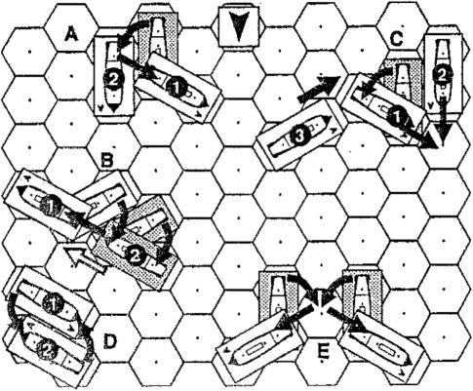
FIGURE 15 - Turning Away While Adjacent

VLB.2 Turning Stem into Occupied Hex. A ship which has two or more MP's remaining of its MA may execute a plotted turn which results in its stern entering or overlapping a hex which is occupied or being occupied by an adjacent ship, provided that the overlap will be corrected on the very next movement impulse. This situation is a temporary violation of the rule which prohibits two ships from occupying the same hex.
V1.B.3 Moving Out of the Occupied Hex. If either the turning ship or the other ship or both move to vacate the overlap hex on the very next impulse, then both ships continue their movement normally.
EXAMPLE (see Figure IS, axsmpie A): Ship 1 executes a turn away from the adjacent ship by moving PI. Ship 2 does not move. This move is legal, because ship 1 vacates the overlap hex on the next impulse.
VLB.4 Failure. If for any reason the overlap hex is not vacated on the next impulse, then movement execution is temporarily returned to the previous impulse and the attempted turn is treated as a contested hex instead (see
- C). Note that in most cases this will result in the turning ship losing ths contested hex and ending its move; all other ships will continue their moves normally,
EXAMPLE 1 (sea Figure 18, example B): Ship 1 plots SI, as does ship 2. At the end of their moves, there would still bs an overlap (second MP of ship 2 shown by white arrow). This Is not allowed, so ship 1 must return to the previous Impulse, There is still an overlap, so ship 1 must go back to its original position. Ship 2 may make the first MP of its move (IS), but cannot make tile second MP, sine® ship 1 is In ths way. Tho result Is that ship 2 collides with ship 1.
EXAMPLE 2 (see Figure 18, example C): Ship 1 plots PI, while ships 2 and 3 both plot 1. If ship 2 wore not presant, then ship 1 could move PI aa plotted, because turning away while adjacent allows ship 1 to swing Its stern into the hex being entered by ehip 3 so long as ship 11mmediately vacates the overlap hex (which H I* doing). Unfortunately, ship 2 is present, and reaches the hex ahead of ship 1. Ship 1 thus must retrace its position to the preceding impulse, which places it at Its starting point. Its log Is amended to show that it moved 0 this game-turn.
VLB.5 Complete Overlapping. If two ships turn simultaneously, so that they overlap each other completely, as shown in Figure 15, example D, only one of the ships is allowed to execute its plotted turn. Roil for this using the normal contested hex procedures. The ship which wins the contested hex roll is allowed to execute its turn. The other ship does not get to turn and ceases all movement for the game-turn.
VLB.8 Non-Adjacent Ships. It is also possible for two non-adjacent ships to attempt to simultaneously turn so that the stem of each ship will overlap the other (see Figure 15, example E). This situation is handled exactly as if adjacent ships were involved, if the ships can vacate, both may turn; if not, use the contested hex rules to determine which one succeeds in turning,
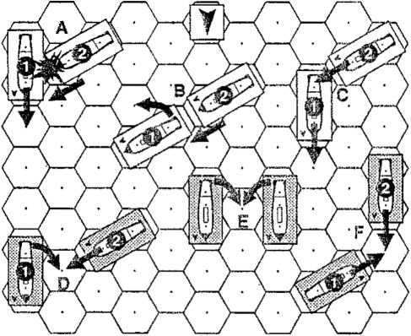
FIGURE 16 - Contested Hexes and Potential Collisions

.im, ii i ii

[VLCCONTESTED HEXES
- C.1 Definition. A contested hex situation occurs when portions of two ships attempt to enter the same hex (a hex which is either empty or being vacated by another ship) during the same impulse. The following rules determine which ship moves into the hex, and the consequences.
Vl.6.2 Simultaneity of Movement. Ships move at the same instant, and all movement for each impulse is completed before checking for collisions or contested hex situations.
EXAMPLE 1 (ue Figure 16): Examples D, E, and F (ships In gray) show contested hex situations; examples A and 8 (ships In white) are not contested hex situations (in each example the ship labeled 1 will vacate the hex at the same time (effectively ’before') the ship labeled 2 enters).
VI.C.3 Winning Contested Hexes. Each ship involved in the contested hex rolls a die. The ship with the highest adjusted DR enters the hex. If the adjusted DR’s are the same, the ships roll again, until one ship or the other gets a higher DR. The following modifiers apply:
- +1 for every CQ level better than the opposing ship.
EXAMPLE: An Elite ship (CQ=A) contesting a hex with a Green ship (LQ---E) would have a +4 chance to enter the hex,
- +1 for a ship that has plotted to use more MP’s than the opposing ship.
- +1 for every class larger than opposing ship.
- C.4 Surrendering Contested Hexes. If one of the ships has a larger net DRM than the other, it may elect to automatically 'lose' the contested hex. In this case the ship with the lower net DRM would enter the hex.
VI.C.5 Bow vs. Bow. The bow of the ship that wins the contested hex DR enters the contested hex; the loser must either bear off (see Vl.D) or collide with the winner.
EXAMPLE (see Figure 16, example F): Two ships are attempting to enter the same hex at the same time. Each ship rolls one die to determine which ship actually enters the contested hex. Ship 1 rolls higher (after all modifiers) and thus enters the hex. Ship 2 may then attempt to bear off.
- C.S Stern vs. Stern (see Figure 16, example E). This situation may or may not be a contested hex. If either of the ships is moving further in the game-turn, turning away while adjacent may be possible. If it is not possible, roll to see which side gets the hex as per VI.C.3. The winner gets the hex and may continue moving; the loser ceases movement (unless this would violate deceleration limits, in which case it would move forward the number of hexes required to fulfill its maximum deceleration requirement). There is no collision.
- C.7 Bow vs. Stern (see Figure IK, example D). This situation may or may not be a contested hex, depending on whether turning away while adjacent is possible. If it is not possible, the ship whose bow is entering the hex gets the hex and may continue movement. The other ship ceases movement (if this violates deceleration limits, it must move forward the number of hexes required to fulfill its maximum deceleration requirement). There is no collision.
- C.S Bow vs. Occupied Hex (see Figure 16). This is not a contested hex situation, since one hex is already occupied! In example A, ship 1 is already occupying the hex, so ship 2 must either bear off or collide (see Vl.D).
VI.C.S Stern vs. Occupied Hex. There is no collision, and the stem does not enter the hex. If the ship whose stern was turning cannot turn away while adjacent, its movement ends (if this violates its deceleration limits, it must move forward the number of hexes required to fulfill its maximum deceleration requirement).
VI.C.10 More Than Two Ships. If more than two ships attempt to enter the same hex in the same impulse, the same procedure as for two ships is followed, with each contesting ship rolling a die, The highest DR among the ships attempting to enter gets the hex. If all ships obtain the same adjusted DR, ail roll again. If two or more ships tie for the highest adjusted DR, only they roll again; the other ships lose the hex. This process continues until one ship gets the hex. The others must try to bear off or collide with the ship that entered the hex.

Vl.D BEARING OFF
Vl.D.1 Potential Collision. A potential collision occurs when one ship attempts to move forward into a hex occupied by another ship. This may occur either because the first ship is attempting to enter a hex already occupied by the second ship at the start of the current impulse, or because the first ship has lost a contested hex roll against the second ship. In either of these cases, the first ship may attempt to bear off to avoid colliding with the second ship.
VI.D.2 Eligibility and Procedure. Instead of entering the collision hex, the ship may attempt to make a 60° turn, provided that this turn is otherwise allowable under the turning rules (e.g., the ship has not turned its maximum number of turns in this game-turn, has not just turned in the previous MP, etc.). To succeed, the ship must roll its SK or more, with modifiers for ship class (-1 for class 1; +1 for class 3; +2 for class 4) and +1 if the ships involved are friendly,
EXAMPLE 1: A class 1, 2 or 3 ship which has already turned twice in a game-turn could NOT bear off during the same game-turn.
EXAMPLE 2: A class 1 ship which plots 1P4 but encounters a potential collision situation after moving only 1P1 could not bear off to port, as this would violate the turning rules. It could however bear off to starboard; if it succeeded, its final move would be 1P1S.
Vl.D.3 Deciding to Bear Off.
- Ships that are deciding whether to bear off may ask to know the entire game-turn's movement for any or all other ships before deciding whether to bear off and in what direction.
- If two or more bearing off situations occur in the same game-turn, the ships involved in the earliest impulse must decide whether to bear off first. Resolve the earliest-occurring bearing off attempts fully before resolving any later bearing off attempts.
- In the rare case that two bearing off situations occur on the same impulse, roll a die to determine which one has to be resolved first.
VI.0.4 Successfully Bearing Off. If successful, the ship turns in the desired direction immediately and ends its move. If this would violate deceleration limits, the ship must move a number of hexes forward sufficient to fulfill the minimum movement requirements.
EXAMPLE: A frigate with a CQ of B used 8 MP'* in the previous game-turn. It move* 1 hex In the current game-turn, then potentially collides with an enemy ship. Tha frigate chooses to try to boar off. its chance to do is Its SK (3) with a DRM of +1 for being a class 3 ship, l.e„ a L2 with one die. if the other ship had been a friendly ship, the frigate would have automatically succeeded in bearing off (+1 for a friendly ship).
Assuming It succeeds, it chooses to bear of! to starboard; it* actual movement Is now IS. Frigetoe may decelerate by 4 MP's, so the frigate, which has only used 2 MP's so far, must continue straight ahead for 3 more MP's, for a total of 5. It* move would then be 1 S3. The player corrects his log to show the new move, and the ship ends its movement.
VLD.5 Failure to Bear Off. Ik a ship either chooses not to bear off or attempts to bear off and fails, it collides with the other ship (see VI.E).
- D.g Limitations on Bearing Off. A ship may only bear off once in a single game-turn.

VIE COLLISIONS and FOULING
- E.1 Definition. A collision occurs when one ship attempts to enter a hex already occupied by another ship. This can happen either voluntarily (because one ship wants to ram another ship) or involuntarily (because the bearing off attempt could not be made or failed).
Vi.E.2 Stoppage of Movement. Both ships involved in the collision stop movement for the remainder of the Movement Phase, even if this violates normal deceleration limits.
- E.3 Rigging Loss Due to Collision. A ship which collides with another ship and which is pointing at the other ship loses 2R if at FS, 4R if at MS, and 6R if at PS. (Exception: A ship which collides by drifting into another ship does not lose extra rigging.]
NOTE: This recreates the effect* of the sudden Whiplash' effect on the masts and line* of the rigging of a ship which had run into another ship.
VI.E.4 Determining Fouling. After subtracting the collision damage, one player rolls one die on the Collision Table. If the adjusted DR is s 2, the two ships Involved in the collision are fouled together. Place a fouled* counter between the two ships to indicate this situation.
- E.5 Dismasted Ships. Dismasted ships may never become fouled with other ships. A ship that is already fouled, then becomes dismasted, remains fouled. Ships which become dismasted as the result of a collision may become fouled during that Movement Phase,
VB.E.S Unfouling. Fouled ships may attempt to unfoul by rolling on the Unfouiing Table during the Maintenance Phase.
- F POOR MANEUVERING
- F.1 Introduction. Some ships were unusually unhandy in maneuvering. Examples include ships with wheels shot away (in which case orders would have to be shouted down to ths men manning the steering tackles) and ships with especially unskillful crews. In either case, the afflicted ships had difficulty maneuvering with the rest of the fleet.
V3.F.2 Procedure. A ship designated "poorly maneuvering" must roll a die whenever its plot shows a turn. If it roils > its SK or > 4 (for ships with an SK of 5), it may make the turn as plotted. Otherwise the ship moves an additional hex forward, then makes the turn. Adjust the log to show ths additional MP forward, and the last MP plotted for the current Movement Phase is deleted, thus retaining the same overall MP expenditure.
EXAMPLE: A »hlp subject to poor maneuvering ha* plotted 2S1S, It* CQ=*E (Green), so it must roll L 4 In order to make the turn plotted for it* third movement point It roll* a 3, and thus must move an additional hex forward before It get* to turn to starboard a* detired. The log la amended to show a movement plot of 381.
VI.F.3 Last MP Plotted. A ship which plots a turn as its last MP (e.g., 48), and which fails to turn as plotted, moves forward instead, and must begin the next game-turn by plotting a turn in the the same direction as the first MP of the next game-turn. This turn automatically succeeds, as it is "left over from the current game-turn.
VI.F.4 Moving Slowly. A ship moving at speed 1 has a +2 DRM to tha DR; at speed 2 the DRM is +1,
VI.F.5 Tacking. A poorly maneuvering ship which is in WF L and does not succeed in turning is in irons.
- F.6 Which Ships Use Poor Maneuvering. Ships must use Poor Maneuvering when foiled on the Hull CHT Aid when called for by scenario special rules.
- GUN FIRE AND MARINE FIRE
’The business of an English Command-in-Chief is first to bring an Enemy's Fleet to Battle on the most advantageous terms to himself, (I mean that of laying his Ships close on board the Enemy, as expeditiously as possible); and secondly to continue them there until the Business is decided ..
Horatio Nelson: Order to the Fleet (1805)
During the age of sail, there were three principal types of combat between ships:
- Firing iron balls from the ‘great guns' - large iron or bronze cannon of two types, 'long' guns and short-barrelled ‘carronades’ - primarily to damage the enemy ship itself.
- Firing small arms (muskets and pistols) and light ‘swivel’ guns at the enemy crews.
- Boarding the enemy ship and defeating its crew in hand-to-hand combat with swords, cutlasses, etc.
This part of the rules covers the first two of these, gun fire and marine fire.

VILA GUN FIRE - CHOOSING TARGETS
VH.A.1 Target Determination. At the start of the Combat
Phase each ship independently and simultaneously decides:
- Whether it will fire this Combat Phase.
- If it will fire, which ship (or ships) it will fire at (if there is more than one enemy ship within the firing ship’s field of fire).
- Whether it is firing low (at the hull) or high (at rigging).
- What type of ammunition to use, if more than one type is possible.
VILA.2 Enforcement. Normally it is not necessary to enforce this rule strictly, as long as all fires by one side are announced before any are resolved, but either side may insist that all fire be plotted at the beginning of the Combat Phase. Use the "notes’ column on the log for this task.
- B GUN FIRE - FIELD OF FIRE
Vll.B.1 Broadsides. A sailing warship carried its guns along both sides, and could only exert serious firepower from these "broad" sides of the ship. Thus, ships were said to have two “broadsides" - one firing to port (left) and one to starboard (right).
Vll.B.2 Bow and Stern Gun Sections. The guns on each broadside are divided into bow and stern sections. Each section calculates whether it can fire (i.e„ due to line of sight restrictions) separately of the other section. Each section has a 60° arc of fire. The bow arc of fire is shown in Figure 17; the stern arc is identical, except that it emanates from the stern hex of the ship rather than the bow.
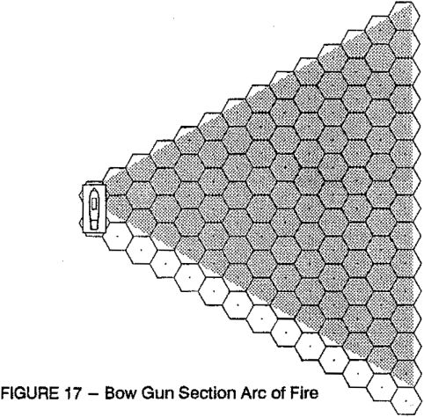

VI1.B.3 Eligible Targets. A section can fire at any enemy ship which has at least one hex within the firing section's arc of fire.
- B.4 Determining Gun Factors per Section. Calculate all the firing factors on the broadside and divide in half, rounding down for the bow section and up for the stern section. If the ship is firing at targets at two different ranges, calculate each section's fire as if the entire ship was firing at the appropriate range.
EXAMPLE: A British 64 has 13 guns and 3 carronades on Its starboard side, and wishes to fire its bow section at a ship at a range of 7, and its stern section at a ship at a range of 2. Only long guns can fire at a range of 7, so the bow section receives half of the 13 long guns (rounded down), or 6 gunnery factors. At a range of 2 carronades count for 2 gunnery factors per box, so the total firepower of the ship is 13 (long guns) + 6 (carronades), or IS. Half of IS (rounded up) - 10 gunnery factors.
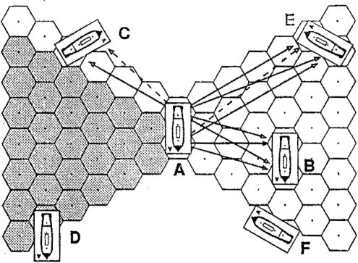
FIGURE 18 - Tracing LOS
- C GUNNERY FIRE - LINE OF SIGHT
VII.C.1 Line of Sight. To fire at an enemy ship, the firing section must also have a line of sight (LOS) to the target.
- C.2 Bow and Stern Sections and LOS. Each gun section of the firing ship independently traces a LOS to the target ship. It is quite possible for one section to be able to trace an LOS to a given target, while the other section of the same ship could not.
VII.C.3 Tracing LOS. The LOS is traced by drawing straight lines between the center of the firing section’s hex to the center of the bow and stern hexes of the target ship, EACH section of the firing ship must have a clear LOS to BOTH HEXES of the target ship to fire.
EXAMPLE (see Figure IS): Ship A wants to fire at ship B. It must trace four separate lines of sight in order to be able to fire both bow and stern gun sections;
- From its bow to ship B's bow;
- From its bow to ship B’s stern;
- From Its stern to ship B's bow;
- From its stern to ship B's stern;
- C.4 Partial Targets. A gun section only has to trace a LQS to hexes within that section's arc of fire.
EXAMPLE 1 (sea Figure 18): Ship A may fire both gun sections at ship E, because the bow hex of E is out of the firing arc of the bow section of A; therefore, the bow section of A does not have to trace LOS to the bow of E (doited line).
EXAMPLE 2 (see Figure 18): Ship A may fire only its starboard bow gun section at ship D, and only its starboard stem gun section at ship C (gray hexes indicate arc of fire for starboard bow). Note that A may fire its stern guns at C oven though only part of C is in the arc of fire; it does not have to trace an LOS to the bow hex of C (dotted line).
EXAMPLE 3 (see Figure IS): Ship A cannot shoot at ship F because none of F Is within the arc of fire of either of A s gun sections.
VII.C.5 Blocked LOS. The LOS is blocked when it passes through a hex which contains another ship, land, or a specified blocking hex. It is thus possible that both, one, or none of the gun sections on a ship’s broadside could fire at the target ship. [Exception: one hex of a ship never blocks the LOS to the other hex of the same ship.]
VII.C.6 Hex Spines. The LOS along hex spines is only blocked when both hexes adjacent to the hex spine in question are occupied by ships or by blocking hexes.
VII.C.7 Hex Vertices. A LOS which passes exactly through the junction point between three hexes is a clear LOS, unless two or three of the adjacent hexes are themselves blocked.
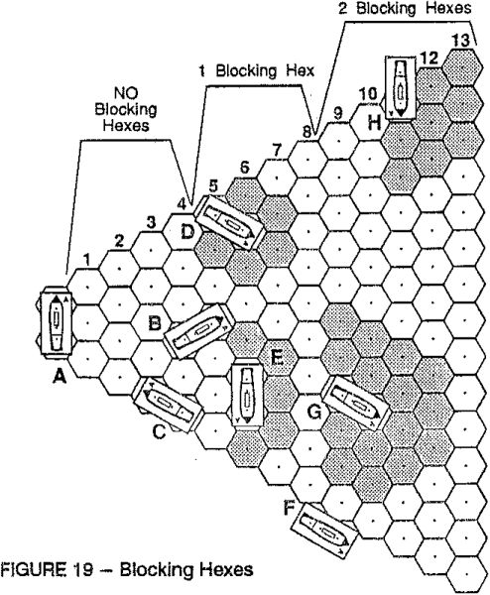

V1I.C.3 Friendly Ships Blocking LOS. There was a natural reluctance to hit friendly ships, so there are certain limitations on firing near friendly ships at medium and long ranges:
- If the LOS passes by a friendly ship at a range of 5-8 hexes, the friendly ship is considered to occupy all ad- jacent hexes which are at least as far away from the firing ship as the blocking ship.
- If the LOS passes by a friendly ship at a range of 9-13 hexes, the friendly ship is considered to occupy all hexes < two hexes away from itself which are at least as far away from the firing ship as the blocking ship. Any LOS which passes through (not into) any blocking hex is blocked for gunnery purposes.
EXAMPLE (see Figure IS): Assuming that ail ships are friendly to one another, ships D and E cause one blocking hex (range 5 and 6 from ship A respectively), while ships G and H cause two blocking hexes (range 9 and 11 from ship A respectively).
- C.9 Ranges of Blocking Hexes. Note that the range is calculated from the firing ship to the nearest hex of the blocking ship, just as if it were being fired at. For example, a ship which occupies both range 4 and 5 would not have any blocking hexes at all, even though part of the ship does extend into the blocking range (range 5).
EXAMPLE (««« Figure 19): Ship B does not create any blocking hexes, because its stern is at range 4 from the firing strip.
- C.10 Blocking Hexes Outside of Firing Arc. Only friendly ships which are partly or entirely inside the firing ship's field of fire create blocking hexes.
EXAMPLE (aoe Figure 19): Ship F does not create any blocking hexes because It is outside the arc of fire of the firing ship.
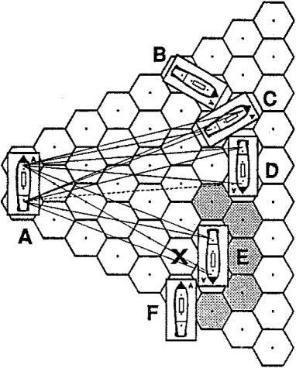
FIGURE 20 - Examples of Gunfire
EXAMPLE (Ships A and E are friendly, others enemy): Ship A can fire both gun sections at ships B and C, its bow section at D, and its stern section at F. The LOS to B is obvious (see Figure 18). A may fire both sections at C because one hex of a ship does not block fire to the other hex of the same ship. A may not fire its stern section at D because the LOS from the stern of A to the bow of D (dashed line) must pass through the blocking hex generated by friendly E.
If ship E were enemy and ship F friendly, then ship A could not fire at E at all, since both gun sections would have to trace to the bow hex of E, and could not because of the blocking hex (marked 'X') created by the proximity of F,

- D LOWER DECK GUNS
VII.D.1 Lower Deck Guns. The tier of guns closest to the water in a sailing warship (called the Lower Deck Guns [LDGJ in Close Action) in certain weather conditions could not fire without endangering the ship. As shown in Figure 21, a ship under sail heels over to leeward: as the wind speed increases, so does the angle of heel. If the angle is sharp enough, the weather bad enough, or the ship's freeboard low enough, opening the lower deck gunports (especially on the leeward side) would allow the sea to flood in, resulting tn the ship capsizing. In practice the lower deck guns would not be used in such conditions.
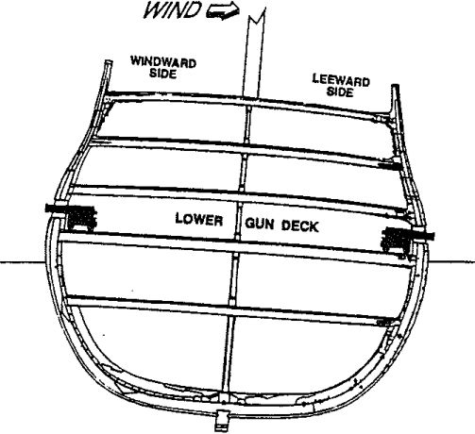
FIGURE 21 - Heel of Ship

- D.2 Leeward and Windward Broadsides. The windward side of a ship is the side of the ship which the wind strikes first. The leeward side is the opposite side. A ship in WF L or R has neither windward nor leeward sides.
EXAMPLE (••• Figure 22): The chips In white have leeward and windward broadsides; the windward broadside of each ship Is Indicated with a *W’, while the leeward broadside is Indicated with a *L*. The ships in gray do not have leeward or windward broadsides.
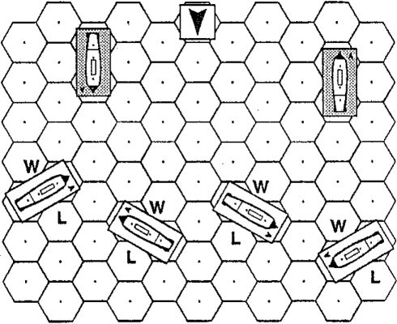
FIGURE 22 - Leeward Broadsides
VII.D.3 Freeboard Table. Under certain circumstances either the leeward LDGs, or all the LDGs, may not fire (although they still absorb damage normally). The Freeboard Table (on the red sheet) shows when these limitations exist.

VILE GUN FIRE RESOLUTION
VI1.E.1 Gunnery Tables. The firing ship's effect on the target ship depends on several factors, including the number of gunnery factors available, the firing ship's CO, the range, type of ammunition and many other considerations. These factors are all assembled on the Gunfire Calculation Table (GOT) on the blue sheet.
- E.2 Gunnery Factors. Determine the number of gunnery factors the firing ship has as follows:
- Count each Gun box as one gunnery factor at all ranges (1-13).
- Count each Carronade box as two gunnery factors at ranges 1, 2 and 3, and one gunnery factor at ranges 4 and 5.
NOTE: a ship may always choose to use fewer factors than the maximum it could employ (for example to force dismasted ships to strike by raking them; using only one gunnery factor would limit the damage done to the ship about to be captured).
- E.3 Range. The range is determined by counting the number of hexes from the firing ship to the closest hex of the target ship.
EXAMPLE Figure 19): The distance from A to D is 5 hexes, not 6; the distance from A to B is 4, and from B to C is 2 hexes.
- E.4 Crew Required. Only sailor OS's may fire guns. Marine CS's may never fire guns. If less than three sailor OS's man the guns, the effects of the ship’s fire are reduced.
VILE.S Splitting Fire. A ship is considered to be "splitting fire" when it fires at two or more targets in the same Combat Phase with its guns. It does not matter whether the ship is splitting fire by using both port and starboard broadsides, or is firing at two different targets with the same broadside; the procedure is the same.
- Each gun section of a ship may fire at only one target. A ship may thus fire on a maximum of two targets per broadside (one from the bow section and one from the stern section). A ship could thus fire at a maximum of four targets, two on each broadside.
- For each additional target above ths first that a ship fires on, each firs is reduced by -Z to her BGN. There is an additional -8 modifier for each subsequent split of firs.
EXAMPLE: A ehip fires on two targets on each broadside, for a total of four targets (the legal maximum). The ship subtracts -15 when calculating the MGN for each fire.
VII.E.6 Basic Gunfire Number. First cross-reference the total number of gunnery factors with the range on the GCT. This yields a number between 0 and 33, which is the Basic Gunfire Number (BGN).
EXAMPLE: A British 74 fires 18 guns and 4 carronadas at a range of 3. The carronadea are doubled at this range, so the ship has a total at 24 gunnery factors. At a range of 3, the resulting BGN is 23.
- E.7 Nationality Differences. British and American guns and shot were intrinsically less accurate at longer ranges than those of other navies. Therefore, at ranges of 8-13 hexes, they use the columns of the GCT indicated by the "British, American" heading. All other navies use the "Other" row. All ships use the same column at ranges 1-7.
Vll.E.8 Modified Gunfire Number. The BGN may be modified according to the skills of the crew and a variety of other factors. The number which results after adding and subtracting all modifiers is called the Modified Gunfire Number (MGN).
- Crew Quality, The BGN is increased or decreased by the following amounts for the specified CQ:
» Current CQ of firing ship is A (Elite): +6
•» Current CQ of firing ship is B (Veteran): +4
» Current CQ of firing ship is C (Trained): +2
- Current CQ of firing ship is E (Green): -2
- Current CQ of firing ship is F (Demoralized): -4
- Sailor Crew Absence. If less than three sailor CSs are available to fire the guns (because of casualties or assignment to other tasks, like fighting fires), there is a -3 to the BGN for each missing CS. If no sailor CSs are available, the ship cannot fire its guns.
- Initial Broadside. If a ship is firing a particular broadside (port or starboard) for the first time in the game, and the target ship is within two hexes of the firing ship, the BGN is increased by 4; if the range is 3 or 4 hexes, the BGN is increased by 2. If the range is more than 4 hexes when the broadside is first fired, there is no addition to the BGN and the initial broadside is lost for ths remainder of the game. Note that a ship may get this modifier twice, once for each broadside (port and starboard). As soon as an initial broadside is fired, the circle with an T in it on the log is crossed off as a reminder that it has been used and that no initial broadside modifier may be obtained again from that side of the ship. NOTE: The initial broadside is expended even if only half the ship's broadside fires.
- At Anchor. A ship anchored either normally or with springs gets a +1 to the BGN.
- Chainshot. The BGN is increased by 2.
- Dismasted, If the ship was dismasted at the start of the current game-turn, the BGN is reduced by the current wind speed (0 to 5).
- Splitting Fire. If the ship is firing at more than one ship, each shot suffers a -5 modifier to its BGN.
- Wind Speed 5. If the wind speed is 5, the BGN is reduced by 2.
VILE.9 Cumulative Effect of Modifiers. All modifiers are cumulative. Note that only one modifier from each lettered paragraph above can apply. Positive and negative modifiers can be combined; this may result in no net effect.
EXAMPLE 1: An Elite crew (+6) firing an initial broadside at range 2 (+4) of Chainshot (+2) while at anchor (+1) would modify its BGN by +13.
EXAMPLE 2: A Demoralized crew (-4) with only one sailor CS remaining (-6) firing at a wind speed of 5 (-2) would modify Its BGN by -12.
EXAMPLE 3: A Veteran crew (+4) with only two sailor CSs firing (-3) would modify its BGN by +1.
VILE. 10 Gunfire Resolution. The firing ship then rolls one die and adds this DR to the MGN to get the Final Gunfire Number (FGN). Find the row with the same number on the Gunfire Result Table (GRT) and cross-index this row with the aim point (i.e., high or low) and sail status of the target ship, The result is the amount of damage to the target ship. Each letter represents a different type of damage, as follows:
r = Rigging;
h = Hull;
c = Crew (Sailor or Marine);
g = Gun (Long Gun or Carronade).
If there is a number in front of the letter, it indicates the number of boxes of that type of damage incurred; just a letter means that only one box of damage is done.
EXAMPLE: If the result is 3h-2g-c-4r, the target ship crosses out 3 hull boxes, 2 gun boxes (roll on the Gun Loss Table to see if lower deck guns, normal guns, or car- ronades are lost), one crew box (roll on the Crew Loss Table to see whether It is a sailor crew or a marine crew box), and tour rigging boxes, The rigging, hull, and sailor boxes must all be crossed out from the lowest-numbered sections which are not already completely crossed out.
- E.11 Rakes. A ship raking another could fire down the entire length of the target ship, doing tremendous damage to the target (each cannonball would smash its way down the inside of the ship, hitting many more men and guns than it would if it hit the side of the target ship).
VII.E.12 Rake Definition. A rake in CA occurs when the target ship is < four hexes from the firing ship and either (or both) of the following are true:
- The firing ship occupies a hex directly ahead or directly astern of the target and may fire at the target.
- The firing ship may fire at the target but the target may not return the fire.
Example: In Figure 23, ship A is raking ships B, F, 81 and S2. Ships 8 and F are being bow raked; ships 81 and S2 are being stem raked. The ships labeled C are not being raked because they are beyond rake range (gray hexes show rake range); ships D and E are not being raked because they can fire back at A; and G is not being raked because it is outside the arc of fire of A.
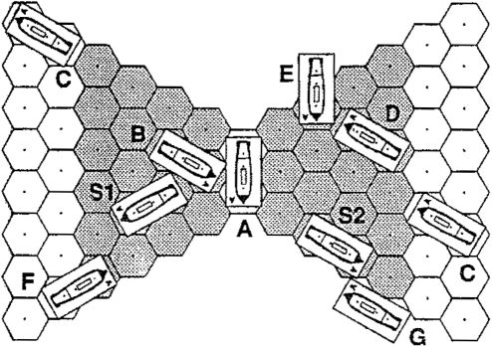
FIGURE 23 - Rakes

- E.13 Rake Determination by Orientation. A shot is a rake if the conditions above are met, regardless of whether only one or both sections of the firing ship can fire at the target. The orientation between the two ships is what is important.
VILE. 14 Rake Bonus. Rakes receive a higher BGN on the GOT. The rake BGN is shown by the numbers in smaller print at ranges 1-4.
VH.E.15 Stern vs. Bow Rakes, if the stern of the target ship is closer to the firing ship than the bow of the target ship, the rake is called a stern rake. If the bow is closer, it is called a bow rake. On stern rakes (firing low), all Gun and Crew hits indicated by the GRT result are doubled.
VILE.16 Simultaneous Fire. All gunfire and marine fire is considered to occur simultaneously. Therefore any damage suffered by a ship does not affect its fire in the same Combat Phase. After all gunfire has been announced, it may therefore be resolved in any convenient order.

VII.F AMMUNITION
VILF.1 Ammunition Types. There are three types of ammunition in CA: Roundshot, Chainshot and Grapeshot.
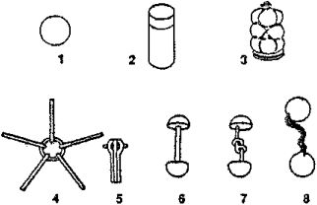
FIGURE 24 - Types of Ammunition

EXAMPLE: 1 - roundshot; 2 - canister; 3 ■= grepoahot;
4 & 5 = dismantling ("star') shot (extended & folded);
6 = bar shot; 7 -- expanding bar shot; 8 -» chain shot.
VII.F.2 Roundshot. Consisting simply of a round iron ball, roundshot is the most frequently used type of ammunition. It has a maximum range of 13 hexes.
Vll.F.3 Chainshot. This is a generic name for all types of ammunition intended for use against rigging. There were actually a number of different types of shot, some of the more popular of which are shown in Figure 24. Chainshot causes only R and C hits, and cannot cause hull critical hits. Chainshot has a range of 5 hexes. Ships firing Chainshot add 2 to the BGN. British ships may never use Chainshot.
Vll.F.4 Grapeshot. Grapeshot is a generic name for ail types of ammunition intended for use against personnel. Both grape and canister were used, usually in combination with one or more roundshot in ths same discharge. Grapeshot fire is resolved on the Grapeshot column of the GRT. Grapeshot has a range of 2 hexes, and does not cause any rigging damage or rigging critical hits.
- F.5 Same Type of Ammunition in a Single Combat Phase. Each ship can fire only one type of ammunition in a single Combat Phase, even if firing at more than one target (this represents the impossibility of sophisticated fire control in the period).

VILG DAMAGE FROM GUN FIRE
VI1.G.1 Types of Damage. A ship can incur rigging, hull, crew and gun damage.
Vll.G.2 Rigging Damage. Rigging hits are marked out from the lowest numbered rigging section which has not been already completely crossed out. When a section Is completely crossed out, roll one die on the Rigging Critical Hit Table, using the left-most column.
VII.G.3 Rigging Damage and Sall States. Ships suffer rigging damage according to their sail state:
- Furl: This is the lowest damage state. Ships at furled sail state only incur half of the damage indicated in the 'FS* column of the GRT. For odd boxes, roll a die; if a 1-3, the box is lost; 4-6, no effect.
- FS: The rigging damage done to a ship under FS is shown in the 'FS' column of the GRT (regardless of whether firing high or low).
- MS: The damage shown under the 'MS' column of the GRT is added to the damage in the FS column to get the total rigging damage.
- PS: The damage shown under the PS column of the GRT is added to both the MS and FS columns to get the total rigging damage.
VII.G.4 PS/MS Damage. A ship that loses PS or MS capability while at PS or MS continues to suffer damage at the PS or MS rate until it alters sail to FS, even when it has lost enough rigging boxes to prohibit it from using the PS or MS MA. To show this, place a '(PS)' or '(MS)' counter on the ship. These counters show that the ship has less movement than the ship and sail counters indicate. It is thus possible for there to be a difference between the sail status for damage and the sail status for movement. The actual capability that the ship has for movement purposes is used for calculating all things associated with the rigging (e.g. drifting and blocked wind), except where otherwise noted; the sail status for when determining damage from gun fire is calculated by the '(PS)' or '(MS)' counter.
VII.G.5 Hull Damage. Hull boxes are crossed off the lowest-numbered hull section first. When all hull boxes are lost, the ship immediately strikes (surrenders), and must roll to see if it will sink (see IX.E).
VII.G.6 Manning the Pumps. When all boxes in hull sections 1 and 2 have been crossed off, or when called for by the Critical Hits Table, a number of crew boxes must be sent to 'man the pumps.' The number of crew boxes required is specified in the SDC or scenario OB (see I.E.6). These boxes are crossed off just as if they had been hit by gun or marine fire, and may never be withdrawn, even if the ship later repairs one or more boxes of her second hull section. However, the ship would not have to send yet more men to the pumps if it lost hull section 2 again.
- Failure to man pumps. A ship which does not have enough crew available to man the pumps when required to do so automatically strikes, and must roll to see if it will sink.
- Where to cross off crew. The required crew boxes may come from either the marine CS or the lowest- numbered sailor CS in any combination desired, if the boxes crossed off result in a CS being entirely crossed out, a morale check must be taken, exactly as if the CS had been lost to gunfire.
EXAMPLE: A ship loses its second hull section and must eond men to the pumps. The ship's pump value Is 3, so It must send 3 crew boxes to the pumps. The following combinations are valid (assuming the ship has enough of each type of crew): 3 sailor crew boxes; 2 sailor crew boxes and 1 marine crew box: 1 sailor crew and 2 marine crew boxes; 3 marine crow boxes.
VII.G.7 Crew Damage. If only one type of crew remains, then all c hits are automatically of that type. Otherwise roll one die on the proper line of the Crew Loss Table for each crew box which is lost. Use the top row of the table if firing low with roundshot; use the bottom row of the table for every other cause of crew loss (e.g., firing high with any type of ammunition, firing low with chainshot or grapeshot, marine fire, and boarding combat).
Vll.G.B Sailor Losses. All sailor crew losses must come from the lowest-numbered sailor crew section.
VII.G.S Striking Due to Loss of Crew. A ship which has no crew available to freely assign (i.e., all the crew is either crossed off or is dedicated to mandatory tasks such as fighting fires) immediately strikes.
VH.G.10 Gun Damage Location.
- Not a rake: Guns must be removed from the side of the target ship closest to the firing ship.
- Bow rakes: Gun losses are split evenly between the port and starboard broadsides. For odd boxes, roll a die; 1-3 = port, 4-6 --- starboard.
- Stern rakes: Since stern rakes cause double ths number of gun losses indicated, half of the guns lost come off the port broadside, and half from the starboard side (there will always be an even number of guns lost because of the doubling).
VII.G.11 The Gun Loss Table. There are three types of gun boxes which can be lost: normal guns, lower-deck guns, and carronades. If a ship has only one type of gun box along a broadside, the box lost must obviously be of that type. However, if there is more than one type of gun box on the affected broadside, roll on the Gun Loss Table for each gun box lost to determine the type of gun box actually lost.
- Normal guns. If a ship has no normal guns, alt normal gun losses become lower-deck gun losses.
- Lower-deck guns. If a ship has no lower-deck guns, all lower-deck gun losses become normal gun losses.
- Carronades. If there are no carronades remaining, carronade losses become lower-deck gun losses.
- If there are no gun boxes of any type on the affected broadside, mark out a hull box instead.
V1I.G.12 Critical Hits. In addition to damage taken according to the above rules, a ship may also suffer critical hits. If the gunnery DR is an unmodified 6, then another DR is made immediately, If this second DR is < the CH number on the FGN row, a critical hit occurs.
- The CH chance is modified by the ship's CH modifier.
- If the second DR resulted in a CH, roll two dice and consult either the Hull or Rigging CHT; the Hull CHT if the firing ship was firing low or firing Grapeshot, or the Rigging CHT if the ship was firing high.
- All critical hits take effect at the end of the Combat Phase, unless otherwise noted.

VII.H MARINE FIRE
VII.H.1 Who May Fire. Only marine sections may use marine fire, and they may fire only at adjacent ships. The orientation of the firing ship to the target ship is immaterial (see back cover of this book for field of fire diagram).
VII.H.2 Target. The entire marine section must fire at one enemy ship, even if more than one target is available.
VII.H.3 Procedure. Count the number of marine boxes available at the beginning of the game-turn and roll one die on the Marine Fire Table (on the blue sheet), adding or subtracting the appropriate DRMs. The result is the number of crew boxes crossed off by the target ship. Roll on the Crew Loss Table for each box lost (unless the ship has only one type of crew remaining).
Vll.H.4 Die Roll Modifiers. The marine fire DRMs are all cumulative. One often misunderstood DRM is for firing from a larger class to a smaller. If the firing ship is larger than the target ship (class # < the target ship class #), the firing ship gets a -1 DRM, regardless of how much larger the firing ship is. Note that there is no modifier when firing from a smaller class to a larger.
EXAMPLE: A class 1 ship firing al a class 2, 3 or 4 ship would have a -1 DRM In all cases. A class 3 ship firing at a class 4 ship would also get a -1 DRM.
Vll.H.5 Marine Availability. A marine section may fire only if it has not been plotted to perform another task in the same game-turn. [Exception: Marines assigned to boarding parties or to repel boarders may fire.]
VII.H.6 Simultaneity with Gunfire. Marine fire is simultaneous with gun fire. Therefore, marine crew losses inflicted by gun fire do not reduce the number of marine boxes which can use marine fire in the same turn.
- BOARDING
- B BOARDING ELIGIBILITY
’At this time the Captain, having lost her foretopmast, not a sail shroud or rope left, her wheel shot away, and [beingl incapable of further service in the line or in chase, I ordered Captain Miller to put the helm a-starboard, and calling for boarders, ordered them to board.’
<W Horatio Nelson
(relating his capture of two Spanish SOLs by boarding at the battle of Cape St. Vincent)
Boarding combat represents the sort of gallant hand-to-hand fighting across the decks of ships with cutlass, pike and pistol which has been often depicted in pirate movies. However, Errol Flynn notwithstanding, boarding attempts were in reality rare (especially against SOL's), and almost always unsuccessful against determined and prepared opponents. It is noteworthy that the incident quoted above is the only occasion in the entire Napoleonic era when ships of the line were captured by boarding.

I Vlfl.A BOARDING PARTIES
Vlll.A.1 Forming a Boarding Party. To board an enemy ship a ship must first form a boarding party (BP). This is done by writing FB in the notes section of the ship's log during the Plot Phase. Each ship can only have one boarding party forming or formed at one time. Forming a BP takes the CS's involved one complete game-turn. At the end of that game-turn those CS's involved are now a BP, and may board on any subsequent game-turn.
- A.2 Prepared Boarding Parties. Once prepared, BPs remain in existence until they either attempt to board an enemy ship or are disbanded.
- A.2 Disbanding. BPs may be voluntarily disbanded by writing DB in the notes column of the log. It takes one game-turn for the BP to disband; during this game-turn the CS’s comprising the BP are not available for any other tasks. [Exception: Marines can use marine fire and are ’available’ for use in grappling/ungrappling attempts.] In the next game-turn the CS’s are free to function normally again.
- A.4 Boarding Party Restrictions. While forming a BP or while a BP is prepared, the CS's comprising the BP may do nothing except board. [Exception: Marines may use marine fire.]
Vill.A.5 Reporting BPs. Any ship forming a BP must announce this fact to all players and place a ’boarding party’ counter on the ship.
- A.6 Defending against Boarding Attempts. Defending against attacking BPs is automatic; plotting is not necessary.
Vltl.B.1 Fouled/Grappled Ships. Boarding may only occur between enemy ships which were fouled or grappled at the beginning of the current game-turn. BPs may not board friendly ships.
VIH.B.2 Ships on Fire. Ships which are on fire may neither board other ships, nor be boarded.
- B.3 Demoralized Ships. Demoralized ships may not board other ships.
- B.4 Boarding Struck Ships. Boarding struck ships is allowed; the boarding party automatically wins (there is no boarding combat procedure), and automatically begins reorganizing in the next game-turn.
- C BOARDING PROCEDURE
- C.1 Declaring "Boarders Away", At the start of the Combat Phase, a ship which has a formed BP may declare boarders away. Note this by marking BA in the notes section of the log. The particular CS’s which will be used in the boarding attempt must also be specified.
EXAMPLE: A ship with these CS's formed Into a BP (the marines and sailor sections 1 and 2) decides to use only CS’s 1 and M, since he thinks he can beat the enemy with only that number of crew, and plans to disband CS 2 so that it can fire the guns. He must specify that CS 1 and the marines are being used by writing BA — 1,M.
- C.2 Declaring "Repel Boarders*. Immediately after all BA’s have been declared, the defending ship may then assign any number of unassigned crew sections to repel boarders (i.e., those CS's that were not assigned to a task during the Plot Phase). The marine section, if available, must be assigned; any or all available sailor sections may be assigned, lowest-numbered first. The defending ship must specify the sections being used to repel boarders in the notes section of the log.
- C.3 When Boarding Occurs. Boarding occurs after all gunnery and marine fire; thus all losses from gunnery and marine fire are deducted from the boarding parties before the start of boarding. All CS’s included in the BA plot must participate in the boarding action.
- C.4 Calculating Boarding Strength. Each side calculates its total Boarding Combat Factors (BCF) by using the combat values given in the Crew Quality Table on the red sheet Each crew box is worth a certain number of Boarding Combat Factors, depending on the ship's current CQ. Add up all the boxes involved in the boarding action to determine the total BCF.
EXAMPLE: Implacable's BP consist* of the marine section, -.'ill four marine boxes remaining, and CS 3, with S boxes i' . -naming. Her CQ is D, so each sailor box Is worth 3 BCFs and each marine box is worth 5 BCFs. Thus her sailor section Is worth 8 x 3, or 24, BCFs, and her marine section is worth 4 x 5, or 20, BCFs, for a combined total of 44 BCFs.
VIII.C.5 Determining the Attacker. One side must be the attacking side and the other the defending side in every boarding action:
a If only one side writes BA, that side is the attacker.
- If both sides write BA, the side with the higher total BCF is the attacker; the other side immediately becomes a ‘repelling* force, and is no longer a BP.
- If one side has established itself upon an enemy ship, that side is the attacker.
- C.6 Established and Unestablished BPs. When a BP first attacks an enemy ship, it has not yet 'established* itself upon the decks of the enemy ship, and is at a disadvantage until it manages to become established. Therefore, a BP must use the 'Unestablished Attackers' modifiers until it succeeds in establishing itself.
- C.7 Continuation of Boarding Actions. CS’s involved in boarding may not withdraw or disband for any reason. They are released only with the defeat of one of the two sides. However, additional CS’s may be added to the boarding action simply by plotting them as a BP or to repel boarders, respectively.
VIII.C.8 Resolving Boarding. Both sides must calculate the odds and apply the applicable DRMs to themselves. After applying these and other applicable DRMs, each side simultaneously rolls two dice on the Boarding Table.
EXAMPLE: The Implacable has a total BCF of 44 (see VIII.C.4. The Henown has a total BCF of 25. The Implacable's BP gets a +1 DRM for having 32 odds In their favor, while the Renown has a -2 DRM for only mustering 1:2 odds. However, Renown is a class 2 ship and is defending, so it Implacable (as an unestablished attacker) racoives a further -2 DRM, for c total of -1 for Implacable and -2 for Renown.
VIII.C.9 Crew Casualties. The result is divided into two parts, a percentage number and a possible other result. The percentage figure is always applied, and represents the proportion of the crew boxes of the enemy BP which are lost {round all fractions up). These losses are converted into crew box losses by rolling on the bottom row of the Crew Loss Table {'All Other Causes') and crossing off the specified type of crew box. Repeat this procedure until all crew losses have been assigned to either sailor or marine boxes.
Vlli.C.10 Special Results. As noted above, a variety of special results can occur. However, if both players roll special results, only the one caused by the higher modified DR occurs; the other player's result is ignored. If both sides get the same modified DR, then whichever side has more total BCF after losses gets the result, if this is still the same, neither side gets the result.
- Repulse. This means that the BP is defeated and gives up the attempt to board the defending ship. The BP is automatically disbanded and the CS’s making up ttie BP must go through the entire preparation cycle before being able to board again.
- Established. This means that the BP is now established upon the defending {repelling) ship, and no longer must use the 'Unestablished* DRMs.
- BP Captured. The crew sections belonging to the BP surrender to the other side, and are no longer available to the parent ship.
- Ship Captured. The defending ship is captured.
V1II.C.11 Attacking Victorious. The attacking side can win a boarding action in three ways:
- If the defending ship cannot or chooses not to assign any OS's to repel boarders.
- By capturing the defending ship via a 'Defending Ship Captured' result on the Boarding Combat Table.
- By eliminating all defending crew assigned to repel boarders.
VIILC.12 Defending Side Victorious. The defending side can win a boarding action in three ways:
- By capturing the attacking BP via a 'Attacker's BP Captured" result on the Boarding Combat Table.
- By eliminating the attacking boarding party.
- By an 'Attacker Repulsed' result on the Boarding Combat Table.
VIII.C.13 BP and Parent Ship. A BP which is actively engaged in a BA immediately surrenders when the ship from which it came strikes, unless the BP has already won its boarding action and has begun to reorganize. Similarly, all adverse morale results are applied to the BP on the next game-turn.
- D REORGANIZING
VIII.D.1 Introduction. After a victorious boarding action, the defeated ship would be a scene of complete chaos, with victorious and defeated crew members intermingled on ail the decks from the orlop to the poop. Much time was required to sort out the prisoners, to mount a guard over them and other vital points likes the magazines and armory, and to detail the prize crew. The victorious BP was therefore extremely vulnerable to a counter-assault until it was reorganized.
VIII.D.2 Who Must Reorganize. A BP which wins a boarding action must immediately begin reorganizing and
may NOT stop until it has finished doing so. A defending ship which drives off the attacker does NOT have to reorganize; instead, the crew are instantly free to resume their duties.
VIII.D.3 Reorganization Time. The time required for reorganization is equal to the BP's SK. Thus an BP with CQ=A takes only 2 game-turns to reorganize, while a Green crew (CQ=E) takes 5 game-turns. Reorganization is plotted in the notes column of the log as ‘Reorg.’
VIII.D.4 Actions While Reorganizing. A reorganizing BP can do nothing except defend its prize against enemy boarding parties. The parent ship may continue to function normally with whatever crew it has remaining. The BP continues to have the same CQ as the parent ship during reorganization.
Vill.D.5 Prize Crews. Once reorganization is complete, crew boxes from the victorious BP must be allocated to form a prize crew; these may be taken from any of the sections making up the BP, in any combination, except that higher-numbered sailor sections must retain at least one more box than the next tower-numbered sailor section after this process is complete. If this process results in the elimination of a CS, the parent ship must take a MC. The remainder of the BP is returned to the parent ship, ready for normal use.
Vlll.D.6 Prize Crew Composition. The minimum number of boxes required for a prize crew is the same as the 'men to the pumps* value in the SDC. More than the minimum number may be allotted if desired. All crew boxes making up the prize crew, whether marines or sailors, are joined into one single sailor section.
EXAMPLE: A British 74 (normal crew 7-6^-5) captures a French ship by boarding, having used all its crew sections to do so. After ail crew losses the ship has 13 sailor crow boxes and 3 marine boxes remaining, and elects to devoie the minimum prize crew to the captured ship, allocating 5 sailor crew to the task. This leaves 8 sailor crew boxes, which may be allocated to OS's 1, 2 and 3 as: 0-2-6, 0-3-5, or 1-3-4. If crew section 1 did not have any crew boxes In it after the reorganization, the ship would have to take a morale check. The three marine boxes are not affected by this process.
- E OPERATION OF CAPTURED SHIPS
VIII.E.1 Introduction. This section is a compendium of all the rules concerning captured ships, assembled here for easy reference.
VIII.E.2 Definition. A captured ship is a ship which has lost a boarding action. Struck ships are not the same as captured ships.
VIII.E.3 Prize Crew Composition. A prize crew may consist of sailors, marines, or both. The prize crew acts as a single crew section, even if it includes both sailors and marines. Prize crews are always a single sailor CS, regardless of what type and numbers of crew boxes were used to make up the prize crew (i.e., marines or sailors both become sailors when making up a prize crew).
VIII.E.4 Prize Crew CQ and MR. Prize crews always have a CQ of F, but retain their original MR (if there was more than one MR in the crew boxes making up prize crew, the MR is the lower of the two MRs).
VIII.E.5 Sailing Captured Ships. Captured ships may never use PS. A captured ship cannot be sailed by its prize crew until the capturing BP is completely reorganized. However, the captured ship could be taken under tow.
- E.6 Combat. Captured ships may never fire guns.
VIII.E.7 Prize Crew Limitations. Prize crews cannot do any of the following actions:
a Form boarding parties.
- "Grapple enemy ships.
- Fire the captured ship's guns.
- Alter sail to PS, or use PS if it is already up when the ship is captured.
Except for these restrictions, the prize crew acts normally.
Vill.E.8 Captured Ship's Crew. The captured enemy crew cannot do anything, unless it first retakes control of the ship as per Vllt.E.9 below. Captured crew boxes cannot be transferred to other ships.
VIII.E.9 Casualties on Captured Ships. All crew losses suffered by the captured ship are taken from the prize crew.
VIII.E.10 Prize Crew Reduction, if the prize crew is completely eliminated, the captured crew is "reactivated,* and is assumed to retake the ship after a number of gameturns equal to the captured ship's original SK. They then receive a CQ of F and MR - to their original MR, and may perform all actions normally.
Vill.E.11 Involuntary Actions. Captured ships which have to man the pumps due to damage received after being captured, or which have to fight fires, can use the original crew of the captured ship for these actions. Voluntary actions, such as changing sail state, preparing to anchor, etc., must be performed by the prize crew.
- MAINTENANCE PHASE
'Had 1 been master of the sea, 1 should have been lord of the Orient.’
Napoleon Bonaparte
During the Maintenance Phase, ships perform a variety of miscellaneous actions that are not appropriately located in the other phases. They are described here in the order in which they are to be done (see the sequence of play).
- A GRAPPLING AND UNGRAPPLING
IX.A. 1 When to Grapple. Each ship may now attempt to grapple each adjacent ship once.
IX.A.2 Maximum Speed. Grappling is only possible when both ships involved in the grapple attempt expended no more than two MP's each. The orientation and movement paths of the two ships with respect to one another do not matter in this determination. Ships that have become fouled in the current game-turn retain their speed for purposes of grappling.
EXAMPLE 1: A ship which expended 3 MP's cannot attempt to grapple another ship, regardless of the other ship's speed (or even If the enemy ship did not move at all).
EXAMPLE 2: A British ship moves 1S2P (5 MP's) and fouls a French ship. The French ship could not try to grapple the British ship because the British ship expended more than 2 MP's in the game-turn.
IX.A.3 Grappling Procedure. Grappling is attempted by rolling on the Grappling Table (on the red sheet). If the attempt is successful, place a “grapple* counter between the two grappled ships.
IX.A.4 Friendly Ships. Friendly ships must roll to grapple each other, just like grappling between enemy ships.
- A.5 Number of Grapples. Only one grapple may connect a pair of ships at any one time.
- A.6 Ungrappling. After ail ships which wish to try to grapple have done so, all ships which are grappled may try to ungrapple by rolling one die on the Ungrappling Table. This action does not require any OS's to perform. Ships may not automatically ungrapple, even //the ship attempting to ungrappie is the ship that originally initiated the grapple! Friendly ships may not automatically ungrapple from each other, but receive a -2 DRM.
- A.7 Ungrappling During Boarding Actions. A ship with its BP established on an enemy ship may not ungrappie from that ship. Conversely, a ship with an enemy BP established on board itself cannot ungrapple from the ship from which the BP came. A ship may try to ungrapple other ships, so long as neither side has established BP‘s (or if there are no BP's present at all). Once the boarding action is resolved, the restrictions concerning established BP's are lifted.
IX.A.S Ungrappling from Struck Ships. Note that struck ships have an CO of G. A ship which is trying to ungrapple from the struck ship receives a -1 DRM for each CO greater than G which it currently possesses.
IX.A.9 Movement While Grappled. Grappled ships may not move, turn, or partially drift.
- B UNFOULING
- B.1 Procedure. A fouled from each ship with which it is die for each foul and consults ing the appropriate DRMs.
- B.2 Mutual Unfouiing Attempts. If two ships are fouled to each other, either or both ships may attempt to unfoul from each other.
ship may now try to unfoul fouled. Each ship rolls one the Unfouling Table, apply-
- B.3 Recording Unfouling Attempts. Each ship must record the number of times it attempts to unfoul from each ship by writing U in the notes column of the log, as the chance of success increases with each succeeding attempt.
- B.4 Unfouiing During Boarding Actions. A ship which has its own BP established on an enemy ship, or which has an established enemy BP on itself, may not unfoul from that ship until the boarding action is resolved. It may attempt to unfoul from all other ships (see IX.A.7).
- C FIGHTING FIRES
IX.C.1 Fighting Fires Mandatory. A ship on fire must assign one CS to try to put out the fire in the Plot Phase. Fighting fires is plotted in the notes column of the Log using the notation Fr - (crew section desired). Note that a CS may voluntarily plot FF even if the ship is not yet on fire.
IX.C.2 Fires and Boarding Parties. If all the crew of a ship are currently in a boarding party, the highest- numbered sailor section is automatically removed from the BP and assigned to firefighting.
IX.C.3 Fighting the Fire. During the Maintenance Phase of each game-turn, a ship which has plotted to fight a fire attempts to extinguish the fire by rolling on the Unfouiing Table. Ships which have struck always continue to fight fires, and put out the fire on a DR of 1.
IX.C.4 Out of Control. If the fire has not been put out after 10 game-turns since the ship originally caught fire, or
if the ship on fire loses all of its crew, the fire is out of control and cannot be put out. The affected ship can do nothing from now on, and will explode (see IX. D),
IX.C.5 More than One Fire. Only one fire can exist on a ship on any given game-turn: ignore all DR's which might cause a second fire to occur.
EXAMPLE: A ship already on tire is adjacent to a ship which explodes (see IX.D), The blast damage is suffered by the the ship on fire, but the DR for catching tire is not made.
IX.C.S Struck Ships. Ships which initially catch fire after striking are still allowed to fight the fire, and will put out the fire on a DR of 1.
- D FIRE DAMAGE AND EXPLOSIONS
- D.1 Causes of Fire, A ship may catch fire in several ways - as a result of critical hits, by being grappled or fouled to a ship on fire, or due to the effects of nearby exploding ships.
IX.D.2 Fire Damage. Each game-turn a ship is on fire it loses 1 hull and 1 rigging box. Cross out this damage during the Fire Damage Phase of the Maintenance Phase. If the ship loses all its hull boxes and the fire is still burning, the ship strikes and will explode. Roll two dice. If the result is 2, the ship explodes. Otherwise the ship continues to bum; roll again for exploding during the Exploding Ships segment in the Maintenance Phase of the next game-turn. There is a +1 chance that the ship will explode each additional game-turn it is on fire. If the DR needed to explode reaches 12, the ship automatically explodes that game-turn.
EXAMPLE: A ship begin* rolling to explode on game-turn 12. On that game-turn it needs a 2 to explode. On gameturn 13, it would need a 2 or 3; on game-turn 14, a 2 through 4, etc.
IX.D.3 Spreading of Fires. Each game-turn there is a chance that a fire will spread to any adjacent grappled or fouled ship. Each adjacent grappled or fouled ship must roll one die. if the DR is < its SK, that ship is afire. However, the chance for a fire to spread will never exceed 3.
Example: An A ship would catch fire only if it rolled a 1; a D, E or F ship would be afire with a DR of 1-3.
- D.4 Exploding Ship Destroyed, When a ship explodes, it is destroyed (removed from the board),
IX.D.5 Explosion Effects. An explosion affects ships in two ways: blast damage and flaming debris.
IX.D.6 Blast Damage. Blast damage represents the shock wave from the explosion of a ship's powder magazine. Blast damage affects all ships at a range of 1 or 2 hexes. Calculate blast damage using the following chart:
Exploding Ship Class: 1:2: 3: 4:
Range 1 :■ 40 35 30 25
Range 2:30 25 20 15
Cross-index the ship class which is exploding with the range to the target ship, and roll on the High side of the GRT, using the number shown in the table above as the MGN. Ships > 3 or more hexes away from the exploding ship suffer no blast damage.
IX.D.7 Flaming Debris. All ships within 5 hexes must roll to determine if a fire breaks out. The ship catches fire if the DR > the range. Ships grappled or fouled to the exploding ship always catch fire.
EXAMPLE: A ship 5 hsxss away catchaa fire If It rolls a 8. A ship adjacent to the exploding ship catches tire on a DR of 2-6 (unless it is grappled or fouled to the ship on fire, In which case it would automatically be on fire as well).

IX.E SINKING SHIPS
- E.1 Which Ships May Sink. A ship which either has lost all its hull boxes or has insufficient crew to man the pumps when required must check to see whether it will sink.
- E.2 Potential Sinking Ships. Roll one die. If the DR - 1 or is < the ship’s class, the ship will sink, if the WS=4, there is a DRM of -1; if the WS=5, there is a DRM of -2. If the ship wiH sink, place a ‘sinking* counter on the ship, and roll to determine if the ship sinks at once (see IX.E.3).
IX.E.3 Rolling for Sinking Ships. Roll two dice for each sinking ship during the Maintenance Phase. If the result is 12, the ship sinks and is removed from the board. If the ship does not sink, roil again on the next game-turn.
- E.4 Sinking and Exploding Ships. A ship may be both sinking and on fire at the same time, In such cases roll two dice as described above and apply the applicable result. In the unusual case that the ship has not exploded for 10 game-turns (and thus is now automatic - [12 or less with two dice]) the ship must still roll; on a DR of exactly 12 the ship sinks rather than exploding.
- E.5 Fouled and/or Grappled Ships. A ship which is either fouled with or grappled to a snip which sinks does not also sink! The fouled/grappled ship is instead automatically unfouled/ungrappled.
IX.E.6 End of Scenario. Even if a sinking ship has not sunk by the end of the scenario, it is still counted as a sunk ship.

IX.F REPAIRS
Definition. A ship which is at FS or Furl/D and which is not engaged in boarding, grappled, fouled or on fire may repair combat damage. Note that a ship may fire its guns while repairing.
IX.F.2 Type of Repairs Allowed. Hull, gun, and rigging boxes may be repaired: crew boxes may not. Repairs must be plotted during the Plot Phase; they are noted in the notes column of the log as RR (rigging), RH (hull) and RG (guns). Repairs do not have to be plotted on consecutive turns.
IX.F.3 Crew Assignment. Only one CS may repair a single type of damage on any given game-turn. However, different CS's may repair different types of damage at the same time. Thus one CS could plot RR while another plots RH, and a third plots RG. Each repair action plotted requires the use of a CS for the entire game-turn.
IX.F.4 Initiation of Repairs. A ship cannot begin repairing a type of damage until the Plot Phase after the ship has lost at least one box of that type.
IX.F.5 Speed of Repairs. Each type of damage is more or less difficult to repair. The number of game-turns necessary to restore one box of each type of damage is shown in the Repair Table (on the red sheet), and depends entirely on the CQ of the repairing ship. *
EXAMPLE: A »hip with a CQ of A takas 3 game-turns to repair one rigging box. 6 game-turns to repair one hull box, and 7 game-turns to repair one gun box.
IX.F.6 Effects of Repairs. After the designated number of game-turns of plotted repairs have passed, the repairing ship regains a box of the indicated type. Each completed repair means that a box of the appropriate type which has been crossed out is erased; it is then treated for all purposes except morale checks as if it had not yet been crossed out.
EXAMPLE: A ship loses rigging section 1, and rolls for ex-
- tra rigging damage. If the ship subsequently repairs one box In rigging section 1, and later has to cross out the last box of rigging section 1 again, it must roll for extra rigging damage once again.
IX.F.7 Repairs While Afire. Ships on fire cannot repair.

1X.G OTHER ACTIONS
IX.G.1 Morale Checks. Roll all morale checks now,
IX.G.2 Message Delivery. All messages written during the Plot Phase are now delivered (see XI, Signalling).
- CREW QUALITY AND MORALE
Captain Pearson: 'Have you Struck?"
John Paul Jones: '/ have not yet begun to fight ft
38” Attributed to Jones but probably apocryphal
Everything a ship does depends on her crew quality, from gunfire to shiphandling to boarding. There are six possible craw quality levels (CQ), rated from A (best) to F (worst). These represent the total range of possibilities from the very best orews to the very worst, but only A through E are possible as initial CQ ratings. As a ship takes damage, It must take morale checks, representing the cumulative effects of fatigue, casualties and panic upon its fighting efficiency.
- A CREW QUALITY. SKILL AND MORALE
XA.1 Morale. Ships may be of different qualities. The crew's ability is rated by both crew quality (CQ) and morale rating (MR). CQ is the measurement of how skillful the crew is at performing the various tasks required on a sailing warship, such as firing the guns, repairing, grappling and ungrappling, altering sail, etc. The ship's skill number (SK) is'derived directly from the ship’s CQ (see the Crew Quality Table on the red sheet).
The ship's morale rating (MR) is the measure of how willing the men are to fight. Usually but not always the two values are closely correlated. Note that while the CQ may degrade during a battle, the MR number never changes.
EXAMPLE: A ship with a CQ/MR of E4 ('green*) has an SK of 5 and an MR of 4.
- A.2 SK Use. A ship’s SK number is a representation of the crew's efficiency, or skill. It is often used to determine how iong various actions will take (repairs, preparing to anchor with springs, and reorganizing boarding parties, for example). It also strongly affects a ship's efficiency in other ways (unfouling, for example).
- A.3 MR Use. In contrast to the SK, the ship's MR is used for only one purpose: checking the morale of the ship when necessary due to adverse fortunes of combat. The MR number of a ship never changes during the course of a scenario.
- B MORALE CHECKS
X.B.1 When to Take Morale Checks. A ship must take a morale check (MC) when any of the following events occur:
- A-ship crosses out the last box in rigging section 4 (i.e., is dismasted).
- When the last box in any hull section is crossed out.
- When the last box in any crew section is crossed out.
- A ship loses all the gun and carronade boxes on a broadside. This may happen twice, once each for the port and starboard broadsides.
- A ship that was already dismasted at the start of the game-turn is raked, or is fired upon at a range of < 4 hexes and cannot return fire. NOTE: ships under tow are not considered dismasted for purposes of this rule, unless the towing ship is itself dismasted. Ships anchored with springs are liable to this rule.
- A ship catches fire. Note that ships already on fire may not catch fire again.
- A MC is specified by a Critical Hits Table. Note that MCs caused by fires from CHT's must always be taken, even if the ship is already on fire.
X.B.2 Repairs and Morale Checks. Ships can repair hull, guns, and rigging, and could therefore conceivably add at least one box to a previously completely eliminated hull section, dismasted ship, or ungunned broadside. The ship does not have to make a MC for losing these sections if they get crossed off again.
- B.3 Passing Morale Checks. A ship passes a morale check by rolling > its MR on a d6. Thus a ship with an MR of 3 would have to roil a 3-6 to pass. See the Crew Quality Table.
X.B.4 Failing Morale Checks. A ship which fails a morale check loses one CQ level. Thus a ship with a MR of 4 fails morale checks on a DR of 1-3. The ship operates at its new CQ for all purposes for the remainder of the game.
EXAMPLE: A ship with a CQ/MR of A2 rolls a 1 on its first morale check; its new CQ is B. If it failed five more morale checks, its CQ would be progressively reduced to B, C, D, E, F and finally to □ (struck). Remember that its MR would remain 2 until it struck.
- C STRIKING
X.C.1 When Ships Strike. A ship strikes when:
- It loses all its hull.
- It fails a morale check at a CQ of F.
- It loses all its crew, or has all remaining crew fighting a fire.
X.C.2 Actions of Struck Ships. Struck ships may not do anything for the remainder of the game except fighting fires. Note that if the ship struck due to lack of crew, it would not be able to this either.
X.C.3 Crew Quality of Struck Ships. Struck ships have a nominal CQ of G. ..This is used to determine the success of actions such as ungrappling and fighting fires.)
- SIGNALLING
'Engage the Enemy more Closely.’
ar Nelson's last signal to the Fleet at Trafalgar
The most difficult problem admiral* faced during the age at tail wu coordinating the movement of a large fleet in a period without Instantansou* communications. All communications between ships was done by signal flags. This was an uncertain method of message transmission at best, and many things hampered the smooth working of this system amidst the confusion of a naval battle. The following roles attempt to recreate the limitations that actually existed in the sending and reading of flag signals.
- A BASIC SIGNALLING RULES
- A.1 When to Use. These signalling rules apply only to multi-player games (i.e., games in which there are at least two players on one of the sides).
- A.2 Number of Messages. Each player may write only one message per game-turn, regardless of the number of ships he commands.
- A.3 Limits on Signals. Players on the same side may transmit information relevant to the scenario in writing only. Players on opposite sides may never communicate at all. [Exception: technical questions about CA rules are obviously permitted, although they should be asked after all other players have written their moves.]
- A.4 Writing Messages. All messages must be written during the Plot Phase and placed face-down near the board until the end of the game-turn. [Exception: If a referee is present, he should always hold all messages.]
XIJL5 Message Delivery. At the end of the game-turn, all messages written in the Plot Phase of the same gameturn are delivered to the appropriate player(s) and may be read. All players on the same side are entitled to read any message, no matter who the message is addressed to.
- B MESSAGE FORMAT AND CONTENTS
- B.1 Message Length. Before 1803, ail nations may send 5 words in a single message. From 1803 onwards, the British may send S words in a single message: all other nations remain limited to 5 words per message.
XI.B.2 Message Format and Limitations. Messages consist of two elements: the address and the message (refer to the Message Form).
- Address. There are only certain allowed addresses for messages, reflecting the lack of flexibility in signalling which was the hallmark of the period. They are:
- 'ALL': A message addressed to the entire fleet.
- 'VAN', 'CENTER', 'REAR': A message addressed to one of the divisions of the fleet/squadron.
* ’SHIP NAME*: The name of a particular ship. Only a single ship may be the address of the message.
- Message, The message may consist of any words or numerals, but may not refer to specific features of either the movement plot system or the hex grid. Thus ■MOVE P2S1*, ‘GO SPEED 6‘, 'GOTO HEX 1712*), aned ‘CLOSE TO 5 HEXES’ are all illegal.
- Messages must be written entirely in capital letters and may not contain any punctuation of any kind, including (but not limited to) periods, commas, apostrophes, parentheses, underlining, bold, italics, etc.).
- C FLAGSHIPS
X1.C.1 Player Flagships. If a player commands more than one ship in a multi-player game, the player must designate one of his ships as his personal flagship. If the player controls a historical flagship in the scenario, he must use that ship as his personal flagship (no player may control more than one historical flagship).
- All messages sent or received by a player are considered to be sent/received by his flagship, even if the message is addressed to another of the player's ships.
- Each player may only send one message per gameturn, regardless of the number of ships he commands.
- Struck ships may not send or receive messages.
- If the player's flagship gets a ‘signal halyard cut* CH, the player cannot send any messages until repaired.
XI.C.2 Loss of Flagship. A player may transfer his flag to another friendly ship if his flagship strikes or is destroyed.
XI.C.3 Transferring Flagships. If the player controls another ship, he must transfer his flag to that ship. If the player controls no other ships, he may transfer his flag to the closest friendly ship that is not another players flagship.
XI.C.4 Procedure. The transfer occurs as follows:
- The player assumes control of his new flagship in the Plot Phase. If he is taking over the ship from another player, the other player hands him the ship's log; no information may be passed from one player to the other either verbally or in writing.
- The player immediately assumes full control of his new flagship, but may not send or receive messages until the plot phase of the next game-turn.
XI.C.5 Talking Between Adjacent Ships. When two friendly ships have their stern hexes adjacent, the players may talk freely if the ships are the respective players' flagships (if either ship is not a flagship, they may not talk). The players may talk during the Weather and Plot phases of the game-turn after their sterns become adjacent.
- SPECIAL MOVEMENT RULES
’His [the Goliath'sI sheet anchor (the cable being out the stem port) not dropping the moment he wished it, he missed, and brought up abreast of the second ship, having given the van ship his fire. 1 saw immediately he had failed of his intention, cut away the Zealous's sheet anchor and came to in the exact situation Captain Foley intended to have taken.’
Captain Samuel Hood (on the battle of the Nile)
The rule« In this section are not likely to be used during a typical Close Action scenario. However, they are not optional rules, and have been separated from the rest of the movement rules simply to make the main section less cluttered.
- A ANCHORING - GENERAL RULES
XILA.1 Introduction. Anchoring could confer several advantages during battle. The most important of these was to keep the ship from drifting, in addition, anchoring made the ship a more stable (and therefore better) gunnery platform, and allowed the sails to be furled, helping to limit rigging damage. Every warship typically carried three or four major anchors, but only two of them were normally available for immediate use.
X1I.A.2 Types of Anchoring. A ship may anchor normally or with springs. A ship anchored normally has a single anchor cable attaching the anchor to the ship. A ship anchored in this manner cannot turn and is therefore vulnerable to being raked by mobile enemy ships. Warships usually anchored in this way only when not expecting to fight. Anchoring with springs was the method usually used by warships when they expected to have to fight at anchor, because the ship could then train its broadsides in any direction, allowing the ship to fight effectively.
X1I.A.3 Anchoring by Bow or Stern. A ship may either anchor by the bow or anchor by the stern. A ship anchored by the bow will swing to WF L (unless anchored with springs); a ship anchored by the stern will swing to WF R (unless anchored with springs). A ship may anchor by the bow or stern normally or with springs, giving the following options:
Anchoring bv the Bow: Anchoring bv the Stem:
- Normally 1. Normally
- With Springs 2. With Springs
- A.4 Numbers of Anchors. Each ship can use two anchors in a single scenario. Anchoring either normally or with springs only requires one anchor. Thus the second anchor fc used only if the first one is shot or cut away and the ship wishes to anchor again.
- A.5 Sail State When Anchoring. A ship must be at Furl or FS in order to anchor. A ship which plots to anchor but is at MS or PS simply loses the anchor, and must prepare to anchor again. After anchoring, a ship may
never be at greater than FS until the turn after it cuts its anchor.
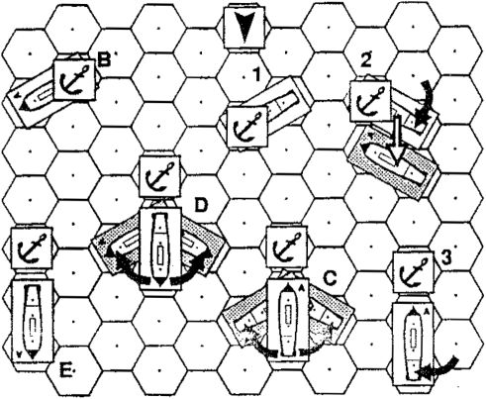
FIGURE 25 - Anchoring

- B PREPARING TO ANCHOR
X1I.B.1 Introduction. A ship cannot anchor until it has prepared to anchor. A ship prepares to anchor by writing PAB (Prepare to Anchor by Bow) or PAS (Prepare to Anchor by Stem) in the notes column of the tog. Both actions require one CS. PAB takes one game-turn; PAS takes two. At the end of these game-turn(s) the ship is prepared to anchor normally.
Xli.B.2 Preparing to Anchor with Springs. A ship that wishes to anchor with springs must undergo further preparation. A ship prepares springs by writing PSB (Prepare Springs for anchoring by the Bow) or PSS (Prepare Springs for anchoring by the Stem) in the notes section of the log. Both actions require one CS. The game-turns required are twice the ship's SK.
EXAMPLE: A ship with a SK of 5 would have to write PSB or PSS tor 10 game-turns. At the end of the tenth gameturn it would have springs prepared.
XII.B.3 Only Bow or Stern. A ship may be prepared to anchor by either the bow or stern; in fact it may be prepared to anchor by bow and stem at the same time. However, a ship may only prepare springs for either the bow or stern; springs cannot be prepared for both at the same time.
EXAMPLE: A ship that has completed PAS may only write PSS. A ship that had completed PAS and PAB could write either PSB or PSS.
XII.B.4 Sequence of Actions. A ship may prepare springs either before or after it has prepared to anchor normally.
- B.5 Maintaining Springs once Prepared. Once a ship has completed preparations, it may anchor at any time. Further, once springs have been prepared, the ship may postpone anchoring for as long as it desires with no penalty; the springs will remain ready.

Xll.C ANCHORING
XN.C.1 Plotting. A ship anchors by writing A in the notes section of the log. The ship may not plot to use any MP's at all on the game-turn it anchors. It may drift, since drifting is not plotted. If the ship plots to use MP's and anchor, the anchor plot is simply erased; it does not occur.
X1I.C.2 Anchoring Procedure. Anchoring is announced during the Movement Phase, but takes effect during the Maintenance Phase of the anchoring game-turn. Place an anchor counter in the bow or stern hex of the anchoring ship at this time, depending on whether the ship has written PAS or PAB. At this time the ship is described as being either anchored by the bow (AB) or anchored by the stern (AS).
EXAMPLE (*•• Figure 25): Example 1 »how» a skip
- which has just anchored by the bow, while example B shows a ship which has just anchored by the stem.
Xll.C.3 Movement While Anchored. An anchored ship may not use any MP’s until it cuts its anchor cable. Anchored ships may warp in or out, and must drift. Ships anchored with springs may pivot (turn).
X1I.C.4 Facing the Wind. After anchoring, the ship will always turn either to WF L (AB) or WF R (AS).
- The ship turns 60° per game-turn until it is in the proper WF. If AB, it will wind up as shown in Figure 25, example 3; if AS, as shown in example E. Thereafter it must remain in that WF. If AS, the ship pivots on its STERN, not on its bow; this is an exception to ail other turning rules.
- The ship must turn in the direction that will make it face the proper WF in the fewest number of gameturns. If a ship is supposed to face WF L but anchors at WF R (or vice-versa), it will turn to port on a DR of 1- 3, and to starboard on a DR of 4-6. Once it begins turning in any direction, it must continue turning in that direction until it is in the proper WF.
- If the wind changes direction, the ship turns to face the new WD in the game-turn following the change in WD.
, EXAMPLE (see Figure 25): Position 1 shows a ship which has just dropped anchor. On the next game-turn the ship pivots 60“ on its bow, to WF C (position 2). On the following game-turn it pivots again to WF L, and drifts (note that the ship could have drifted on the fir»t or second gameturns also; it is just random chance that the ship drifts on thia particular game-turn). The ship has now (position 3) reached its Anal resting point, and will not move from thir position unless it anchored with springs, cuts its cable, cr the wind changes direction.
Drifting after Anchoring. After anchoring, Me --'lip v/ill drift, using the normal drift rules, one hex directly «j l&award.
XII.C.6 Wind Direction Change. If the wind changes direction, the ship will again drift normally so that the bow is adjacent to and directly downwind of the anchor counter. This means the ship will drift in an oblique fashion, at an angle to the wind.
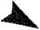

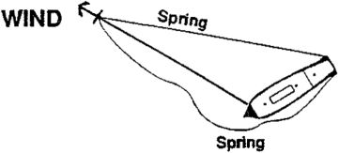
FIGURE 26 - Ship Anchored with Springs
drift until drift requirements for all WO’s have been satisfied.
EXAMPLE: A ship write# WO on three consecutive gameturns. The ship is at FS and the WS=3, so It drifts on an 8 or greater with two dice. This is a 42% chance per gameturn to drift each hex, so the chance that the ship will drift on three consecutive game-turns is only 7%! The ship rolls for drifting each game-tum, and drifts on game-turns 2, 5 and 6, whereupon it stops, having warped out as far as possible.
- WO may not occur on the same game-tum that the ship pivots.
XII.E.2 Warping In. A ship may "Warp In' (Wl) as many times as it has warped out The ship may never Warp In more times than it has WO. Wl requires one CS for one game-tum. Unlike WO, Wl takes effect the same game- tum as plotted (during drifting). If another ship is blocking the Wl, it does not occur; erase the plot from the log. There is no collision. A ship may not Wl on the same game-turn that the ship pivots.

XII.D ANCHORING WITH SPRINGS
XN.O.1 Facing the Wind. Unlike normal anchoring, a ship anchored with springs does not automatically turn to face the wind. Instead, it will maintain the WF at which it anchored until the ship voluntarily plots to turn, or pivots.
XII.D.2 Pivoting. After anchoring with springs, the ship may pivot 60° per Movement Phase. These pivots must be plotted, just like all other movement, if AB, the ship pivots on its bow hex (see Figure 25, example C). If AS, the ship pivots on its stern hex (see Figure 25, example D). Note that a grappled or fouled ship cannot pivot, even if anchored with springs. Also note that pivoting must obey the normal turning rules: in particular, fishtailing is not allowed.
X1I.D.3 Crew Requirements. One CS must be devoted to pivoting, and can do nothing else for the entire game-turn, if no CS is allocated in the notes section of the log, the ship may not pivot in that game-turn.

XII.E WARPING|
XI1.E.1 Warping Out. Although the standard distance from the ship's anchor to the ship itself is one hex, as shown in Figure 25 examples C, D, and E, a ship could slip downwind by paying out more cable.
- If a ship decides to let out cable, it indicates this by writing •WO" in the log, and the ship will drift 1 hex further downwind for each WO. The ship can only have three WO's in effect at the same time.
- Each WO requires one CS for one game-turn.
- The ship drifts to its new position at the normal drifting rate, according to the current WS. Continue rolling for

XII.F GETTING UNDER WAY
Xll.F.t. Introduction. There were two methods of getting under way: by weighing the anchor and by cutting or slipping the anchor cable. Anchored ships confronted by a nearby enemy would automatically cut or slip their cables, rather than weighing, to save valuable time; thus only cutting is considered here.
XII.F.2 Cutting the Anchor Cable. A ship may cut the anchor cable by writing A in the notes column of the Log. The next game-tum it is no longer anchored, and may plot movement. The ship may not pivot, Wl or WO on the game-turn the cable is cut.
XII.F.3 Removing Anchor Marker. The anchor marker is removed in the Maintenance Phase of the game-turn in which the anchor is cut. Record the loss of one anchor in the Anchors box of the log. if a ship has no anchors remaining, it may not anchor again during the scenario.
XII.F.4 After Cutting. A ship in WF L that cuts its anchor cable is not in irons on the first game-tum after it cuts the anchor cable.

XII.G TOWING
XII.G.1 Introduction. Towing was a frequent occurance; in fact, several battles were fought partially or entirely to protect ships under tow.
XII.G.2 Who Can Be Towed. A ship may tow another friendly ship (including ships captured from the enemy). A ship may never tow an enemy ship.
XII.G.3 Number. A ship may only tow one other ship; a ship may only be towed by a single ship.
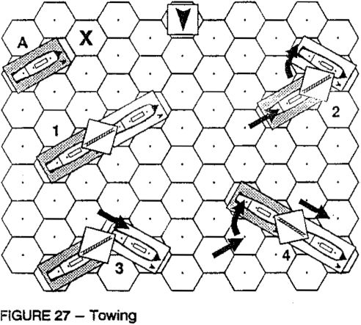

XII.G.4 Preparing to Tow. A ship must prepare for two consecutive game-turns before it is able to tow. One CS must be used for this purpose. It may do nothing else in that turn. Write PT in the log to indicate preparing to tow.
Xll.G.5 Beginning Tow. A ship begins towing another ship by placing its stern hex in the hex to which the bow of the ship to be towed is pointing. The towing ship then rolls for grappling on the Grappling Table during the grappling portion of the Maintenance Phase. The CQ modifier applies to the towing ship only. Grappling is not automatic.
EXAMPLE (sea Figure 27, example A): The hex marked with the 'X" must be occupied by the stern of the prospective towing ship before that ship can begin attempting to take the ship in gray under tow,
XII.G.6 Success. If the grapple attempt is successful, link the two ships with a lowing' counter; the ships maneuver as a single unit on succeeding game-turns.
X1I.G.7 Movement of Towed Ships. Ships being towed must follow directly in the path of the towing ship when possible. The following rules are used to determine the movement of the towed ship, in order of descending priority:
- The towed ship must remain adjacent to the towing ship.
- The towed ship must point its bow towards the towing ship.
- In order to accomplish (a) and (b) above, the towed ship may both move forward one hex and turn at the same time if necessary.
EXAMPLE (sea Figure 27): Pocrftons 1-4 show the actions □f a towing ship (in white) and a towed ship (In gray) on three successive MF’s. The towing ship’s total movement for the three MP's is 82. On the first Impulse, the towing ship turns to starboard, and the towed ship moves forward one hex, to remain adjacent to the tawing ship, as specified in Xil.Q.7.a above.
On the next impulse, the towing ship moves forward one hex, and the towed ship doos not move at ail.
On the final impulse, the towing ship moves forward one more hex, and the towed ship moves forward one hex also, then, following rules XII.G.7.b and XII.G.7.C above, turns to starboard also, to point at the towing ship.
XII.G.8 Plotting Towed Movement. Only the towing ship must plot, since the towed ship must follow the tow exactly. NOTE: A ship under tow may not contribute its intrinsic MA (if any) to the movement of the towing ship. Only the tewing ship's MA is used to calculate the movement of the two linked ships. Note that a "Anchor Cable Severed* critical hit automatically cuts the tow.
XII.G.S Speed Loss. A ship towing another ship moves more slowly than usual, due to the additional drag of the towed ship. A ship may tow ships of any size. The movement penalties to the towing ship are as follows, in MP’s:
- The towing ship always loses 1 MP because it is towing.
- If the towing ship is a smaller class than the ship being towed, the towing ship loses an additional MP for each level of difference in class,
- If the ship being towed is dismasted, the towing ship loses another MP in addition to (a) and (b) above.
EXAMPLE: A class 3 ship towing a dismasted class 1 ship would lose 1 MP for towing, 2 MP for ths difference in class numbers (3-1=2) and 1 MP for towing dismasted ship, for a total loss of 4 MP. A class 1 shlo towing a class 3 ship which was not dismasted would only loss 1 MP (for towing).
XII.G. 10 Tacking. A ship may never tack while towing another ship.
X1I.G.11 Turning. A towing ship that has an MA of 0 due to the towing penalty may make a turn, but must plot for two consecutive game-turns, just as with non-towing ships.
XII.G.12 Cutting Tow. Either the towing ship or towed ship may cut the towline at any time by plotting T in the notes section during the Plot Phase. This takes effect In the Maintenance Phase.

5 XII.H ROWING
Xll.H.1 Introduction. Most class 4 vessels (corvettes) could move by rowing or sweeping when the wind was very light or nonexistent. Therefore, unless otherwise noted, all class 4 vessels have the ability to row.
XII.H.2 Wind Speed. Class 4 ships may row in WS 0, and have a MA of 1 (see the MOT).
XII.H.3 Preparation for Rowing. Class 4 vessels require 1 game-turn of preparation before they can use rowing movement. This preparation requires the participation of all 4 CS's.
XII.H.4 Crew Sections Required, in order to move by rowing, a ship must assign 2 CS's to rowing each turn. This is done by plotting ROW in the sail section of the log and the CS's used.
XII.H.5 In trona. Ships using rowing movement are never in irons.
XII.H.6 Gunfire While Rowing. A ship may not fire its guns on a game-turn when it moves via rowing. If it does not move forward or turn with oars, it may fire.

I XIIJ SHALLOW WATER & LAND
XII.1.1 Draft. Each ship has a certain draft, which is indicated on the SDC or in the scenario OB. This number is the depth of water occupied by the ship, in feet.
Xll.1.2 Running Aground - Shallow Water. A ship will run aground if its bow enters a hex which has a depth of water < its draft. The ship immediately loses rigging, just as if it had collided with another ship (see VI.E.3).
XII.1.3 Running Aground - Land. A ship also runs aground if its bow or stern enters a land hex.
XII.1.4 Consequences of Running Aground. A ship which runs aground is destroyed. The ship is not removed from the board, but its full VP value is credited to the enemy side.
EXPLANATION: Most ships which went aground could not be saved and became total losses. Refloating those tew ahips which were not totally loat took many hours or even days of work - beyond the length of any scenario.
- A ship must use < 3 MP's during a Movement Phase to cast the lead.
- The referee then reveals the depth of water of each hex to which the bow of the casting ship is pointing for each MP used during the Movement Phase, in some scenarios the depth of water is random; in these circumstances, roll according to the scenario rules to determine the depth of water of the hex.
Xll.J.3 Able to Bear Off. A ship casting the lead may bear off after any impulse, exactly like a ship about to collide. Thus a ship finding too shallow water ahead of it could attempt to bear off, saving itself from running aground.

XII.K LIGHTNING TACK
XII.K. 1 Handy Corvettes. Some corvettes have a class of '4**. These ships were exceptionally maneuverable, and have a special turning ability,
XII.K.2 Lightning Tacks. Class 4* vessels do not have to stop when turning into WF L This does not allow these ships To move forward in WF L; rather, they may simply complete a tacking maneuver in a single game-turn by plotting SS or PP. After completing a lightning tack a ship must stop all movement tor that game-turn, even if it has MP's remaning. The ship could move normally in the next MP, but would be considered to be accelerating from 0.
XII.K.3 Electing to Tack Normally. Class 4* ships may also tack normally. That is, they could opt to only turn into WF L in one game-turn, turning the remaining 60° in the next game-turn.
EXAMPLE: A class 4* ship at MS could lightning tack with a move of 2PP. However, the ship could also move 2P, completing the tack In the next game-turn with another move of P.
XII.K.4 In Iron-". Lightning tacking ships are still in irons if they do not turn out of WF L in the second game-turn.
Xll.K.5 Damage Effects. The ability to lightning tack is lost as soon as one rigging section is destroyed.

XII.J CASTING THE LEAD
XII.J.1 Purpose. A ship casts the lead to test the depth of the water ahead of it, so as not to run aground.
XII.J.2 Procedure. A ship casts the lead as follows:
a. The notation ’Cast" must be written in the notes column of the Log during the Plot Phase.
- OPTIONAL RULES
- A PRO-RATED MOVEMENT
Xlll.A.1 introduction. The normal movement rules are unrealistic, because slow ships get to move at the same time as faster ships, allowing them to (for example) compete for hexes that in reality would have been reached by the faster ship first. Pro-rated movement corrects this problem by dictating each each ship’s movement according to how many MP’s the ship is plotted to use. This greatly reduces the chance that two ships will be attempting to enter a hex at the same time
The disadvantage to pro-rated movement is that it is very much slower than normal movement, since the impulse movement table given below must be constantly consulted during the Movement Phase. For this reason, pro-rated movement is most beneficial for use with small actions, and is emphatically not recommended for fleet actions, as play slows dramatically.
XIII.A.2 Impulse Movement. IMPULSE:
There are now 4 impulses per | SPEED: | 1 | 2 | 3 | _4
Movement Phase. Ships now | 1 | - | - | 1 | -
expend MP's when called for on | 2 | - | 1 | - | 1
specific impulses, as shown on | 3 | - | 1 | 1 | 1
the chart at right. | 4 | 1 | 1 | 1 | 1
 | 5 | 1 | 1 | 2 | 1
Xlli.A.3 Movement. All ships | 6 | 1 | 2 | 1 | 2
perform all movement for each | 7 | 1 | 2 | 2 | 2
impulse before moving on to | 8 | 2 | 2 | 2 | 2
the next impulse. | 9 | 2 | 2 | 3 | 2
EXAMPLE: A ship plotted to use 3 MP’s will expend 1 |  |  |  | MP
each during impulses 2, 3, and 4, while a ship plotting to use only 1 MP would not be able to move until the third impulse.

Xlll.A.4 Plotting. Movement plotting is unchanged; a ship plots planned movement for the entire game-turn, and must follow that plot without deviation.
Xltl.A.5 Turning Away While Adjacent. A ship may still occupy a hex that is already occupied if necessary to do so to turn away while adjacent (see VLB).
XIII.A.5 Bearing Off. If two ships are plotted to enter the same hex during the same impulse, they roll to determine occupies the hex, as specified in VI.C. The ship which loses the contest for the hex may then attempt to bear off, as specified in VI.D.
XIII.A.7 Collisions. Die rolls to determine who gains a hex are now much rarer than previously, and must only be taken within an impulse.
- A.8 Combat. All fire is resolved normally, after all movement is complete. (Exception: in actions with only a single ship on each side, it is recommended that ships be allowed to fire at the end of any IMPULSE. This is to prevent ships sailing right by each other without being able to fire. If this option is used, the entire move of both ships must be read out at the start of the game-turn, so that the players will know the best impulse on which to fire.
- B SURRENDERING
XIII.B.1 Introduction. Prior to the 20th century, it was normal and honorable for a ship to strike her colors (surrender) when confronted with what her commander judged was an unwhmabte situation. However, if the situation changed, sometimes the ship would run her flag up again and sail off! These rules attempt to replicate this state of affairs.
- B.2 Voluntary Surrender. A ship may, if certain conditions are met, choose to surrender to the enemy and thus ■strike" before it is forced to. If the ship does this, the following conditions exist.
- The surrendered ship may not do anything-repair, move, signal, etc., except fight fires.
- The surrendered ship may not be fired upon.
XNI.8.3 When to Surrender. A ship may surrender when:
- It has lost at least two crew sections.
- It has lost all normal hull boxes.
- It is dismasted.
- it has failed at least one Morale Check.
XHI.B.4 Rallying. A surrendered ship may try to rally - i.e., "raise its flag" - at any time after it has surrendered. In order to do so, it must take an MG. if it passes, it has successfully rallied, and may begin moving and fighting again normally. If it fails, the ship loses one CQ. The ship may continue trying to rally until either it succeeds or strikes due to successive morale failures. (A ship which has already become CQ=G may not try to rally).
- B.5 Repeat Surrenders. A ship cannot rally twice, so if it surrenders twice, the ship's morale becomes G, and the ship remains struck for the remainder of the game.
- B.6 Capture. A surrendered ship may be boarded. Once boarded, it may no longer rally.
I XIII.C LIMITED INTELLIGENCE I
XIII.C.1 Limited Information. To best simulate realistic conditions, limited information about ship damage should be given to opposing players in aU non-toumament multiplayer games. Players should only be given the following information:
- Rigging. Only the number of rigging sections lost.
- Hui Only the number of hull sections lost
- Crew. Only the number of crew sections lost.
- Guns. The exact number of gun and carronades boxes remaining (this is necessary so that enemy players may check the accuracy of gunfire determination).
XNI.C.2 Other Information. All other information, such as critical hits, must be revealed to enemy players upon request (this is for playability reasons, rather than strict reality).
XIII.C.3 Tournament Play Situations. In tournament games (whether single-player or multi-player), all Information about all ships is freely available to all players. (Tournament games we primarily tests of skill, and as such are concerned primarily with the skill of the game, rather than accuracy of the simulation).

DESIGNER'S NOTES
- first became interested in the "age of fighting sail* after reading the incomparable Horatio Horn blower novels by C. S. Forester. Later, after playing every available naval game on the subject and being disappointed with all of them, I began work on Close Action, hoping to create the ultimate tactical wargame about the age of sail. After a dozen years of continuous and gradual development, I think CA is realistic, playable and enjoyable. I hope you agree.
My crucial concern was to balance the two contradictory design objectives of realism and playability. On the one hand, a wargame must be reasonably realistic to be worth playing - else why not just play Checkers and call it CA? A player should have the same restrictions and options that a ship's captain would have had. On the other hand, a game simulating every last cannonball would certainly be too complex to be enjoyed by all but the most diehard wargamers. I have tried to straddle the middle, including detail where it was necesary to simulate sailing warships, and leaving 'chrome* out where it was not vital
Where Close Action really shines is in the multi-player game. Most land games are not well-suited for multiplayer use; on the other hand, you will find that increasing the number of players in a CA game will not only increase your enjoyment but will actually speed up play! Moreover, adding more players makes the game much more realistic.
Ship-to-ship communications was a great problem during the Napoleonic era Vision during a battle often deteriorated to the point that ships were completely unaware of events only hundreds of yards away. Thick clouds of gun smoke, ships blocking the view of other ships, and the normal friction inherent to all combat combined to ensure that flag signals were often not received aboard the intended ship in the heat of battle. In such an environment the only possible fighting formation was the famous 'line ahead.' This formation allowed the admirals of the era some modicum of tactical control, even with the amazingly inefficient signalling systems available.
Close Action multi-player games recreate this feeling very well, and I have had great success hosting CA 'monster* gamas at various conventions around the country. The largest number of players I have had at one game was 45; and, while I don't recommend that many, 20 to 30 is a perfectly workable number. With this many players, it is possible to get close to a 1:1 ratio of players to ships, and, when this occurs, all of a sudden the problems of command and control in the age of sail become apparent Even with as few as five or six players you will find thaS aquatic 'ballet* movements (quite easy to accomplish in a Individual game) will become Impossible, and you will experience the true feeling of naval combat in the age of sal The more players, the better!
= Mark A. Campbell

GLOSSARY
AB | Anchored by the Bow.
AS | Anchored by the Stern.
BCF | Boarding Combat Factors.
BGN | Basic Gunfire Number. This is the number determined by cross-indexing the number of gunnery factors firing with the range on the Gunfire table.
Bow | The front end of a ship or ship counter.
BP | Boarding Party.
CA | Close Action. The game you're playing!
CH | Critical Hit.
CHT | Critical Hit Table.
Class | There are four ship classes, from 1 to 4:  1 = Three-decked SOLs; 2 - Two-decked SOLs; 3 = Frigates; 4 = Corvettes.
CQ | Crew Quality. A letter from A-G representing a ship's skill level, with A being best and G being worst. The seven possible levels of CQ are: A=Elite; B=Veteran; C-Trained; D=Ordinary; E=Green; F=Demoralized; G=Struck.
CS | Crew Section. There are four OS's: 3 sailor crew sections and one marine crew section.
DR | Die Roll. All die rolls in CA are made either with one or two six-sided dice.
DRM | Die Roll Modifier. A value which if preceded by a •+• is added to the DR, or if preceded by a is subtracted from the DR.
FGN | Final Gunfire Number. Determined by adding a d6 DR to the MGN. Result = row on the GRT used to determine damage done by gunfire.
FS | Fighting Sail.
GOT | Gunfire Calculation Table.
GRT | Gunfire Result Table.
ID | Identification Letter (for ships).
HF | Heavy Frigate. A frigate mounting 24-pounder long guns on its gun deck.
Leeward: The direction away from the direction the wind is blowing, i.e., downwind.
Log | Each ship has its own log on which the ship’s status and plotted actions are recorded.
LOS | Line of Sight.
LDG | Lower Deck Guns.
MA | Movement Allowance.
MC | Morale Check.
MDT | Movement Determination Table.
MGN | Modified Gunfire Number.
MP | Movement Point.
MR | Moraie Rating. A number from 2 io 5, which determines a ship’s desire to fight. Usually but not always related to CQ.
MS | Maneuver Sail.
PS | Plain Sail.
Rz | Razee. A SOL cut down by one deck.
SDC | Ship Data Chart. Lists all data for ail strips in CA.
Sl< | Skill Level. A number which shows a ship's ability to accomplish tasks. See Craw Quality Table.

SOL Ship of the Line. A type of ship supposedly strong enough to ‘lie in the line of battle."
Speed The number of MPs used in a movement phase.
Stern The rear end of a ship or ship counter.
2D Two Decker. A ship too small to be considered a •ship of the line,' but of the same design.
2d6 Abbreviation for 'two six-sided dice."
VP Victory Point. The value and cost of a ship.
WD Wind Direction.
WF Wind Facing. The orientation of a ship with respect to the wind.
Windward: The direction towards the direction the wind Is blowing, relative to the object being discussed.
WS Wind Speed.

LOG CODES
Movement:
[0-9] A number from 0 to 9, indicating the number of hexes to move straight ahead.
D Indicates ship drifted on that game-turn.
P Turn to port (left).
S Turn to starboard (right).
Tow A ship under tow.
Altering Sall:
PS Go to Plain Sai!. [2 CS]
MS Go to Maneuvering Sail. [1-2 CS]
FS Go to Fighting Sail. [1 CS]
Furl Go to Furled. [1 CS]
Boarding:
FB Form Boarding Party. (1 game-turn)
DB Disband Boarding Party. (1 game-turn)
BA Boarders Away!
RB Repel Boarders.
Reorg. Reorganize Boarding Party.
Anchorlng-Towlng-Rowlng:
PAB Prepare anchor by bow. [1 CS]
PAS Prepare anchor by stern. [1 CS]
P8B Prepare springs for bow anchor. [1 CS]
PSS Prepare springs for stern anchor. [1 CS]
A Anchor. [0 CS]
A Cut Anchor cable. [0 CS]
Wl Warp In. [1 CS]
WO Warp Out. [ I CS]
PT Prepare to Tow. [1 CS]
T Cut Tow cable. [DCS]
PR Prepare to Row. [ACS]
Row Rowing. [2 CS]
Repairs:
FF-(s) Fight Firs. [1 CS]
RR-(s) Repair Rigging. [1 CS]
RH-(s) Repair Hui!. [1 CS]
RG-(s) Repair Gun. [1 CS]
(s) = crew section doing action.

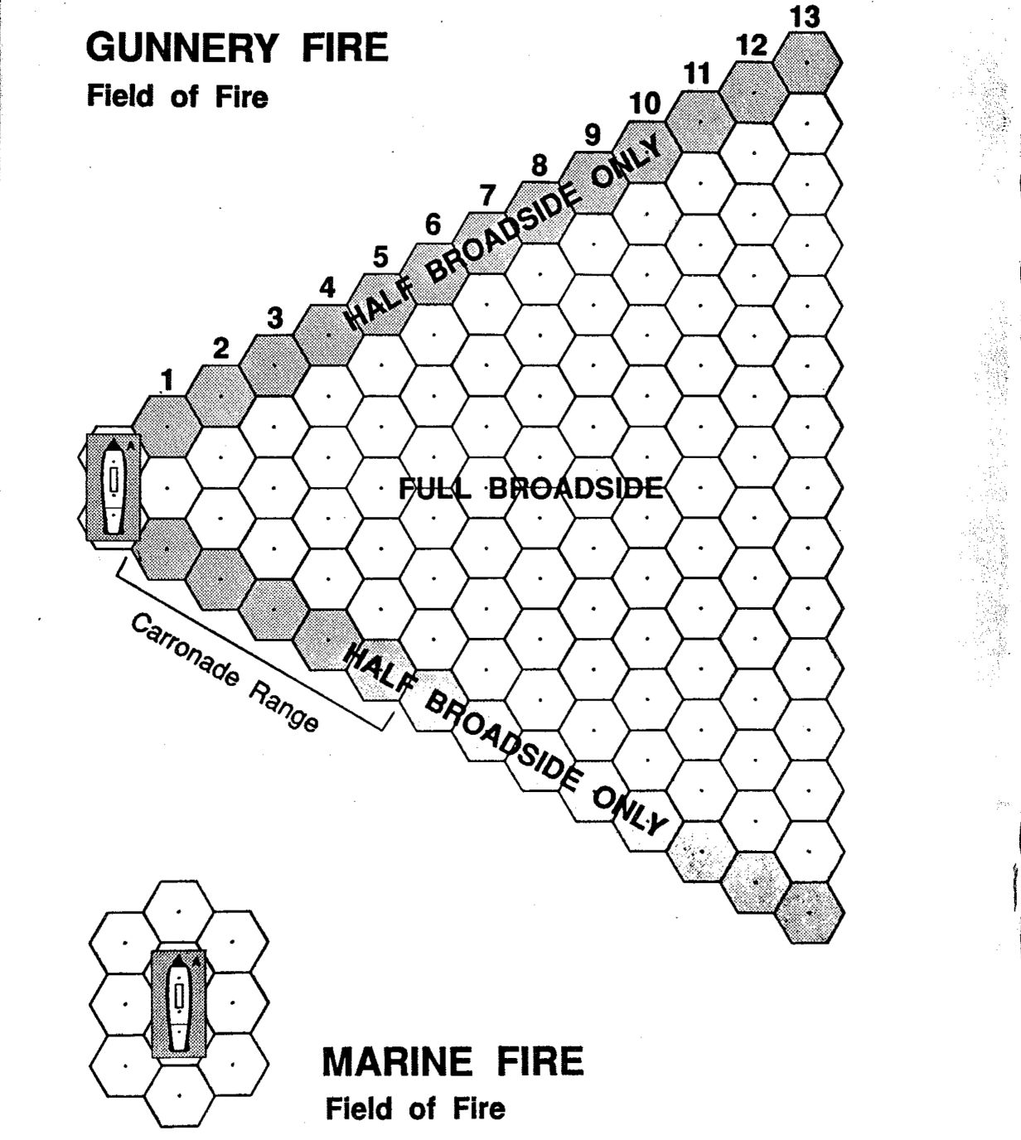

CLOSE ACTION 6.3
RULES ERRATA

As of 3/18/1994
NOTE: Version 6.2 of the Ship Data Chart, the 6.2 Scenario and Tournament Rules Book, and this errata sheet, updates your copy of CA 6.1 to version 6.3.
- v.s Prize Crews: [Add after last sentence] A reorganized BP may alternatively choose to remain aboard the captured ship: this must be noted at the start of reorganization. The BP retains the CQ of the parent ship, not the prize. (Explanation: this has been added specifically to allow for a historically unique event; Horatio Nelson’s capture of the Spanish 112 San Josef from the decks of a Spanish 74 which he had just captured by boarding!)
- F.8 Repairing Rigging of Dismasted Ships [New Rule]: A rigging hit on either a previously dismasted ship or a ship which becomes dismasted in the current game-turn, cancels any rigging repairs plotted in that game-turn, and also cancels all accumulated rigging repairs up to that point. NOTE: This does not apply to previous repairs which have already resulted in rigging boxes being restored to the ship; this rule only affects repairs in progress.
EXAMPLE: A ship of CO-83 needs four game-turns of rigging repairs to repair one rigging box. After three accumulated game-turns of plotting RR, it loses one rigging box due to enemy fire on the fourth game-turn of rigging repairs (i.e., the game-turn it would get back a rigging box, thus making it no longer dismasted). All the repairs are wiped out, and the dismasted ship would have to begin repairs again from scratch.
V.H.7 Sail State for Drifting [New Rule]: The sail state of a ship for drifting is the ship's sail state before combat (this is why the sail counters are not adjusted until after the drift phase).
XILF.2 [correction]: A ship cuts anchor cable by writing A
XII.G.12 [correction]: A ship cuts the towline by writing T
XII.K.2 [correction]: In last sentence, change “MP" to ’movement phase’.
MARINE FIRE TABLE: Delete the row labeled "Firing Marines CQ - A (Elite):". There is no longer any bonus for CQ=A marines using marine fire.
HULL CRITICAL HITS TABLE #12 - SHIP MAY EXPLODE: [Change Rule as Follows] Roll two dice. If the DR is < the target ship's Class Number, the ship explodes (-1 DRM for CQ~E, —2 for CQ=F). If ship survives, it loses 1-4 hull boxes (Class 1=4 hull, Class 2 = 3 hull, etc.) and 1G from each broadside, Is afire and must take a morale check.
IN IRONS TABLE: Replace entire existing table with new rules below and new table (at bottom).
V.E.2 Tacking [replace entire rule]. A ship which turns into WF L will usually desire to continue turning in the same direction, thus completing its tack. However, the completion of the tack is not automatic; rather, a die must be rolled on the Tacking and In Irons table on the red sheet; apply the appropriate modifiers to the DR to determine whether the tack is successful or not. If it is not, the ship is in irons. A ship in irons rolls on the same table when attempting to turn out of irons; if the chance to turn is < 0, the ship is stuck in WF L, and may never escape unless towed out of irons.
CL: I | WIND SPEED:
 | 1: | 2: | 3: | 4:
1 | 6+ | 4+ | 2+ | 1 +
2 |  | 3+ | 1 + | 0+
3 | 3+ | 1 + | 0+ | 0+
4 | 1 + | 0+ | 0+ | 0+
TACKING AND IN [RONS
DR MODIFIERS:
CL -» ship class.
For each rigging section tost:
Each crew section missing:
Cd -< A, 8:
Cd -- S, F:
In Irons:

CLOSE ACTION version 6.1 Counter Sheet © 1991 by Tempest Games
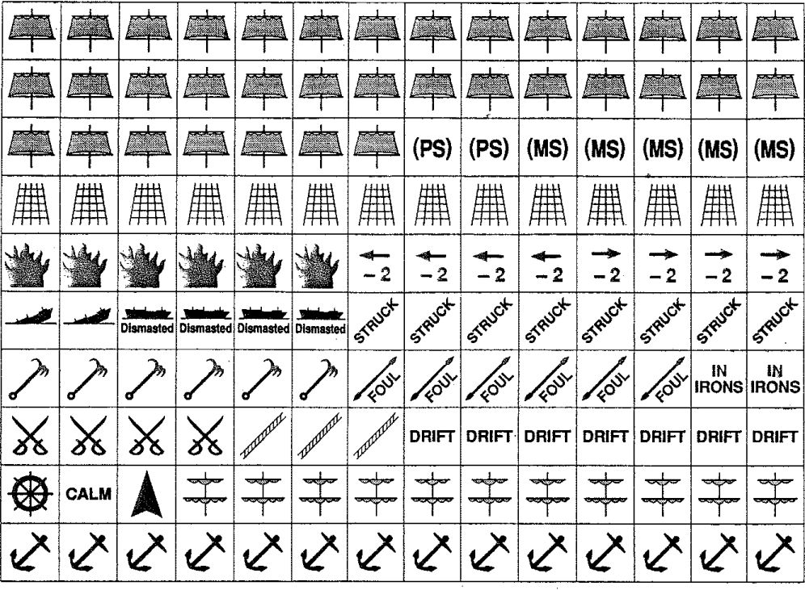

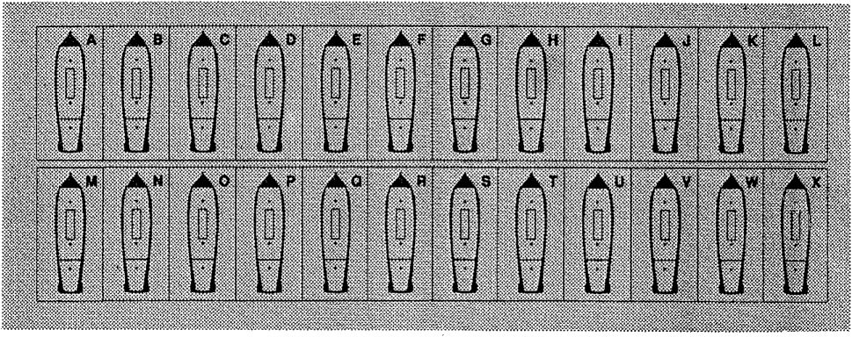

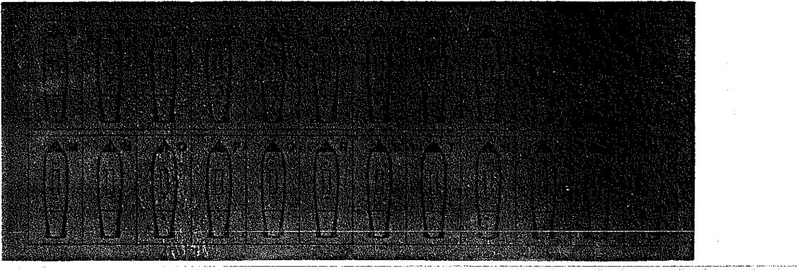

SHIP DATA CHART 1793-1815
 |  |  |  |  |  | RIGGING: | HULL: |  | CREW: |  |  | GUNS: |  | COST/VP:
Type: | Rate: | C: | ST: | D: | F; | 1-2-3-4 | 1 -2-3 (CH) | Si S2 S3 M (P) |  |  |  | G C (LD) | A2 | B3 | C4 | D4 | E4
BRITISH
S0L3 | 120 | 1 | L-f | 29 | 6 | 8-8-8-8 | 15-14-14(+1) | 10 | 9 | 9 | 8 (7) | 28 3(12) | 75 | 60 | 54 | 49 | 45
SOL3 | 110 | 1 | L-f | 28 | 6 | 8-S-8-7 | 14-14-13(4-1) | 9 | 9 | 8 | 8 (6) | 26 3(11) | 72 | 58 | 52 | 47 | 43
S0L3 | 100 | 1 | L-f | 27 | 5 | 8-8-7-7 | 13-13-12(4-1) | 9 | 8 | 8 | 7 (6) | 24 1 (11) | 64 | 52 | 46 | 42 | 38
S0L3 | 98 | 1 | L-s | 25 | 4 | 7-7-7-7 | 12-12-11 (0) | 8 | 8 | 7 | 7 (6) | 21 1 (10) | 59 | 48 | 43 | 39 | 35
SOL | 80 | 2 | L-f | 23 | 6 | 7-7-7-7 | 11-11-11 (0) | 8 | 7 | 7 | 6 (5) | 20 3(11)' | 58 | 47 | 42 | 38 | 34
SOL | 74L | 2 | L-f | 22 | 6 | 7-7-6-6 | 10-9-9(0) | 7 | 6 | 6 | 5 (4) | 18 4(10) | 55 | 44 | 39 | 36 | 32
SOL | 74 | 2 | L-f | 21 | 5 | 7-6-6-6 | 9-8-8 (0) | 6 | 6 | 6 | 5 (4) | 16 4(10) | 48 | 39 | 35 | 33 | 29
SOL | 64 | 2 | L-f | 20 | 5 | 6-6-S-6 | 8-7-7 (-1) | 5 | 5 | 5 | 4 (4) | 13 3(7) | 40 | 32 | 29 | 27 | 24
Rz | 44 | 32 | F-f | 19 | 6 | 6-6-6-5 | 7-7-7 (-1) | 4 | 4 | 3 | 3 (3) | 7 5(7) | 37 | 30 | 26 | 24 | 22
HF | 40 | 3 | F-f | 18 | 7 | 6-S-6-5 | 6-6-6 (-1) | 4 | 3 | 3 | 3 (2) | 7 4(7) | 33 | 27 | 24 | 22 | 20
F | 38 | 3 | F-f | 17 | 7 | 6-5-5-5 | 6-5-5 (-2) | 3 | 3 | 3 | 2 (2) | 6 4(6) | 30 | 24 | 22 | 20 | 18
F | 36 | 3 | F-f | 17 | 7 | S-5-5-5 | 5-5-5 (-2) | 3 | 3 | 2 | 2 (2) | 6 3(6) | 27 | 22 | 20 | 18 | 16
F | 32 L | 3 | F-s | 16 | 6 | 5-5-5-4 | 5-5-4 (-2) | 3 | 2 | 2 | 2 (2) | 6 2(6) | 25 | 20 | 18 | 16 | 14
F | 32 | 3 | F-s | 15 | 6 | 5-S-4-4 | 5-4-4 (-2) | 2 | 2 | 2 | 2.(2) | 4 2(4) | 21 | 17 | 15 | 13 | 12
DUTCH
SOL | 74 | 2 | L-f | 19 | 5 | 7-6-6-6 | 8-8-8 (-1) | 6 | 6 | 6 | 5 (4) | 20 0(11) | 49 | 39 | 32 | 28 | 25
SOL | 64L | 2 | L-f | 18 | 5 | 6-6-6-6 | 7-7-7 (-1) | 5 | 5 | 5 | 4 (4)' | 18 0(10) | 44 | 35 | 29 | 26 | 23
SOL | 64 | 2 | L-f | 18 | 5 | 6-6-S-6 | 7-7-7 (-1) | 5 | 5 | 4 | 4 (4) | 16 0(10) | 41 | 33 | 27 | 24 | 21
2D | 50 | 2 | L-s | 17 | 4 | 6-5-5-5 | 6-6-5 (-2) | 4 | 4 | 3 | 3 (3) | 11 0(7) | 30 | 24 | 20 | 18 | 16
F | 40 | 3 | F-f | 16 | 6 | 6-6-5-S | 5-5-5 (-2) | 3 | 3 | 3 | 2 (2) | 8 1 (7) | 26 | 21 | 18 | 16 | 14
F | 32 | 3 | F-s | 15 | 6 | 5-5-5-4 | 4-4-4 (-2) | 3 | 2 | 2 | 2 (2) | 5 1 (4) | 21 | 17 | 14 | 12 | 11
FRENCH
SOL3 | 120 | 1 | L-f | 29 | 6 | 8-8-8-S | 14-14-14(4-1) | 11 10 1011(8) |  |  |  | 29 1 (13) | — | 70 | 57 | 46 | 39
SOLS | 110 | 1 | L-f | 28 | 5 | 8-8-8-7 | 13-13-13(4-1) | 10 10 1010(8) |  |  |  | 27 1 (12) | — | 67 | 54 | 44 | 37
SOL | 80 | 2 | L-f | 24 | 6 | 7-7-7-7 | 12-12-11 (0) | 8 | 8 | 8 | 8 (6) | 24 1 (12) | — | 56 | 46 | 38 | 32
SOL | 74L | 2 | L-f | 23 | 6 | 7-7-6-6 | 10-10-9(0) | 7 | 7 | 7 | 7 (5) | 21 1 (11) | — | 48 | 39 | 32 | 27
SOL | 74 | 2 | L-f | 22 | 6 | 7-7-6-6 | 9-9-9 (0) | 7 | 7 | 6 | 7 (5) | 19 1 (11) | — | 43 | 35 | 29 | 25
HF | 44L | 32 | F-f | 19 | 7 | 6-6-6-6 | 7-6-6 (-1) | 5 | 4 | 4 | 4 (3) | 10 1 (S) | — | 31 | 25 | 20 | 17
HF | 44 | 3 | F-f | 18 | 6 | 6-6-6-5 | 6-6-6 (-1) | 4 | 4 | 3 | 4 (3) | 9 1 (8) | — | 28 | 22 | 18 | 15
F | 40 | 3 | F-f | 17 | 7 | 6-6-S-5 | 6-5-5 (-2) | 4 | 4 | 3 | 3 (2) | 8 1 (7) | — | 25 | 20 | 16 | 13
F | 38 | 3 | F-f | 17 | 6 | 6-S-5-5 | 5-5-5 (-2) | 4 | 3 | 3 | 3 (2) | 7 1(6) | — | 24 | 19 | IS | 12
F | 36 | 3 | F-f | 16 | 6 | S-5-5-5 | 5-5-4 (-2) | 3 | 3 | 2 | 3 (2) | 5 1 (4) | — | 20 | 16 | 13 | 11
SPANISH
SOL3 | 130 | 1 | L-s | 29 | 4 | 8-8-8-7 | 14-14-14 (4-1) | 11 11 10 10(8) |  |  |  | 28 0(13) | — | — | 62 | 47 | 34
SOL3 | 112 | 1 | L-f | 28 | 5 | 8-8-8-7 | 14-14-13(4-1) | 10 10 10 10(8) |  |  |  | 26 0(12) | — | — | 58 | 44 | 32
SOL | 80 | 2 | L-f | 23 | 6 | 7-7-7-7 | 11-10-10(0) | 8 | 8 | 8 | 7 (6) | 21 0(12) | — | — | 46 | 35 | 26
SOL | 74L | 2 | L-f | 22 | 6 | 7-7-6-S | 9-9-9 (0) | 7 | 7 | 7 | 6 (5) | 18 0(10) | — | — | 38 | 30 | 22
SOL | 74 | 2 | L-f | 21 | 5 | 7-6-6-6 | 9-9-8 (0) | 7 | 6 | 6 | 6 (5) | 16 0(8) | — | — | 35 | 27 | 20
SOL | 64 | 2 | L-f | 20 | 5 | 6-S-6-6 | 8-7-7 (-1) | 6 | 6 | 6 | 5 (5) | 12 0(7) | — | — | 29 | 22 | 16
F | 40 | 3 | F-f | 17 | 7 | 6-6-5-S | 6-6-5 (-2) | 4 | 4 | 4 | 3 (3) | 7 0(6) | — | — | 21 | 16 | 12
F | 34 | 3 | F-f | 16 | 6 | 5-5-5-5 | 5-5-4 (-2) | 3 | 3 | 3 | 2 (2) | 4 0 (3) | — | — | 15 | 11 | 8
AMERICAN
HF | 44 | 32 | F-f | 20 | 7 | 6-6-6 6 | 8-8-7 (-1) | 5 | 5 | 4 | 4 (3) | 8 5(8) | 39 | 33 | 30 | 27 | 25
F | 38 | 3 | F-f | 18 | 7 | 6-6-5-S | 6-6-5 (-2) | 4 | 4 | 3 | 3 (2) | 6 4(6) | 31 | 26 | 24 | 22 | 21
F | 36 | 3 | F-f | 17 | 7 | 6-5-5-5 | 5-5-5 (-2) | 4 | 3 | 3 | 3 (2) | 6 3(6) | 28 | 24 | 22 | 20 | 19
F | 32 | 3 | F-f | 16 | 6 | 5-5-5-5 | 5-5-4 (-2) | 3 | 3 | 3 | 2 (2) | 0 8(5) | 27 | 23 | 21 | 19 | 18
NOTES:
♦ Fast ships may be changed to Slow, reducing the ship's price by 1 point (only 50% of ships in a force [FRO] may be slowed).
« Slaw ships may not be made either slower or faster.

ADVANCED SHIP DATA CHART (for CA version 5.0)
 |  |  |  |  |  | R!GGING: |  |  |  |  | CREW: |  |  |  | GUNS: |  | COST:
Type: Rate: |  | T: | Spd: | D: | F: | 1 | 2 3 4 |  |  | HULL: | 1 | 2 | 3 | M: | G-C (LD) G-C: |  | A: | B: | C: | D: | NOTES:
BRITISH |  |  |  |  |  |  |  |  |  |  |  |  |  |  |  |  |  |  |  |  | V c
SOL3 | 120 | 1 | L-f | 29 | 6 | 8 | 8 | 8 | 7 | 30+15 | 10 | 9 | 9 | 8 | 28-3 (12) - |  | 66 | 54 | 47 | 41
SOL3 | 112 | 1 | L-f | 28 | 5 | 8 | 8 | 8 | 7 | 26+15 | 9 | 9 | 8 | 8 | 27-1 | (11) - | 61 | 50 | 43 | 37 | San Josef
SOL3 | 110 | 1 | L-f | 28 | 6 | 8 | 8 | 8 | 7 | 28+14 | 9 | 9 | 8 | 8 | 26-3 (11) - |  | 63 | 51 | 44 | 38 | Ville de Paris
SOL3 | 100L | 1 | L-f | 27 | 5 | 8 | 8 | 7 | 7 | 26+13 | 9 | 8 | 8 | 7 | 25;1 | (11) - | 56 | 46 | 40 | 35 | Queen Charlotte
SOL3 | 100 | 1 | L-f | 27 | 5 | 8 | 8 | 7 | 7 | 25+13 | 9 | 8 | 8 | 7 | 24-1 | (11) - | 55 | 45 | 39 | 34 | Victory, Royal Sovereign
SOL3 | 100 | 1 | L-s | 27 | 5 | 8 | 8 | 7 | 7 | 25+13 | 9 | 8 | 8 | 7 | 23-1 | (11) - | 54 | 44 | 38 | 33 | Britannia
SOLS | 98L | 1 | L-f | 26 | 5 | 8 | 7 | 7 | 7 | 24+12 | 8 | 8 | 7 | 7 | 22-1 (10) 21-3 |  | 53 | 43 | 37 | 32 | Neptune
SOLS | 98 | 1 | L-f | 26 | 4 | 7 | 7 | 7 | 7 | 24+12 | 8 | 8 | 7 | 7 | 22-1 | (10) - | 52 | 42 | 36 | 31 | Prince
SOL3 | 98 | 1 | L-s | 26 | 4 | 7 | 7 | 7 | 7 | 23+12 | 8 | 8 | 7 | 7 | 21-1 | (10) - | 51 | 41 | 35 | 30
SOL3 | 90 | 1 | L-s | 25 | 4 | 7 | 7 | 7 | 6 | 21+12 | 8 | 7 | 7 | 6 | 19-1 | (10) - | 50 | 40 | 34 | 29 | Namur
SOL | 80F | 2 | L-f | 24 | 6 | 7 | 7 | 7 | 7 | 22+11 | 8 | 7 | 7 | 6 | 22-1 | (11) 20-3 | 53 | 43 | 37 | 33 | c » 1806+
SOL | 80 | 2 | L-f | 23 | 6 | 7 7 |  | 7 | 7 | 22+10 | 8 | 7 | 7 | 6 | 21-1 | (11) 20-3 | 53 | 43 | 37 | 32 | c = 1006+
SOL | 80 | 2 | L-s | 23 | 6 | 7 | 7 | 7 | 6 | 20+11 | 8 | 7 | 7 | 6 | 17-3 | (S) - | 49 | 40 | 34 | 29 | Gibraltar
SOI. | 741 | 2 | L-f | 22 | 6 | 7 | 7 | 6 | 6 | 19+9 | 7 | 7 | 6 | 5 | 20-1 | (10) 18-4 | 48 | 39 | 33 | 29 | c = 179S+
SOL | 74M | 2 | L-f | 22 | 6 | 7 | 7 | 6 | 6 | 18+9 | 7 | 6 | 6 | 5 | 18-1 | (10) 16-4 | 44 | 36 | 31 | 27 | c - 1798+
SOL | 74 | 2 | L-f | 21 | 5 | 7 | 6 | 6 | 6 | 17+8 | 7 | 6 | 6 | 5 | 18-1 | (10) 16-4 | 43 | 35 | 30 | 26 | C « 17984-
SOL | 64 | 2 | L-f | 20 | 5 | 6 | 6 | 6 | 6 | 15+7 | 6 | 5 | 5 | 4 | 14-1 | (7) 13-3 | 36 | 29 | 25 | 22 | 0 = 1798+
SOL | 6’4E | 2 | L-s | 20 | 5 | 6 | 6 | 6 | 6 | 14+7 | 5 | 5 | 5 | 4 | 13-1 | (7) - | 34 | 27 | 24 | 21 | East I nd la men
Rz | SG | 2 | L-f | 20 | 5 | 7 | 6 | 6 | 6 | 16+8 | 6 | 5 | 5 | 4 | 9-5 | (9) - | 35 | 28 | 25 22 |  | Razeed 74
2D | 56E | 2 | L-s | 19 | 5 | 6 | 6 | 5 | 5 | 12+6 | 4 | 4 | 3 | 3 | 0-13 | (9) - | 33 | 26 | 23 | 20 | Glatton
2D | 50 | 2 | L-s | 18 | 4 | 6 | 5 | 5 | 5 | 12+6 | 4 | 4 | 3 | 3 | 10-1 | (6) 6-6 | 24 | 19 | 17 | 15 | c = 1800;-
20 | 44 | 2 | L-S | 18 | 3 | 5 | 5 | 5 | 5 | 10+5 | 4 | 3 | 3 | 2 | 8-1 | (6) - | 21 | 17 | 15 | 13
HF | 60 | 2 | F-s | 21 | 7 | 6 | 6 | 6 | 6 | 14+5 | 5 | 5 | 4 | 4 ' | 8-5 | (8) - | 35 | 29 | 24 | 21 | Leander, Newcastle
Rz | 44 | 2 | F-f | 19 | 6 | 5 | 6 | 6 | 6 | 14+7 | 4 | 4 | 3 | 3 | 7-5 | (7) - | 31 | 25 | 22 | 19 | Razeed 64s
HF | 40 | 3 | F-f | 18 | 7 | 5 | 6 | 6 | 6 | 13+5 | 4 | 3 | 3 | 3 | 7-4 | (7) - | 29 | 23 | 20 | 17 | Endymion
F | 38F | 3 | F-f | 17 | 7 | 5 | 5 | 6 | 6 | 12+5 | 3 | 3 | 3 | 2 | 6-4 | (6) - | 25 | 20 | 17 | 15 | Captured French 40s
F | 38 | 3 | F-f | 17 | 7 | 5 | 5 | 5 | 6 | 11+4 | 3 | 3 | 3 | 2 | 6-4 | (6) - | 25 | 20 | 17 | 15
F | 36 | 3 | F-f | 16 | 7 | 5 | 5 | 5 | 5 | 10+4 | 3 | 3 | 2 | 2 | 6-3 | (6) - | 23 | 19 | 16 | 14
F | 36F | 3 | F-f | 16 | 6 | 5 | 5 | 5 | 5 | 10+4 | 3 | 2 | 2 | 2 | 5-2 | (S) - | 20 | 16 | 13 | 11 | Captured French 36s
F | 321 | 3 | F-s | 16 | 6 | 5 | 5 | 5 | 5 | 9+4 | 3 | 2 | 2 | 2 | 6-2 | (6) - | 21 | 17 | 14 | 12
F | 32 | 3 | F-s | 15 | 6 | 5 | 5 | 5 | 4 | 8+4 | 2 | 2 | 2 | 2 | 4-2 | (4) - | 17 | 14 | 12 | 10
LF | 28 | 3 | F-s | 14 | 6 | 5 | 4 | 4 | 4 | 7+3 | 2 | 2 | 2 | 1 | 3-2 | (3) - | 15 | 12 | 10 | 9 | GO armed with 9-pdrs.
C | 24 | 3 | C-s | 14 | 5 | 4 | 4 | 4 | 4 | 6+3 | 2 | 2 | 1 | 1 | 0-6 | (4) - | 16 | 13 | 11 | 10 | •Post-Ship’ (Cyane)
c | 22 | 3 | C-f | 14 | 6 | 4 | 4 | 4 | 3 | 6+2 | 2 | 2 | 1 | 1 | 0-5 | (4) - | 15 | 12 | 10 | 9 | Lg. ship-rigged corvette j
c | 18L | 3 | C-f | 13 | 6 | 4 | 4 | 3 | 3 | 5+2 | 2 | 2 | 1 | 1 | 0-4 | (4) - | 13 | 11 | 9 | 8 | Normal ship-rigged cotv.
c | 18 | 3 | C-s | 12 | 6 | 3 | 3 | 3 | 3 | 4+2 | 2 | 1 | 1 | 1 | 0-4 | (4) - | 12 | 10 | 8 | 7 | Brig-rigged (32c)
c | 16 | 3+ | C-s | 11 | 5 | 3 | 3 | 3 | 2 | 3+2 | 1 | 1 | 1 | 1 | 0-3 | (3) - | 10 | 8 | 6 | 5 | Brig-rigged (24c)
c | 12 | 3+ | C-s | 10 | 5 | 3 | 3 2 |  | 2 | 2+2 | 1 | 1 | 1 | 1 | 0-2 | (2) - | 9 | 7 | 5 | 4 | Brig-rigged (18c)
FRENCH
S0L3 | 120 | 1 | L-f | 29 | 6 | 8 | 8 | 8 | 7 | 30+15 | 11 | 10 10 11 |  |  | 29-1 | (13) 28-4 | — | 59 | 45 | 38
SOLS | 110 | 1 | L-f | 28 | 5 | 8 | 8 | 7 | 7 | 27+14 | 10 10 10 10 |  |  |  | 27-1 | (12) 26-4 | —* | 57 | 43 | 36 | Normal 110a
S0L3 | 110 | 1 | L-f | 28 | 5 | 8 | 7 | 7 | 7 | 25+14 | 10 10 10 10 |  |  |  | 27-1 | (12) - | — | 56 | 42 | 35 | Bretagne
SOL | 80 | 2 | L-f | 24 | 6 | 7 | 7 | 7 | 7 | 23+11 | 8 | 8 | 8 | 8 | 24-1 | (12) 23-4 | «n» | 50 | 37 | 31 | 0 - 1806+
SOL | 74 | 2 | L-f | 23 | 6 | 7 | 6 | 6 | 6 | 20+9 | 7 |  | 6 | 7 | 21-1 | (11) 20-4 |  | 42 | 31 | 26 | C - 1806+
SOL | 74S | 2 | L-f | 22 | F | 7 | 6 | 6 | 6 | 18+9 |  | 7 | ?■ | 6 | 19-1 | (11) 18-4 |  | 38 | 28 | 24 | Few 11 any w/carr.

SHIP DATA CHART (SDC) - NOTES AND EXPLANATIONS
TYPE:
SOL3 = Three-Decked Ship of the Line (i.e., carrying its main armament on three complete gun decks). SOL - Two-Decked Ship of the Line (i.e., carrying its main armament on two complete gun decks).
2D = Two Decker (a ship with two complete gun decks, but not powerful enough to be considered
an SOL).
Rz = Razee (a ship of the line which has had one or more decks removed to reduce weight).
HF = Heavy Frigate (any frigate mounting 24-pdr. guns on the gundeck).
F - Frigate (any frigate mounting 18-pdr. guns or smaller on the gundeck).
Rate: This is the nominal number of guns carried by the ship. However, in most cases the number of guns actually carried was higher than this figure, especially in the British and American navies. An ’L" after the rate means Large (usually meaning that the ship carried larger guns),
C [Class]: There were four major types of warships in the Napoleonic period. Each type is called a class in GA, and is assigned a number from 1 to 4, in descending order of size. A ship’s class matters for many reasons which are explained in the rules. The little superscripted number next to a few of the class numbers indicate that the ship is of one class, but turns like a ship of the class indicated by the superscripted number.
Notice that only class 1, 2 and 3 ships are included on the SDC; class 4 ships (corvettes) may be found in the Advanced SDC (included with The Fighting Ships) and in some scenarios.
ST [Speed Type]: Listed here are the abbreviations of ship speeds used to determine a ship’s movement abilities on the Movement Determination Table:
Abbr: Meaning:Abbr: Meaning:Abbr: Meaning:
L-f: ship of the Line - Fast F-f: Frigate - Fast C-f: Corvette - Fast
L-s: ship of the Line - Slow F-s: Frigate - Slow C-s: Corvette - Slow
D [Draft]: The draft of the ship (in feet) in moderate load condition.
F [Freeboard]: The height in feet of the gunport sills of the lower deck guns (LDG) above the water, in moderate load condition.
RIGGING (1-2-3-4): Rigging Sections 1 through 4.
HULL (CH): Each ship has three hull sections, which are listed in order from left to right. The small number in parentheses is the ship’s Critical Hit Die Roll Modifier. Positive modifiers mean the ship is harder to be critically damaged, while negative numbers mean the ship is more susceptible to critical hits.
CREW (s1-s2-s3-M):
Sailor crew sections 1, 2 and 3, and the Marine crew section. The small number in parentheses is the number of crew boxes which must be "sent to man the pumps' (i:e., crossed out) when called for.
G-C (LD) [Long Guns - Carronades (Lower Deck)]: Shown are the number of Guns and Carronades per side. The value in parentheses is the number of boxes of guns which are LDG; these boxes may not be able to fire in certain circumstances (see rules and Freeboard table on red sheet).
COST/VP [Victory Points]: The cost to purchase the ship in free build games; also the value of the ship in Victory Points. Note:
- The French may not purchase Elite (CQ=A) ships.
- The Spanish may not purchase Elite (CQ=A) or Veteran (CQ=B) ships.

CREW QUALITY

BOARDING COMBAT
c  Q | NAME | SK#: | BCF
 |  |  | 8: | M:
A | ELITE | 2 | 6 | 8
B | VETERAN | 3 | 5 | 7
C | TRAINED | 3 | 4 | 6
D | ORDINARY | 4 | 3 | 5
E | GREEN | 5 | 2 | 4
F | DEMORALIZED | 6 | 1 | 3
(G) | STRUCK | (7) | -

CQ - Ship's Crew Quality Abbreviation; SK - Skill bevel;
BCF - Boarding Combat Factor* per Craw Box (S-Saltor, M-Marine)

UNFOULING
DR z | % of Enemy BP lost* | OTHER RESULTS
 |  | if rolled by Attacker; | If rolled by Defender:
L4 | Q% | No Effect | No Effect
5 | 5% |  | Attacker Repulsed
6 | 5% | AE: No Effect  ANE: Attacker Established
7 | 5%
0 | 10% | AE: roll die; If DR < defender's MR, defending ship is captured  ANE: Attacker Established | AE: roll die; if DR < attacker's MR, attacker's BP is captured  ANE: Attacker Repulsed
9 | 15%
10 | 20%
11 | 30% | Defending ship captured | AE: Attacker’s DP captured ANE: Attacker Repulsed
L12 | 40%

• - Measured In Crew Boxes (round up). Roll on Craw Lora Table tor eesh crew box lost
AE: Use If attacker already established. ANE: Us® If attacker Is not yet established.
TURN# |  |  | RESULT
1 | 2 | 3+
1-2 | 1-3 | 1-4 | ACTION SUCCEEDS
3-6 | 4-6 | 5-6 | ACTION FAILS

CQ A: -2 CQ-B,C:-1 CQ ™ E, F: +1

GRAPPLING L UNGRAPPLING

COLLISIONS
Die Roll | RESULT
1-2 | FOULED
36 | NOT FOULED

Oritohfl Ship: >1
Each atrip at MS: -t
Eash ship at FS: -c
EXTRA RIGGING E - fs - a
MS - 4r PS • er
Die Roil | RESULT
1-2 | SUCCEEDS
3-6 | FAILS

LSSWL CO.-A:
CQ 0,C: -1
CQ«EcrF: +1
Wind Speed 4: +1
Wind Speed 5; +2
Ships rue Fouled: -1
Marina Section Not Available: el
UNG RAFFLING: Friendly Ships: -2
Each CQ better than enemy: -1
Marina Section Not Available: +1
Wind Speed 4: -1
Wind Speed S: -2
OddaDRMo(A:D)
(Applies io both sides)
Sl:4 -4 3:2 +1
1:3 -3 2:1 +2
IL -2 3:1 +3
2:3 -1 24:1 +4
Applies to Unostabllohod AHackws Only:
Defending ship Is class 1 or 2: -3
Defending ship Is class 3: -2
Defending ship Is larger class: -1 per class did.
Defending ship Is smaller class: +1 per class dlff.

IN IRONS
CO: z | SHIP CLASS
 | 1 | 2 | 3 | 4
A | 1-3 | 1-4 | 1-5 | 1-6
B,C | 1-2 | 1-3 | 1-4 | 1-5
D | I | 1-2 | 1-3 | 1-4
E,F | — | 1 | 1-2 | 1-3

For each rigging section lost +1
Wind Speed 2: +1
Wind Speed 1: +2

CREW LOSS
CAUSE | s | M
Roundshot at Hull | 1-8 | 6
All Other Causes | 1-3 | 4-6

S - Sailor*; M -» Marinas

REPAIRS

WIND SPEED

GUN LOSS
SHIP CLASS | LD | G | c
Classi (SOLS) | 1-2 | 3-5 | 6
Class 2 (SOL, 2D) | 1-2 | 3-4 | 5-6
Class 3/4 (Rz, HF, F, C) | 1-2 | 3 | 4-6

ID * Lower Deck Gun;
G » Other Gun; C « Cezron&de
T: | CREW QUALITY
 | A | B,C | D | E,F
R | 3 | 4 | 5 | 6
H | 6 | 8 | 10 | 12
G | 7 | 9 | 11 | 13

T: ■ Typ® of repair sooxsch:
R * figging: H r- hull; G « gun.
DR (2 de) | STEADY | GUSTY
2 | CHANGES* | CHANGES*
3 | NO CHANGE | CHANGES*
4-10 | NO CHANGE | NO CHANGE
11-12 | 1 — INITIAL WS | 1 - INITIAL WS

* - Roil Again: 1-3 « -1 Speed; 4-4 - Speed

FREEBOARD

DRIFTING
Sail State | WIND SPEED
 | 0 | 1 | 2 | 3 | 4 | 5
PS | — | 10+ | 8+ | 6+ | 4+ | 3+
MS | — | 11+ | 9+ | 7+ | 6+ | 4+
FS | — | 12+ | 10+ | S+ | 7+ | 5+
D/F | — | 13+ | 11 + | 10+ | S+ | 6+

# E Cha/rce with 2dS to drift each turn:
DR MS: Cfa»3-+1; Vise* 4- ^2
F: ; | WIND SPEED
 | 0-1 | 2 | 3 | 4 | 5
7+ | - | to | to | to | to
6 | - | - | to | - | L
5 | - | to | - | L | N
4 | * | • | L | N | N
3 | - | L | N | N | N

L * Leeward LD gurtt cannot be used.
« NO ID guns can ba used.

WIND DIRECTION
DR (2d6) | OCEANIC | COASTAL
2 | CHANGES 60° * | NO CHANGE
3 | NO CHANGE | CHANGES 60° *
4-11 | NO CHANGE | NO CHANGE
12 | 60° - INITIAL WD | 60° - INITIAL WD

* - Roll Again: 1-3 » Left; 4-S Right

GUNFIRE CALCULATION TABLE
GUNNERY FACTORS 1 | , > RANGE IN HEXES:
 | 1 | 2 | 3 | 4 | 5 | 6 | 7 | 8 | S | 10-11 | 12-13
 |  |  |  |  |  |  |  | 8-9 | 10-11 | 12-13 | —
1 | 59 | 4 S | 36 | 2 4 | 1 | 0 |  |  |  |  | WWW
2 | 711 | 5 9 | 47 | 35 | 2 | 1 | 0 | WWW |  | .WWW | WWUU
3 | 9 13 | 711 | 69 | 58 | 4 | 3 | 2 | 0 |  | WWWW
4 | 11 15 | 9 13 | 7 10 | 69 | 5 | 4 | 3 | 2 | 0 | W - .<
5-6 | 13 17 | .11 15 | 9 12 | 710 | 6 | 5 | 4 | 3 | 2 | 0
7-8 | 15 19 | 1317 | 11 14 | 9 12 | 8 | 7 | 6 | 5 | 4 | 2 | -1
9-10 | 17 21 | 15 19 | 1316 | 11 14 | 9 | 8 | 7 | 6 | 5 | 3 | 0
11-12 | 19 23 | 17 21 | 1518 | 13 16 | 11 ! | S | 8 | 7 | 6 | 4 | 1
13-14 | 21 25 | 19 23 | 1720 | 1518 | 13 | 11 | 10 | 9 | 7 | 5 | 2
15-16 | 22 26 | 20 24 | 1821 | 1619 | 14 | 12 | 11 | 10 | 8 | 6 | 3
17-1 a | 23 27 | 21 25 | 1922 | 17 20 | 15 | 13 | 12 | 11 | 9 | 7 | 4
19-20 | 24 28 | 2226 | 20 23 | 18 21 | 16 | 14 | 13 | 12 | 10 | 8 | 5
21-23 | 25 29 | 23 27 | 2124 | 1922 | 17 | IS | 14 | 13 | 11 | 9 | 6
24-26 | 27 31 | 25 29 | 23 26 | 21 24 | 19 | 17 | 15 | 14 | 12 | 10 | 7
27-29 | 28 32 | 26 so | 24 27 | 22 25 | 20 | 18 | 16 | 15 | 13 | 11 | 8
30+ | 29 33 | 27 31 | 25 28 | 23 26 | 21 | 19 | 17 | 16 | 14 | 12 | 9

-< British, American
« Other Navies
GUNFIRE MODIFIERS:
CREW QUALITY:
A - Elite: | +6
B — Veteran: | +4
C - Trained: | +2
D — Ordinary: | 0
E - Green: | -2
F — Demoralized:
CREW SECTIONS:
3 Sailor sections: | 0
2 Sailor sections: | -3
1 Sailor sections: | —6
INITIAL BROADSIDE:
Range 1 or 2: | +4
Range 3 or 4: | +2
OTHER:
Anchored: | + 1
Chainshot: | +2
Each Split of Fire: | —5
Dismasted: — | WS*
Wind Speed 5: | -2
*WS - Wind Speed

TARGET TYPE: I ~~ ~ HULL OR RIGGING ~l RIGGING ONLY 1

. LONG GUN: s ' I I
.MEDIUM GUN: £range = 9 hexes (see BATTLE FLEETS module) I

CARRONADE; I 2 GF perCarronade box I 1 GFper'box ~"l

MARINES: I I
ROUNDSHOT: I " " . . ~~~ ' —■ J
CHAINSHOT: I ~~ ' 1
GRAPESHOT: F 1
NOTES:
- RAKES: The number in smaller print at ranges 1-4 is used when raking the enemy ship.
- BASIC GUNFIRE NUMBER (BGN): the BGN is determined by cross-referencing the number of factors firing with the range.
- MODIFIED GUNFIRE FACTOR (MGN): The MGN is found by adding all applicable modifiers to the BGN.
- Ships may never fire at a MGN of < 0.
- No firing allowed in grayed-out ranges.
MARINE FIRE TABLE
MARINE FIRE MODIFIERS:
Firing ship grappled or fouled to target ship:
Firing Marines CQ - A (Elite):
Firing Marines CQ « E (Green):
Firing Marines CQ - F (Demoralized): Target ship has BP preparing or prepared:
Firing ship class # ,< target ship class #:

-1 -1 +1 +2 -1 T 1
DIE ROLL | # MARINE BOXES FIRING:
 | 1 | 2-3 | 4-5 | 6-7 | 8-9 | 10+
⁰ | 1 | I | 1 | 2 | 2 | 2
1 | 1 | 1 | 1 | 1 | 2 | 2
2 |  | 1 | 1 | 1 | 1 | 2
3 |  |  | 1 | 1 | 1 | 1
4 | • | • |  | 1 | 1 | 1
5 ' | - | - | - |  | 1 | 1
' 6 | ; - | * |  |  | -

Result = Number of Crew Boxes Lost: see Crew Loss Table.

Roll ONE die on left-hand column whenever ship loses a Rigging Section; Roll TWO dice on right-hand column for Critical Hits.
DIE
ROLL:
- 2 LEADERSHIP CASUALTIES [2MC],
Lose 1G. Ship must take two morale checks.
- 3 ♦ MAST MAY FALL. (Ignore if firing Chainshot)
Roll one die with the following DRMs: +1 for MS, +2 for PS, +1 for each rigging section lost, +1 for Wind Speed 4 or 5. If the final result is L S, cross out current rigging section.
- 4* BRACES CUT [BC].
Lose 1R at MS or PS. Ship loses 1 MP in all directions in every sail state. Braces may be repaired by rolling on the Unfouling Table during the Maintenance Phase.
- 5 ♦ LINES JAMMED [U].
Ship may not alter sail state until lines are cleared. If ship is changing sail state, change is aborted and ship remains at current sail state. Dismasted ships automatically clear jammed lines. To clear lines, roll on the Unfouling Table during the Maintenance Phase.
- 6 SIGNAL HALYARDS CUT [SH].
Lose 1R at MS or PS. Ship may not send messages until halyards are repaired. Dismasted ships must repair signal halyards normally. Roll repairs on the Unfouling Table during the Maintenance Phase.
- 7 ♦ SHEETS CUT [-1].
Some sheets are severed. Ship loses 1 MP in all directions in every sail state and is —1 to acceleration. These effects only last for the next game-turn, and then are automatically repaired. Ignore this result if it has already occured to the same ship in the current combat phase.
- 3 FALLING RIGGING ENCUMBERS DECK [-2 PB or -2 SB].
Ship loses 1R at MS, 2R at PS (nothing additional at FS). Falling Rigging obscures a broadside; 1-3 = left, 4-6 = right. That broadside is -2 until cleared. To clear roll on the Unfouling Table during the Maintenance Phase.
- 9 YARD SHOT AWAY [-2 PB and -2 SB].
Lose 1R at FS, 2R at MS, 3R at PS. Both Broadsides are -2 until cleared. Each broadside must be cleared separately. To clear roll on the Unfouling Table during the Maintenance Phase.
- 10 ♦ MAST WOUNDED. (Ignore If firing Chainshot)
The current rigging section no longer counts for movement purposes, but continues to absorb damage normally (mark boxes with single slashes). This damage can be repaired as per normal rigging repair rules. Example: An SOL with no rigging damage suffers this CH. Although the ship still has rigging boxes remaining in her first rigging section, she moves as if the section has been crossed out (i.e., as if she has only 3 rigging sections).
- 11 ♦ STAYS CUT [SC].
Lose 2R. Every game-turn after the current one that the ship uses more than its original FS MA, roll one die; if result < ship’s SK, cross out current rigging section & take a morale check.
- 12 MAST FALLS ON DECK [MC]. (Ignore if firing Chainshot)
Cross out current Rigging section. Class 1 or 2 ships lose 3C; Class 3, 2C; Class 4,1C. All of these losses must be Marine boxes if possible. Ship must also take a morale check.
Ignore these results if target becomes dismasted fir the current combat phase.
NOTE: Rigging) critical hits do not occur oh ships which were dismasted previous to the current combat phase.
NOTE: More than one of each result may apply to a single ship unless otherwise noted.
CH# | FGN  I | FIRING LOW (AT HULL): |  |  |  | FIRING HIGH (AT RIGGING): |  |  | FGN | CH# I
 |  | FS: | +MS: | + PS: | GRAPE: | FS: | +MS: | +PS:
-1 | 1 |  |  | - | - |  |  |  | 1 | -1
-1 | L | • |  | • | - |  | th |  | 2 | -1
-1 | 3 | ♦ |  | • |  |  |  | th | 3 | -1
-1 | 4 | w- |  | th |  | • . |  |  | 4 | -1
-1 | 5 | th |  | • |  | th | th |  | 5 | -1
-1 | 6 | h/- | th |  | h/- | th |  |  | 8 | -1
0 | 7 | g/- |  | « | h/- | tI- |  |  | 7 | 0
0 | 8 | h/■ |  | • | 9/' | hl- | th |  | 8 | 0
0 | 9 | th |  | • | c/- | th |  | r | 9 | 0
0 | 10 | h |  | r | W- | th |  |  | 10 | 0
0 | 11 | tic |  | ♦ | g /• | 9/• | r |  | 11 | 0
0 | 12 | h | r |  | h/c | r/c |  | r | 12 | 0
1 | 13 | tlQ |  | • | h/c | r |  |  | 13 | 1
1 | 14 | r/h |  | r | c/g | r |  | r | 14 | 1
1 | 15 | h-g/- |  | • | h/c | r/h | r |  | IS | 1
1 | 16 | g-r/h |  | - | h/c | r/9 |  | r | 16 | 1
1 | 17 | r-c |  | r | h/g | r | r |  | 17 | 1
1 | 18 | 2h | r |  | g-c/- | r-c/* |  | r | IS | 1
2 | 19 | r-S |  | r | h-c/g | r-h |  | r | IS | 2
2 | 20 | h-g | r | * | c-g | 2r | r | r | 20 | 2
2 | 21 | r-h-c |  | r | h-Q | r-h | • | • | 21 | 2
2 | 22 | r-h-g |  | r | h-c | r-g | r | r | 22 | 2
2 | 23 | r-h-c |  | • | c-g | r-h | r | r | 23 | 2
2 | 24 | r-2h-g | r | r | h-e-g | 2r-c | r | r | 24 | 2
3 | 25 | r-h-o-g | » | r | h-c-g | 2r-h | r | r | 25 | S
3 | 26 | r-h-2g | r | r | h-c-g | Sr | r | r | 26 | 3
3 | 27 | r-Zhc-g | r | r | 2h-c-g | 2r-h~g | r | r | 27 | 3
3 | 28 | 2r-2h-c-g | a | r | h-2c-g | 3r-g | r | 2r | 28 | 3
3 | 29 | 2r-2hc-g | k | r | 2h-2c-g | 2r-h-c | r | 2r | 29 | 3
3 | 30 | 2r-3h-c-g | r | r | 2h-2c-g | 3r-h-c | r | 2r | 30 | 3
4 | 31 | 2r-3h-c-2g | r | r | 2h-2c-2g | 4r-h-g | 2r | 2r | 31 | 4
4 | 32 | 2r-3h-c-2g | r | 21- | 2h-2c-2g | 4 r-h-c | 2r | 2r | S3 | 4
4 | 33 | 2r-3h-2c-2g | r | r | 3h-2c-2g | 5r-h-g | 2r | Sr | S3 | 4
4 | 34 | 3r-4h-c-3g | r | 2r | 3h-2c-3g | Sr-h-c-g | 2r | Sr | 34 | 4
4 | 35 | 3r-5h-c-3g | r | r | 4h-2c-3g | 4r-2h-c-g | 2r | Sr | 35 | 4
4 | 36 | 3r-5h-2c-3g | 2r | 2r | 3h-3c-3g | 6r-h-c-g | 2r | Sr | 36 | - 4
5 | 37 | 4r-5h-2c-3g | r | 2r | 4h-3c-3g | 7r-2h-g | Sr | 3r | 37 | 8
5 | 38 | 4r-5h-2c-4g | 2r | 2r | 5h-3c-3g | 7r-2h-c-g | Sr | 4r | 38 | 2
5 | 39 | 5r-6h-2c-4g | 2r | Sr | 4h-4c-4g | 8r-3 h-c-g | 3r | 4r | 39 | 5
5 | 40 | 6r-7h-2c-5g | 2r | Sr | 6h-4c-4g | 9r-2h-c-g | 4r | 5r | 40 | 5
5 | 41 | 6r-9h-3c-4g | 2r | Sr | 6h-5c-5g | 9r-2h-2c-2g | 4r | 5r | 41 | 5
5 | 42 | 7r-9h-3c-6g | 3r | 4r | 7h-6c-4g | 10r-2h-c-2g | 4r | Sr | 42 | 8
6 | 43 | 7r-10h-4c-6g | 3r | 4r | 7h-6c-6g | 11r-4h-c-2g | 5r | Sr | 43 | 6
6 | 44 | 8r-10h-4c-7g | 3r | 5r | 8h-7c-6g | 12r-4h-2g-2c | Sr | 7r | 44 | S
6 | 45 ~ | 9r-12h-4c-7g | Sr | 5r | 9h-8c-7g | 13r-5h-2c-2g | Sr | 7r | 45 | 6
6 | 46 | 10r-13h-5c-8g | 4r | 6r | ISh-Sc-Sg | 14r-4h-2c-2g | Sr | 7r | 46 | 6
6 |  | 11r-15h-6c-8g | 4k | sr | 11h-9c-8g | 15r-5h-2c-3g | 6 r | Sr | 47 | 6
6 | 43 | 12r-15h-6c-1 Og | Sr | Sr | 12h-9c-9g | 16r-6h’2c-3g | 6r | Sr | 48 | 8
7 | 49 | ! 13r-16h-7c-10g | Sr | 7r | 14h-10c-9g | 17r-6h-2c-4g | 6r | Sr | 48 | 7
7 | 504- | 13r-17h-8c-11g | 6r | 7r | 15h-11c-10g | 18r-7h-3c-4g | 7 r | Sr | 50+ | 7

■ "Stashed* rssukts: A resuit showing two values separated by a slash, like this: r/c means that either result may occur. Roll another dis: 1-3 - result on left of slash applies, -1-6 - result on right applies.
> II two slashed results occur on the same line, roll for each result separately.
- Tire slashed results apply only to the values separated by the slash: thus h-g/- = hull + either a gun or nothing..
CRITICAL HITS PROCEDURE:
If the DR is a 6, there is a possibility that a critical hit has secured. Roll another die. If this DR is L the number shown in the *CH#‘ column on the GRT above, then a critical hit has occurred. Roll 2 dice on the appropriate Critical Hit Table.
The CH chance is modified by the target ship’s C.H.MOD (Critical Hits Modifier) value. The C.H.MOD value is found under the HULL column on the SDC.
EXAMPLE: A ship fires at a French 40 with a BGN (basic gunfire number) of 26. The die roll is a 6, resulting in a FGN (final gunfire number) of 34. The chance for a CH is “4‘ on the '24' row; the DR is a *6', which would normally miss, but the French 40 has a ~2 C.H.MOD, so a DR of 6 (- 2) -- 4). Thus a critical hit does occur in this situation. Roll two dice on the appropriate Critical Hits Table (either Rigging or Hull, depending upon the original target) and apply the results.
Roll TWO dice
DIE
ROLL:
- LEADERSHIP CASUALTIES [2MC].
Lose 10. Ship must take two morale checks.
- WHEEL SHOT AWAY [WSA],
The ship may only make one 60" turn per game-turn, and must henceforth use the Poor Maneuvering rule (VI.F). A ship is not affected by this result while anchored with springs.
- WHEEL JAMMED [WJ].
If ship moves, must continue turning in the direction of the last MF used. If straight, ship may not turn: if a turn, moving ship must turn at least once in that direction per movement phase, and may not turn at all in the opposite direction (if the ship does not move forward, it does not have to turn). The wheel may be unjammed by rolling on the Unfouling table during the Maintenance Phase.
Does not apply if ship is anchored with springs. Only one of this result may be in effect at the same time.
- ANCHOR CABLE SEVERED [cross out 1 anchor].
Lose 1H. One Anchor is lost. If preparing or prepared to anchor with springs, the ship must prepare to anchor again from the beginning. Ship is no longer anchored if anchored normally. If anchored with springs, ship loses spring and becomes anchored normally, and will immediately turn to face the wind (see anchoring rules). If ship is towing or being towed, tow is broken.
- LEADERSHIP CASUALTIES [MC],
Ship must take a morale check.
- RIGGING DAMAGE, (ignore this result if tiring Grapsshot)
Roll on the Rigging Critical Hits Table.
- MINOR EXPLOSION [FIRE].
Lose 1H. Roll one die. If the die roil is < ship's SK, ship is afire and must take a morale check.
S WATERLINE DAMAGE.
Ship must send ths appropriate number of crew boxes to “man the pumps." These crew boxes are marked off exactly like normal crew losses, and may never be withdrawn.
- RUDDER DESTROYED [RD].
Ship's turning ability is decreased by one class (i.e. a class 2 ship now turns as a class 1 ship).
Class 1 ships must now move 1 extra box in every speed band on T urn Ing table. If ship ever enters Wind Facing L, she is automatically IN IRONS, with a +2 DRM to get out. No effect if rudder already destroyed.
- SHIP IS AFIRE [FIRE],
Ship is automatically afire and must take a morale check.
- MAJOR EXPLOSION [FIRE].
Roll one die. If DR is < ship's Class Number, ship explodes (-1 DRM for CQ=E/F ships). If ship survives, it loses 2H (1H for Class 3 and 4 ships) and 1G from each broadside, is afire and must take a morale check.
More than one of each result may apply to a single ship during the same game-turn, unless otherwise noted.
MVMT. | Rigg. |  |  |  | WIND | SPEED
TYPE | Sect. | Sail | 0 (Calm) | 1 (V. Light) | 2 (Light) | 3 (Moderate) | 4 (Heavy) | 5 (Tempest)
I | Left: | State | L-C-B-R | L-C-B-R | L-C-B-R | L-C-B-R | L-C-B-R | L-C-B-R
 |  | PS: | o-o-o-o | 0-2-4-3 | 0-3-7-5 | 0-4-8-6 | 0-4-8-6 [3] | 0-3-8-7 [5]
 | 4 | MS: | 0-0-0-0 | 0-1-3-2 | 0-2-5-4 | 0-3-6-5 | 0-3-6-5 | 0-2-6-6 [3]
 |  | FS: | O-O-O-O | 0-0-2-1 | 0-1-3-2 | 0-2-4-3 | 0-2-4-3 | 0-1-4-4
L-F | Q | MS: | o-o-o-o | 0-0-2-1 | 0-1-4-3 | 0-2-5-4 | 0-2-5-4 | 0-1 -5-5 [41
 | Q | FS: | o-o-o-o | 0-0-1-1 | 0-0-2-1 | 0-1-3-2 | 0-1-3-2 | 0-1-3-3
 | 2 | FS: | o-o-o-o | 0-0"0-0 | 0-0-1-1 | 0-0-2-1 | 0-0-2-1 | 0-0-2-2
 | 1 | FS: | O-O-O-O | o-o-o-o | O-O-O-O | 0-0-1-1 | 0-0-1-1 | 0-0-1-1
 |  | PS: | o-o-o-o | 0-2-4-3 | 0-3-6-4 | 0-4-7-5 | 0-4-7-5 [3] | 0-3-7-6 [5]
 | 4 | MS: | O-O-O-O | 0-1-3-2 | 0-2-4-3 | 0-3-5-4 | 0-3-5-4 | 0-2-5-5 [3]
 |  | FS: | O-O-O-O | 0-0-2-1 | 0-1-3-2 | 0-2-4-3 | 0-2-4-3 | 0-1-4-4
L-S | o | MS: | O-O-O-O | 0-0-2-1 | 0-1-3-2 | 0-2-4-3 | 0-2-4-3 | 0-1-4-4 [4(
 | O | FS: | o-o-o-o | 0-0-1-1 | 0-0-2-1 | 0-1-3-2 | 0-1-3-2 | 0-1-3-3
 | 2 | FS: | O-O-O-O | O-O-O-O | 0-0-1-1 | 0-0-2-1 | 0-0-2-1 | 0-0-2-2
 | 1 | FS: | o-o-o-o | O-O-O-O | O-O-O-O | 0-0-1-1 | 0-0-1-1 | 0-0-1-1
 |  | PS: | O-O-O-O | 0-3-5-4 . | 0-4-7-6 | 0-5-9-7 | 0-4-9-7 [4] | 0-3-6-6 [6]
 | 4 | MS: | O-O-O-O | 0-2-4-3 | 0-3-6-5 | 0-4-7-6 | 0-3-7-6 | 0-2-5-5 [4]
 |  | FS: | o-o-o-o | 0-1-3-2 | 0-2-4-3 | 0-3-5-4 | 0-2-5-4 | 0-1-44
F-F | Q | MS: | O-O-O-O | 0-1-3-2 | 0-2-5-4 | 0-3-6-5 | 0-2-6-5 | 0-1-4-4[5]
 | 4 | FS: | O-O-O-O | 0-0-2-1 | 0-1-3-2 | 0-2-4-3 | 0-1-4-3 | 0-1-3-3
 | 2 | FS: | O-O-O-O | 0-0-1-1 | 0-0-2-1 | 0-1-3-2 | 0-0-3-2 | 0-0-2-2
 | 1 | FS: | o-o-o-o | O-O-O-O | 0-0-1-1 | 0-0-2-1 | 0-0-2-1 | 0-0-1-1
 |  | PS: | O-O-O-O | 0-3-5-4 | 0-4-6-5 | 0-5-8-6 | 0-4-8-6 [4] | 0-3-6-6 [6]
 | 4 | MS: | O-O-O-O | 0-2-4-3 | 0-3-5-4 | 0-4-6-5 | 0-3-6-5 | 0-2-5-5 [4]
 |  | FS: | O-O-O-O | 0-13-2 | 0-2-4-3 | 0-3-5-4 | 0-2-5-4 | 0-1-4-4
F-S |  | MS: | o-o-o-o | 0-1-3-2 | 0-2-4-3 | 0-3-5-4 | 0-2-5-4 | 0-1-4-4 [5]
 | d | FS: | o-o-o-o | 0-0-2-1 | 0-1-3-2 | 0-2-4-3 | 0-1-4-3 | 0-1-3-3
 | 2 | FS: | o-o-o-o | 0-0-1-1 | 0-0-2-1 | 0-1-3-2 | 0-0-3-2 | 0-0-2-2
 | 1 FT: |  | O-O-O-O | O-O-O-O | 0-0-1-1 | 0-0-2-1 | 0-0-2-1 | 0-0-1-1
 |  | PS: |  | 0-4-7-6 | 0-5-8-7 | 0-5-9-7 | , 0-3-8-6 [5] | 0-2-5-5 [7]
 | 4 | MS: | 1-1-1-1-r | 0-3-5-4 | 0-4-6-5 | 0-4-7-6 | 0-2-6-5 | 0-1-4-4 [5]
 |  | FS: | 1-1-1~1>r | 0-2-4-3 | 0-3-5-4 | 0-3-5-4 | 0-1-5-4 | 0-0-44
C-F | q | MS: | 1-1-1-1*-!- | 0-2-4-3 | 0-3-5-4 | 0-3-6-5 | 0-1-5-4 | 0-0-3-3 [6]
 | J | FS: | 1-1-1-1»r | 0-1-3-2 | 0-2-4-3 | 0-2-4-3 | 0-1-4-3 | 0-0-3-3
 | 2 | FS: |  | 0-0-2-1 | 0-1-3-2 | 0-1-3-2 | 0-0-3-2 | 0-0-2-2
 | 1 | FS: |  | 0-0-1-1 | 0-0-2-1 | 0-0-2-1 | 0-0-2-1 | 0-0-1-1
 |  | PS: | 1-1-1-1-r | 0-4-6-5 | 0-5-7-6 | 0-5-8-6 | 0-3-8-6 {5] | 0-2-5-5 [7]
 | 4 | MS: | ►r | 0-3-5-4 | 0-4-6-5 | 0-4-6-5 | 0-2-6-5 | 0-1-44 [5]
 |  | FS: | 1-1-1-1 | 0-2-4-3 | 0-3-5-4 | 0-3-5-4 | 0-1-5-4 | 0-044
C-S | q | MS: | 1-1-1->r | 0-2-4-3 | 0-3-5-4 | 0-3-5-4 | 0-1-5-4 | 0-0-3-3 [6]
 |  | FS: | 1-1-1-1-r | 0-1-3-2 | 0-2-4-3 | 0-2-4-3 | 0-1-4-3 | 0-0-3-3
 | 2 | FS: | 1-1-1-1 *-r | 0-0-2-1 | 0-1-3-2 | 0-1-3-2 | 0-0-3-2 | 0-0-2-2
 | 1 | FS: |  | 0-0-1-1 | 0-0-2-1 | 00-2-1 | 0-0-2-1 | 0-0-1-1
- Bracketed numbers are chance of losing a rigging section each turn (2d6).
DR M's: CQ - A,B,C: +1; E.F: -1
- "►r* means rowing.
TURNING

SPEED CHANGE
Act: z | SHIP CLASS
 | 1 | 2 | 3 | 4
Accel. | 2 | 2 | 3 | 4
Decel. | 2 | 3 | 4 | 5

Spd  I . | SHIP CLASS
 | 1 | 2 | 3 | 4
1 | 0 | 0 | 0 | 0
2 | 1 | 1 | 1 | 0
3-1 | 2 | 1 | 1 | 1
5-6 | 3 | L | 1 | 1
7-9 | 3 | 3 | 2 | 1

/. WEATHER PHASE
- Wind Direction. Roll 2d6 each turn to see if wind direction changes.
- Wind Speed. Roll 2d6 each turn to see if wind speed changes.
- Losing Rigging. If WS L 4, roll 2d6 for ships with PS (at W2 4) or ?2 and MS (at WS 5) to see if the ship loses rigging.
//. PLOT PHASE
- Plotting. Plot all actions for all ships, including the following actions: movement, anchoring, lowing, casting the lead, sal! state, boarding party preparation, crew reorganizations, repairs and firefighting. Write all messsages.
- MOVEMENT PHASE
A. In Irons. All ships in irons which have plotted to turn may try to escape.
- Movement. All other plotted movement !Z done, resolving possible collisions as they occur in the foi- lowlng order:
- Contested Hex. Determine which ship gets the contested hex (if any),
- Searing Away. Any ship now sbrut tc rs.m another ship may attempt to hear .way, if it desires to do so.
- Rigging Loss. If the bearing away attempt Is unsuccessful or not taken, a collision occurs, Subtract rigging from the appropriate ship(s),
- Roll for Fouling. Roll to see if the ships Involved in ths collision are fouled or not.
- COMBAT PHASE
- Gunnery and Marine Fire. Fire all guns desired. All marine sections which are not plotted for any tasks may use marine fire against adjacent ships, Resolve all critical hits except morale checks; note that critical hits do not take effect until the end of the combat phase,
- Boarding Combat. Al! boarding is new resolved,
- Critical Hits. All critical hits now lake effect. ’Manning the pumps" must also be done now,
- MAINTENANCE PHASE
- Drifting. Ships roll 2d6 and drift if called for, including partial drifts. Roll for fouling if necessary.
- Grappling. Every ship may attempt to grapple each adjacent ship with which it is not already grappled, C Uitgrappllng. All ships may now attempt to ungrapple each ship to which they are grappled.
EX. Unfoullng Actions. Al! actions which require rolling on Ms Unfoullng table are now rolled for. These actions are:
Braces Cut [BO] Wheel Jammed [WJ] Lines Jammed [LJ]
Signal Halyards [SIT] Fouled ships Obscured Broadsides [-2pb/sb]
All actions may be rolled for on the same turn that the damage occurs; no crew is required.
E> Fir® Damage and Resulting Explosions.
- Firefighting. All ships which are on fire and which have plotted a OS to fight the fire may now roll on the unfouling table.
- Fire Damage. All ships which are still on fire now cross off 1H and 1R.
- Fire Spreading. The fire may spread to any ships fouled or grappled to the burning ship.
- Exploding Ships. Burning ships which have no hull remaining must roll to explode. The chance to explode is a '2' on 2d6 with a +1 to the DR for each additional turn rolled for.
F. Status Adjustment.
- Exploding Ships. Remove those ships which have exploded.
- Sinking Ships. Check to see if sinking ships sink (12 on 2d6). If they do, remove the ship.
- Anchor & Towing. Place/remove anchor & towing counters.
- Sails. Adjust sail markers to conform with plotted changes in sail status.
8. Record Repairs. All completed repairs are noted on the ship's log by erasing the correct number and type of crossed-out boxes.
6. Crew Adjustment, Mark changes in crew status due to prize crew formation and completed reorganization.
CL Morale Checks. Roll all morale checks required. Place a strike marker on those ships which strike.
H. Message Delivery. All messages written In the Plot phase of this game-turn are now delivered.
Nat. Rate CQ MR SHIP NAME ID
Nat. Rate CQ MR SHIP NAME ID
Nat. Rate CQ MR SHIP NAME ID
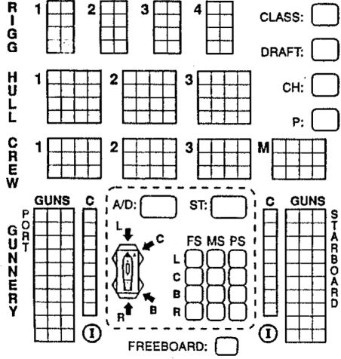
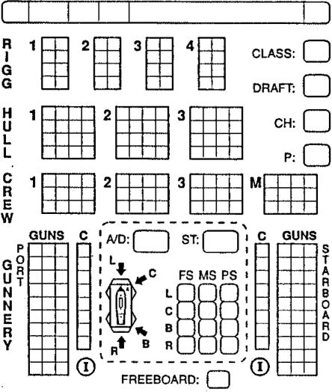
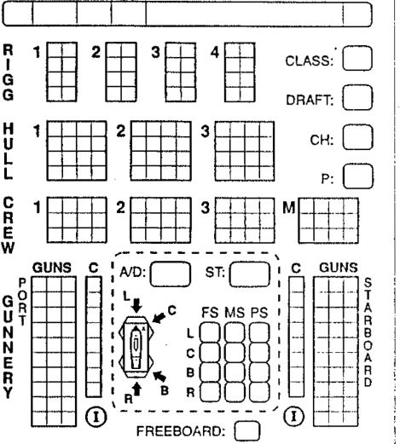

 | MOVE | SAILS | NOTES
1
2
3
4
5
6
7
8
9
10
11
12
13
14
15
16
17
18
19
20
21
22
23
24
25

 | MOVE | SAILS | NOTES
1
2
3
4
5
6
7
8
9
10
11
12
13
14
IS
16
17
18
19
20
21
22
23
24
25

 | MOVE | SAILS | NOTES | i
1 |  |  |  | I
2 |  |  |  | I
3 |  |  |  | i
4
5 |  |  |  | j
6 |  |  |  | i
7
8
9
10
11
12 |  |  |  | i
13
14
IS
16
17
18
19
20
21
22
23
24
25 |  |  |  | i

