Subset_1.fastq

|  |  |
| --- | --- |
| Total Sequences | 458003 |
| Total Bases | 61.6 Mbp |

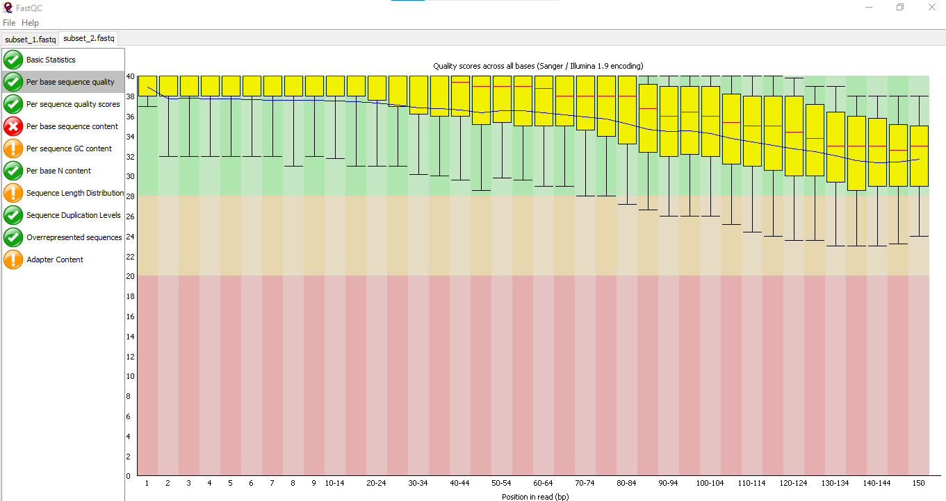

|  |  |
| --- | --- |
| Subset_2.fastq  Total Sequences: 458003 |  |
| Total Bases:64.4 Mbps |  |
| Human genome file indexing error: RAM shortage |  |
| Deduplication Error: Sorting is not done with read-name, if done (samtools) throwing error for mis-matching reads for R1 & R2. |  |

