**User Testing Review:**

Padraig C., Oliver K., Laura Y., Poppy S.

Considering some user testing has been performed (currently 4 people have participated, with more to come very shortly) to accompany our working beta, we feel as though it would be beneficial to review the anonymous responses to our user testing form. This will help us by indicating areas in which users feels changes need to be made to the app, or where improvements could be implemented. We have reviewed the responses to each question below and have explained the ways in which this could alter (or not alter) our approach to the final product we build.

1. On a scale from 1 to 10, how easy/intuitive was the user interface to navigate?

The average answer for this question was 8.25. This indicates to us that we have built a relatively simple app to navigate, and we agree, as there are not many tabs which the users have to mess around with to use the functionality of our app. Based on this high rating, we will aim to keep the user interface like how it is now, as the testers seem to enjoy it as is.

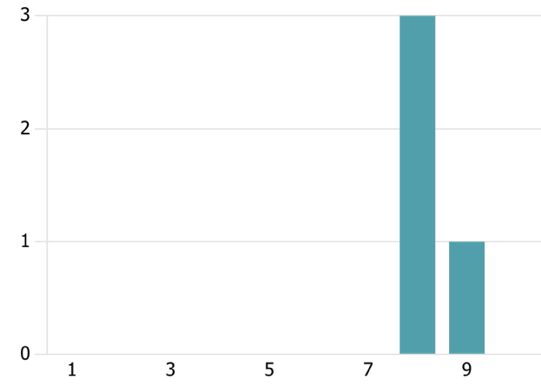

1. Were you able to understand the purpose of the app upon first use?

Every answer to this question was a yes. The testers all seem to have found the purpose of the app easily, and therefore we do not think any changes need to be made to try make the purpose of the app even more obvious.

1. On a scale from 1 to 10, how satisfied were you with the speed and responsiveness of the app?

The average answer for this question was 6.75. All responses bar one was above this mark, with a review of 3 dragging the score down a bit. However, we must acknowledge that all testers have different experiences, and we cannot ignore any responses. Therefore, we are moderately happy with the speed/responsiveness of the app, but if there is the opportunity to increase the speed of the app further, we should investigate this and try to implement it.

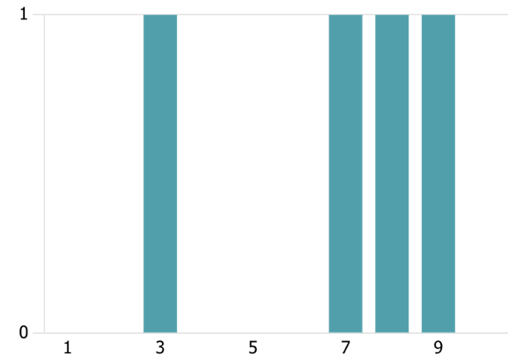

1. Is there anything that you would change about the user interface to improve it?

We received a couple suggestions here, but the glaring and most common one was to add some colour to the app. This should be a relatively easy fix and hasn’t been done to this point as we were mainly focusing on the functionality of the app before the design. Thereby adding a splash of colour to our app, we would hope that users like the GUI even more than before.

1. Was the model able to accurately read ASL gestures or signs?

The most common response here was “Somewhat”. This was expected, as we have implemented our detection with an image dataset to handle all possible situations in real cam. Though we managed to increase the performance through ‘mediapipe’ which draws landmarks on fingers, it looks like the lighting and the distance of user from the camera still matters from the result of user testing. Therefore, the app is able to accurately read ASL gestures/signs only most of the time, not all the time.

1. On a scale of 1 to 10, how accurate and natural did the app's speech synthesis sound?

The average response was 5.25. This was expected, because as a group we made the decision to swap out our TTS system with another (TTS -> espeak-ng), which had the benefit of drastically increasing the speed and responsiveness of the app, at the cost of voice clarity. We believe the espeak-ng TTS system could be made to sound better, and perhaps we are missing a dependency/requirement of espeak-ng to improve the voice quality.

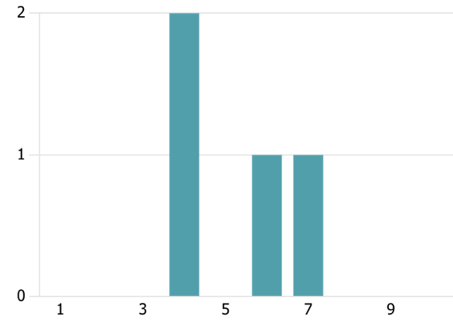

1. Were you able to engage in a flowing, natural conversation using the app?

We received every answer possible here, therefore we may have to do some further testing to find out how well people are able to engage in flowing conversations using our app.

1. On a scale of 1 to 10, how well did the app manage to facilitate communication between individuals with hearing issues and those without? (Skip if N/A)

This went unanswered, as we have not been able to find a user for user testing that struggles with or has hearing problems.

1. On a scale from one to ten, how important is customisation of the speech output (voice type, speed, pitch, etc.) to you?

Average response was 7.75, indicating to us that the ability to alter the speech output is important to our users, and should be a feature focused on before our final release.

1. Are there any additional features or functionalities you would like to see in the app?

The testers suggested instructions/tips for users in the app, and for the ability for the voice to be customized. A customizable voice seems to be a feature that is very sought after, and tips for the user using the app could be implemented relatively easily, i.e., a tips/instructions page.

1. What changes, if any, would enhance your overall experience with the app?

Again, tips/instructions were suggested, telling us that a guide for new users would be handy. A user suggested a notification for when the light conditions are not optimal, which would be useful and was something we hadn’t thought about. These should be a goal for us to implement, however we are going to need to decide what should be prioritized.

1. On a scale of 1-10, how likely are you to recommend this web app to others?

Average score was 7.75. This indicates a moderately high level of satisfaction and likelihood to recommend.

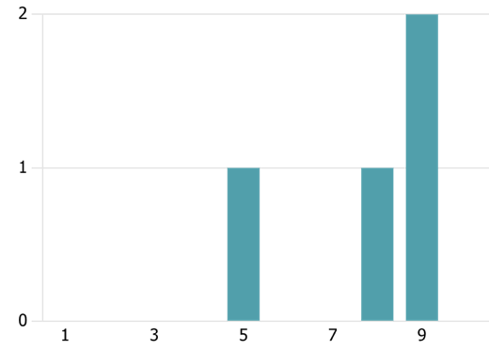

1. How satisfied are you with your experience using our web app?

This question scored an average of 8.00. We are happy with this rating, and hope that listening to the suggestions made by testers above would cause this to increase.

All participants in the user testing have signed the required consent forms. These are not on our GitHub (for privacy reasons) but can be supplied if/when required.