

**Family Planning Executive Dashboard**

**User’s Manual**



**Population Program Wing,**

**Ministry of National Health Services, Regulations & Coordination,**

**Government of Pakistan**

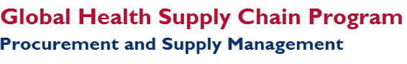

|  |
| --- |
| Executive Dashboard  in cLMIS |

This chapter introduces to the features of the Executive Dashboard available in Contraceptives Logistics Management Information System (cLMIS).

|  |
| --- |
| **In this section, you will be introduced to**:   1. Executive Dashboard Overview 2. Transactional Data Table 3. District’s Stock Availability 4. SDP Level Stock Availability 5. Health Facilities Compliance Rate |

## Executive Dashboard Overview

The Executive Dashboard has been developed to provide an overview of stock sufficiency of family planning commodities for selected province, its Districts and Service Delivery Points. In each province, health and population departments are main consumer of FP commodities and in some provinces both departments are procuring and storing in central warehouse Karachi. This dashboard also enables the users to drill down to commodity-wise stock situation at SDP level for a deeper insight into commodity wise stock levels.

## Working with Executive Dashboard

To open the Executive Dashboard:

1. Go to [www.lmis.gov.pk](http://www.lmis.gov.pk).
2. Log into your LMIS account using the credentials provided to you.

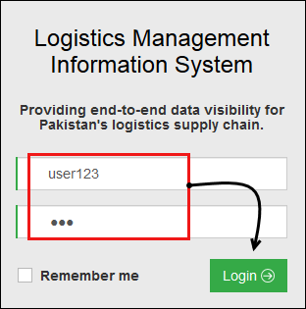

1. After logging in, click **Executive Dashboard** on the side menu.

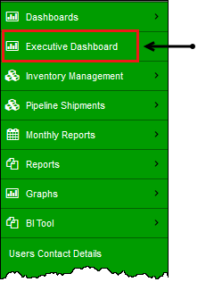

The Executive Dashboard displays.

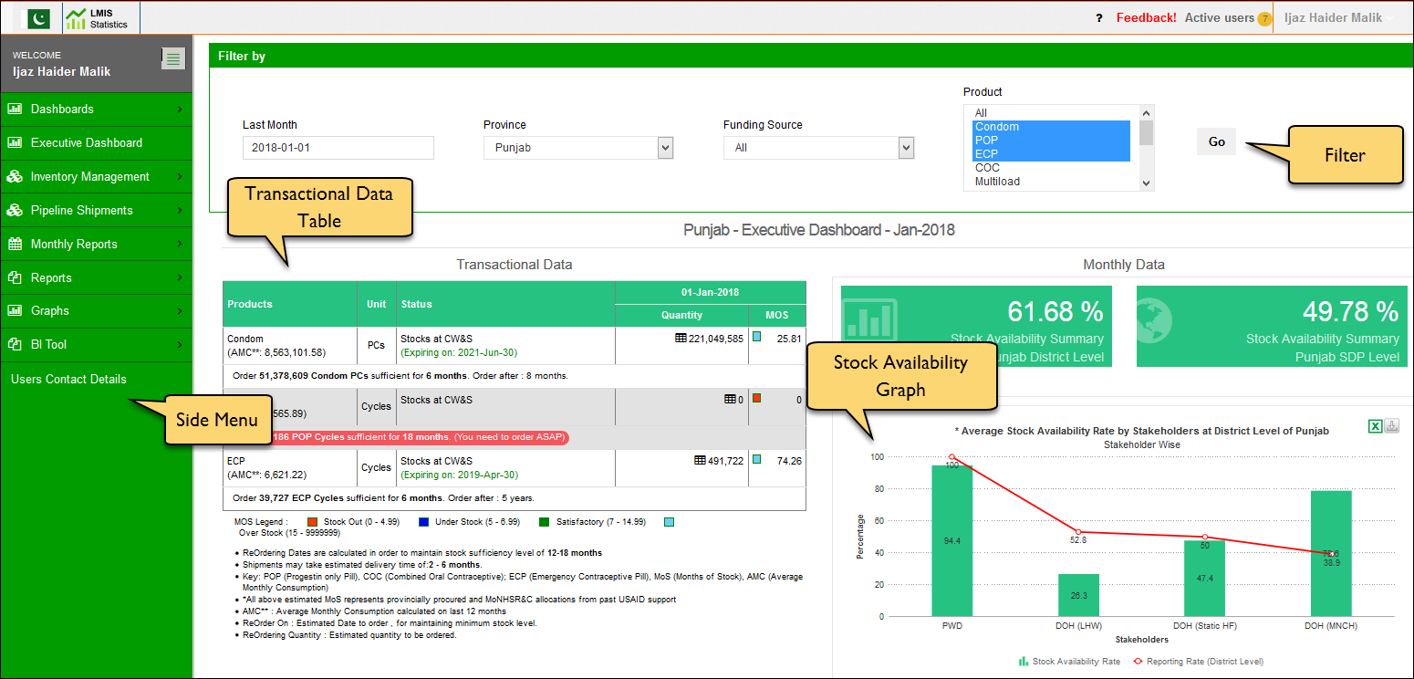

1. In order to populate the Executive Dashboard reports, select the required filter options.

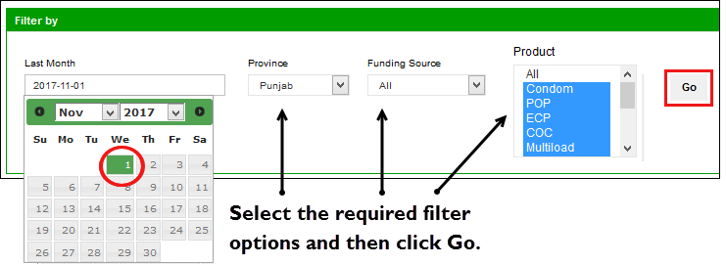

The options include:

* + **Date**: select the required date from the date picker tool.
  + **Province**: specify the province.
  + **Funding Source**: specify the funding source from **Govt. of Punjab PWD**, or **Govt of Punjab – DoH**.
  + **Products**: specify the product(s). You can select one or more products of your choice.

1. Click **GO** to populate the dashboard graphs.

The next sections explain each of the analysis reports available in the Executive Dashboard.

## Transactional Data Table

The Transactional Data table provides the status of the available stock and the stock in pipeline for each product for the selected province.

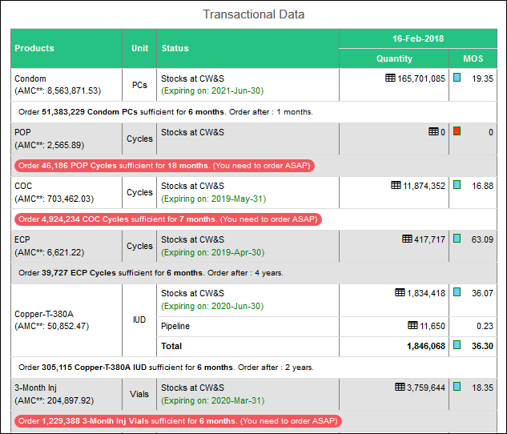

The information includes:

* **Products**: displays the product.
* **Unit**: displays the unit for the product.
* **Status**: displays the Stock and Pipeline labels.
* **Quantity**: displays the quantity of available stock and the stock in pipeline.

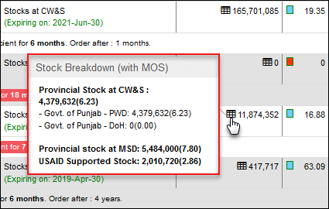Hover over the  icon with the available stock to view the stock breakdown funding source wise.

* C:\Users\HP\AppData\Local\Temp\SNAGHTMLd10239.PNG**MOS**: displays the months of stock for each product. The legends include:

## District Stores Stock Availability

The Monthly Data is a comprehensive report that shows the stakeholder wise stock availability rate of District stores of the selected province. The image below describes the information available in the graph report.

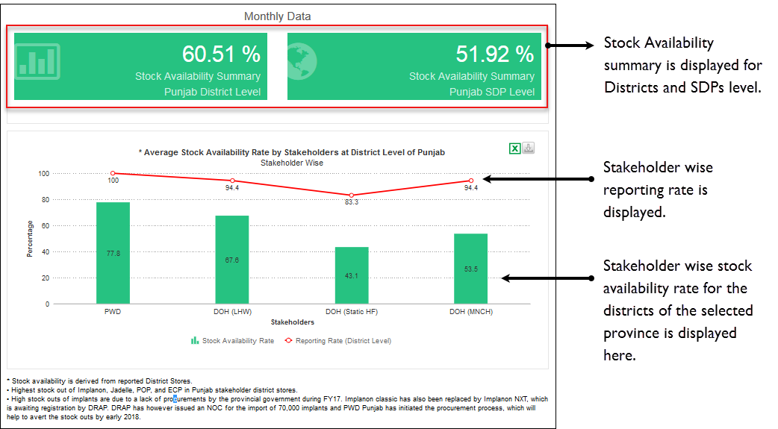

* **Stock Availability Summary**: The Stock Availability Summary is displayed at the district and SDP level at the top.
* **Reporting Rate (District Level)**: The Stakeholder-wise reporting rate is displayed as a red line, that enables the decision-makers to analyze the credibility of the reported numbers through the district’s reporting rate. A good reporting rate validates the stock availability information better.
* **Stock Availability Rate at Districts**: The green bars display the stakeholder wise stock availability rate in the districts of the selected province.

|  |  |
| --- | --- |
|  | You can click C:\Users\HP\AppData\Local\Temp\SNAGHTML19f83e3.PNG to export the graph in Excel format. You can also click  to export the graph as a chart. |

Click any of the green bars to view the product-wise stock availability rate of each stakeholder, as shown in the image below:

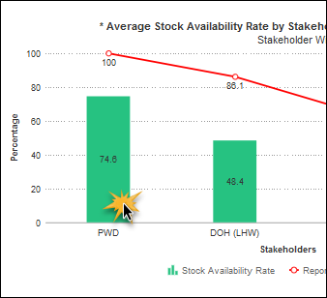

For the selected stakeholder, the stock status of each of the products is displayed in form of a bar graph. See image below for more information:

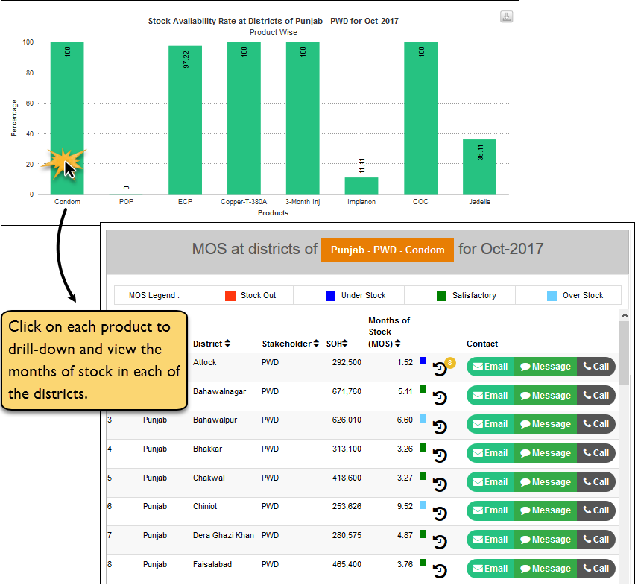

You can further drill down and click each of the product to view the months of stock of that product in each of the districts for the selected stakeholder. You can view the following information:

* **Province**: displays the selected province.
* **District**: displays the districts in the province.
* **Stakeholder**: displays the stakeholder.
* **SOH**: displays the Stock on Hand of the product.   
  Stock on Hand is the actual stock in the district.
* **Months of Stock**: displays the months of stock of the product.  
  Months of stock refers to the number of months that the stock will be able to fulfill the consumption demands.
* **Contact**: You can even contact the district to inquire about any information.

**Contact via Email**

You can contact the district via email by clicking the email button.

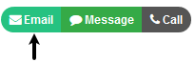

The email dialog displays as shown in the image below:

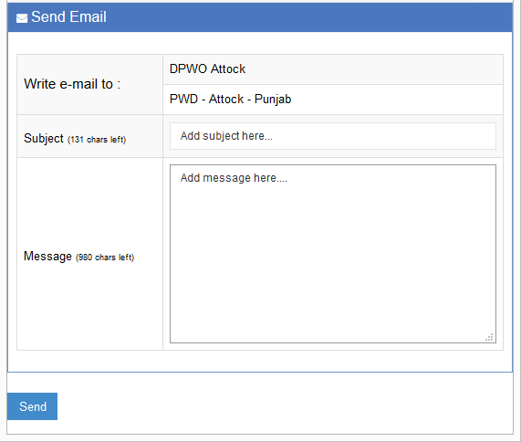

Specify the email **Subject** and **Message** and then click **Send** to send an email.

**Contact via Message**

You can contact the district via SMS by clicking the Message button.

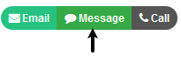

The Message dialog displays as shown in the image below:

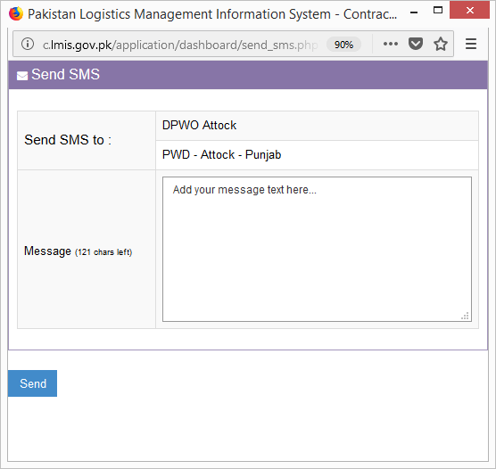

Specify the **Message** and then click **Send** to send an SMS.

## SDP Level Stock Availability

The report shows the Stakeholder wise average stock availability rate at SDP level for the selected month along with the SDP’s reporting rate.

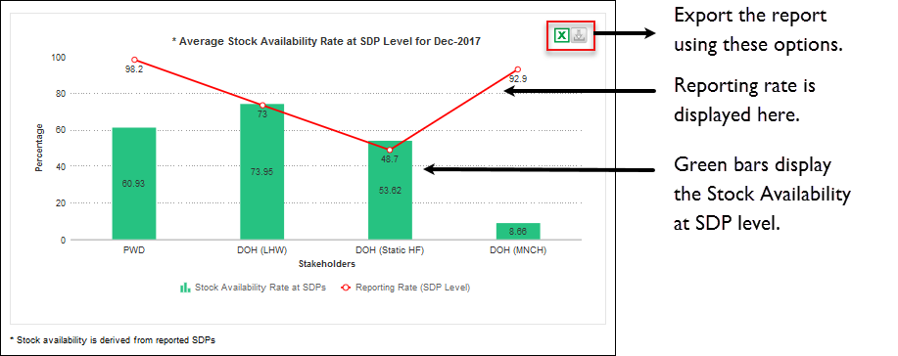

* **Stock Availability Rate at SDPs**: The green bars display the stakeholder wise stock availability rate in the districts of the selected province.
* **Reporting Rate (SDP Level)**: The Stakeholder-wise reporting rate is displayed as a red line, that enables the decision-makers to analyze the credibility of the reported numbers through the district’s reporting rate. A good reporting rate validates the stock availability information better.

|  |  |
| --- | --- |
|  | You can click C:\Users\HP\AppData\Local\Temp\SNAGHTML19f83e3.PNG to export the graph in Excel format. You can also click  to export the graph as a chart. |

Click any of the green bars to view the product-wise stock availability rate of each stakeholder, as shown in the image below:

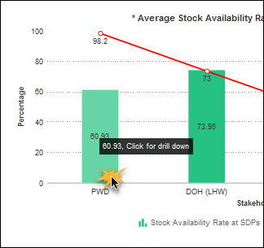

Click on the stakeholder to view the product-wise stock availability status in form of a bar graph. See image below for more information:

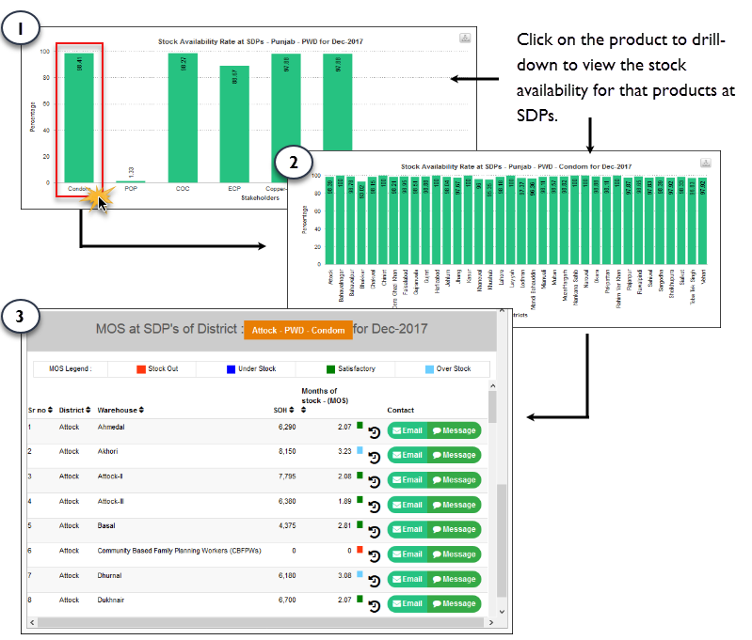

Click on the product to further drill down to view the selected product’s availability at SDPs for the selected stakeholder and province. You can view the following information:

* **Province**: displays the selected province.
* **District**: displays the districts in the province.
* **Warehouse**: displays the warehouse.
* **SOH**: displays the Stock on Hand of the product.   
  Stock on Hand is the actual stock in the district.
* **Months of Stock**: displays the months of stock of the product.  
  Months of stock refers to the number of months that the stock will be able to fulfill the consumption demands.
* **Contact**: You can even contact the district to inquire about any information.

**Contact via Email**

You can contact the district via email by clicking the email button.  


The email dialog displays as shown in the image below:



Specify the email **Subject** and **Message** and then click **Send** to send an email.

**Contact via Message**

You can contact the district via SMS by clicking the Message button.

The Message dialog displays as shown in the image below:



Specify the **Message** and then click **Send** to send an SMS.

|  |
| --- |
| In case of any further information, please contact our support representative at [support@lmis.gov.pk](mailto:support@lmis.gov.pk). |