Data Leakage:
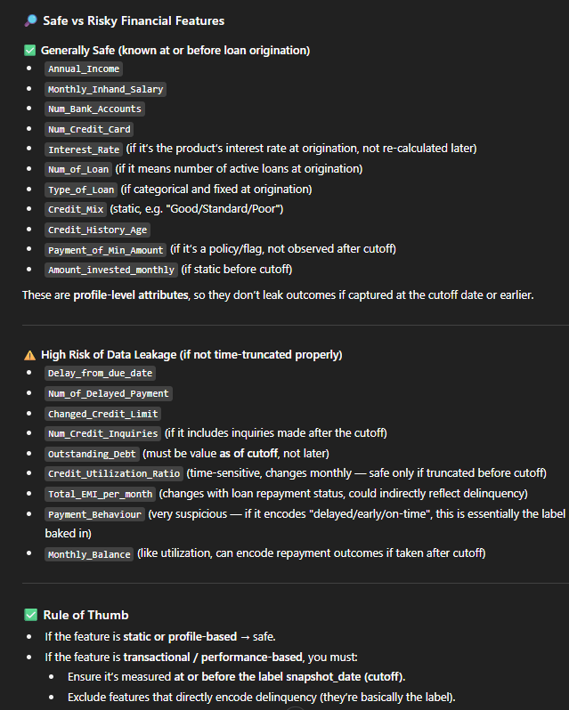
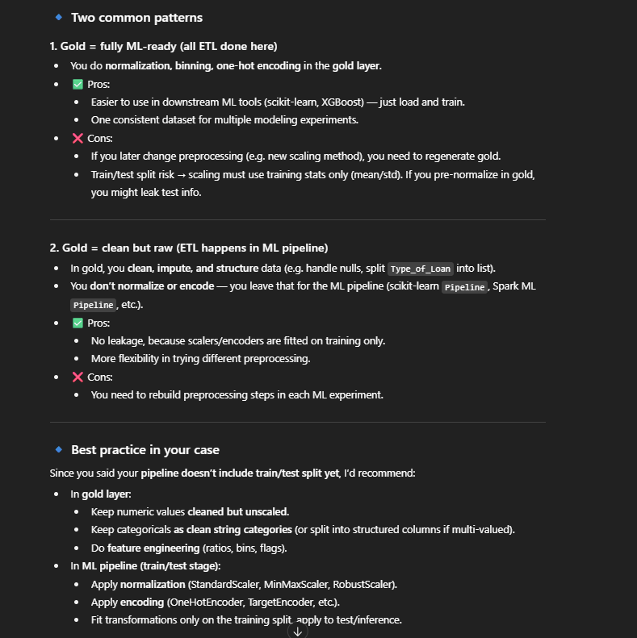
Silver and Gold Table: Remove all PII
Gold Table:
bin multi-categorical features
Ensure the temporal features are captured before the label ot date.

