Agentic AI Loan Approval Demo

1. Overview
Build a ‘point of view demo’ of an agentic AI solution that automates loan approval at a bank, and present it as you would to a banking customer in a presales meeting.
This assignment is part of the selection process for the Business Analyst – Data & AI Presales role. It mirrors the work our Business Analysts in the presales team do every week: understanding a customer's business process, shaping a data and AI solution around it, and telling that story convincingly.
We are assessing four things:
- How well you understand the real-world loan approval process in a bank
- How you structure a solution (business/functional architecture) across a modern data platform and AI agents
- How you communicate that solution visually to a non-technical business audience
- How effectively you use AI tools, especially Claude, to accelerate your own work
The demo does not need to be perfect or production-grade. We value clear thinking, sound research and an AI-native way of working over polish.

2. Business context
Loan approval in a bank is a multi-step, document-heavy process that draws on three very different kinds of data. Today much of it is manual, slow and inconsistent across branches and credit officers.
Data type | Examples | Typical challenge
Unstructured | RBI circulars, internal credit policies, product guidelines, customer-submitted documents (KYC, salary slips, bank statements, ITRs, property papers) | Policies change often; documents arrive as scans and PDFs that must be read and checked
Structured | Core banking system data: customer profile, accounts, existing loans, repayment history, transactions | Data sits in silos and is hard to combine with other sources in real time
External APIs | Credit bureaus (e.g. CIBIL), CERSAI for charges on collateral, PAN/Aadhaar verification, GST, account aggregators | Each source has its own format, latency and cost per call
A modern answer combines a lakehouse that brings these sources together with AI agents that reason over them, apply policy and recommend a decision, while keeping a human credit officer in control of the final approval.

3. Problem statement
You are a presales BA preparing for a first meeting with the Retail Lending head of a mid-sized Indian bank. They want to see how agentic AI could cut loan turnaround time while improving consistency and compliance.
Design and build a ‘point of view demo’ of an agentic loan approval solution that:
- Reflects how loan approval actually happens in a bank, end to end (from application to sanction and disbursement)
- Uses a lakehouse-style data layer to bring together unstructured, structured and external data
- Uses one or more AI agents to perform meaningful steps in the process, such as document checks, policy lookup, credit assessment or risk flagging
- Keeps a human in the loop where the bank would expect one
In scope: one loan product of your choice (for example home loan, personal loan, MSME loan or gold loan), clearly stated.
Out of scope: real customer data, live connections to actual bureau or government systems, and production-grade security.

4. Deliverables
Submit a single web application with the pages below, plus a short write-up and a live walkthrough.
# | Deliverable | What we expect to see
D1 | Loan approval demo (UI/UX) | A working journey aligned to the bank's actual loan approval workflow. Show the applicant or officer view, agent actions, data pulled from each source, and the final recommendation with reasons.
D2 | Approach story page | Your approach diagram turned into a polished web page. Tell the story in two acts: first the lakehouse (how data is brought together), then the agentic solution built on top of it. Write it for a business audience.
D3 | Architecture page | A separate page in the same app showing the technical architecture: data sources, ingestion, lakehouse (BigQuery), agents, tools/APIs, UI, and governance.
D4 | Supporting pages | Finishing touches that make it feel like a real client-facing product, such as a Contact Us page, About, or FAQ.
D5 | Research note (1–2 pages) | How loan approval really works in a bank: stages, roles, checks, documents, typical turnaround times and pain points. Name your sources, including any conversations with banking professionals.
D6 | AI usage log (1 page) | How you used Claude and other AI tools: key prompts, what worked, what you corrected, and the time it saved.
Bonus: host the demo with actual (dummy/generated) data in BigQuery, built using Claude Desktop or Claude Code, and share a live link.

5. Technical guidance
You are free to choose your stack. The guidance below reflects what we look for, not a mandatory design.
- Data layer: use Google BigQuery as the lakehouse. Dummy or synthetic data is fine; generating it with AI is encouraged. Aim for realistic volumes and fields (for example 200–1,000 applicants with accounts, loans and repayment history).
- Unstructured data: include a few sample circulars or policy documents and applicant documents. These can be public RBI circulars or documents you create.
- External APIs: simulate CIBIL, CERSAI and other checks with mock services or stub responses. Make the mock behaviour realistic (scores, flags, existing charges).
- Agents: show clearly what each agent does, which data or tools it uses, and how it hands off to the next step or to a human. One well-designed agent is better than many shallow ones.
- Explainability: every recommendation should show its reasons and the policy or data it relied on.
- Use of Claude/AI: use Claude/AI throughout, for research, data generation, coding, UI design and writing. Claude Desktop, Claude Code, Codex, Antigravity etc are all acceptable.
Any cloud credits or paid services you choose to use are at your own discretion; free tiers are sufficient for this assignment.

6. Evaluation criteria
Submissions are scored out of 100, with up to 10 bonus points.
Criterion | Weight | What a strong submission shows
Banking domain research | 20 | Accurate, specific view of the real loan process: stages, roles, checks and regulations, backed by sources and conversations with banking practitioners
Approach diagram and storytelling | 20 | A clear, visually strong two-part story (lakehouse, then agentic AI) that a business executive understands in two minutes
AI-native way of working | 20 | Thoughtful, extensive use of Claude across research, data, build and content; honest reflection in the AI usage log
Solution design and architecture (more of functional/business architecture) | 15 | Sensible agent design, data flows, human-in-the-loop points and governance; a clean architecture page
Demo UI/UX | 15 | A working, intuitive journey that follows the actual bank workflow
Presentation and communication | 10 | Clear, confident walkthrough that handles questions well
Bonus: live hosting with real data | +30 | Demo hosted and running on BigQuery data, built with Claude Desktop or Claude Code

7. Submission and timeline
You have 7 calendar days from receiving this assignment to submit.
Step | When | What happens
Assignment issued | Day 0 | You receive this document
Clarifications | By Day 2 | Email any questions you have
Submission | By Day 7, 6:00 PM IST | Send all deliverables
Walkthrough | Within a week of submission | 30-minute session: 20 minutes of demo, 10 minutes of Q&A
How to submit: email with the subject line Data & AI Presales Assignment – [Your Name], including:
- A link to the hosted demo, or a repository link (GitHub or similar) with run instructions
- The research note (D5) and AI usage log (D6) as PDF or links
- A short screen recording (5 minutes or less) of the demo, in case of any access issues on the day

8. Ground rules and FAQs
- Work alone. This is an individual assignment. Talking to banking friends or professionals for domain context is encouraged; please credit them in your research note (names optional).
- AI tools are expected, not just allowed. Using Claude heavily is part of what we assess. Be transparent about what you built and what the AI produced.
- No real customer data. Use only synthetic or publicly available data.
- Your work stays yours. We use submissions only to evaluate your application.
Do I need to write code? Some building is expected, but you can rely on Claude to generate most of it. We assess the thinking and the outcome, not just the coding skill.
Can I use a cloud other than Google Cloud? BigQuery is preferred. If you use an alternative, explain why in your architecture page.
What if I cannot finish everything? Submit what you have, with a short note on what you would do next. A strong story and solid research count for more than a complete build.

9. Reference Architecture & Point of View Demo
We expect your solution (primarily business architecture) to have the following layers at the least. The reference is given because the BA role need not be technical but need to have skin in the game (technical architecture) on top of which business architecture can be envisioned. Both architectures map to each other - technical focuses on services to be used for each layer/component and functional/business focuses on functional layers/components that must be involved.
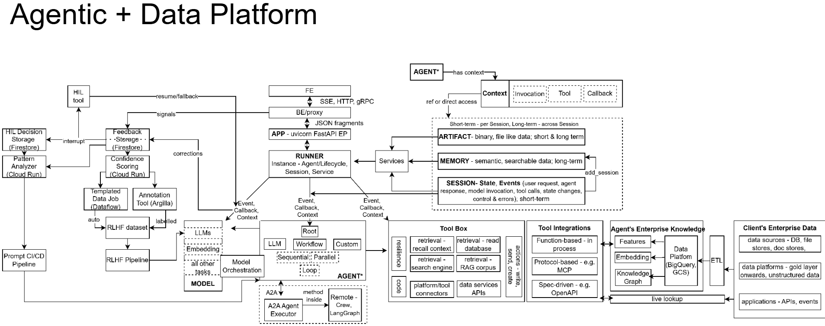
https://pnb-frontend-7kxckvikva-uc.a.run.app/

