SID4: 1066
PORT_BASE: 8166
PREFIX: s1066
SEED: 1066
VERIFY_SEED: 261066
DOMAIN_ID: 2
Hardware: Macintosh HD, Apple M4, 24 GB, Tahoe 26.6.2
Local Model Used:
Part 1)
I: HTML
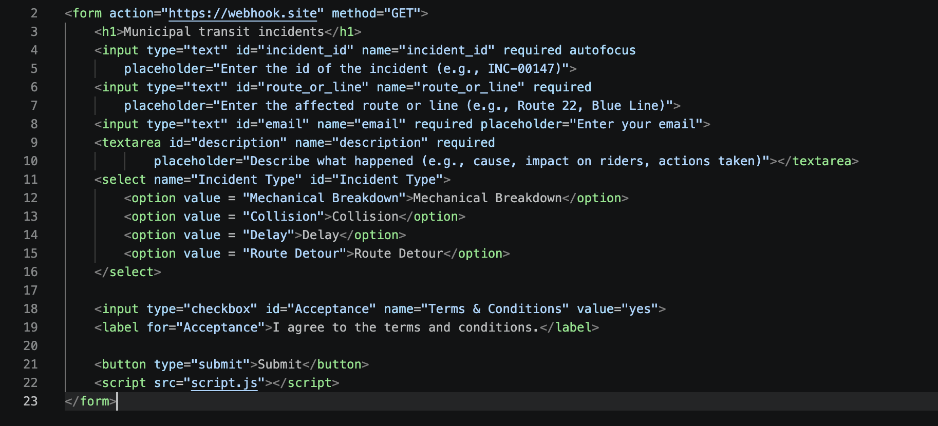

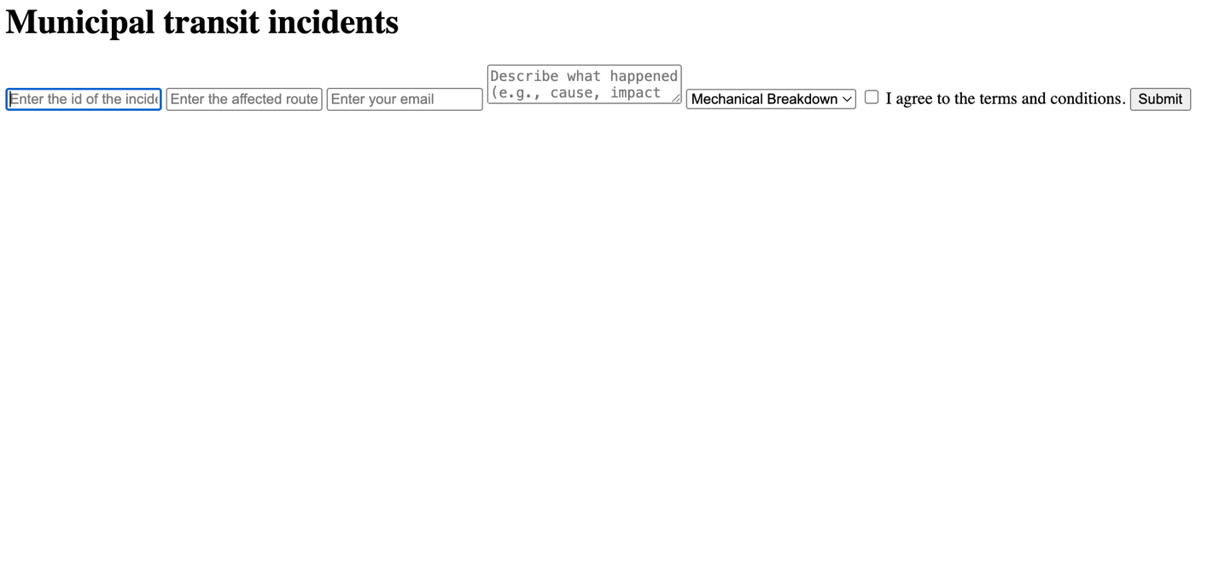
II: Javascript
1.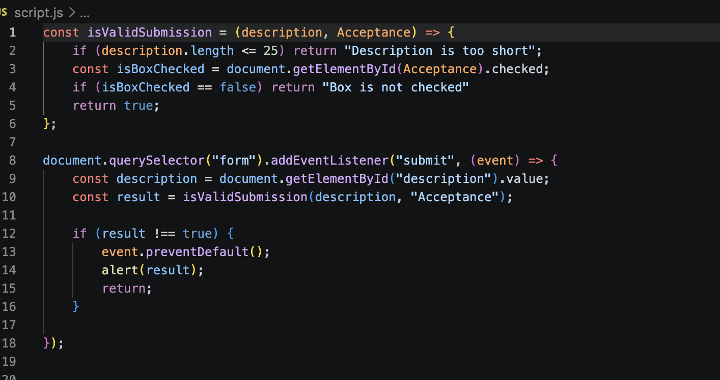

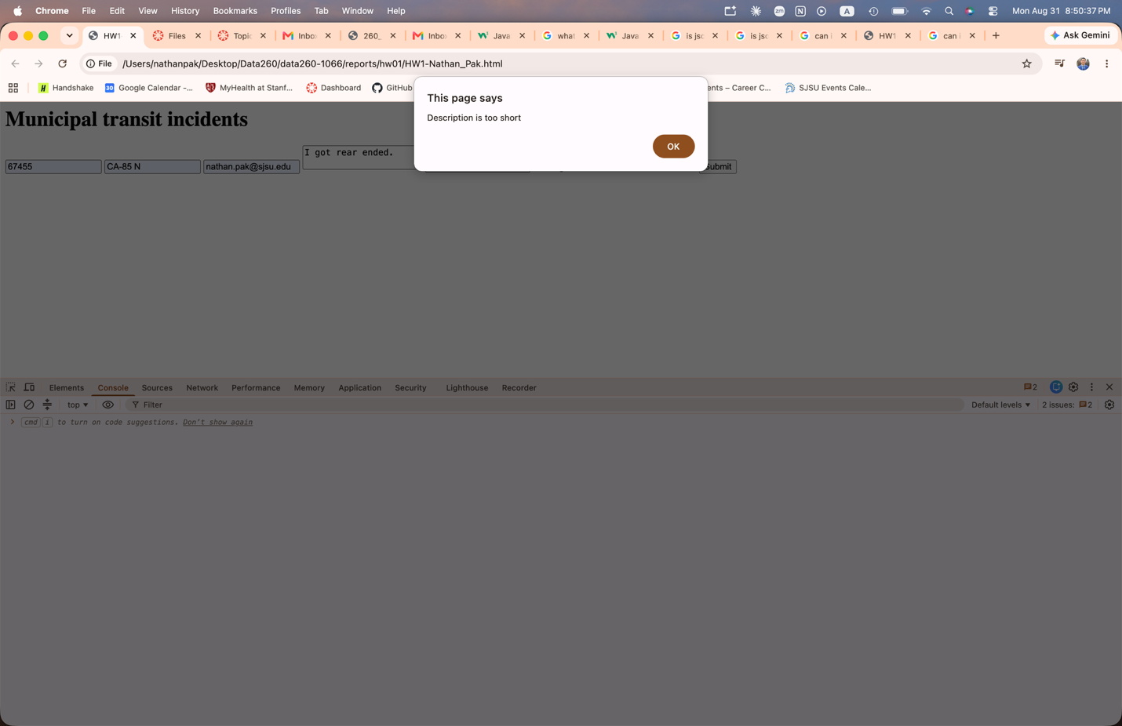

2.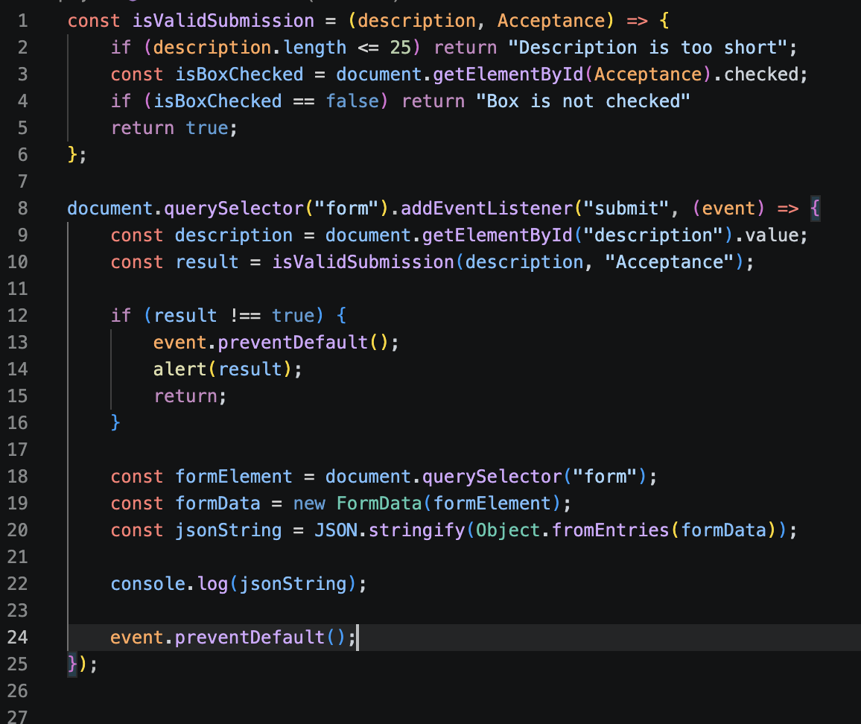
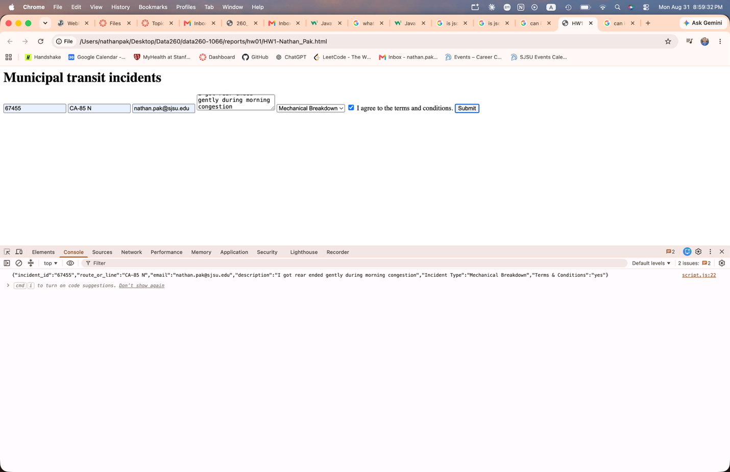
3.
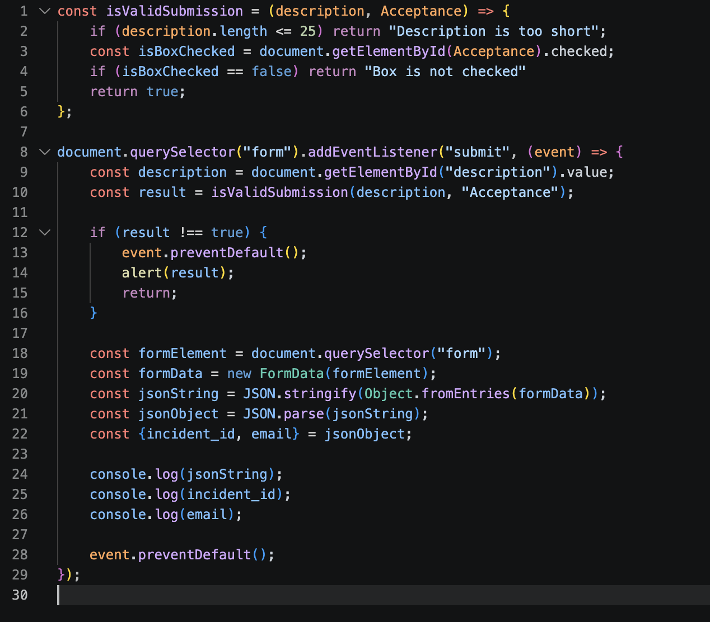
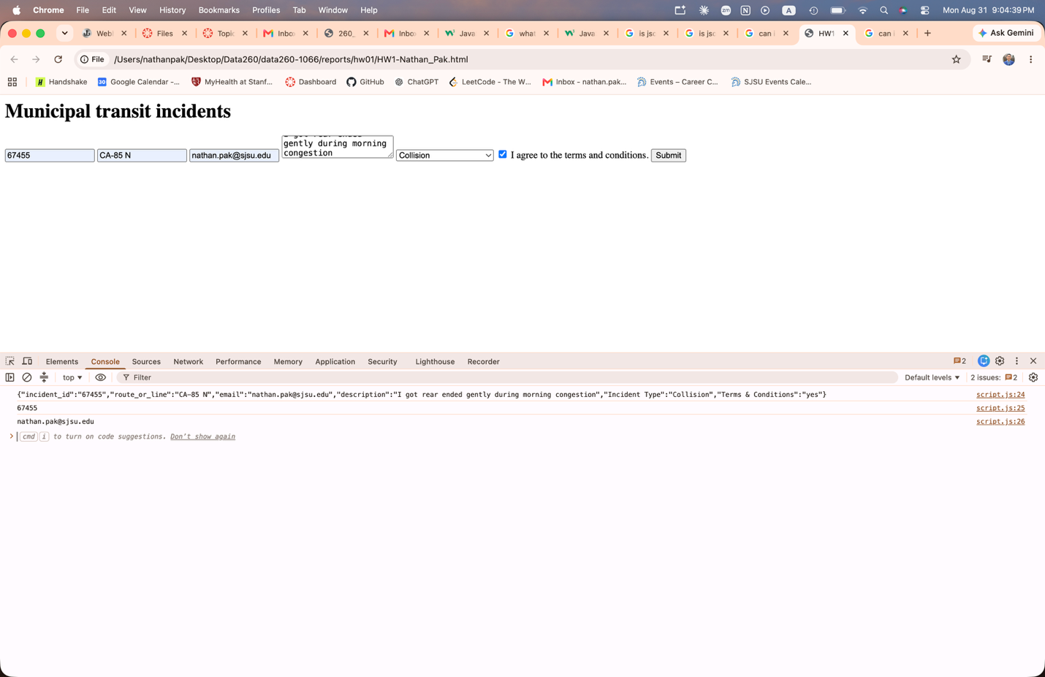
4.
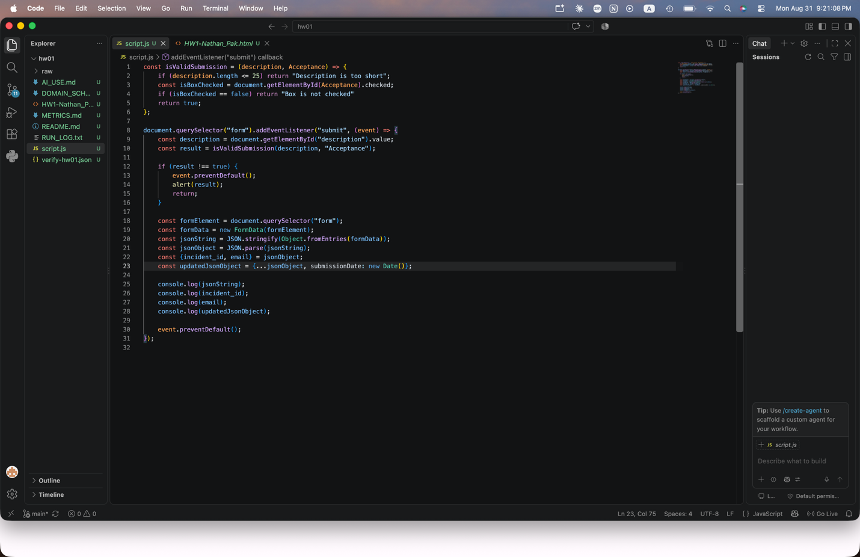
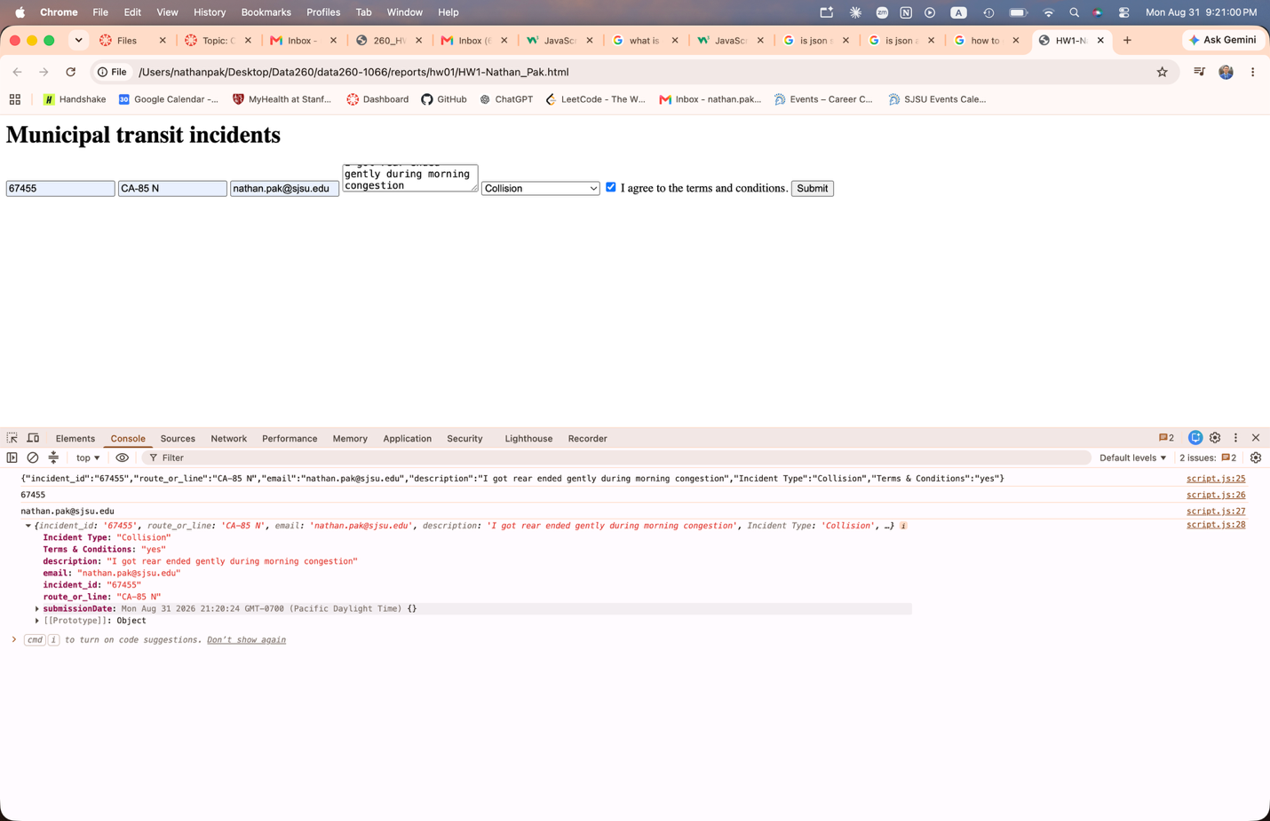
5.
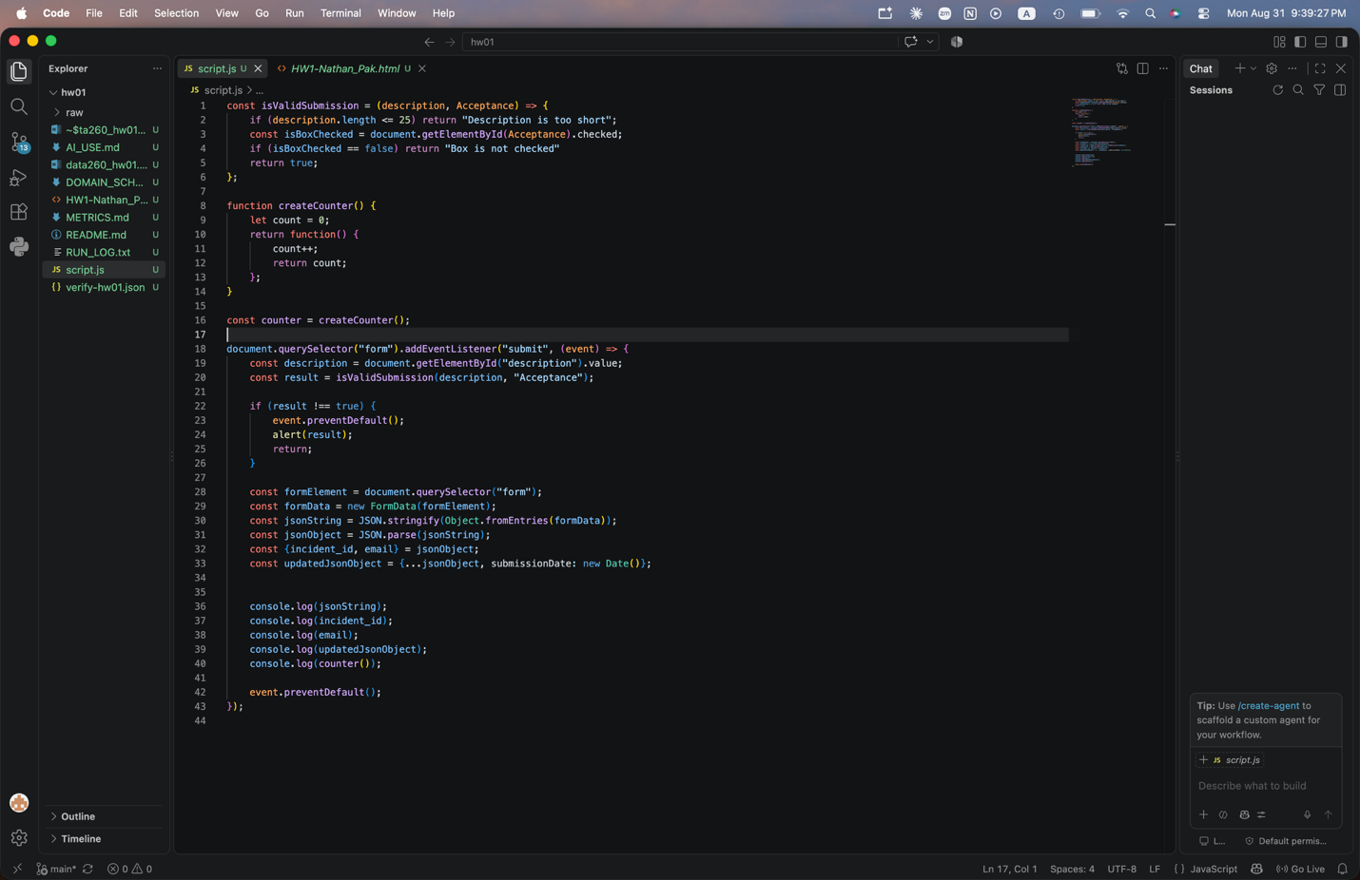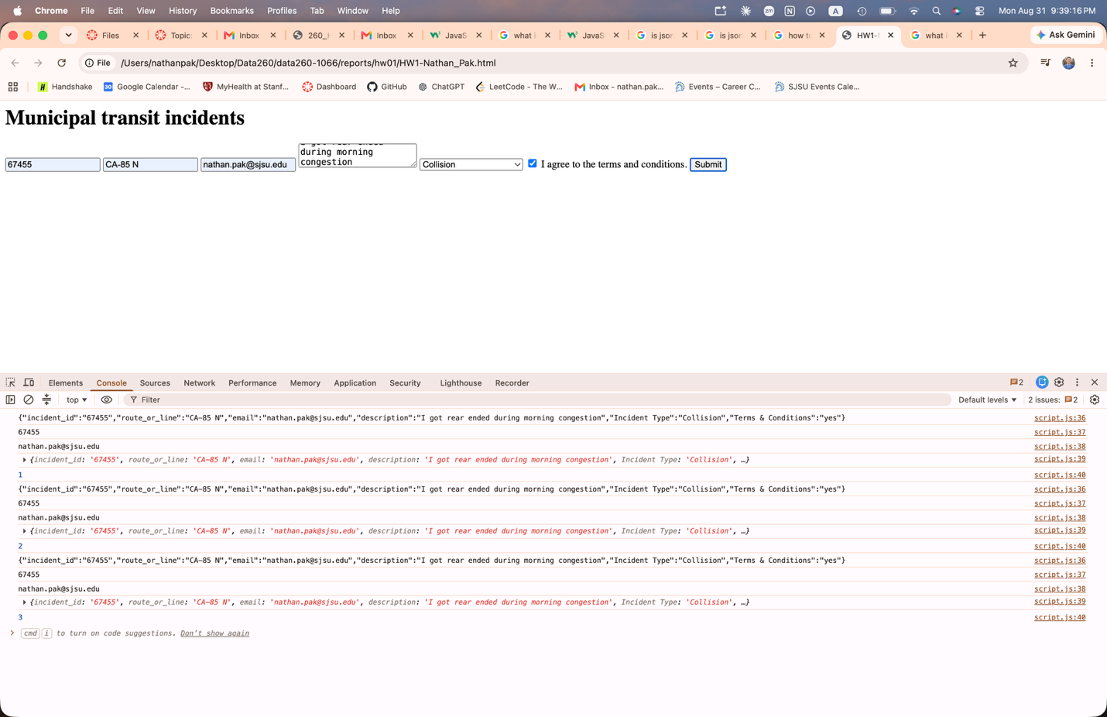

Screenshot of app running on localhost via Docker:
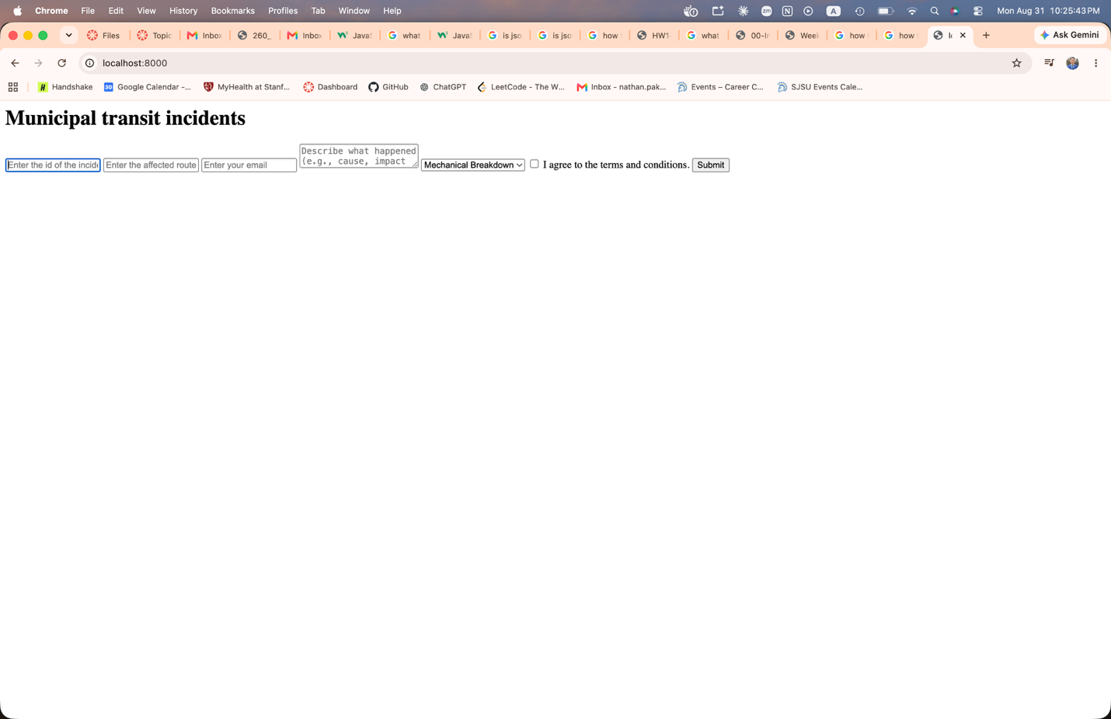

Screenshot of app running on public IP Address via AWS ECS:
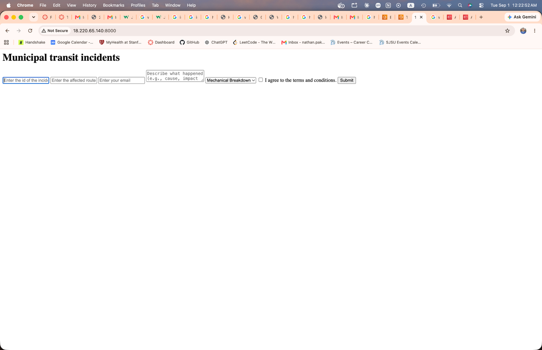

Part 2)
1 & 2)
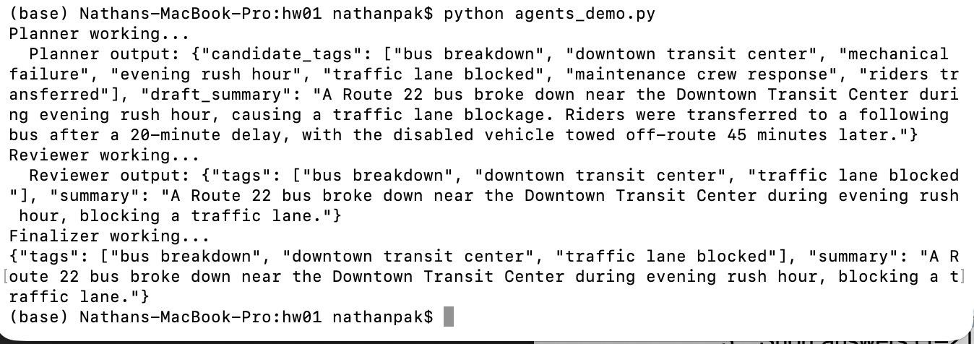
3)
Q1. The 3 final tags you obtained.
bus breakdown, downtown transit center, traffic lane blocked
Q2. The final summary (≤25 words).
A Route 22 bus broke down near the Downtown Transit Center during evening rush hour, blocking a traffic lane.
Q3. Did the Reviewer agent change anything? (yes/no + explanation)
Yes. The reviewer agent narrows the tag count down to three most relevant tags and tightens the summary to no more than 25 words.
4)
The planner reads the title and content input and generates a generous amount of tags along with a draft summary of the input data relevant to the assigned domain entity.

The reviewer step takes in the output of the planner agent and chooses the three most relevant tags out of the list that fit with the given domain of the input. The reviewer also shortens the summary to at most 25 words.

The finalizer agent validates the output from the reviewer step. Unlike the previous two steps, it doesn’t call the LLM model. It makes sure that the summary is at most 25 words and there are just 3 tags. If it is invalid, it first asks the model by giving instructions to correct the input. If it still fails, it deterministically truncates the input so that the input data becomes valid. Then, it outputs the new transformed data.

Part 3)

