SID4: 1066
PORT_BASE: 8166
PREFIX: s1066
SEED: 1066
VERIFY_SEED: 261066
DOMAIN_ID: 2
Hardware: Macintosh HD, Apple M4, 24 GB, Tahoe 26.6.2
Local Model Used: Ollama qwen3:8b
Part 1)
I: HTML
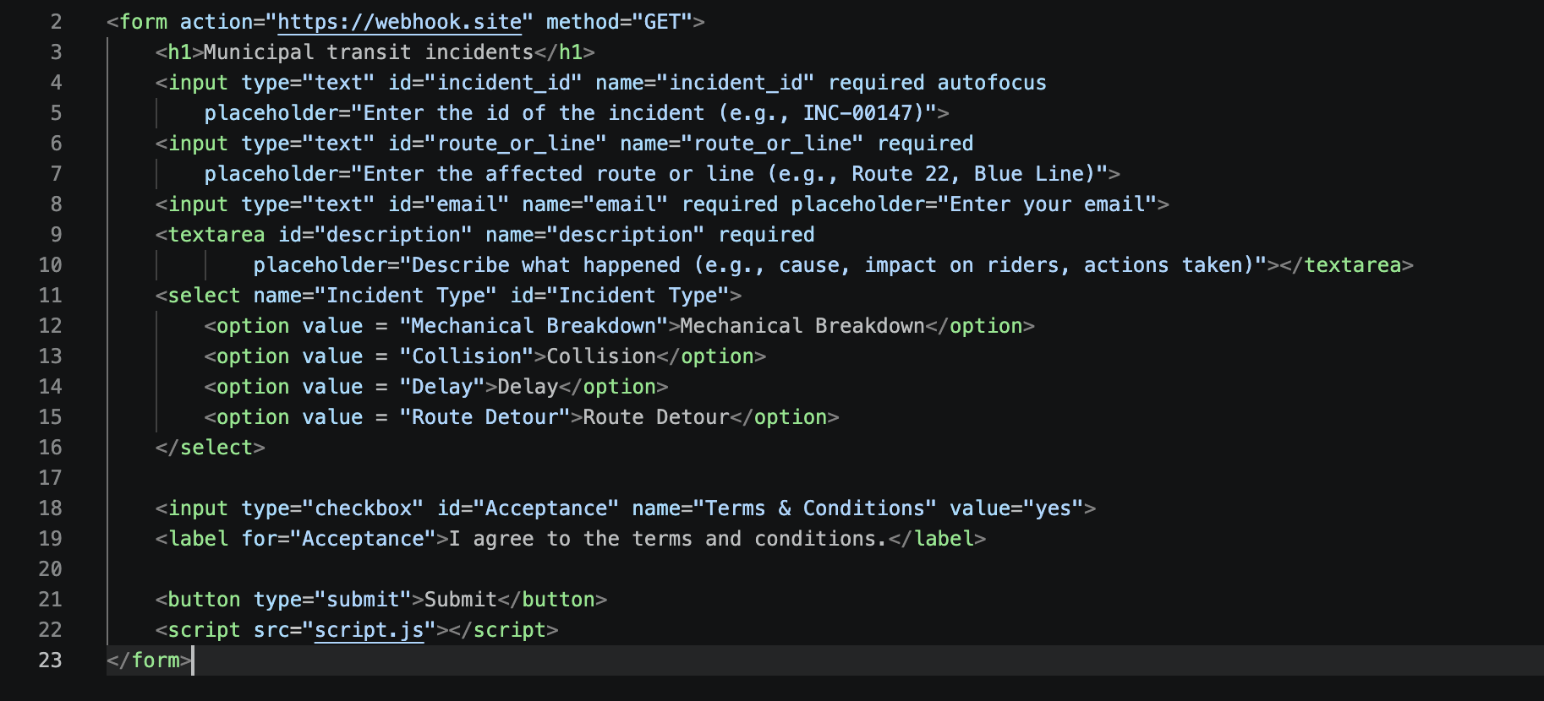

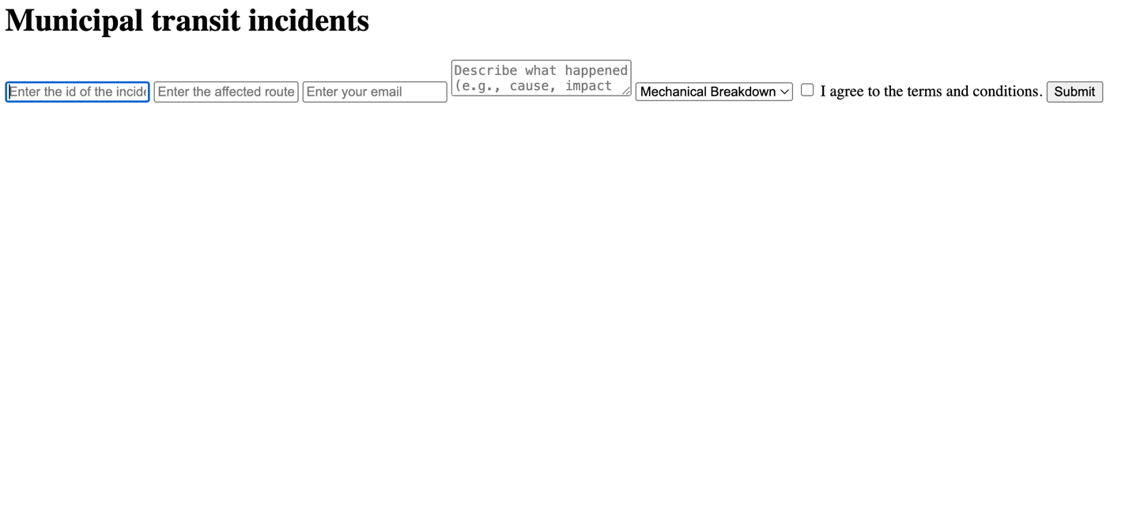
II: Javascript
1.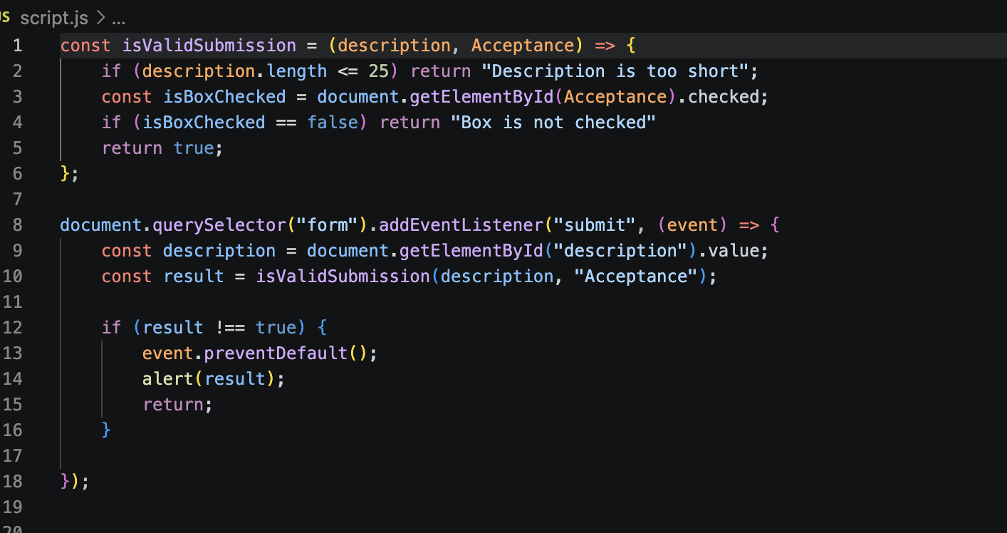

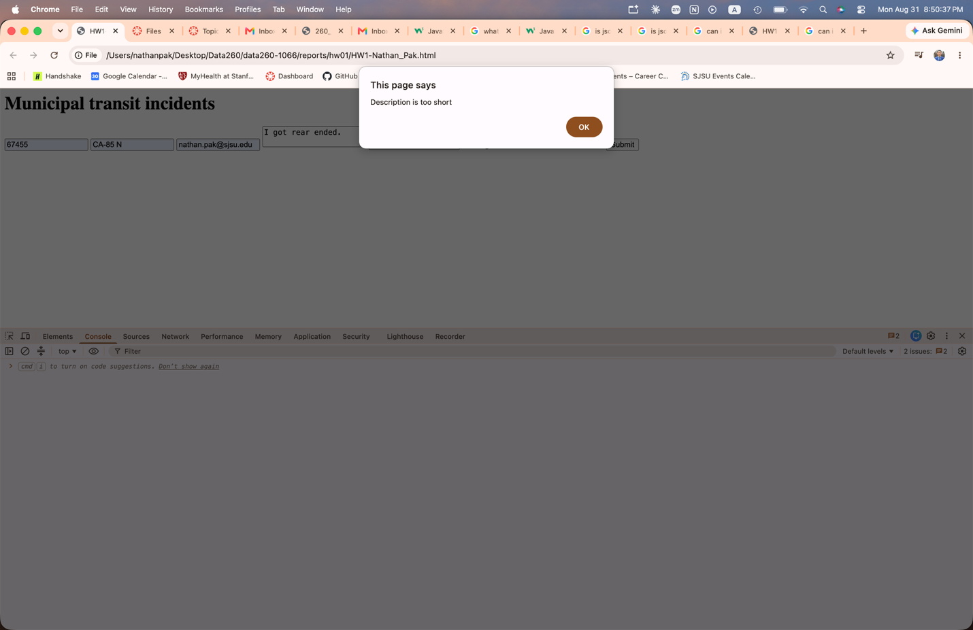

2.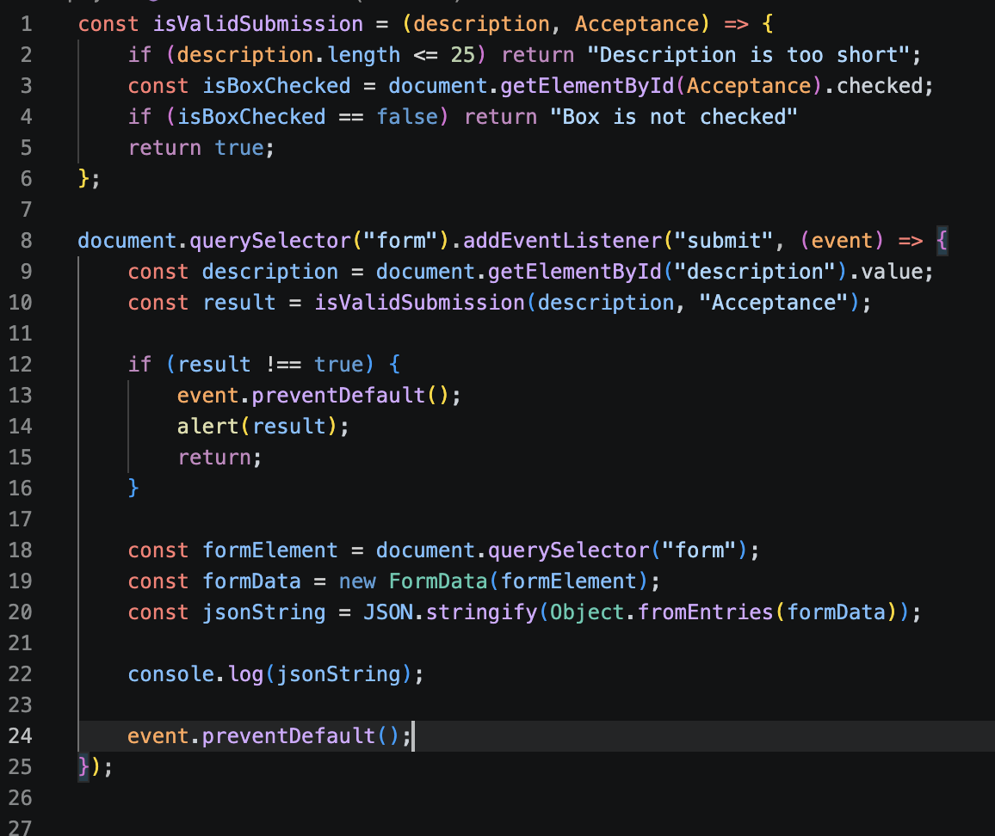
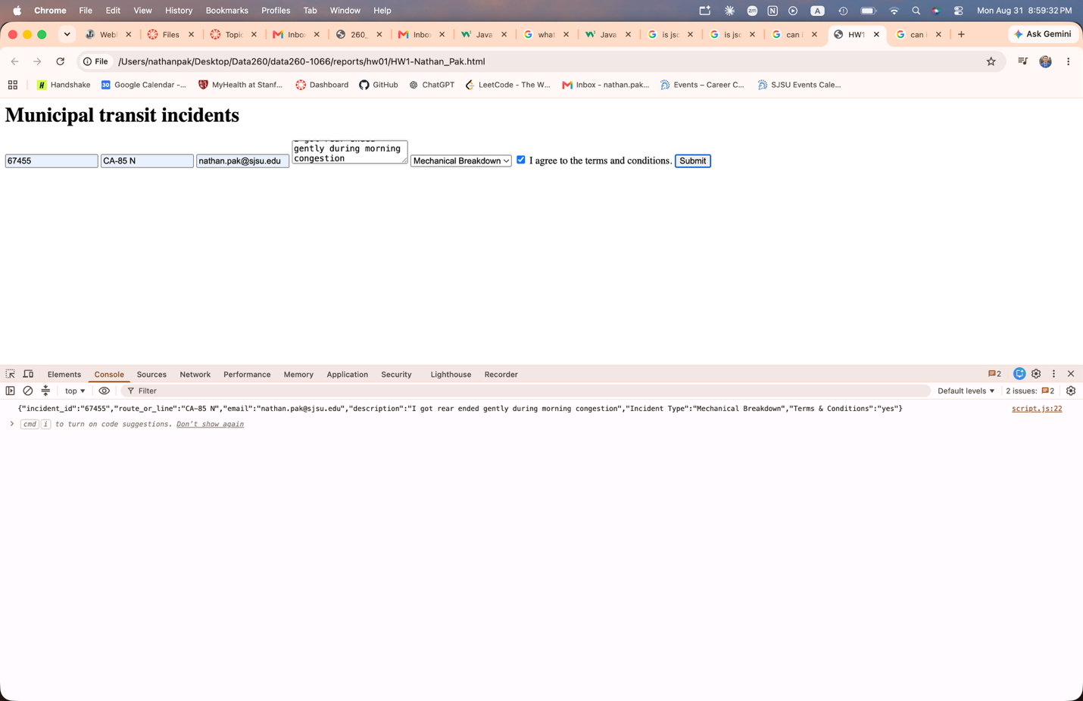
3.
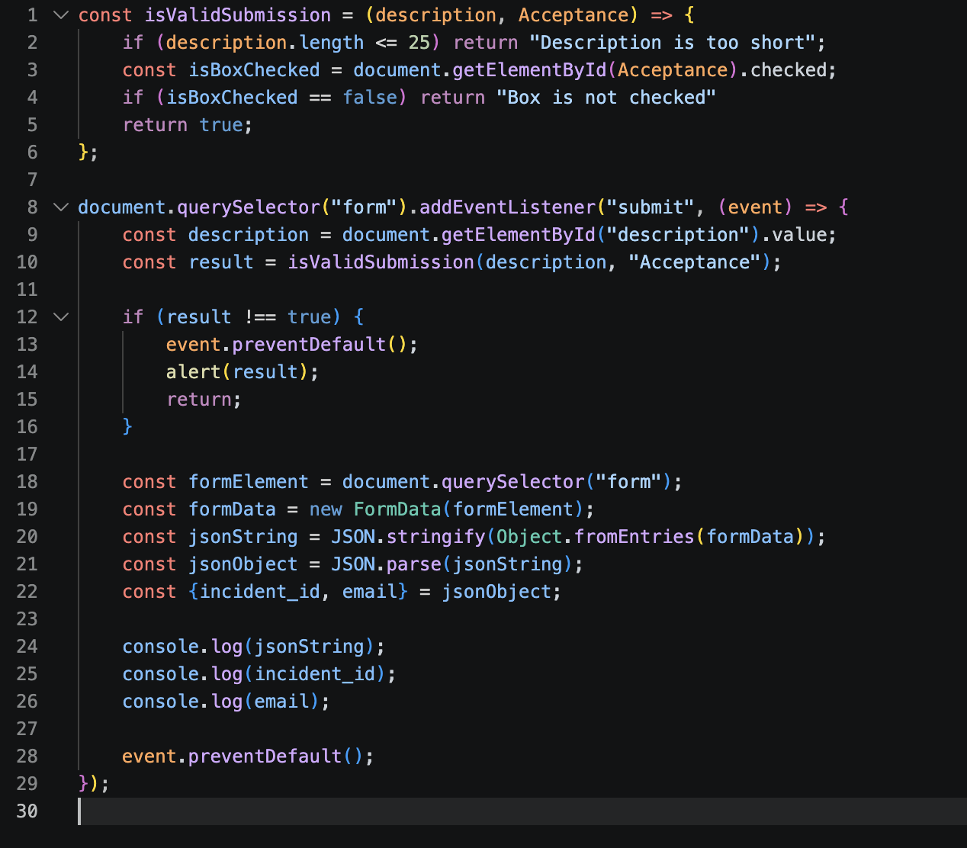
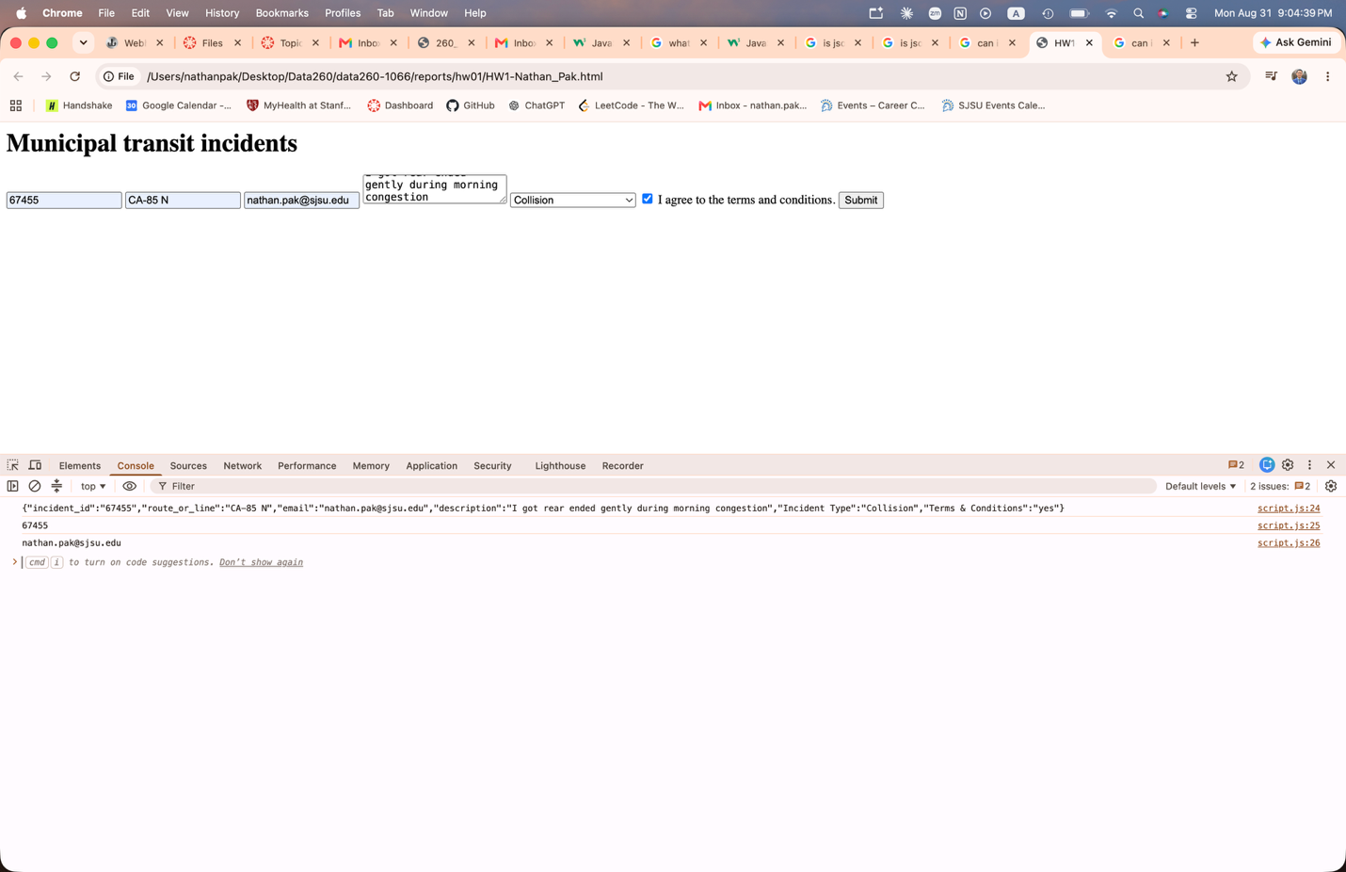
4.
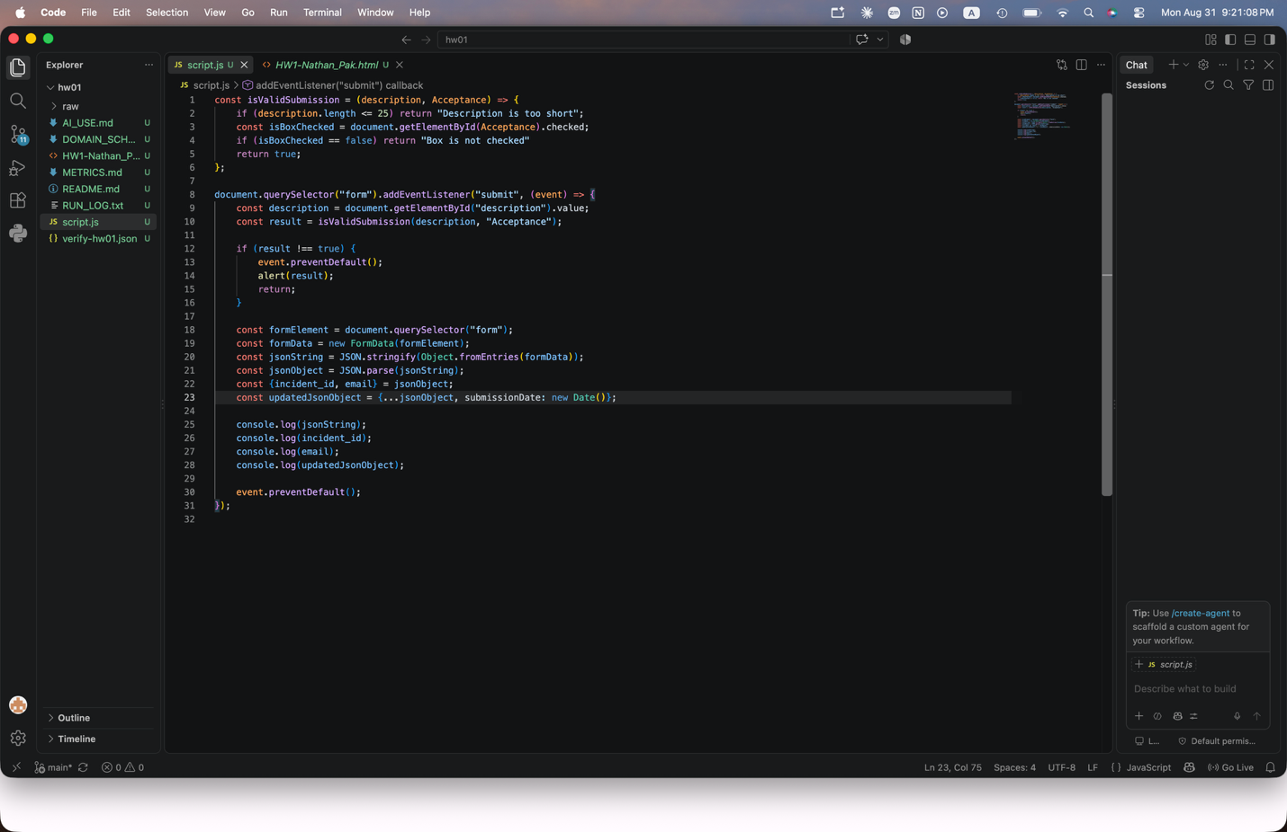
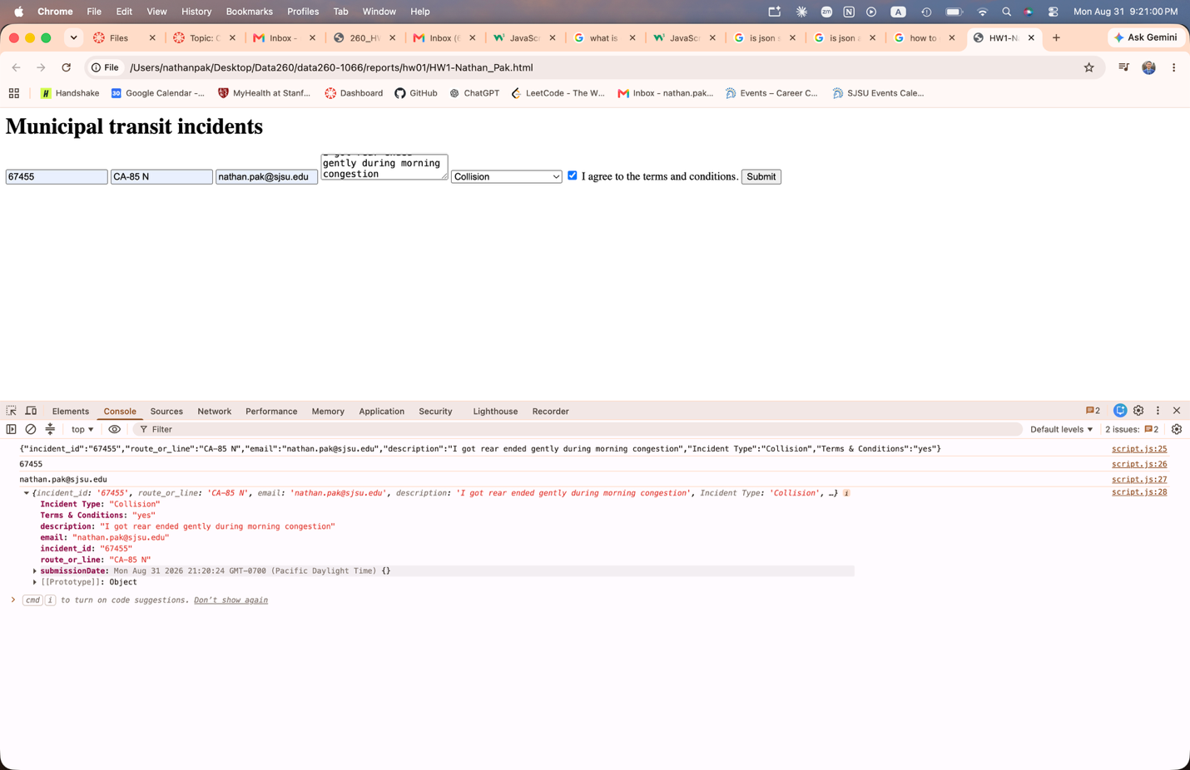
5.
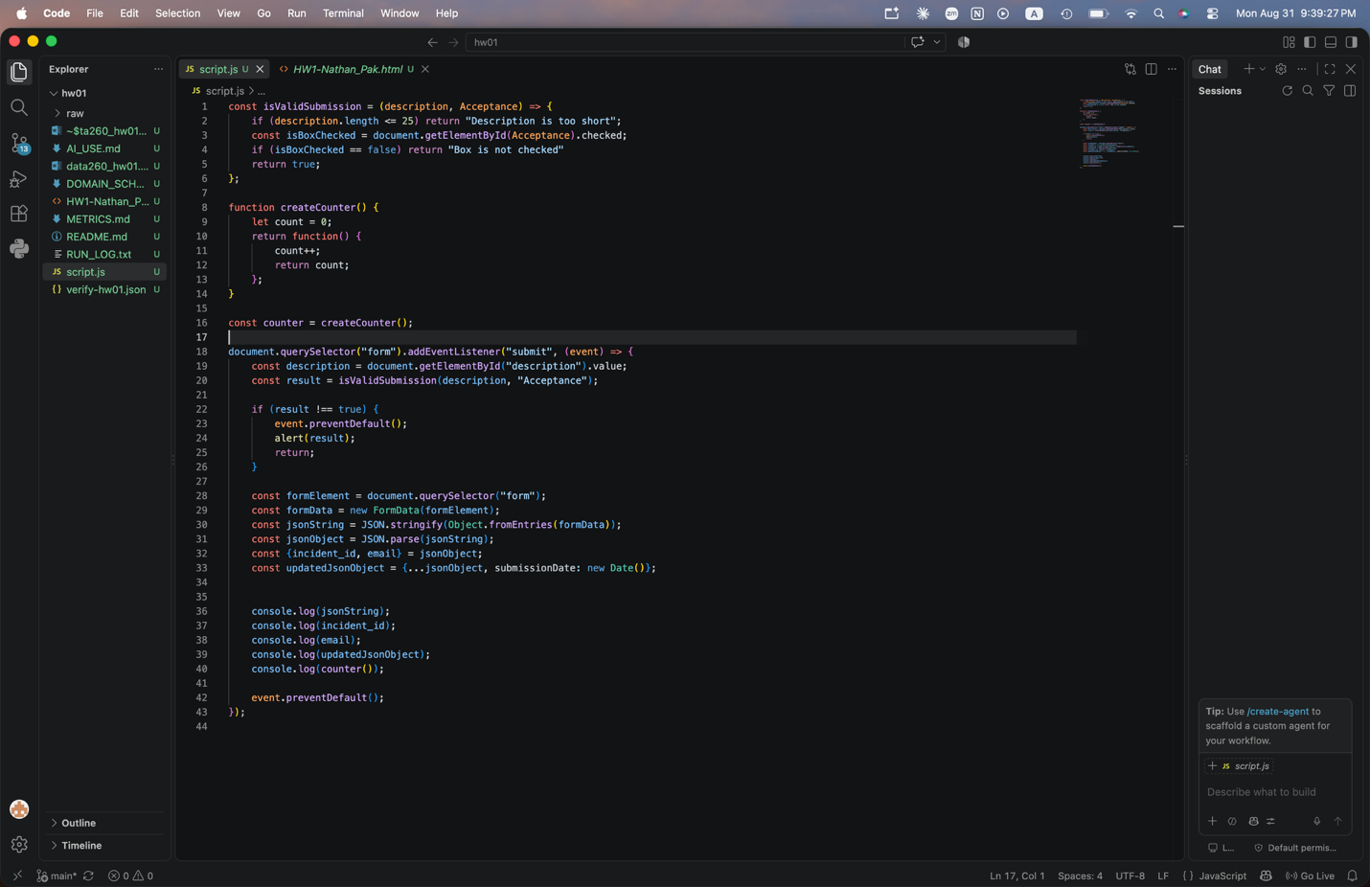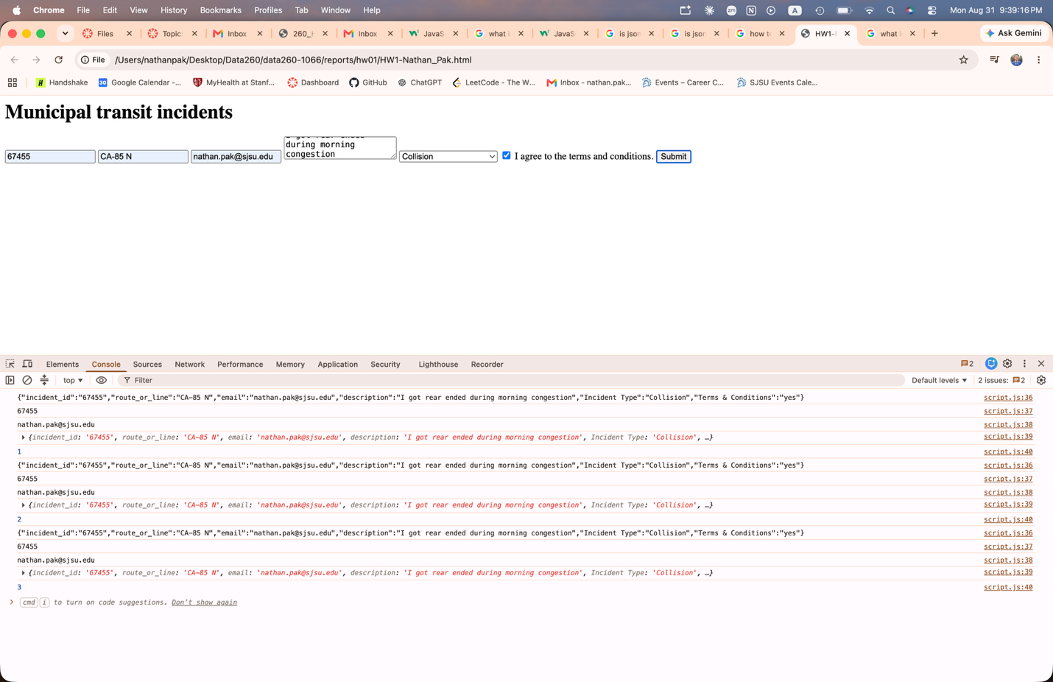

Screenshot of app running on localhost via Docker:
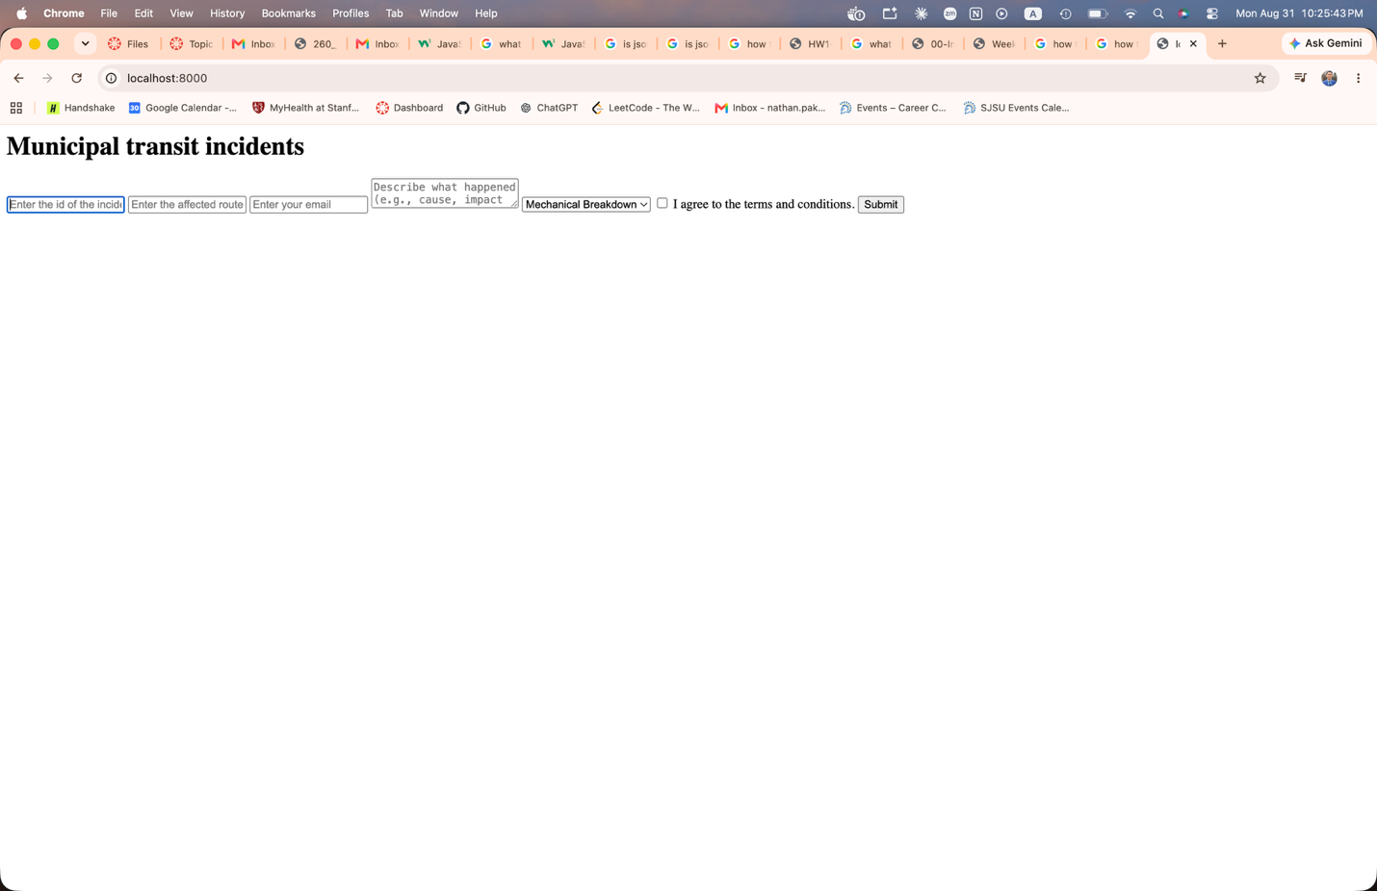

Screenshot of app running on public IP Address via AWS ECS:
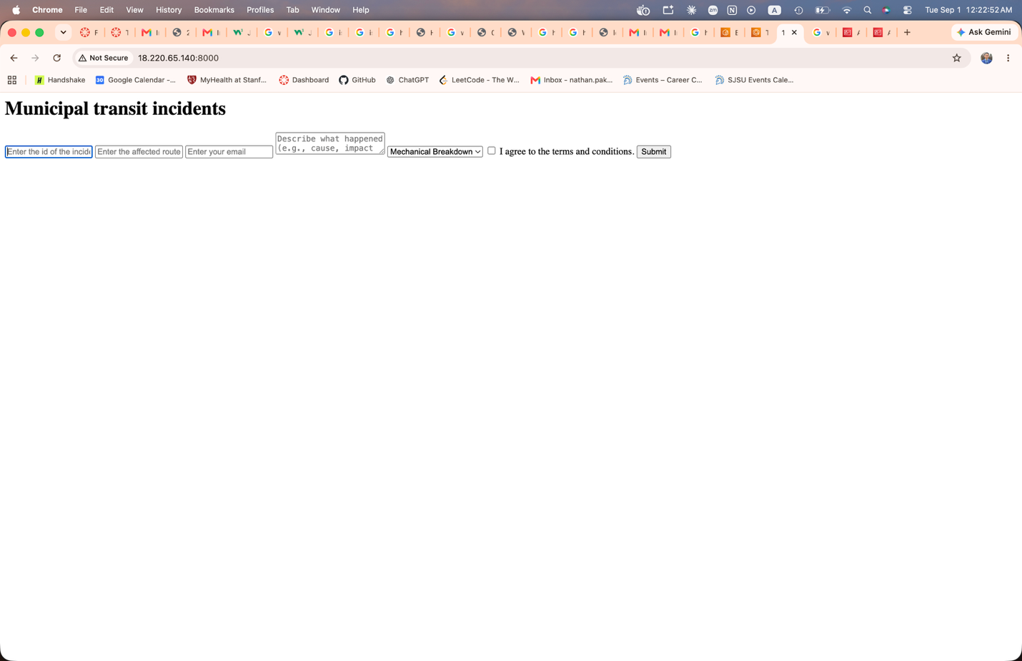

Part 2)
1 & 2)

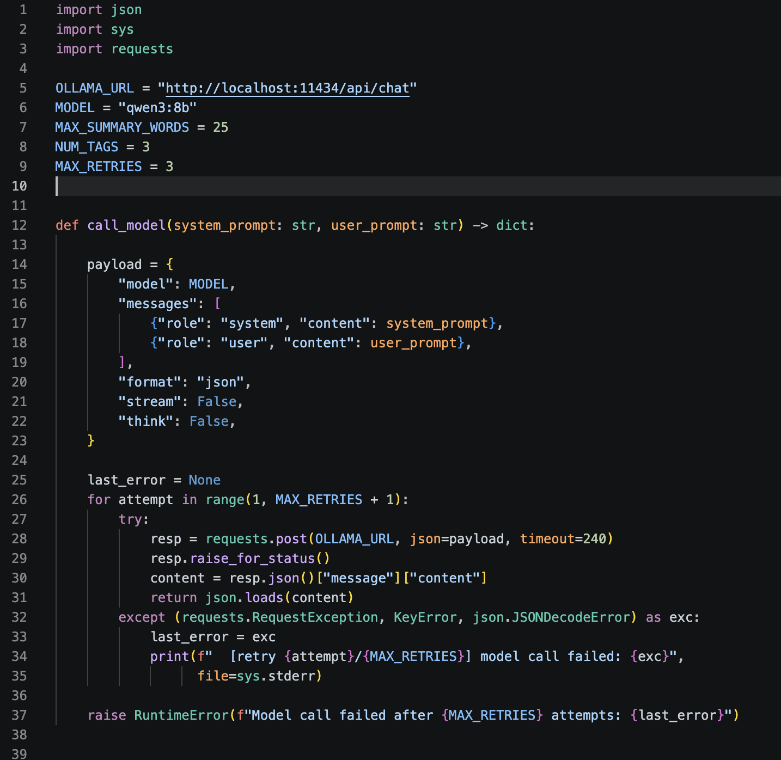
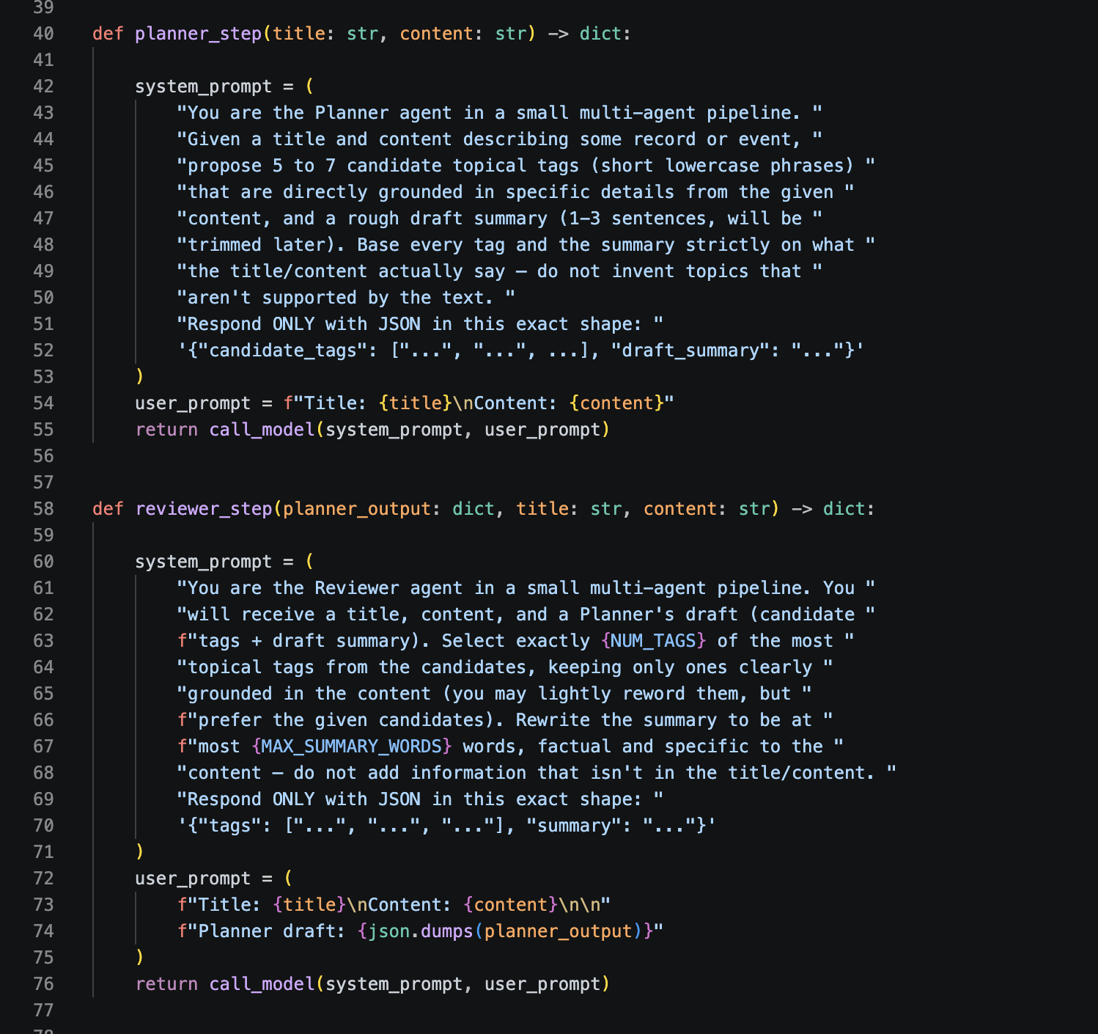
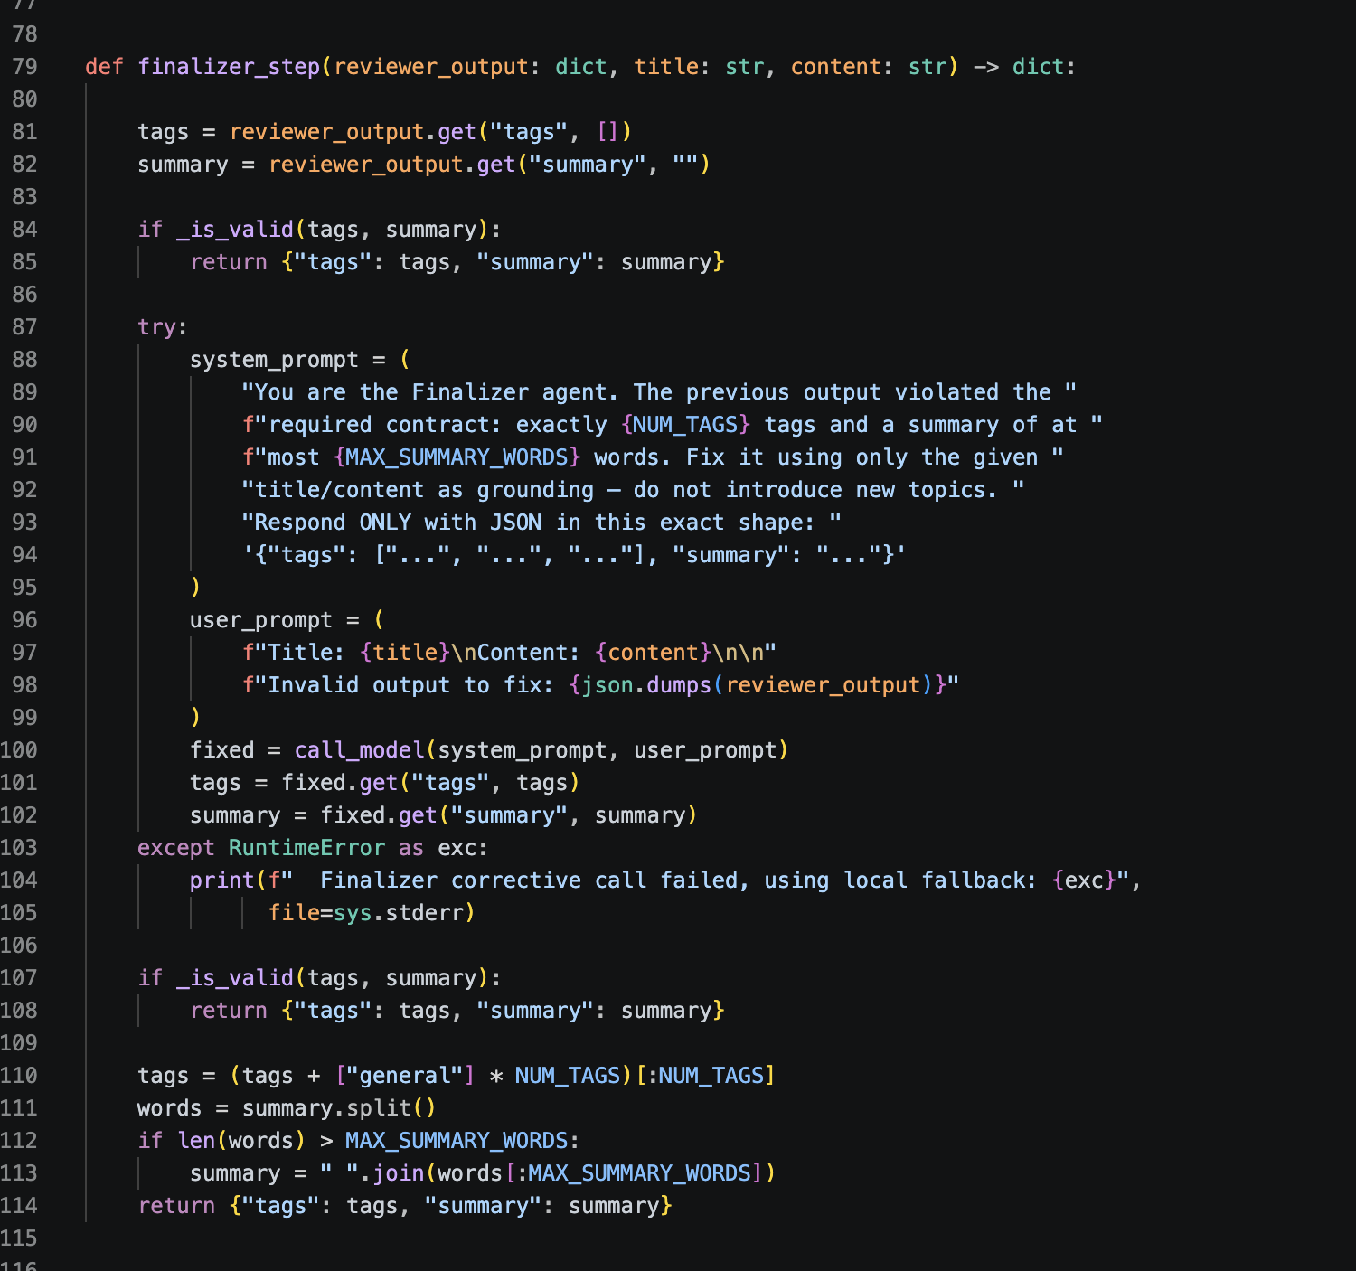
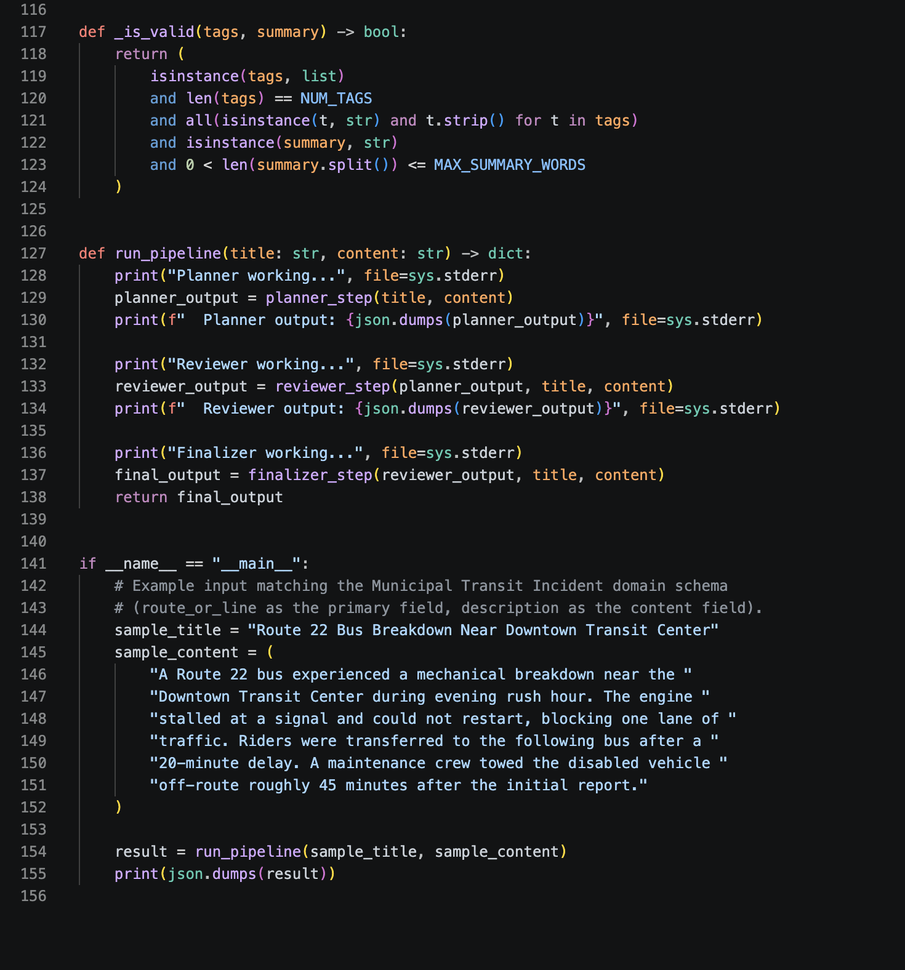
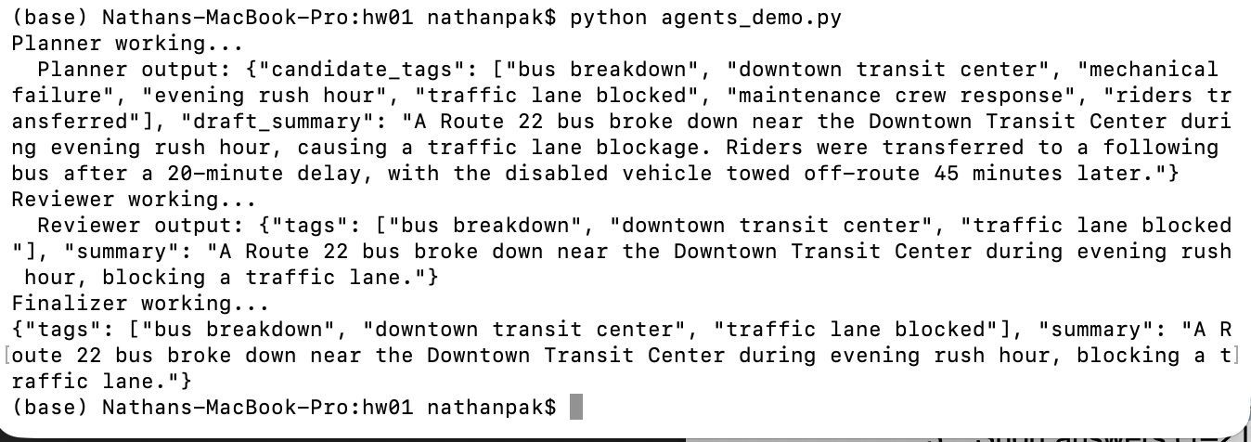
3)
Q1. The 3 final tags you obtained.
bus breakdown, downtown transit center, traffic lane blocked
Q2. The final summary (≤25 words).
A Route 22 bus broke down near the Downtown Transit Center during evening rush hour, blocking a traffic lane.
Q3. Did the Reviewer agent change anything? (yes/no + explanation)
Yes. The reviewer agent narrows the tag count down to three most relevant tags and tightens the summary to no more than 25 words.
4)
The planner reads the title and content input and generates a generous amount of tags along with a draft summary of the input data relevant to the assigned domain entity.

The reviewer step takes in the output of the planner agent and chooses the three most relevant tags out of the list that fit with the given domain of the input. The reviewer also shortens the summary to at most 25 words.

The finalizer agent validates the output from the reviewer step. Unlike the previous two steps, it doesn’t call the LLM model. It makes sure that the summary is at most 25 words and there are just 3 tags. If it is invalid, it first asks the model by giving instructions to correct the input. If it still fails, it deterministically truncates the input so that the input data becomes valid. Then, it outputs the new transformed data.

Part 3)
1&2)
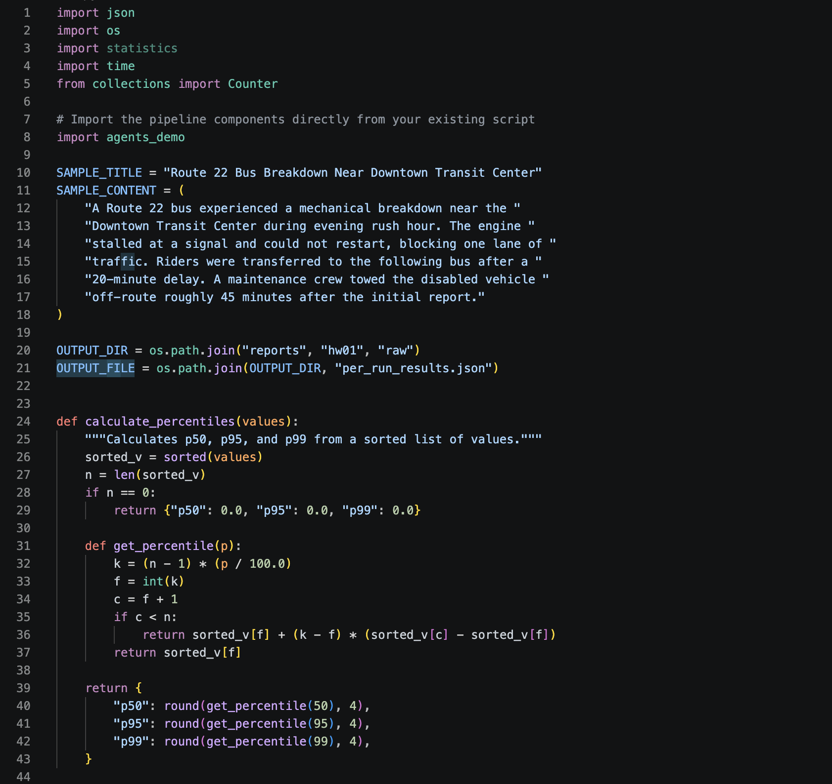
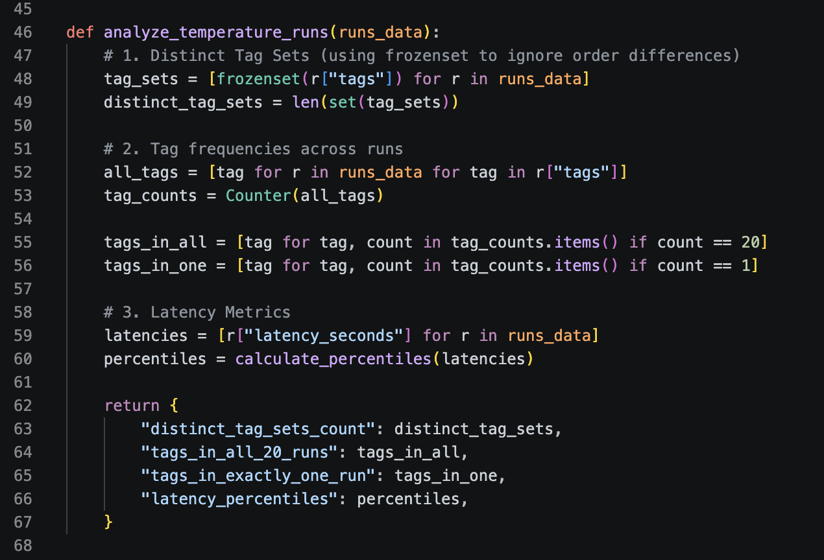
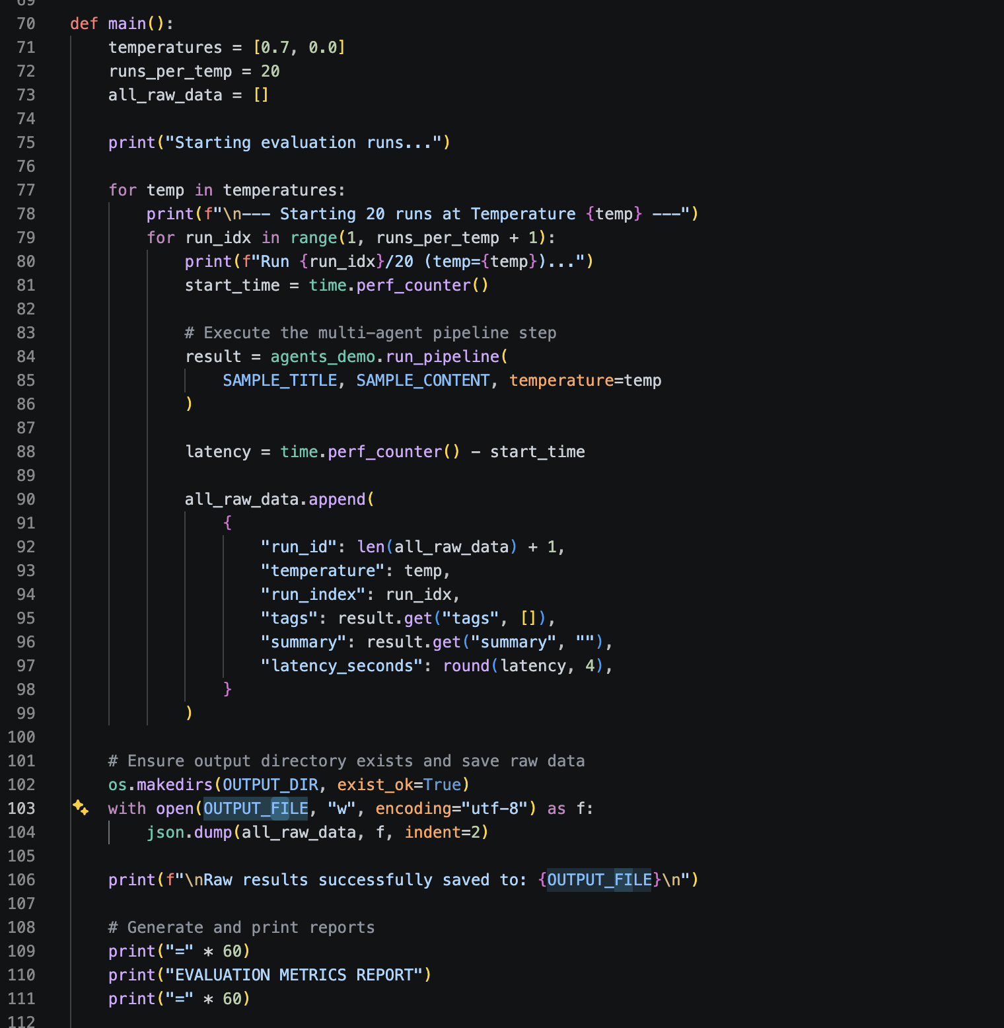
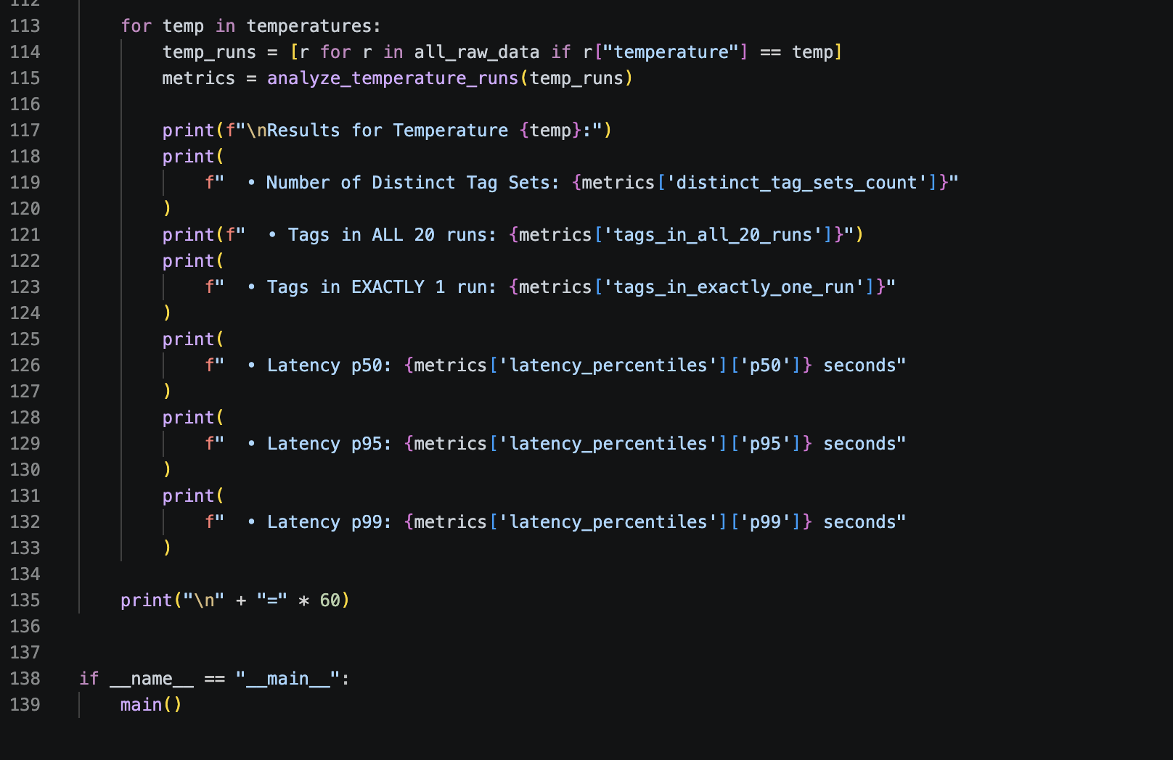
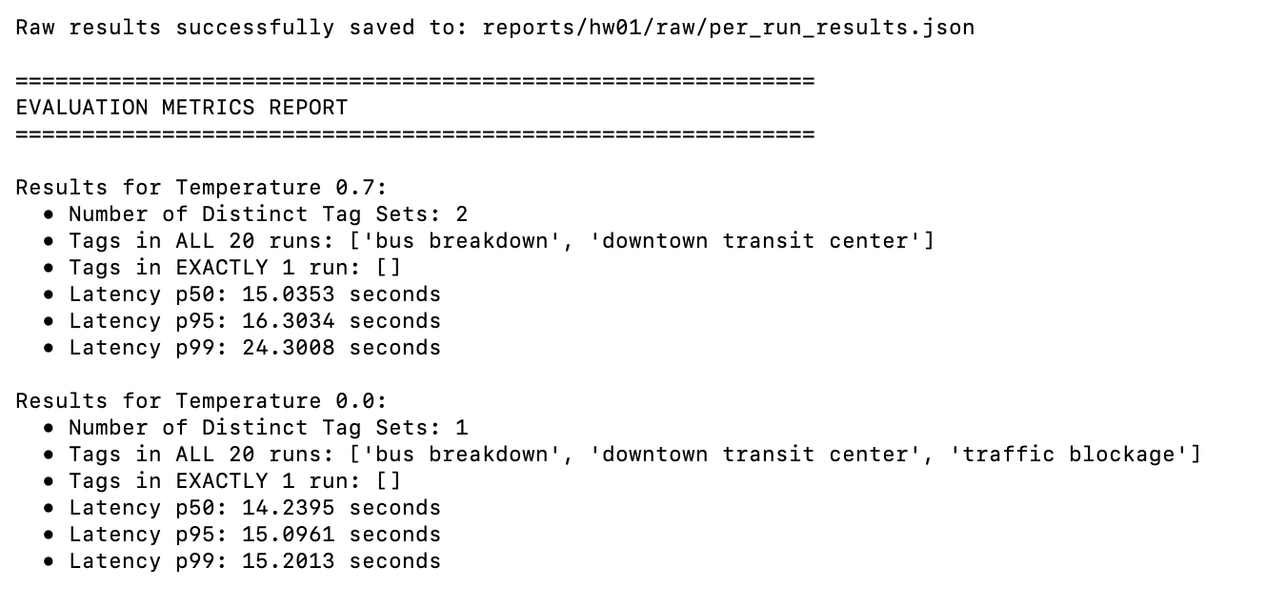
3)
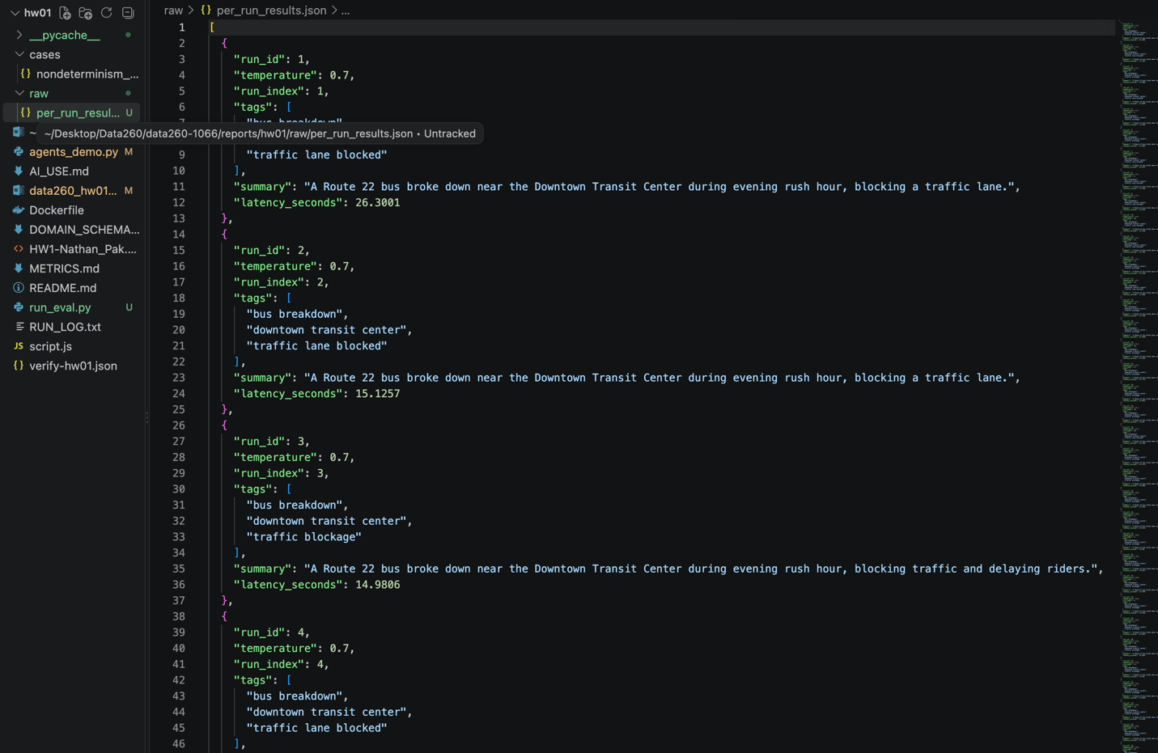
4) Using your own numbers, explain what two users sending identical input might see, and give one example where run-to-run variation is acceptable and one where it is not.
At temperature 0.0, two users sending identical input will receive 100% identical tag outputs. Meanwhile for temperature 0.7, two users sending identical input may receive slightly different outputs. While both users are guaranteed to see ‘bus breakdown’ and ‘downtown transit center’, the third tag will vary. That is why there are two distinct tag sets across 20 runs. Run to run variation is acceptable in creative content generation. When we want many different ideas for coming up ways to solve a problem, variations across runs can be helpful. However, for compliance auditing, we want identical inputs to map strictly to identical outputs in order to ensure correct information for legal or financial services.

Part 4)
1&2) Create hw1_client.py as a small command-line demo that imports the adapter.
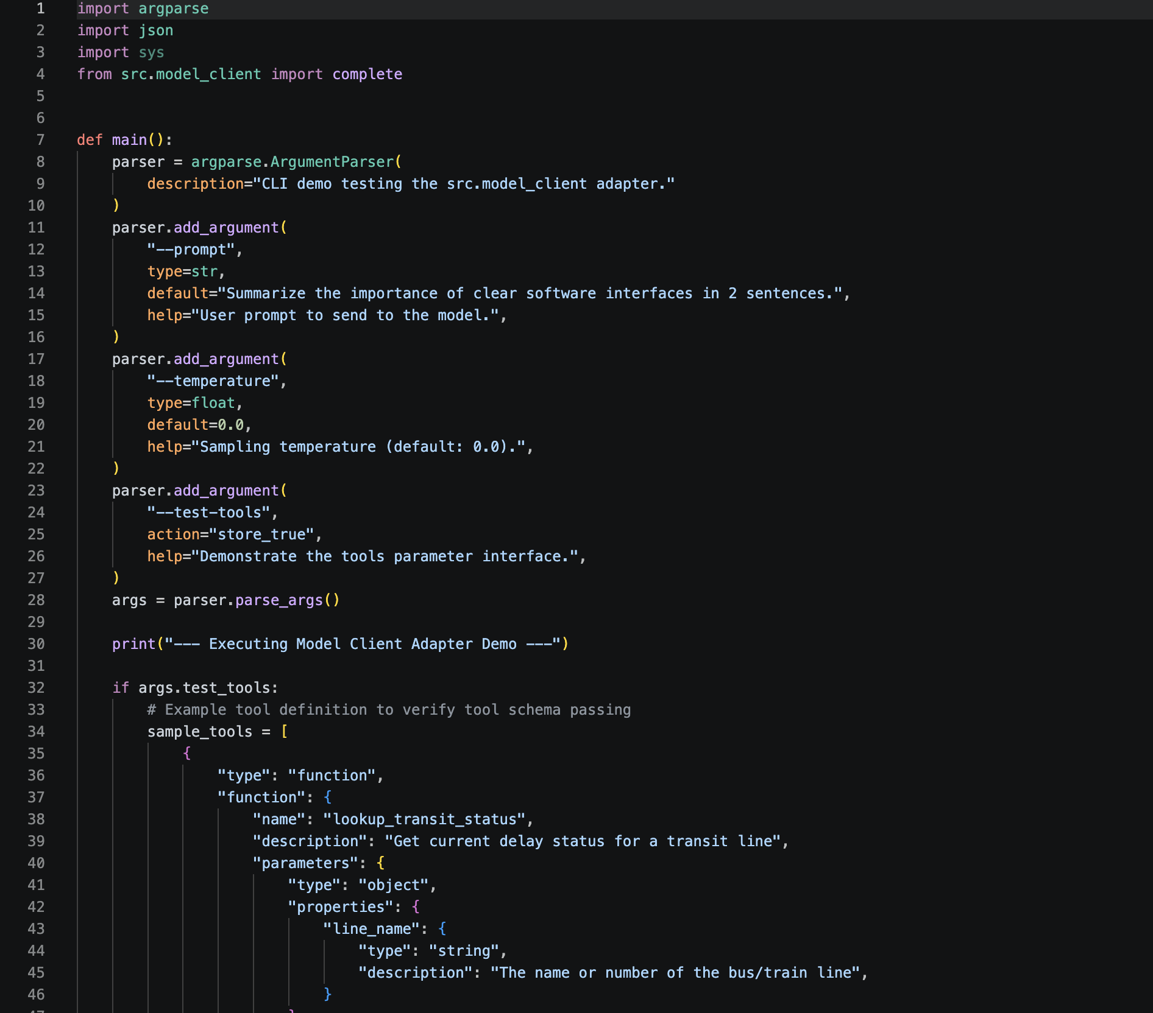
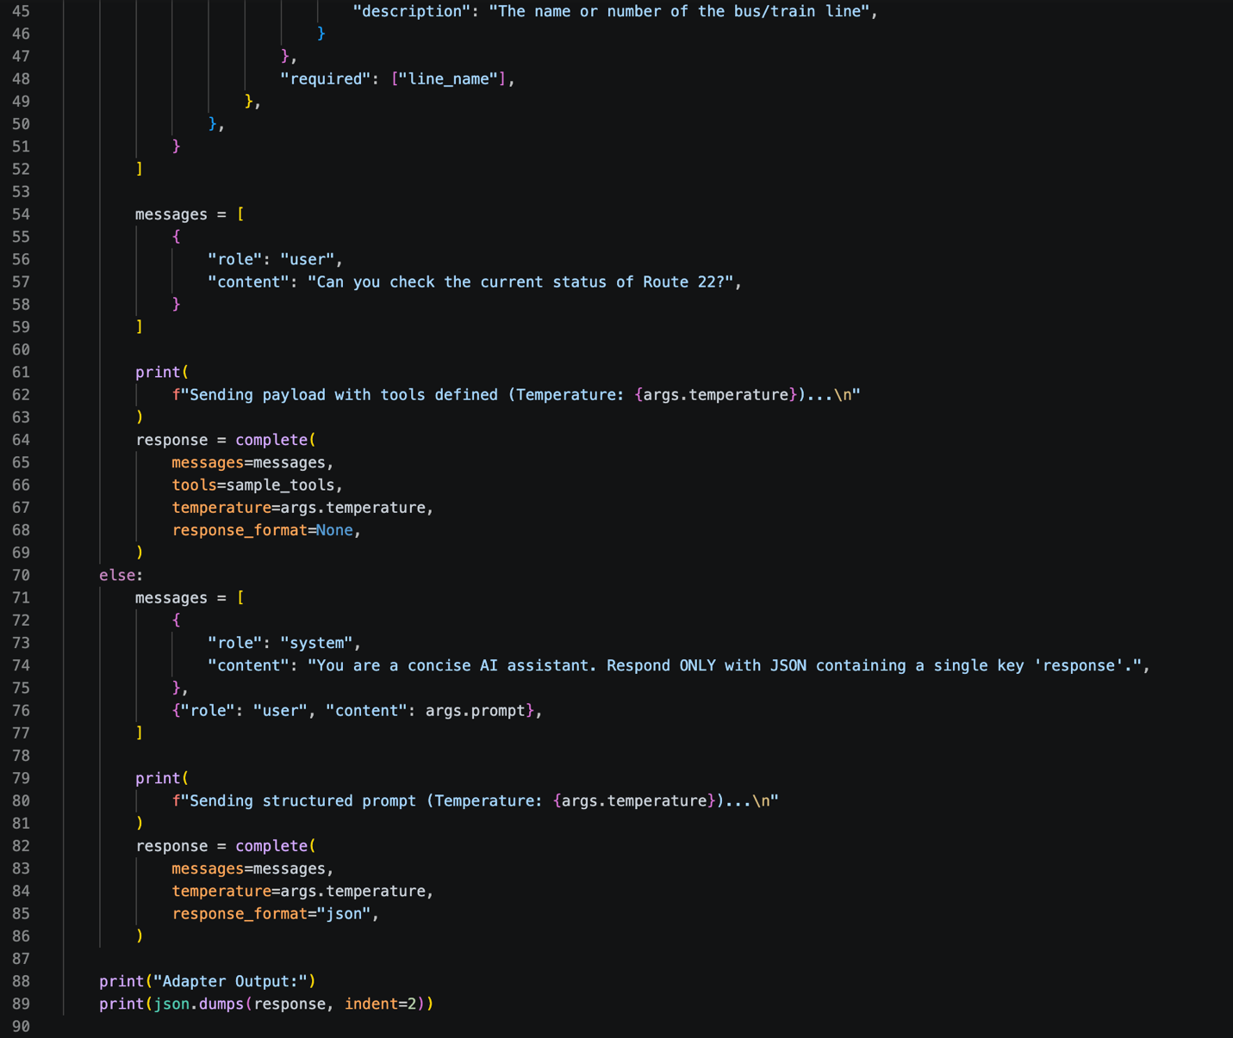
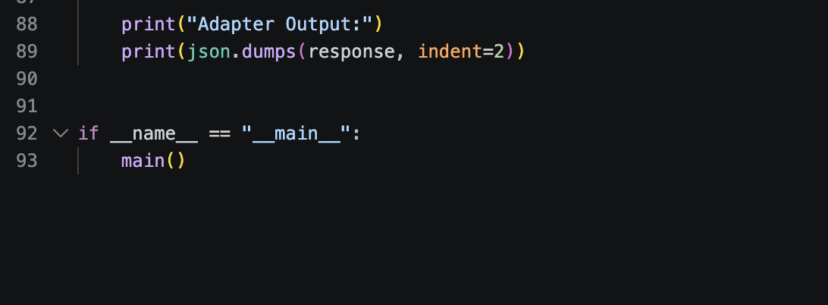
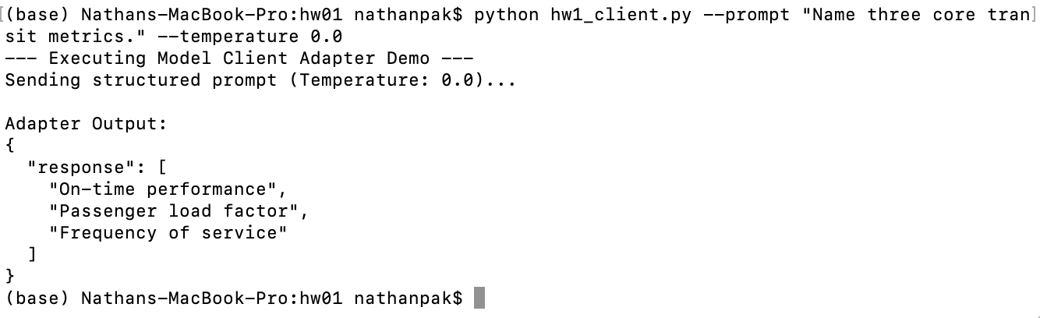

3. Create AGENT.md asking for strict bullet-only code review, and verify the model actually follows it.
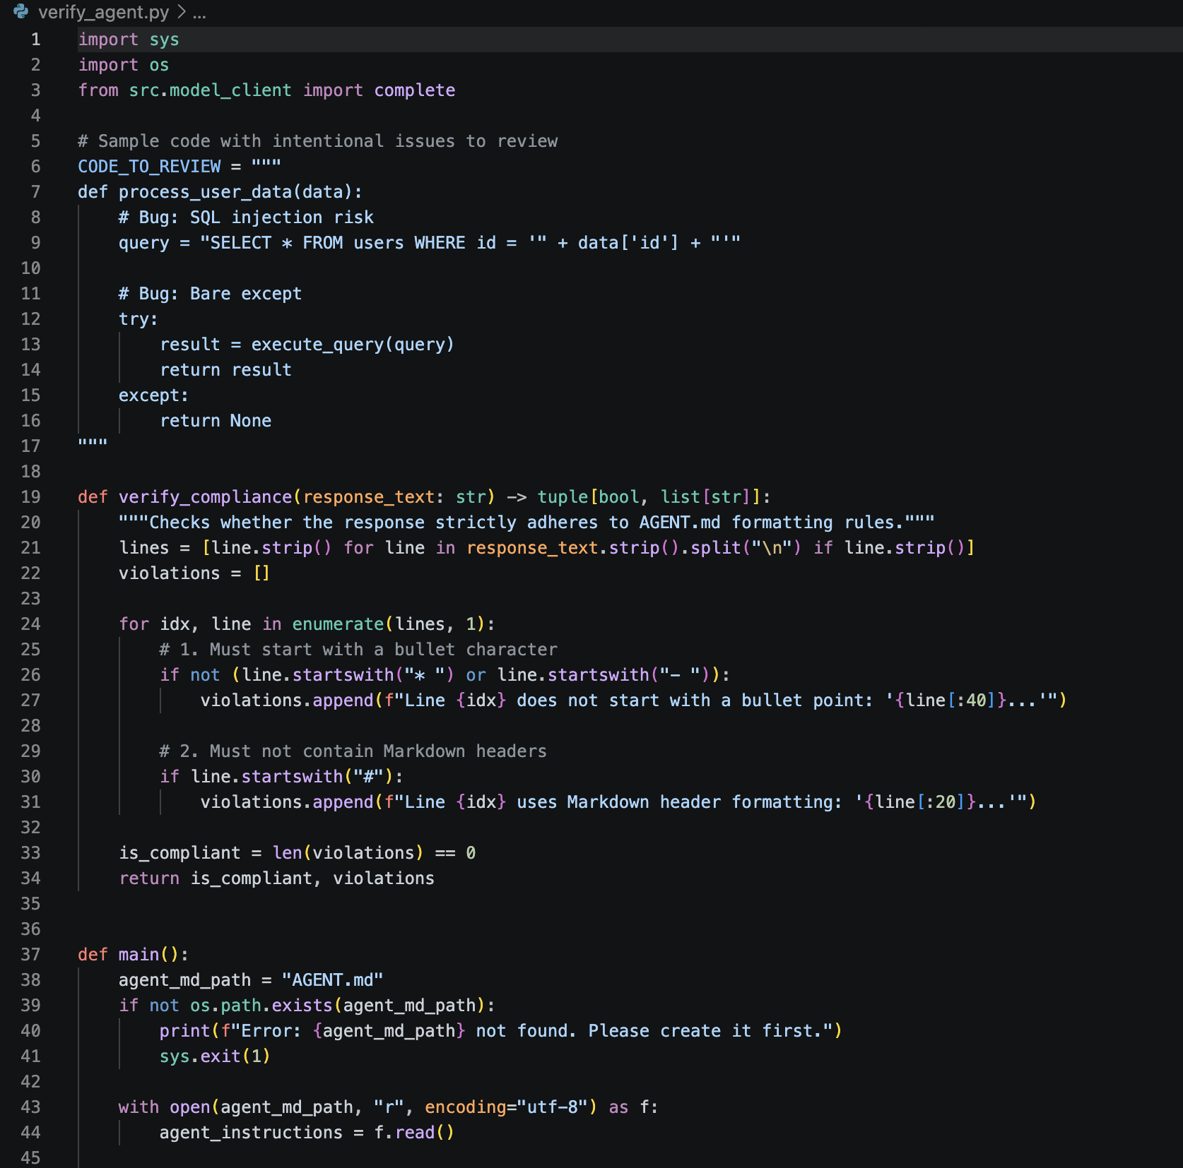
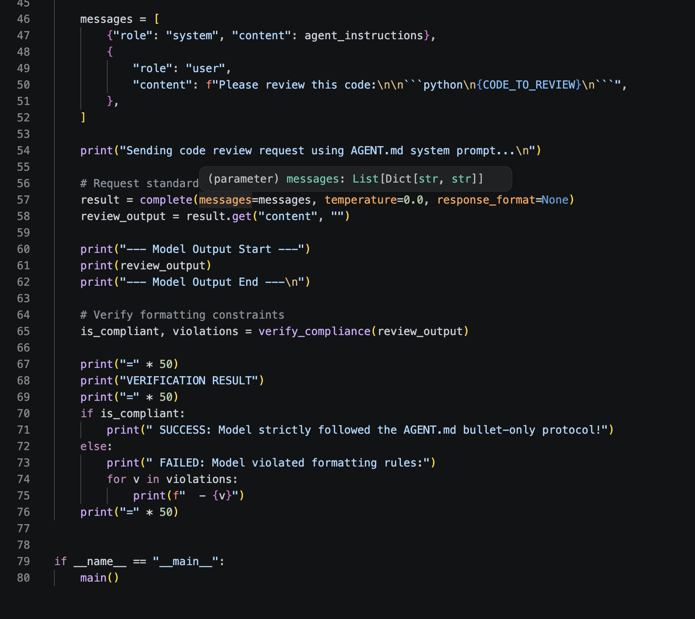

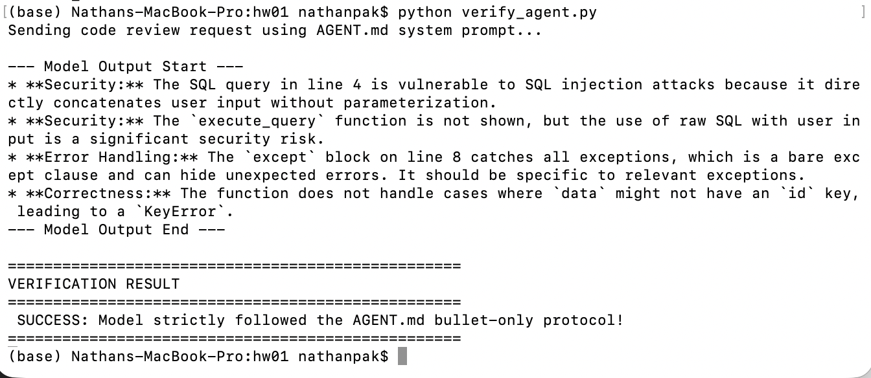
4) After every model response, print input tokens, output tokens, and total tokens for that turn. On exit, print cumulative input tokens, output tokens, and turn count.
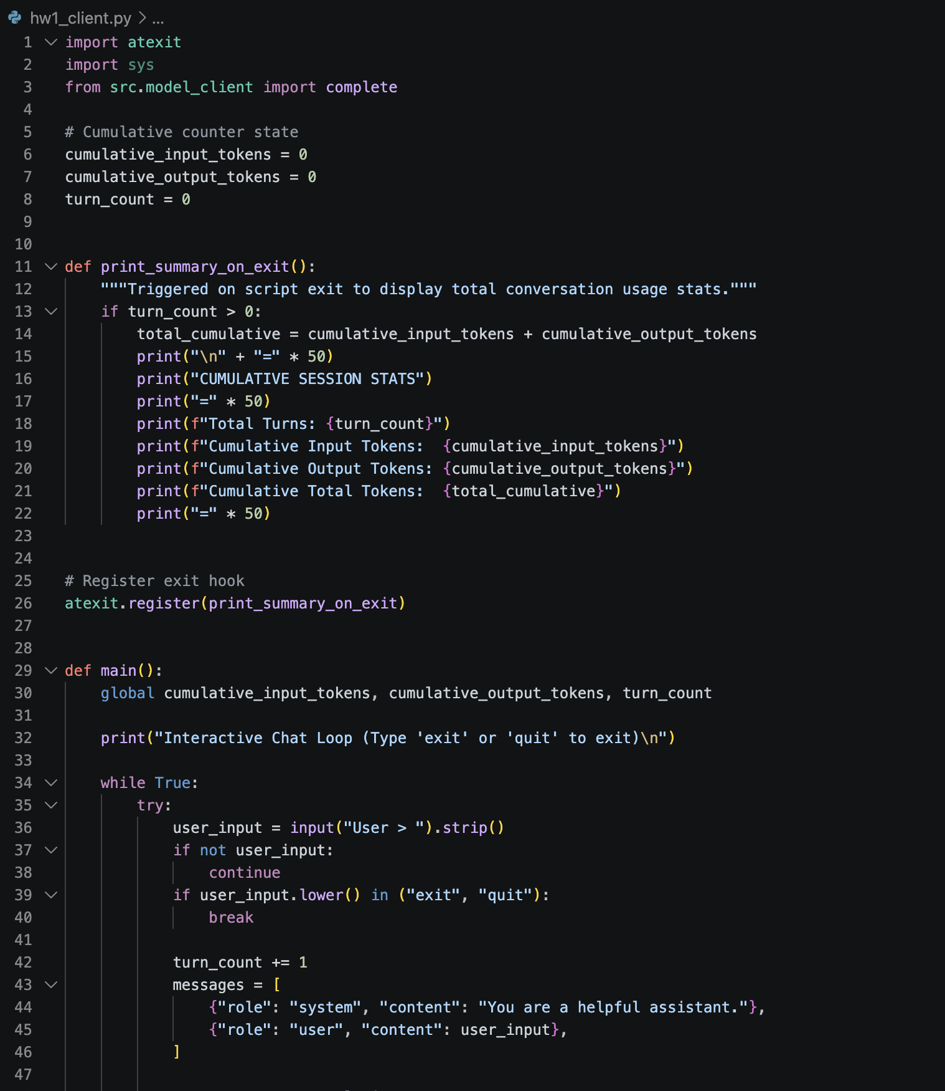
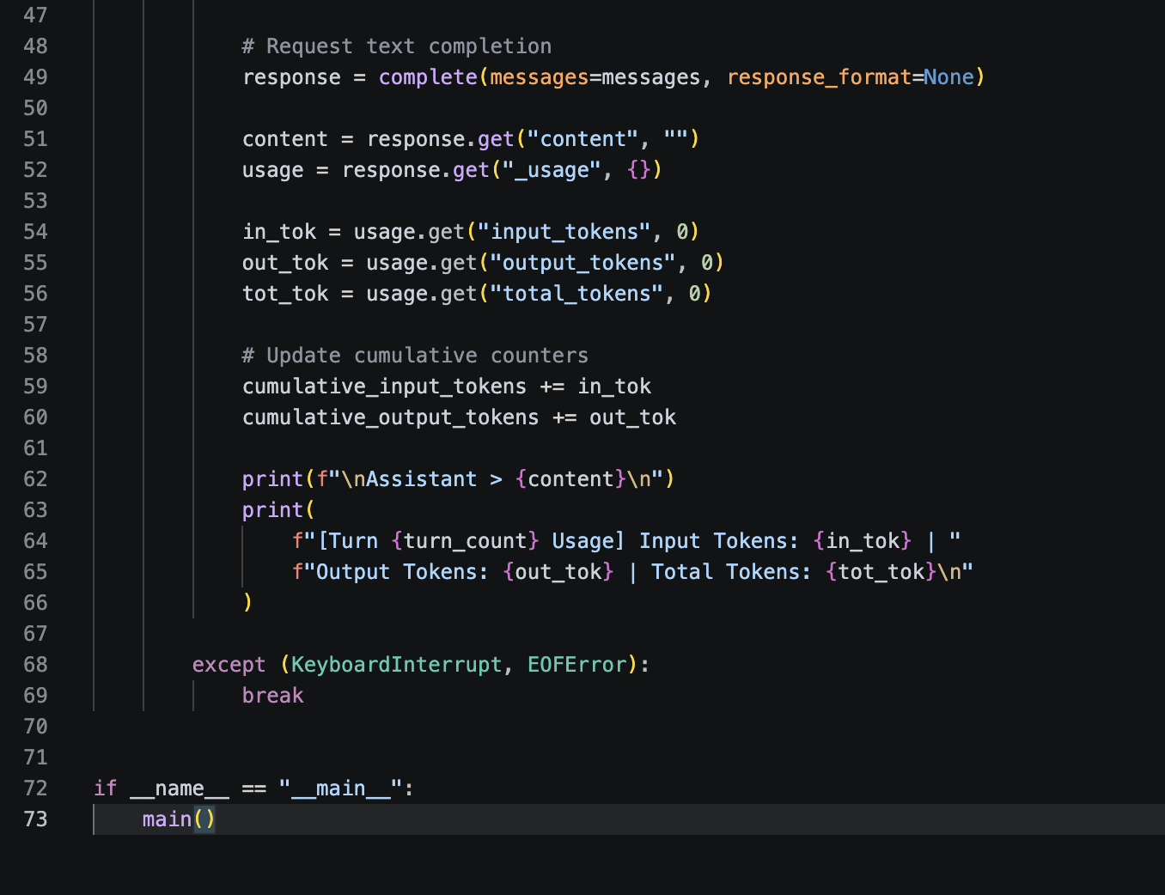
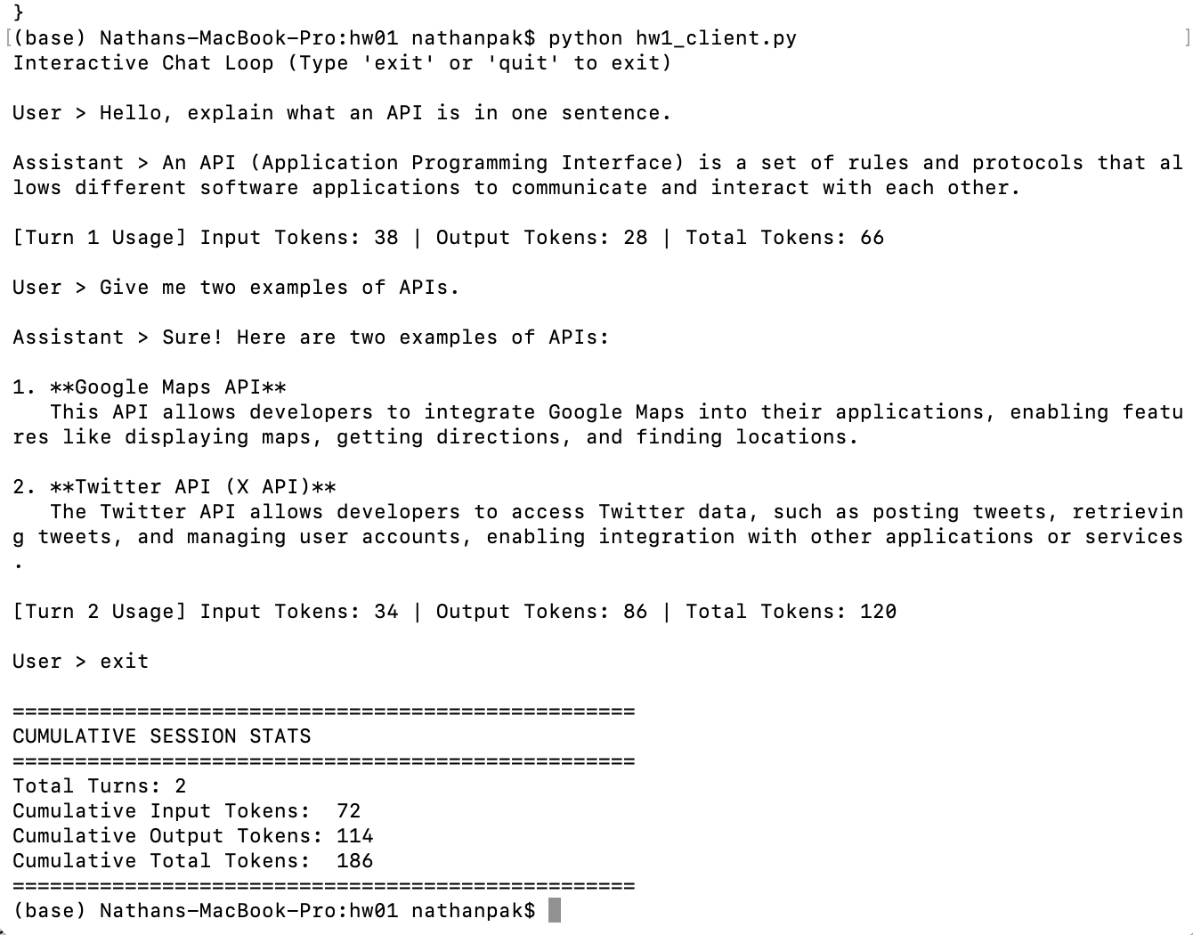
5 & 6) Add a /stats command showing turn count, cumulative token counts, and serialized conversation-history length, without altering the history. Run a five-turn conversation; record /stats output after turn 3 and after turn 5. 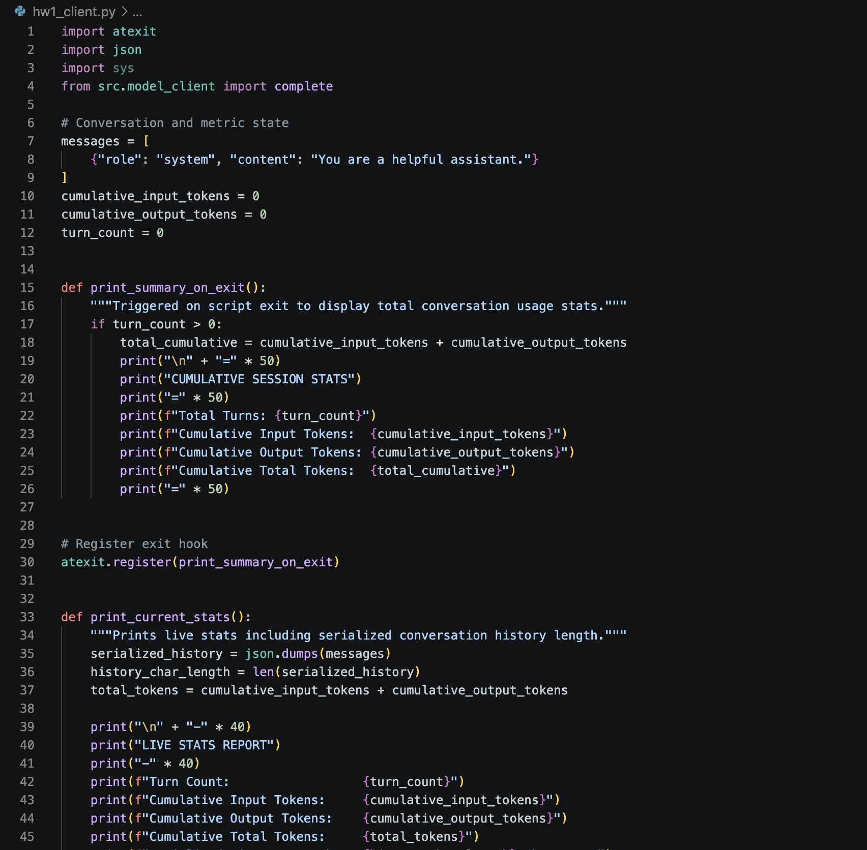
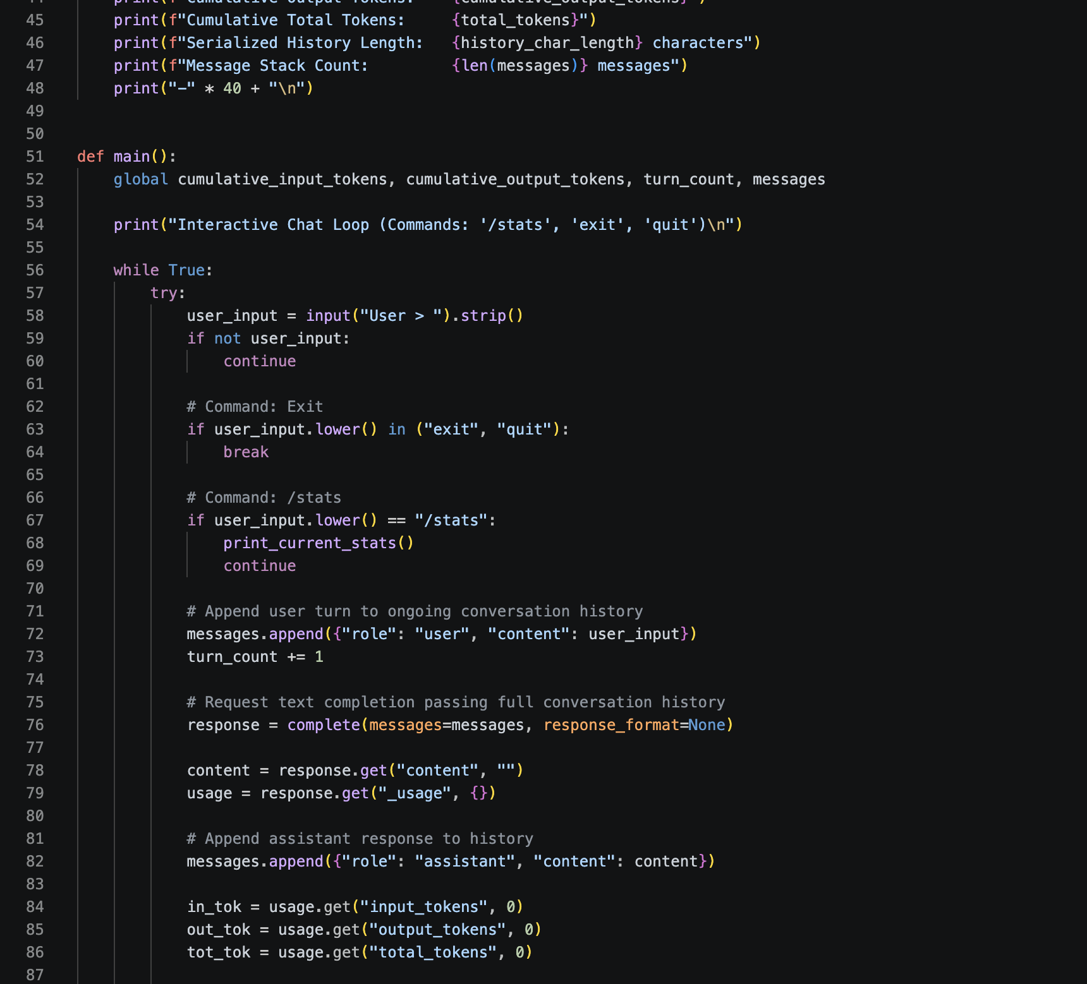
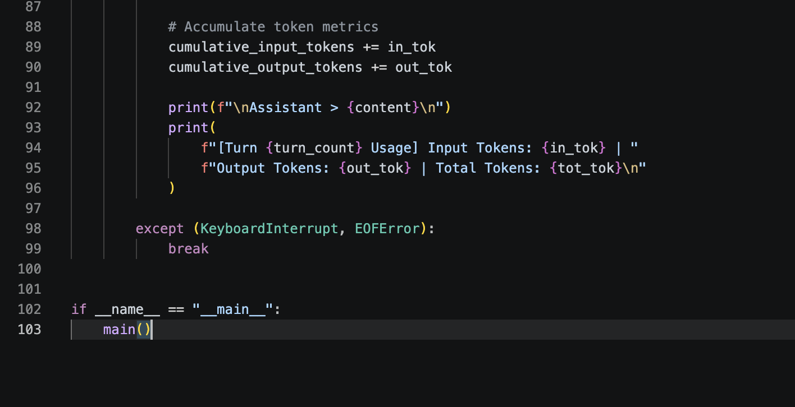

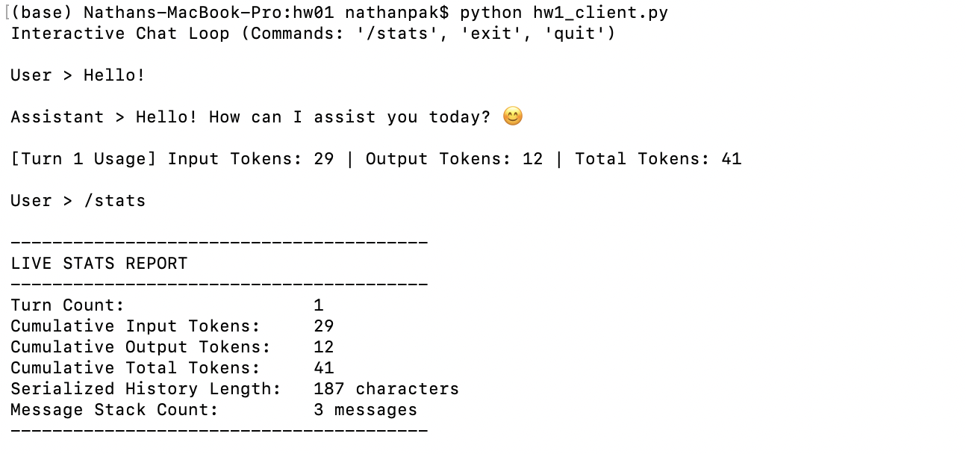
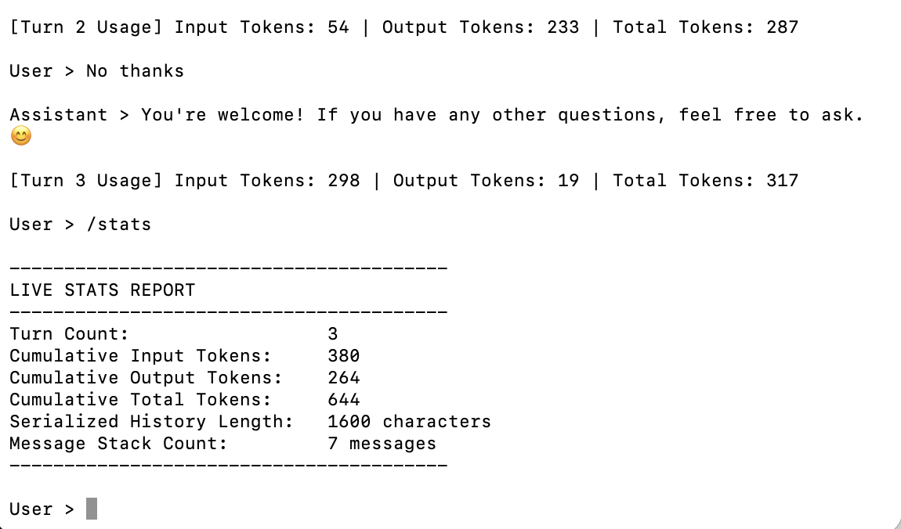
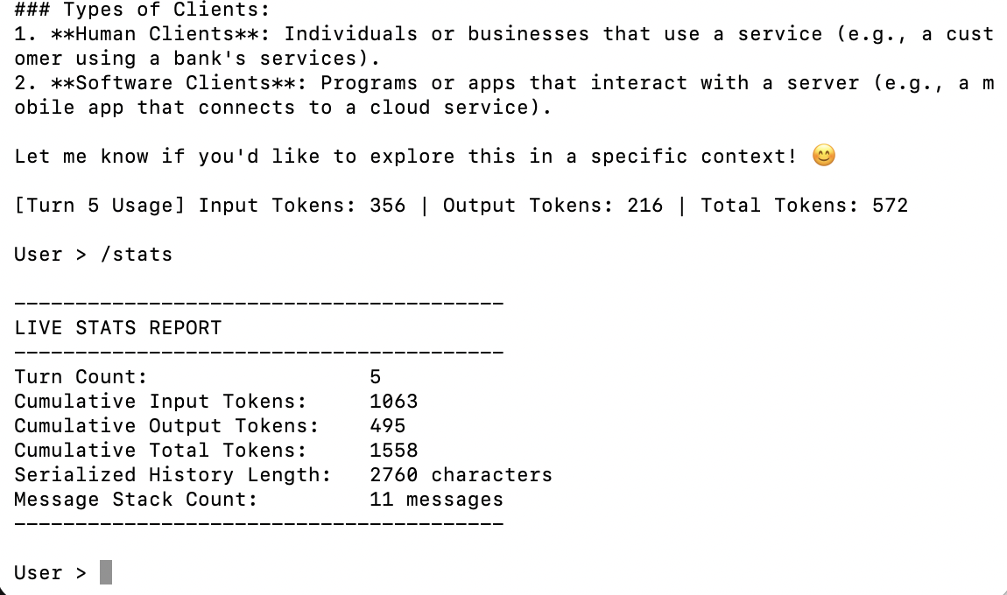

7) Why is prior conversation context resent with every turn? How is a system prompt different from a user message? Why do input tokens grow over a conversation? What eventually limits that growth?
LLMs are stateless APIs. They do not maintain an internal persistent memory between distinct HTTP requests. The model would have zero awareness if there was no memory context in each turn of conversation.
The system prompt defines global guidelines, rules, persona, and output constraints. User messages represent dynamic inputs, questions, or commands evaluated within those system-defined rules.
Input Tokens grow because each turn appends both user’s new message and the past conversational history stack.
Even though input tokens grow, there are things that can limit that growth: Model Context Window, which are hard token limits set by the architecture, Hardware VRAM limits, which are memory constraints on underlying GPUs, and Cost & Latency.

