SID4: 1066
PORT_BASE: 8166
PREFIX: s1066
SEED: 1066
VERIFY_SEED: 261066
DOMAIN_ID: 2
Hardware: Macintosh HD, Apple M4, 24 GB, Tahoe 26.6.2
Local Model Used: Ollama qwen3:8b
Tagged Commit Hash:
https://github.com/paknathan/data260-1066
- Routes
Home, Login, & Dashboard Page
Index.html
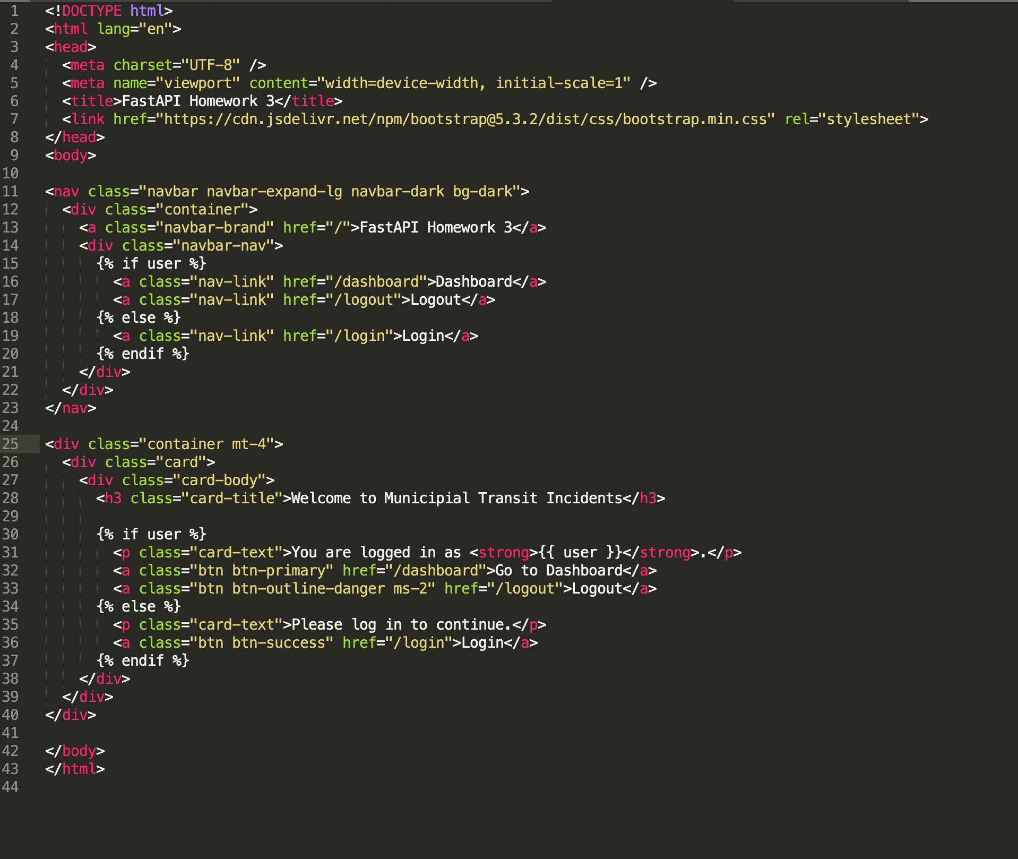
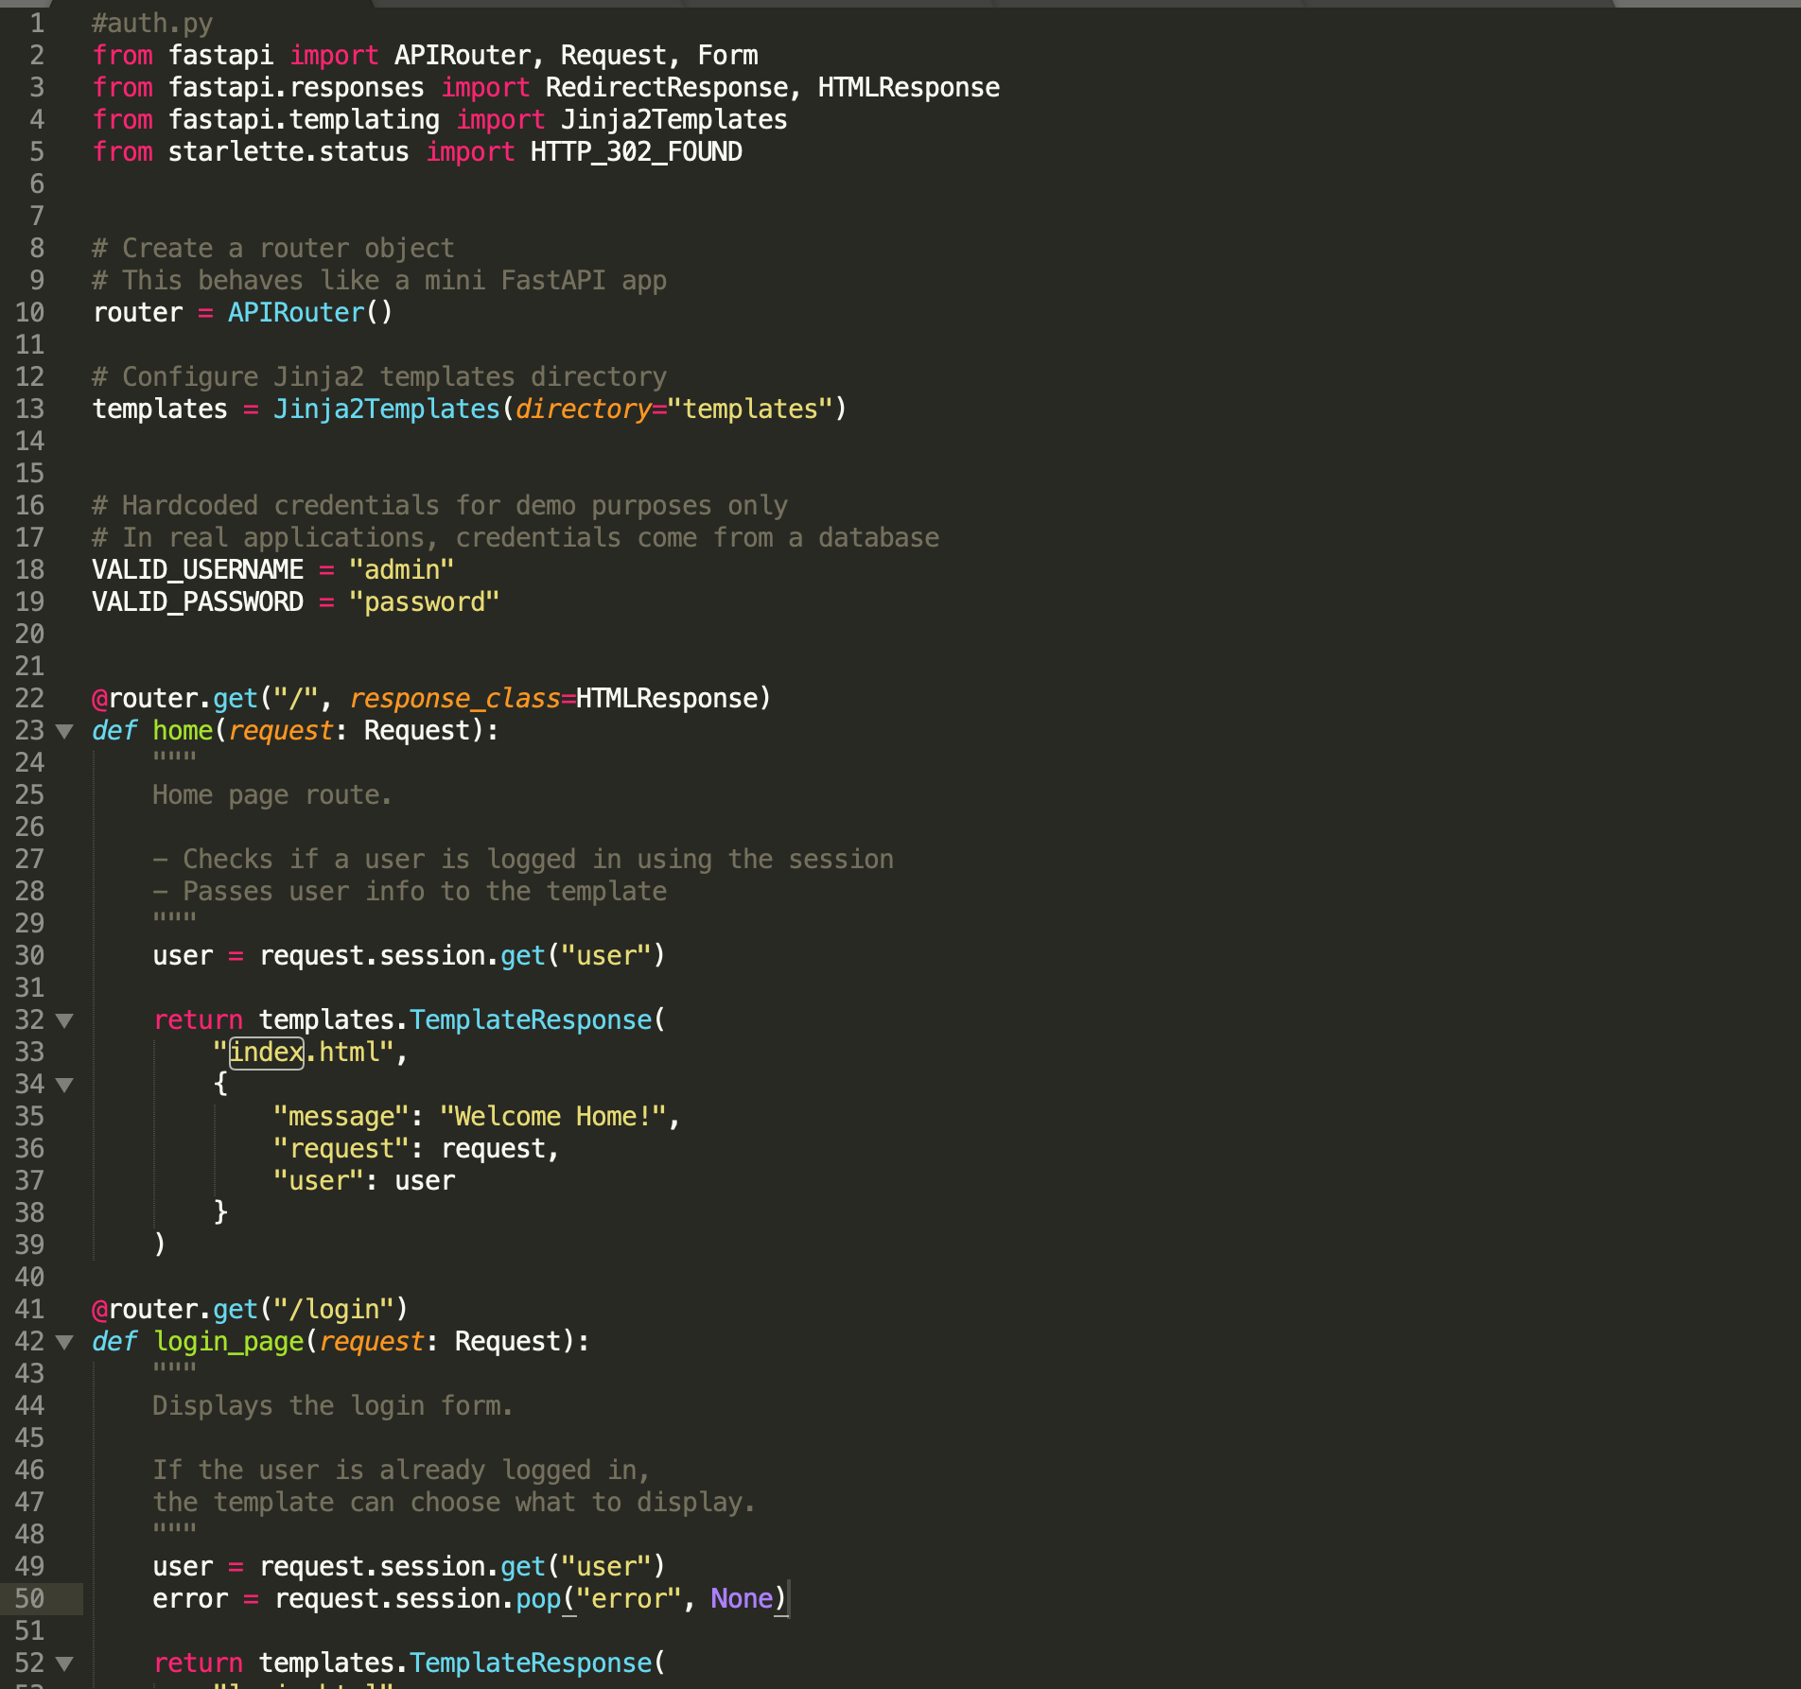
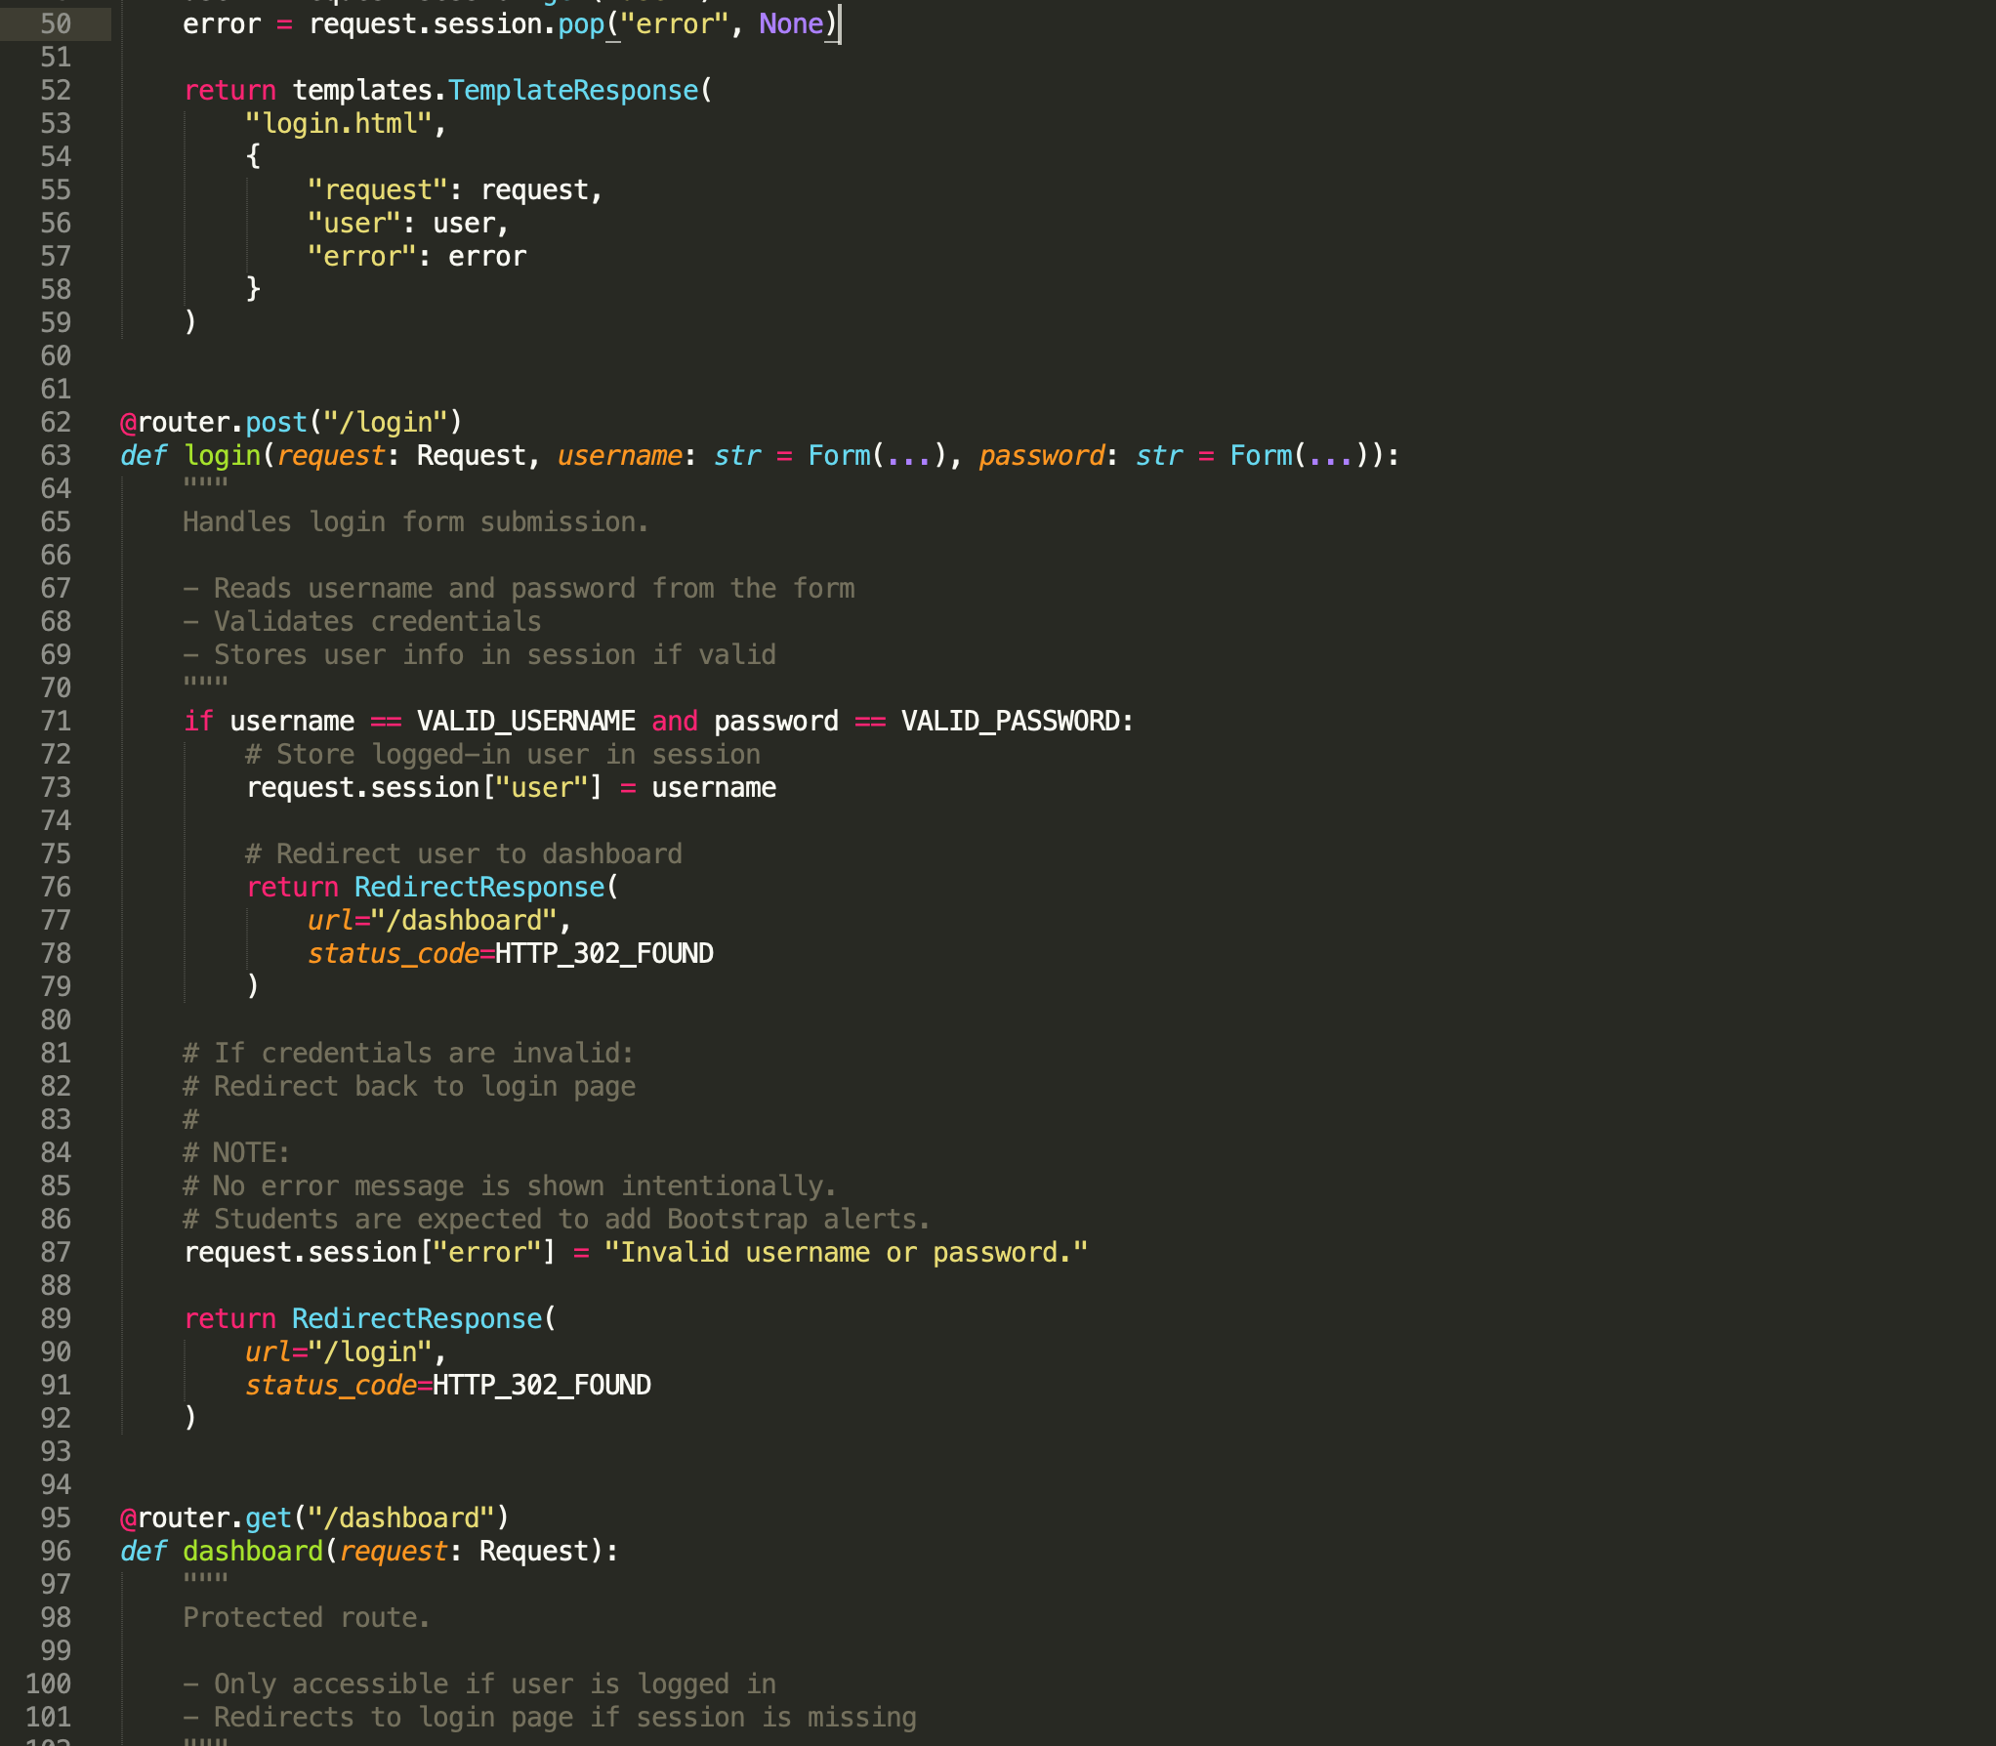
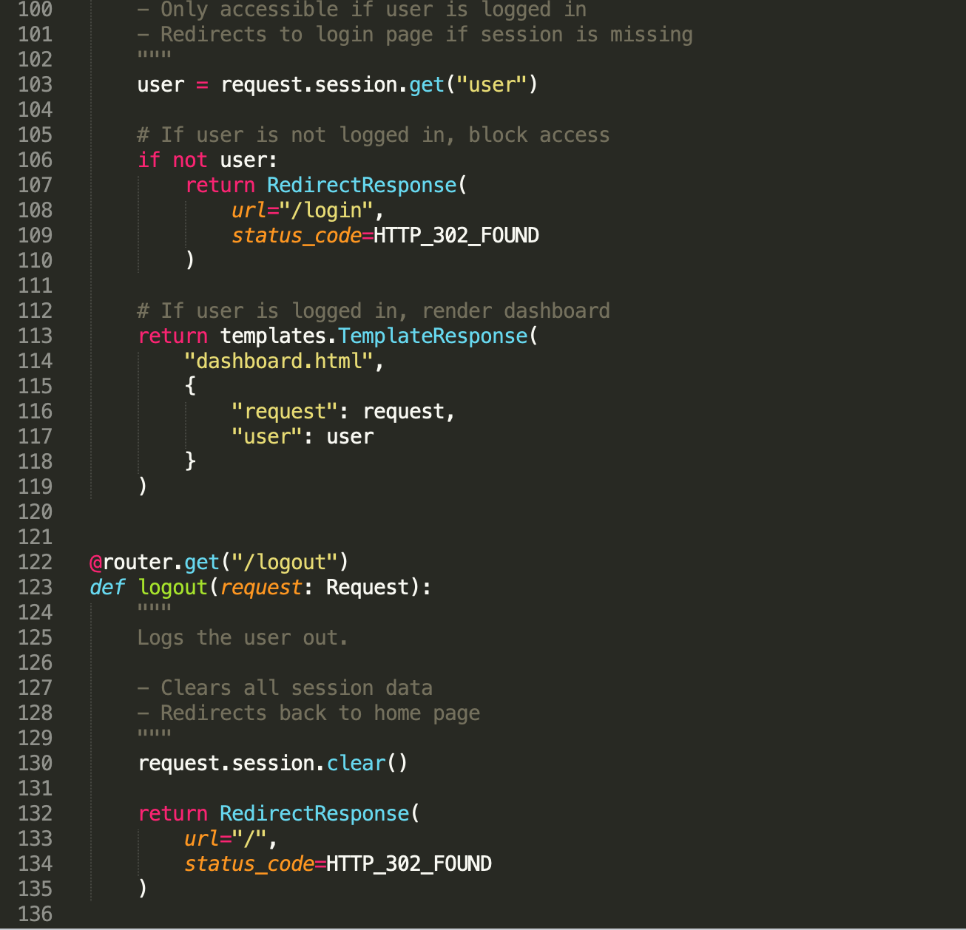
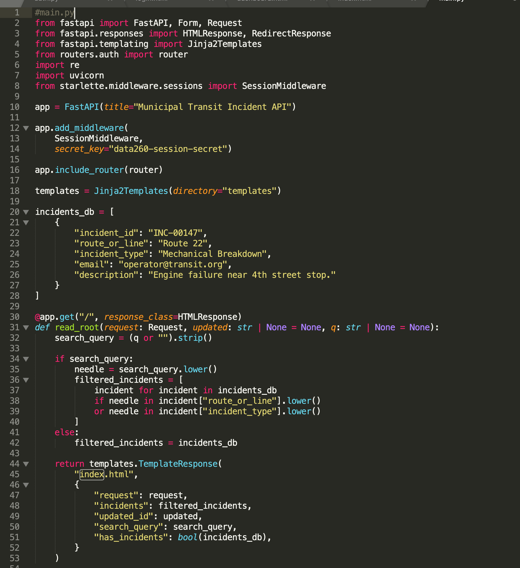
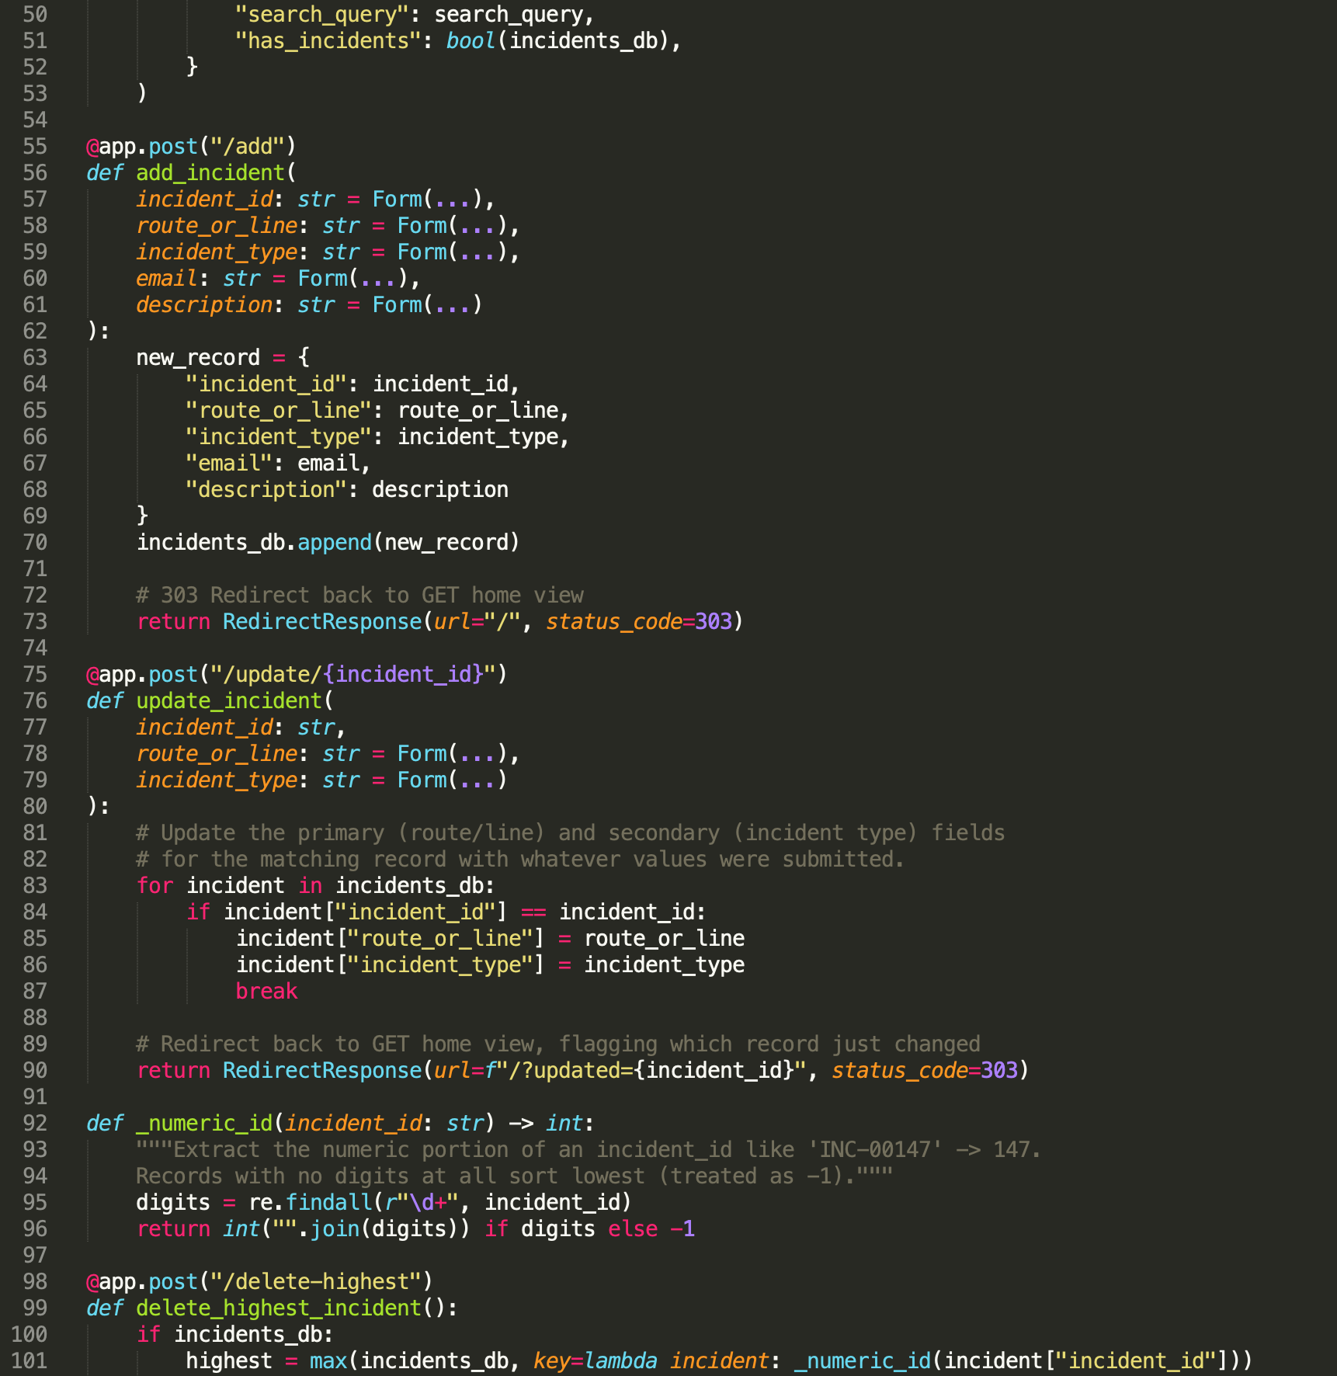
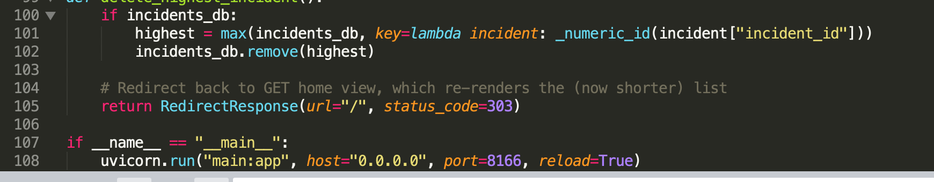

Home, Dashboard, Login, Logout Demo:
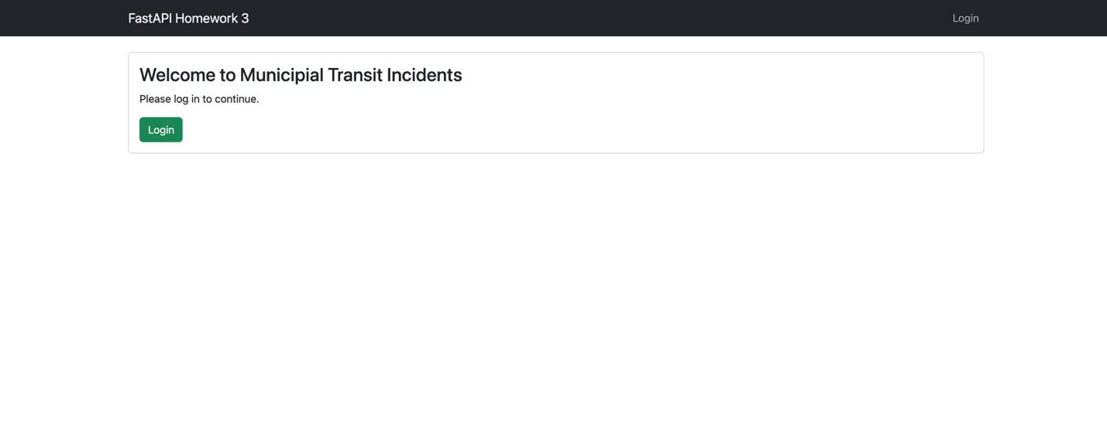
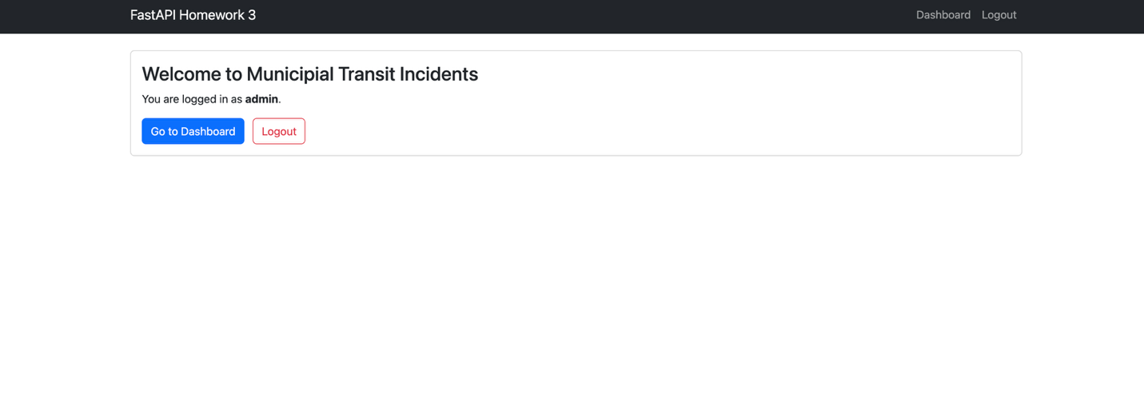
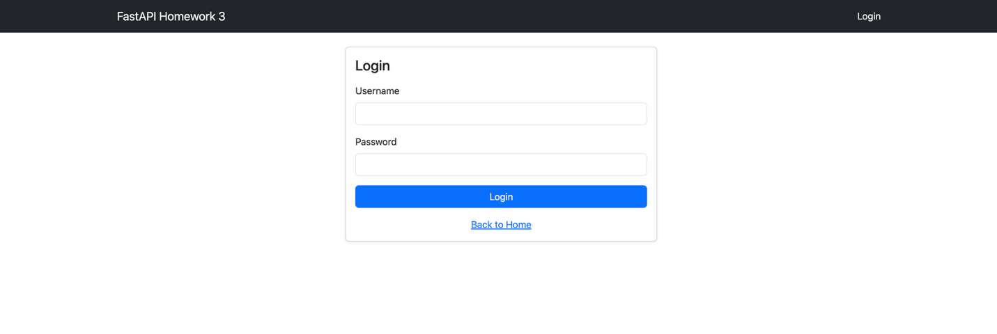
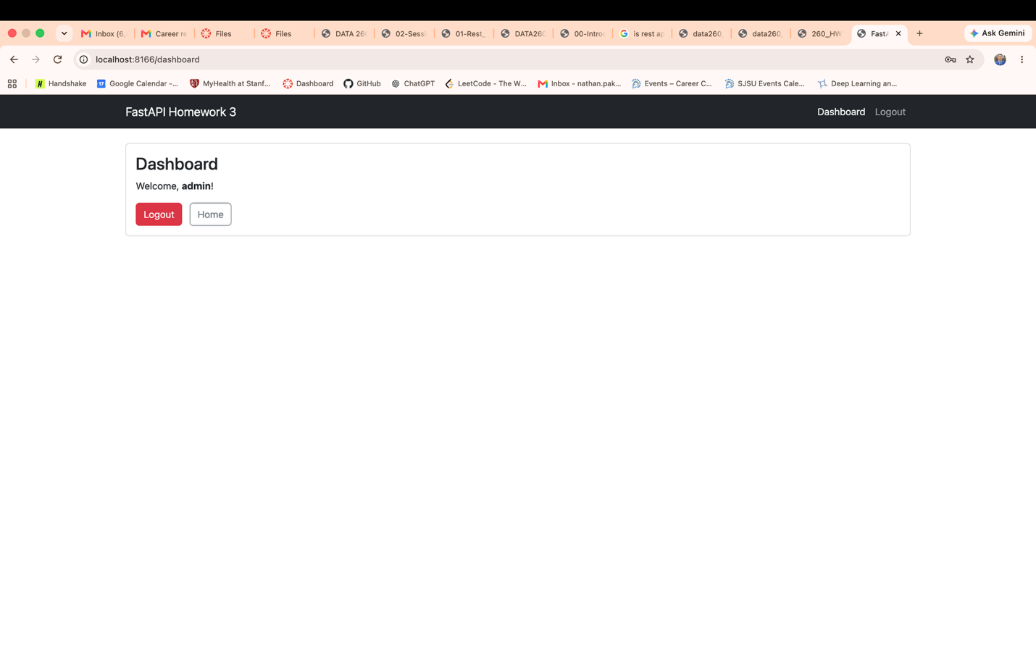
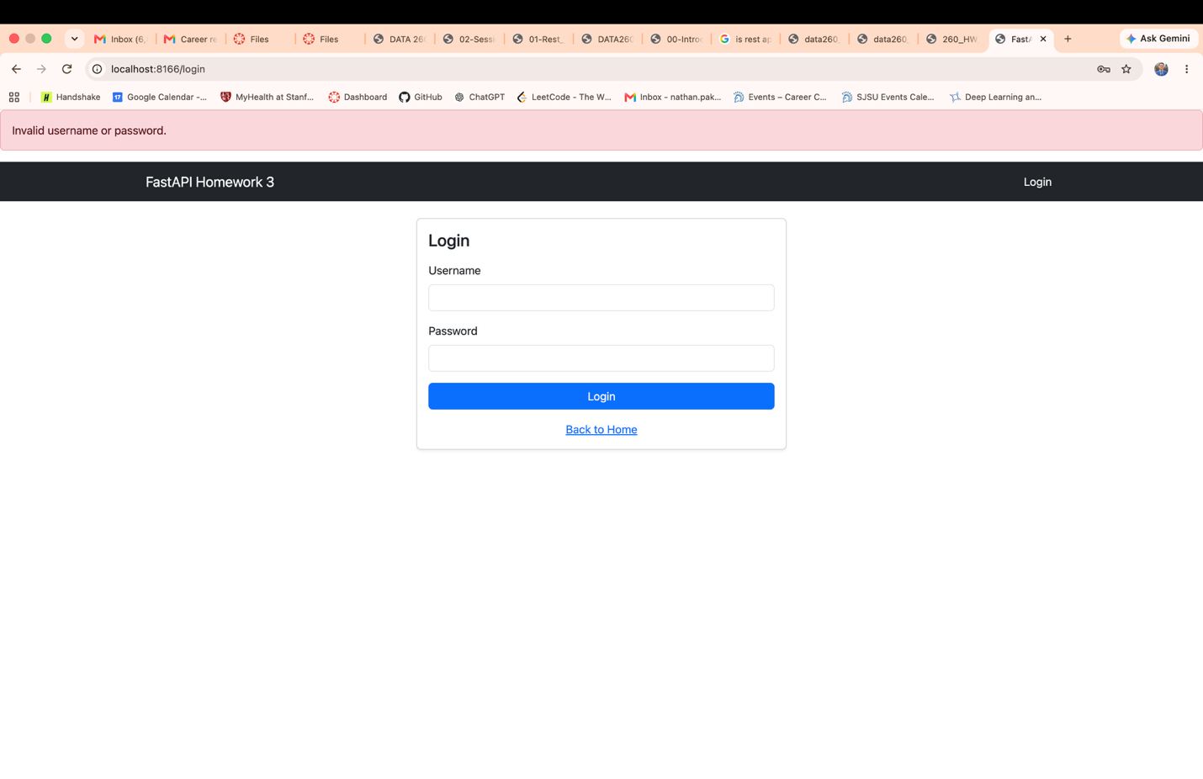

- Session Management
Session cookie is Secure
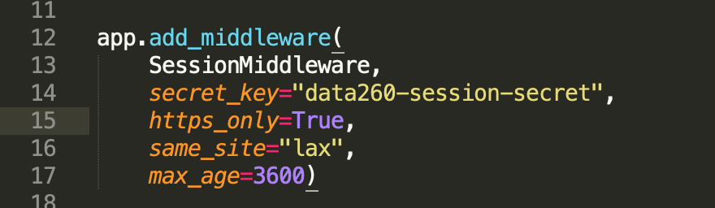
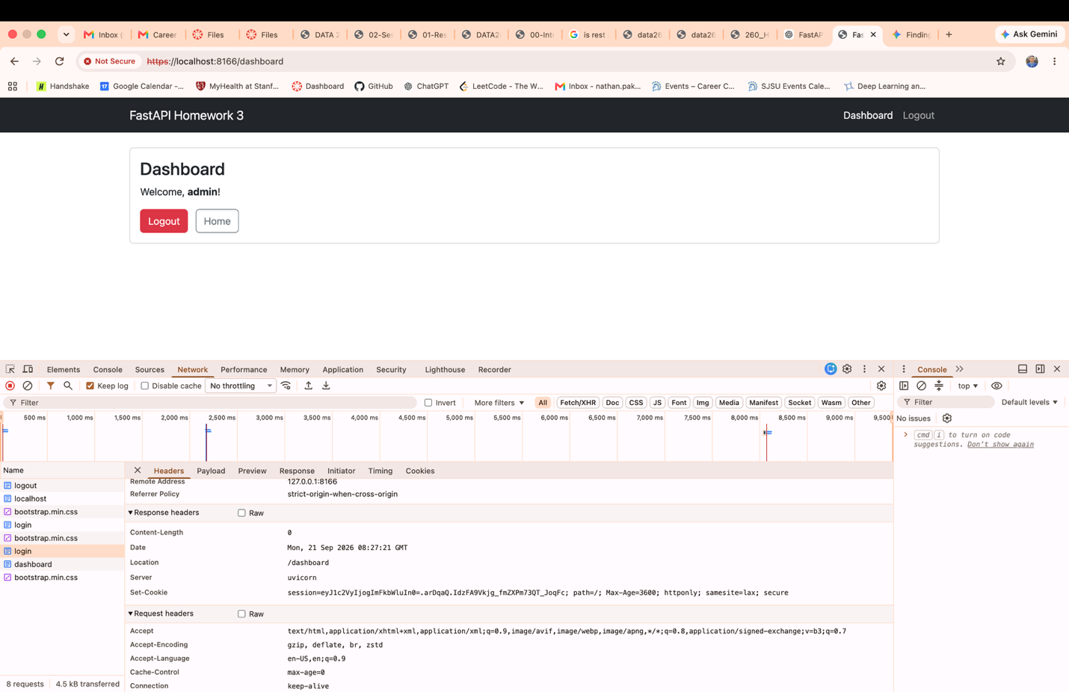

Idle Session Timeout: After waiting for more than 60 seconds in the dashboard page after logging in, I attempted to access /dashboard and it redirected me to the login page as shown below.
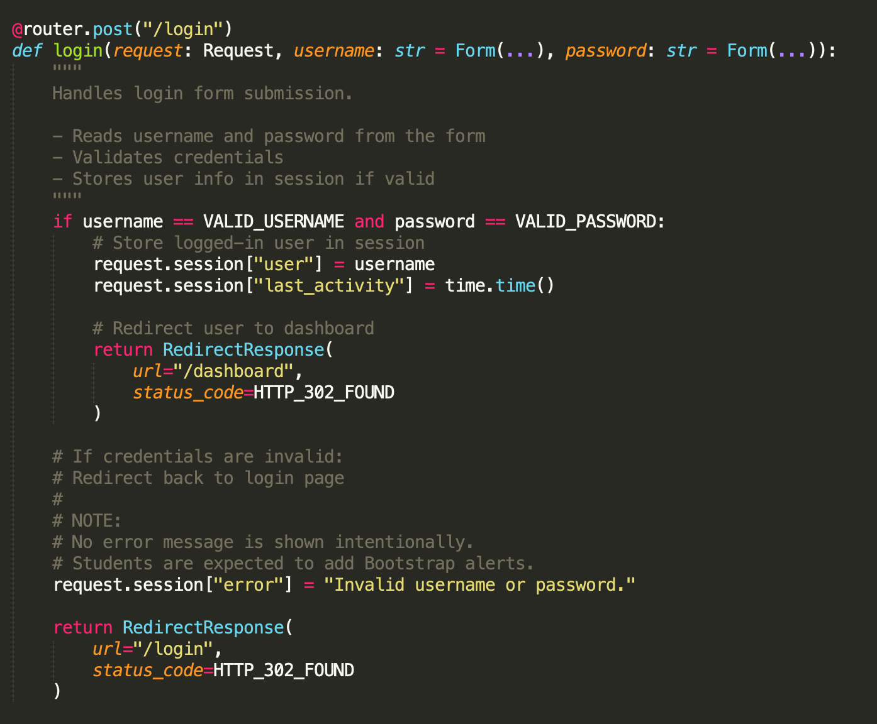
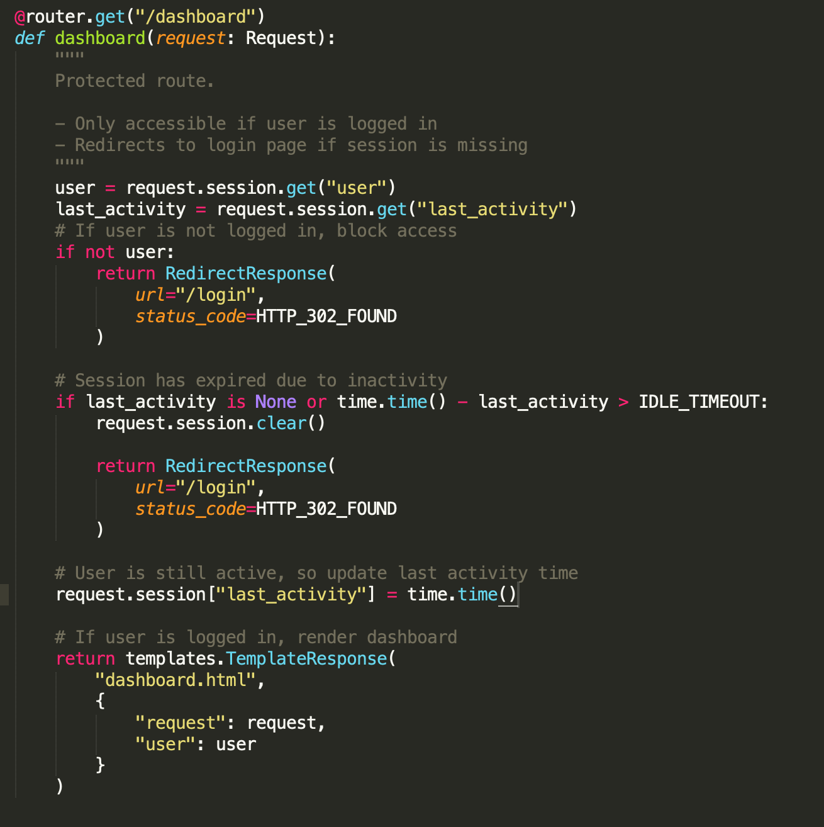
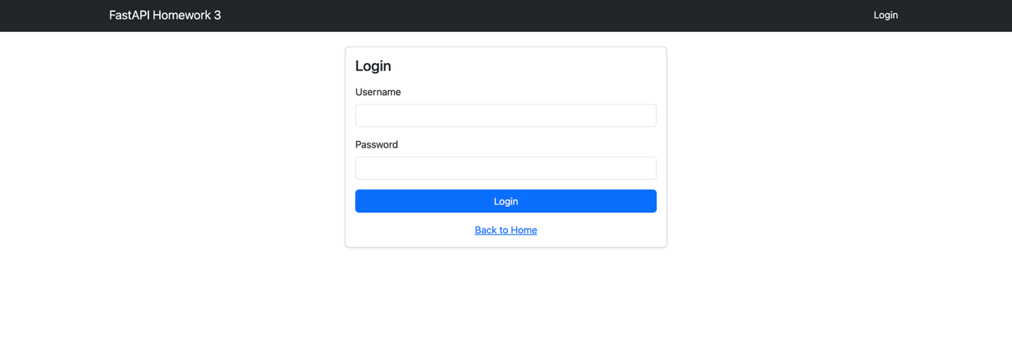
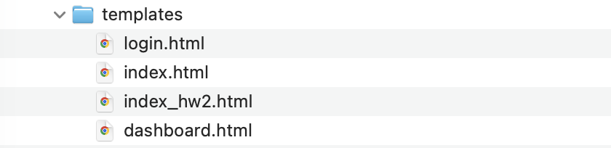
Part 2: Compare Three LlamaIndex chunking techniques

Chunking_comparison.py
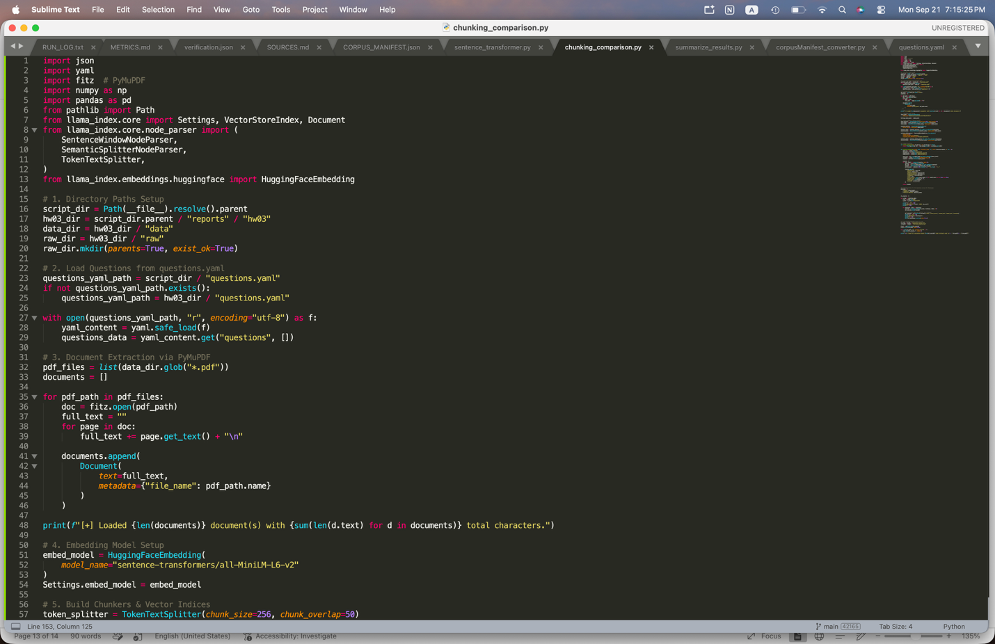
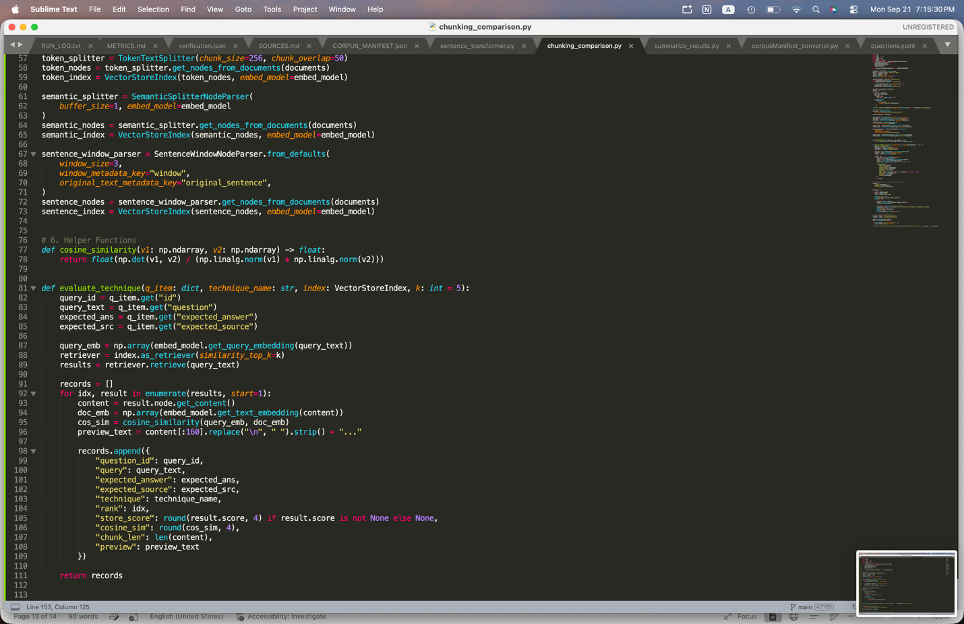
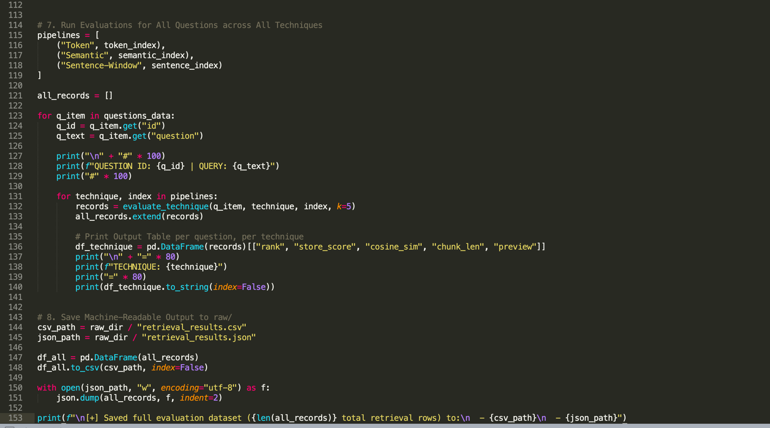

Summarize_results.py
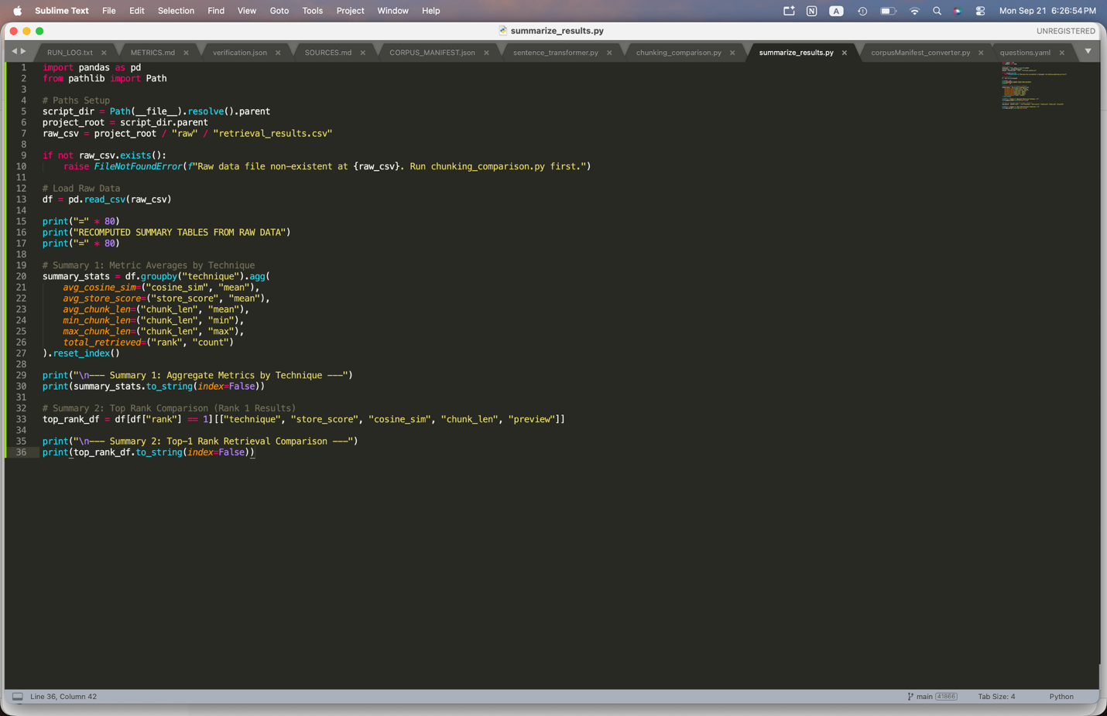
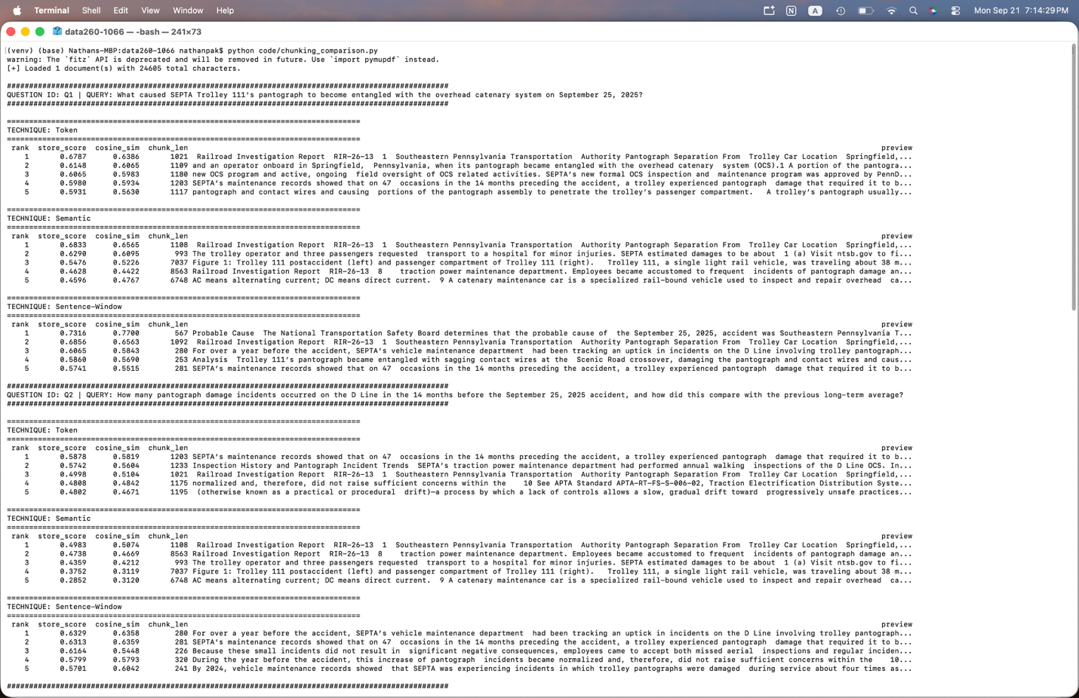
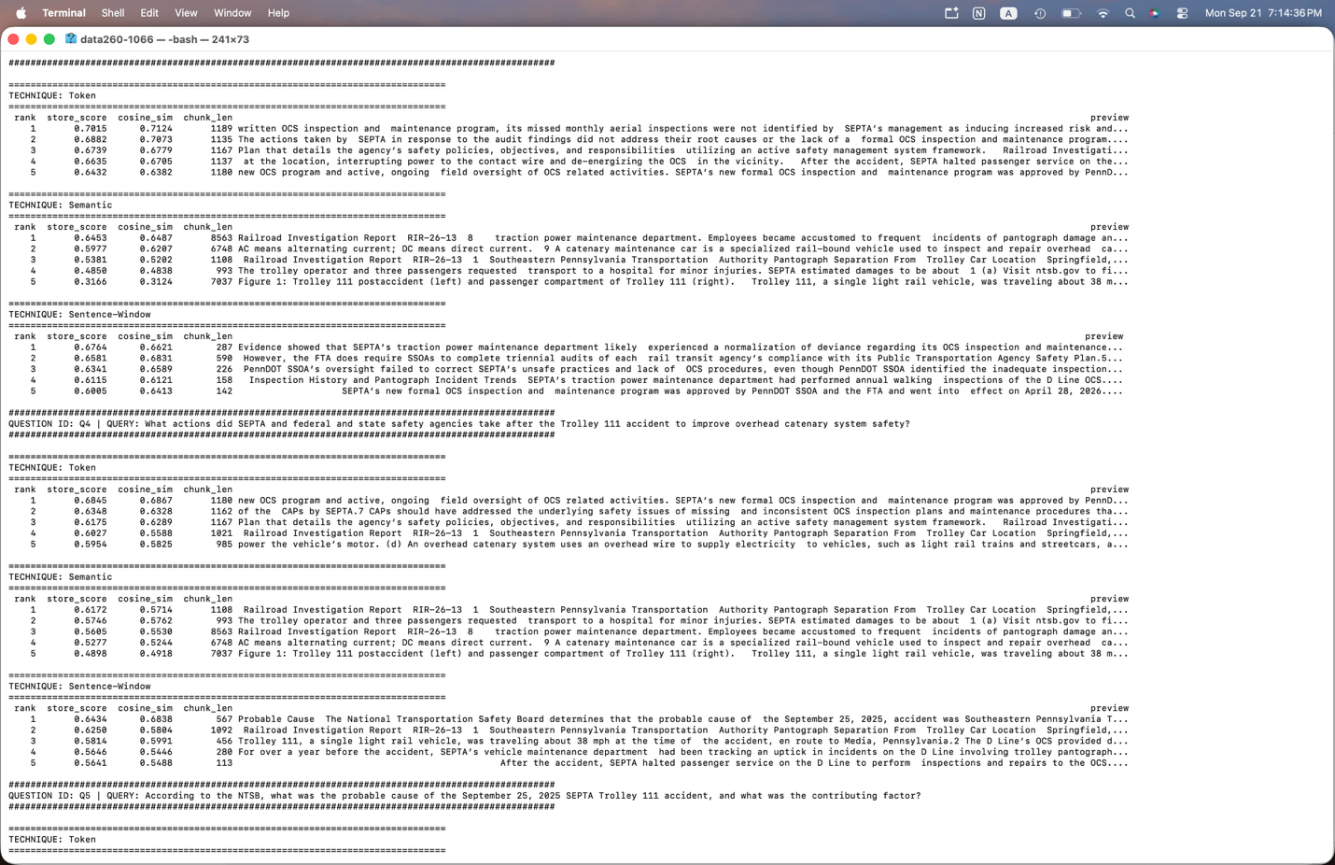
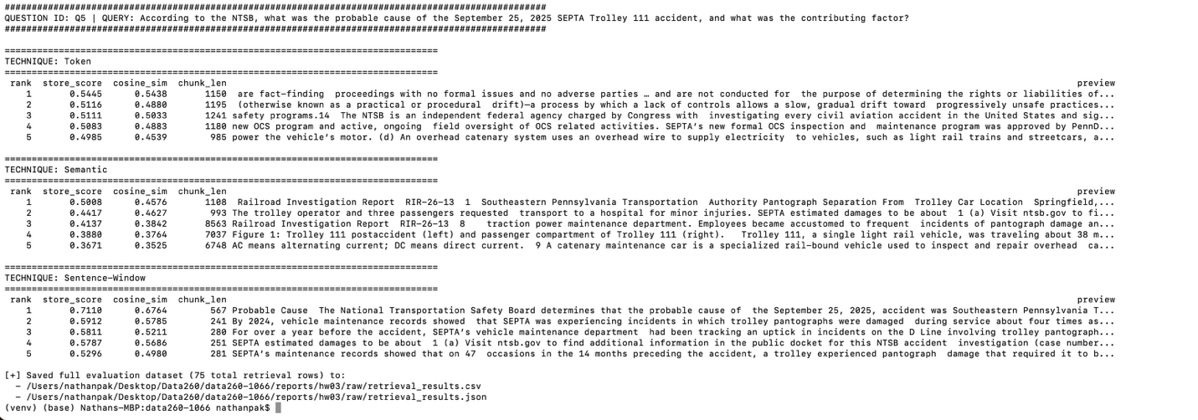

2. Observations
Sentence-window chunking performed best on this corpus because it optimizes vector representation while maintaining complete downstream context. By embedding single sentences (~205 characters on average), the vector model (all-MiniLM-L6-v2) evaluates dense, focused semantic units without vector dilution from surrounding sentences. During retrieval, attaching the adjacent context window (3 sentences) provides full explanatory background for answer generation without sacrificing vector precision. In contrast, Token chunking (~1,139 characters) frequently splits sentences arbitrarily across chunk boundaries, while Semantic chunking produced overly large blocks (~3,515 characters) that diluted core facts, resulting in the lowest Top-1 similarity (0.5683).

Across all evaluated queries, Sentence-window chunking consistently achieved the highest Top-1 cosine similarity (0.6856) and highest Mean@5 cosine similarity (0.6075). While Token chunking occasionally retrieved useful context, its rigid character boundaries introduced background noise and split crucial technical facts. Semantic chunking failed to isolate granular answers cleanly due to its coarse boundary thresholding on this structured incident report.

3. Conclusion
Sentence-window chunking is the superior technique for this domain corpus. Supported by our empirical measurements, it achieved the highest Top-1 cosine similarity (0.6856 vs. 0.6327 for Token and 0.5683 for Semantic) while maintaining 100% Recall@5 at a low average retrieval latency of 9.74 ms. By isolating single sentences for similarity search while attaching neighboring context windows for LLM synthesis, Sentence-window chunking prevents context truncation across chunk boundaries and maximizes retrieval precision.

