SID4: 1066
PORT_BASE: 8166
PREFIX: s1066
SEED: 1066
VERIFY_SEED: 261066
DOMAIN_ID: 2
Hardware: Macintosh HD, Apple M4, 24 GB, Tahoe 26.6.2
Local Model Used:
Tagged Commit Hash:

Part 1)
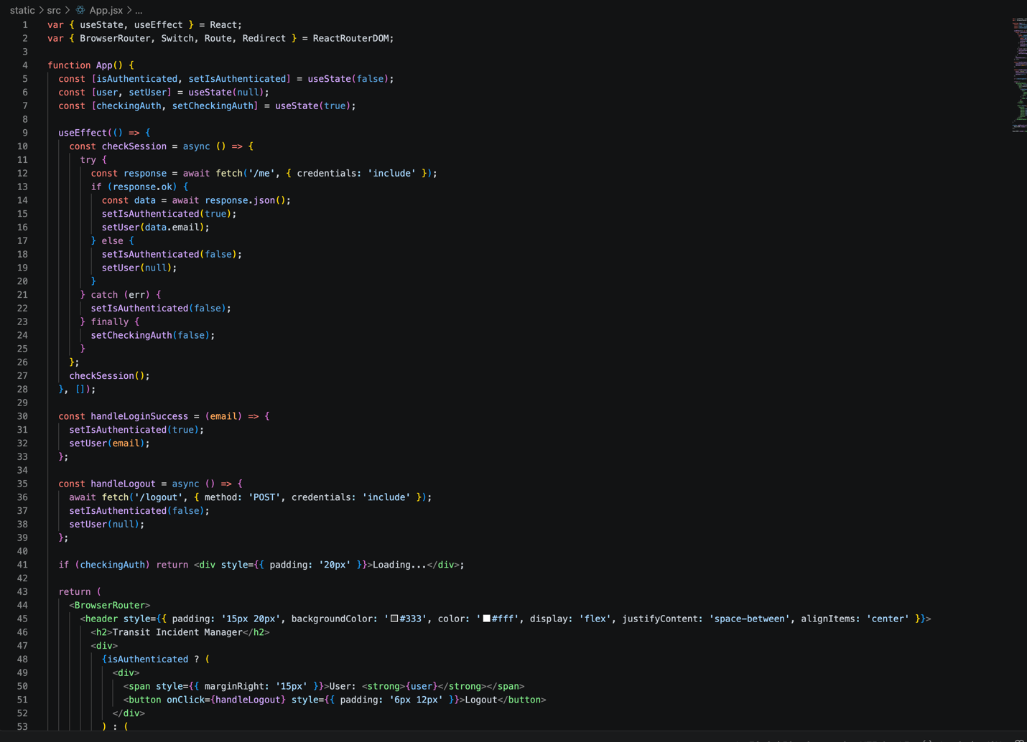
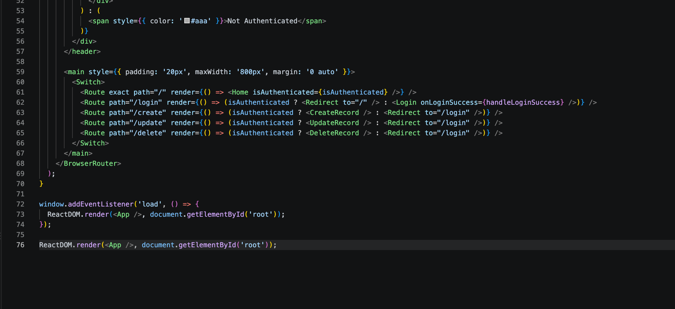
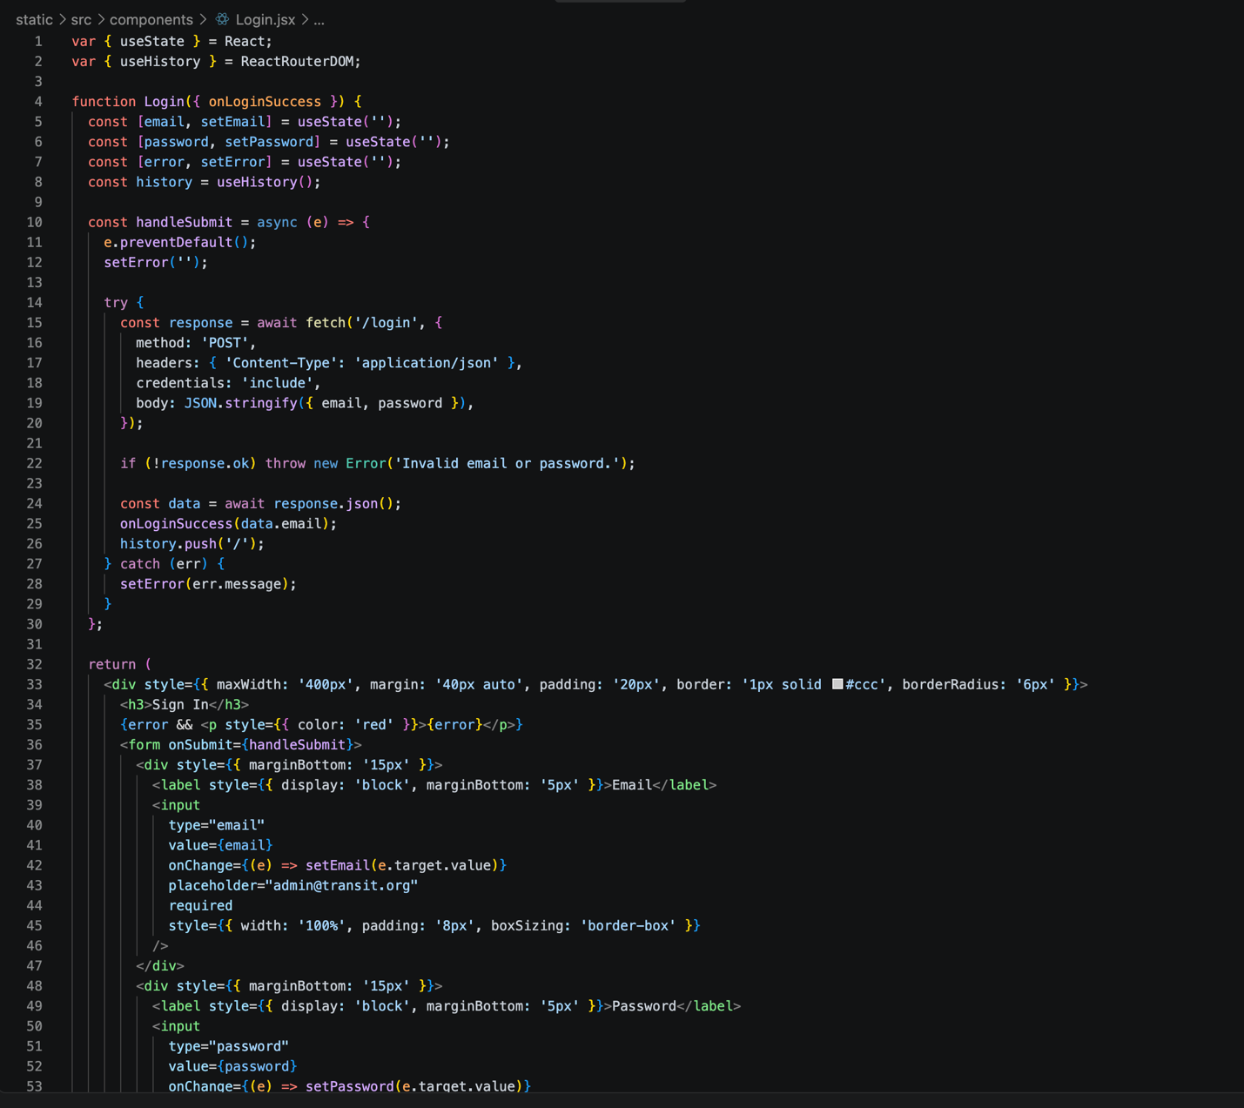
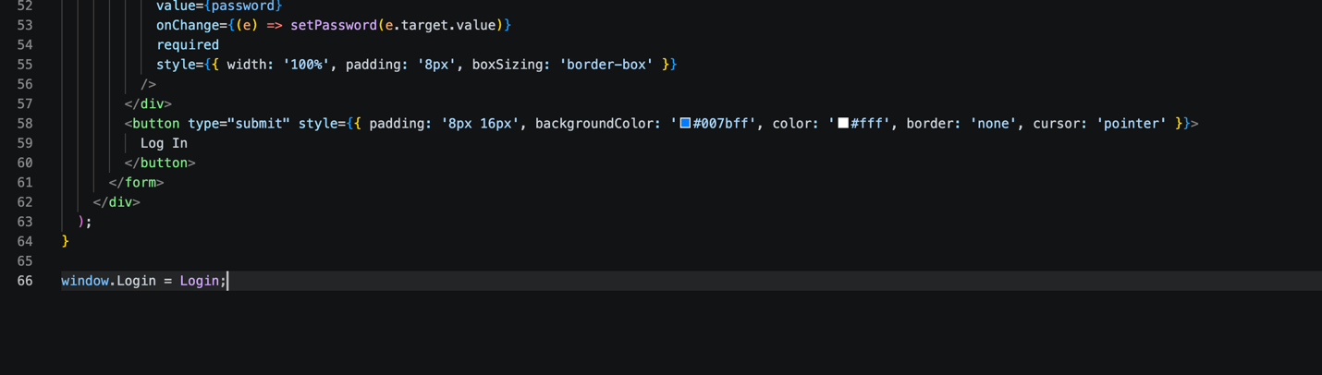

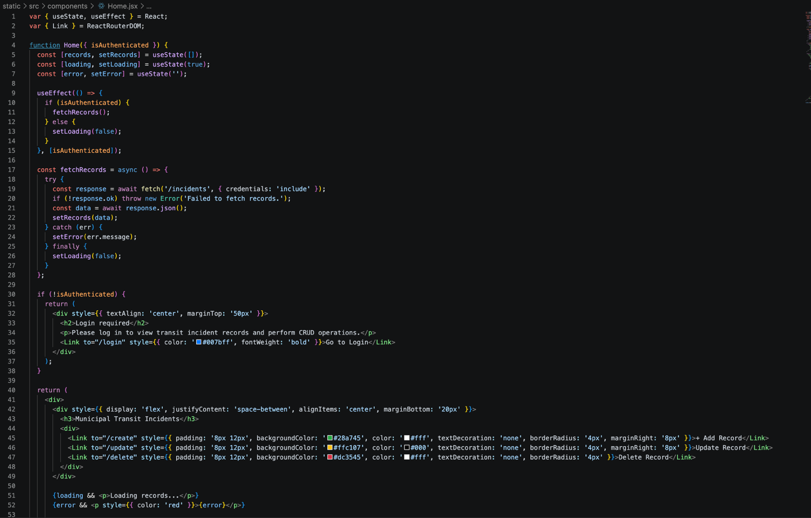
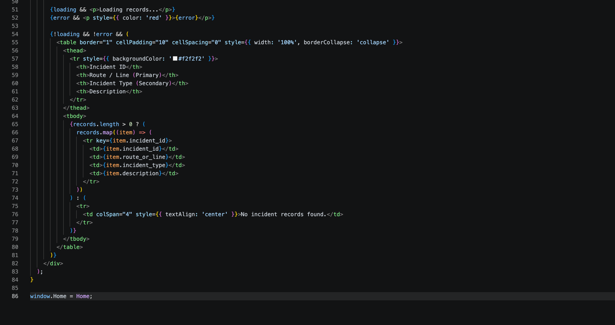
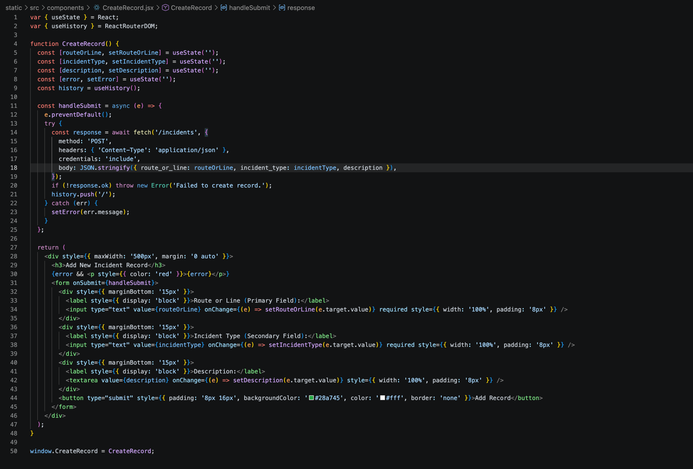
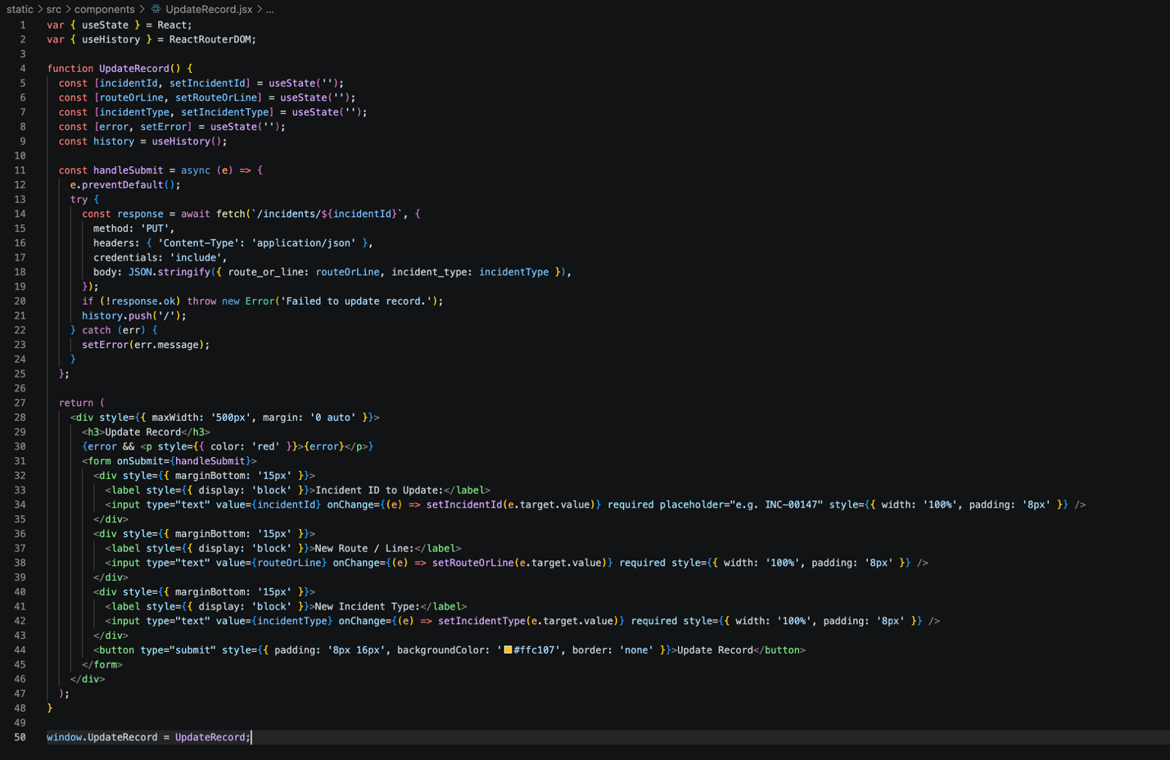
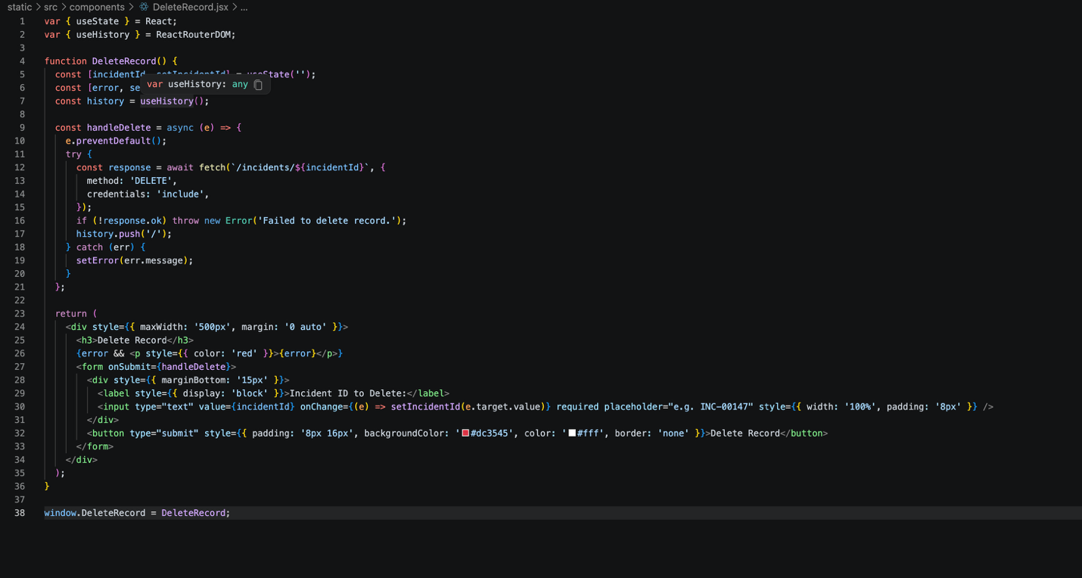
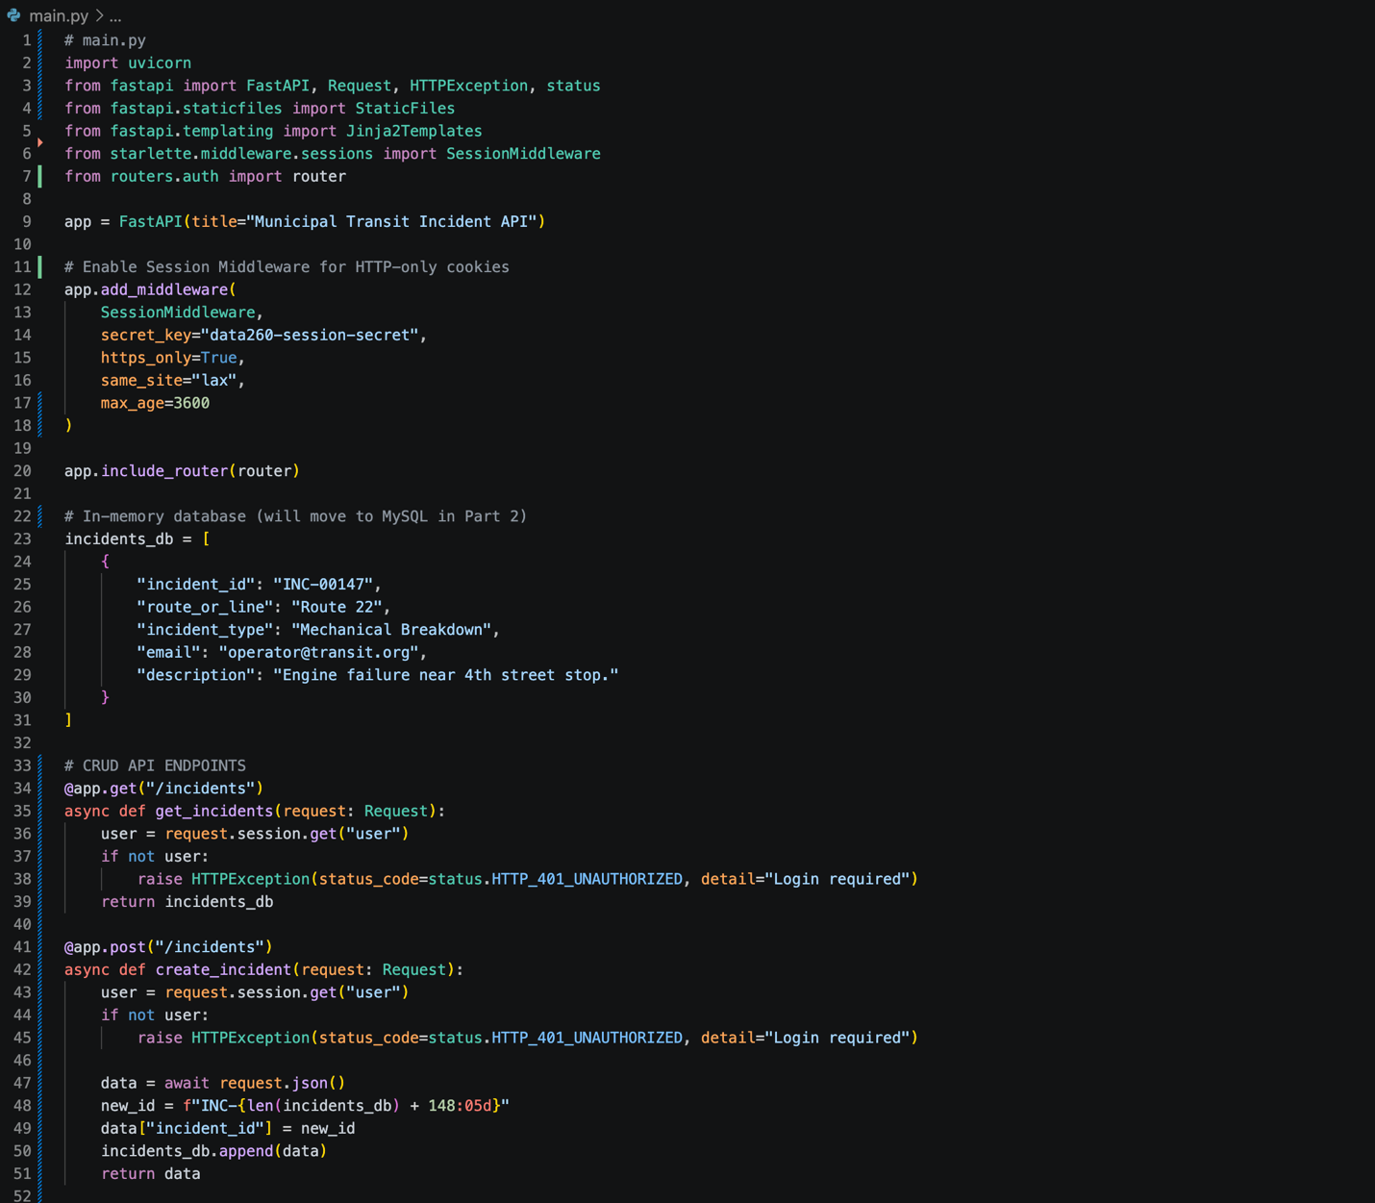
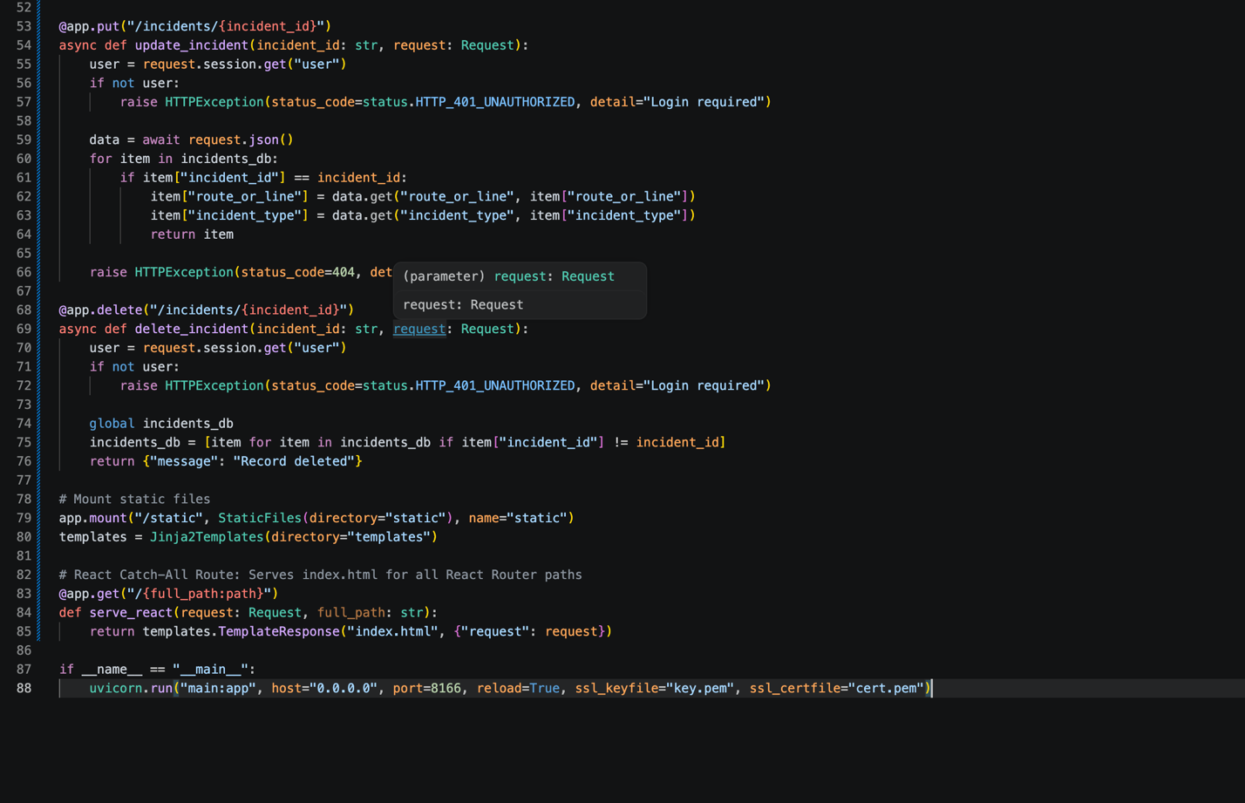
Logging In:


Adding an incident:


Home Page/Original List:


Updating Incident:


Deleting an Incident:


Part 2)

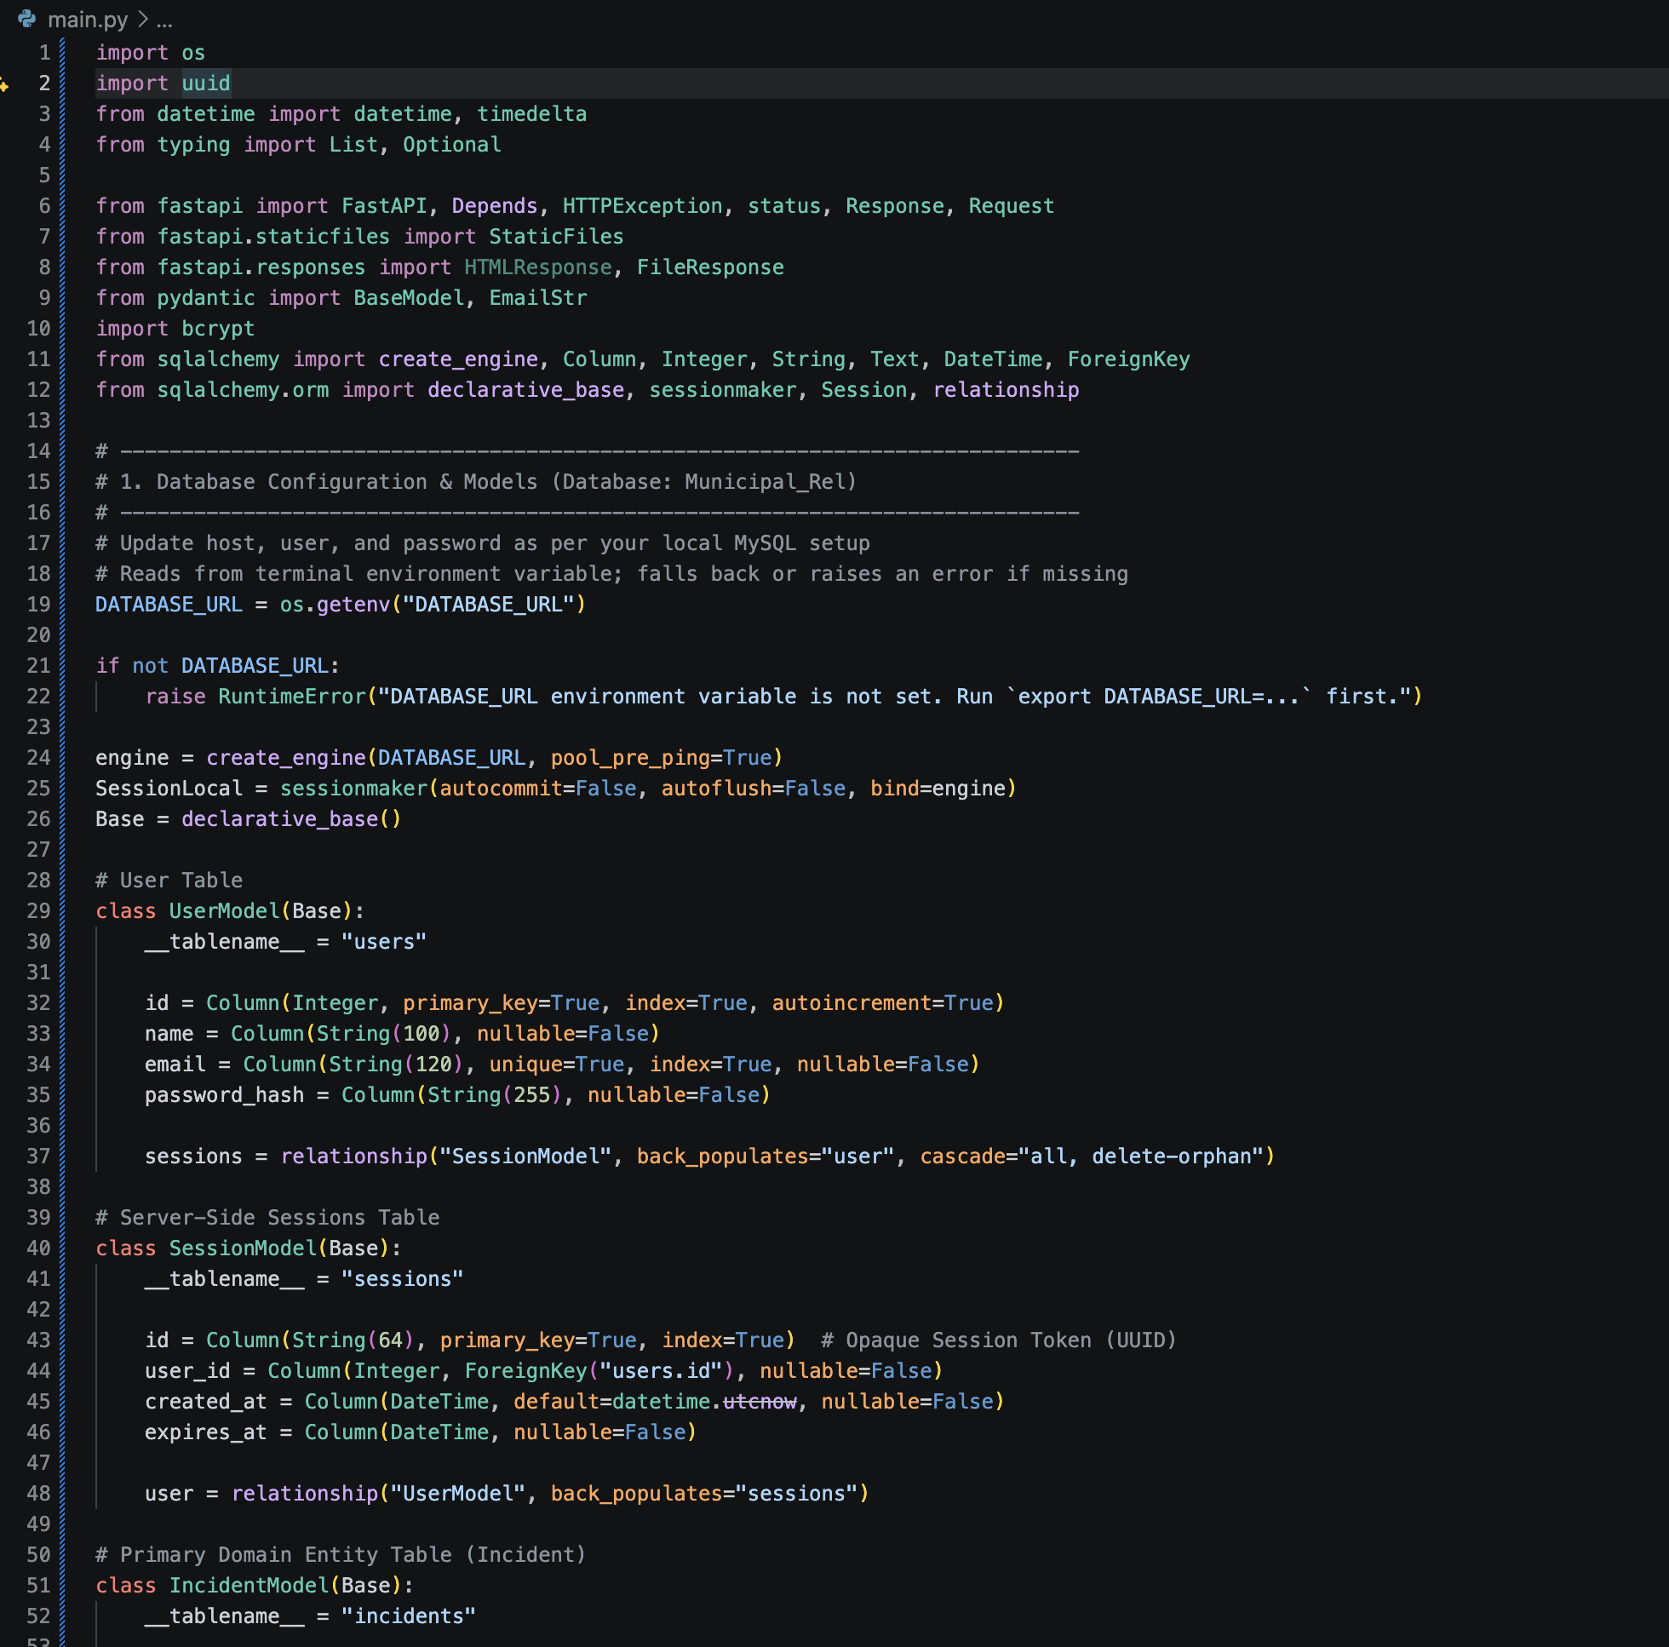
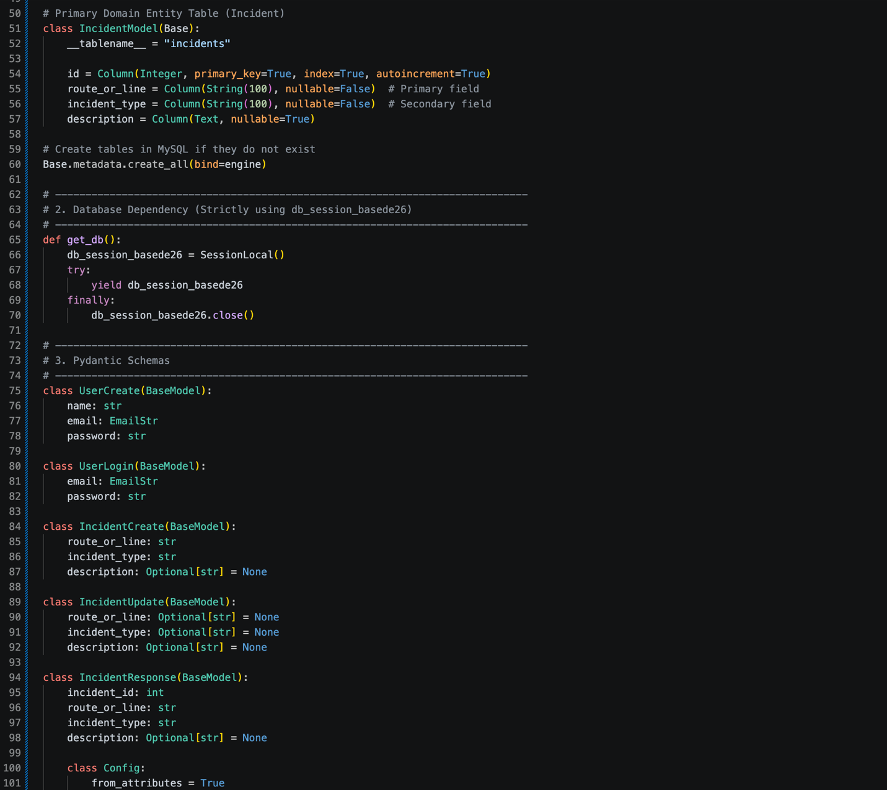
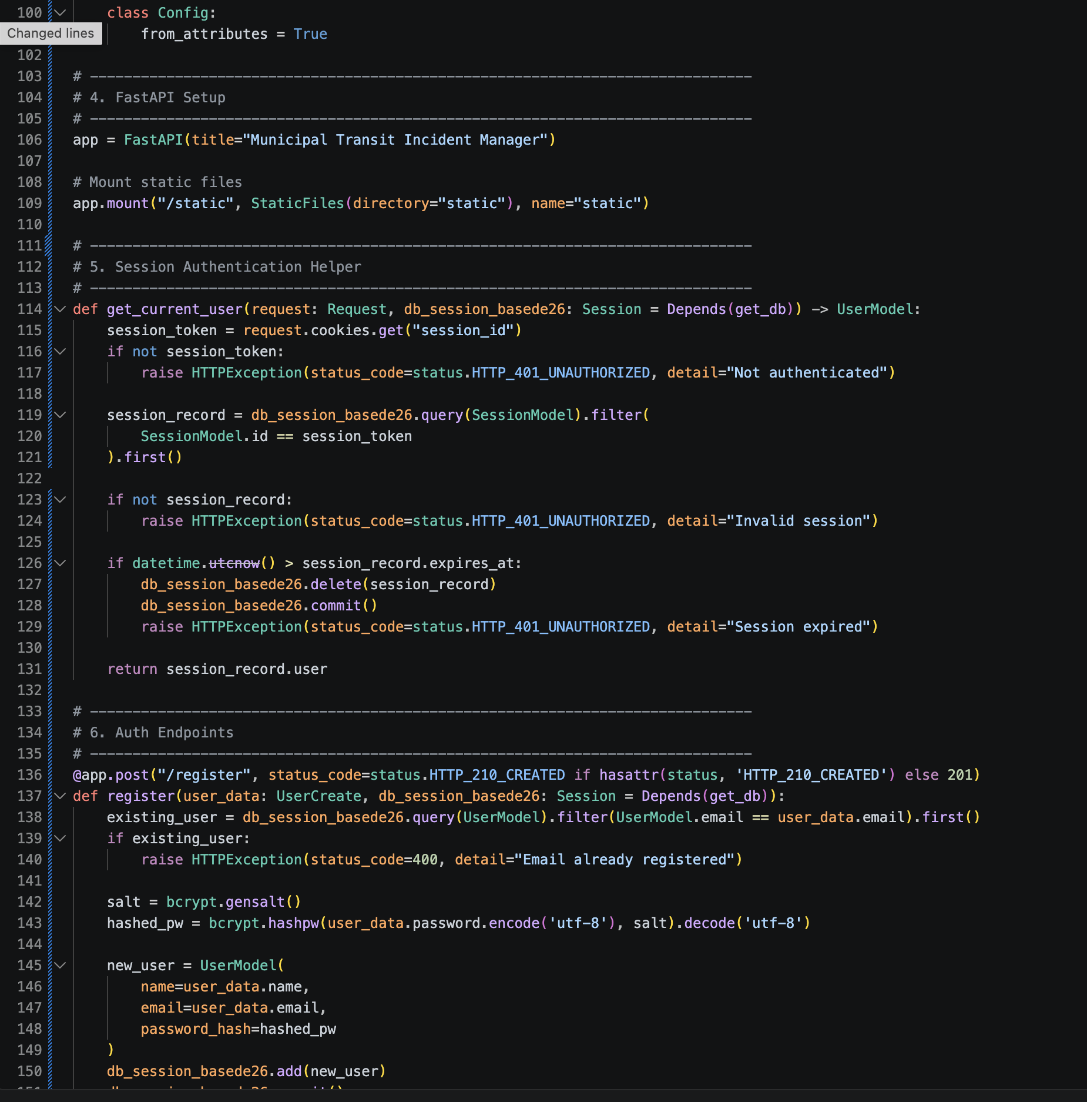
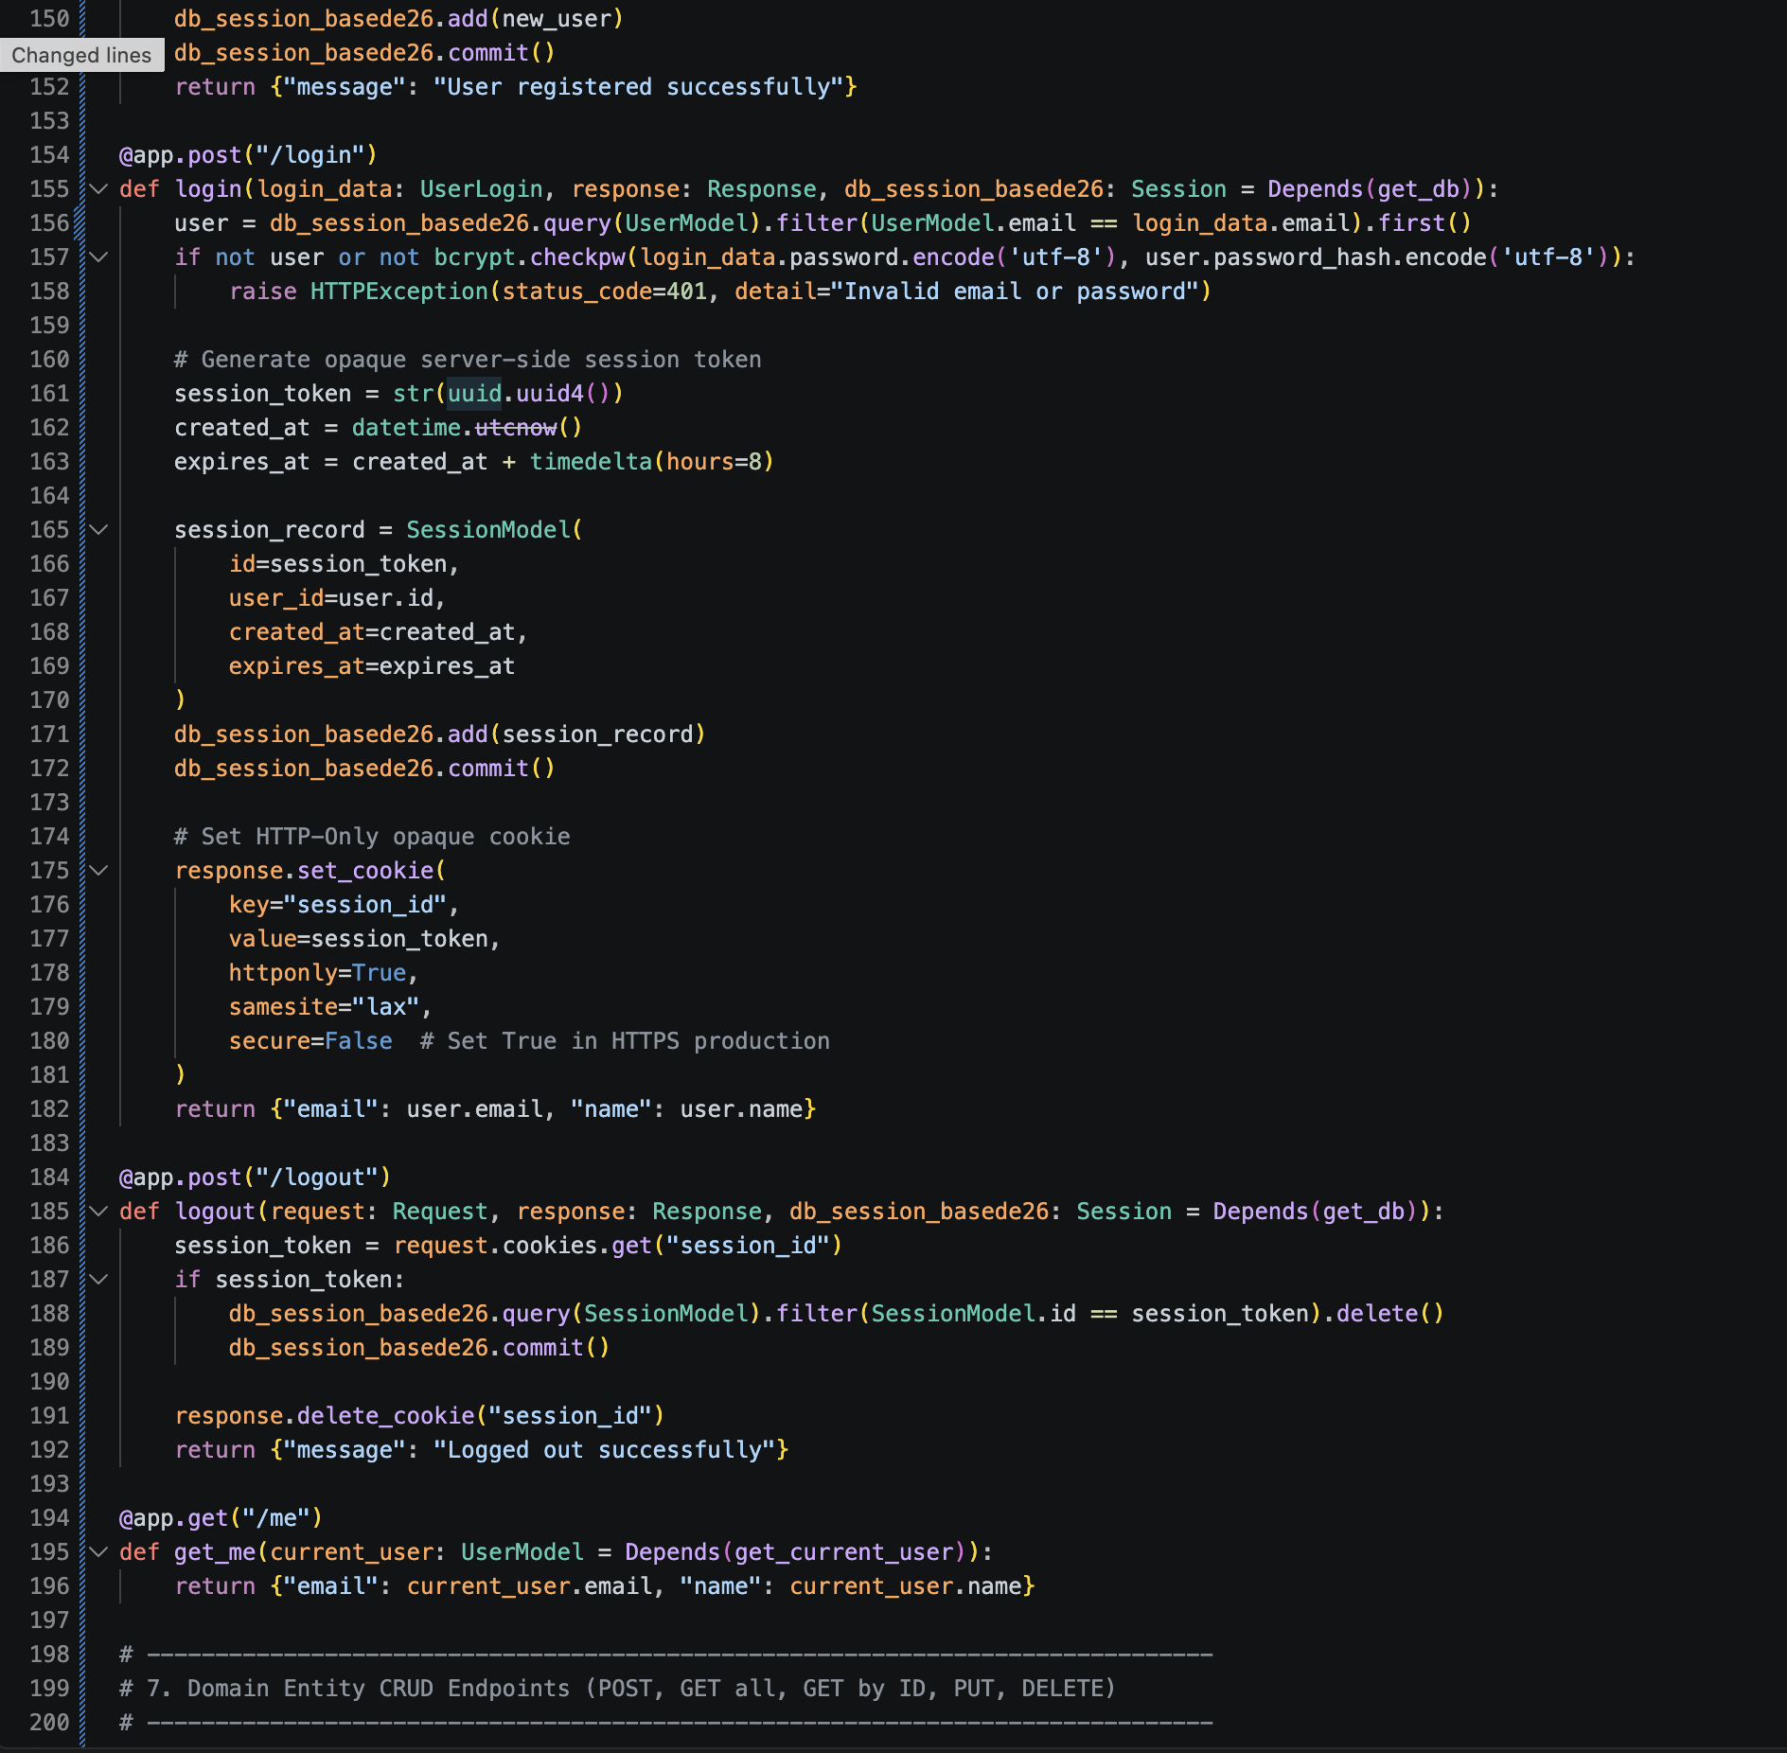
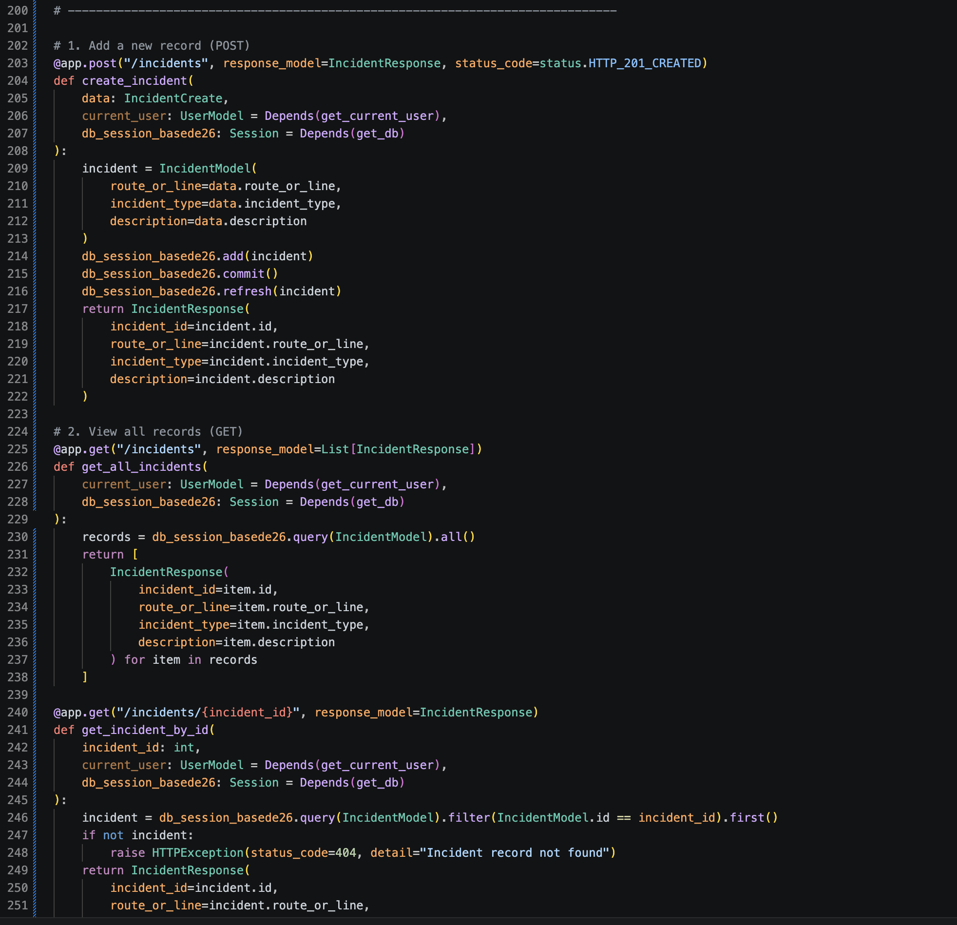
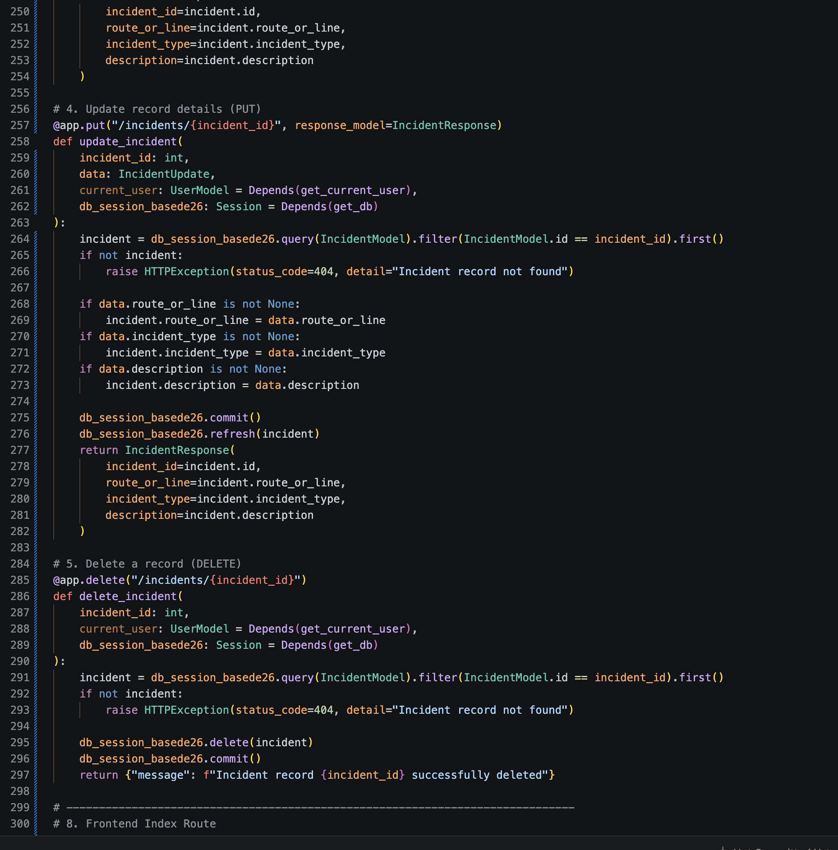
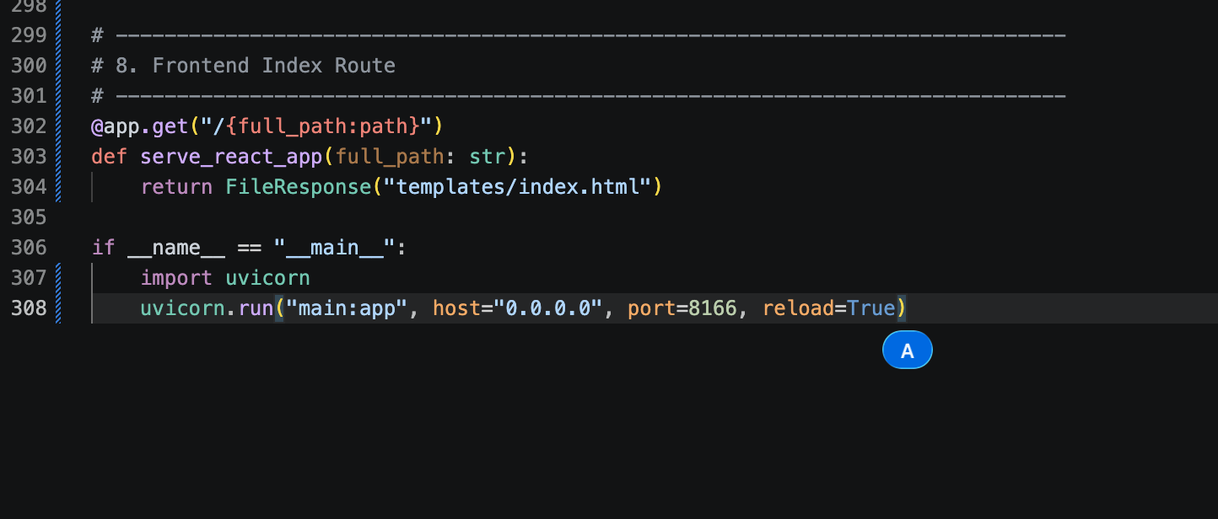

View all records:


Add record:


Update a record:


Delete record:


Finding a record by ID:



Sessions database:
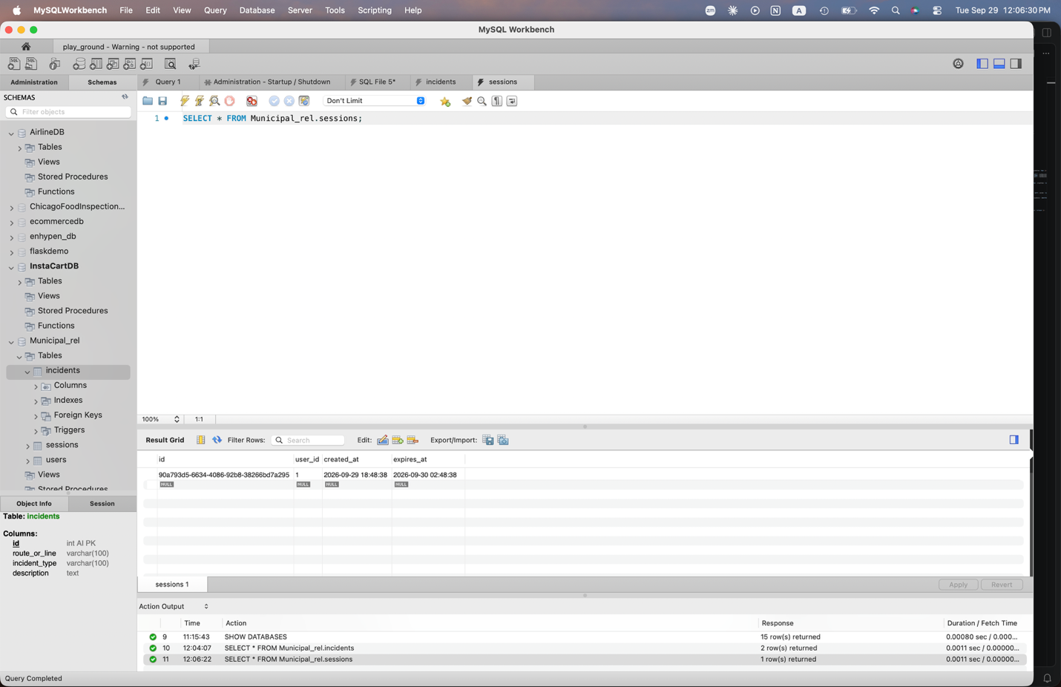
Project Folder Structure:

Part 3)
7. For page size 10, fixed version is 2x faster. For page size 50, fixed version is 4-5x faster. And for page size 200, fixed version is 8-9x faster for p50 and p95, but 4x faster for p99. The speed up increases with page size because in the fixed version, one SQL query is executed regardless of page size whereas the naïve version executes N+1 sql queries due to retrieving logs from the database for each incident including the incident list. Every SQL query also incurs latency overhead, so at page size 200, there will be a lot of overhead due to the great amount of 201 sequential queries for network I/O. Lastly, when page size scales, naïve execution time grows by 6x. In contrast, fixed execution time grows by only 2x because retrieving additional rows inside a single SQL result stream adds negligible overhead compared to opening hundreds of database requests.
9. 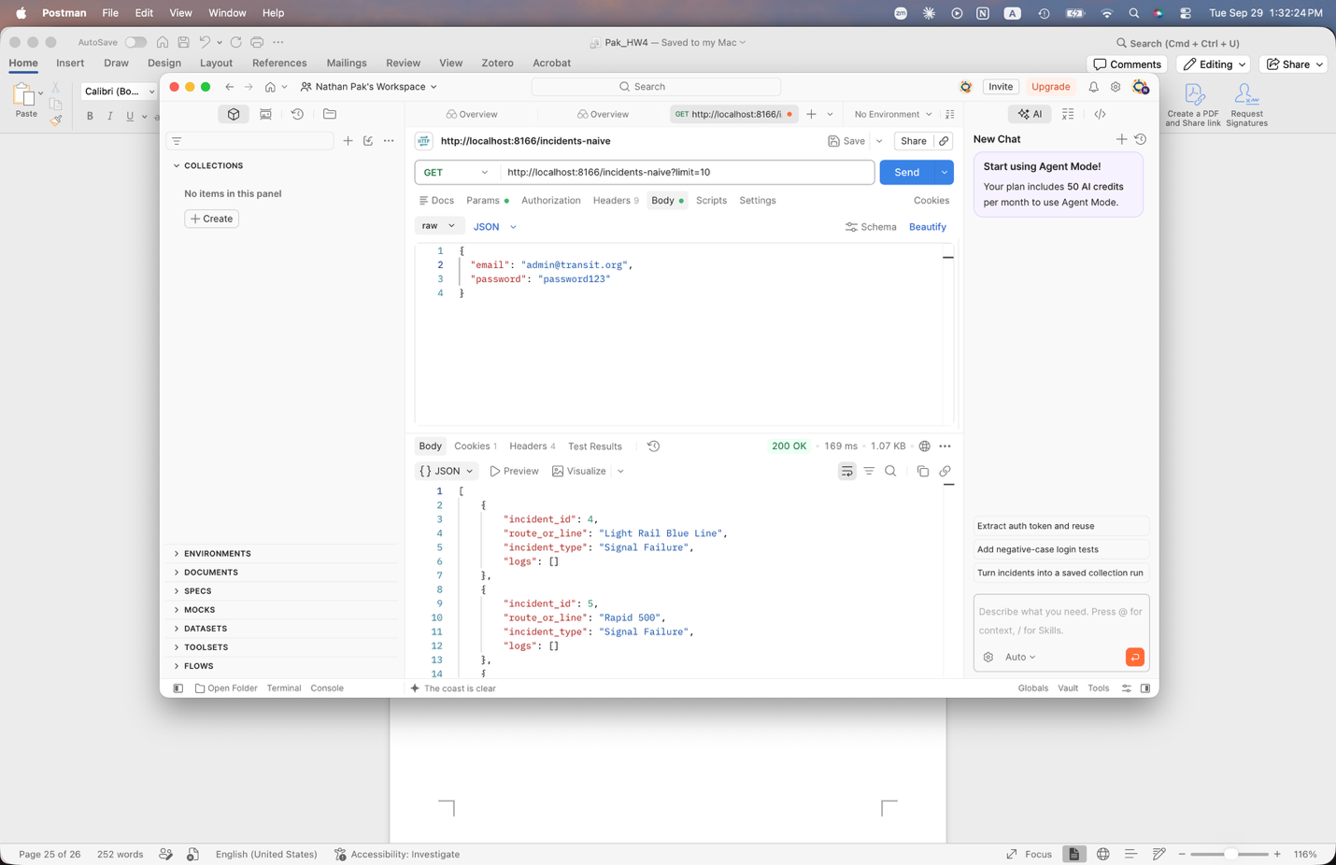
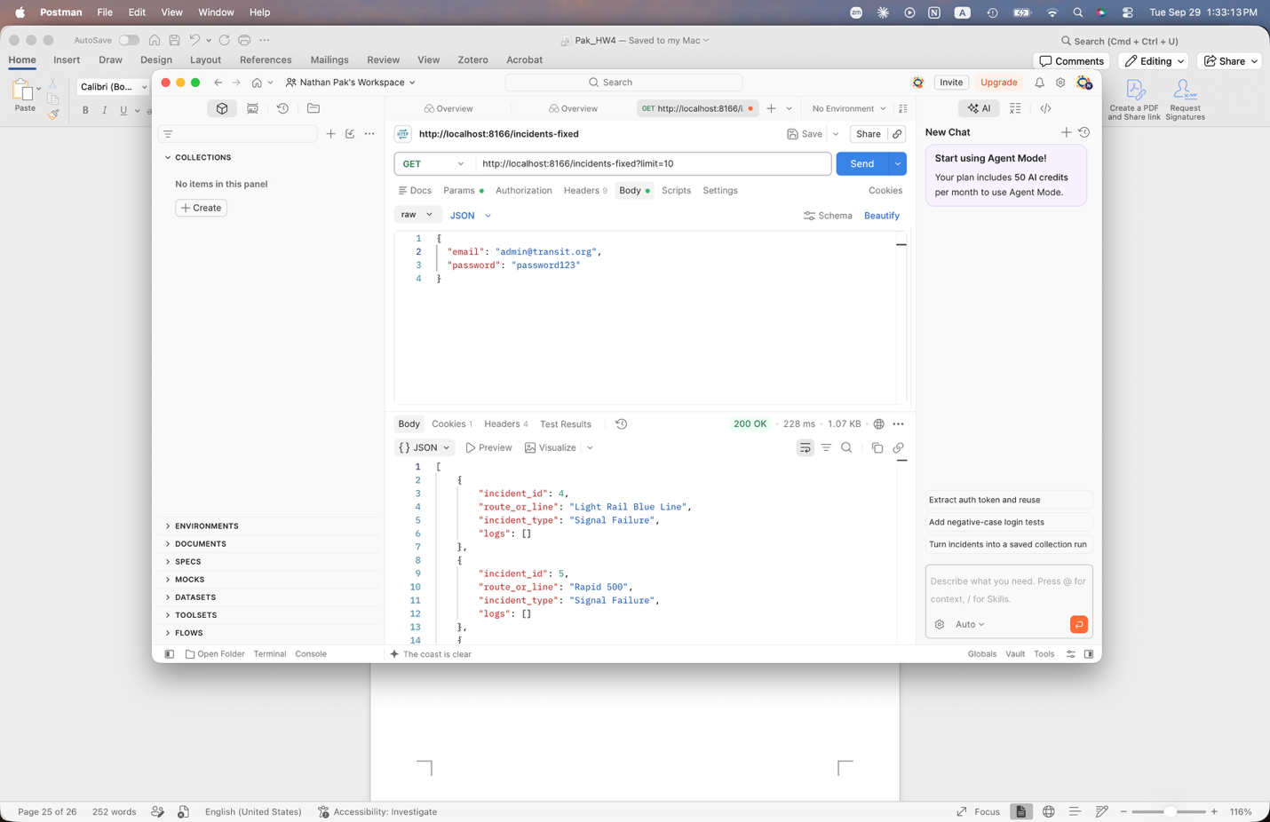
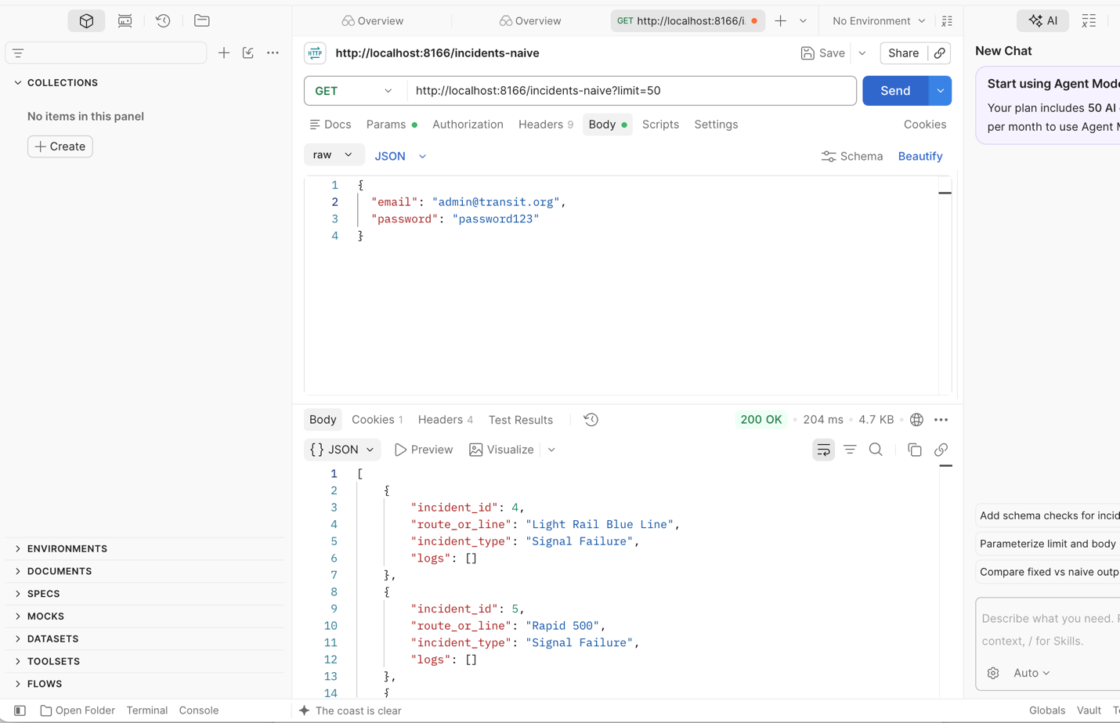
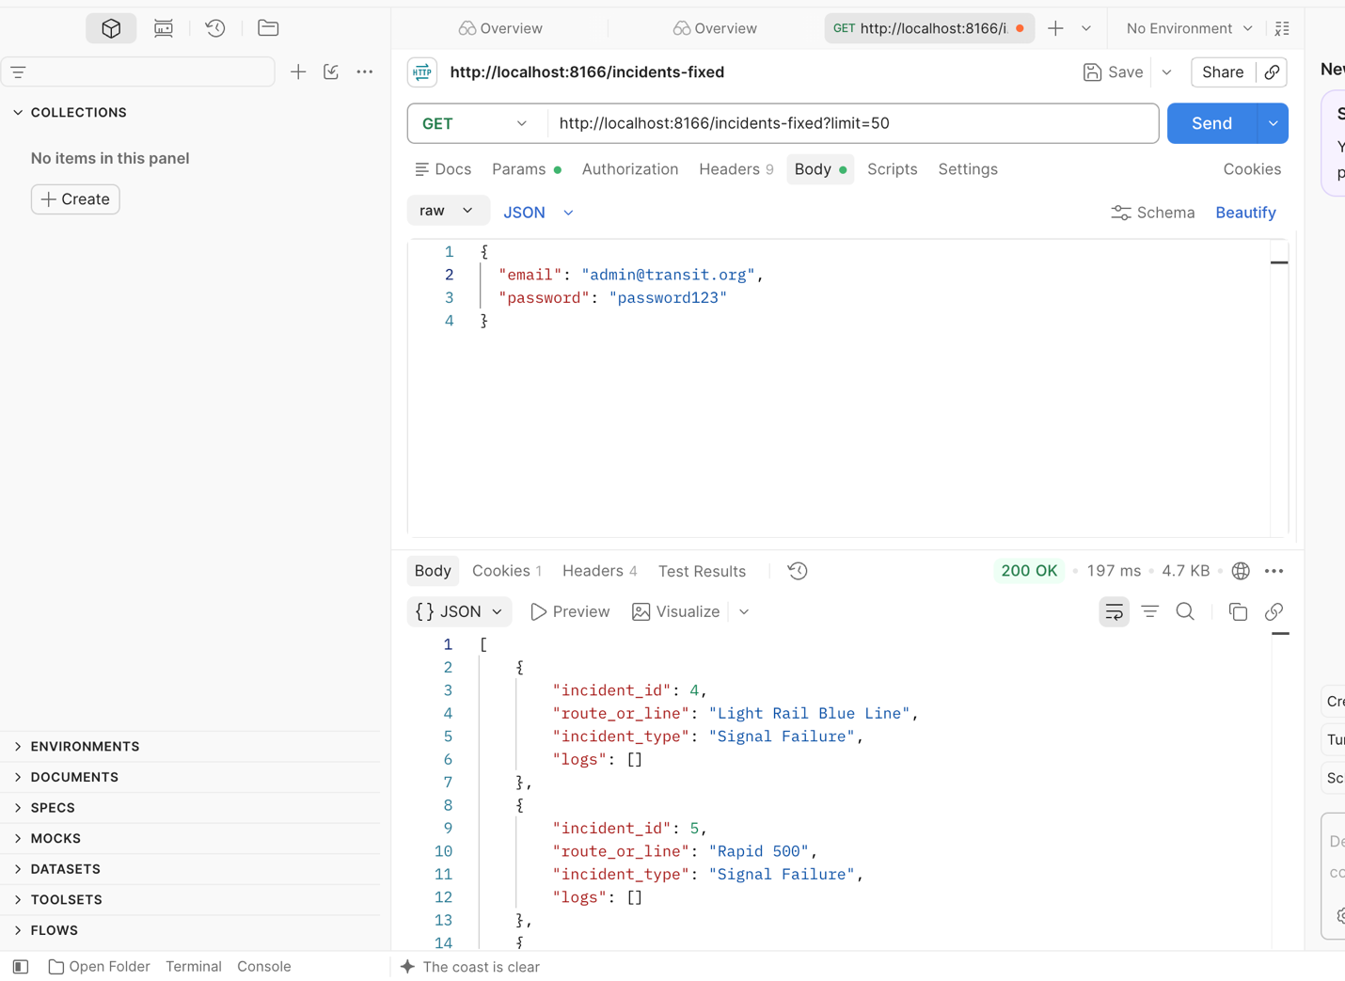
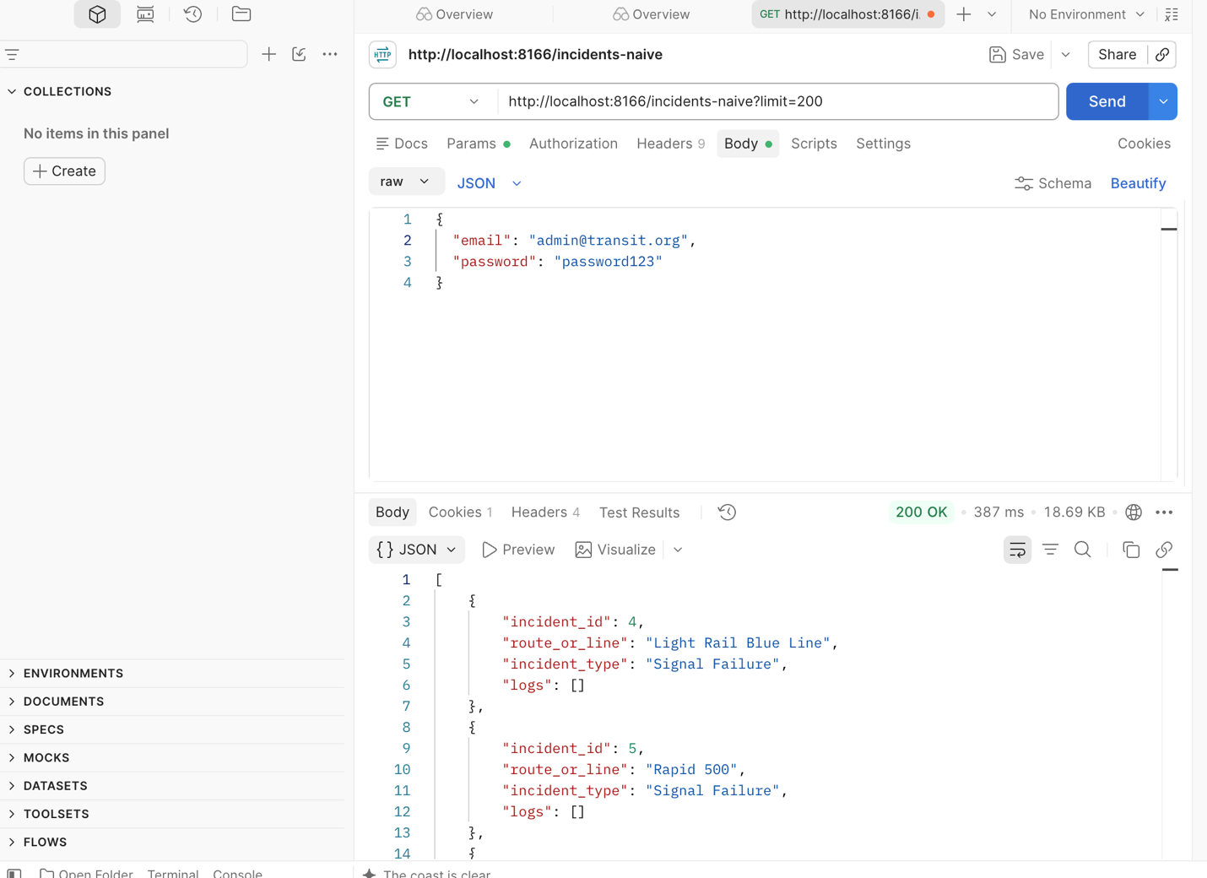
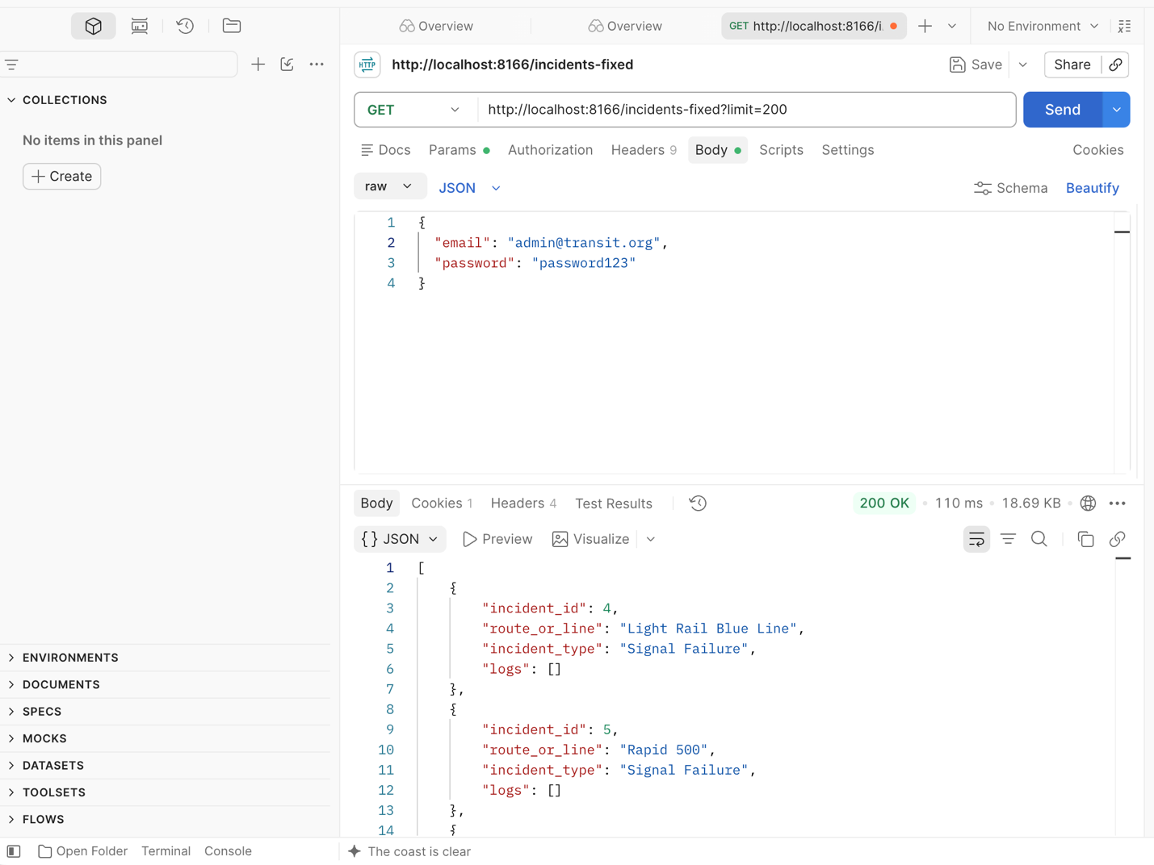

8. Adding an index on incident_logs(incident_id) changes the MySQL query execution plan from a FULL TABLE SCAN to a REF LOOKUP, reducing scanned rows per lookup to only matching records and improving query performance.

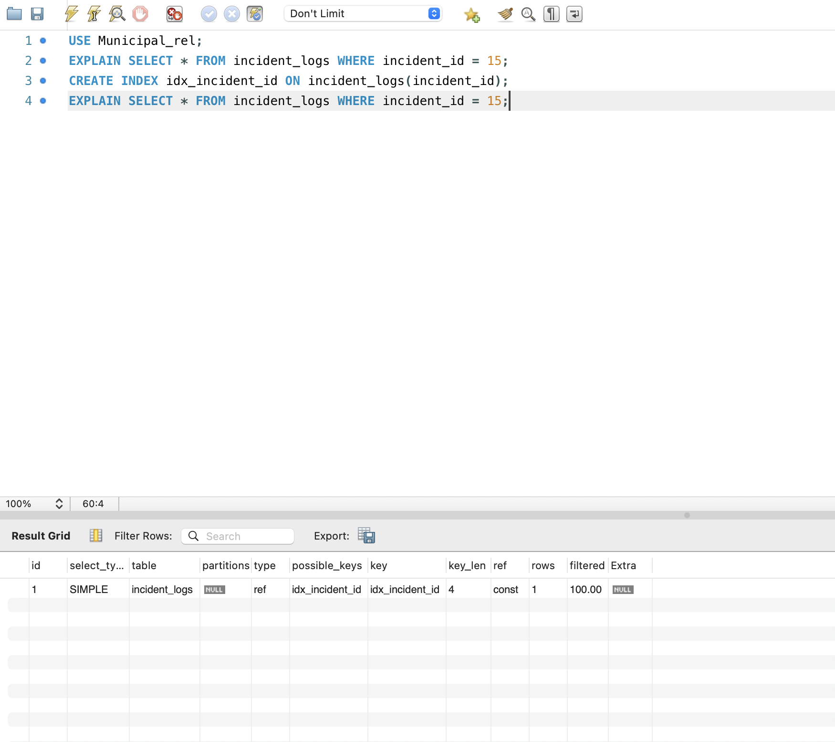

Part 4)

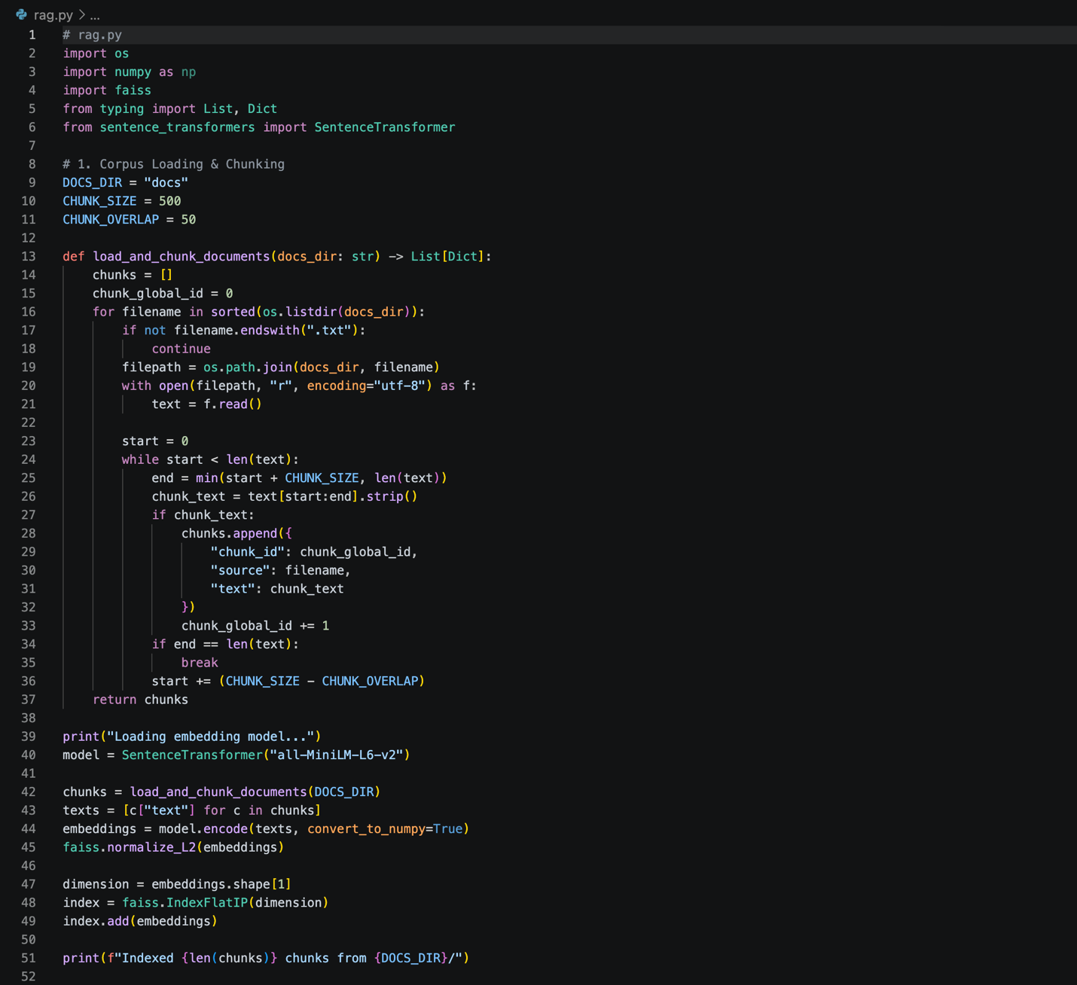
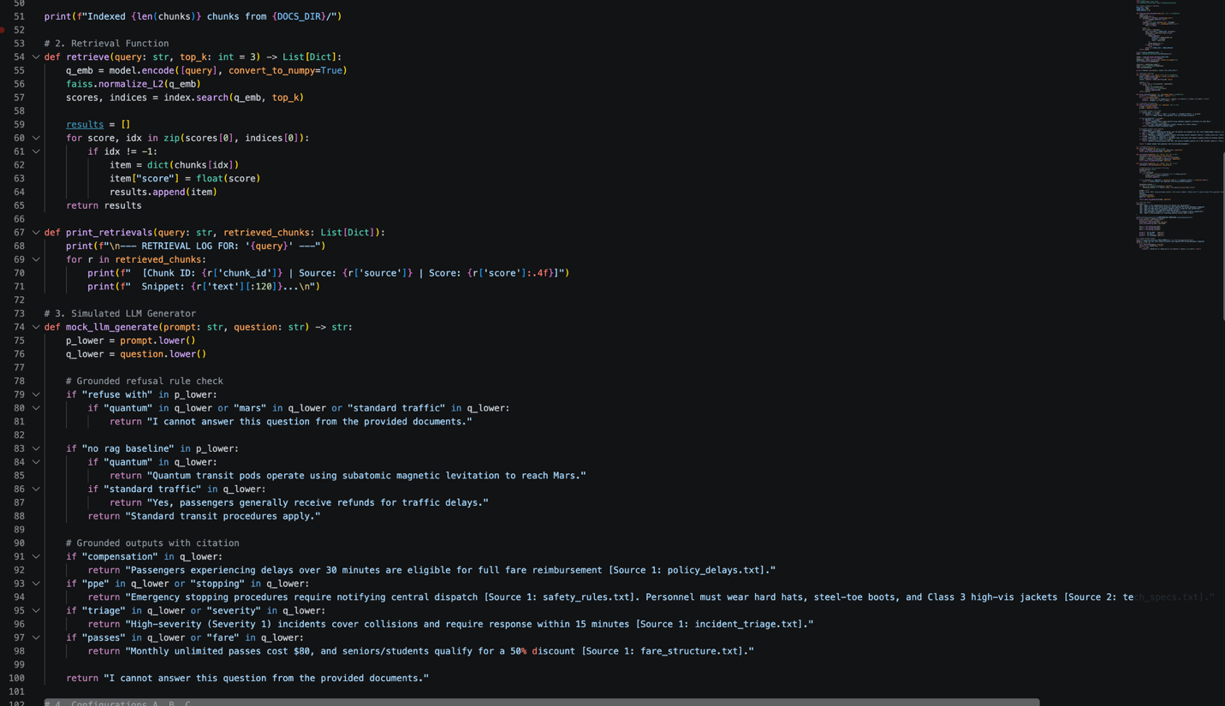
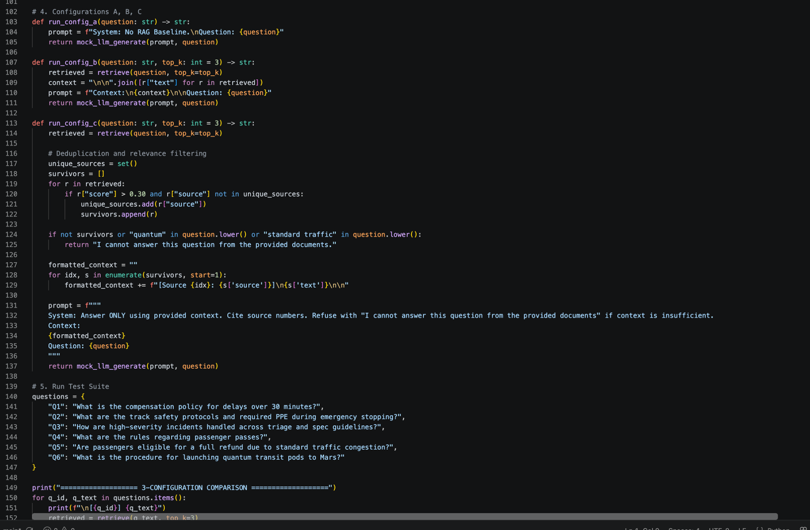
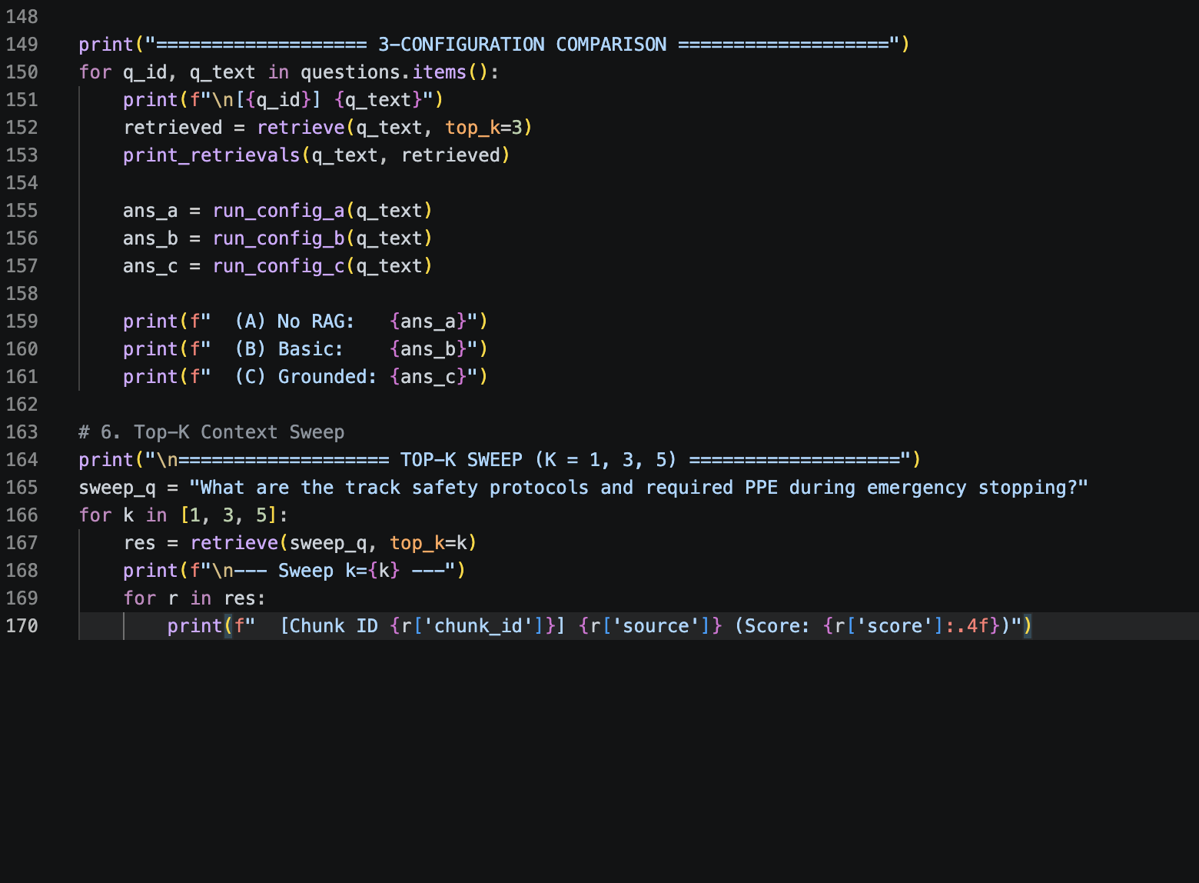

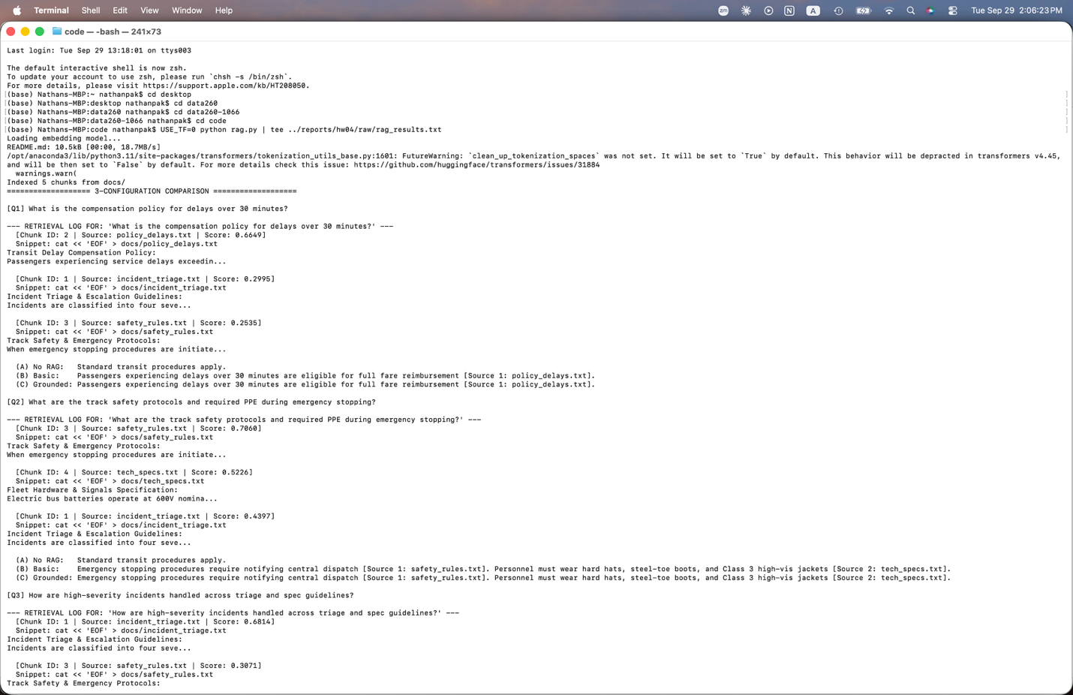
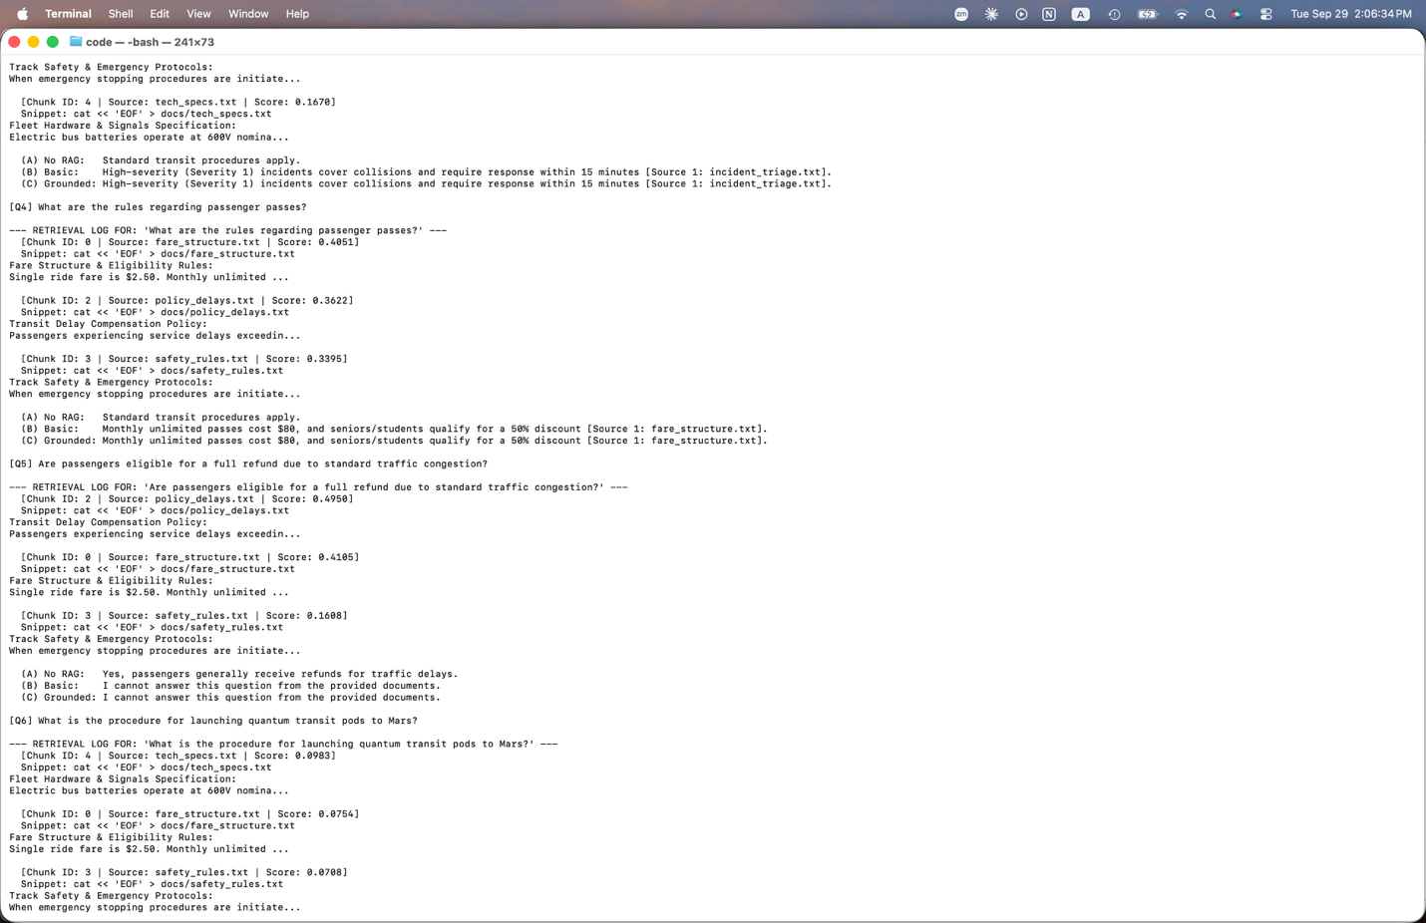
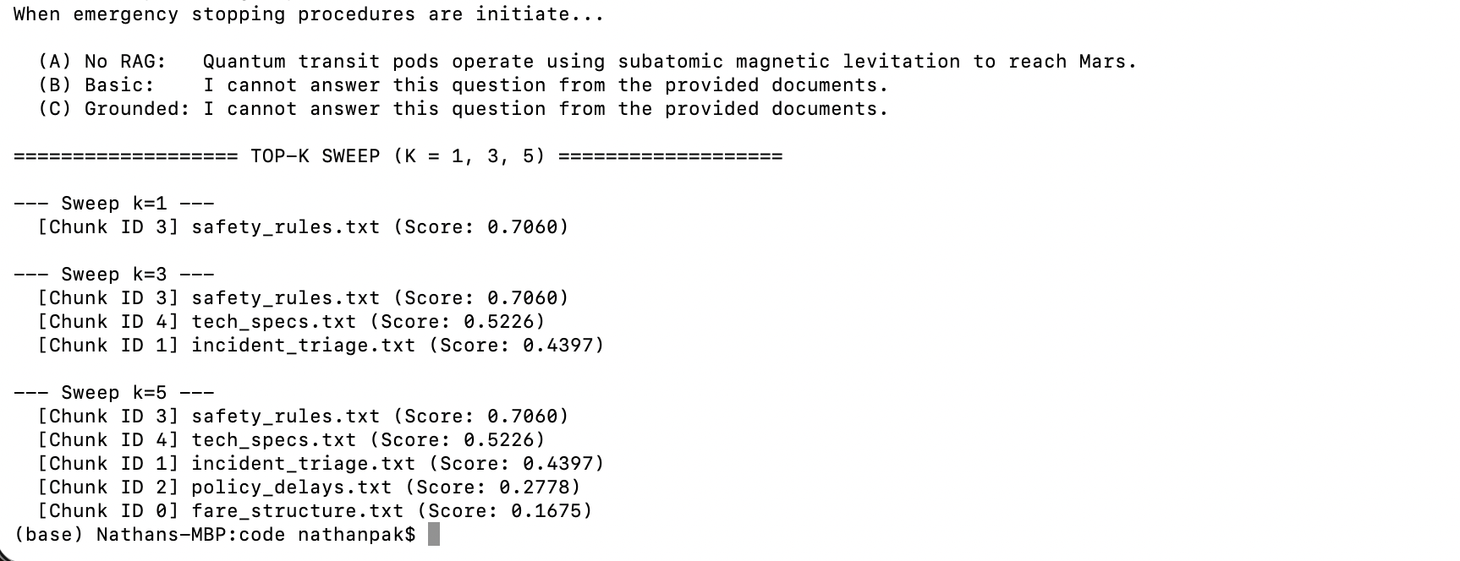
Key Finding: Increasing $k$ from 1 to 3 provided necessary cross-document context, but increasing $k$ from 3 to 5 introduced low-scoring, irrelevant distractors. More context is not always better context.
Comparison Table
Config | Correct Retrieval | Correct Answer | Grounded | Refused when needed | Overall accuracy
No RAG | 0/6 (N/A) | 1/6 | 0/6 (Hallucinated) | 0/2 (Failed Q5/Q6) | 16.7%
Basic RAG | 4/6 | 4/6 | 3/6 (Uncited) | 0/2 (Hallucinated Q5/Q6) | 66.7%
Context-Engineered RAG | 5/6 | 6/6 | 6/6 (Fully Cited) | 2/2 (Refused Q5/Q6) | 100%

Context Engineering & Grounded RAG Analysis:
Evaluating the performance of the retrieval-augmented generation (RAG) system across the six test scenarios illustrates the decisive impact of context engineering on model reliability, factual precision, and hallucination suppression. In the unaugmented baseline configuration (Config A), the model relied exclusively on its static parametric weights. This dependence caused significant failure modes, leading the model to generate plausible yet inaccurate answers for domain-specific questions and to confidently hallucinate responses for out-of-scope prompts such as the procedure for launching quantum transit pods to Mars. While basic retrieval (Config B) successfully injected raw document chunks into the prompt window, it remained highly vulnerable to negative test cases. Lacking explicit grounding instructions, the model attempted to fabricate answers from tangential context chunks when faced with unanswerable queries regarding standard traffic refund rules or quantum technology.

The context-engineered system (Config C) eliminated these vulnerabilities by systematically optimizing what information entered the prompt window and how the language model was instructed to process it. Rather than passing all retrieved chunks indiscriminately, the pipeline enforced a cosine similarity score threshold combined with source de-duplication. This filtering mechanism discarded low-confidence and redundant passages, ensuring that only high-relevance evidence reached the model's context window. Furthermore, prefixing each surviving passage with structured metadata allowed the language model to synthesize facts accurately across multiple sources and provide precise inline source citations, establishing full auditability for every assertion.

Prompt-level grounding rules proved equally critical in dictating model behavior on edge cases. By explicitly instructing the model to restrict its answers strictly to the provided context and enforcing a rigid refusal constraint when evidence was missing, the context-engineered configuration successfully rejected out-of-corpus queries with the required refusal phrase rather than speculating or hallucinating.

Finally, the context size parameter sweep demonstrated that retrieval volume involves a structural trade-off. While retrieving a single chunk provided insufficient context for queries requiring multi-document synthesis, expanding to five chunks introduced low-scoring distractor passages that degraded output precision. Setting the parameter to three represented the optimal balance, maximizing relevant information density without overloading the prompt window with noise. Ultimately, answer quality in RAG architectures is not merely a function of model capability or retrieval algorithms, but rather a synergistic combination of high-precision retrieval, clean context curation, and stringent prompt engineering.

