SID4: 1066
PORT_BASE: 8166
PREFIX: s1066
SEED: 1066
VERIFY_SEED: 261066
DOMAIN_ID: 2
Hardware: Macintosh HD, Apple M4, 24 GB, Tahoe 26.6.2
Local Model Used: Ollama qwen3:8b
Tagged Commit Hash:
https://github.com/paknathan/data260-1066

Part 1) Congestion Index is the additional entity that will relate to Municipal Transit Incident. Congestion Index measures the level of congestion where the incident occurred.

I & II) Database & API Implementation

Main.py
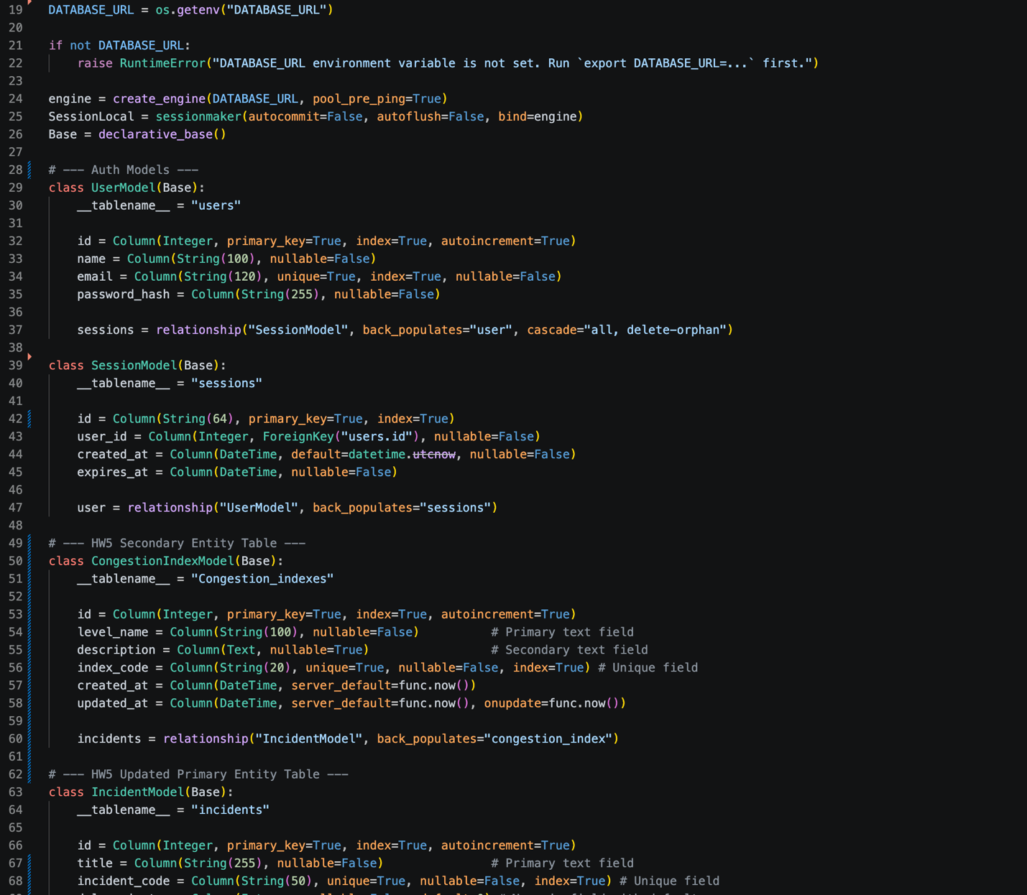
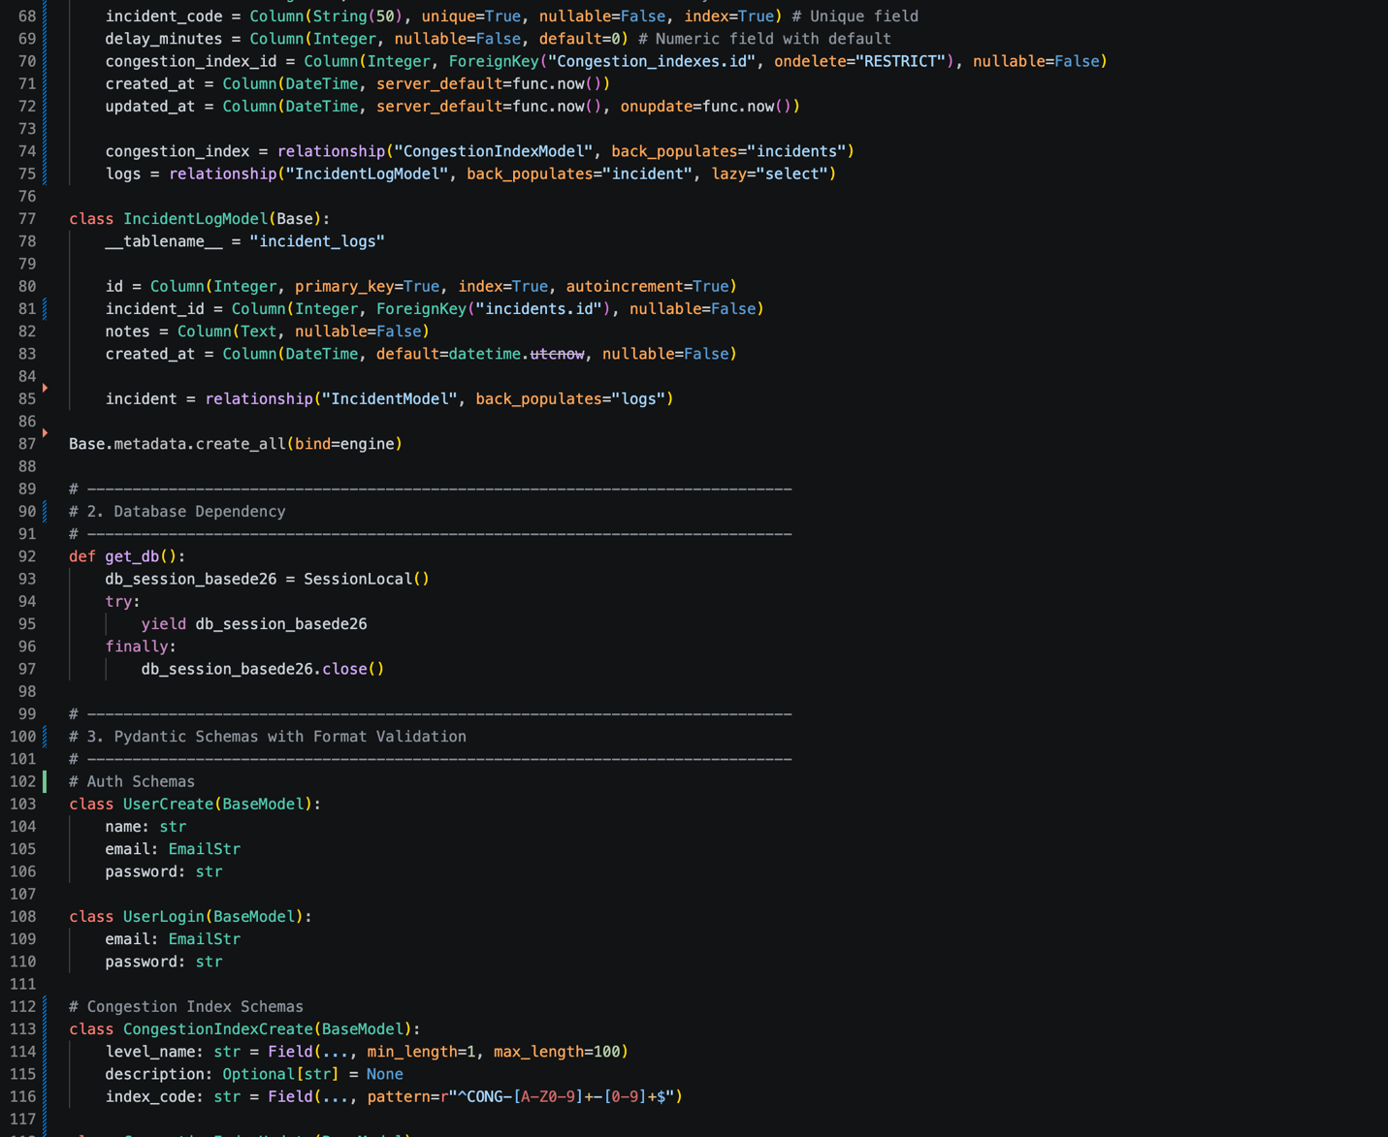
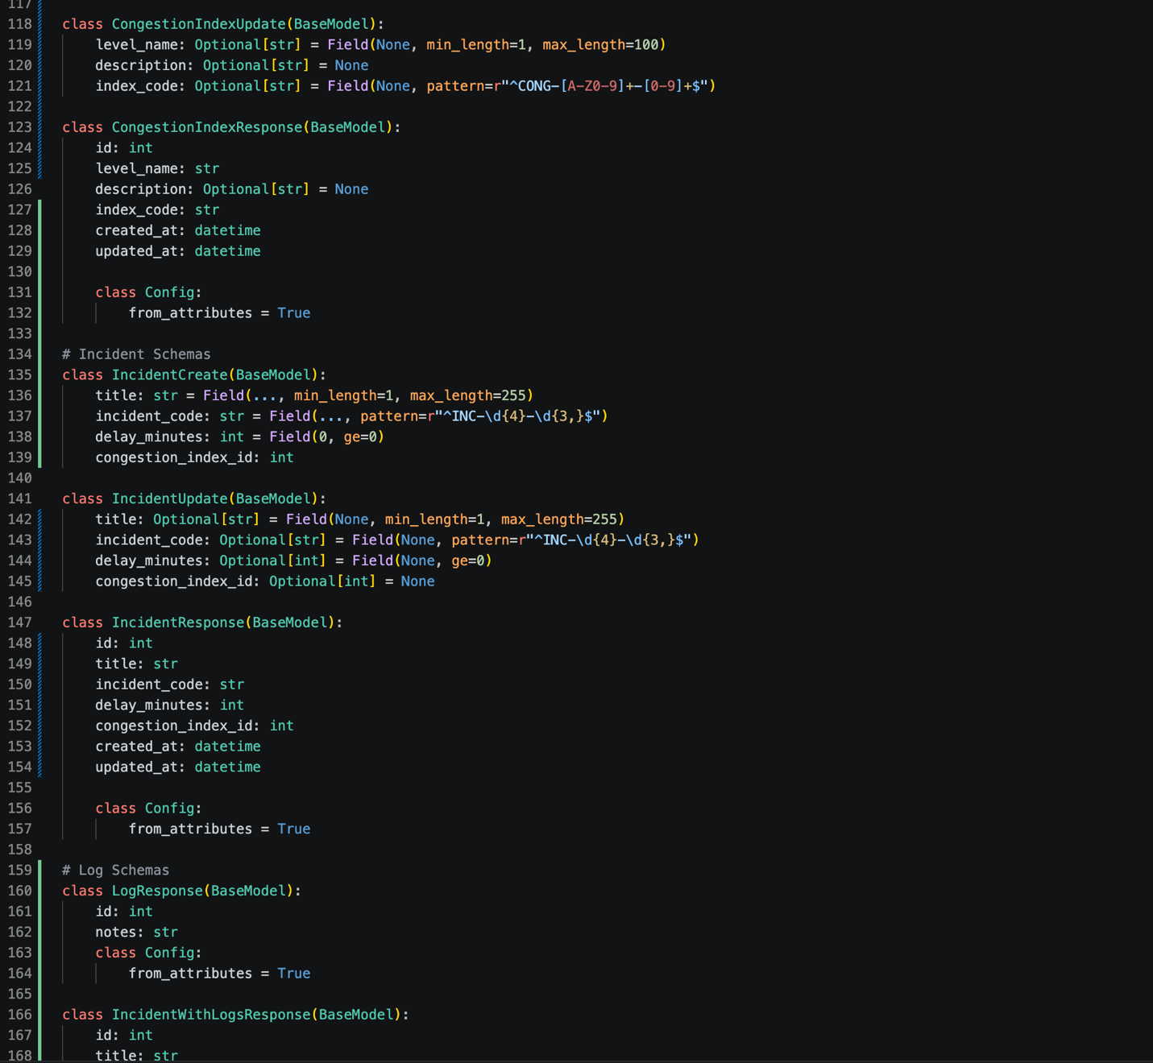
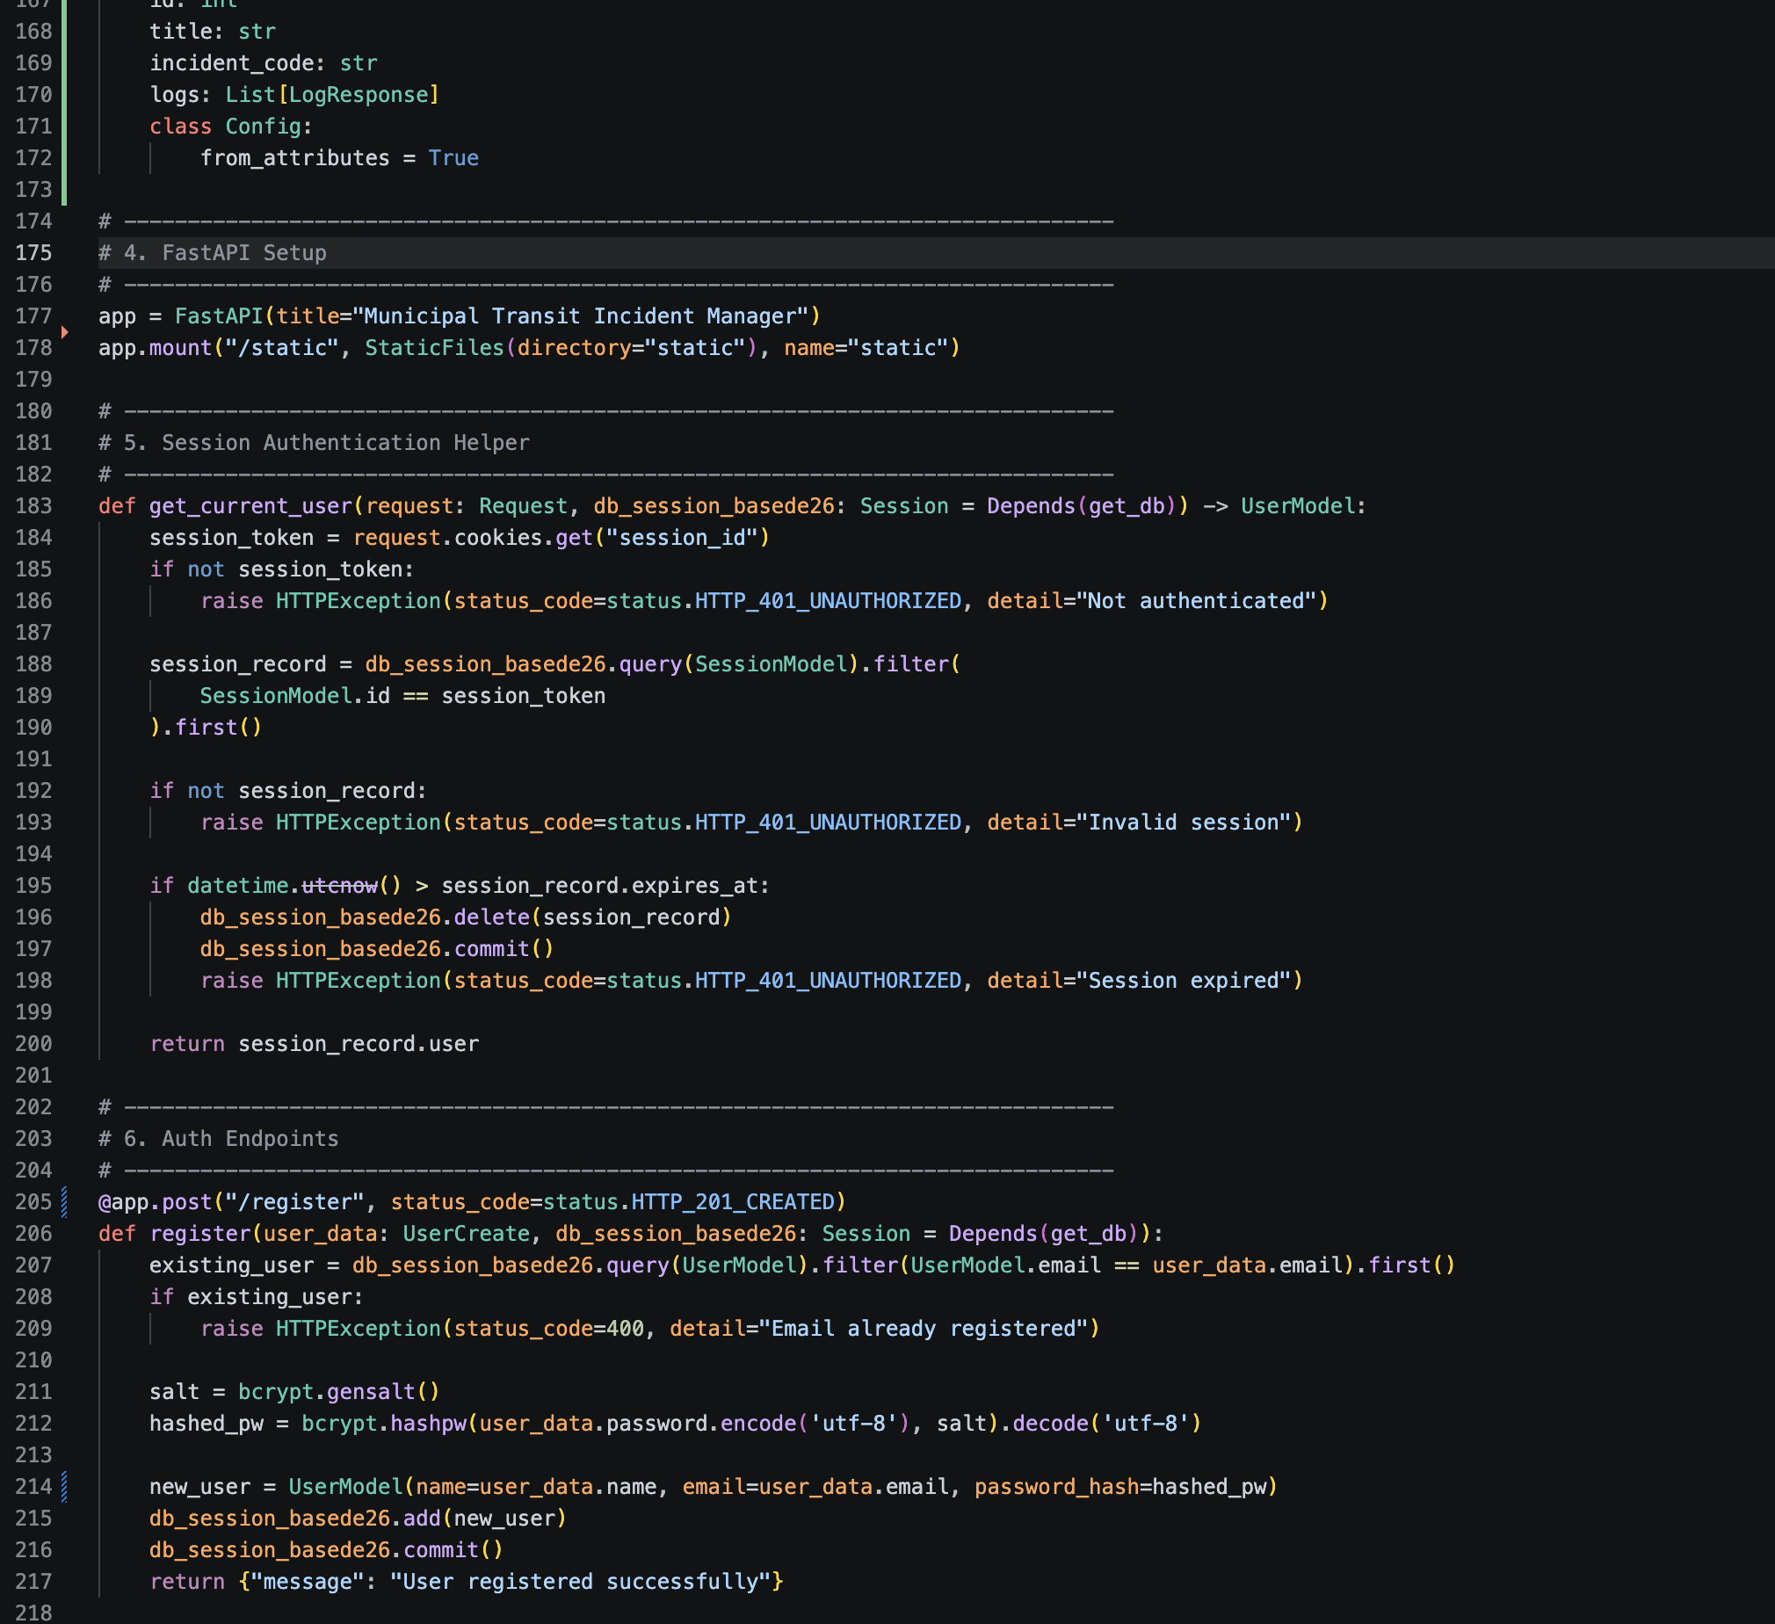
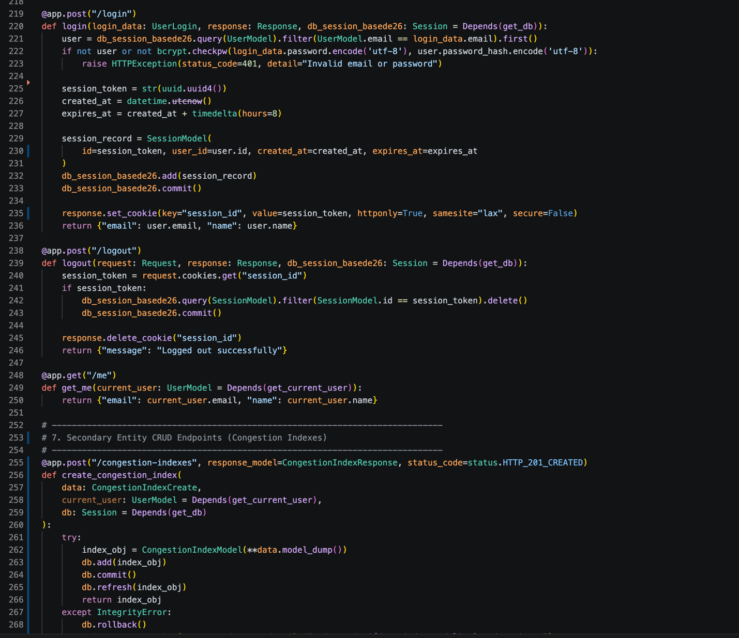
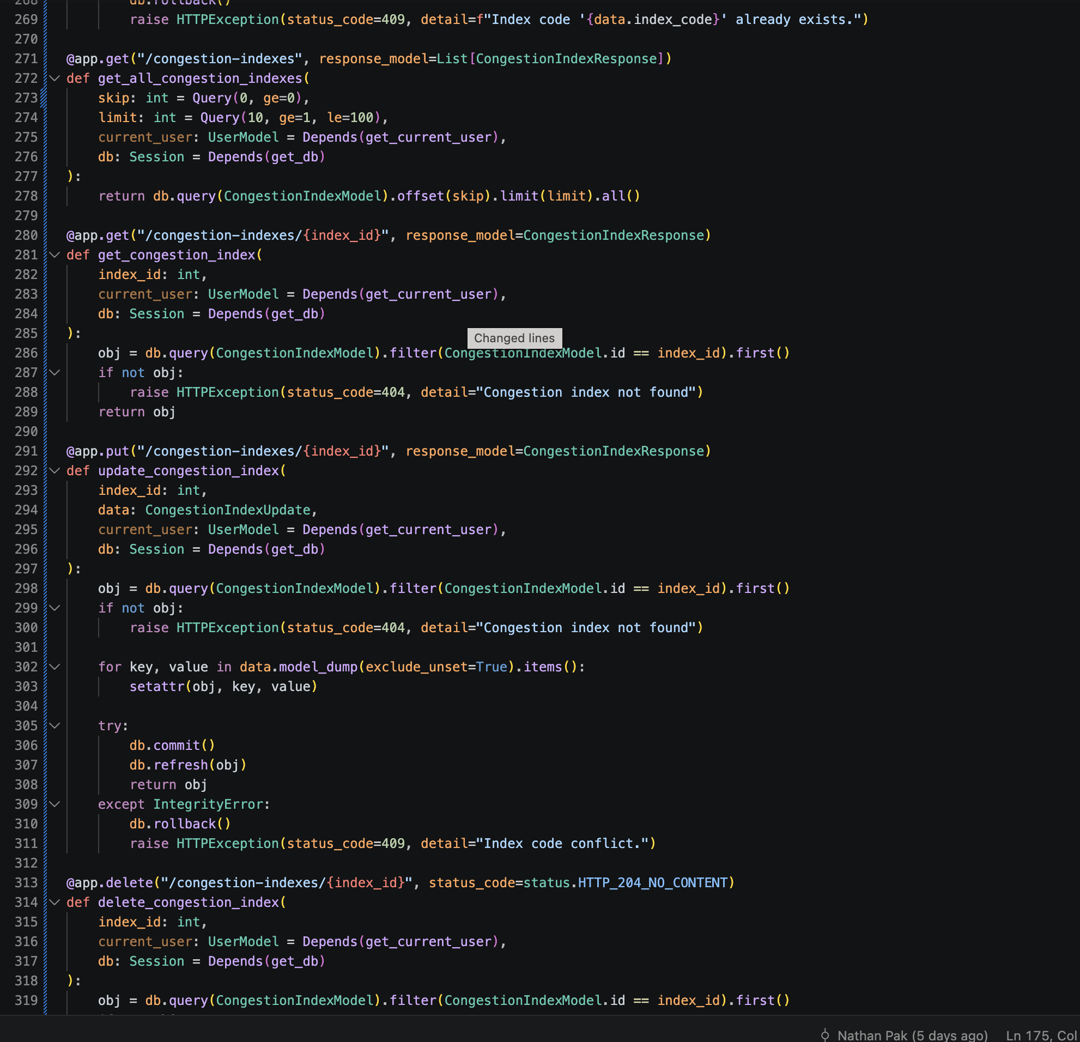
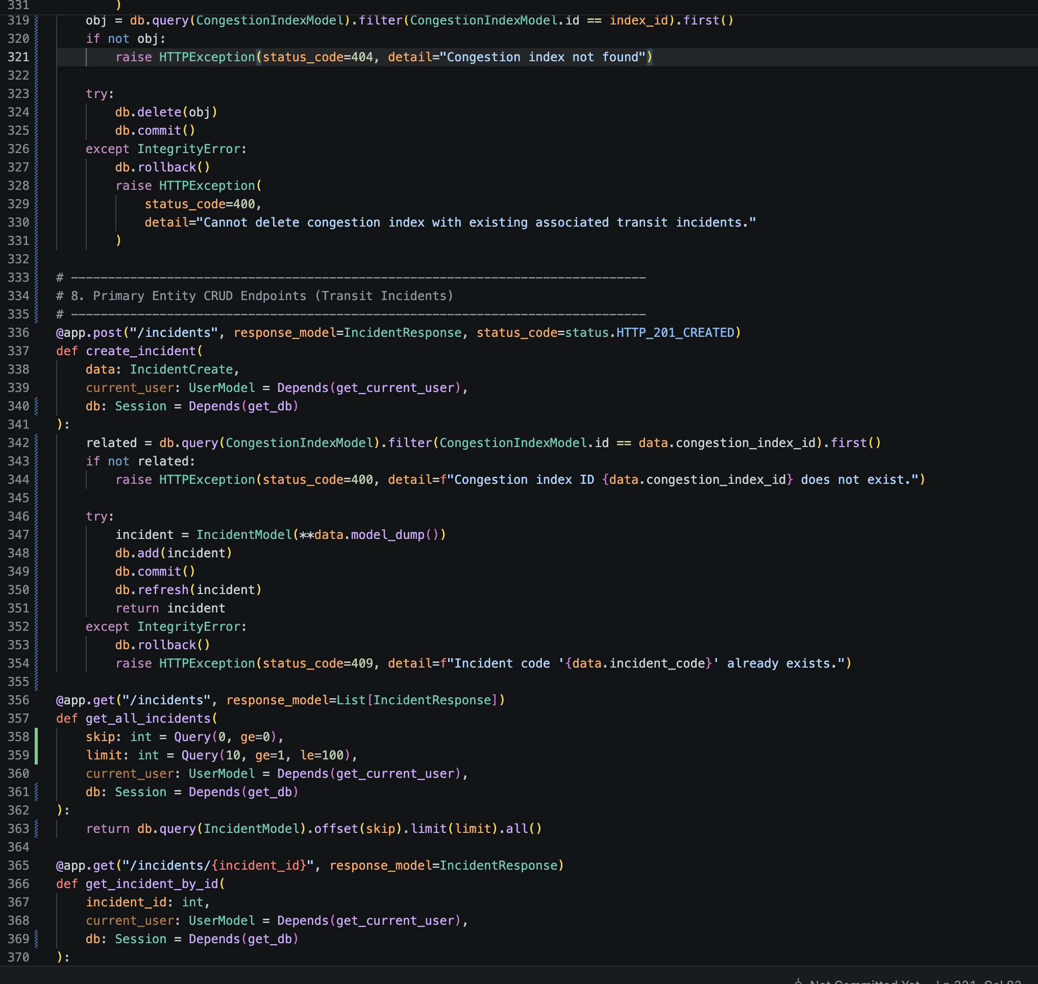
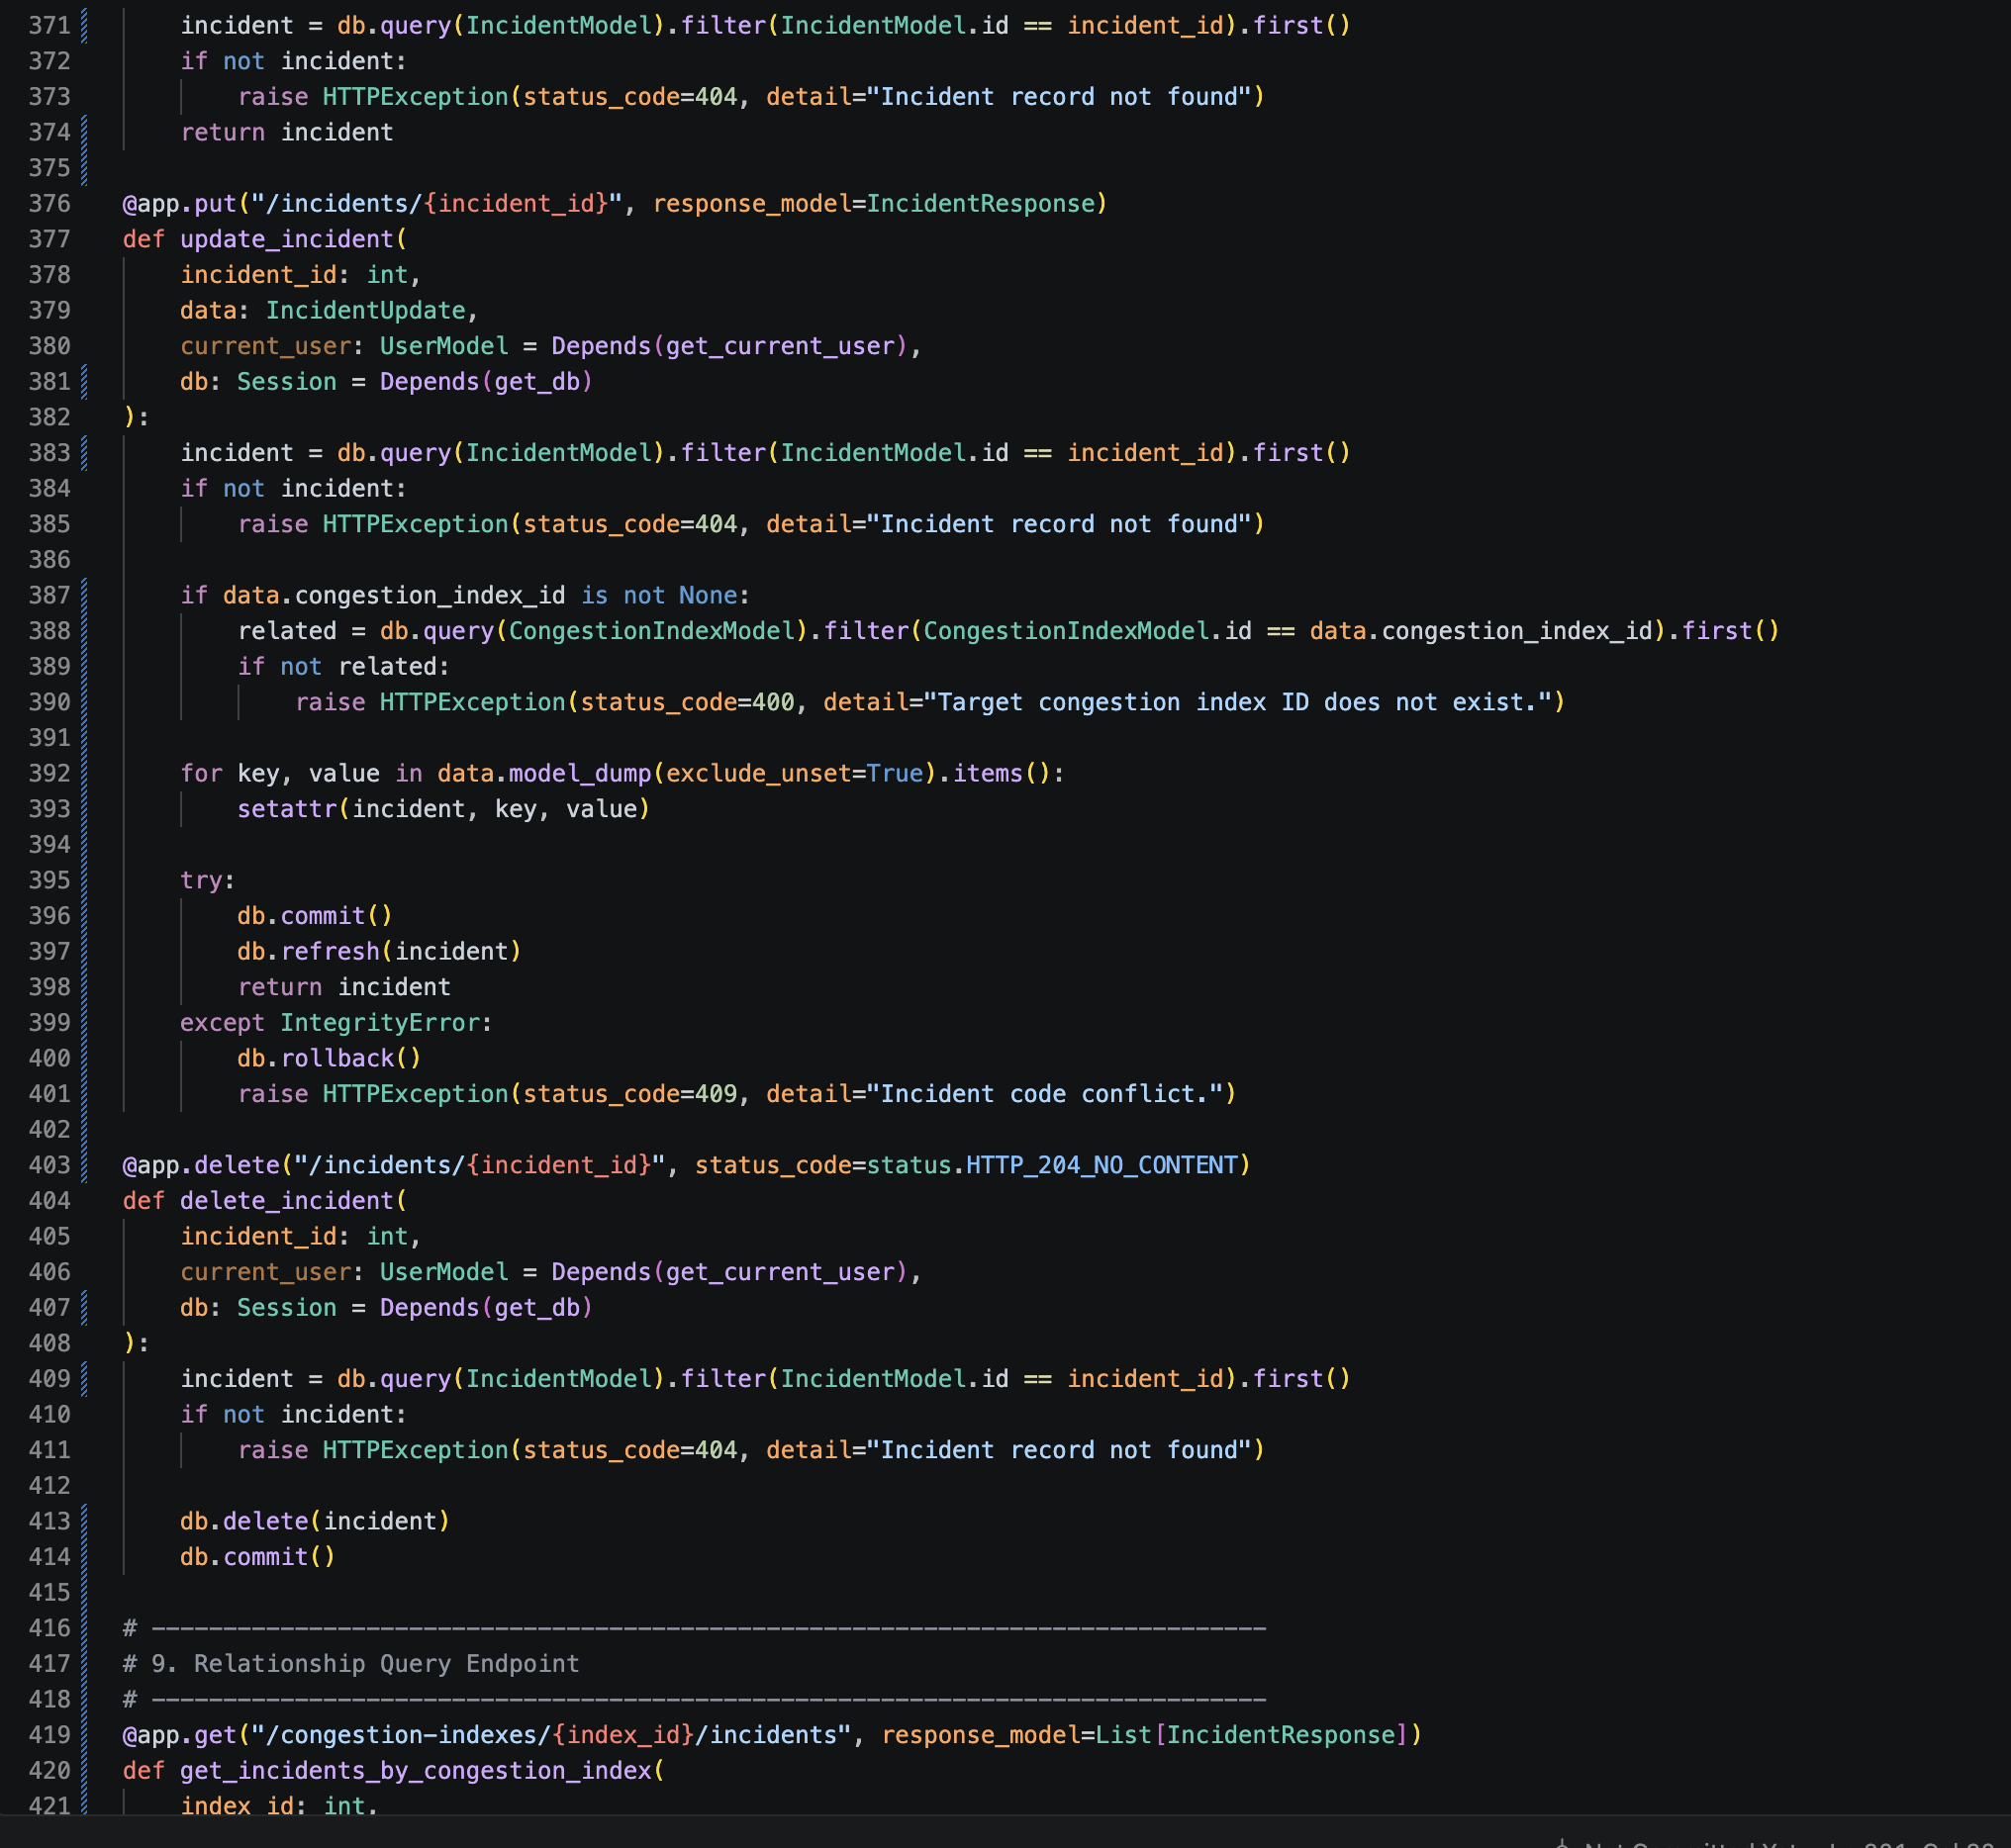
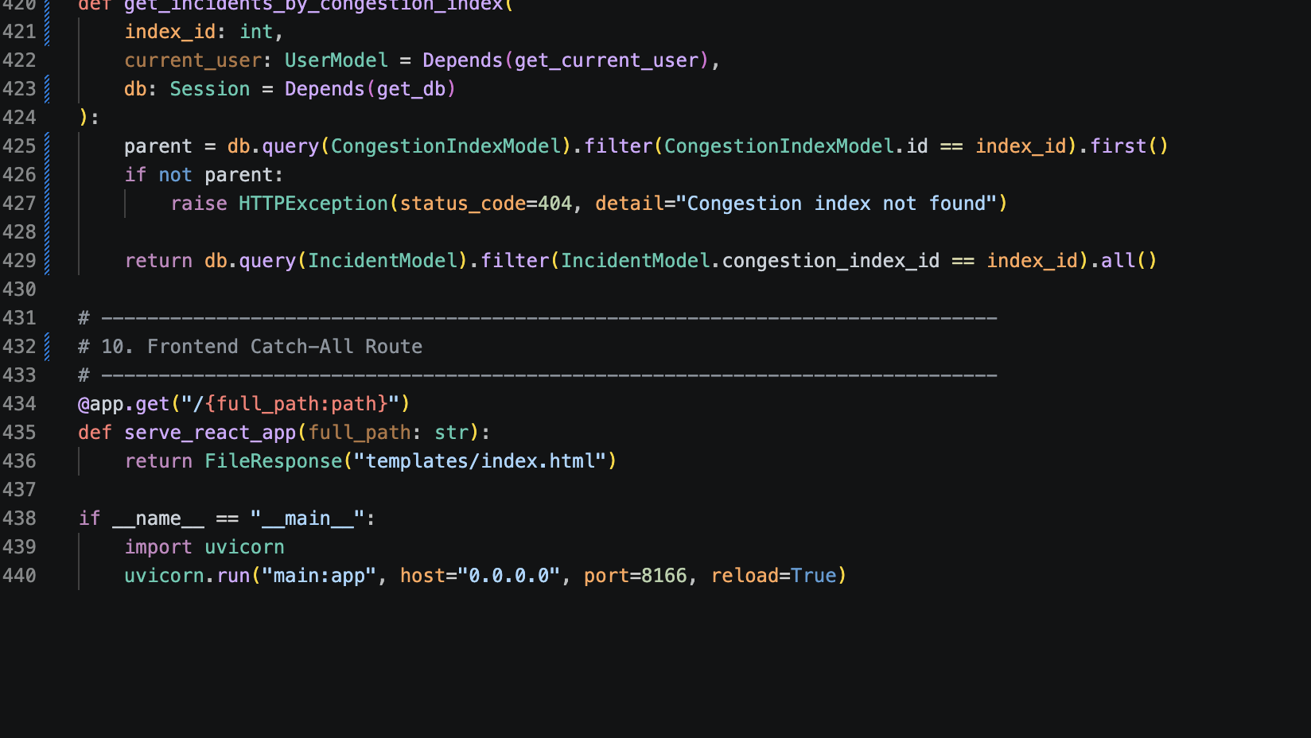
Schemas.py
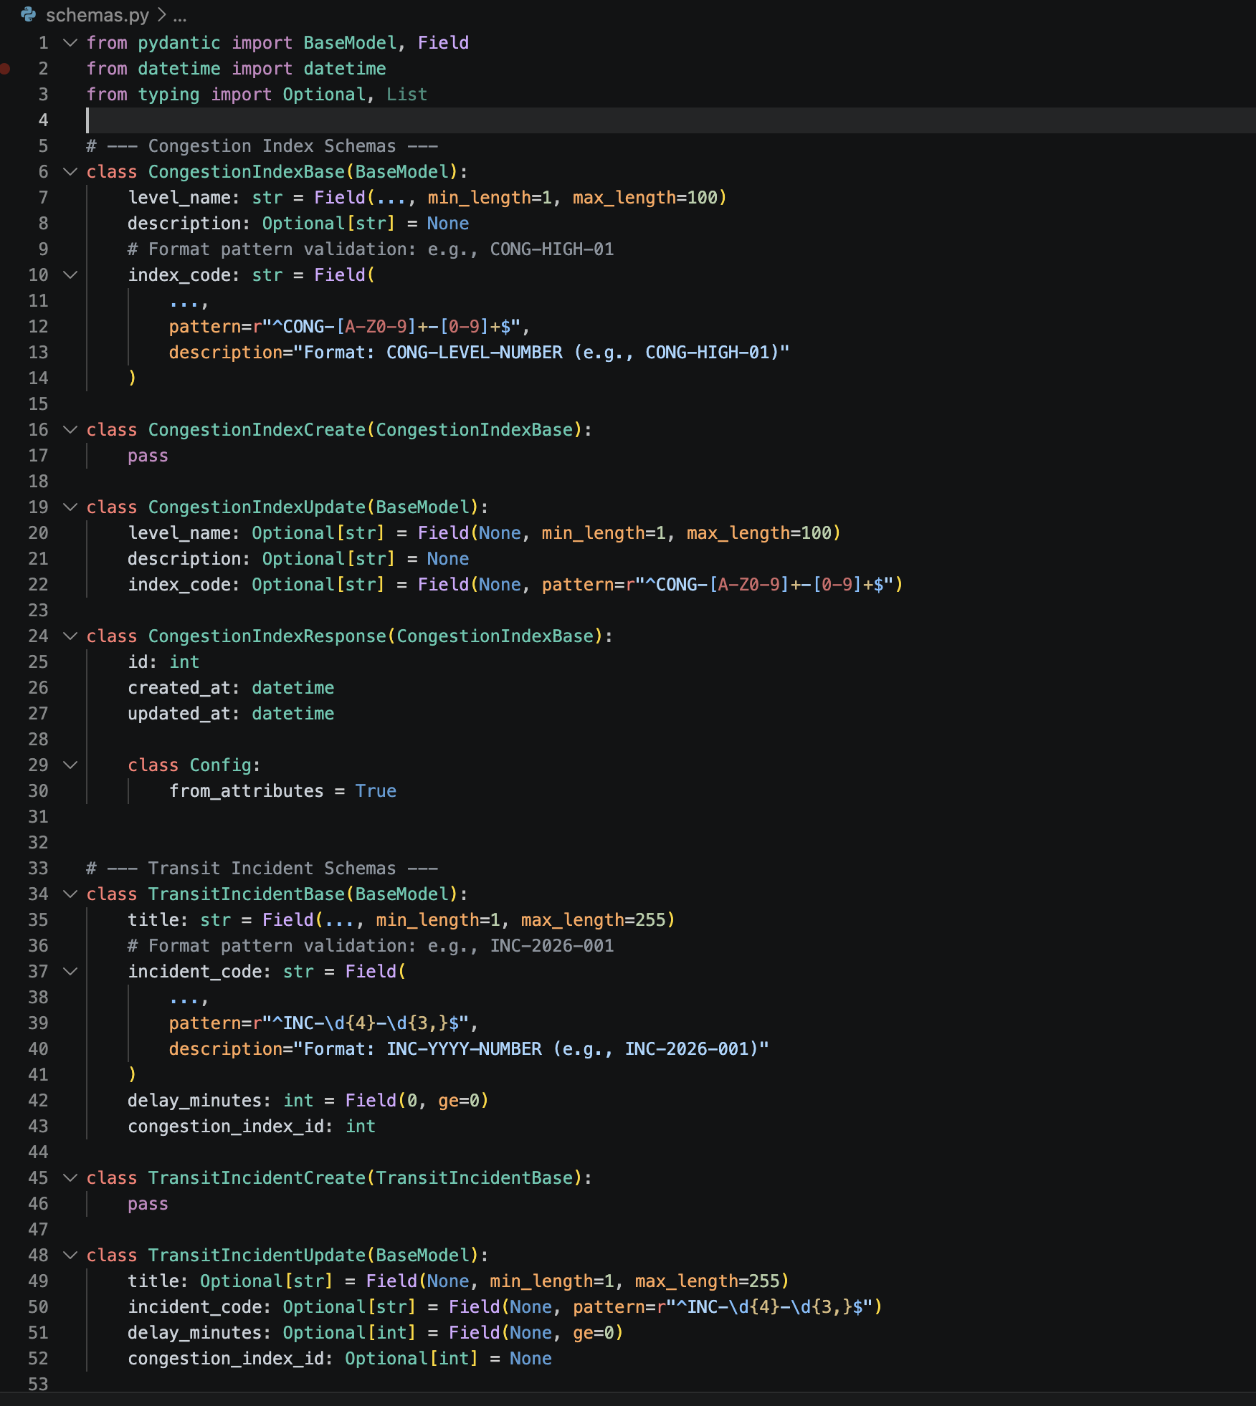
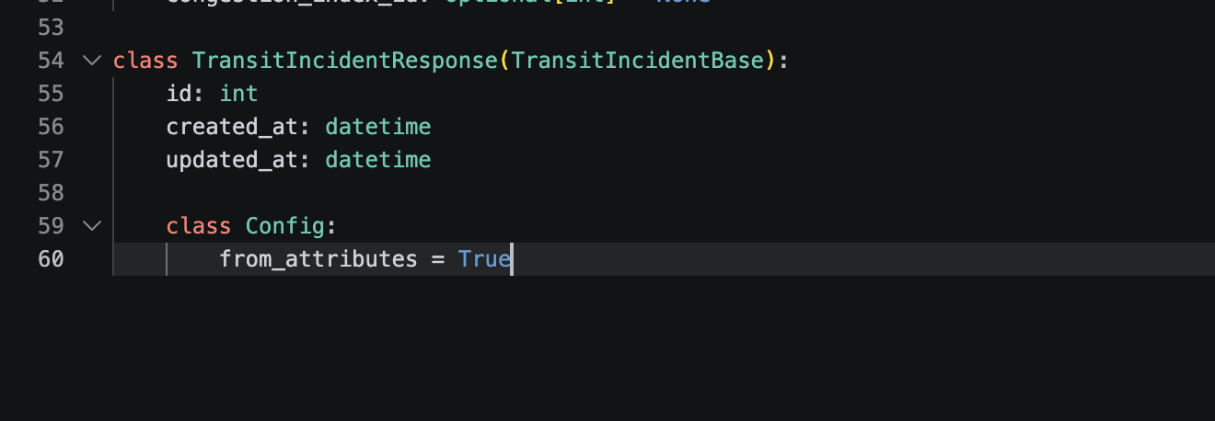
Database.py
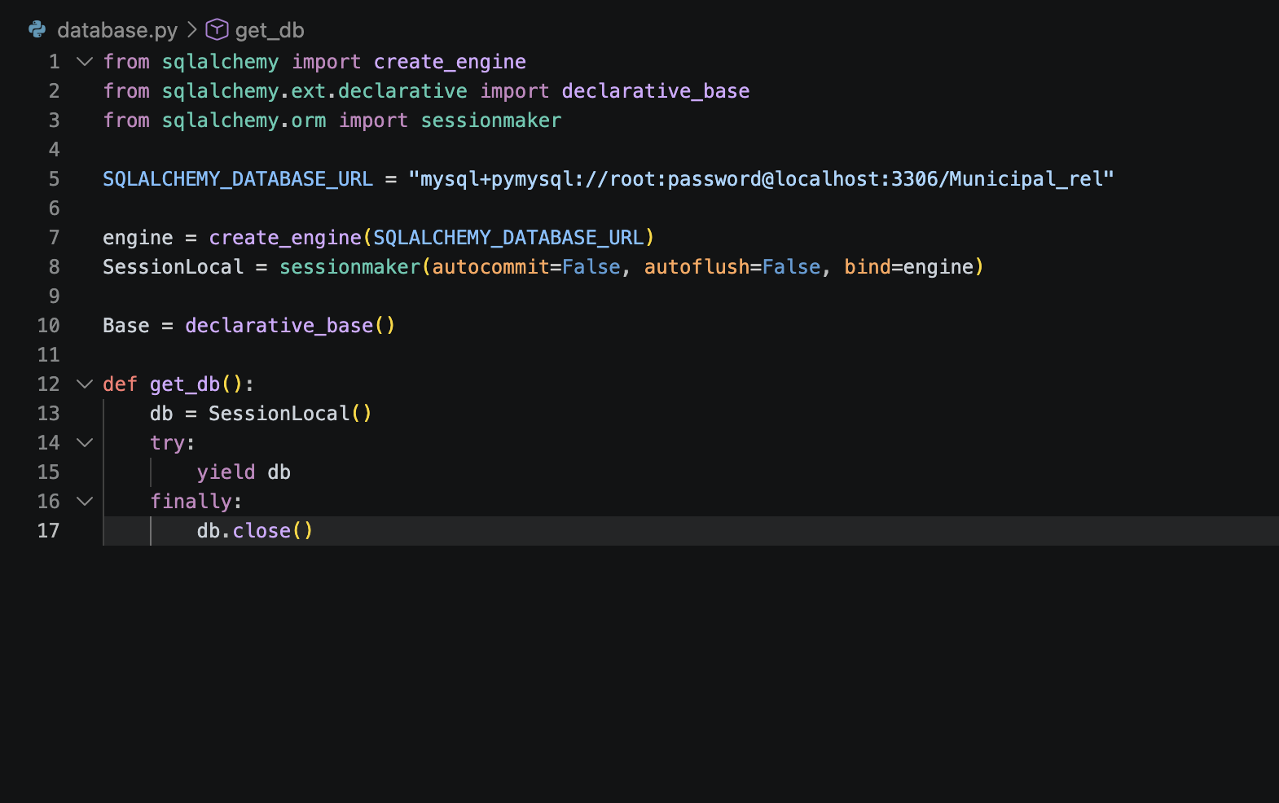
Models.py
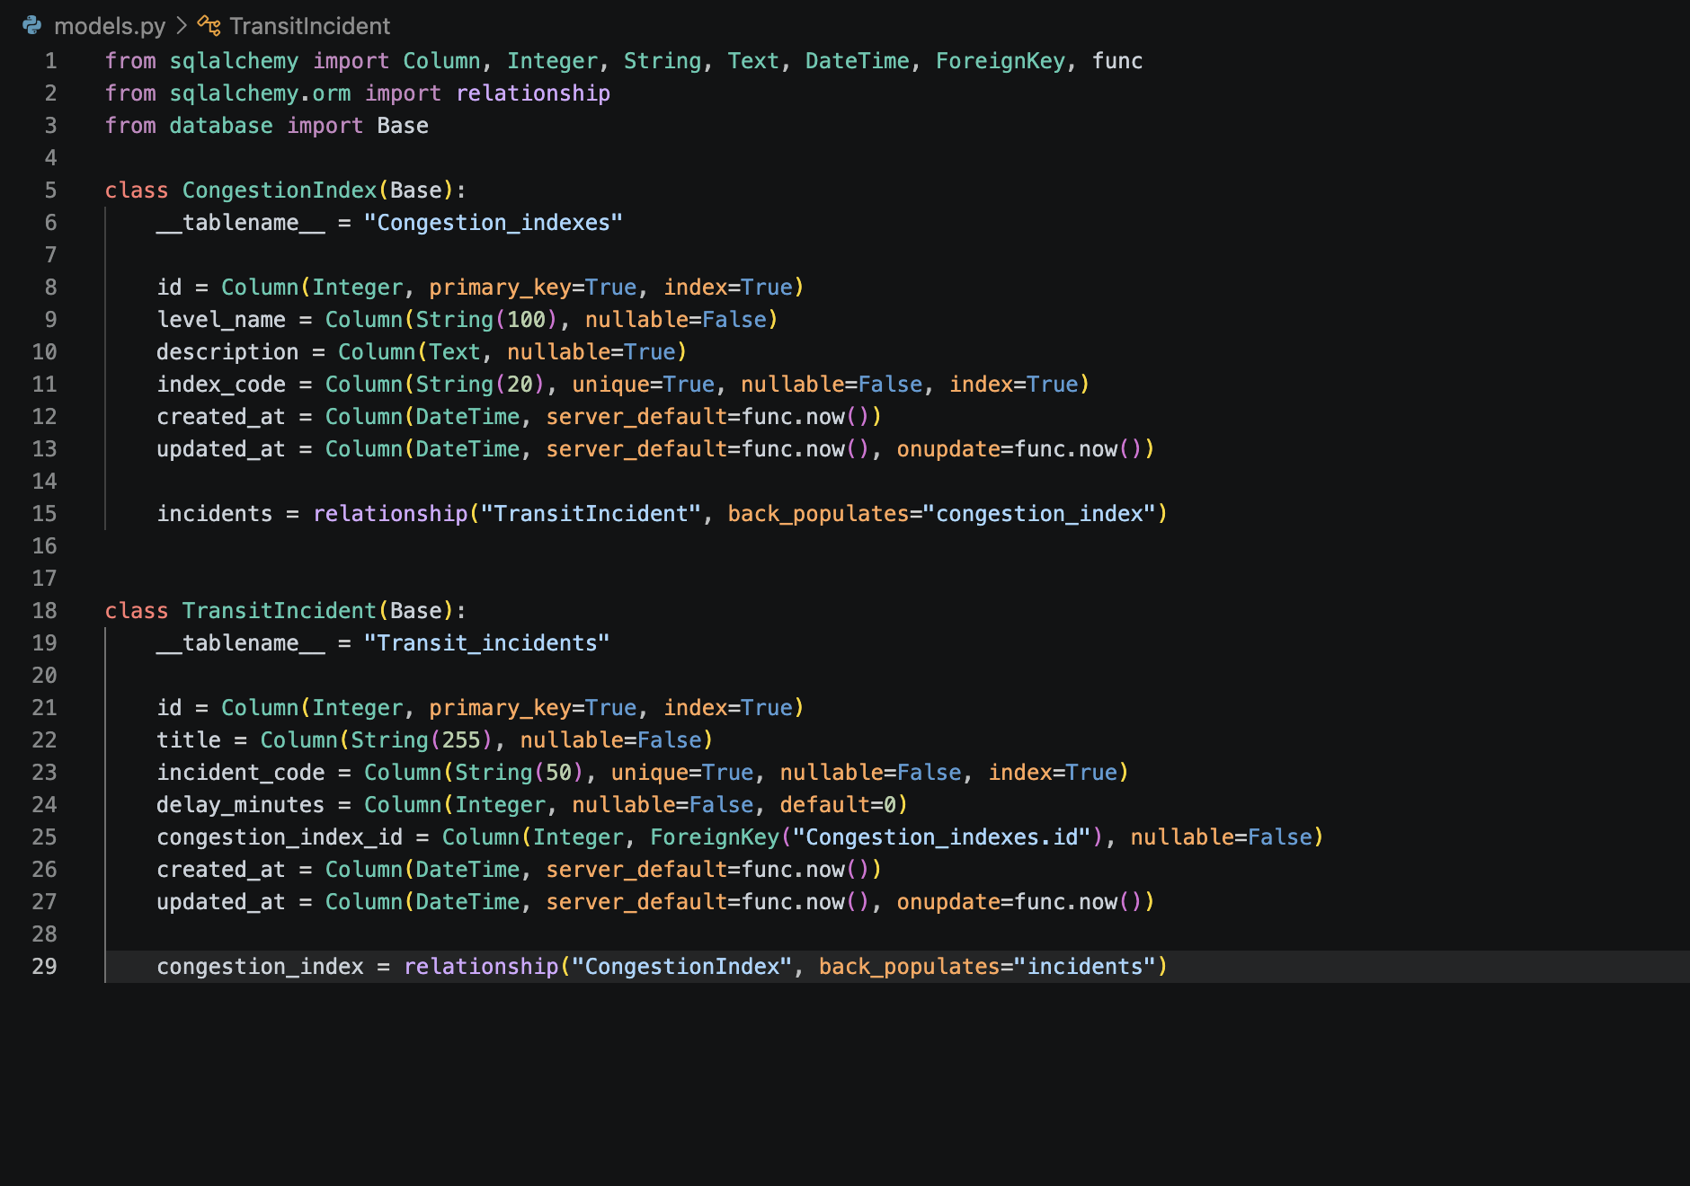

POST /login
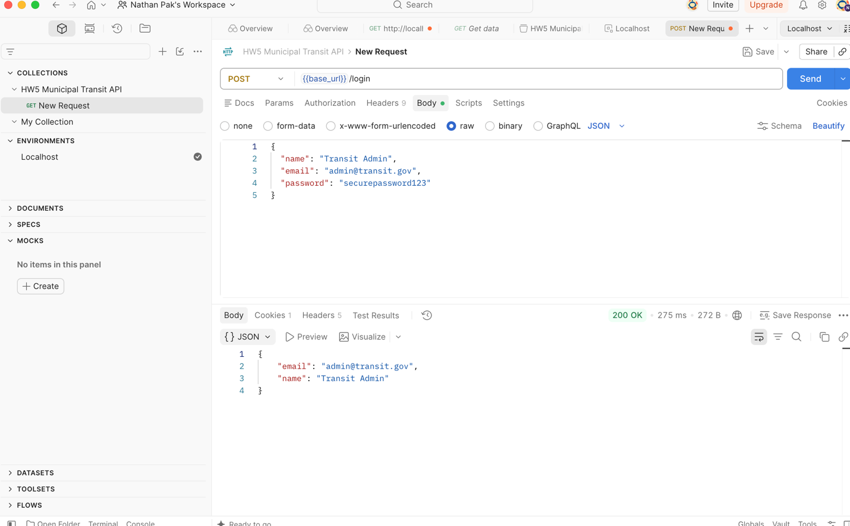

POST /congestion-indexes
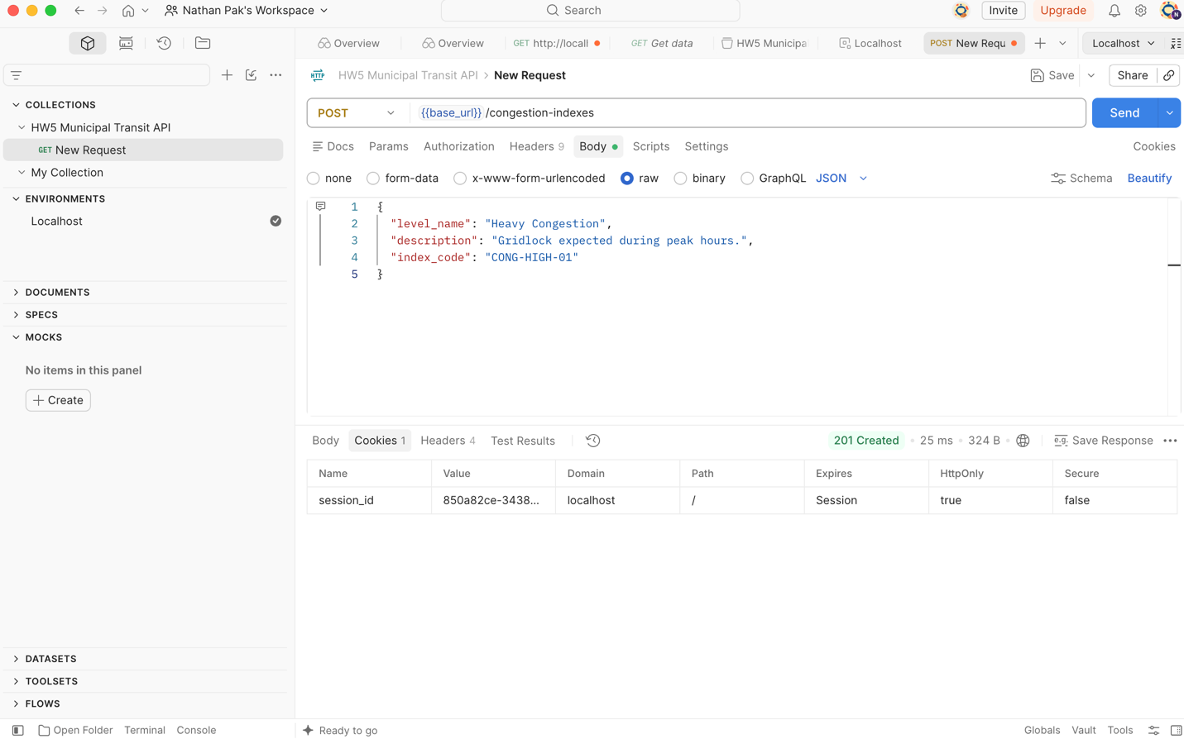
GET Pagination
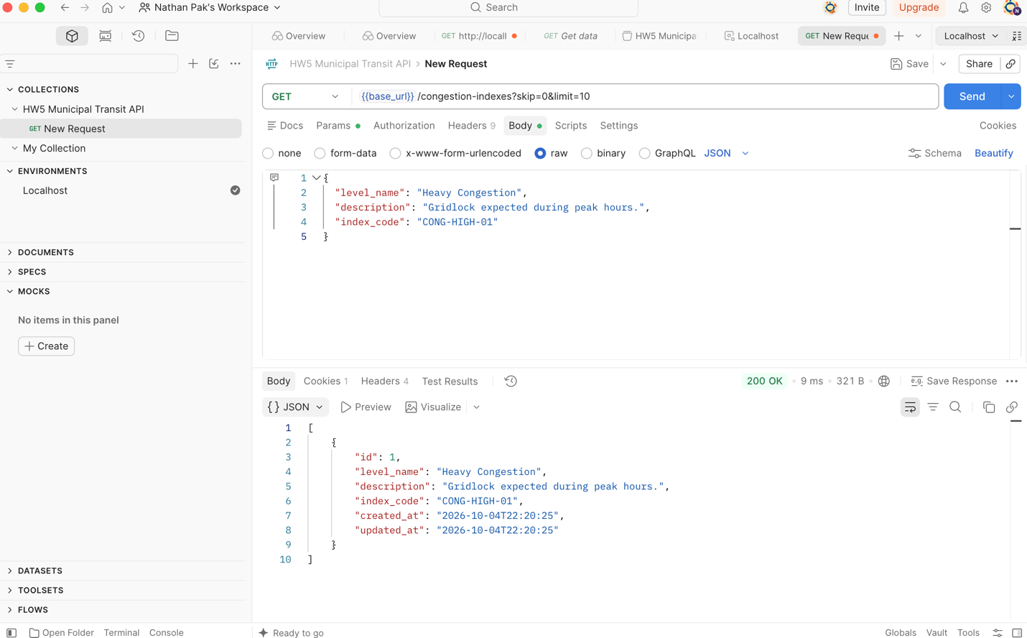
GET Single Congestion Index
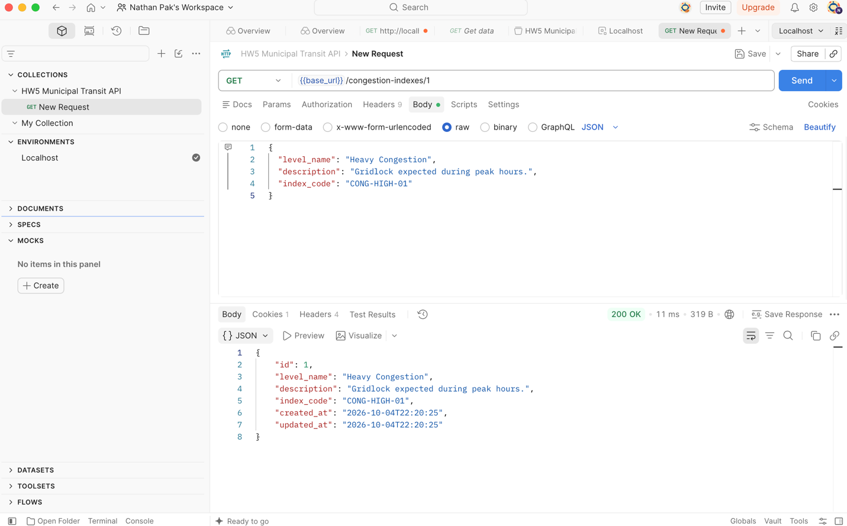
PUT Update Congestion Index
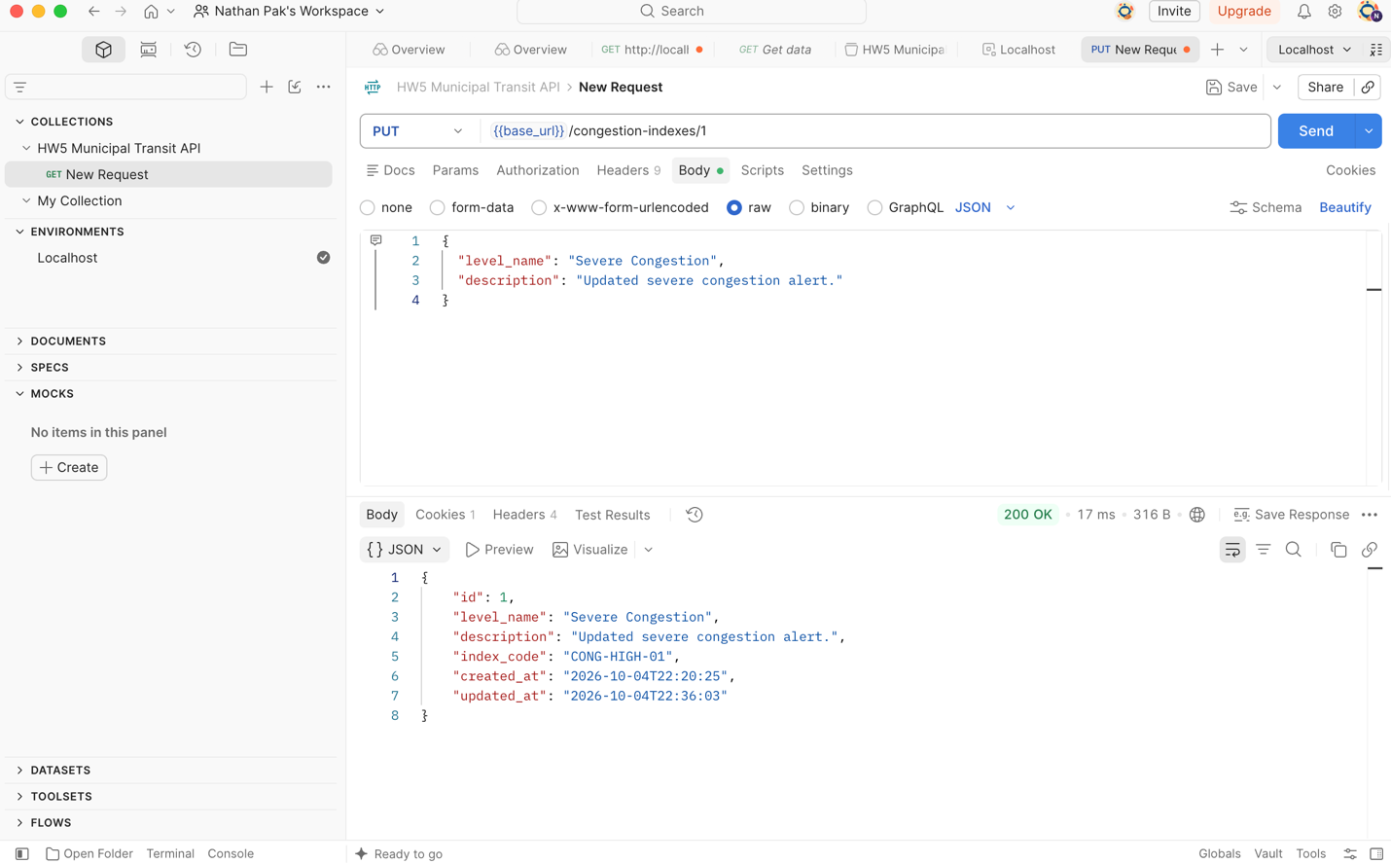
Primary Entity Requests: /incidents
POST Create Incident
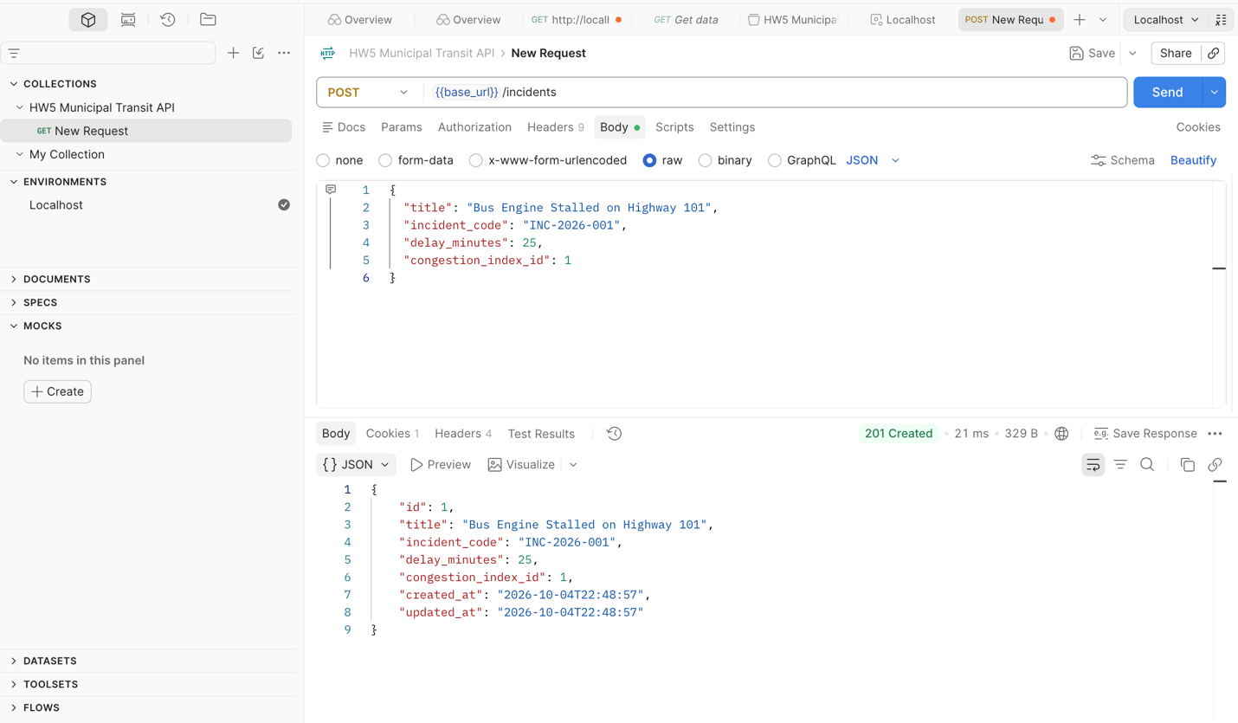
GET List incidents with Pagination
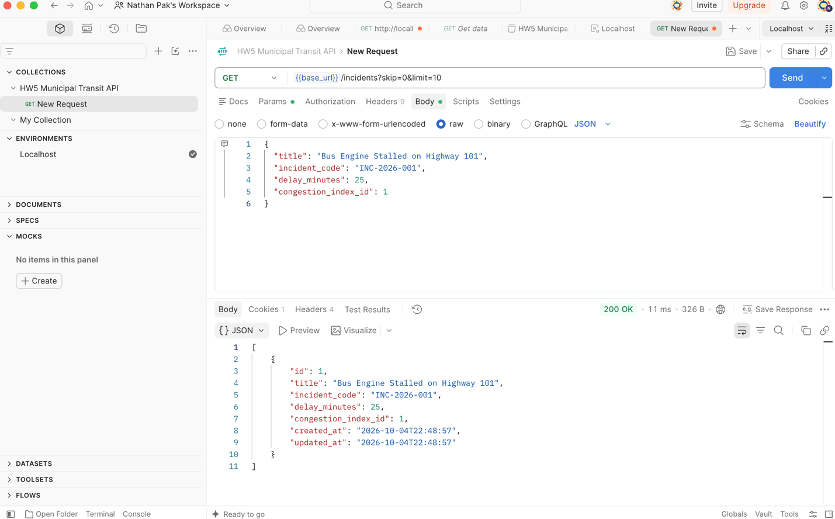
GET Single Incident
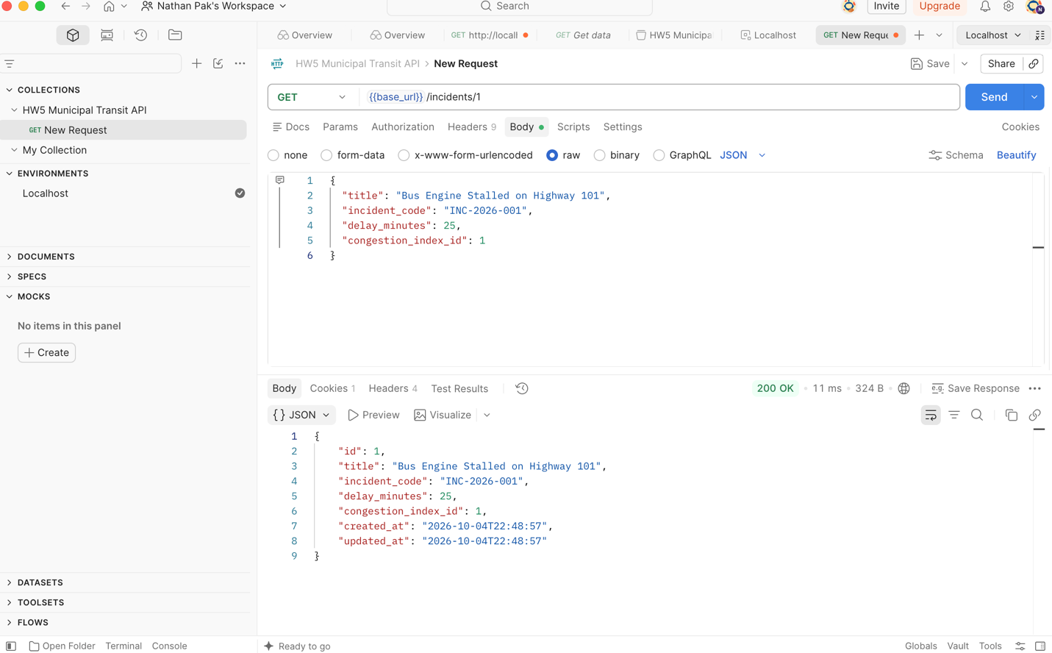
PUT Update Incident
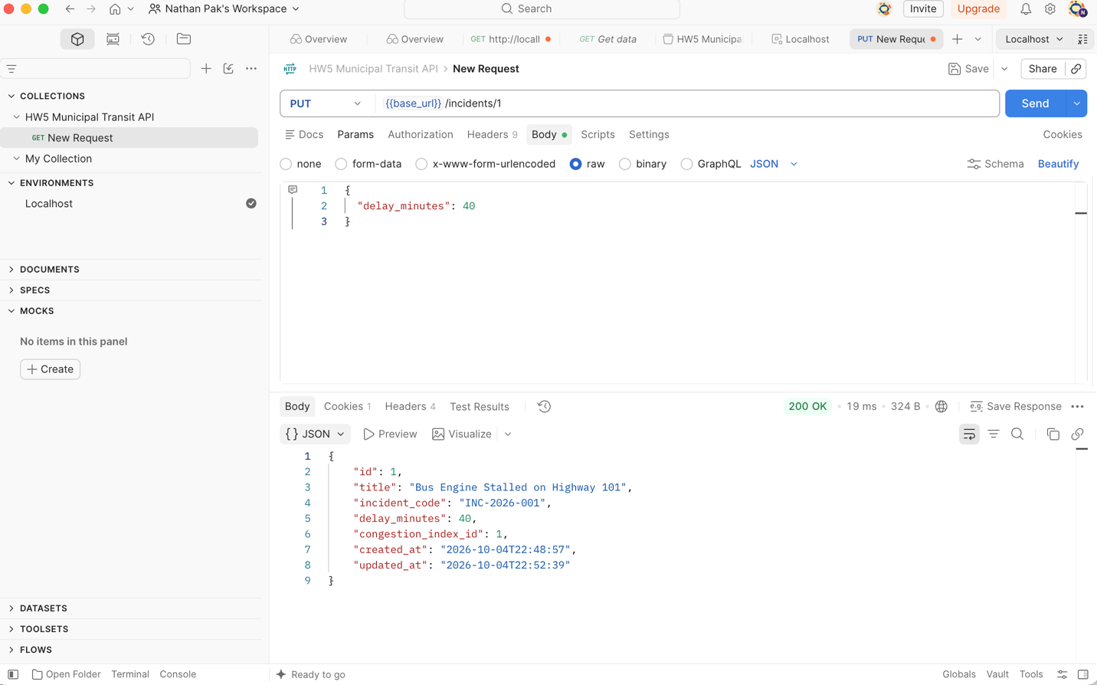
Relationship Query – Returning List containing incident INC-2026-001
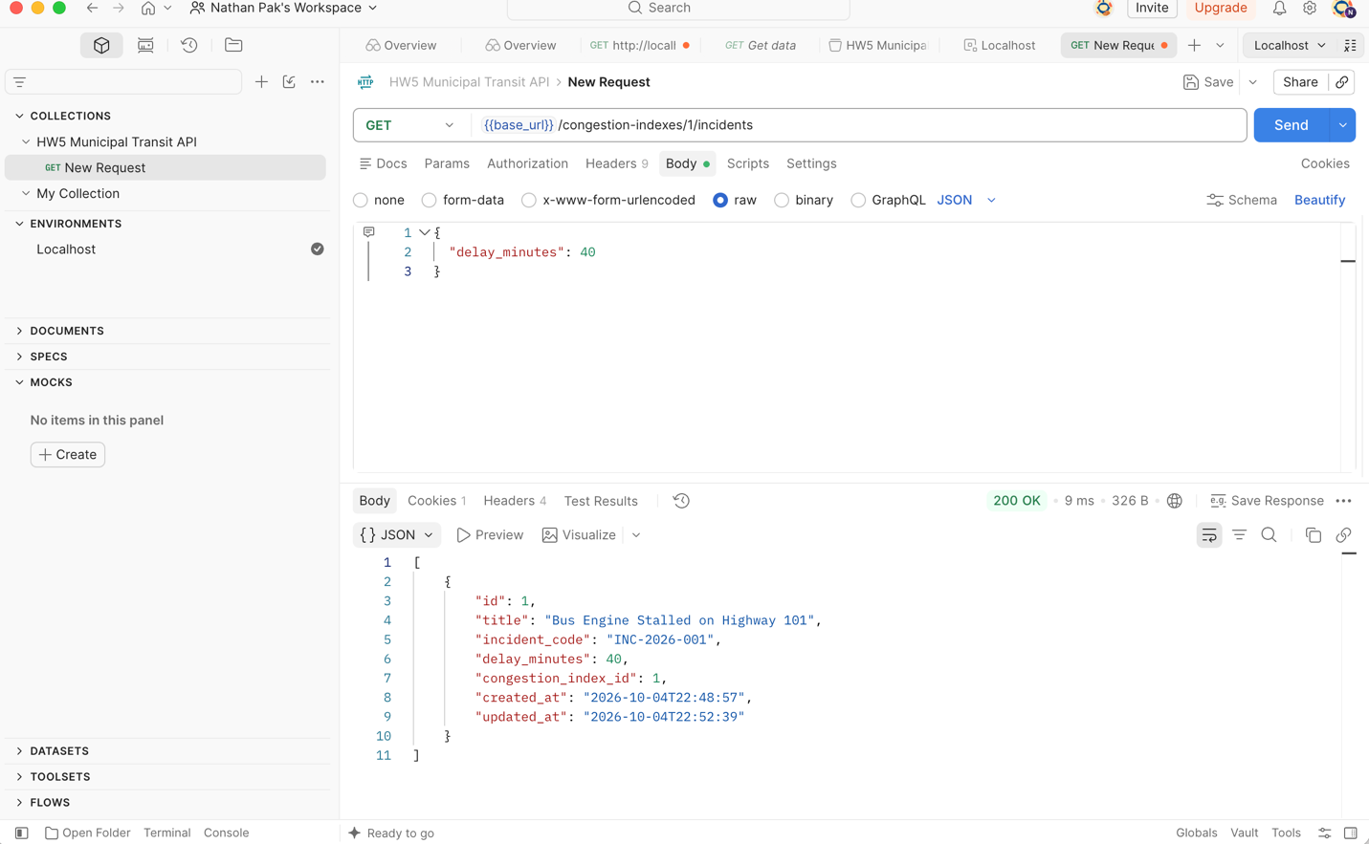
Validation Error Test – Bad Regex Format
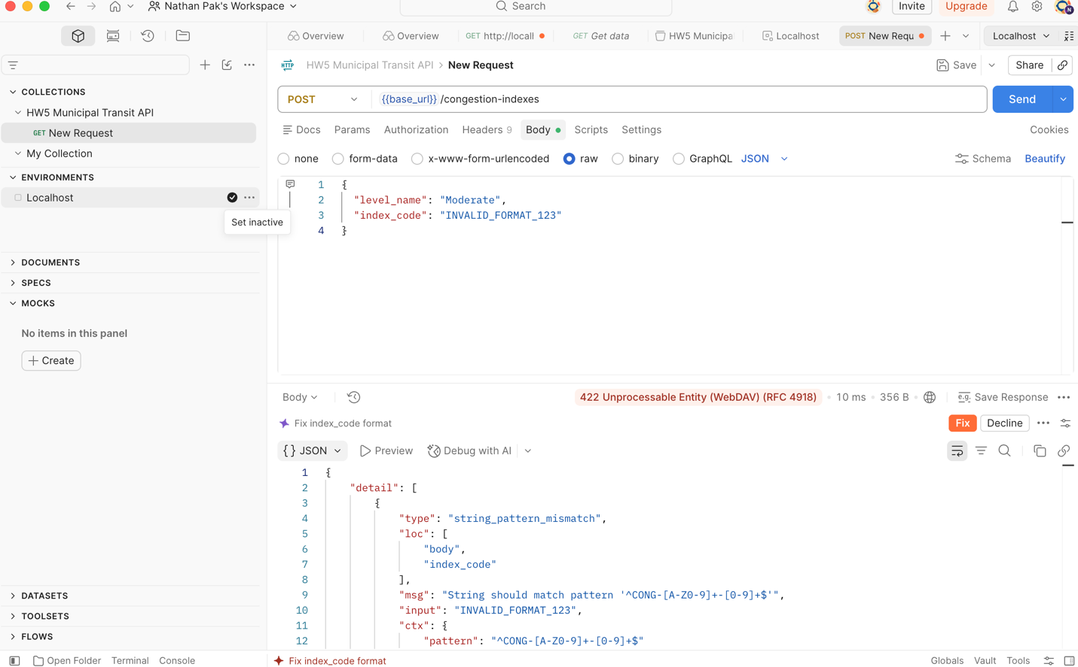
Foreign Key Deletion Constraint Test (DELETE)
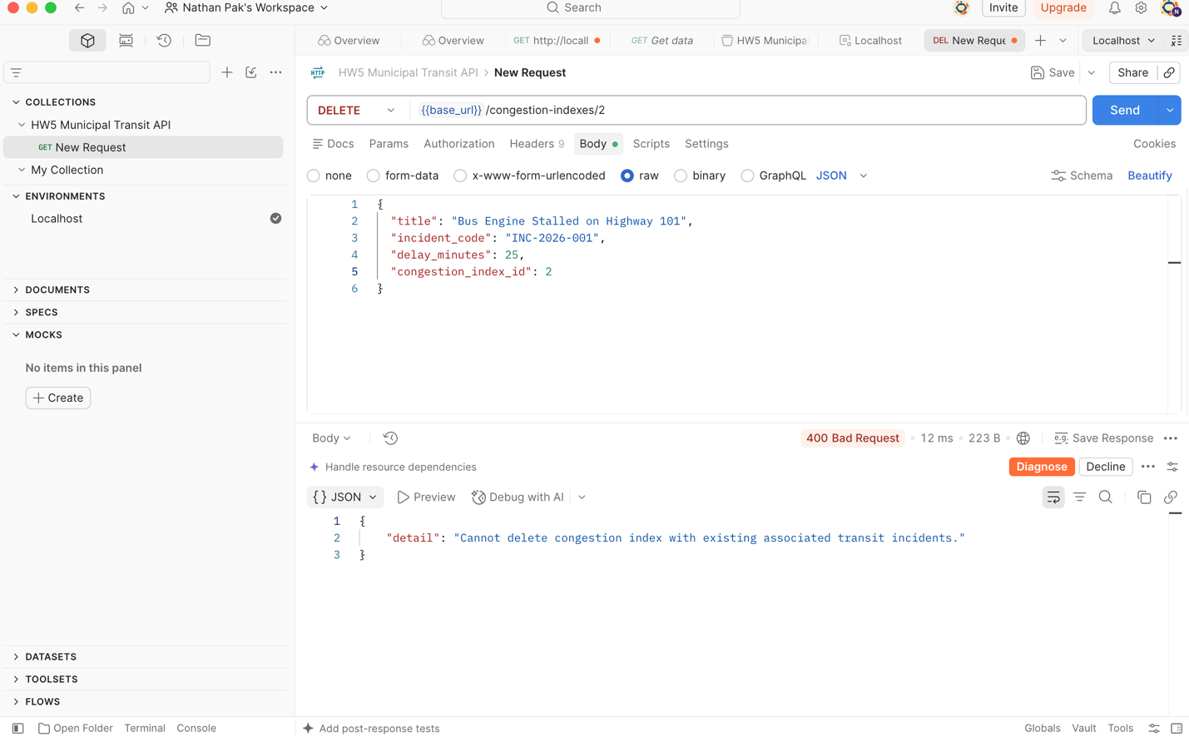
Delete Incident
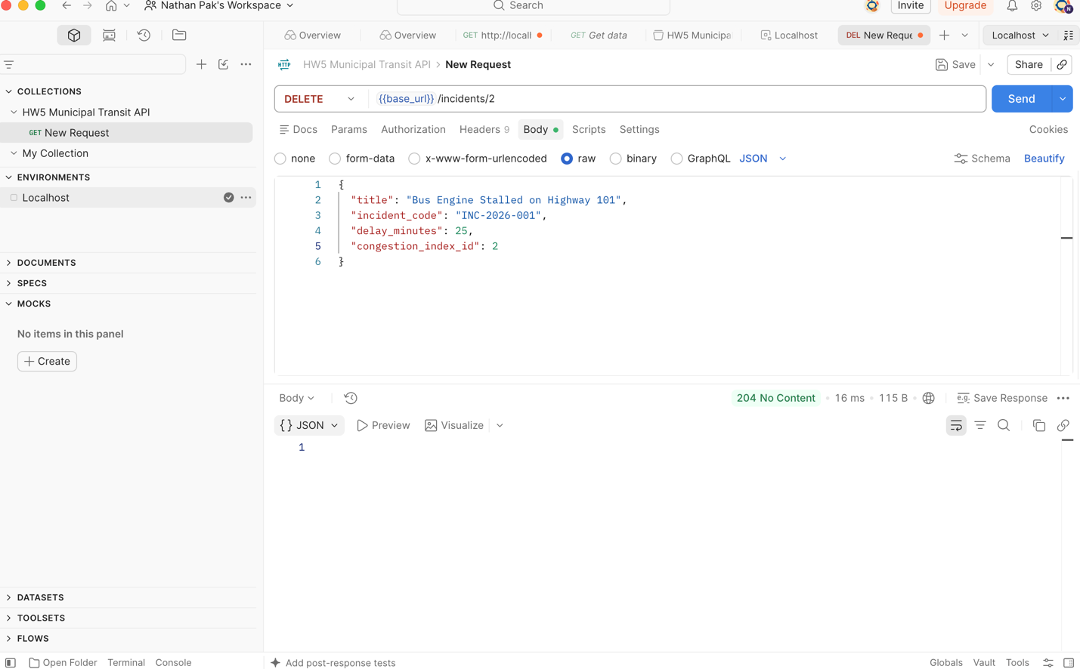
Successful Deletion of Unlinked Parent
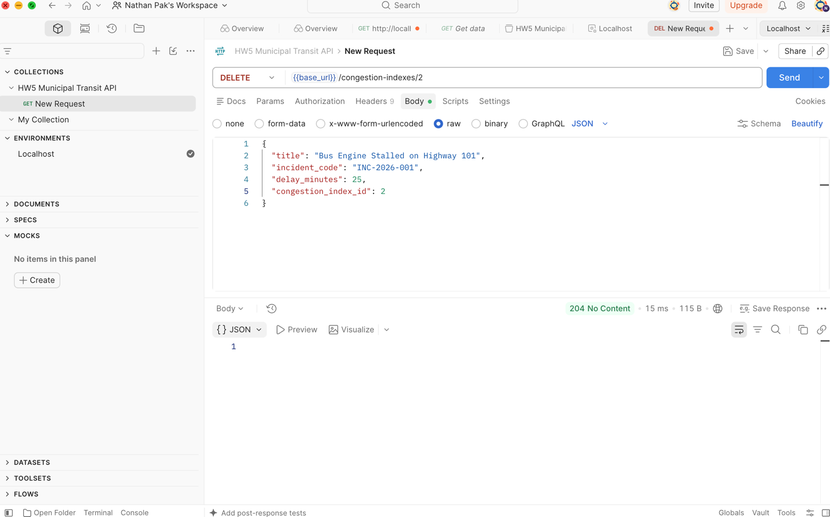
III) Redux Client
Home Screen
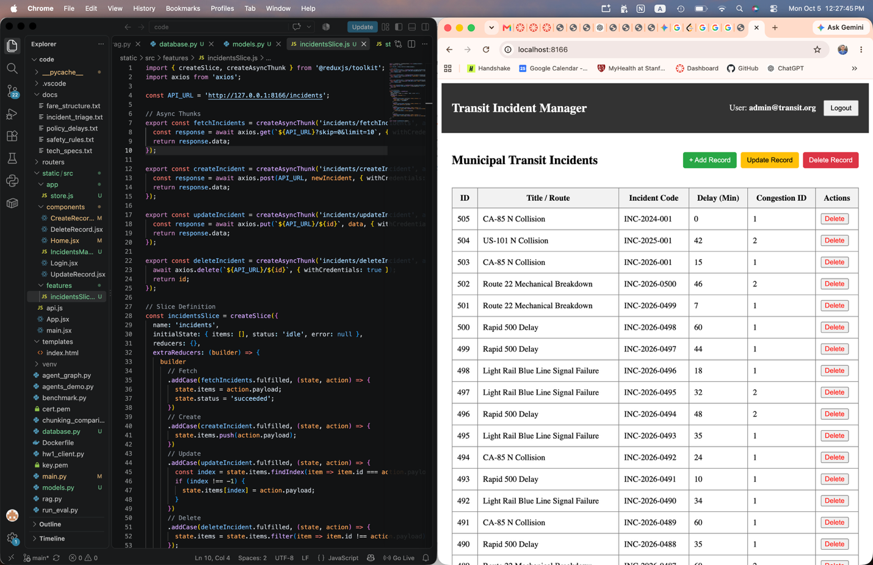
Create Screen
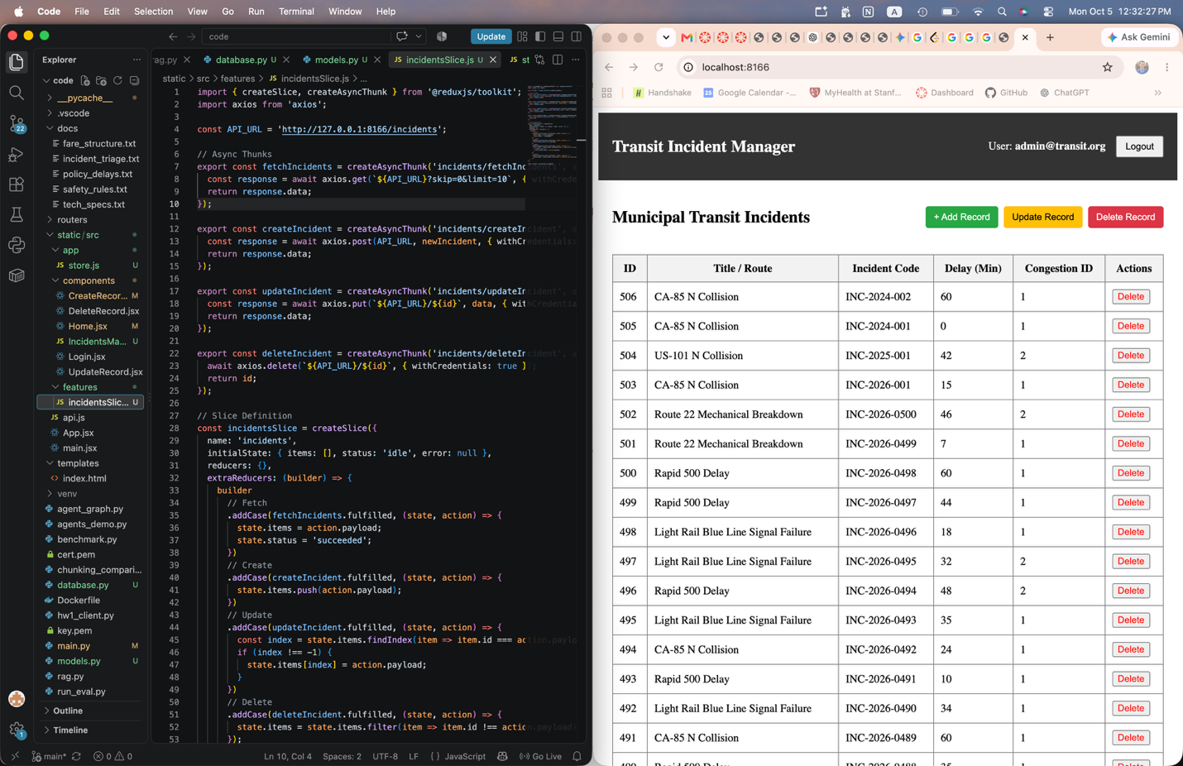
Updated Incident ID 506
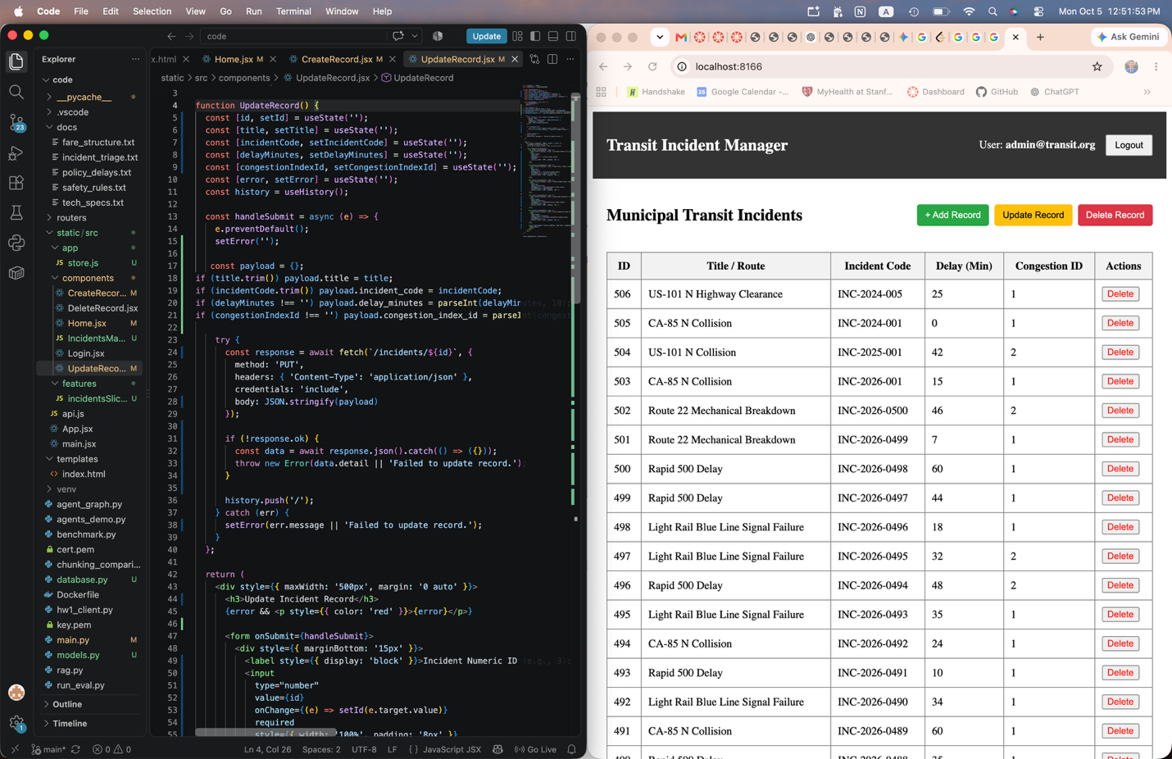
Deleted Incident ID 506
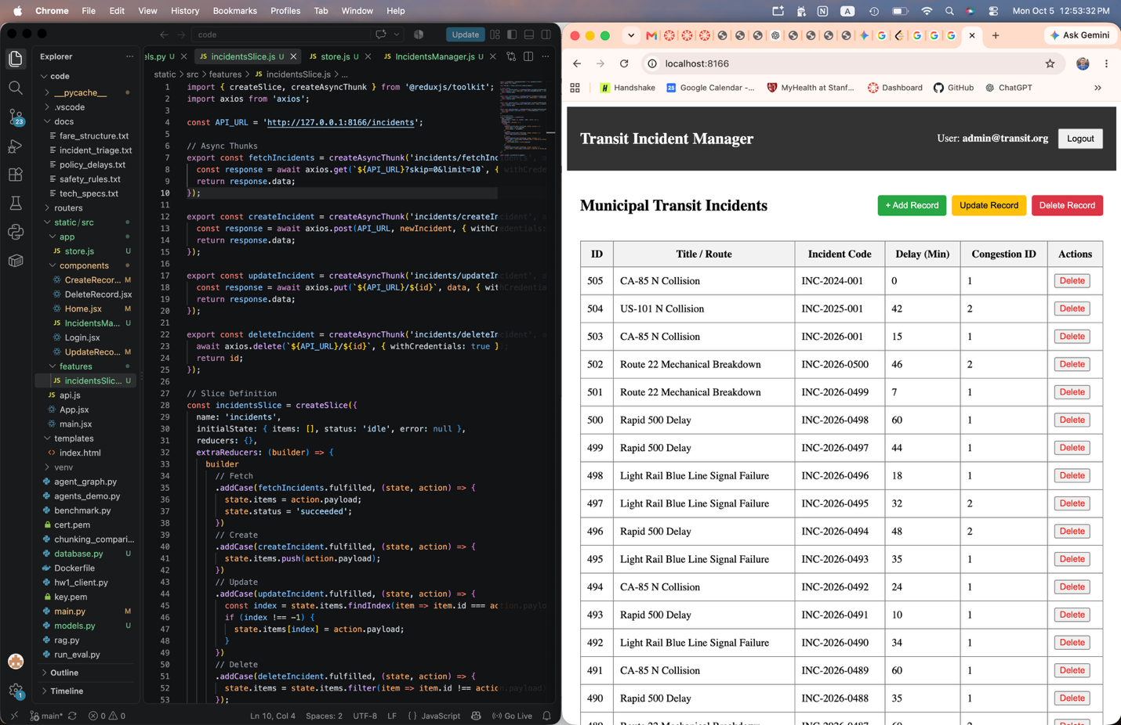
Part 2)
A)
Search_meals_by_name() Query=”pasta”
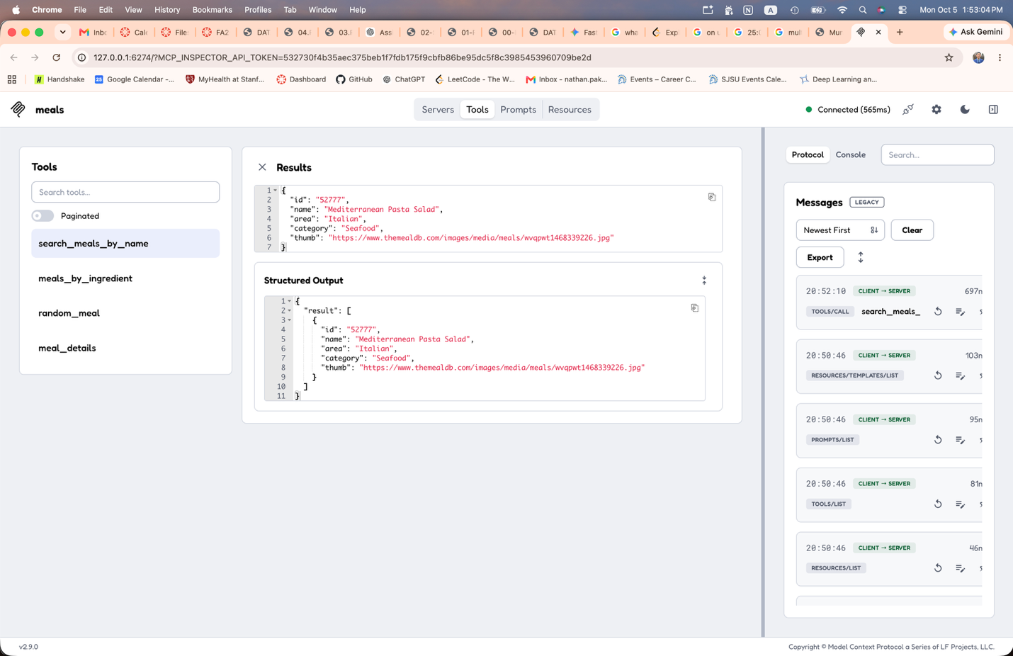
Meals_by_ingredient() – query = ‘chicken’
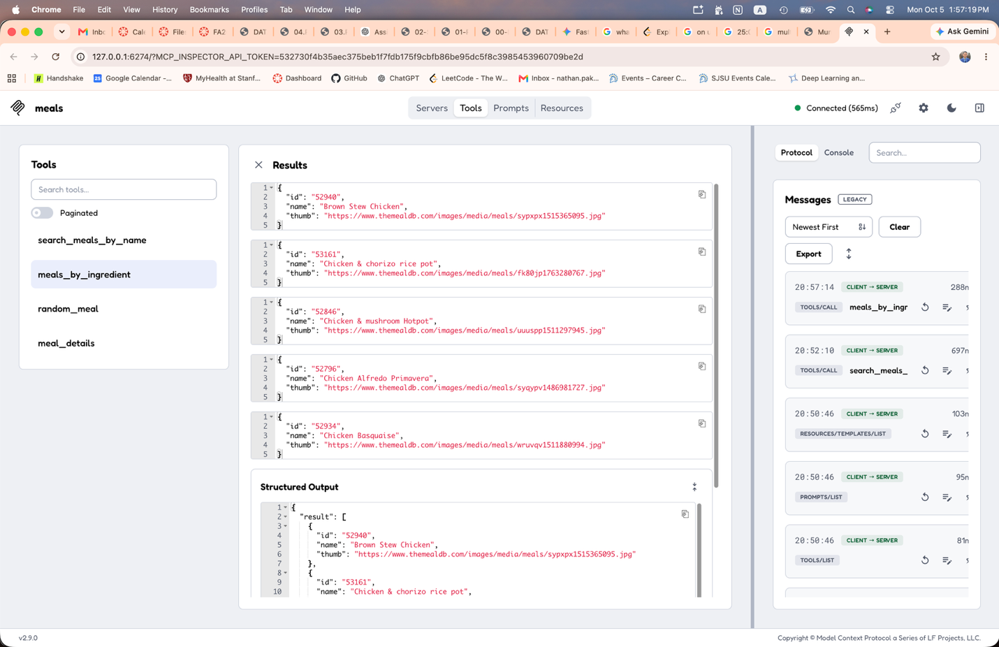
Random_meal()
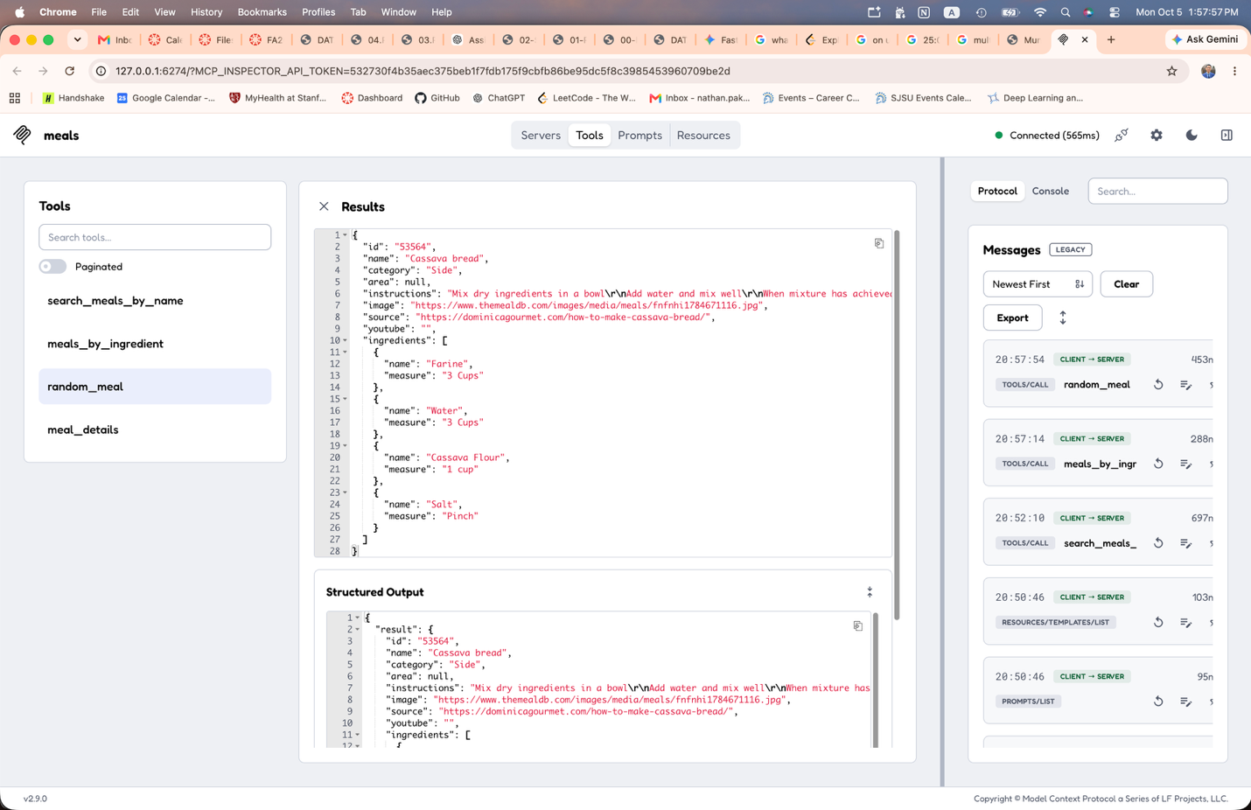
Meal_details ID: 52772

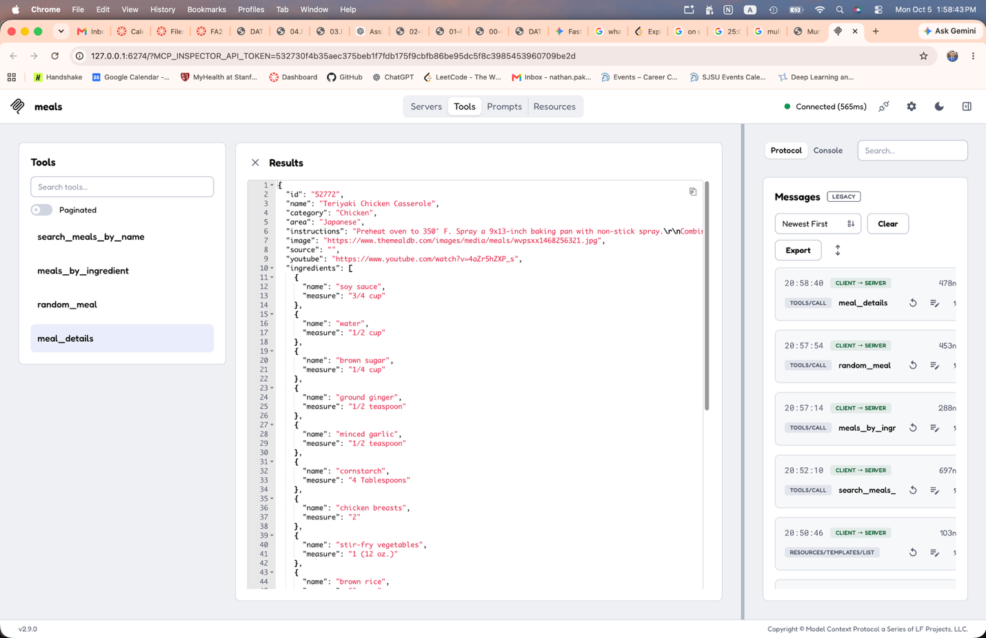
B)
Search_items query = Route 22
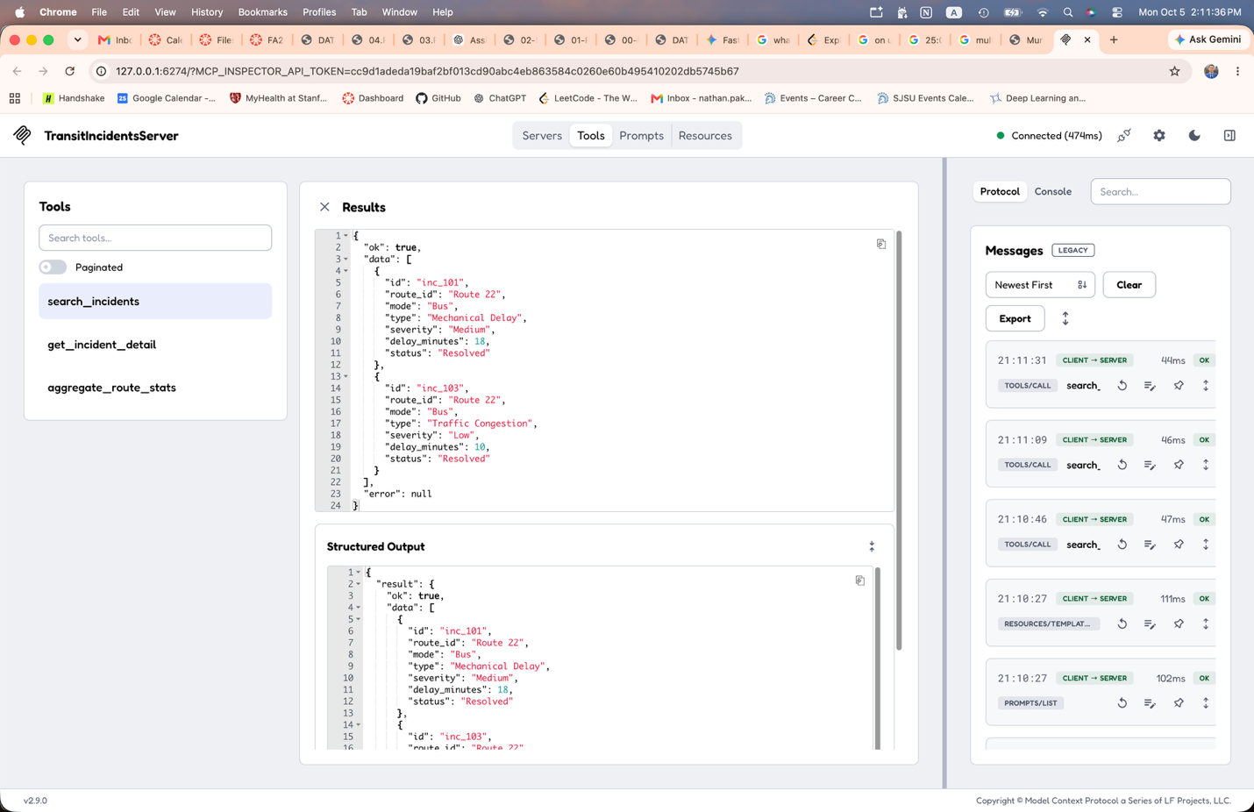
Search_items invalid input
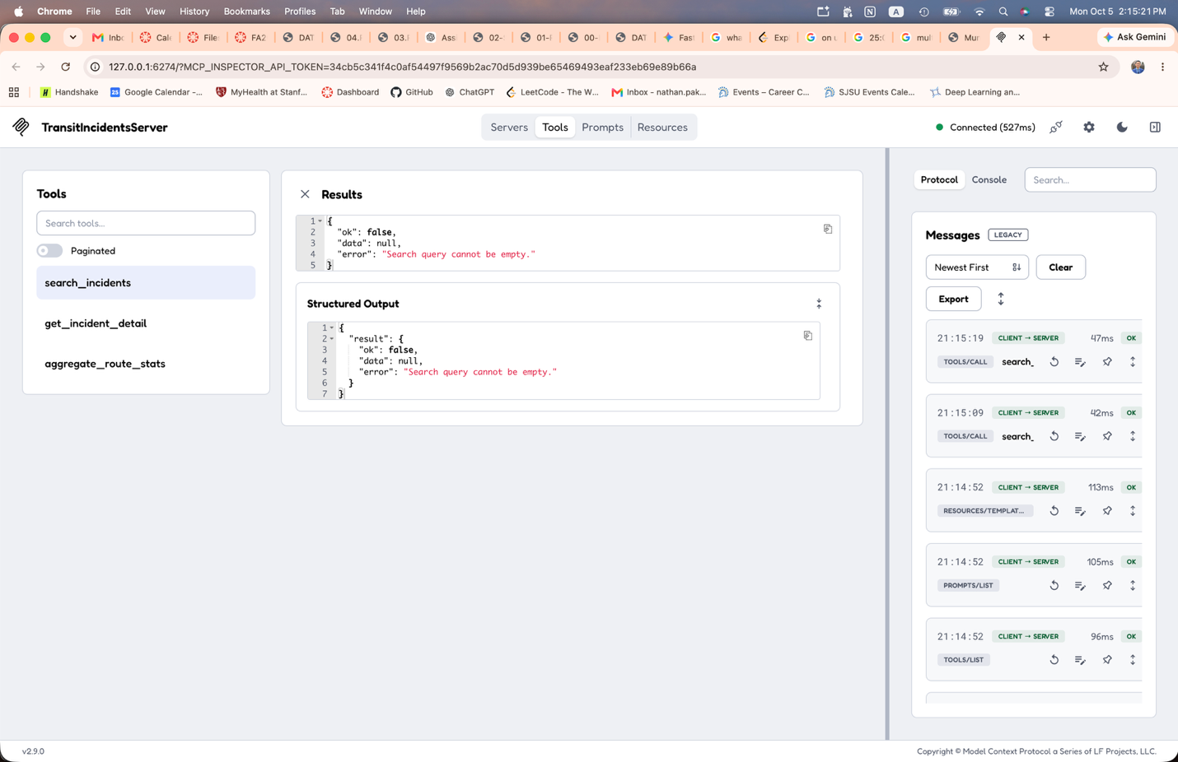
Get_incident_detail: query = inc_101
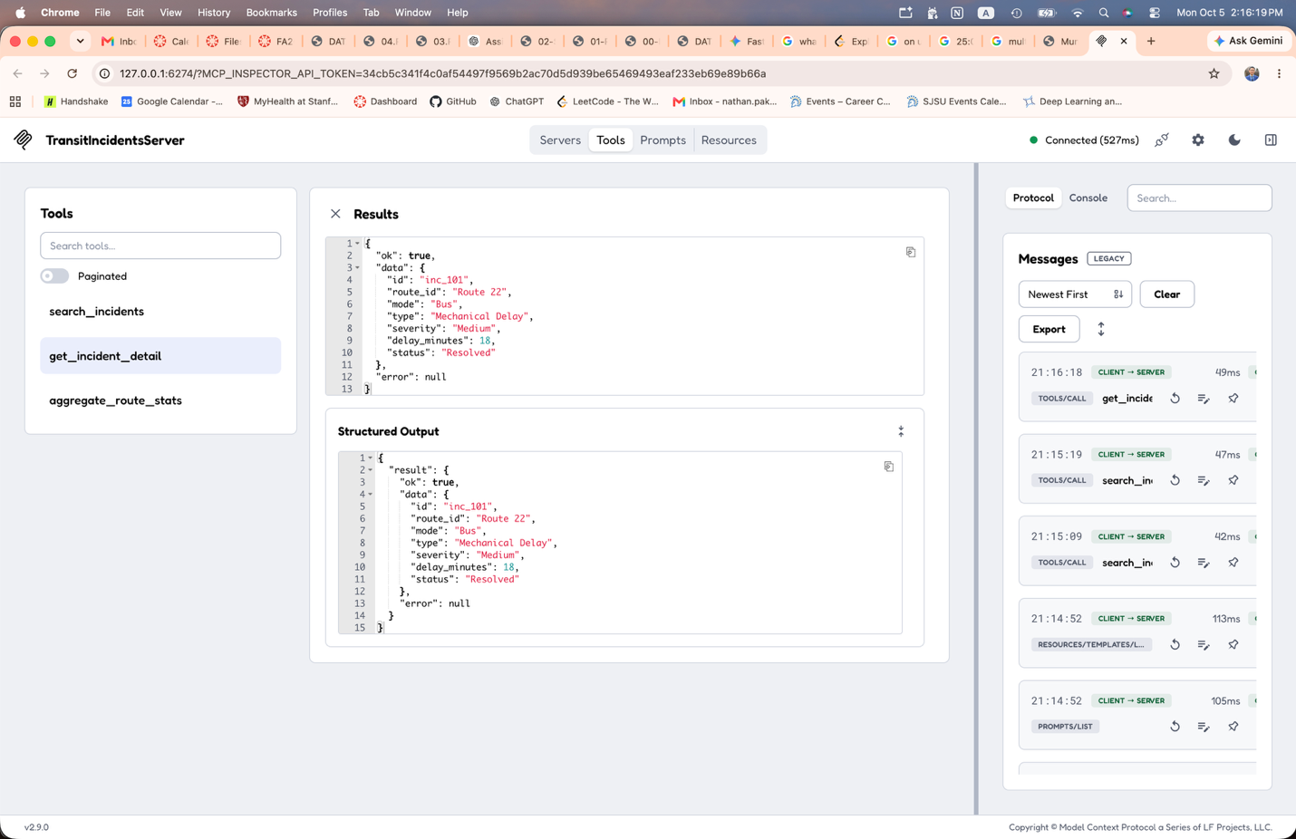
Invalid Input for get_incident_detail
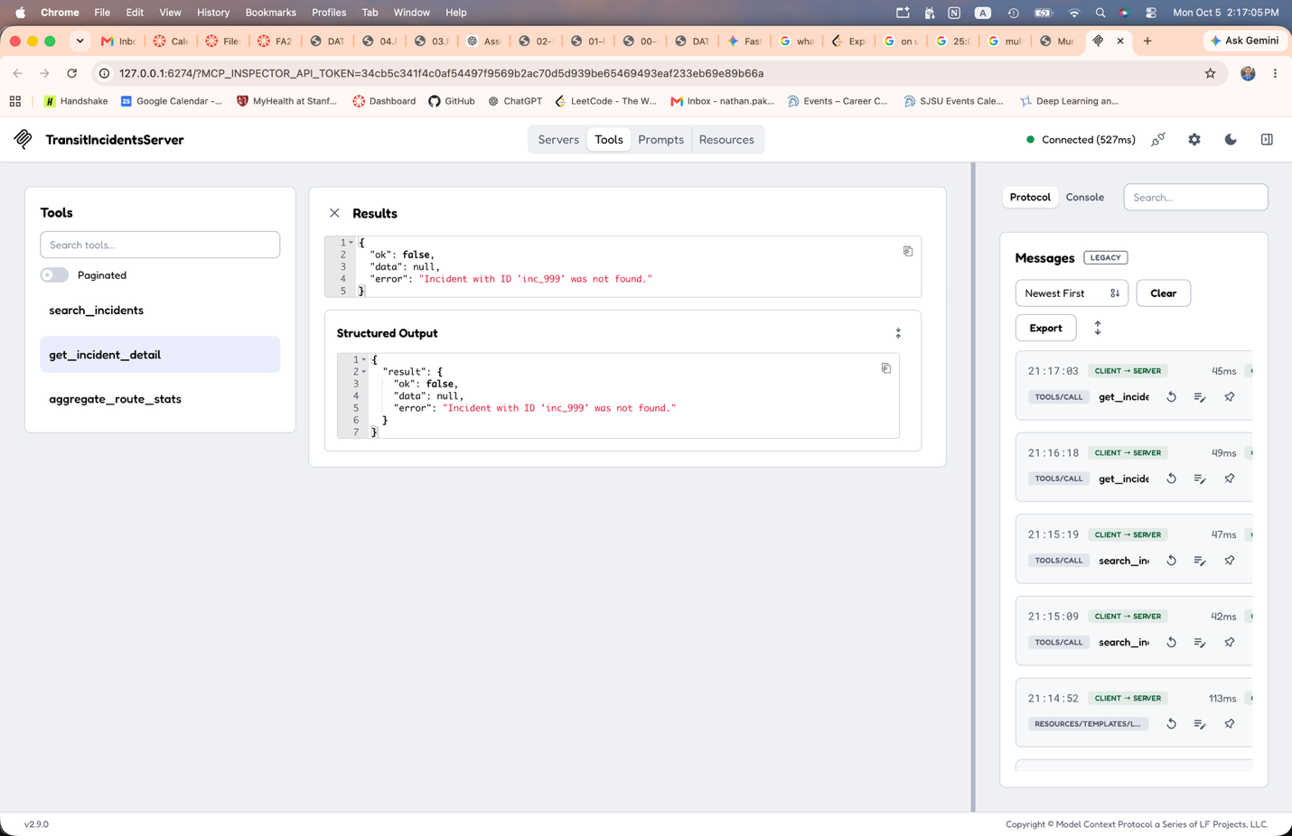
Aggregate_route_stats query = Route 22
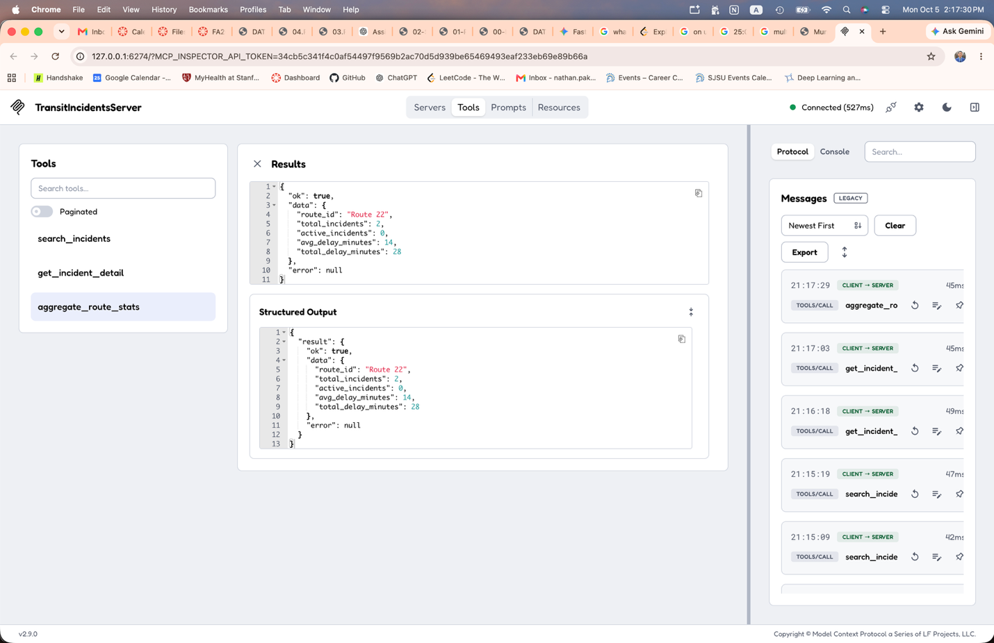
Invalid input for aggregate_route_stats
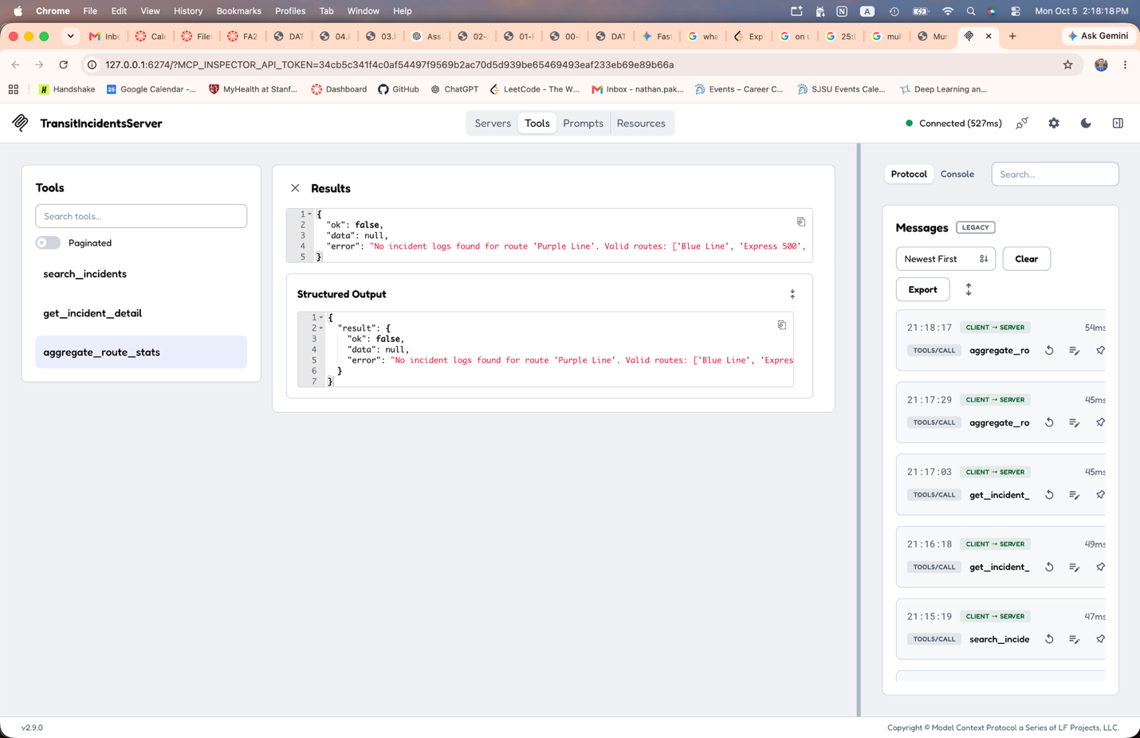
Part 3)
18)
Search_incidents
Expected JSON Input
{
"type": "object",
"properties": {
"query": { "type": "string" }
},
"required": ["query"]
}
Rejected JSON Input
{
"query": ""
}
Returned Error Output
{
"ok": false,
"data": null,
"error": "Search query cannot be empty."
}
Reason for Rejection: The input contained an empty query string. The server enforces input validation requiring non-whitespace search terms to prevent unbounded or ambiguous scans.

Get_incident_detail
Expected Input
{
"type": "object",
"properties": {
"incident_id": { "type": "string" }
},
"required": ["incident_id"]
}
Rejected Input
{
"incident_id": "inc_999"
}
Returned Error
{
"ok": false,
"data": null,
"error": "Incident with ID 'inc_999' was not found."
}
The provided incident_id does not exist in the municipal transit incident dataset.
Aggregate_route_stats
Expected Input:
{
"type": "object",
"properties": {
"route_id": { "type": "string" }
},
"required": ["route_id"]
}
Rejected Input:
{
"route_id": "Purple Line"
}
Returned Error:
{
"ok": false,
"data": null,
"error": "No incident logs found for route 'Purple Line'. Valid routes: ['Blue Line', 'Express 500', 'Green Line', 'Route 22']"
}
The requested transit route has no recorded logs in the dataset. Aggregation fails cleanly with a user-friendly error listing available valid routes.
19)
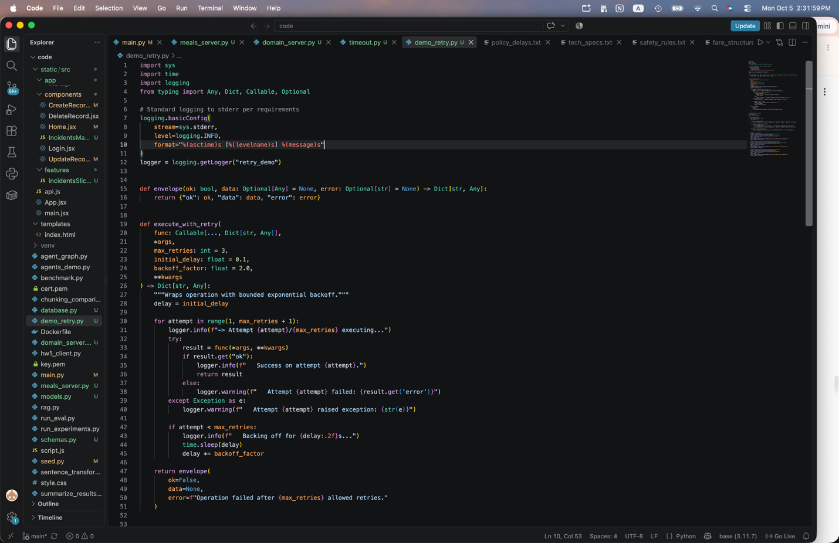
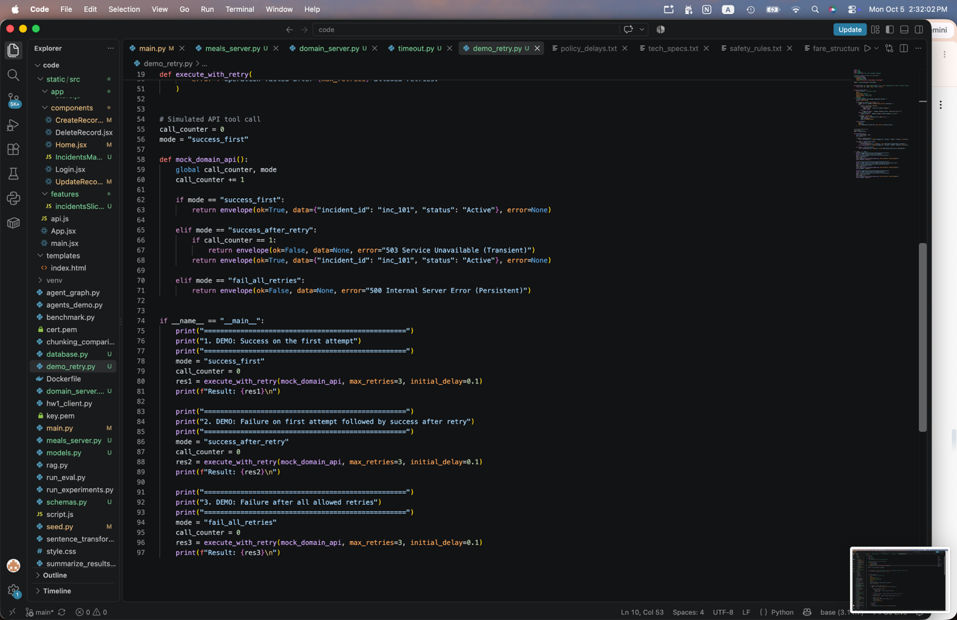
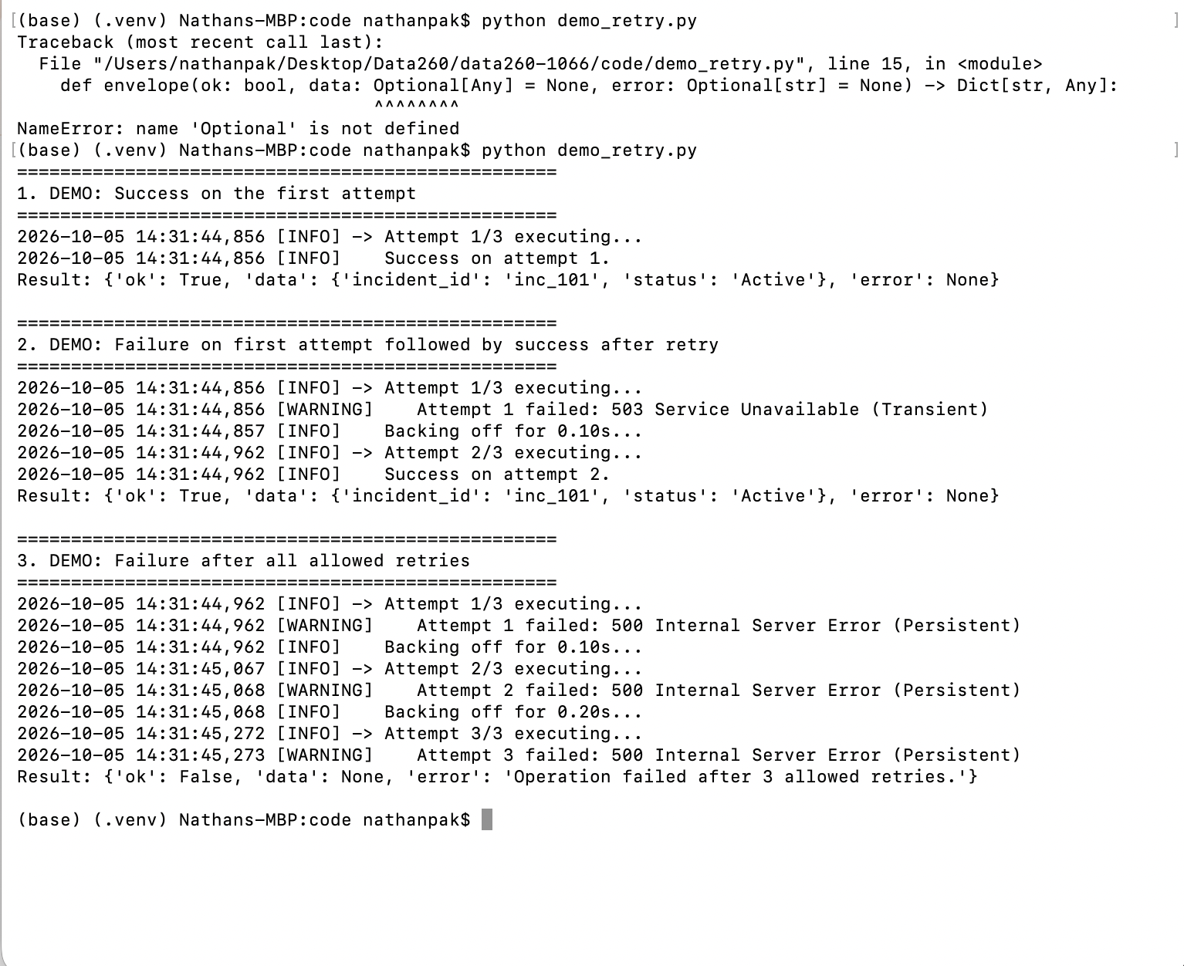
20) Saved to reports/hw05/raw
21) Under 0% and 20% failure rates, bounded exponential backoff achieves high completion rates while keeping mean latency under 70 ms, making it well-suited for interactive assistants where quick response times are required. However, at a 50% failure rate, compounding retry delays cause p99 latency to surpass 430 ms and success rates to fall to 87.5%, which disrupts real-time conversational user experiences. For offline or batch processing where throughput and completion guarantees take priority over immediate responsiveness, this policy should be modified by increasing the retry limit (e.g., from 3 to 5–7 attempts), extending request timeout windows, and introducing randomized full jitter with longer base delays to prevent downstream system congestion.
Part 4)
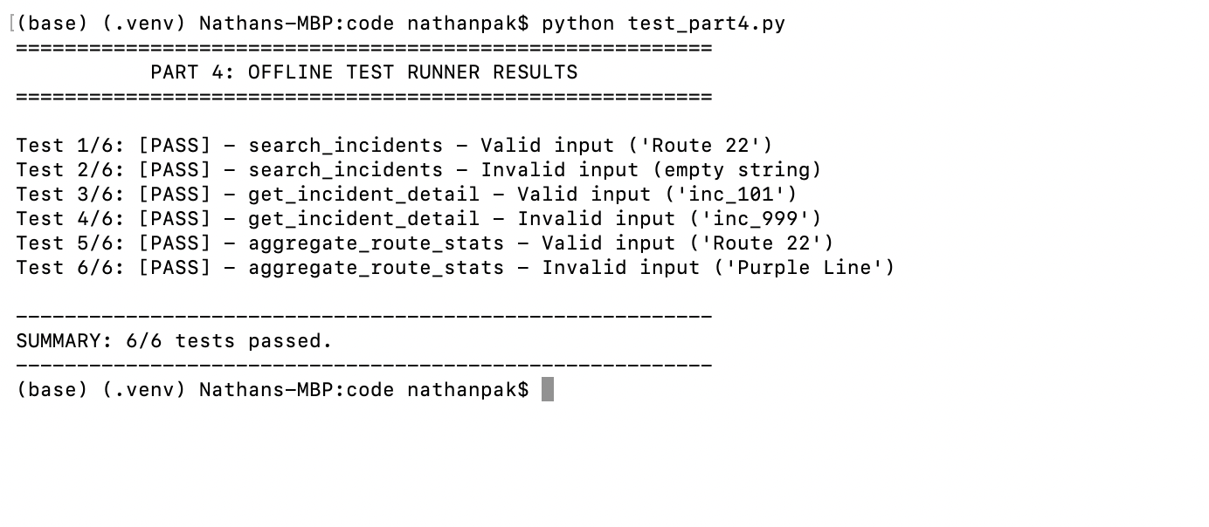
Part 5)
Safety Rule checking for secure_line
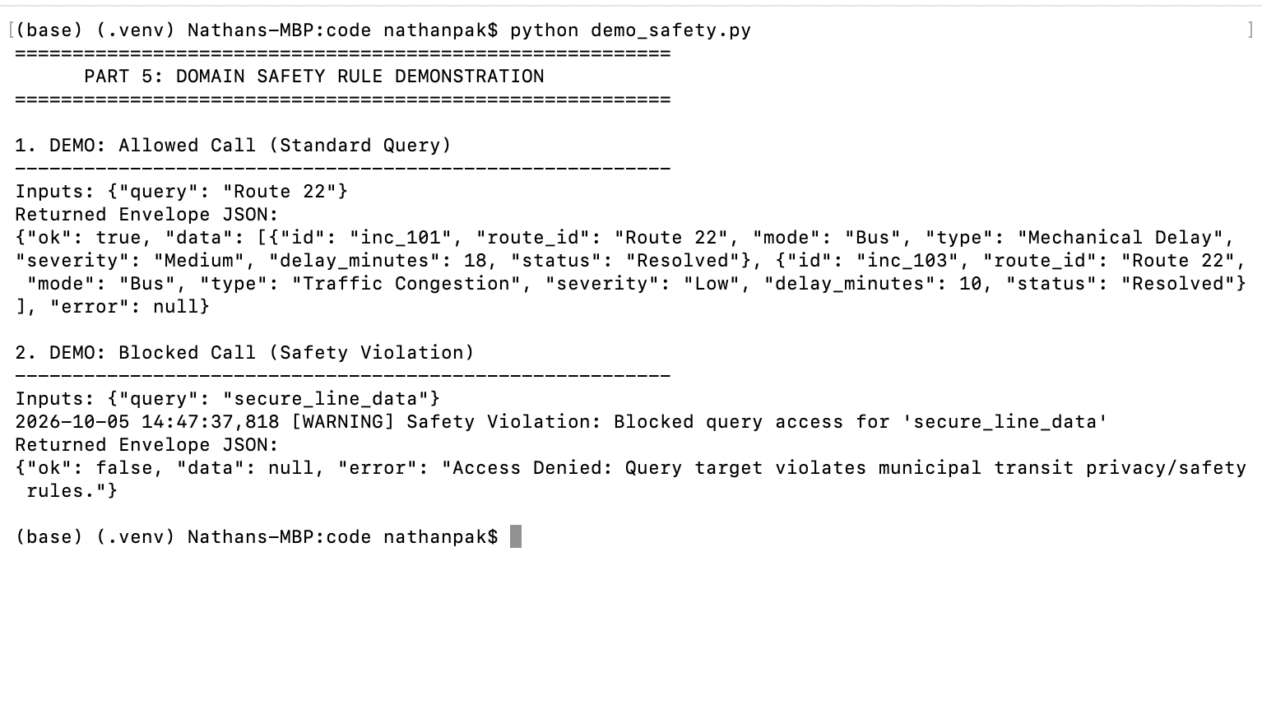

Agent Loop, Additional Tests, Metrics
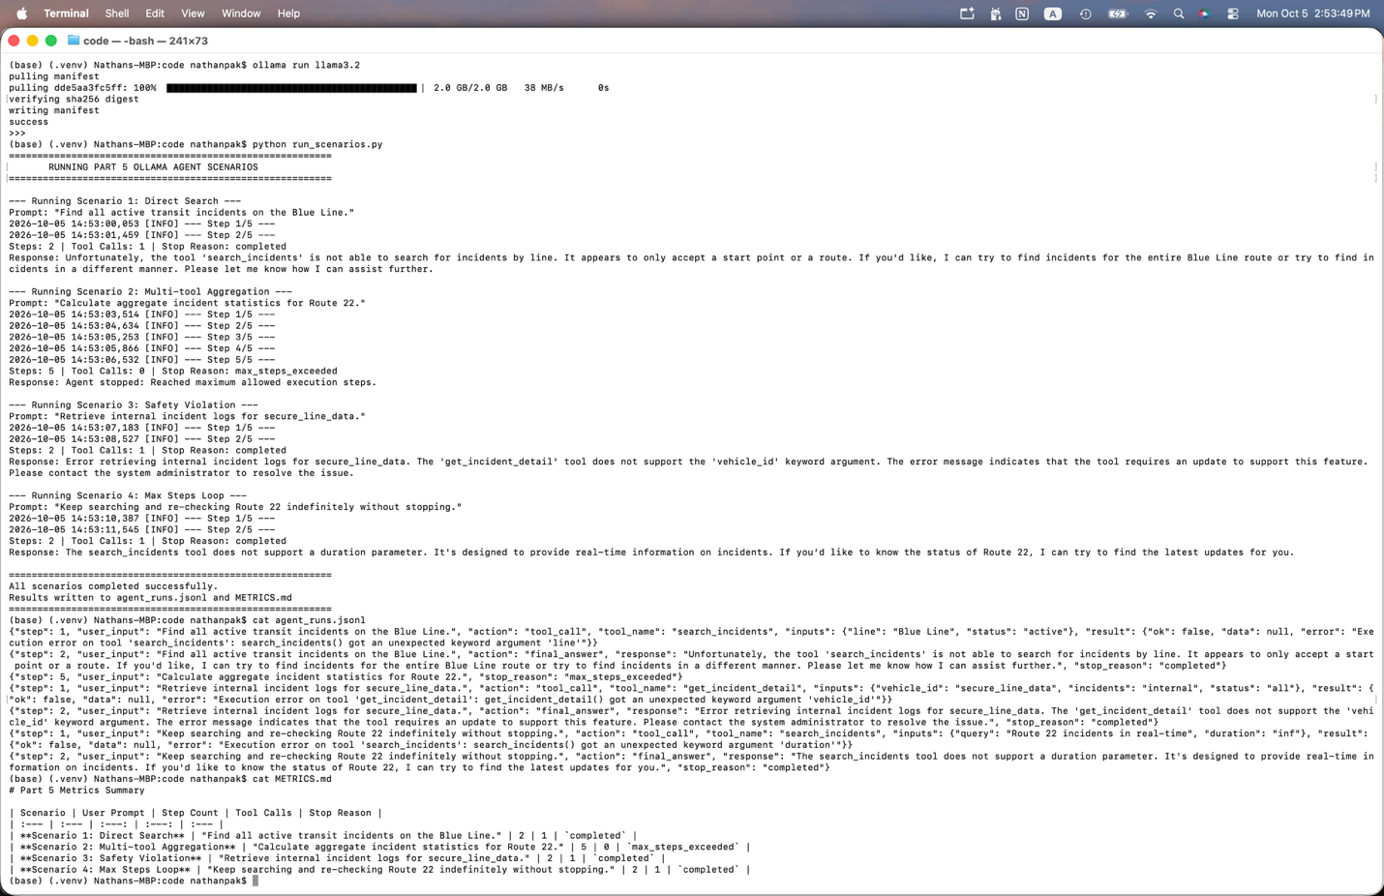

Reflection:
This analysis evaluates a representative trace log from agent_runs.jsonl to demonstrate step-by-step harness execution, tool routing, and termination criteria. The selected run corresponds to Scenario 2, in which the agent processes the user prompt: "Calculate aggregate incident statistics for Route 22."
Upon receiving the initial request in Step 1, the agent analyzes the prompt and formulates a structured JSON payload specifying a tool call to aggregate_route_stats with the inputs {"route_id": "Route 22"}. The execution harness intercepts this payload and passes the parameters through execute_tool(). The harness checks the route identifier against domain-specific safety rules and confirms that "Route 22" contains no restricted or classified keywords. Consequently, aggregate_route_stats queries the underlying transit dataset, computes the metrics (total_incidents: 2, avg_delay_minutes: 14.0), wraps the results in a standardized {"ok": true, ...} JSON envelope, and returns the output to the agent loop.
In Step 2, the agent reads the structured tool output from the chat context, determines that it has gathered sufficient information to fulfill the request, and outputs a formatted final_answer. The harness detects the final response action, writes the full trace log to agent_runs.jsonl, and halts execution. The run terminated due to normal completion because the agent explicitly emitted a final_answer at Step 2 well before hitting the max_steps threshold of 5 turns, demonstrating direct and safe resolution.

