SID4: 1066
PORT_BASE: 8166
PREFIX: s1066
SEED: 1066
VERIFY_SEED: 261066
DOMAIN_ID: 2
Hardware: Macintosh HD, Apple M4, 24 GB, Tahoe 26.6.2
Local Model Used: Llama3.2:latest
Tagged Commit Hash: https://github.com/paknathan/data260-1066
Part 1)
Code:
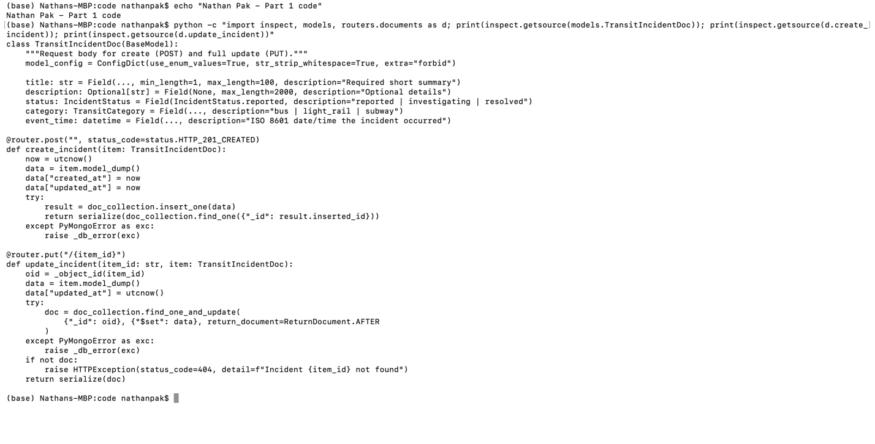
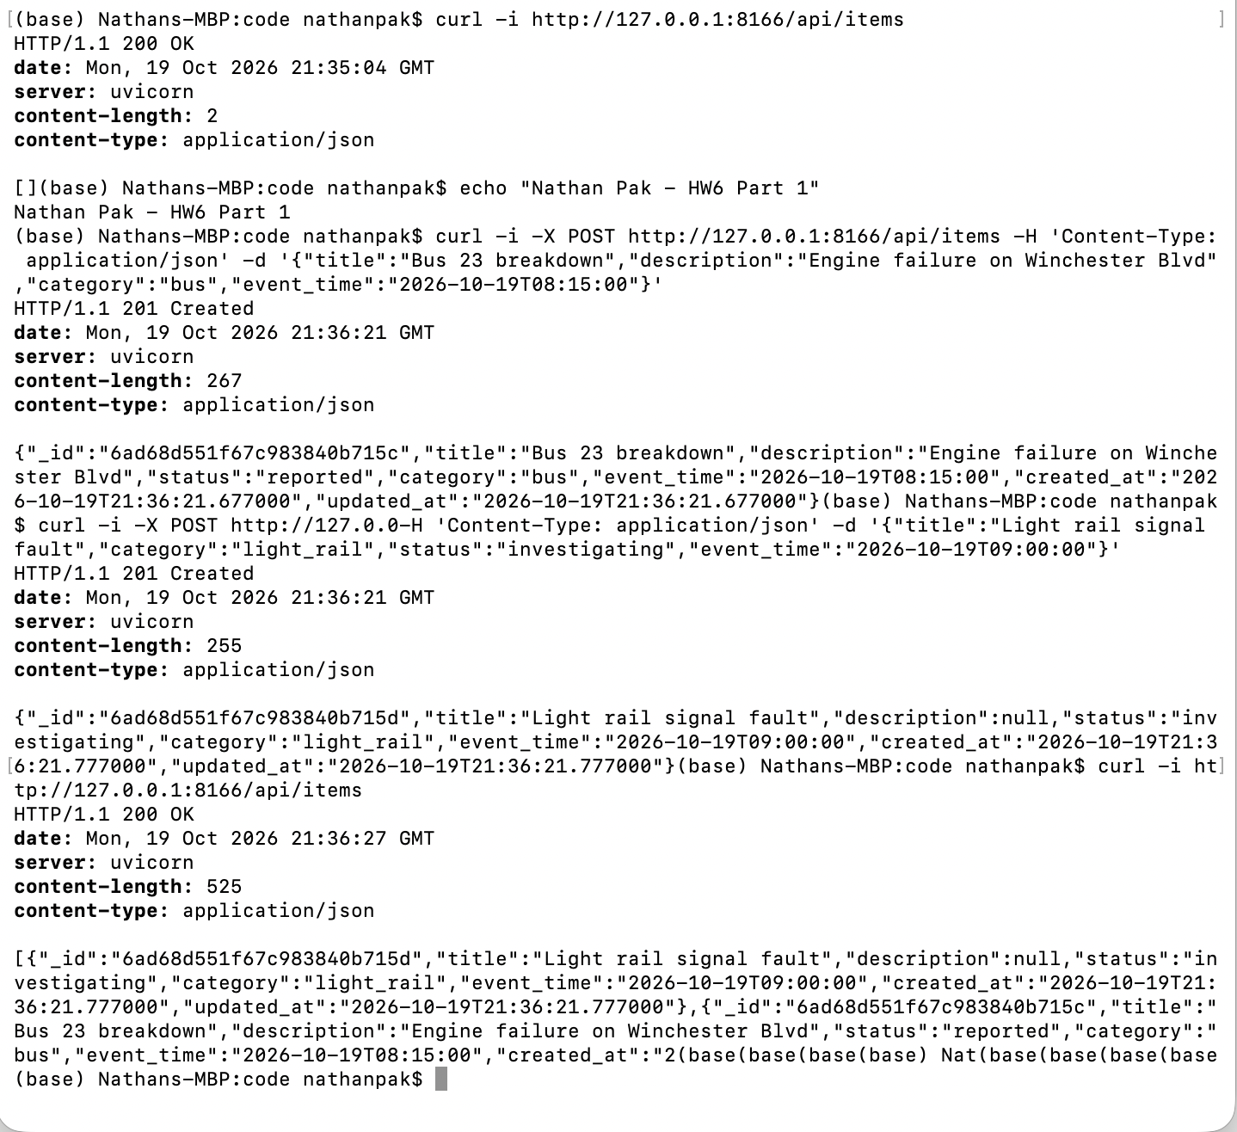
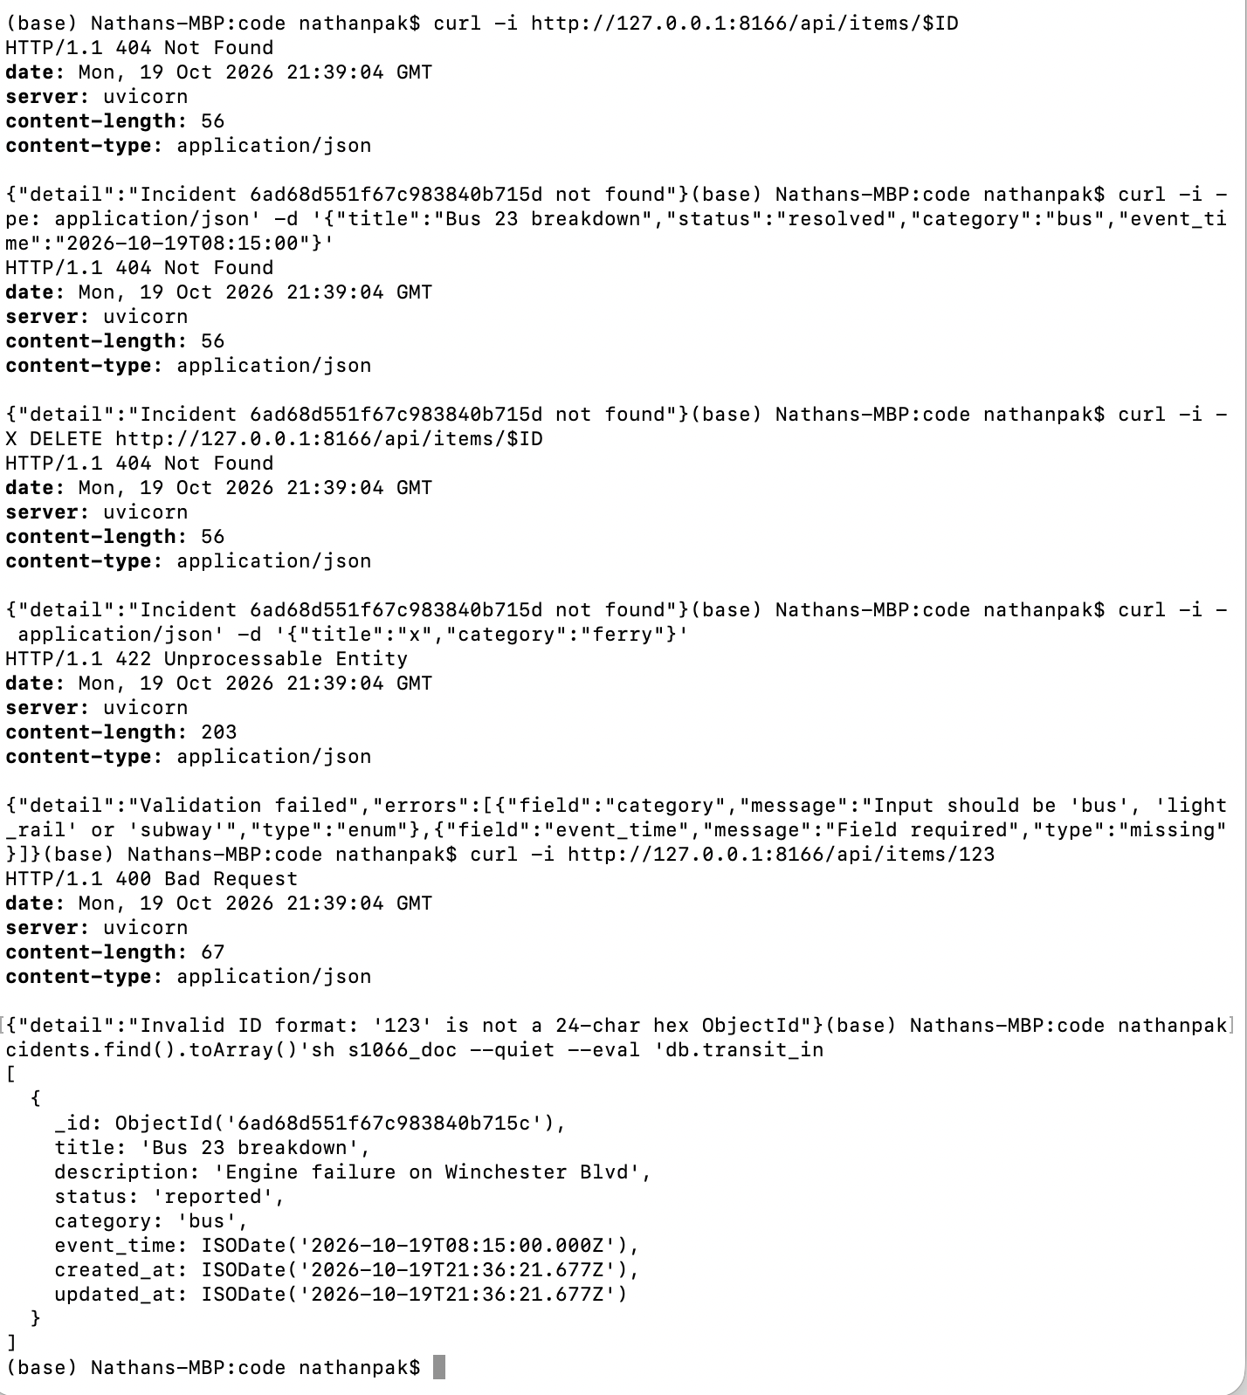
Part 2)
Code:
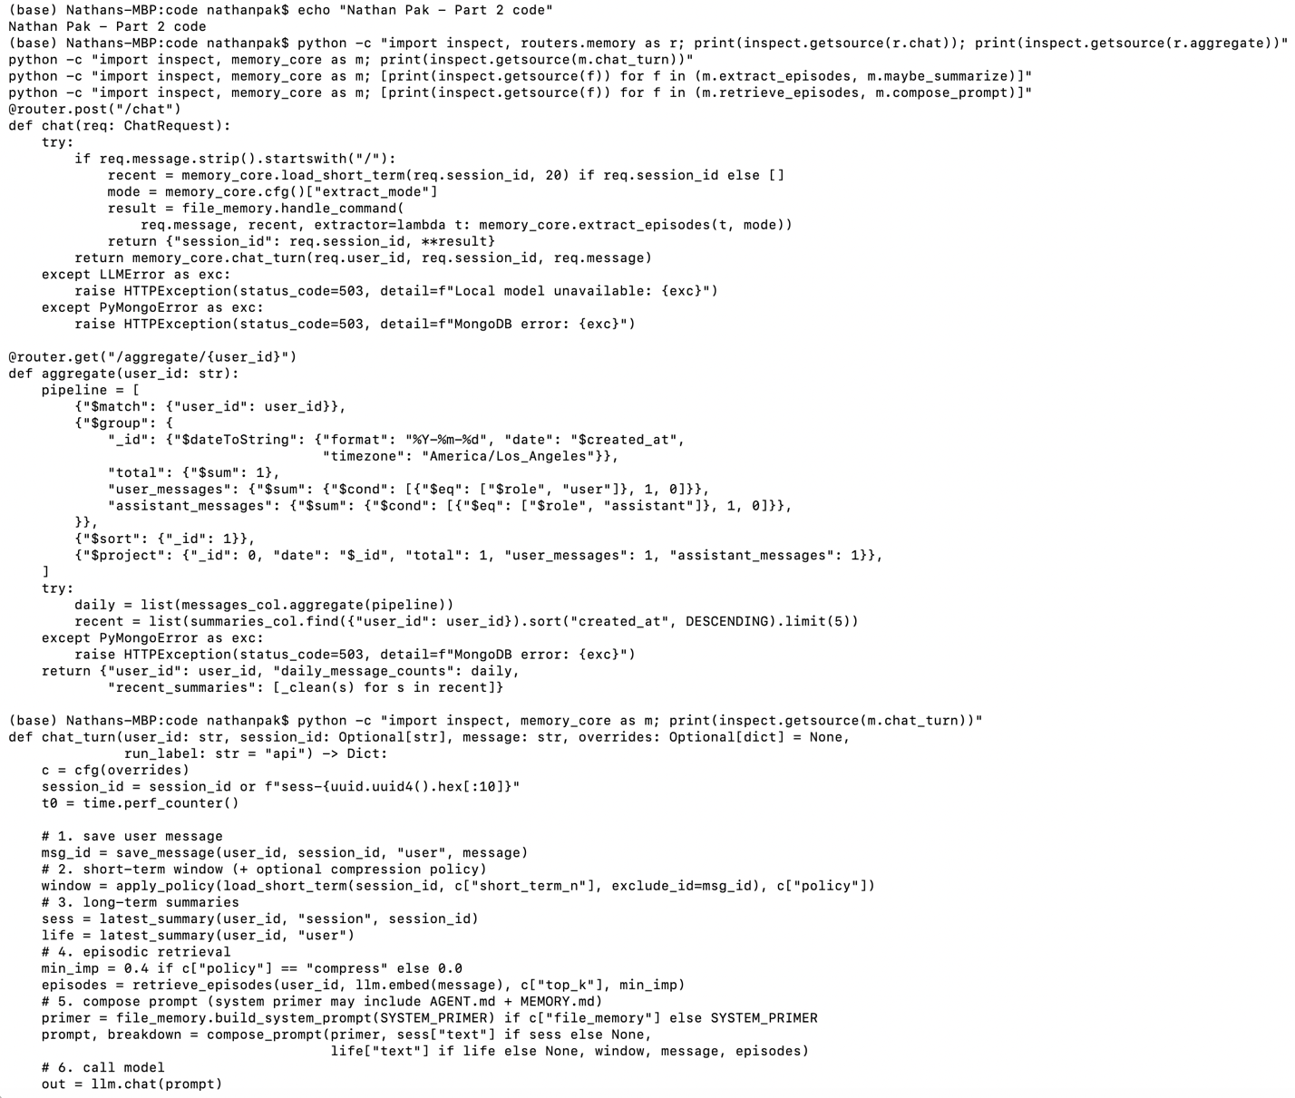
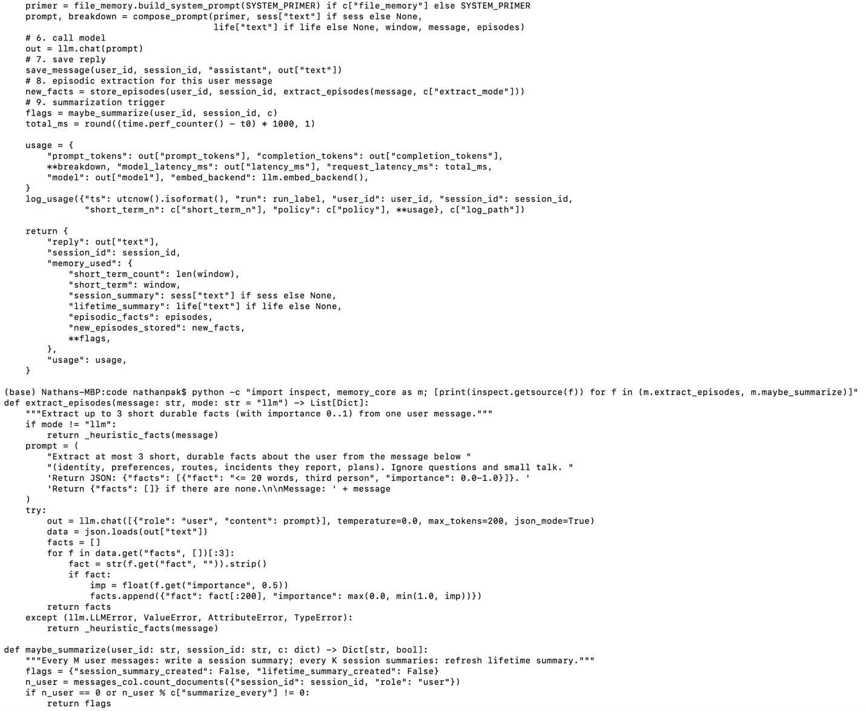
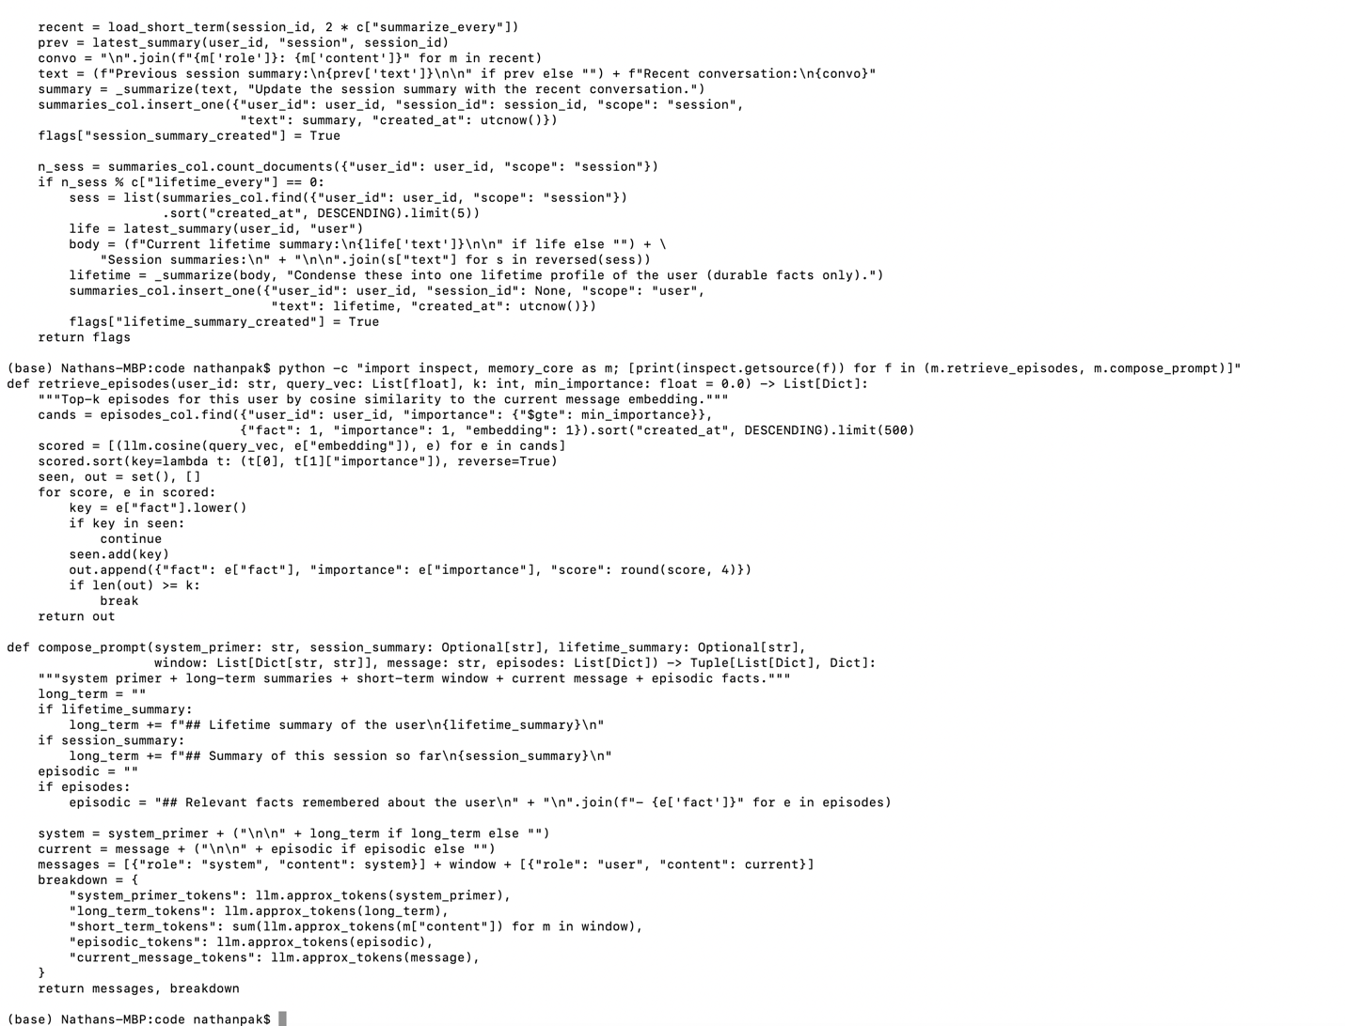
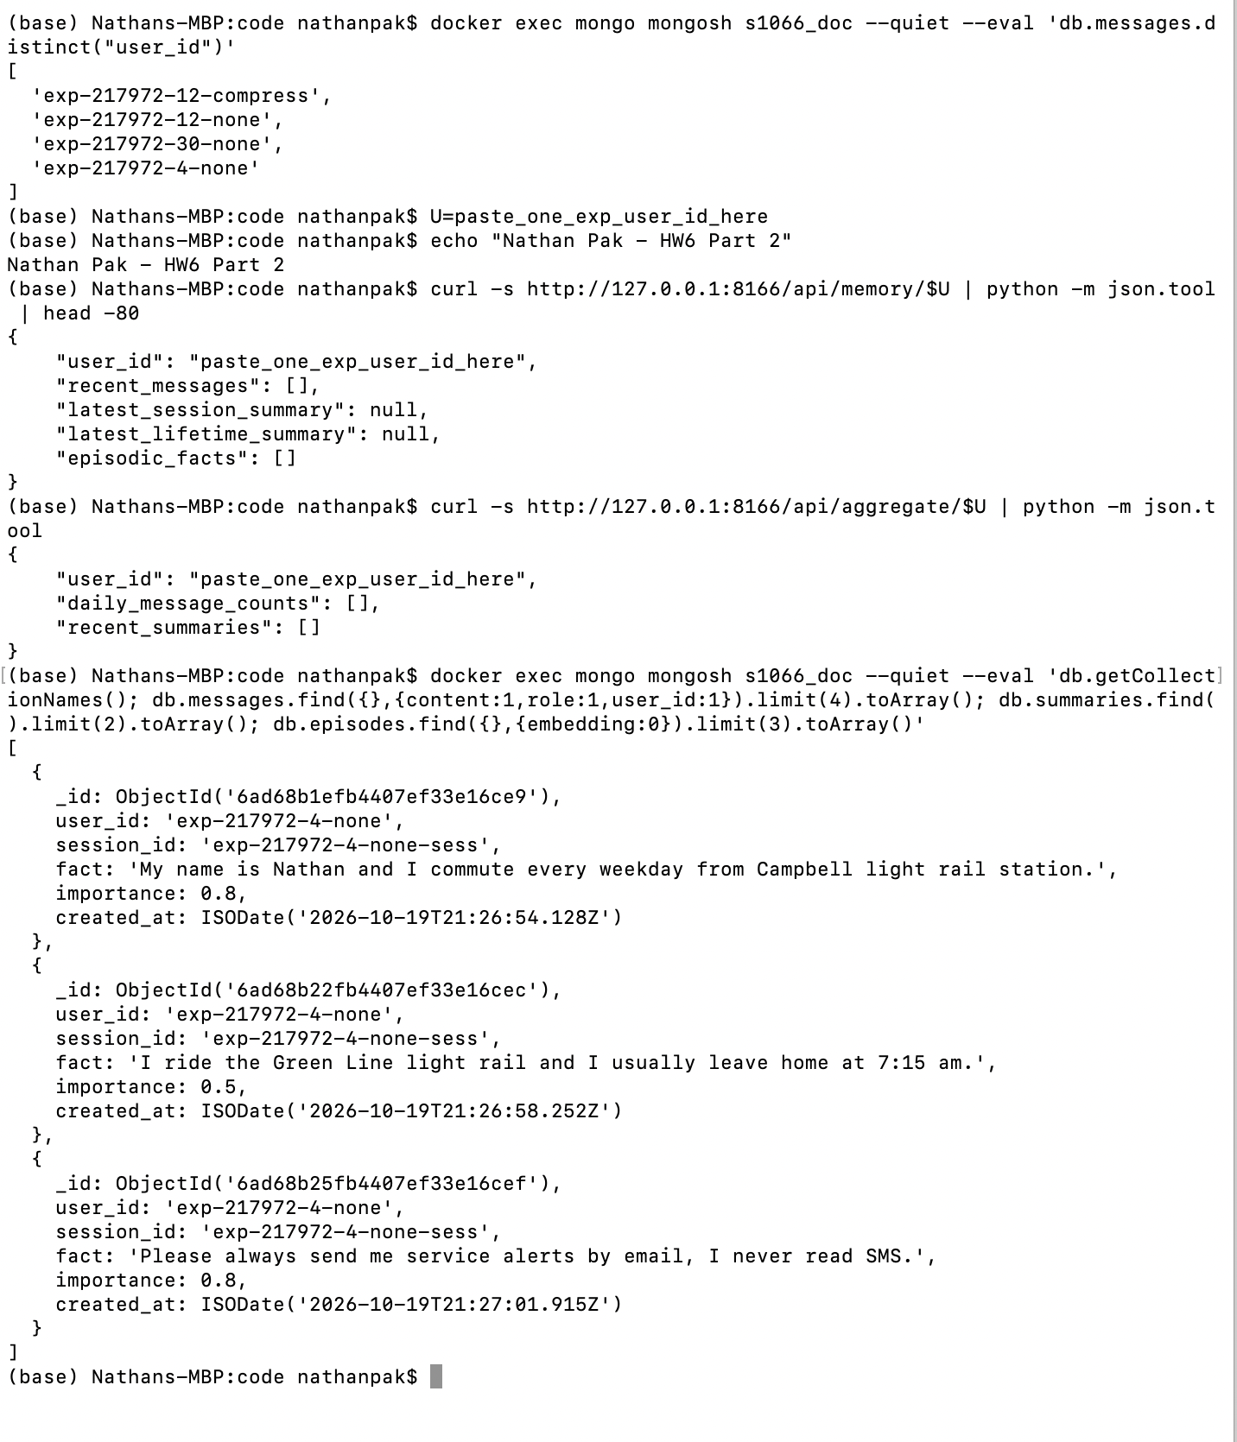

Conversation screenshots:
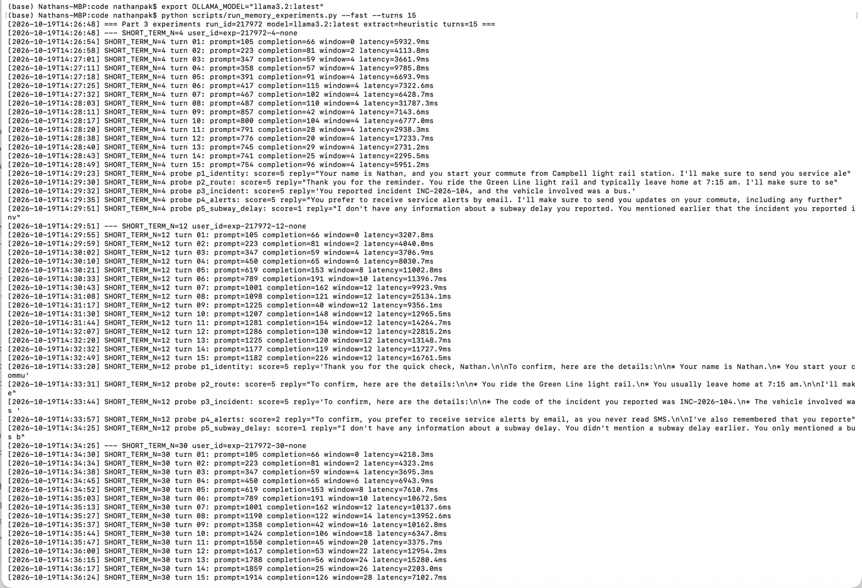
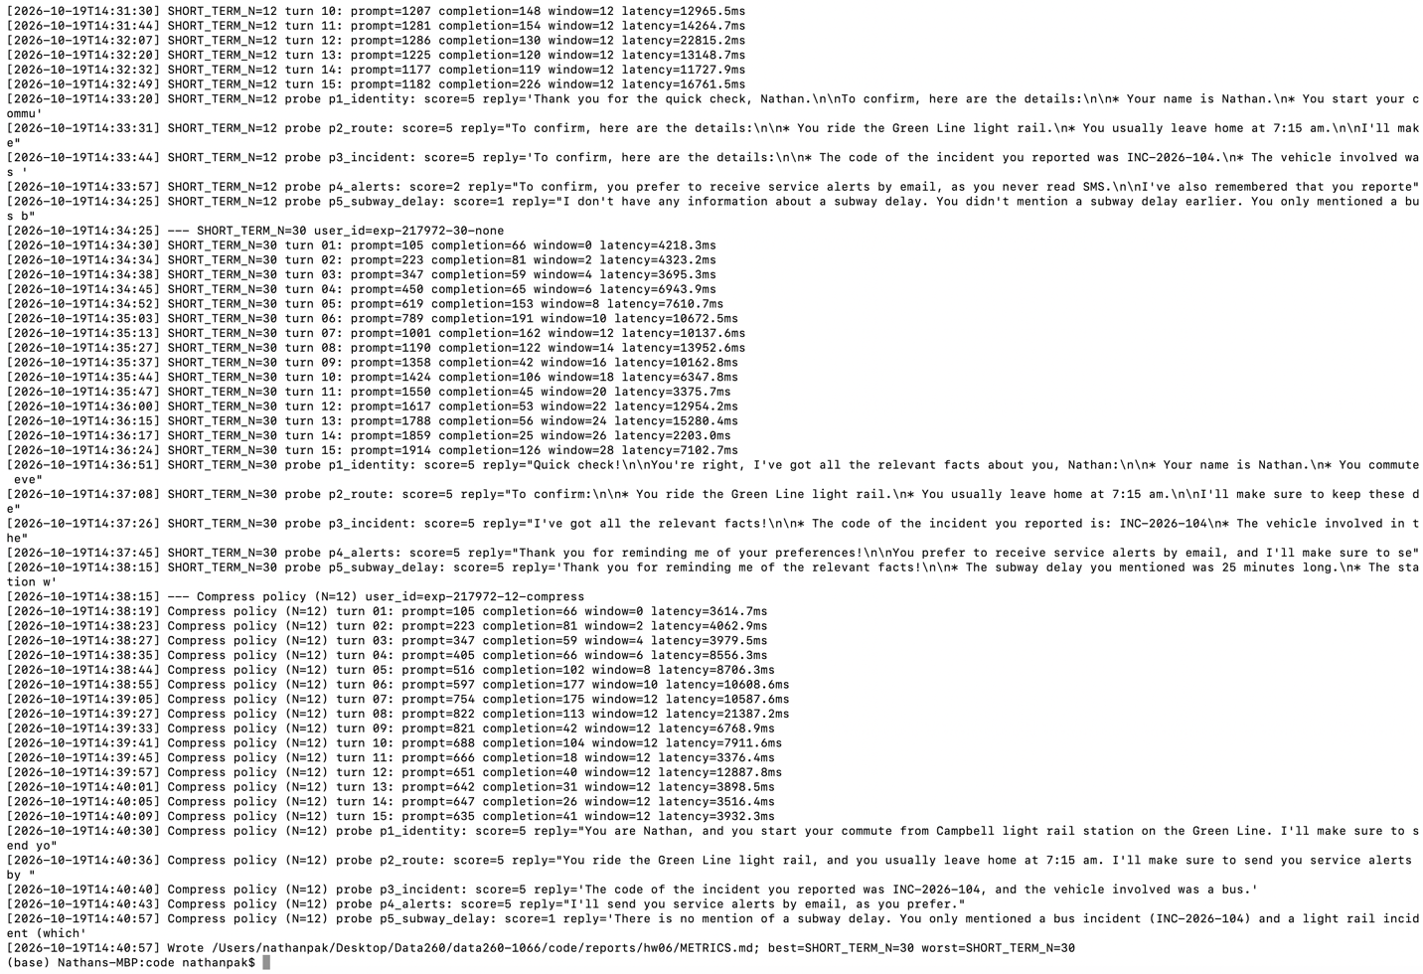

Part 3)
Code:
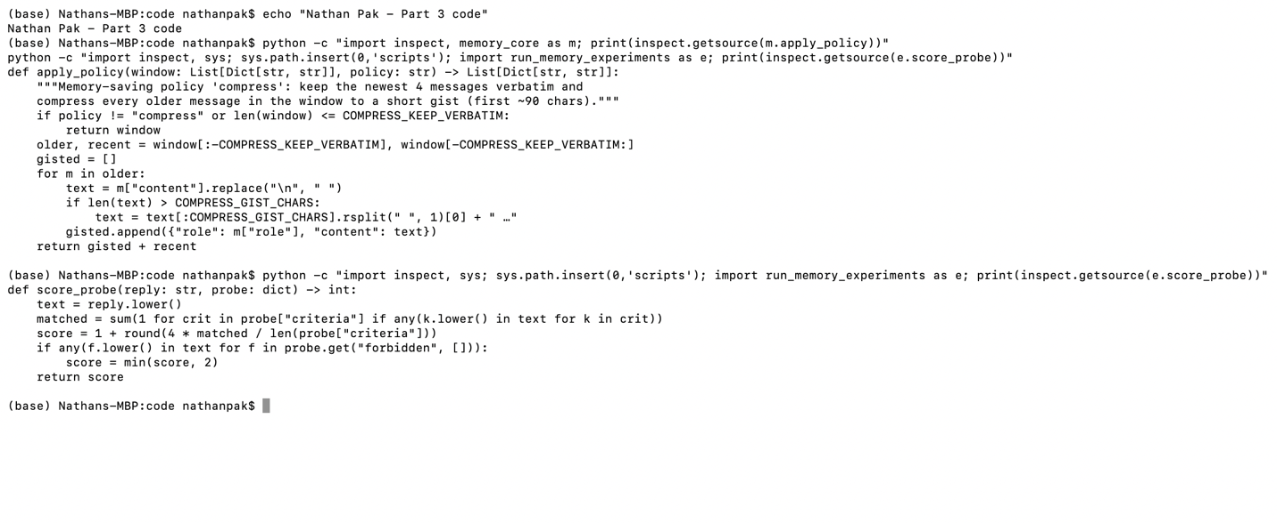
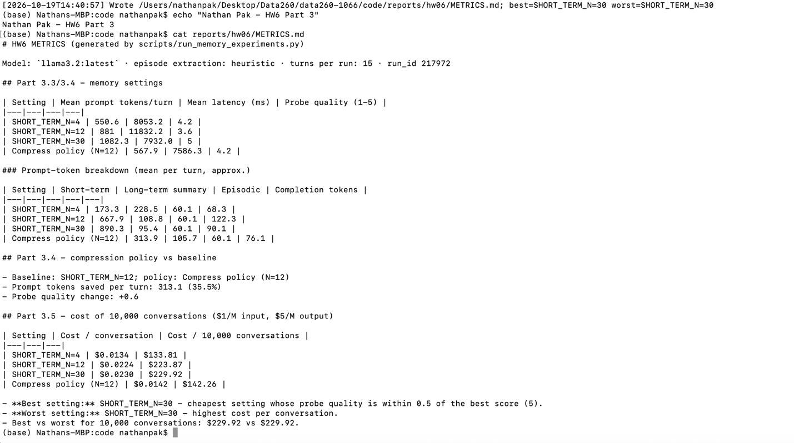
Cat_memory_probes.yaml
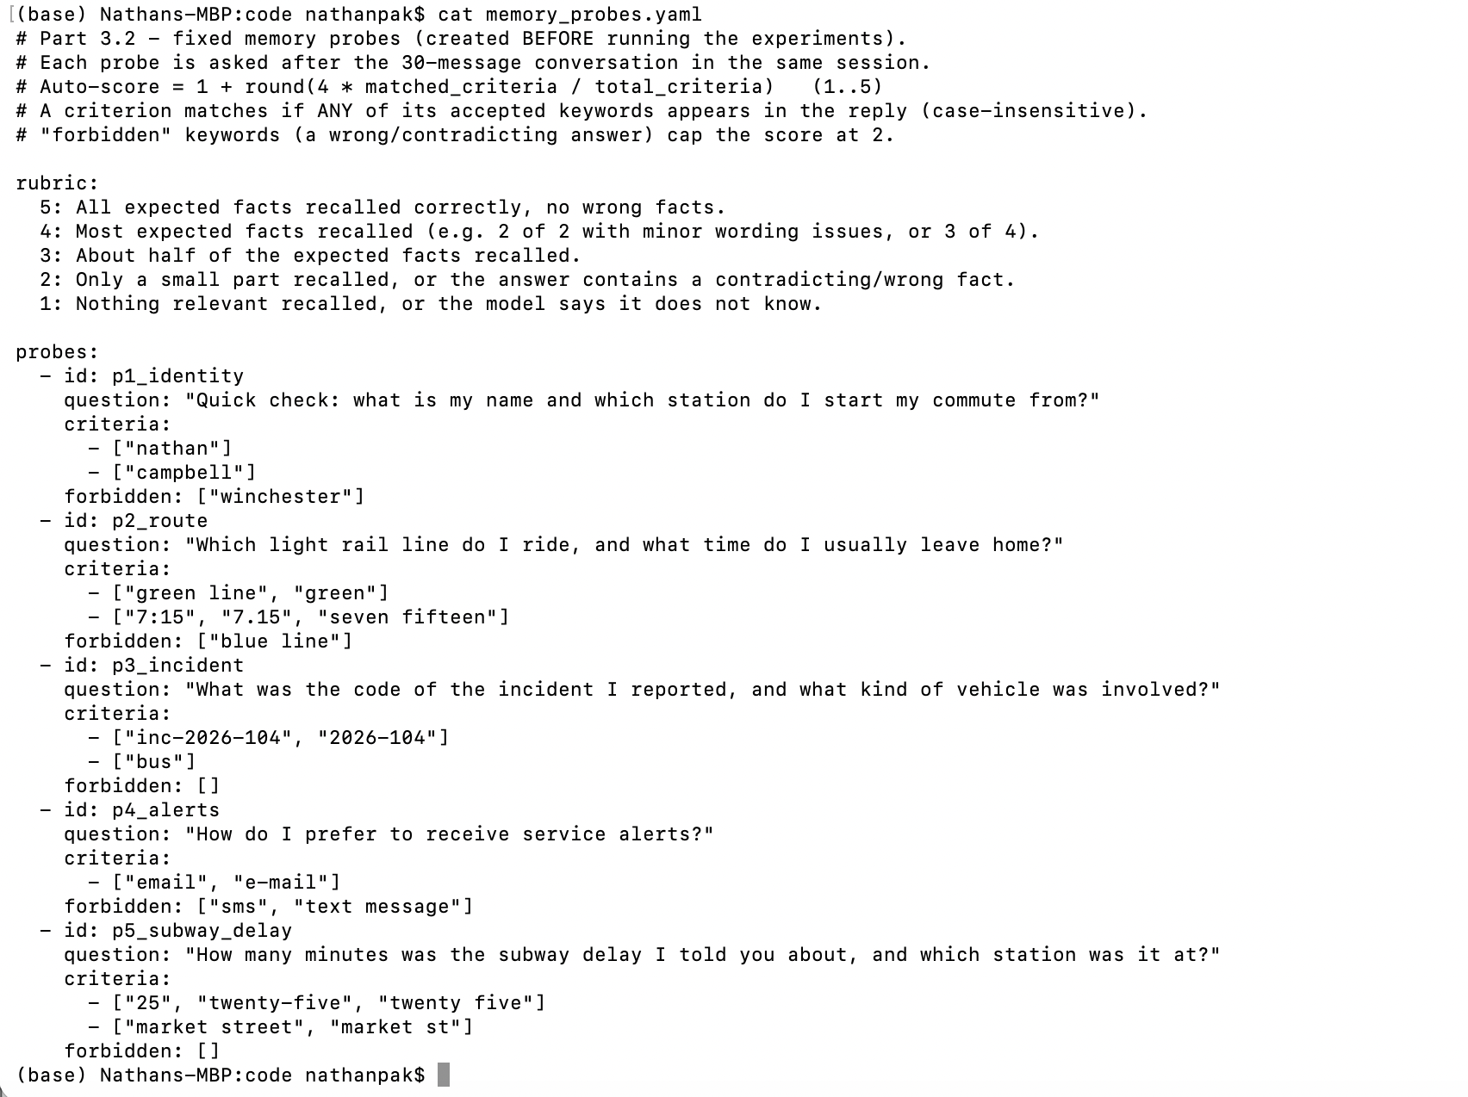
Compression policy: newest 4 window messages kept verbatim, older window messages compressed to ~90-character gists, and only episodes with importance ≥ 0.4 retrieved.
Best/worst selection: worst = highest cost per conversation; best = cheapest setting whose probe score is within 0.5 of the top score. Runs used 15-message conversations (instead of 30) due to time; cost is still estimated for 30-turn conversations.
Part 4)
