|  |  |  |  |  |  |  |  |
| --- | --- | --- | --- | --- | --- | --- | --- |
| I0 | I1 | NI0 | NI1 | NI0 A NI1 | I0 A NI1 | NI0 A I1 | I0 A I1 |
| 0 | 0 | 1 | 1 | **1** | 0 | 0 | 0 |
| 0 | 1 | 1 | 0 | 0 | 0 | **1** | 0 |
| 1 | 0 | 0 | 1 | 0 | **1** | 0 | 0 |
| 1 | 1 | 0 | 0 | 0 | 0 | 0 | **1** |

Try to find a news article, think of the ethical issues behind the system, how it was resolved?

[The Universe is Hostile to Computers - YouTube](https://www.youtube.com/watch?v=AaZ_RSt0KP8)

[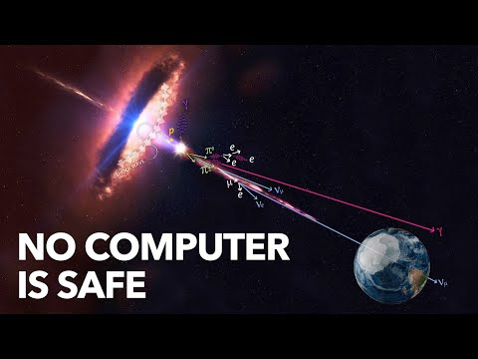](https://www.youtube.com/watch?v=AaZ_RSt0KP8)

That’s a nice video on that matter, presenting the danger of single-event upset.

We resolved it by adding radiation hardening process, which makes components resistant to radiation.

[Radiation hardening - Wikipedia](https://en.wikipedia.org/wiki/Radiation_hardening)