Parth Patel

CSCI 24000

Final Project Proposal

**Car Dealership Menu**

**Project Summary**

In C++, write a program that will create and navigate a menu for a computer that stores the information of all the cars owned by the dealership. The menu will let the user add, remove, sort and look at all the cars in the system. The menu should be able to take vehicles from a separate file or from the user and when exiting be able to export the data to a separate file to be saved to and loaded from for future use. This menu will require multiple classes, one that is the menu and one for each type of vehicle in the dealership’s inventory. The intended user for this is someone who owns or works at a car dealership that wants to have a database so that they can access this database easier and make changes quicker. The problem that this will solve is advancing from outdated pen and paper system for a business. This will make it so that the database can take data from a correctly formatted file and being able to transfer the data to multiple computers to make sure it is always available. This menu could help a small dealership look at and manage their inventory in a more efficient way. The technologies I plan on using are files for storing and getting data. I will also use vectors to organize each car in the inventory. I will need multiple classes to store the different style of vehicles. I will also create a simple menu like the ones we have created for other projects this semester.

**Case Analysis**

After a user boots up the program they will see a menu with options for navigating the inventory. The options will be:

1. Import from file
2. Add a vehicle (Bought by dealership)
3. Remove a vehicle (Sold by dealership)
4. See all vehicles
5. Search for vehicle by VIN
6. Sort vehicles by Make
7. Exit

If the user chooses to import from a file, then the program will look for a specific file and add cars from that file if the format of the file is correct. The dealership will know the name of the file and make sure it is formatted correctly before starting the program. If the user chooses to add a car they will be prompted for the info about the car and the car will be added. If they remove a car, they enter the VIN of the car they want deleted and that car gets removed. See all vehicles will print all the cars in the system. Search by VIN will look through the system until a car with a matching VIN is found and if no match is found then error is displayed. Sort vehicles by make will be need when cars are added out of order, so the list is easier to look through. Exit will save to output file and end the program.

**Data Design**

That data for this project will rely on classes and vectors. The classes will represent the different style of vehicles and will need to be inherited from a generic vehicle class so that they all share a common format with a few variations. The vector will store all the cars so that they can be saved and accessed later. The dealership will need to be able to save the data and move it to a different computer if need be, so at the end of the program the inventory is saved to a file and the menu will let the user import cars if they need to. The input and output files will be different files and it the responsibility of the user to correctly name and format the files if changes are made outside the program. Both files should have the same format, but might end up being changed if the user makes changes outside the program.

**UI Design**

This program will have a simple menu like the one used in the bank assignment earlier in the semester. One way that it could look is:

**Inventory Management Menu**

What action would you like to perform?

1. Import cars from file
2. Add a vehicle to the database
3. Remove a vehicle from the database
4. See all vehicles in the system
5. Search for vehicle by VIN number
6. Sort vehicles by Make
7. Exit and export data to file

If the user presses 1 then the program will say cars imported if the file was found or say error no file found if the file was not found.

If the user presses 2 then the program will ask for the information of the vehicle 1 line at a time then say vehicle added then return to the main screen.

If the user presses 3 then they will be asked for the VIN and the program will say car deleted if the car was found in the system or return an error if no car was found with that VIN number.

If the user presses 4 then all the vehicles will be listed in a formatted manner with all the information about the car (Make, model, year, mileage, color, VIN, body style, and cost).

If the user presses 5 then the program will prompt the user for a VIN then show the vehicle if it was found or an error if it was not found.

If the user presses 6 then the program will sort the vehicles in alphabetical order by brand so that they are formatted when they choose to display all vehicles.

If the user presses 7 then the program will export the date to a file with a specific name that will be told to the user and the program will exit.

**Algorithm**

I plan to have 5 classes and a main. The five classes will be vehicle, car, truck, van, SUV. Vehicle will be the parent of all the other classes and contain the variables for color, make, model, year, cost, mileage and body style. Each of the children will have those variables and a few variations depending on the type of vehicle (ex. truck bed or seat number). For methods each type of vehicle will have a setter and getter for each variable that it has, since most of the functions will be in the main file along with the menu. The main will serve as a place to view the menu and perform the actions on the vector containing the different types of vehicles.

**UML Diagram**

This is my initial UML diagram:

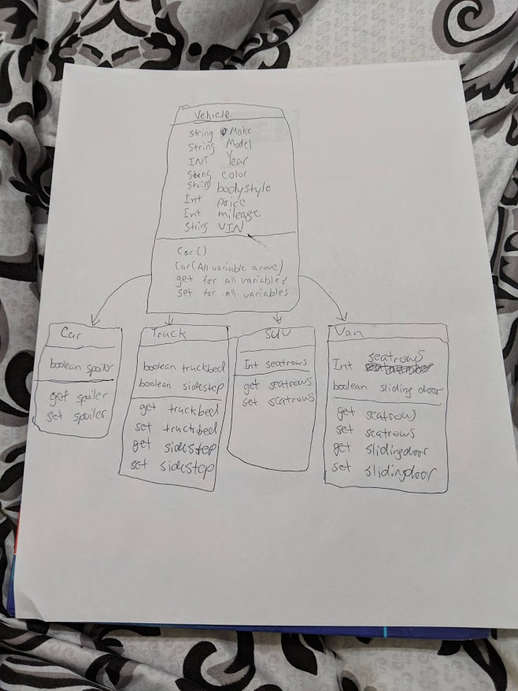

Updated UML diagram:

