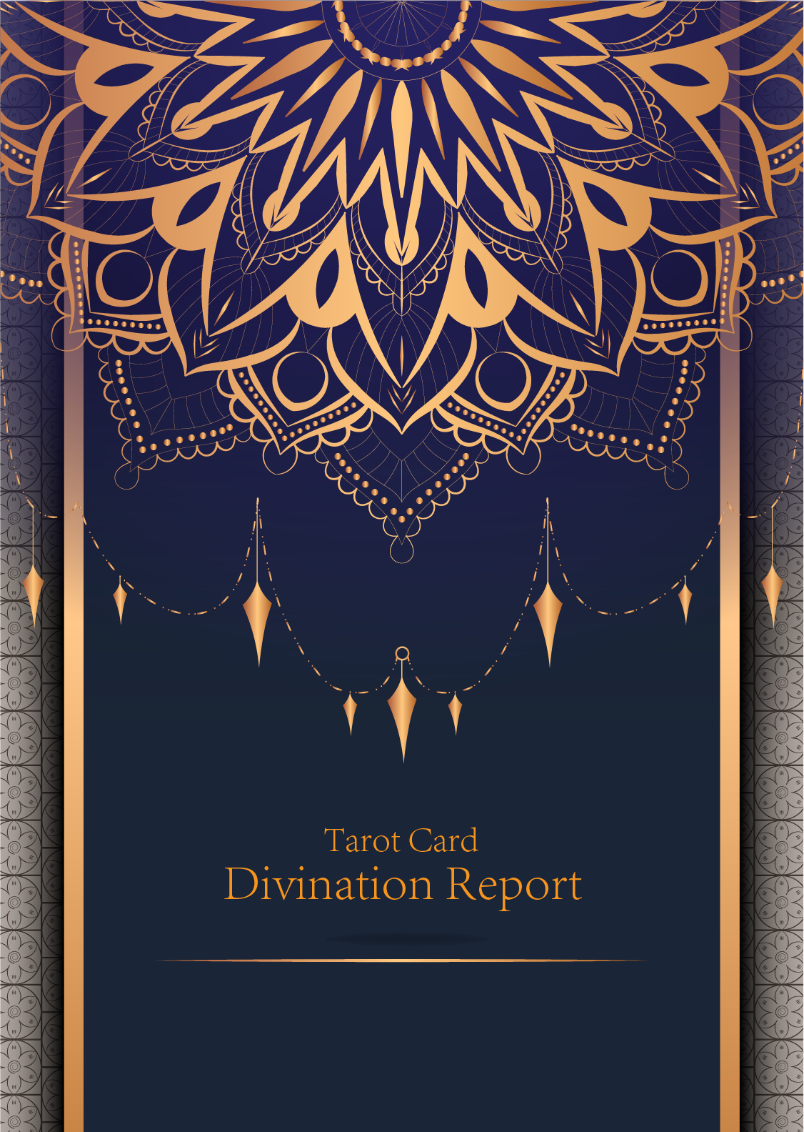

|  |
| --- |
| October 10,2024 |

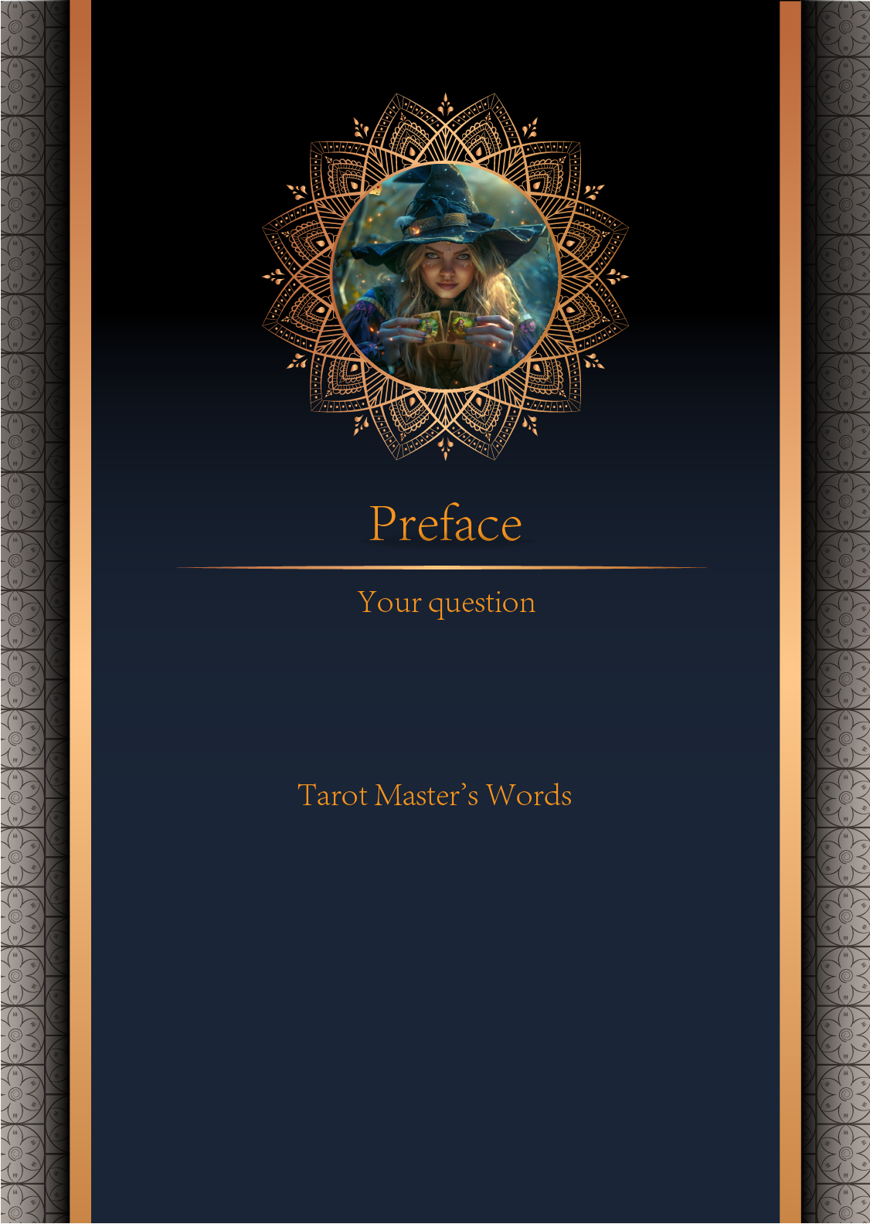

|  |
| --- |
| 11Can I get married this year?Can I get married this year?Can I get married this year?Can I get married this year?Can I get married this year?Can I get married this year?Can I get married this year?Can I get married this year?Can I get married this year?Can I get married this year?Can I get marri... |

|  |
| --- |
| 22Can I get married this year?Can I get married this year?Can I get married this year?Can I get married this year?Can I get married this year?Can I get married this year?Can I get married this year?Can I get married this year?Can I get married this year?Can I get married this year?Can I get marri... |

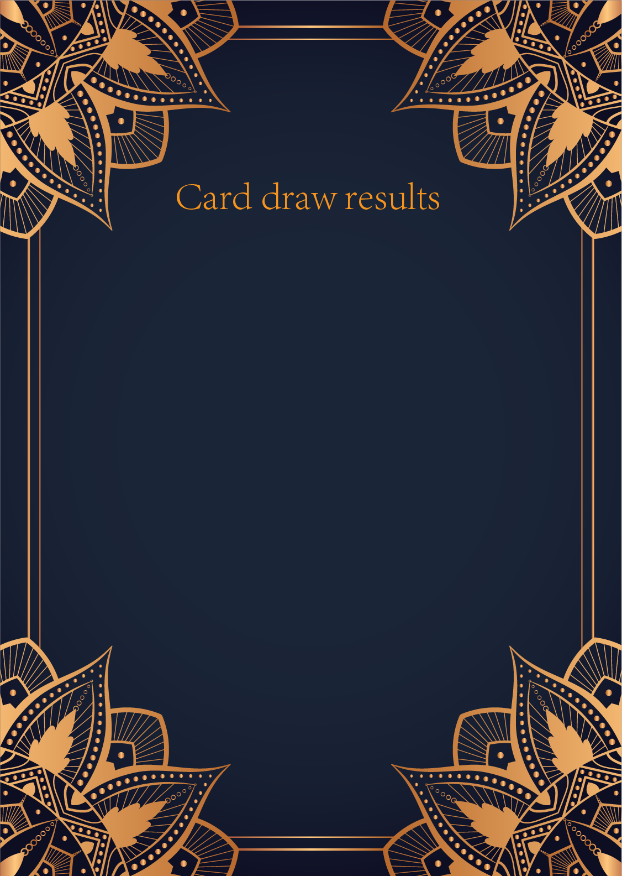

|  |
| --- |
| CardⅠ The MAGIGIAN |
|  |
| 111The Magician is one tarot card that is filled with symbolism. The central figure depicts someone with one hand pointed to the sky, while the other hand points to the ground, as if to say "as above, so below". This is a rather complicated phrase, but its summarization is that earth reflects heaven, the outer world reflects within, the microcosm reflects the macrocosm, earth reflects God. It can also be interpreted here that the magician symbolizes the ability to act as a go-between between the world above and the contemporary, human world. |

|  |
| --- |
| CardⅡ The MAGIGIAN |
|  |
| 222The Magician is one tarot card that is filled with symbolism. The central figure depicts someone with one hand pointed to the sky, while the other hand points to the ground, as if to say "as above, so below". This is a rather complicated phrase, but its summarization is that earth reflects heaven, the outer world reflects within, the microcosm reflects the macrocosm, earth reflects God. It can also be interpreted here that the magician symbolizes the ability to act as a go-between between the world above and the contemporary, human world. |

|  |
| --- |
| CardⅢ The MAGIGIAN |
|  |
| 333The Magician is one tarot card that is filled with symbolism. The central figure depicts someone with one hand pointed to the sky, while the other hand points to the ground, as if to say "as above, so below". This is a rather complicated phrase, but its summarization is that earth reflects heaven, the outer world reflects within, the microcosm reflects the macrocosm, earth reflects God. It can also be interpreted here that the magician symbolizes the ability to act as a go-between between the world above and the contemporary, human world. |

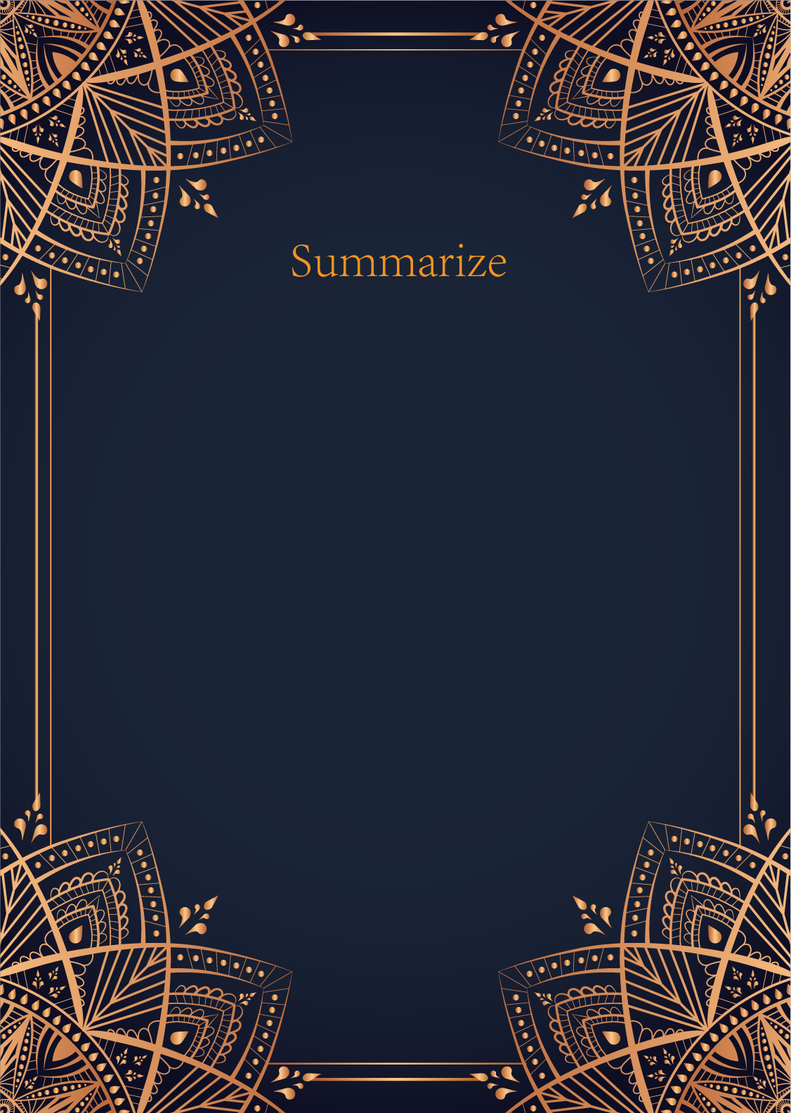

|  |  |  |
| --- | --- | --- |
|  |  |  |
| 333The Magician is one tarot card that is filled with symbolism. The central figure depicts someone with one hand pointed to the sky, while the other hand points to the ground, as if to say "as above, so below". This is a rather complicated phrase, but its summarization is that earth reflects hea... | | |

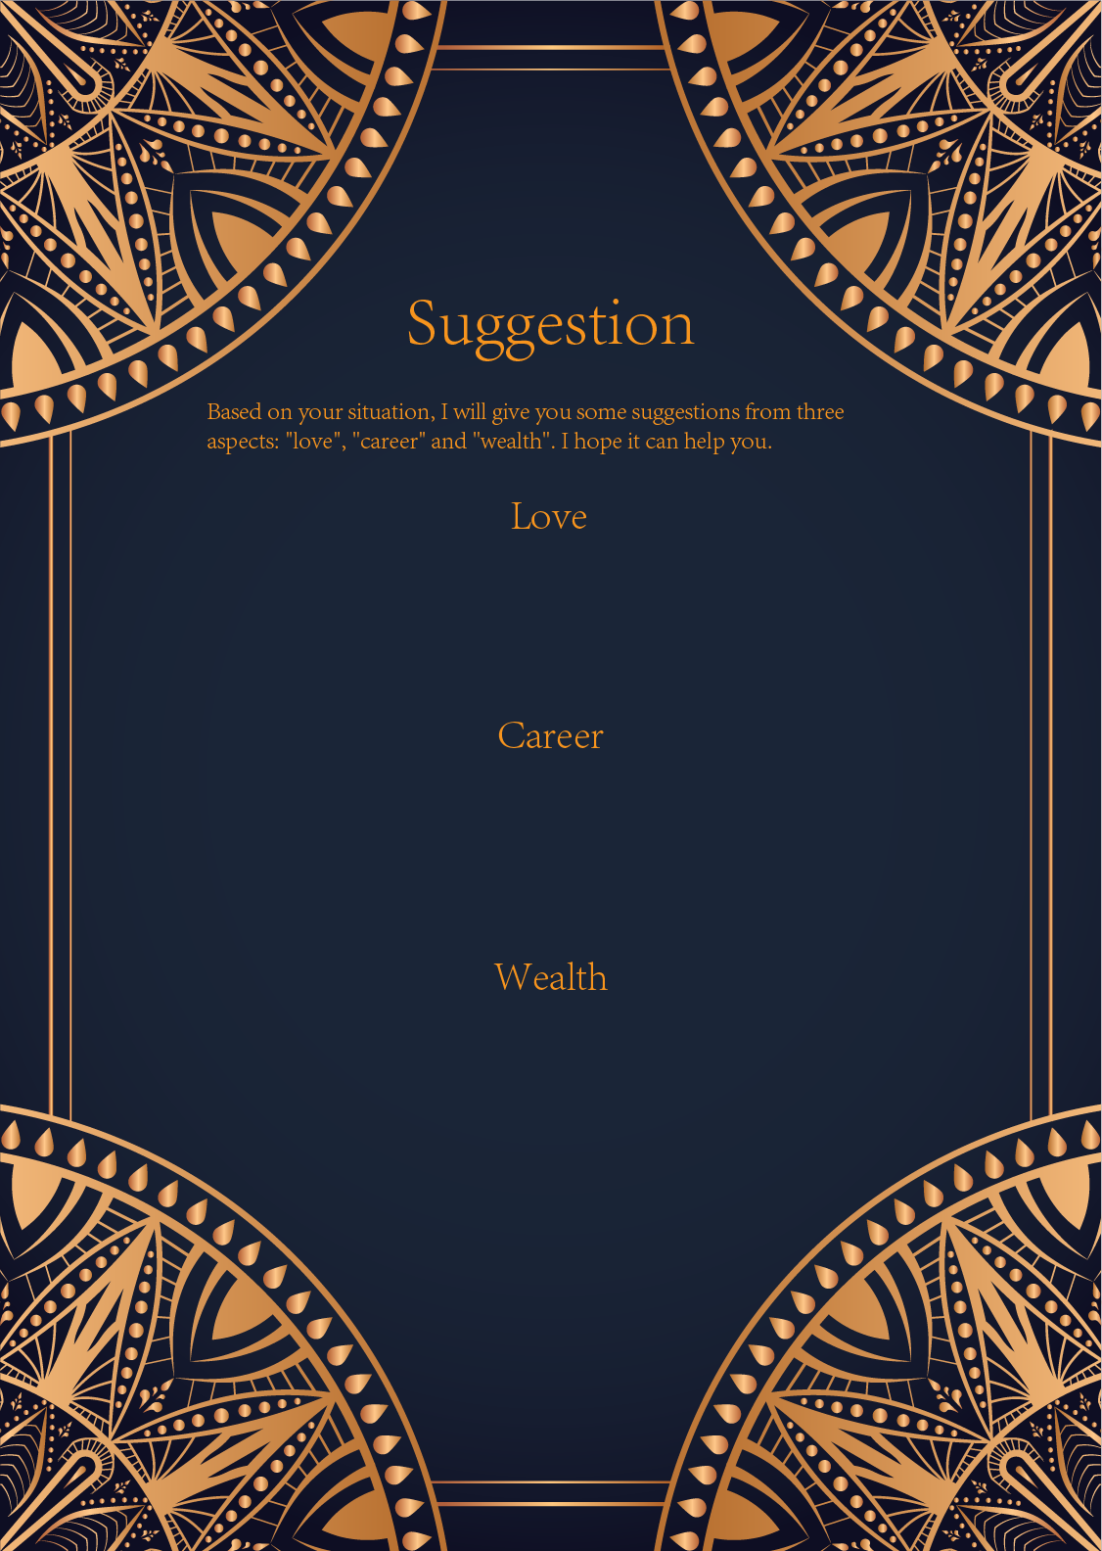

|  |
| --- |
| 333The Magician is one tarot card that is filled with symbolism. The central figure depicts someone with one hand pointed to the sky, while the other hand points to the ground, as if to say "as above, so below". This is a rather complicated phrase, but its summarization is that earth reflects hea... |

|  |
| --- |
| 333The Magician is one tarot card that is filled with symbolism. The central figure depicts someone with one hand pointed to the sky, while the other hand points to the ground, as if to say "as above, so below". This is a rather complicated phrase, but its summarization is that earth reflects hea... |

|  |
| --- |
| 333The Magician is one tarot card that is filled with symbolism. The central figure depicts someone with one hand pointed to the sky, while the other hand points to the ground, as if to say "as a the microcosm reflects the macrocosm, earth reflects God. It can also be interpreted here that the magician symbolizes the ability to act as a go-between between the world above and the contemporary, human world. |

