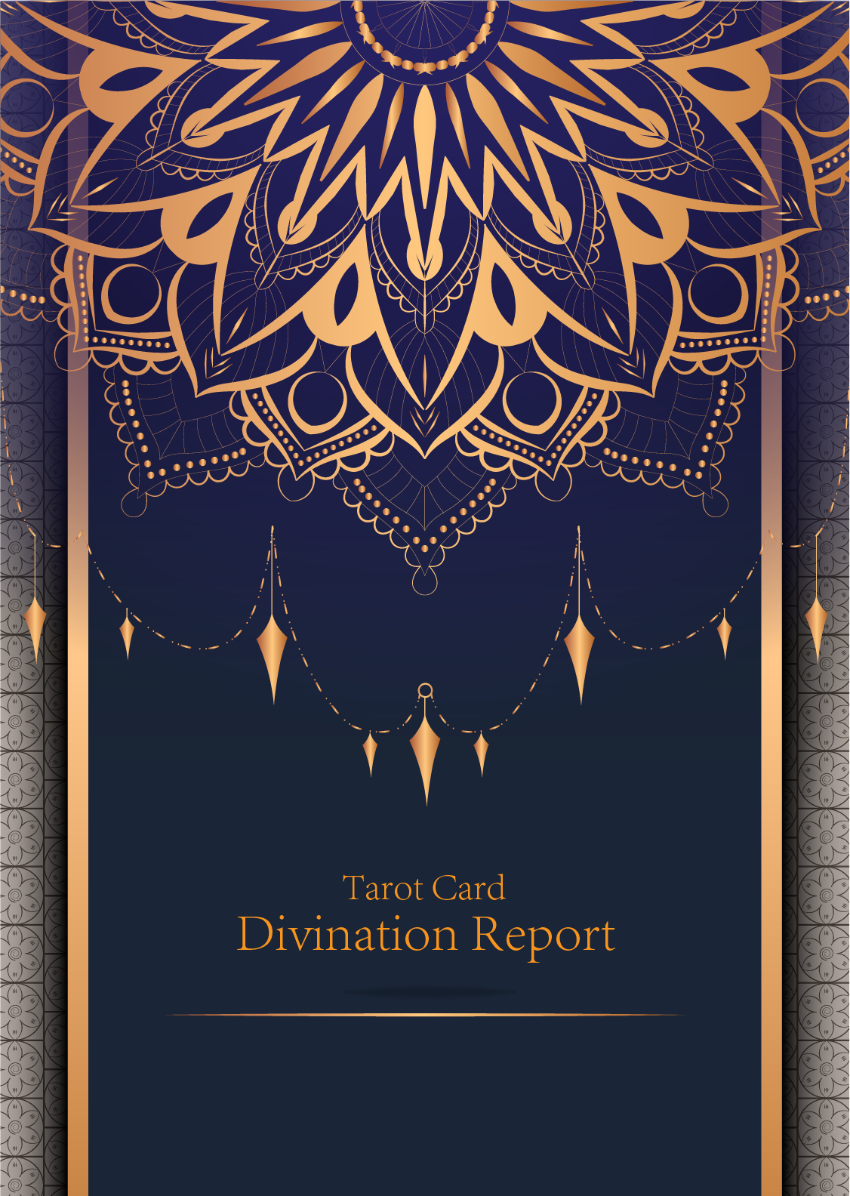

|  |
| --- |
| February 23, 2024 |

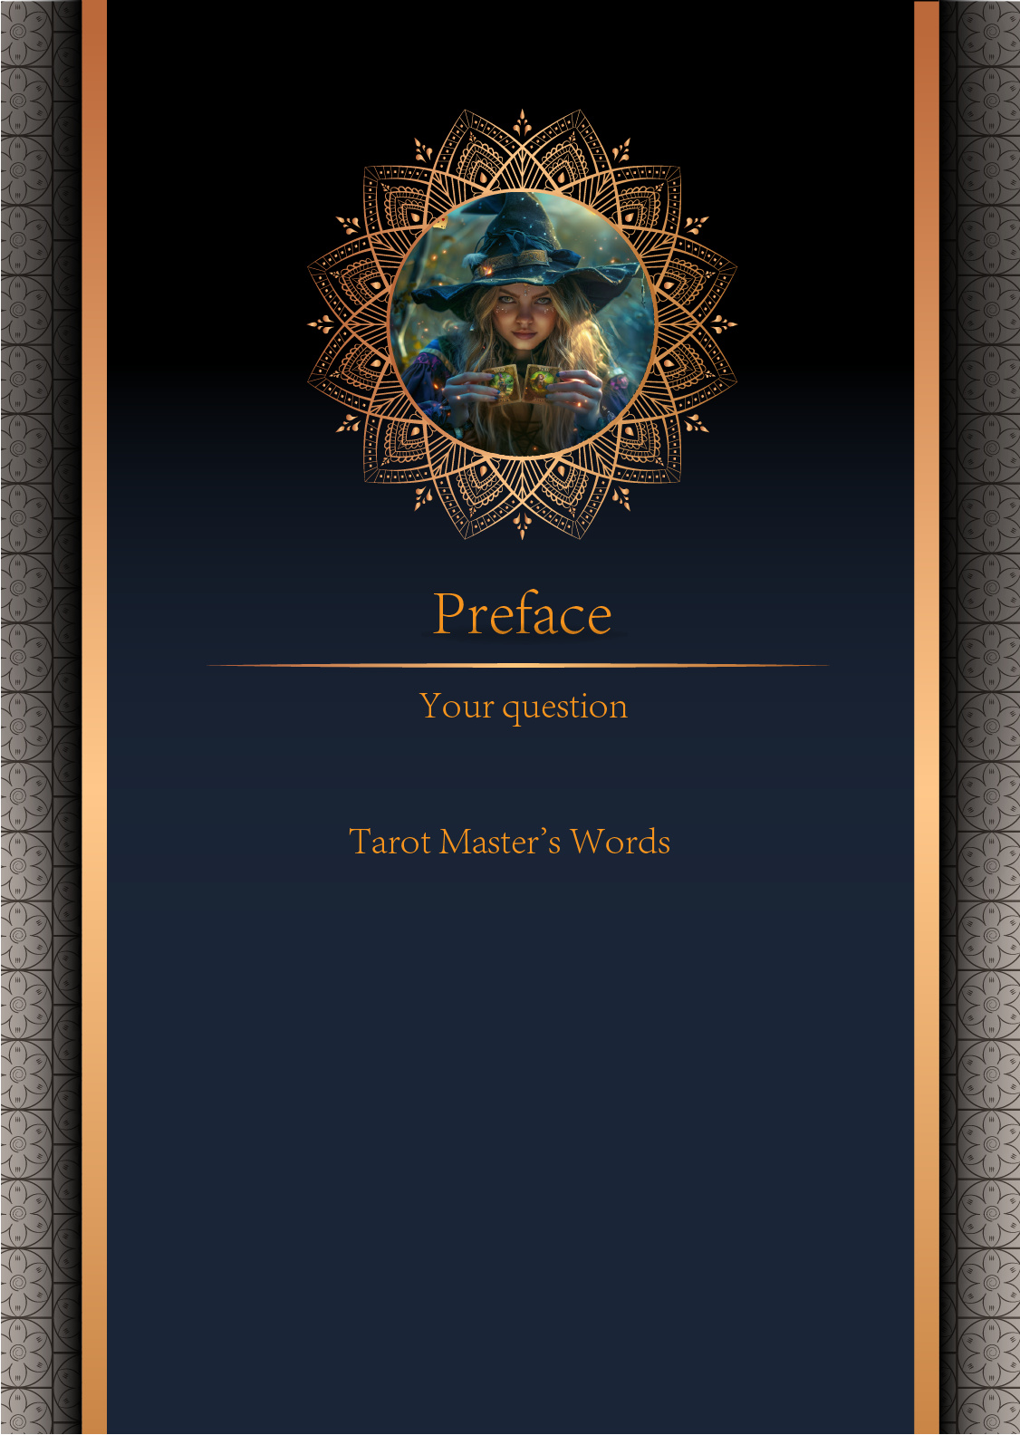

|  |
| --- |
| can i marry this year? |

|  |
| --- |
| Before we begin the interpretation, I would like to explain some important points to you. Tarot cards are not tools for predicting the future, but rather tools for guiding us to delve deeper into various situations in life. Therefore, when receiving the reading, please maintain an open mindset and trust your intuition. Our goal is to provide you with inspiration and guidance through the guidance of the tarot cards, helping you better deal with challenges and decisions in life. Alright, you can start reading now! |

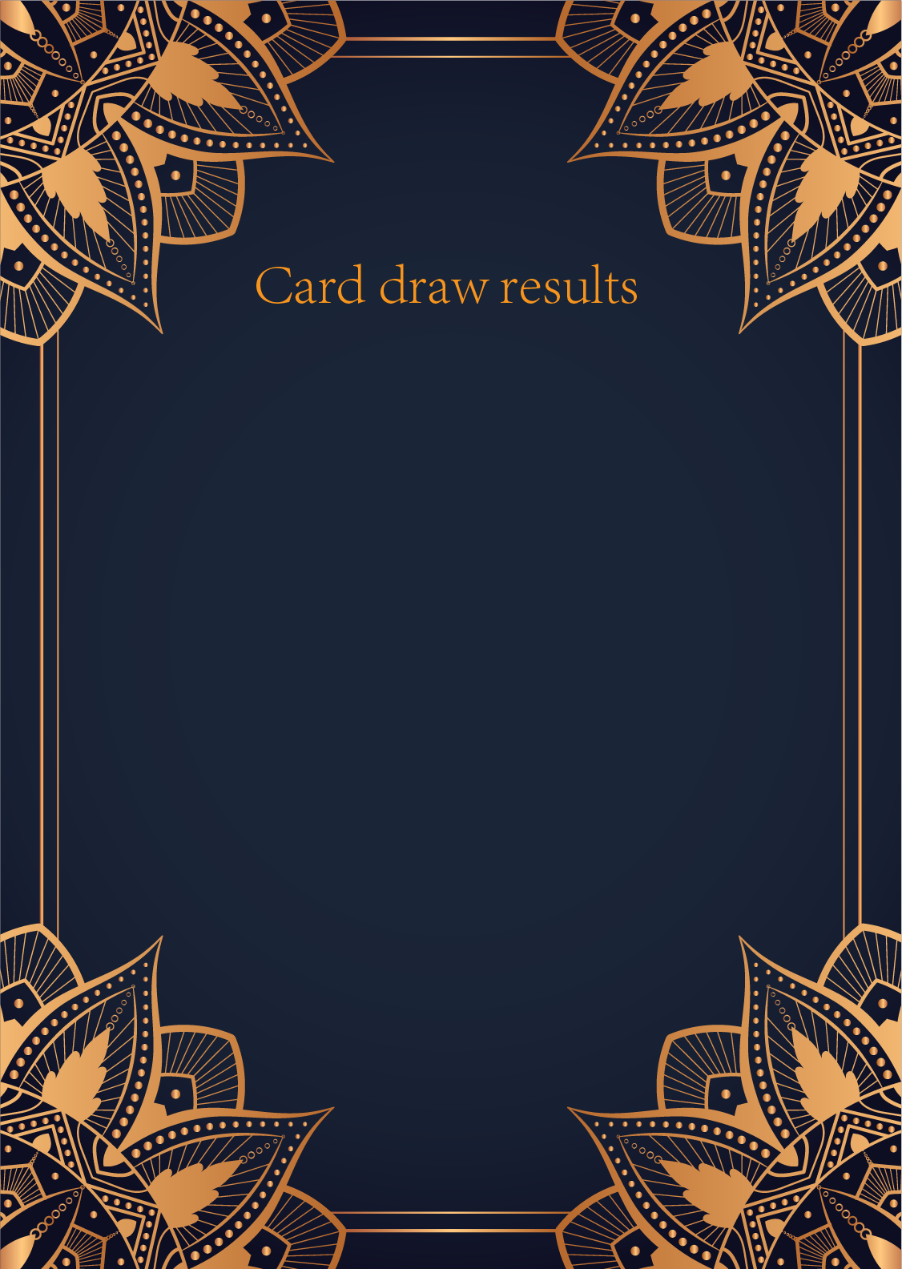

|  |
| --- |
| CardⅠ The Star |
|  |
| The Star card shows a woman kneeling at the edge of a small pond. She is holding two containers of water. One container pours the water out to the dry land, as if to to nourish it and ensure its fertility. The lush green land around her seems to say that it is working. One foot is inside the water which shows the spiritual abilities and inner strength of the woman. The other foot on the ground shows her practical abilities and strengths. Behind her, there is a large central star surrounded by seven small stars which represent the chakras. There is bird standing at a tree branch which represents the holy ibis of thought. The Star's astrological correspondent is Aquarius. |

|  |
| --- |
| CardⅡ The Moon |
|  |
| When we encounter the Moon, we see a path that leads off into the distance. On either side of the path stand a wolf and a dog, representing our animalistic nature - one is civilized, and the other wild and feral. There is a crawfish that is crawling out of the pond from which the path stems from. In the distance, we can see two towers flanking the central path, once again alluding to the doubles visible in this card. Everything in this card seems to echo the other, as if to allude to two possibilities. When we walk down the path, we walk the fine line between conscious and unconscious, between the tamed side of civilization of the dog, and the forces of nature represented by the wolf. |

|  |
| --- |
| CardⅢ The Sun |
|  |
| The Sun card presents an feeling of optimism and fulfillment. This card represents the dawn which follows the darkest of nights. The Sun is the source of all the life on our planet, and it represents life energy itself. There is a child depicted in the card, playing joyfully in the foreground. A symbol of our innocence, it represents the happiness that occurs when you are in alignment with your true self. The child is naked, meaning that he has absolutely nothing to hide. The card also depicts the childhood innocence and absolute purity. This is particularly emphasized through the white horse upon which the child is riding. The horse here is also a symbol of strength and nobility. |

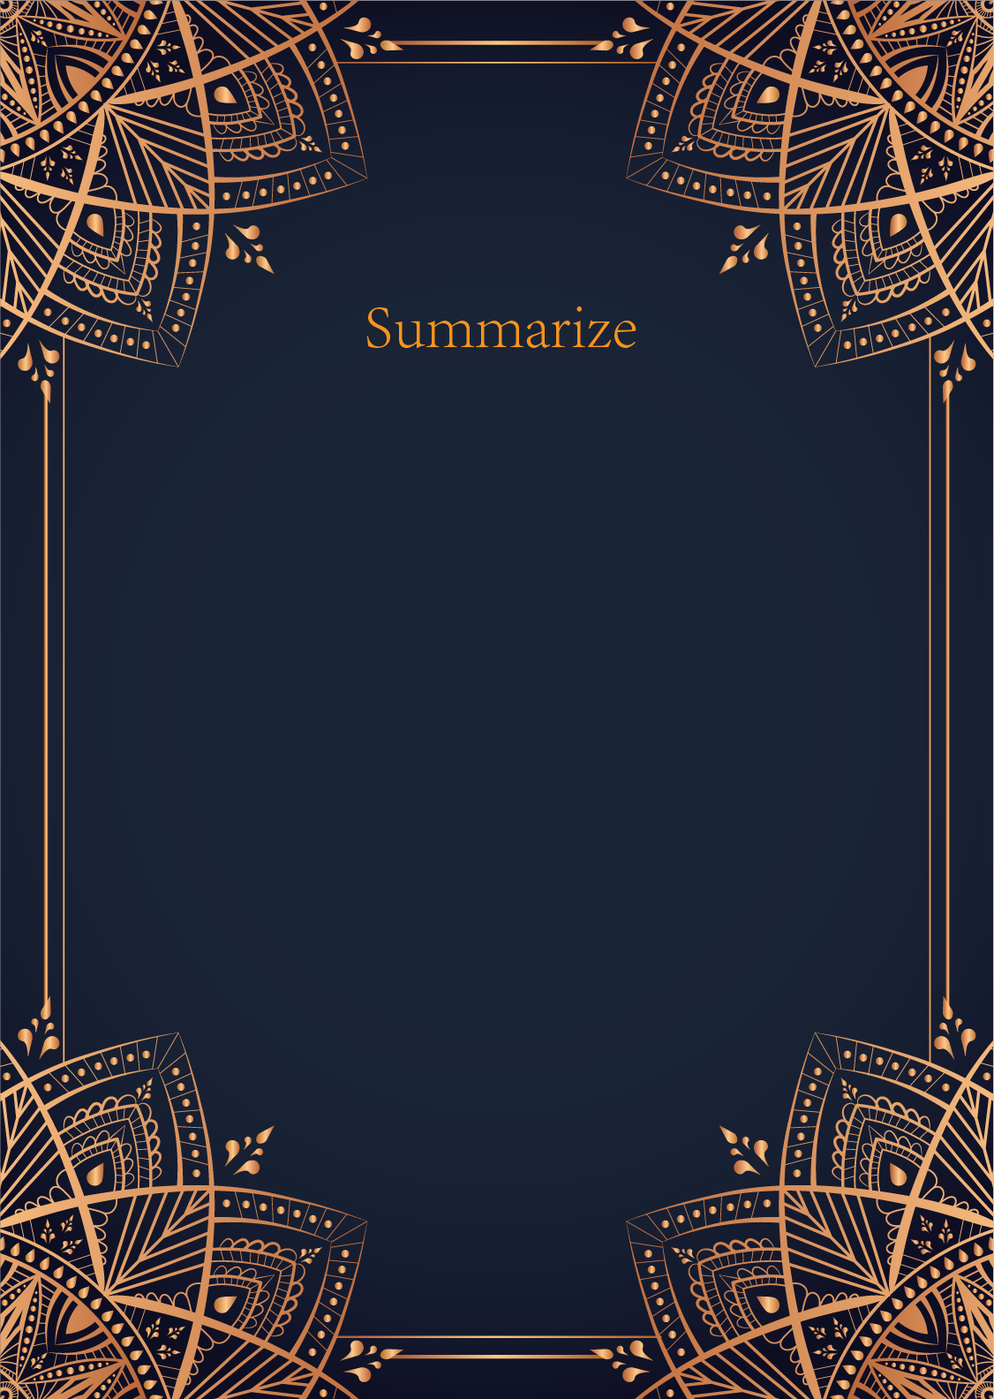

|  |  |  |
| --- | --- | --- |
|  |  |  |
| result_overview | | |

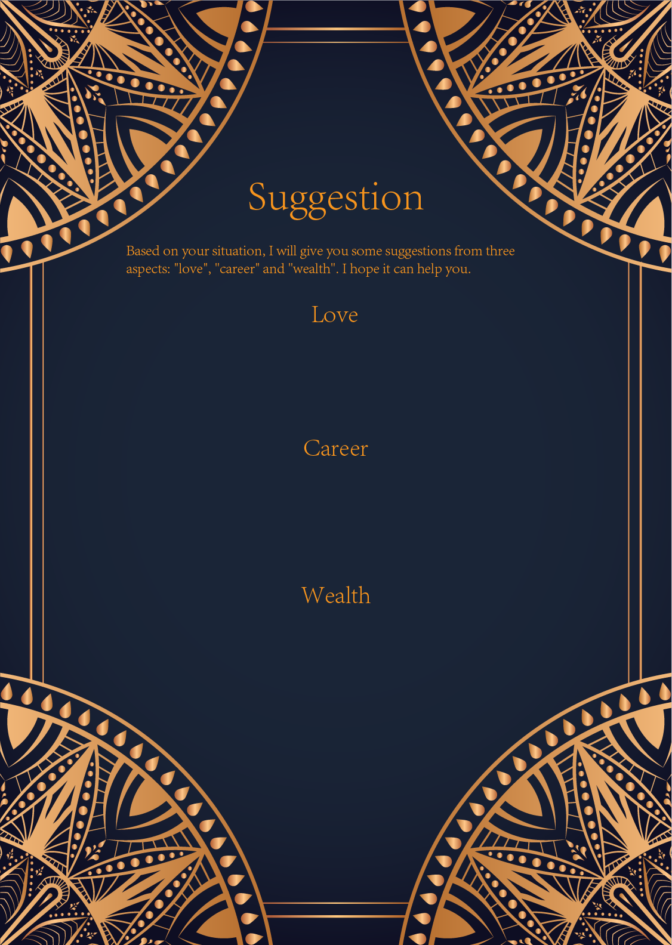

|  |
| --- |
| result_love |

|  |
| --- |
| result_career |

|  |
| --- |
| result_finances |

