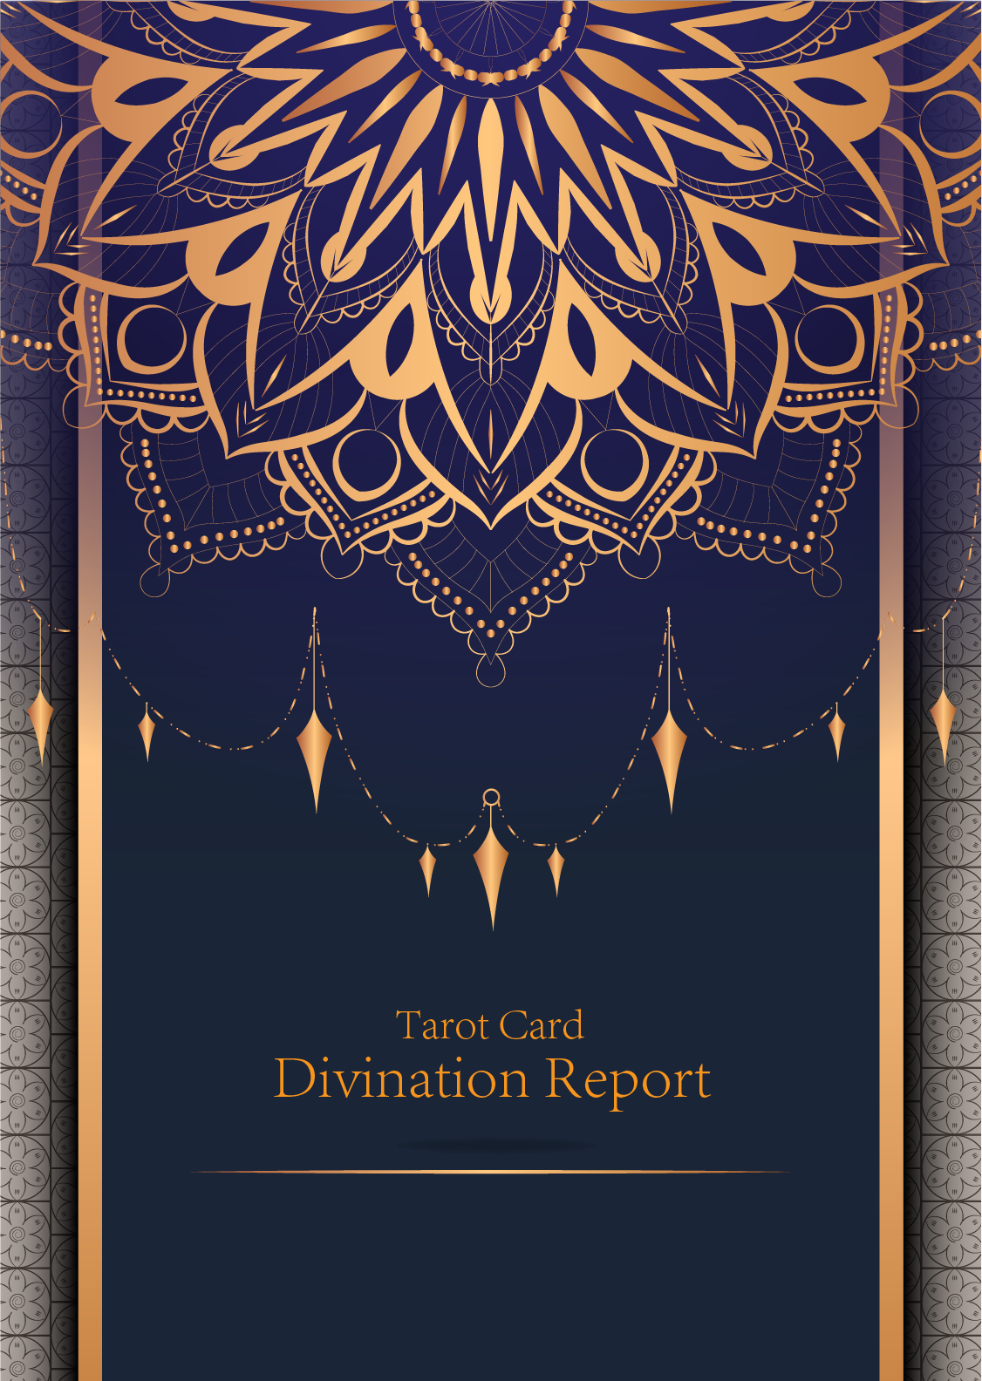

|  |
| --- |
| February 23, 2024 |

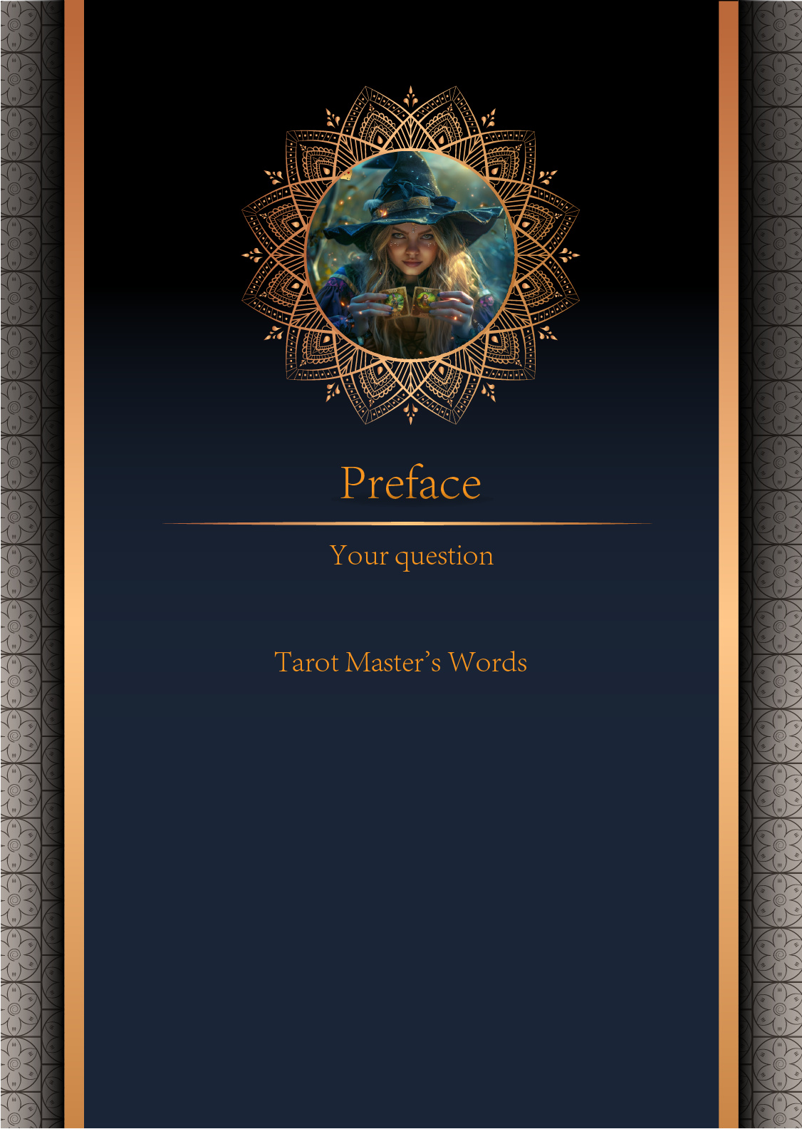

|  |
| --- |
| 我什么时候能结婚 |

|  |
| --- |
| Before we begin the interpretation, I would like to explain some important points to you. Tarot cards are not tools for predicting the future, but rather tools for guiding us to delve deeper into various situations in life. Therefore, when receiving the reading, please maintain an open mindset and trust your intuition. Our goal is to provide you with inspiration and guidance through the guidance of the tarot cards, helping you better deal with challenges and decisions in life. Alright, you can start reading now! |

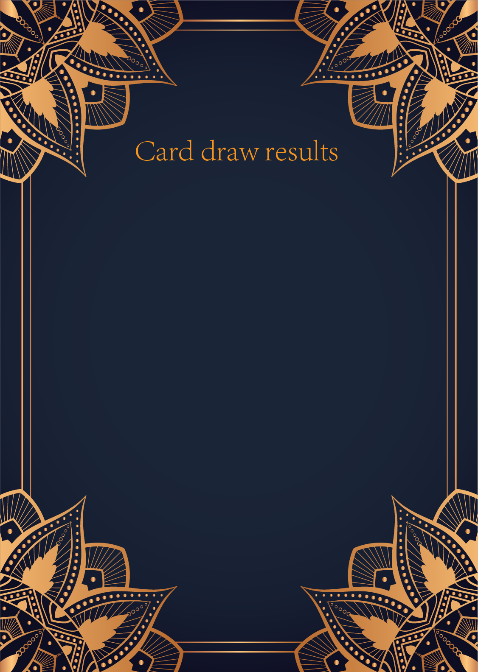

|  |
| --- |
| CardⅠ The Sun |
|  |
| The Sun card presents an feeling of optimism and fulfillment. This card represents the dawn which follows the darkest of nights. The Sun is the source of all the life on our planet, and it represents life energy itself. There is a child depicted in the card, playing joyfully in the foreground. A symbol of our innocence, it represents the happiness that occurs when you are in alignment with your true self. The child is naked, meaning that he has absolutely nothing to hide. The card also depicts the childhood innocence and absolute purity. This is particularly emphasized through the white horse upon which the child is riding. The horse here is also a symbol of strength and nobility. |

|  |
| --- |
| CardⅡ The Moon |
|  |
| When we encounter the Moon, we see a path that leads off into the distance. On either side of the path stand a wolf and a dog, representing our animalistic nature - one is civilized, and the other wild and feral. There is a crawfish that is crawling out of the pond from which the path stems from. In the distance, we can see two towers flanking the central path, once again alluding to the doubles visible in this card. Everything in this card seems to echo the other, as if to allude to two possibilities. When we walk down the path, we walk the fine line between conscious and unconscious, between the tamed side of civilization of the dog, and the forces of nature represented by the wolf. |

|  |
| --- |
| CardⅢ The Star |
|  |
| The Star card shows a woman kneeling at the edge of a small pond. She is holding two containers of water. One container pours the water out to the dry land, as if to to nourish it and ensure its fertility. The lush green land around her seems to say that it is working. One foot is inside the water which shows the spiritual abilities and inner strength of the woman. The other foot on the ground shows her practical abilities and strengths. Behind her, there is a large central star surrounded by seven small stars which represent the chakras. There is bird standing at a tree branch which represents the holy ibis of thought. The Star's astrological correspondent is Aquarius. |

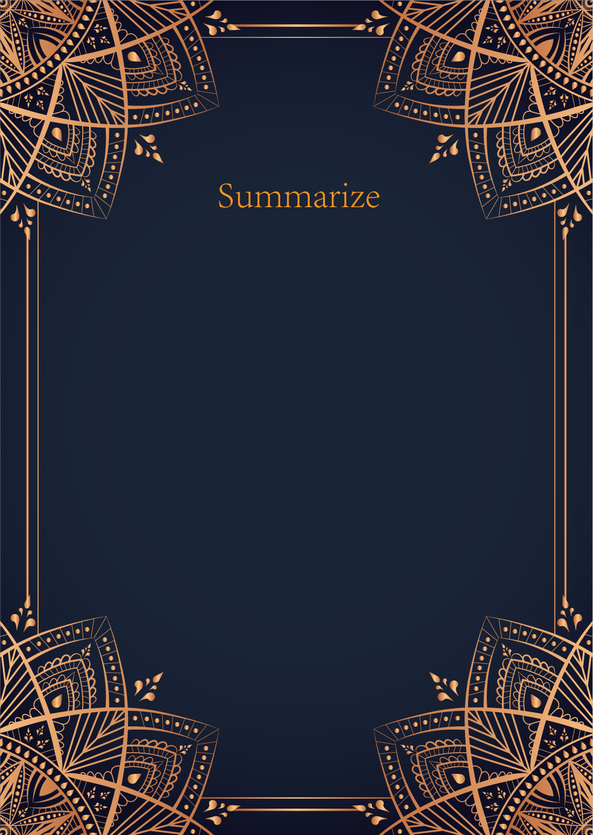

|  |  |  |
| --- | --- | --- |
|  |  |  |
| Ah, dear seeker, the cards have revealed a powerful message for you regarding the timing of your marriage. Let us delve into the mystical realm of the Tarot to uncover the wisdom hidden within the Sun, the Moon, and the Star.  The Sun card shines brightly upon you, illuminating a path of joy, ful... | | |

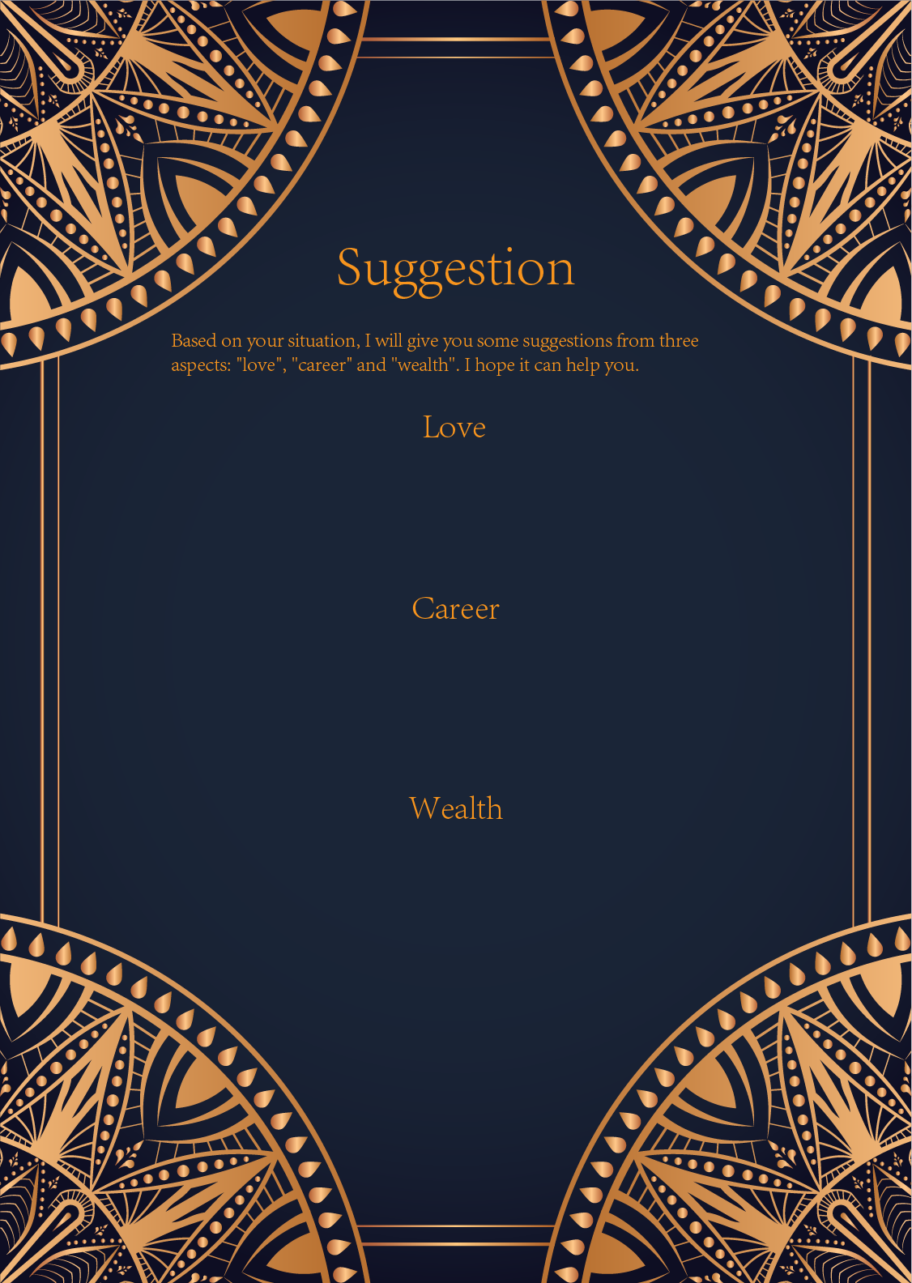

|  |
| --- |
| Ah, the Sun, the Moon, and the Star. A powerful trifecta of cards in the realm of love and relationships. Let us unravel the mysteries that lie within these cards and shed light on your romantic journey.  The Sun, a symbol of positivity, success, and happiness. In the context of love, this card u... |

|  |
| --- |
| Ah, the Sun, the Moon, and the Star. Such powerful and illuminating cards you have drawn, my dear seeker. Let us delve into the mystical realm of career guidance guided by the wisdom of the tarot.  The Sun shines brightly upon your path, urging you to embrace your inner confidence and radiance. I... |

|  |
| --- |
| Ah, dear seeker, you have drawn powerful cards indeed - the Sun, the Moon, and the Star. This combination of cards suggests a harmonious balance between light and dark, conscious and subconscious, and hope for the future. In the realm of finances, these cards offer a message of abundance, intuition, and guidance.  The Sun card represents success, vitality, and prosperity. It shines a light on your financial situation, indicating that you are currently in a period of growth and abundance. This card reminds you to bask in the warmth of your achievements and to be grateful for the financial blessings that are coming your way. It is a sign that now is the time to focus on building your wealth and making the most of the opportunities that present themselves to you.  The Moon card symbolizes intuition, mystery, and the subconscious mind. This card speaks to the importance of listening to your inner voice when it comes to financial matters. Trust your gut feelings and pay attention to any signs or symbols that may be guiding you towards prosperity. The Moon urges you to explore your deepest desires and fears surrounding money, and to address any emotional blocks that may be holding you back from financial success.  Lastly, the Star card represents hope, inspiration, and guidance. This card is a beacon of light in the darkness, offering you reassurance that your financial goals are within reach. The Star encourages you to dream big and to believe in the power of manifestation. It is a reminder that as long as you stay true to your dreams and aspirations, you will find the financial success and stability you seek.  In conclusion, the message from these three powerful cards is clear: embrace the abundance and success that is already present in your life, trust your intuition when making financial decisions, and stay focused on your long-term goals with unwavering faith and determination. By following this guidance, you will navigate the realm of finances with wisdom and grace, and attract prosperity and wealth into your life.  Embrace the light of the Sun, the mysteries of the Moon, and the guidance of the Star, dear seeker, and may your financial journey be filled with blessings and abundance. |

