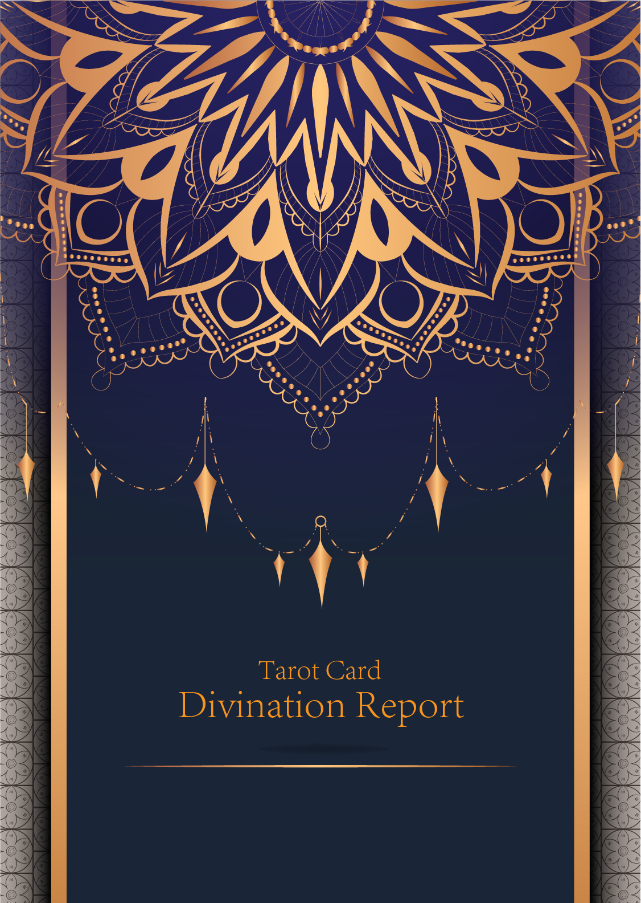

|  |
| --- |
| February 23, 2024 |

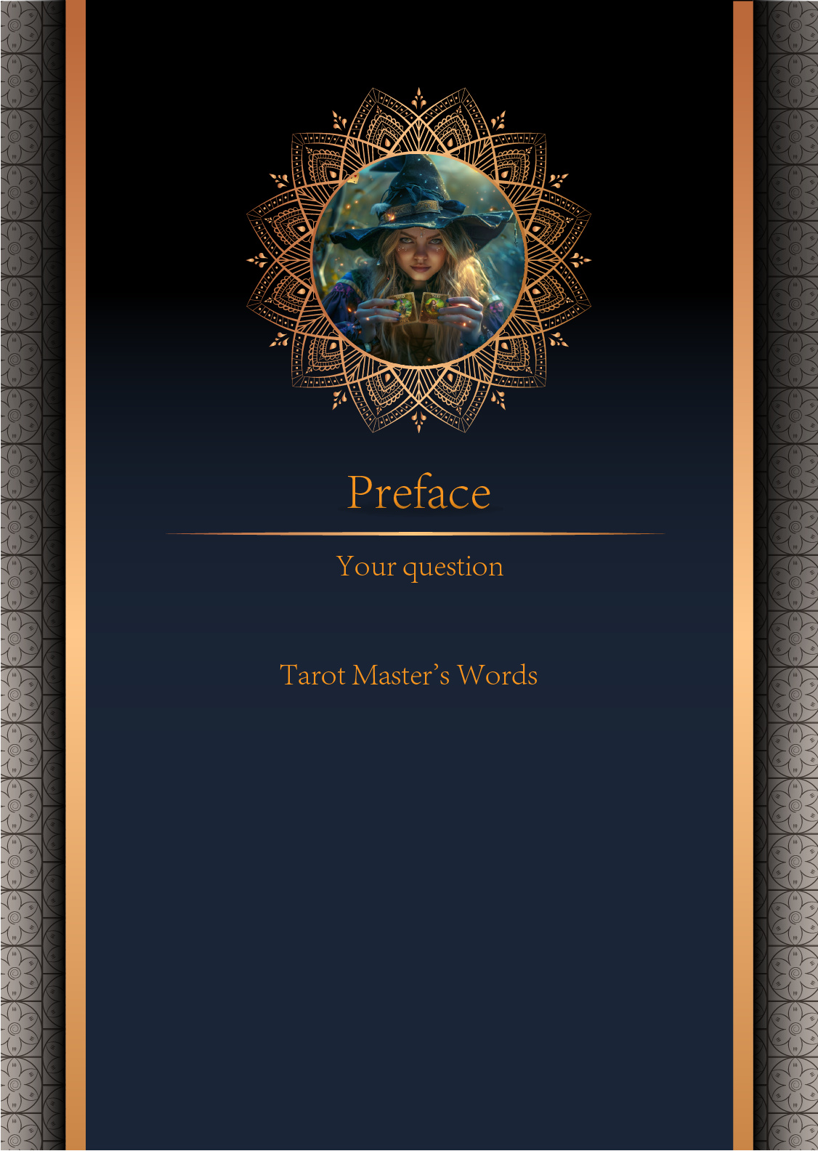

|  |
| --- |
| 我什么时候能结婚 |

|  |
| --- |
| Before we begin the interpretation, I would like to explain some important points to you. Tarot cards are not tools for predicting the future, but rather tools for guiding us to delve deeper into various situations in life. Therefore, when receiving the reading, please maintain an open mindset and trust your intuition. Our goal is to provide you with inspiration and guidance through the guidance of the tarot cards, helping you better deal with challenges and decisions in life. Alright, you can start reading now! |

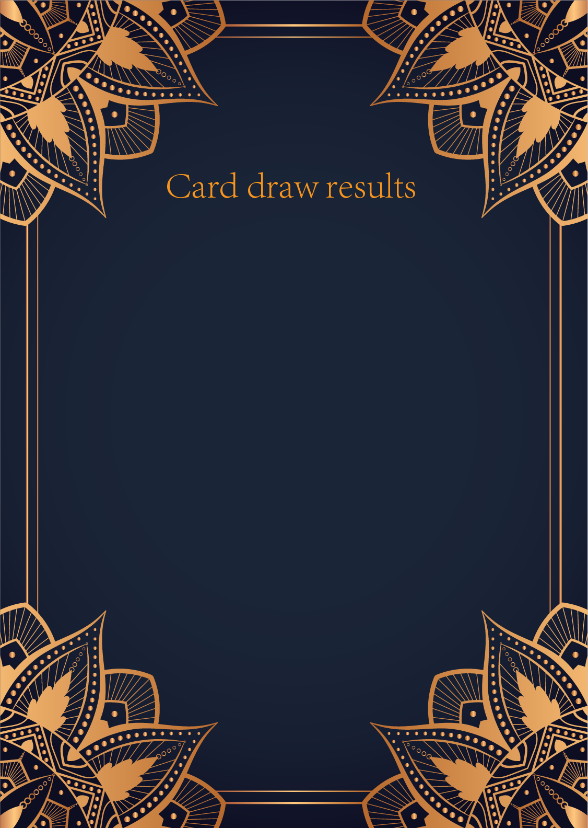

|  |
| --- |
| CardⅠ The Sun |
|  |
| The Sun card presents an feeling of optimism and fulfillment. This card represents the dawn which follows the darkest of nights. The Sun is the source of all the life on our planet, and it represents life energy itself. There is a child depicted in the card, playing joyfully in the foreground. A symbol of our innocence, it represents the happiness that occurs when you are in alignment with your true self. The child is naked, meaning that he has absolutely nothing to hide. The card also depicts the childhood innocence and absolute purity. This is particularly emphasized through the white horse upon which the child is riding. The horse here is also a symbol of strength and nobility. |

|  |
| --- |
| CardⅡ The Moon |
|  |
| When we encounter the Moon, we see a path that leads off into the distance. On either side of the path stand a wolf and a dog, representing our animalistic nature - one is civilized, and the other wild and feral. There is a crawfish that is crawling out of the pond from which the path stems from. In the distance, we can see two towers flanking the central path, once again alluding to the doubles visible in this card. Everything in this card seems to echo the other, as if to allude to two possibilities. When we walk down the path, we walk the fine line between conscious and unconscious, between the tamed side of civilization of the dog, and the forces of nature represented by the wolf. |

|  |
| --- |
| CardⅢ The Star |
|  |
| The Star card shows a woman kneeling at the edge of a small pond. She is holding two containers of water. One container pours the water out to the dry land, as if to to nourish it and ensure its fertility. The lush green land around her seems to say that it is working. One foot is inside the water which shows the spiritual abilities and inner strength of the woman. The other foot on the ground shows her practical abilities and strengths. Behind her, there is a large central star surrounded by seven small stars which represent the chakras. There is bird standing at a tree branch which represents the holy ibis of thought. The Star's astrological correspondent is Aquarius. |

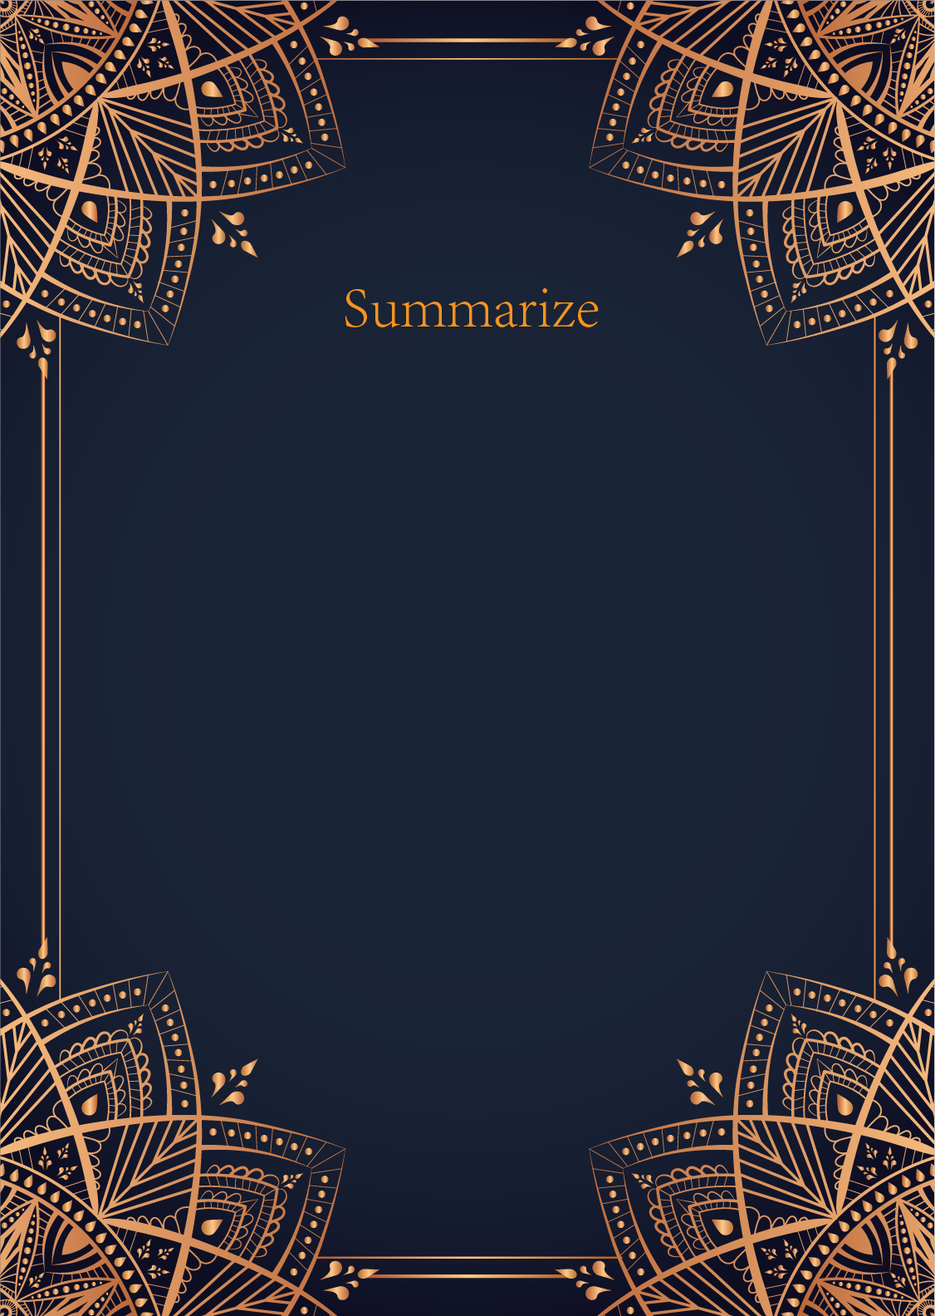

|  |
| --- |
| Ah, my dear querent, your inquiry about the timing of marriage is a matter of great significance and intrigue. The Sun, the Moon, and the Star have revealed themselves to you, offering insights into the journey that lies ahead on the path to matrimony.  The Sun card, radiant and full of life, speaks of joy, success, and fulfillment. When this card appears in a reading, it signifies that a period of happiness and clarity is on the horizon. In the context of your question, the Sun suggests that the time for marriage may be approaching sooner than you think. It encourages you to embrace positivity, confidence, and vitality as you prepare for this new chapter in your life.  The Moon, shrouded in mystery and intuition, represents the subconscious mind, dreams, and illusions. This card reminds you to trust your instincts and listen to your inner voice when it comes to matters of the heart. The presence of the Moon in your reading suggests that there may be some emotional complexities or u... |

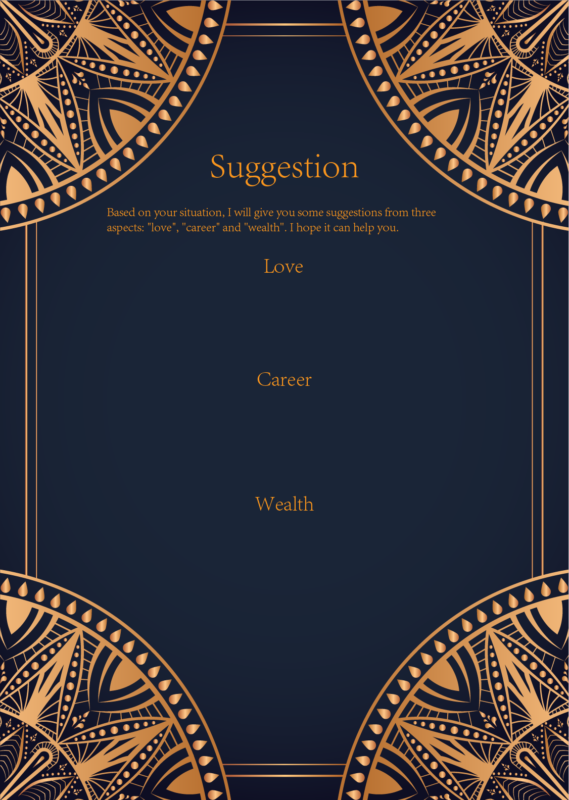

|  |
| --- |
| Ah, my dear seeker, the Sun, the Moon, and the Star have revealed themselves to you in this moment of seeking guidance in matters of love. These three powerful cards hold within them a message of illumination, intuition, and destiny.   The Sun card represents joy, success, and vitality in your romantic endeavors. It speaks of a time of happiness, clarity, and bountiful energy in your love life. This card urges you to embrace the present moment with optimism and confidence, allowing your true self to shine brightly in the eyes of your beloved. Remember to bask in the warmth of love and let go of any shadows from the past that may dim your light.  Ah, the Moon card, with its mysterious and intuitive energy, whispers to you of the importance of listening to your inner voice and exploring the depths of your emotions in matters of the heart. This card signals a time of heightened sensitivity and intuition in your relationships. Trust your instincts and pay attention to the subtle shifts ... |

|  |
| --- |
| Ah, the Sun, the Moon, and the Star - such powerful and illuminating cards you have drawn. Each card carries its own unique energy and message, guiding you towards your true path in the realm of career and professional development.  The Sun card speaks of success, abundance, and fulfillment in your career. It signifies a time of confidence, vitality, and creativity. This card urges you to embrace your talents and abilities, shining brightly in all that you do. It suggests that now is the time to pursue your goals with enthusiasm and optimism. Channel the radiant energy of the Sun into your work, and you will no doubt achieve great things.  On the other hand, the Moon card represents intuition, mystery, and the subconscious mind. It symbolizes a period of deep reflection and inner exploration in your career. This card encourages you to trust your instincts, listen to your inner voice, and pay attention to the unseen forces at play. Embrace the unknown and embrace uncertainty, for it ... |

|  |
| --- |
| Ah, my dear seeker, the Sun, the Moon, and the Star have blessed you with their illuminating wisdom on matters of wealth and prosperity. Let us delve into the mystical realm of the Tarot to unravel the secrets they hold for you in the realm of finances.  The Sun card shines brightly upon you, heralding a time of abundance and success. It signifies financial growth, prosperity, and achievement. Now is the time to bask in the warmth of this radiant energy and harness it to expand your financial horizons. Be bold in your investments, take calculated risks, and trust in your abilities to manifest wealth and abundance in your life.  The Moon card, with its enigmatic aura, urges you to navigate through the shadows of uncertainty with intuition and trust. While the path to financial stability may seem unclear at times, trust in your inner guidance to lead you towards prosperity. Embrace the mystical forces at play, and allow your instincts to guide you towards making wise financial decisions. By embracing the ebb and flow of the lunar energies, you will find the hidden treasures that await you in the realm of wealth.  Lastly, the Star card bestows upon you the gift of hope and inspiration. It serves as a beacon of light in times of uncertainty, reminding you to stay true to your dreams and aspirations. This card encourages you to set ambitious financial goals, for the universe is conspiring to help you achieve them. Trust in the cosmic energy that surrounds you, and have faith that your financial dreams are within reach. Stay aligned with your true purpose and allow the divine guidance of the Star to lead you towards financial fulfillment.  In conclusion, dear seeker, the Sun, Moon, and Star have spoken. Embrace the abundance and success that the Sun offers, trust in your intuition and navigate through uncertainty with the Moon's guidance, and hold fast to your dreams and aspirations with the Star's inspiration. By heeding the wisdom of these mystical cards, you will find yourself on a path towards financial prosperity and fulfillment. Trust in the magic of the Tarot, and may your financial journey be blessed with abundance and success. |

