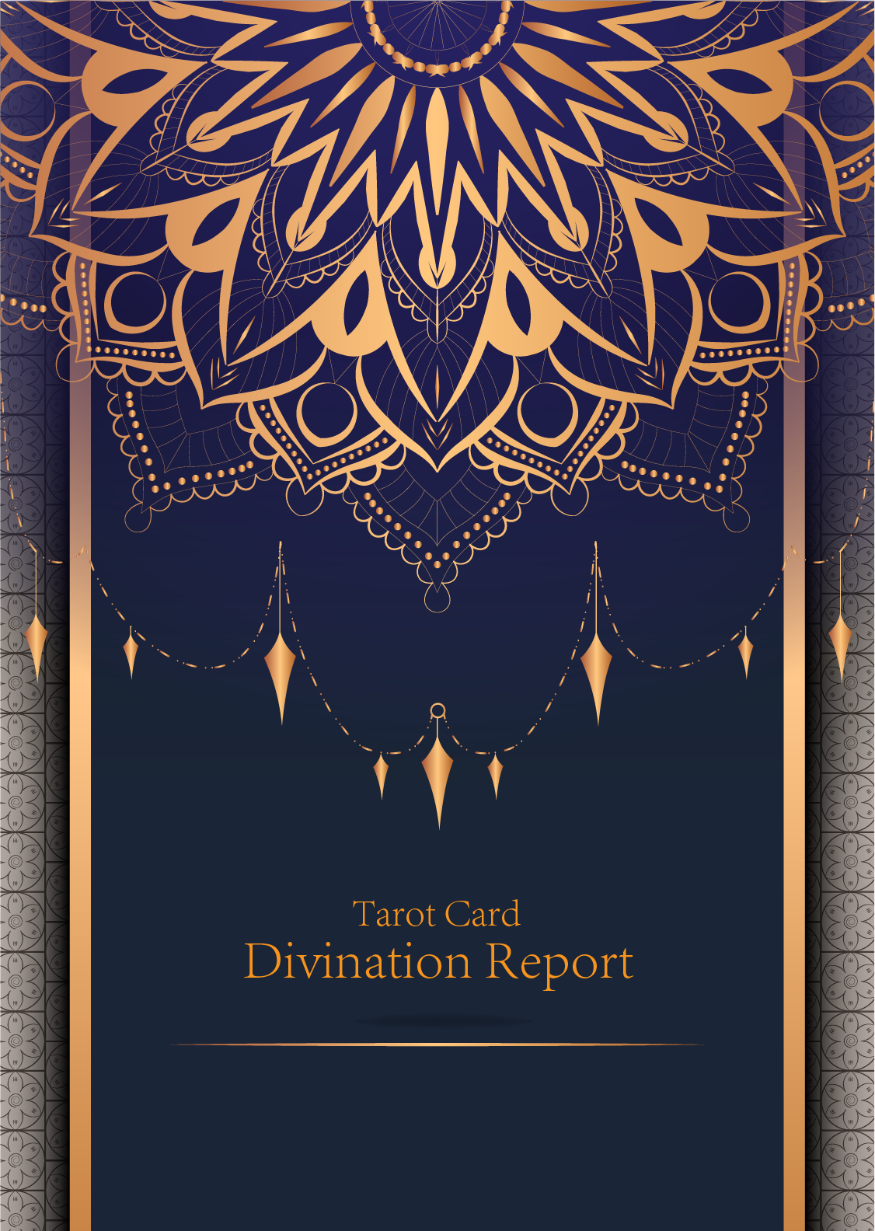

|  |
| --- |
| February 23, 2024 |

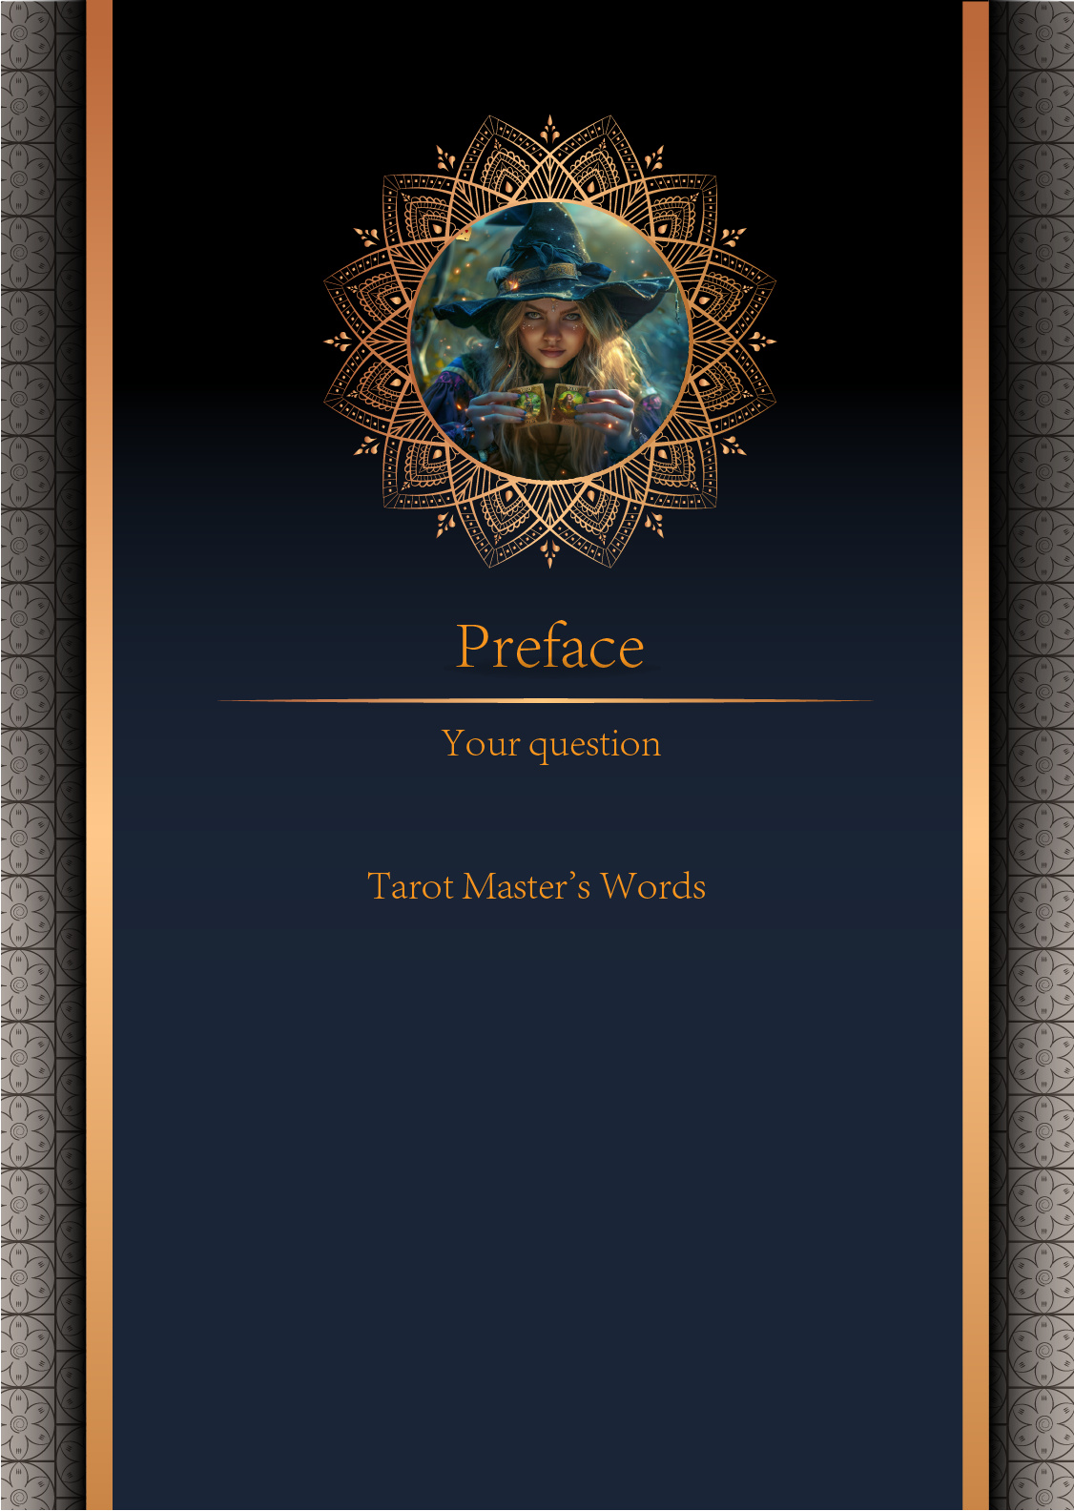

|  |
| --- |
| 我什么时候能结婚 |

|  |
| --- |
| Before we begin the interpretation, I would like to explain some important points to you. Tarot cards are not tools for predicting the future, but rather tools for guiding us to delve deeper into various situations in life. Therefore, when receiving the reading, please maintain an open mindset and trust your intuition. Our goal is to provide you with inspiration and guidance through the guidance of the tarot cards, helping you better deal with challenges and decisions in life. Alright, you can start reading now! |

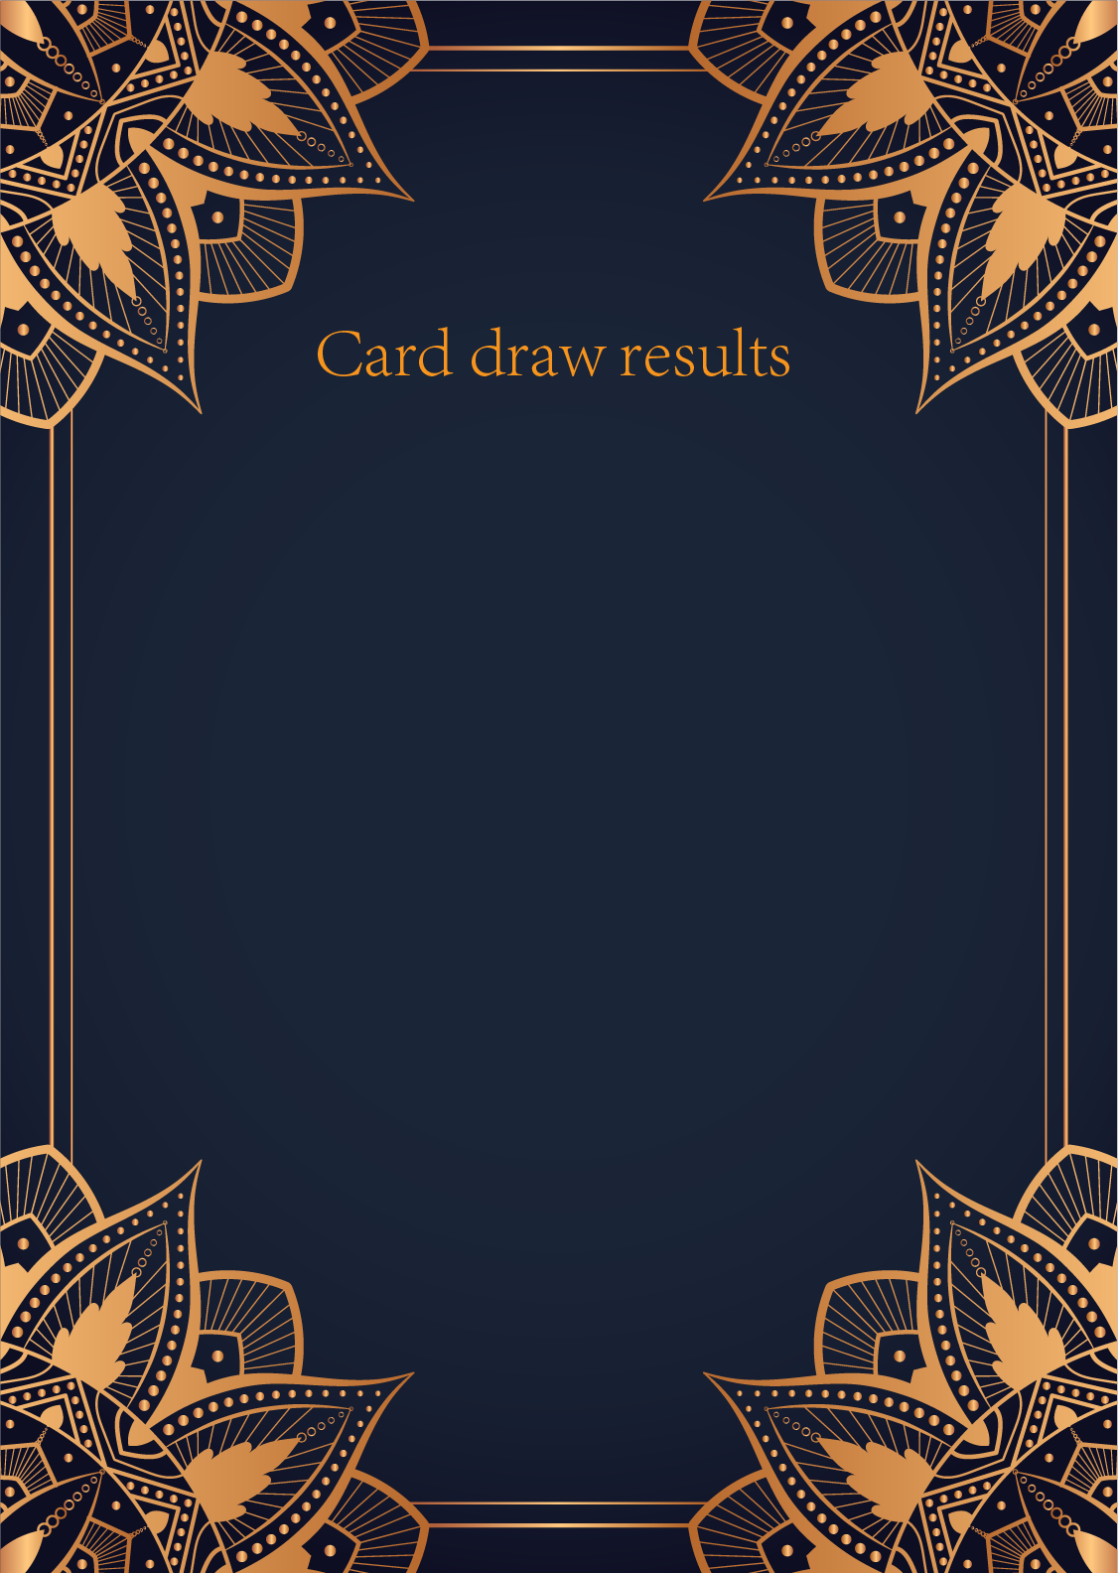

|  |
| --- |
| CardⅠ The Sun |
|  |
| The Sun card presents an feeling of optimism and fulfillment. This card represents the dawn which follows the darkest of nights. The Sun is the source of all the life on our planet, and it represents life energy itself. There is a child depicted in the card, playing joyfully in the foreground. A symbol of our innocence, it represents the happiness that occurs when you are in alignment with your true self. The child is naked, meaning that he has absolutely nothing to hide. The card also depicts the childhood innocence and absolute purity. This is particularly emphasized through the white horse upon which the child is riding. The horse here is also a symbol of strength and nobility. |

|  |
| --- |
| CardⅡ The Moon |
|  |
| When we encounter the Moon, we see a path that leads off into the distance. On either side of the path stand a wolf and a dog, representing our animalistic nature - one is civilized, and the other wild and feral. There is a crawfish that is crawling out of the pond from which the path stems from. In the distance, we can see two towers flanking the central path, once again alluding to the doubles visible in this card. Everything in this card seems to echo the other, as if to allude to two possibilities. When we walk down the path, we walk the fine line between conscious and unconscious, between the tamed side of civilization of the dog, and the forces of nature represented by the wolf. |

|  |
| --- |
| CardⅢ The Star |
|  |
| The Star card shows a woman kneeling at the edge of a small pond. She is holding two containers of water. One container pours the water out to the dry land, as if to to nourish it and ensure its fertility. The lush green land around her seems to say that it is working. One foot is inside the water which shows the spiritual abilities and inner strength of the woman. The other foot on the ground shows her practical abilities and strengths. Behind her, there is a large central star surrounded by seven small stars which represent the chakras. There is bird standing at a tree branch which represents the holy ibis of thought. The Star's astrological correspondent is Aquarius. |

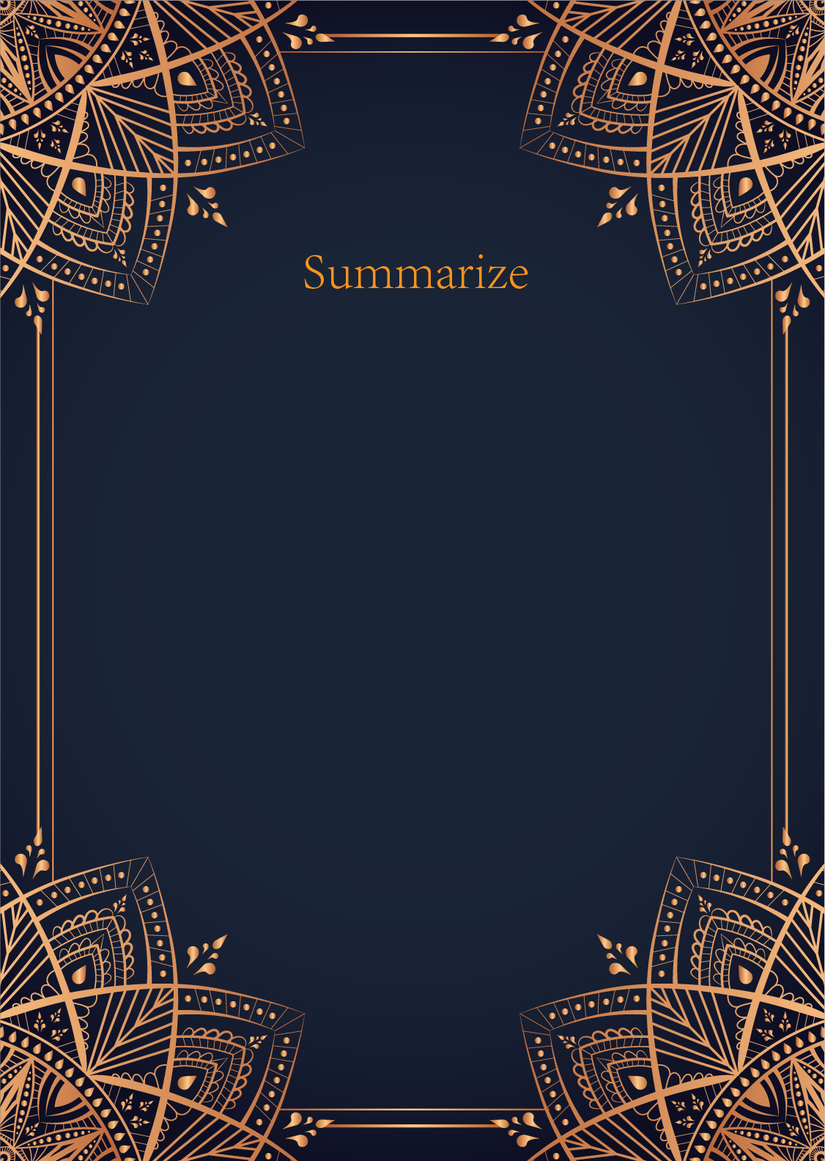

|  |
| --- |
| Ah, my dear seeker of mysteries, the cards have revealed to me a path illuminated by the radiant Sun, the enigmatic Moon, and the guiding Star. Each card holds a message for you, a whisper from the universe about the timing of your union.  The Sun, with its joyful energy and vitality, speaks of a time of clarity and illumination in your romantic life. It heralds a period of happiness and fulfillment, a time when your heart is open and ready to embrace love in its purest form. This card suggests that your path to marriage is one filled with warmth, positivity, and abundance.  The Moon, shrouded in mystery and intuition, tells a tale of dreams, emotions, and deep inner reflections. It suggests that there may be hidden truths and subconscious desires at play in your quest for marriage. Trust your intuition, for it will guide you through the shadows and illuminate the path to your heart's true desires.  And finally, the Star, a beacon of hope and inspiration, shines brightly upon your q... |

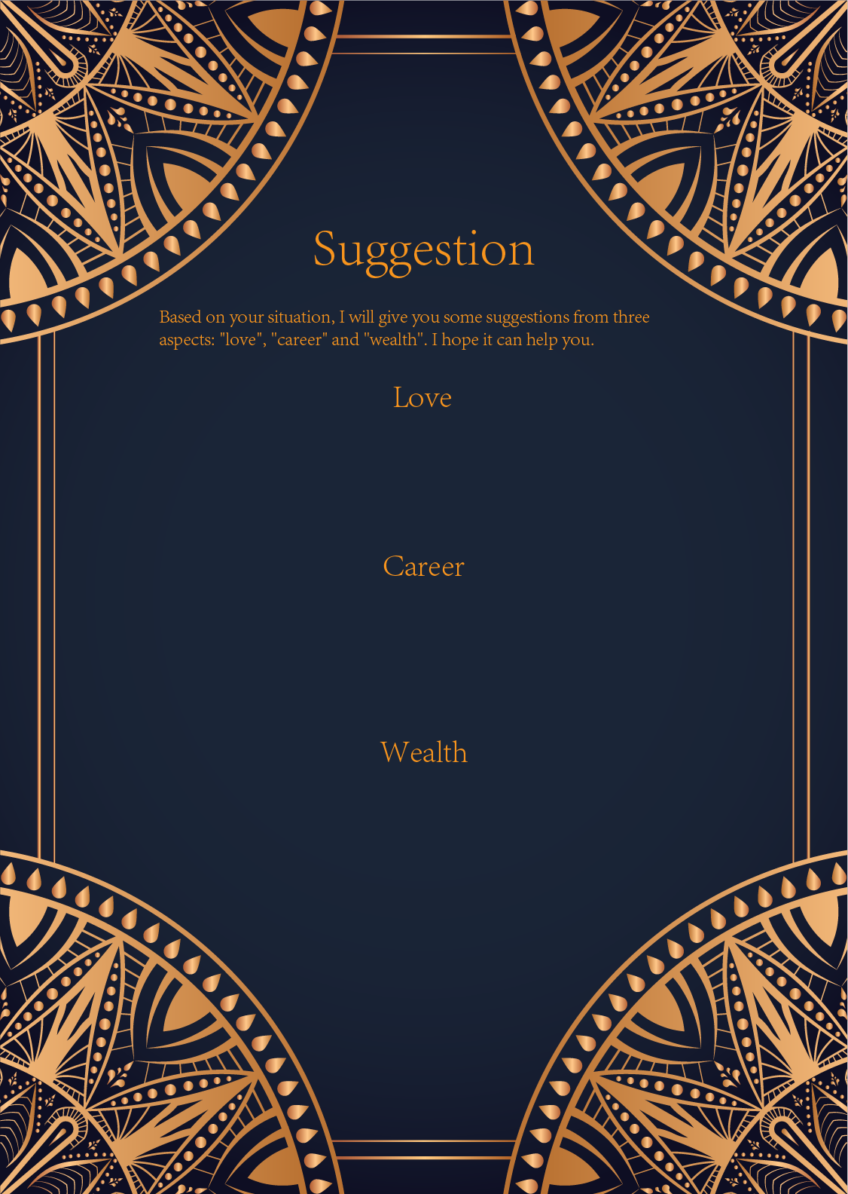

|  |
| --- |
| Ah, the Sun, the Moon, and the Star. Three powerful cards that speak deeply to matters of the heart and soul. In the realm of love, these cards suggest a journey of self-discovery, illumination, and hope.  The Sun card brings warmth, joy, and positivity to your love life. It signifies a time of happiness, clarity, and fulfillment in your relationships. It encourages you to embrace the light within yourself and share it with others. Remember to bask in the glow of love and let your true self shine brightly.  The Moon card symbolizes intuition, mystery, and emotional depth. It reminds you to trust your instincts and explore the hidden realms of your heart. Embrace your dreams, fears, and desires in love, for they hold the key to true connection and understanding. Be open to the ebb and flow of emotions, and let your inner world guide you in matters of the heart.  The Star card brings hope, inspiration, and guidance to your love journey. It signifies a period of healing, renewal, and d... |

|  |
| --- |
| Ah, dear seeker of guidance, the Sun, the Moon, and the Star have revealed themselves to you in this moment of seeking clarity in your career path. Allow me to decipher their messages for you.  The Sun card shines brightly upon you, illuminating a path of success and fulfillment in your career. It signifies confidence, achievement, and recognition. This card urges you to embrace your talents and abilities with assurance, and to pursue your goals with enthusiasm and optimism. It encourages you to step into the spotlight and showcase your skills to the world.  Next, the Moon card whispers of intuition, creativity, and the subconscious mind. It guides you to listen to your inner voice and trust your instincts when navigating your professional journey. The Moon's soft glow caresses your path, urging you to explore your emotions and tap into your artistic and imaginative side. This card reminds you to embrace the unknown and embrace the mysteries of your career with grace and intuition. ... |

|  |
| --- |
| Ah, the Sun, the Moon, and the Star - a powerful trio of cards that signify abundance, intuition, and guidance in the realm of finances. The Sun card brings a sense of joy and success, indicating that financial prosperity is within reach. It reminds you to harness your confidence and take bold steps towards your goals.   On the other hand, the Moon card represents intuition and the subconscious mind. It suggests that you may encounter financial uncertainties or hidden obstacles along your path. Trust your instincts and pay attention to your inner voice when making financial decisions. Embrace the unknown with courage and stay open to new possibilities.  Finally, the Star card shines brightly with hope and inspiration. It tells you to keep your faith alive and believe in the abundance that surrounds you. Have a clear vision of your financial goals and let your inner light guide you towards success. Stay optimistic and know that you are supported by the universe in your financial endeavors.  In conclusion, these cards urge you to embrace your confidence, trust your intuition, and stay hopeful in your financial journey. Remember to have a balance between boldness and intuition, and let your inner light guide you towards financial prosperity. Trust in the universe's abundance and remain open to the opportunities that come your way. With determination and faith, you will achieve financial success and abundance. |

