**Software Project Development On**

**Electroweb.com**

In Partial Fulfilment Of

Bachelor of Computer Application (BCA)



**Gujarat University (2019-20)**

(Third Year Bachelor of Computer Application)

**Project created by**

**GROUP NO: 48**

**SHAH JINESH**

**SHAH DEVANSH**

**SHAH AYUSH**



**Lokmanya College of Computer Application (LCCA)**

**Shivranjani Cross Road, 132 Feet Ring Road,**

**Satellite, Ahmedabad-3800008**

**Contact No: - (079)-26920259**

***ACKNOWLEDGEMENT***

*A study such as this cannot be work of single group of three people. I hereby express deep gratitude to all those who have helped us directly or indirectly for completing this work and who have encouraged and inspired us all through the project.*

*Words are inadequate to express our deep sentiments and gratitude towards my project mentor and guide* ***“KRISHNA SAPRA”*** *for her zeal scholarly guidance during this pursuit inspire of her multifarious responsibility.*

*The word of acknowledgement is an expression of heartfelt thankfulness for her inspiration*

*Finally we would thank the people who have taken time of from their busy schedule to help by providing us with their valuable inputs.*

Group No: 48 LCCA Page No: 01

Electroweb.com

|  |  |  |
| --- | --- | --- |
|  | **Title** | **Page No.** |
| ***1*** | ***Introduction*** | ***3*** |
|  | ***1.1 Company Profile*** | ***4*** |
|  | ***1.2.Project Definition*** | ***5*** |
| ***2*** | ***Analysis*** | ***6*** |
|  | ***2.1.Existing System*** | ***7*** |
|  | ***2.2.Need for New System*** | ***8*** |
|  | ***2.2.1New System Advantage*** | ***9*** |
|  | ***2.3 MODULES*** | ***10*** |
|  | ***2.3.1 MODULE(FIGURE)*** | ***11*** |
|  | ***2.3.2 Admin Module list*** | ***12*** |
|  | ***2.3.3 Customer Module list*** | ***13*** |
|  | ***2.3.4 Visitor Module list*** | ***14*** |
|  | ***2.4 Hardware and software requirement*** | ***15*** |
|  | ***2.5 Feasibility study*** | ***16*** |
|  | ***2.5.0 Four areas of feasibility*** | ***17*** |
|  | ***2.5.1 Technical feasibility*** | ***18*** |
|  | ***2.5.2 Economical feasibility*** | ***19*** |
|  | ***2.5.3 Operational feasibility*** | ***20*** |
|  | ***2.5.4 Scheduling feasibility*** | ***21*** |
|  | ***2.6 Water fall Modal*** | ***22*** |
|  | ***2.6.1 Advantage & Disadvantage*** | ***24*** |
| ***3*** | ***DATA FLOW DIAGRAM*** | ***25*** |
|  | ***3.1 What is Data Flow Diagram?*** | ***26*** |

***INDEX***

|  |  |  |
| --- | --- | --- |
|  |  |  |

|  |  |  |
| --- | --- | --- |
|  | ***3.1 What is data flow diagram?*** | ***26*** |
|  | ***3.2 Data Flow Diagram Levels*** | ***27*** |
|  | ***3.2.1 context(0) level*** | ***28*** |
|  | ***3.2.2 first (1st) level*** | ***29*** |
|  | ***3.2.3 second (2nd)level*** | ***30*** |
|  | ***3.3.1 context level Diagram*** | ***31*** |
|  | ***3.4.1 1st level Diagram-Admin*** | ***32*** |
|  | ***3.4.2 1st level Diagram-Customer*** | ***33*** |
|  | ***3.5.1 2nd level Diagram-Admin login table*** | ***34*** |
|  | ***3.5.2 2nd level Diagram-Admin Category Master*** | ***35*** |
|  | ***3.5.3 2nd level Diagram-Admin Product Master*** | ***36*** |
|  | ***3.5.4 2nd level Diagram-Admin Customer Master*** | ***37*** |
|  | ***3.6.1 2nd level Diagram-Customer login table*** | ***38*** |
|  | ***3.6.2 2nd level Diagram-Customer order table*** | ***39*** |
|  | ***3.6.3 2nd level Diagram-Customer payment table*** | ***40*** |
| ***4*** | ***DATA DICTIONARY TABLES*** | ***41*** |
|  | ***4.1 ROLE TABLE*** | ***42*** |
|  | ***4.2 CUSTOMER TABLE*** | ***43*** |
|  | ***4.3 LOGIN TABLE*** | ***44*** |
|  | ***4.4 COUNTARY TABLE*** | ***45*** |
|  | ***4.5 STATE TABLE*** | ***46*** |
|  | ***4.6 CITY TABLE*** | ***47*** |
|  | ***4.7 PRODUCT TABLE*** | ***48*** |
|  | ***4.8 CATEGORY TABLE*** | ***49*** |
|  | ***4.9 SUB-CATEGORY TABLE*** | ***50*** |
|  | ***4.10 SIZE TABLE*** | ***51*** |
|  | ***4.11 COLOR TABLE*** | ***52*** |
|  | ***4.12 ORDER TABLE*** | ***53*** |
|  | ***4.13 DISCOUNT TABLE*** | ***54*** |
|  | ***4.14 PAYMENT TABLE*** | ***55*** |
|  | ***4.15 FEEDBACK TABLE*** | ***56*** |
| ***5*** | ***5 ER-DIAGRAM*** | ***57*** |
|  | ***5.0 ER-DIAGRAM(FIGURE)*** | ***58*** |
| ***6*** | ***CONCLUSION*** | ***59*** |
| ***7*** | ***BIBLIOGRAPHY*** | ***60*** |
|  | ***THANK YOU*** | ***61*** |
|  |  |  |

***CHAPTER: 1***

***INTRODUCTION***



Group No: 48 LCCA Page No: 04

Electroweb.com1.1Company Profile

Company Name: KRISHNA TECHNOLOGIES

Company Address: 410,4th floor, Orange Mall, Nr.chandkheda Cross Road, Chandkheda, Ahmedabad

Mobile No: +91 9408241439

Email: contact@krishnatech.co.in

***1.1Project Definition***

***Title:Electroweb.com***

***Internal Guide: Krishna Sapra***

* ***Electroweb.com Website is here to makeyour shoppingeasy. Customer can easily view the product. Customer can pay with available option.***
* ***Electroweb.com provide you to shop any accessories and apparels, user can do shopping of clothes, shoes etc. .if customer are already signing then they can purchase any product is they are not signing then they can only view the product.If user not satisfied with product then company refund to the customer and they can return the product.***

Group No: 48 LCCA Page No: 05

Electroweb.com

***CHAPTER : 2***

***ANALYSIS***



Group No: 48 LCCA Page No: 06

Electroweb.com

***2.1. Existing System***

* ***In the existing system all transactions, dealings of products, purchasing of products were done manually which is time consuming.***
* ***Reports are prepared manually as and when needed. Maintaining of reports is very tedious task.***
* ***To buy any product user has to collect information about it either by visiting the shop or asking people which is the better one.***
* ***There is no computer system for handling payments. All calculations are performed manually which may not be accurate always. Maintaining the recordis really a tedious task.***

Group No: 48 LCCA Page No: 07

Electroweb.com

***2.2.Need for New System***

* ***Online Shopping Portal is a specific requirement of the client that integrates the buying and selling services specifically to their customers.***
* ***Need for the new system is due to major drawbacks of existing system.***
* ***The details regarding all users, products can also be maintained as their information is very helpful and sometimes becomes a critical requirement.***
* ***Allows user to get registered from their places and transact for the required product.***
* ***To overcome these problems in existing system we develop “Online Shopping Portal”.***

*Group No: 48 LCCA Page No: 08*

*Electroweb.com*

***New System: Advantage***

* ***Online shopping mainly based on the two items used one is desktop or any electronic device that connect on internet and second item is internet network is used in shopped any product and items.***
* ***Online shopping in many items like cloths and electronics product in many categories and sub-categories in choose any item and purchased with discounts and offers.***
* ***New system in online shopping very easy to purchase any products and items just one click of mouse button.***
* ***Online shopping system provide best features like online transaction, cash on delivery and best quality of product etc.***
* ***New system is time, money and power saving.***

*Group No: 48 LCCA Page No: 48*

*Electroweb.com*

***2.3 MODULES***

* ***Online shopping system in 3 modules :-***

***ADMIN CUSTOMER VISITOR***

********

*Group No: 48 LCCA Page No: 10*

*Electroweb.com*

***2.3.1 MODULES***

*Group No: 48 LCCA Page No: 11*

*Electroweb.com*

***2.3.2 ADMIN MODULE LIST***

***🖎 Manage Category***

***🖎 Manage Item***

***🖎 Manage Reports***

***🖎 Manage Order***

***🖎 Manage Payment***

***🖎 Manage Feedback***

*Group No: 48 LCCA Page No: 12*

*Electroweb.com*

***2.3.3 CUSTOMER MODULE LIST***

***🖎 Registration***

***🖎 Login***

***🖎 Select Item***

***🖎 Add To Cart***

***🖎 Make Payment***

***🖎 Give Feedback***

*Group No: 48 LCCA Page No: 13*

*Electroweb.com*

***2.3.4 VISITOR MODULE LIST***

***🖎 Search Item***

***🖎 View Services***

***🖎 View Discounts***

***🖎 Give Feedback***

*Group No: 48 LCCA Page No: 14*

*Electroweb.com*

***2.4 HARDWARE AND SOFTWARE REQUIREMENT***

***\*HARDWARE REQUIRMENT:***

***Processor: CORE Intel i5 OR Higher***

***Ram: 128MB OR Higher***

***Cache: 512 MB***

***Hard disk: 10GB***

***\*SOFTWARE REQUIRMENT:***

***Operating system: Windows7 above***

***Front End: PHP***

***Back End: MYSQL***

***Diagram tool: MS Visio 2007***

*Group No: 48 LCCA Page No: 15*

*Electroweb.com*

***2.5 Feasibility Study***

* ***As the name implies, a feasibility study is used to determine the viability of an idea, such as ensuring a project is legally and technically feasible as well as economically justifiable.***
* ***It tells us whether a project is worth the investment—in some cases, a project may not be doable.***
* ***There can be many reasons for this, including requiring too many resources, which not only prevents those resources from performing other tasks but also may cost more than an organization would earn back by taking on a project that isn’t profitable.***

*Group No: 48 LCCA Page No: 16*

*Electroweb.com*

***2.5.0 FOUR AREAS OF FEASIBILITY***

1. ***Technical Feasibility***

***2. Economic Feasibility***

***3. Operational Feasibility***

***4. Scheduling Feasibility***

*Group No: 48 LCCA Page No: 17*

*Electroweb.com*

***2.5.1 TECHNICAL FEASIBILITY***

*• RESPONSE TIME UNDER CERTAIN CONDITIONS.*

*• ABILITY TO PROCESS A CERTAIN VOLUME OF TRANSACTION AT A PARTICULAR SPEED.*

*• FACILITY TO COMMUNICATE DATA TO DISTANT LOCATION.*

*IN EXAMINE TECHNICAL FEASIBILITY; CONFIGURATION OF THE SYSTEM IS GIVEN MORE IMPORTANCE THAN THE ACTUAL MAKE OF HARDWARE. THE CONFIGURATION SHOULD GIVE THE COMPLETE PICTURE ABOUT THE SYSTEM’S REQUIREMENT: HOW MANY WORKSTATIONS ARE REQUIRED, HOW THESE UNITS ARE INTERCONNECTED SO THAT THEY COULD OPERATE AND COMMUNICATE SMOOTHLY. WHAT SPEEDS OF INPUT AND OUTPUT SHOULD BE ACHIEVED AT PARTICULAR QUALITY OF PRINTING. THIS CAN BE USED AS A BASIS FOR THE TENDER DOCUMENT.*

*Group No: 48 LCCA Page No: 18*

*Electroweb.com*

***2.5.2 OPERATIONAL FEASIBILITY***

*• WHAT CHANGES WILL BE BROUGHT WITH THE SYSTEM?*

*• WHAT ORGANIZATIONAL STRUCTURES ARE DISTRIBUTED?*

*• WHAT NEW SKILLS WILL BE REQUIRED? DO THE EXISTING STAFF MEMBERS HAVE THESE SKILLS? IF NOT, CAN THEY BE TRAINED IN DUE COURSE OF TIME?*

*GENERALLY PROJECT WILL NOT REJECTED SIMPLY BECAUSE OF OPERATIONAL INFALLIBILITY BUT SUCH CONSIDERATIONS ARE LIKELY TO CRITICALLY AFFECT THE NATURE AND SCOPE OF THE EVENTUAL RECOMMENDATIONS.*

*Group No: 48 LCCA Page No: 19*

*Electroweb.com*

***2.5.3 ECONOMIC FEASIBILITY***

*ECONOMIC ANALYSIS IS THE MOST FREQUENTLY USED TECHNIQUE FOR EVALUATING THE EFFECTIVENESS OF A PROPOSED SYSTEM. MORE FREQUENTLY KNOWN AS COST BENEFIT ANALYSIS; THE PROCEDURE IS TO DETERMINE THE BENEFITS AND SAVING THAT ARE EXPECTED FROM A PROPOSED SYSTEM AND COMPARE THEM WITH COSTS. IF BENEFITS OUTWEIGH COSTS, A DECISION IS TAKEN TO DESIGN AND IMPLEMENT THE SYSTEM. OTHERWISE, FURTHER JUSTIFICATION OR ALTERNATIVE IN THE PROPOSED SYSTEM WILL HAVE TO BE MADE IF IT IS TO HAVE A CHANGE OF BEING APPROVED. THIS IS AN ONGOING EFFORT THAT IMPROVES IN ACCURACY A TEACH PHASE OF THE SYSTEM LIFE CYCLE.*

*Group No: 48 LCCA Page No: 20*

*Electroweb.com*

***2.5.4 Schedule Feasibility***

*IT IS A DETERMINATION OF WHETHER A PROPOSED PROJECT WILL BE ACCEPTABLE TO MANAGEMENT .IF DOES NOT ACCEPT A PROJECT OR GIVES  AN ELIGIBLE SUPPORT TO IT; THE ANALYST WILL TEND TO VIEW THE PROJECT AS A NON-FEASIBLE ONE.*

*Group No: 48 LCCA Page No: 21*

*Electroweb.com*

***2.6 Waterfall Model:***

*In* ***“The Waterfall****” approach, the whole process of software development is divided into separate phases. In this Waterfall model, typically, the outcome of one phase acts as the input for the next phase sequentially.*

*The following illustration is a representation of the different phases of the Waterfall Model.*

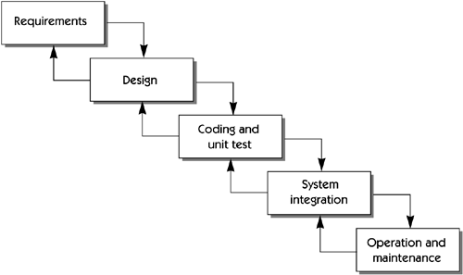

*Group No: 48 LCCA Page No: 22*

*Electroweb.com*

* ***Requirement*** *− All possible requirements of the system to be developed are captured in this phase and documented in a requirement specification document.*
* ***Analysis-*** *After gathering user requirement analyzing is done on it.*
* ***Design****– After the analysis from second phase the system design is prepared. This system design helps in specifying hardware and system requirements and helps in defining the overall system architecture.*
* ***Coding −****with inputs from the system design, the system is first developed in small programs called units, which are integrated in the next phase. Each unit is developed and tested for its functionality, which is referred to as Unit Testing.*
* ***Testing –*** *Each module is tested integrated & entire system is testing.*
* ***Integration*** *− Unit program are integrated and test as whole system to check that the software requirement have been met. After software system is delivered to customer.*
* ***Operation and maintenance****- This is longest life cycle phase. System is installed and put into practical use. Maintenance involves correcting error, improving the implementation of system unit and enhancing system services as new requirementare discover and ensure software system work properly.*

*Group No: 48 LCCA Page No: 23*

*Electroweb.com*

***ADVANTAGES***



* *This model is simple and easy to understand and use.*
* *In this model phases are processed completed one at a time. It do not overlap.*
* *Waterfall well for smaller projects where requirements are well understood.*

***DISADVANTAGE***



* *We can go only one step back for changing the requirement.*

*Group No: 48 LCCA Page No: 24*

*Electroweb.com*

***CHAPTER: 3***

***DATA FLOW DIAGRAM***

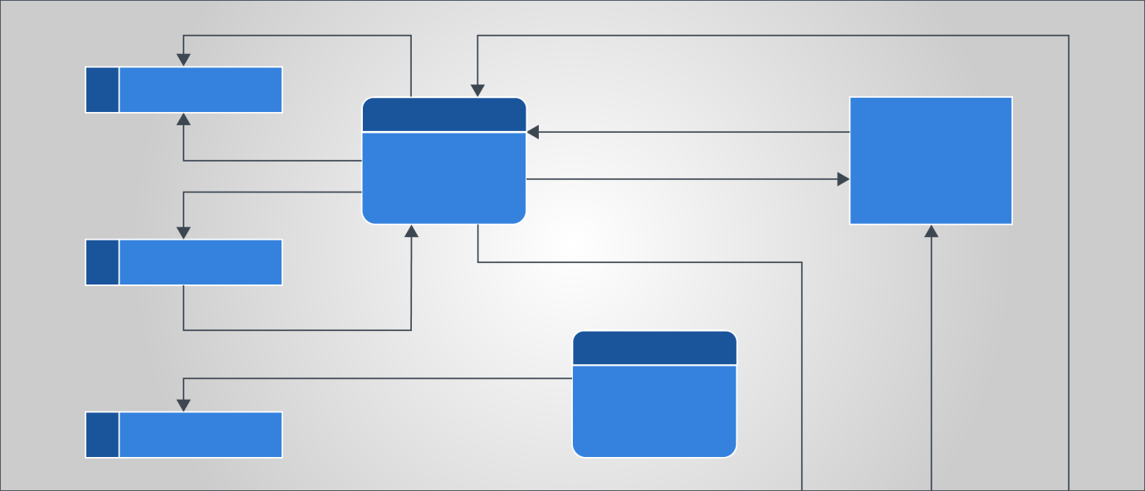

*Group No: 48 LCCA Page No: 25*

*Electroweb.com*

***3.1 What is Data Flow diagram?***

*A data flow diagram shows the way information flows through a process or system. It includes data inputs and outputs, data stores, and the various sub processes the data moves through. DFDs are built using standardized symbols and notation to describe various entities and their relationships.*

*Data flow diagrams visually represent systems and processes that would be hard to describe in a chunk of text. You can use these diagrams to map out an existing system and make it better or to plan out a new system for implementation. Visualizing each element makes it easy to identify inefficiencies and produce the best possible system.*

*Group No: 48 LCCA Page No: 26Electroweb.com*

***3.2 Data Flow Diagram Levels***

*1. Context (0) level*

*2. First (1st) level*

*3. Second (2nd) level*

*Data flow diagrams are also categorized by level. Starting with the most basic, level 0, DFDs get increasingly complex as the level increases. As you build your own data flow diagram, you will need to decide which level your diagram will be.*

*Group No: 48 LCCA Page No: 27Electroweb.com*

***3.2.1 Context (0) level***

***Level 0 DFDs****, also known as context diagrams, are the most basic data flow diagrams. They provide a broad view that is easily digestible but offers little detail. Level 0 data flow diagrams show a single process node and its connections to external entities.*

*Group No: 48 LCCA Page No: 28*

*Electroweb.com*

***3.2.2 First (1st) level***

***Level 1 DFDs****are still a general overview, but they go into more detail than a context diagram. In a level 1 data flow diagram, the single process node from the context diagram is broken down into sub processes. As these processes are added, the diagram will need additional data flows and data stores to link them together.*

*Group No: 48 LCCA Page No: 29*

*Electroweb.com*

***3.2.3 Second (2nd) level***

***Level 2 DFDs****simply break processes down into more detailed sub processes. In theory, DFDs could go beyond level 3, but they rarely do. Level 3 data flow diagrams are detailed enough that it doesn’t usually make sense to break them down further.*

*Group No: 48 LCCA Page No: 30*

*Electroweb.com*

***3.3.1 Context (0) level diagram***

**

*Group No: 48 LCCA Page No: 31*

*Electroweb.com*

***3.4.1 1st level Diagram-Admin***

**

*Group No: 48 LCCA Page No: 32*

*Electroweb.com*

***3.4.2 1st level Diagram-Customer***

**

*Group No: 48 LCCA Page No: 33*

*Electroweb.com*

***3.5.1 2nd level Diagram-Admin login Table***

**

*Group No: 48 LCCA Page No: 34*

*Electroweb.com*

***3.5.2 2nd level Diagram Admin-category Master***

**

*Group No: 48 LCCA Page No: 35*

*Electroweb.com*

***3.5.3 2nd level Diagram-Admin Customer Master***

**

*Group No: 48 LCCA Page No: 36*

*Electroweb.com*

***3.5.4 2nd level Diagram-Admin Product Master***

**

*Group No: 48 LCCA Page No: 37*

*Electroweb.com*

***3.6.1 2nd level Diagram-Customer login Table***

**

*Group No: 48 LCCA Page No: 38*

*Electroweb.com*

***3.6.2 2nd level Diagram-Customer order Table***

**

*Group No: 48 LCCA Page No: 39*

*Electroweb.com*

***3.6.3 2nd level Diagram-Customer Payment Table***

**

*Group No: 48 LCCA Page No: 40*

*Electroweb.com*

***CHAPTER 4***

***DATA DICTIONARY TABLE***

*Group No: 48 LCCA Page No: 41*

*Electroweb.com*

***4.1 ROLE TABLE***

***TABLE NAME: ROLE***

***DESCRIPTION: IT CONTAINT ROLE PARSON DETAILS***

***PRIMARY KEY: ROLE_ID***

***FOREIGN KEY:***

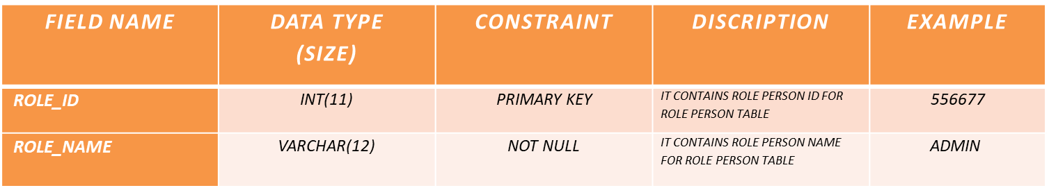

*Group No: 48 LCCA Page No: 43*

*Electroweb.com****4.2CUSTOMER TABLE***

***TABLE NAME: CUSTOMER***

***DESCRIPTION: IT CONTAINT CUSTOMER PARSON DETAILS***

***PRIMARY KEY: C_ID***

***FOREIGN KEY: C_COUNTRY_ID, S_S_ID, C_CITY_ID, R_R_ID***

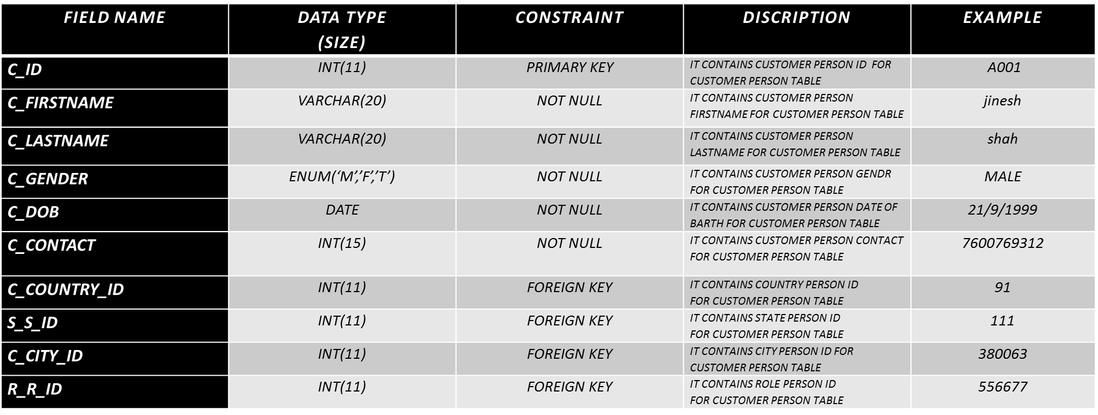

*Group No: 48 LCCA Page No: 44*

*Electroweb.com*

***4.3 LOGIN TABLE***

***TABLE NAME: LOGIN***

***DESCRIPTION: IT CONTAINT LOGIN PARSON DETAILS***

***PRIMARY KEY: L_ID***

***FOREIGN KEY: R_PAR_ID***

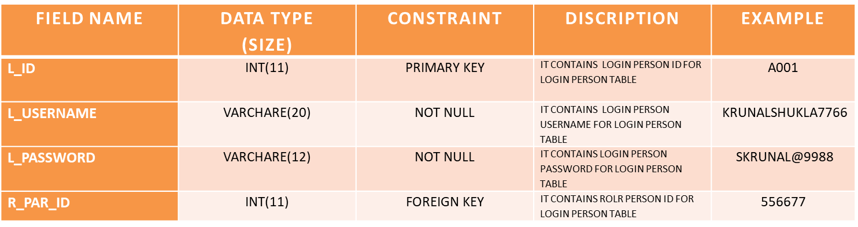

*Group No: 48 LCCA Page No: 45*

*Electroweb.com*

***4.4 COUNTRY TABLE***

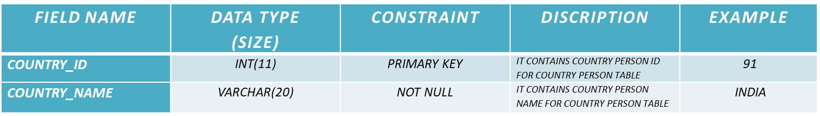

Group No: 48 LCCA Page No: 46

ShopMe.com

***TABLE NAME: COUNTRY***

***DESCRIPTION: IT CONTAINT COUNTRY PARSON DETAILS***

***PRIMARY KEY: COUNTRY_ID***

***FOREIGN KEY:***

***4.5 STATE TABLE***

***TABLE NAME: STATE***

***DESCRIPTION: IT CONTAINT STATE PERSON DETAILS***

***PRIMARY KEY: STATE_ID***

***FOREIGN KEY: COUNTRY_ID***

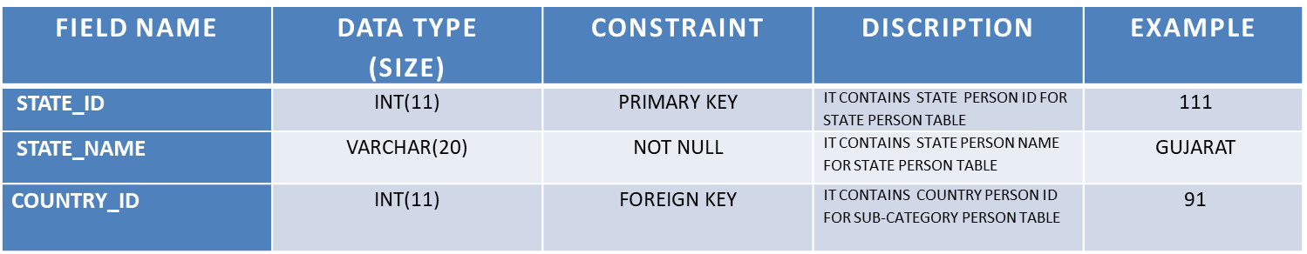

Group No: 48 LCCA Page No: 47

ShopMe.com

***4.6 CITY TABLE***

*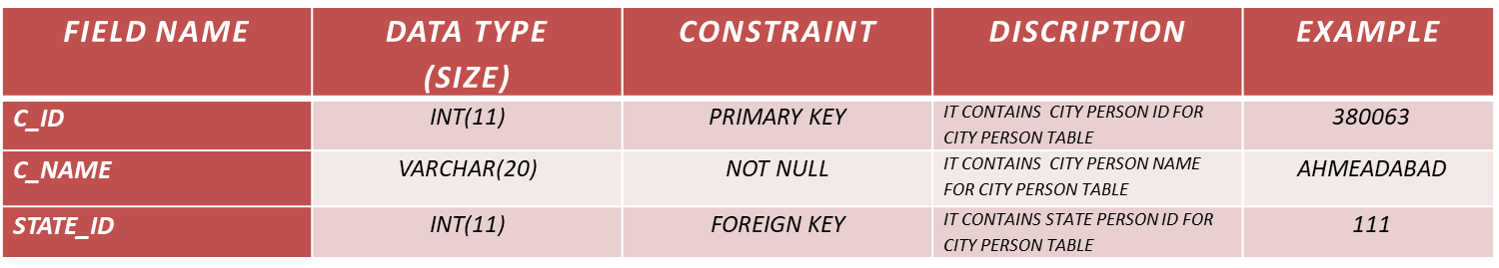****4.7PRODUCT TABLE***

Group No: 48 LCCA Page No: 48

ShopMe.com

***TABLE NAME: CITY***

***DESCRIPTION: IT CONTAINT CITY PARSON DETAILS***

***PRIMARY KEY: C_ID***

***FOREIGN KEY: STATE_ID***

***TABLE NAME: PRODUCT***

***DESCRIPTION: IT CONTAINT PRODUCT PARSON DETAILS***

***PRIMARY KEY: P_ID***

***FOREIGN KEY: SUBC_ID, P_COLOR_ID, P_SIZE_ID***

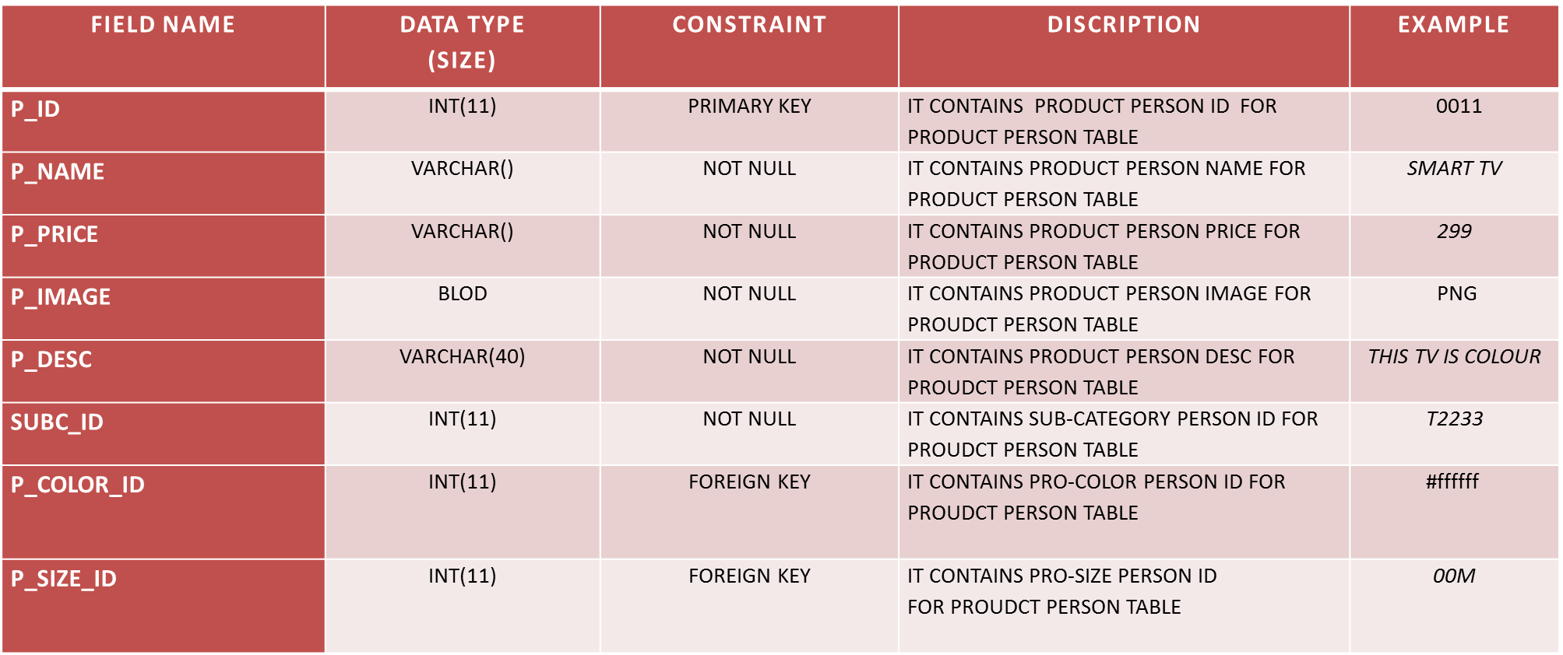

*Group No: 48 LCCA Page No: 49*

*Electroweb.com****4.8 CATEGORY TABLE***

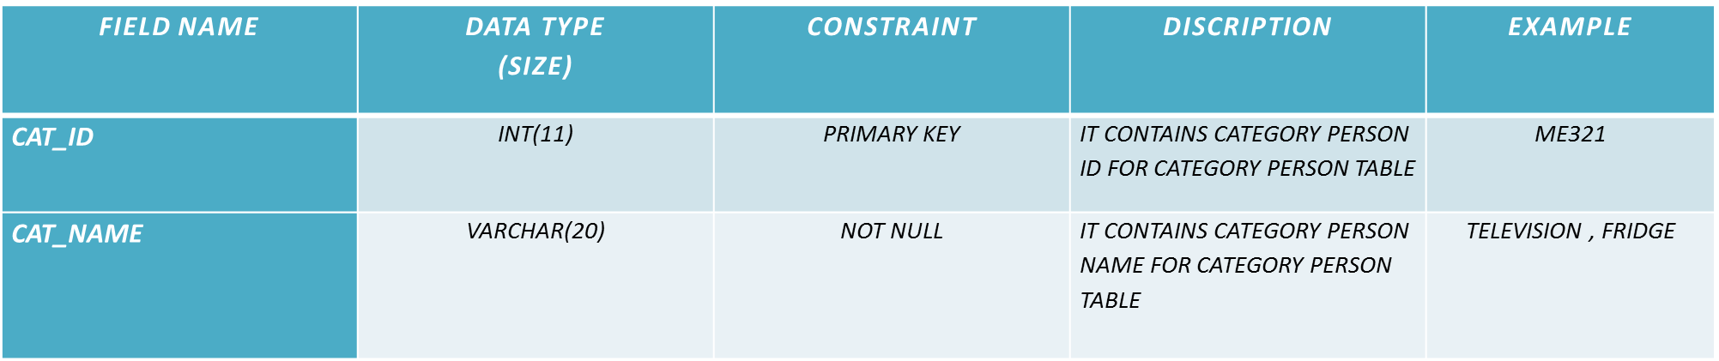

Group No: 48 LCCA Page No: 50

ShopMe.com

***TABLE NAME: CATEGORY***

***DESCRIPTION: IT CONTAINT COLOR PARSON DETAILS***

***PRIMARY KEY: CAT_ID***

***FOREIGN KEY:***

***4.9 SUB-CATEGORY TABLE***

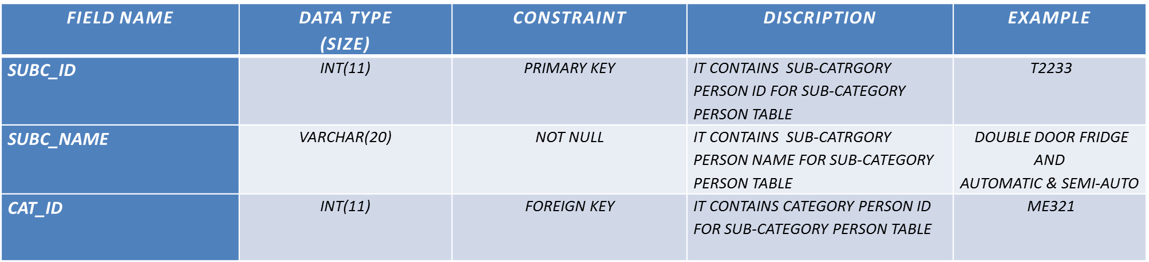

Group No: 48 LCCA Page No: 51

ShopMe.com

***TABLE NAME: SUB-CATEGORY***

***DESCRIPTION: IT CONTAINT SUB-CATEGORY PERSON DETAILS***

***PRIMARY KEY: SUBC_ID***

***FOREIGN KEY: CAT_ID***

***4.10 SIZE TABLE***

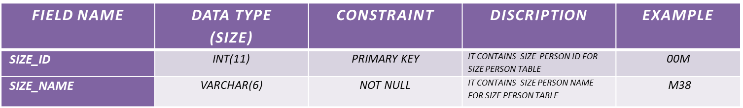

Group No: 48 LCCA Page No: 52

ShopMe.com

***TABLE NAME: SIZE***

***DESCRIPTION: IT CONTAINT SIZE PARSON DETAILS***

***PRIMARY KEY: SIZE_ID***

***FOREIGN KEY:***

***4.11 COLOR TABLE***

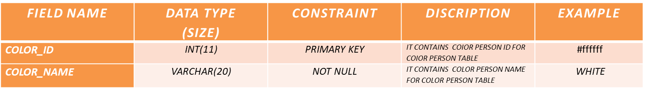

***TABLE NAME: COLOR***

***DESCRIPTION: IT CONTAINT COLOR PARSON DETAILS***

***PRIMARY KEY: COLOR_ID***

***FOREIGN KEY:***

Group No: 48 LCCA Page No: 53

ShopMe.com

***4.12 ORDER TABLE***

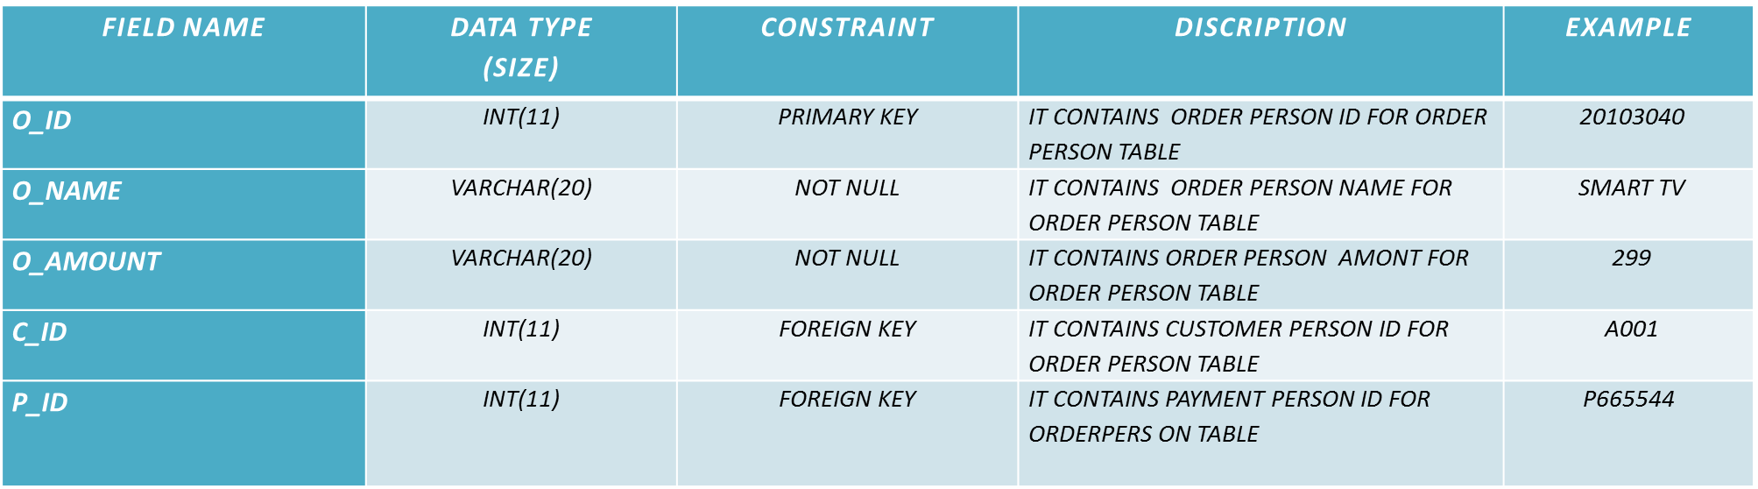

***TABLE NAME: ORDER***

***DESCRIPTION: IT CONTAINT ORDER PARSON DETAILS***

***PRIMARY KEY: O_ID***

***FOREIGN KEY: C_ID, P_ID***

Group No: 48 LCCA Page No: 54

ShopMe.com

***4.13 DISCOUNT TABLE***

***TABLE NAME: DISCOUNT***

***DESCRIPTION: IT CONTAINT DISCOUNT PARSON DETAILS***

***PRIMARY KEY: D_ID***

***FOREIGN KEY: D_PAY_ID***

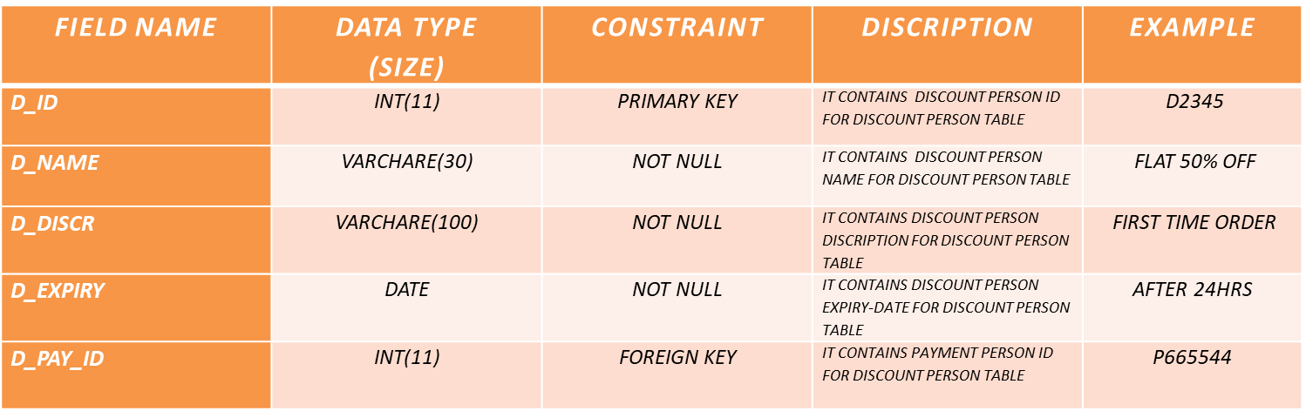

Group No: 48 LCCA Page No: 55

ShopMe.com

***4.14PAYMENT TABLE***

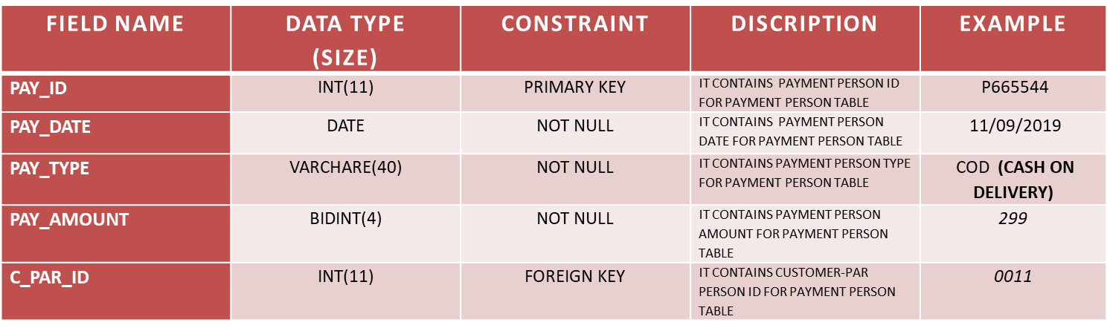

Group No: 48 LCCA Page No: 56

ShopMe.com

***TABLE NAME: PAYMENT***

***DESCRIPTION: IT CONTAINT FEEDBACK PARSON DETAILS***

***PRIMARY KEY: PAY_ID***

***FOREIGN KEY: C_PAR_ID***

***4.15FEEDBACK TABLE***

***TABLE NAME: FEEDBACK***

***DESCRIPTION: IT CONTAINT FEEDBACK PARSON DETAILS***

***PRIMARY KEY: F_ID***

***FOREIGN KEY: C_CUSTOMER_ID***

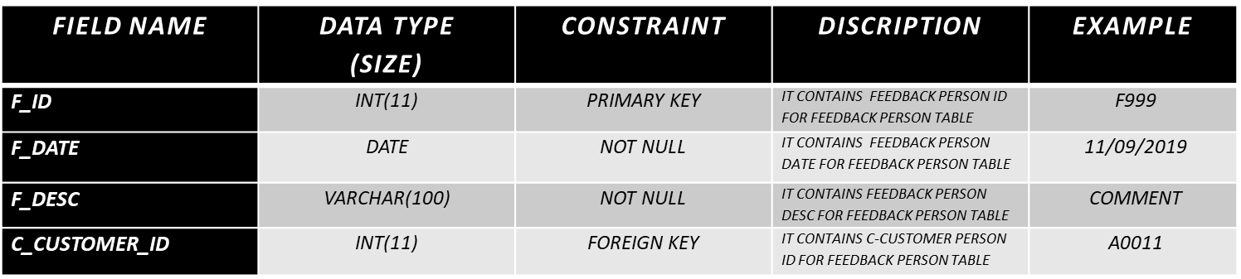

Group No: 48 LCCA Page No: 57

ShopMe.com

***CHAPTER 5***

***ER-DIAGRAM***

*Group No: 48 LCCA Page No: 58*

*Electroweb.com*

***5.0 ER-DIAGRAM (FIGURE)***

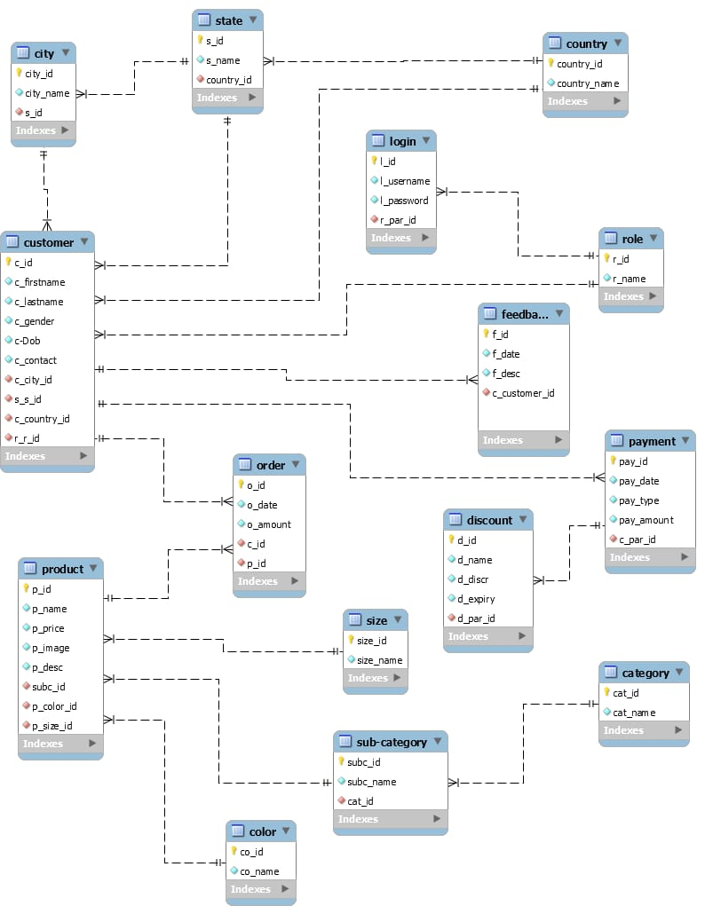

*Group No: 48 LCCA Page No: 59*

*Electroweb.com*

***CHAPTER 6***

***CONCLUSION***

* *WE HAVE MAKE MORE ENFICIENCY PIECEFUL WORK ON 100% BEST IN THE PROJECT.*
* *THIS PROJECT TO BE GUIDENCE OF INTERNAL FACULTY OF US.*
* *THAT THIS SYSTEM MAY FULFIL ALL THE REQUIREMENT OF CHAIRMAN* ***“KRISHANA TECHNOLOGIES”.***
* *WE HAVE TRUSTED WEBSITE****“Electroweb.com”*** *TO PROVE WORK SUCCESSFULLY DEMAND ON FOR THE CHAIRMAN OF “****KRISHNA TECHNOLOGIES****”.*
* *ANY SUGGESTING TO MAKE THIS PROJRCT MORE USFUL ARE ALWAYS WELCOME.*

*Group No: 48 LCCA Page No: 60*

*Electroweb.com****CHAPTER 7***

***BIBLIOGRAPHY***

***REFERENCES****:-*

*Bibliographies are special reference works that are used to identify as many published works on a given subject as possible, and serve as compilations for other authors or researchers.*

*Some websites that are we use as bibliography for understand some topics*

*1.* [*https://www.smiletemplates.com/free/ecommerce/powerpoint- templates/0.html*](https://www.smiletemplates.com/free/ecommerce/powerpoint-templates/0.html)

*2.* [*https://slidemodel.com/templates/low-poly-business-presentation-template/beautiful-thank-you-page-for-powerpoint/*](https://slidemodel.com/templates/low-poly-business-presentation-template/beautiful-thank-you-page-for-powerpoint/)

*Group No: 48 LCCA Page No: 61*

*Electroweb.com*

THANK YOU……..!!!

*Group No: 48 LCCA Page No: 62*

*Electroweb.com*