AICTE - IBM SKILLSBUILD INTERNSHIP PROGRAM 2026
DATA ANALYTICS WITH AI INTERNSHIP PROJECT REPORT

PROJECT TITLE: Strategic Hotel Portfolio Booking Cancellation Analytics
SUBMITTED BY: Akshaya P
INTERNSHIP BODY: BharatCares in Association with AICTE & IBM SkillsBuild

1. PROJECT PROBLEM STATEMENT
Hospitality firms experience operational inventory losses due to volatile reservation cancellation tendencies. Without data transparency around scheduling leads and location variables, hotels miss room revenue potential. This analytical project establishes deep metric visibility across booking windows to optimize hotel reservation stability.

2. SYSTEM KPIs & EMPIRICAL FINDINGS
- Total Customer Bookings Evaluated: 118,732 records
- Baseline Portfolio Attrition Volume: 44,142 instances
- Baseline System Cancellation Rate: 37.18%
- Average Daily Room Revenue Rate (ADR): $102.13
PROPERTY TYPE ANALYSIS:
- City Hotels exhibit high cancel tendencies at 41.78%.
- Resort Hotels remain more resilient, recording a lower 27.98% cancellation benchmark.
LEAD TIME RISK THRESHOLDS:
- Last-Minute Bookings (0-7 Days Notice): 9.69% cancellation rate.
- Extreme Lead Windows (181+ Days Notice): 56.99% cancellation rate.

3. DATA VISUALIZATION OUTPUT SCREENSHOT
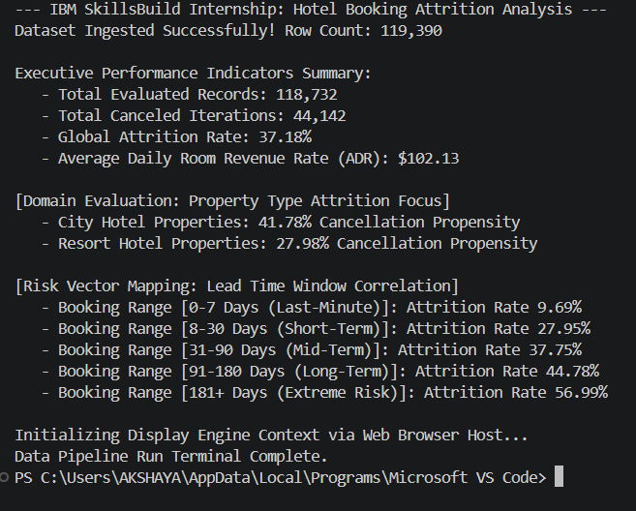
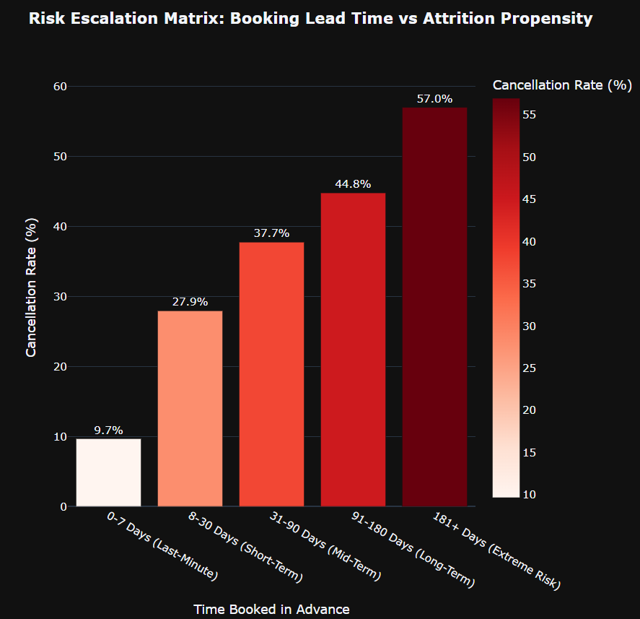
4. DIRECT RECOMMENDED STRATEGIC BUSINESS ACTIONS
1. Non-Refundable Deposit Windows: Enforce absolute cash deposit rules on reservations booked over 90 days out to protect room allocations.
2. Property Overbooking Margins: Apply a targeted 40% systematic overbooking padding ratio exclusively to City Hotel properties to balance high baseline group attrition volumes.
3. Short-Notice Discounts: Roll out active promotional discounts for open reservation blocks under 7 days out to capture highly reliable customer commitments.

