

FALL SEMESTER – 2026

Course Title : Agile Development Process and DevOps
Course Code : ISWE406L
Faculty : Sweta Bhattacharya
Slot : A1+TA1
Programme : M.Tech-Software Engineering
School : SCORE
Topic : Course Project

Project Title : Surplus Resource Exchange and Redistribution System

Submitted By,

Team Members:
- Shreemathi E - 24MIS0008

- Akshaya P - 24MIS0112

ResourceX: Intelligent Surplus Resource Exchange and Redistribution System

Problem Statement
Large quantities of usable resources such as food, clothing, and essential goods are wasted daily by households, restaurants, and organizations. At the same time, many individuals and communities lack access to these basic necessities. Existing systems for redistribution are inefficient, lack real-time coordination, and often fail to ensure timely delivery of perishable items. Additionally, there is limited privacy and accessibility for recipients, making it difficult for them to benefit from such systems.
Proposed Solution
The proposed system, ReSourceX, is a digital platform that connects donors with recipients and facilitates the efficient redistribution of surplus resources. The system enables donors to list available items, while recipients receive notifications based on their needs and location. An intelligent matching mechanism ensures optimal allocation of resources, considering factors such as urgency, availability, and proximity. The platform also supports secure and time-bound pickup or delivery, reducing waste and improving accessibility.
Users of the System
- Donors: Restaurants, hostels, shops, individuals
- Recipients: NGOs, shelters, individuals in need
- Admin: Manages system, monitors activity

Objective
To design and develop a system that minimizes resource wastage by efficiently redistributing surplus items to those in need using intelligent matching and real-time coordination.
1. SYSTEM MODULES
1. Donor Module
This module allows users (donors) to contribute surplus resources.
Functions:
- Register and login
- Add surplus resources (item name, quantity, type)
- View and manage their uploaded items

2. Recipient Module
This module is used by users who need resources.
Functions:
- Register and login
- View available resources
- Request required items

3. Matching and Allocation Module
This is the core component of the system.
Functions:
- Matches available resources with recipient requests
- Basic matching based on availability and request
- Updates resource status:
  - Available → Requested → Completed

4. Admin Module
This module manages the overall system.
Functions:
- Monitor users and resources
- View all transactions
- Manage system activities

2. SYSTEM WORKFLOW
- A donor registers and logs into the system
- The donor adds details of surplus resources
- The system stores the resource information
- A recipient logs in and views available resources
- The recipient requests a required resource
- The system processes the request and updates status
- The resource is allocated and marked as completed

3. DATA USED IN THE SYSTEM
User Data:
- Name
- Role (Donor / Recipient)
- Contact details
Resource Data:
- Item name
- Quantity
- Type (food, clothes, etc.)
- Status (Available / Requested / Completed)

4. SMART FEATURE
Priority-Based Allocation
Resources (especially perishable items like food) are given priority based on urgency and availability to reduce wastage.

5. TEAM RESPONSIBILITY
- Member 1: Backend development and system logic
- Member 2: Frontend design and user interface
- Both members will collaborate on documentation and testing

PRODUCT BACKLOG
This is just a list of features (in order of priority)
Product Backlog
- User Registration and Login
- Add Surplus Resource
- View Available Resources
- Request Resource
- Update Resource Status
- Priority-based Allocation
- Admin Dashboard
USER STORIES
User Stories
- As a donor, I want to add surplus resources so that others can use them
- As a recipient, I want to view available resources so that I can request what I need
- As a recipient, I want to request resources so that I can receive them
- As an admin, I want to monitor system activity to ensure proper functioning
SPRINT PLANNING
We divided the project into 3 sprints
Sprint 1 (Basic System)
Focus:
- User registration/login
- Add surplus resource
Output:
- Donor can add items
Sprint 2 (Interaction)
Focus:
- View resources
- Request resources
Output:
- Recipient can interact with system
Sprint 3 (Completion + Improvement)
Focus:
- Status updates
- Priority feature
- Basic admin view
Output:
- Complete working system
SPRINT GOALS
- Sprint 1: Develop core functionality for adding resources
- Sprint 2: Enable interaction between donors and recipients
- Sprint 3: Improve system efficiency and complete workflow
WHY AGILE
Agile methodology is used to develop the system in iterative phases, allowing continuous improvement, flexibility, and early delivery of functional components.

Identify All Required Screens
Common
- Login / Register
Donor
- Add Resource
- View My Resources
Recipient
- View Available Resources
- Request Resource
Admin
- Admin Dashboard
Total = 6 screens

Define Each Screen
1. Login / Register Screen
Fields:
- Username / Email
- Password
- Role selection (Donor / Recipient)
- Login / Register button
2. Donor – Add Resource
Fields:
- Item Name
- Quantity
- Type (Food / Clothes / Others)
- Submit Button
3. Donor – My Resources
Shows:
- List of items added
- Status:
  - Available
  - Requested
  - Completed
4. Recipient – View Resources
Shows:
- List of available resources
- Each item:
  - Name
  - Quantity
  - Type
- “Request” button
5. Recipient – Request Action
Action:
- Click request
- Confirmation message
6. Admin Dashboard
Shows:
- Total users
- Total resources
- Status overview

Define Navigation Flow
System Flow (UI Level)
Donor Flow:
Login → Add Resource → View Resources → Status Updates
Recipient Flow:
Login → View Resources → Request Resource → Status Update
Admin Flow:
Login → View Dashboard

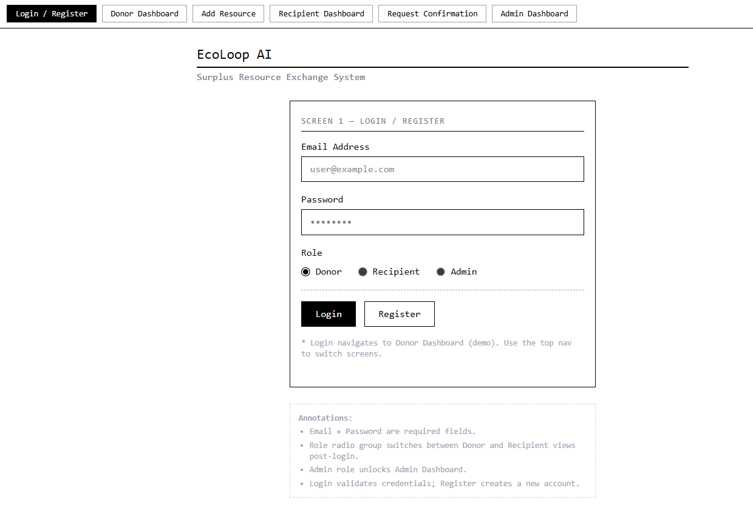
WIREFRAME DESIGN
1. Login / Register Screen
Description:
This screen allows users to log in or register into the system by providing email, password, and selecting their role (Donor, Recipient, Admin). It acts as the entry point to the system.
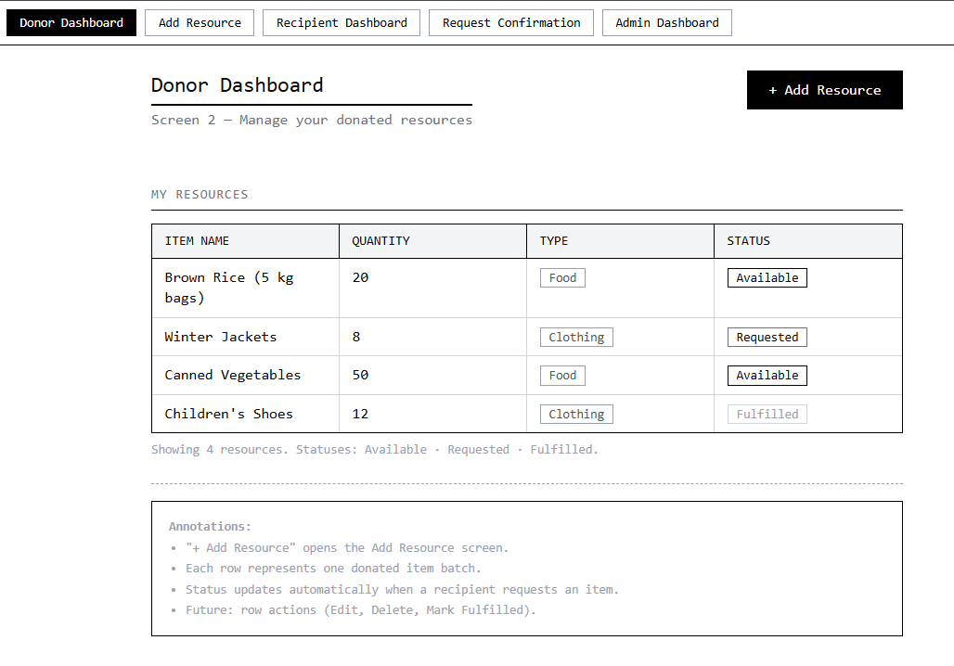
2. Donor Dashboard
Description:
This screen displays all resources added by the donor along with details such as item name, quantity, type, and status (Available, Requested, Fulfilled). Donors can also navigate to add new resources.

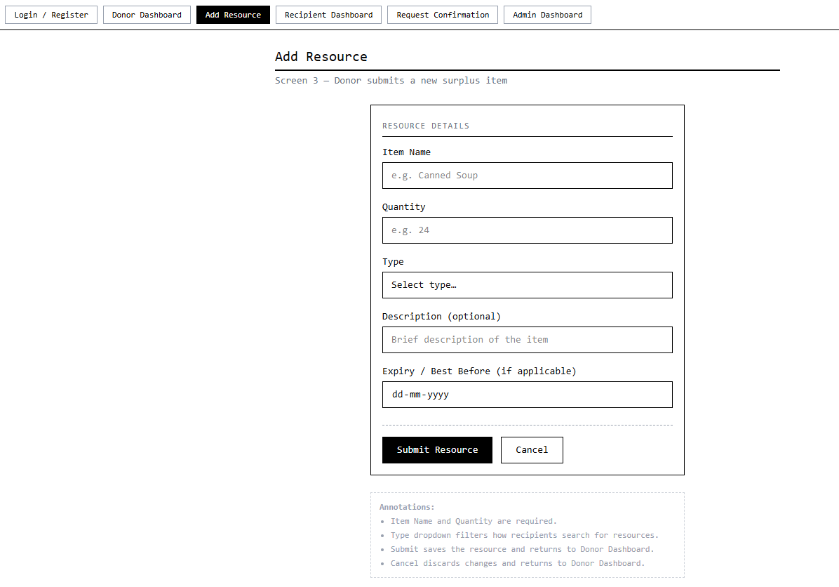

3. Add Resource Screen
Description:
This screen enables donors to submit new surplus resources by entering details such as item name, quantity, type, description, and expiry date. It is used to update available resources in the system

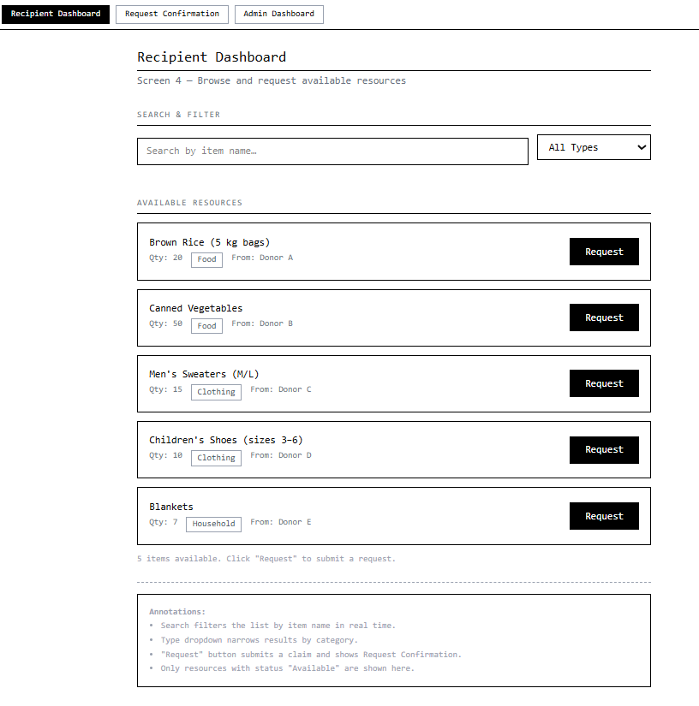

4. Recipient Dashboard
Description:
This screen allows recipients to browse available resources. It includes search and filter options and provides the ability to request items based on their needs.

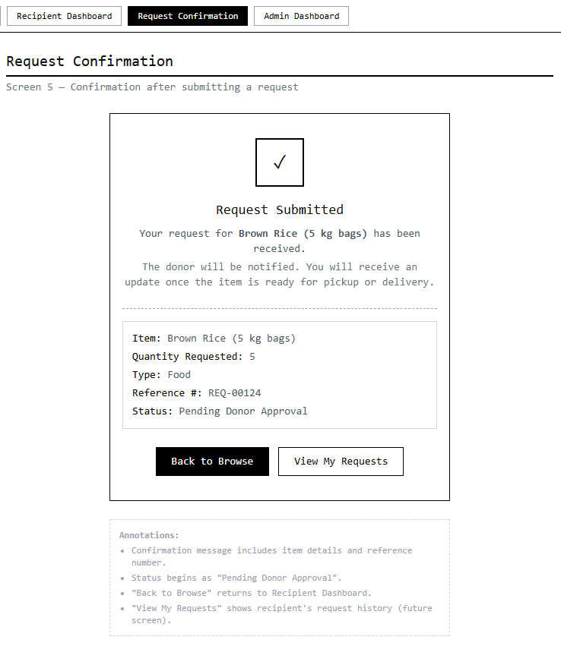

5. Request Confirmation Screen
Description:
This screen confirms that a resource request has been successfully submitted. It displays request details such as item name, quantity, and status.

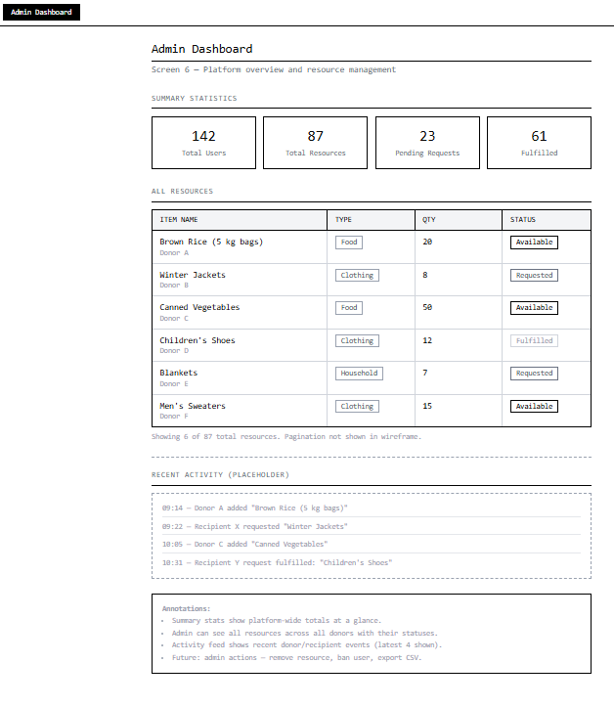
6. Admin Dashboard
Description:
This screen provides an overview of the system including total users, resources, pending requests, and fulfilled items. It allows the admin to monitor system activity.

