Titanic: Machine Learning from Disaster

AkshayKumar
Machine Learning
AITS
California
akshayiscool07@gmail.com

Abstract— Complete the analysis of what sorts of people were likely to survive.
In particular, we ask you to apply the tools of machine learning to predict which passengers survived the Titanic tragedy. When exploring data, predictive analytics techniques have proven to be effective. In this report, the efficiency of several predictive analytics methods are explored. During the time of this study, Kaggle.com, a data science competition website, had the predictive modeling competition, "Titanic: Machine Learning from Disaster" available. This competition posed a classification problem to build a predictive model to predict the survival of passengers on the RMS Titanic. The focus of our approach was on applying a traditional classification and regression tree algorithm. The algorithm is greedy and can over fit the training data, which consequently can yield non-optimal prediction accuracy.

Introduction
The sinking of the RMS Titanic is one of the most infamous shipwrecks in history. On April 15, 1912, during her maiden voyage, the Titanic sank after colliding with an iceberg, killing 1502 out of 2224 passengers and crew. This sensational tragedy shocked the international community and led to better safety regulations for ships. In particular, we apply the tools of machine learning to predict which passengers survived the tragedy. The machine learning algorithm used are Support Vector Machine and NN with 3 layers. The accuracy is compared between these two ML algorithm.

The Titanic passenger data consists of a training set and a test set, both of which are .csv files. The training set includes the response variable Survived and 11 other descriptive variables pertaining to 891 passengers. The test set does not include the response variable but does contain the 11 other variables for 418 passengers. Note that the 418 passengers in the test dataset are different from the 891 passengers in the training dataset. It is to my knowledge that Kaggle did not specify the details as to how the training and test datasets were chosen. At least, one can assume that individuals were selected at random to form the training and test data sets.

Objective
The objective of this project is then to build a predictive model to predict which of the passengers survived the shipwreck. In particular, the response variable Survived will be modeled given ten possible predictors. The remainder of this report includes background on the methods used to build the predictive model, specifically classification and regression trees, cost complexity pruning, bagging and random forests. A case study based on the RMS Titanic data implementing the methods will be conducted. Compare accuracy between NN and SVM.

Data Set
The first data set that we want is called train.csv. This is the data set that we will use to create our model. The second data set that we need is in test.csv, which contains information on passengers but without information on whether or not they survived. This is the data we will use to test our model. We will work with the training data first.
Here is a brief description of each of the columns. PassengerId – an identification number for each person in the training data set. Survived – a binary (0 for no and 1 for yes) indicating whether or not that passenger survived; this is sometimes referred to as an indicator or dummy variable. Pclass – each passenger on the ship was assigned to a class, much like on an airplane. First class (1) was the nicest part of the ship, generally near the decks of the boat, second class (2) in the middle, and third class (3) at the bottom. Note that this variable can also serve to indicate the socioeconomic class of the passenger, where 1, 2, and 3 indicate upper, middle, and lower class, respectively. Name – the name of each passenger. Sex – the sex of the passenger. Note that this may also be transformed into an indicator variable similar to the Survived variable. Age – the age of the passenger. SlbSp – the number of siblings/spouses aboard the ship. Parch – the number of parents/children aboard the ship. Ticket – the ticket number. Fare – amount paid by the passenger to embark on the vessel (i.e., ticket price). Cabin – cabin where the passenger stayed.
Overfitting
Overfitting means that a model is very carefully designed and adjusted so that it fits a particular data set perfectly (or almost perfectly), in this case, test.csv. However, overfitted models generally have poor predictive performance when applied to other data sets, because they are too specific to this particular data set and do not adapt well to other data. In addition, as one team can submit multiple entries every day, over a period of several months one can submit hundreds of models for testing. It is possible that one of these models fits very well with the testing data set by accident and achieves a high score on the leaderboard, but whether it’s good at predicting other data remains questionable. To avoid the problem of overfitting, each competition4 has two testing data sets. One (public) is used for quick testing and gives you the score on the Public Leaderboard, and the other one (private) is used for the final testing. Both public and private testing sets contain 50% of the test.csv. Which observations are included in the final testing is known only by Kaggle and competition sponsors. Your final score will be solely determined by the private testing data set, and you will only know your score at the end of the contest. This method is implemented to prevent users from overfitting the data. The scores on the leaderboard only serve as indicators of model performance but they are not the final scores. If you overfit your model to achieve higher score on the public leaderboard, the model may actually perform badly with the private testing data set and give you a lower score. Hence, you must be careful not to overfit your data. You can choose which models you want to submit for final private testing, and your scores will then be given based on the performance of these few models.
Background of Predictive Analytics

Since the 1980s, companies have collected copious amounts of customer data to be stored in databases (Finlay, 2014). As the companies collected all of this data they began to think how they could use this data to improve operations or to provide additional benefits. This type of thinking formed “a natural progression toward using the data to improve estimates, forecasts, decisions, and ultimately, efficiency” . These databases grew to such an enormous size that in turn became too large for humans to analyze on their own. Predictive analytics was an answer on how to handle such large databases. Predictive analytics is a procedure that incorporates the use of computational methods to determine important and useful patterns in large data. Furthermore, predictive analytics was devised from related fields of study such as, pattern recognition, statistics, machine learning, artificial intelligence, and data mining .
ML Algorithm
SVM
In machine learning, support-vector machines (SVMs, also support-vector networks) are supervised learning models with associated learning algorithms that analyze data used for classification and regression analysis. Given a set of training examples, each marked as belonging to one or the other of two categories, an SVM training algorithm builds a model that assigns new examples to one category or the other, making it a non-probabilistic binary linear classifier (although methods such as Platt scaling exist to use SVM in a probabilistic classification setting). An SVM model is a representation of the examples as points in space, mapped so that the examples of the separate categories are divided by a clear gap that is as wide as possible.
When data is unlabelled, supervised learning is not possible, and an unsupervised learning approach is required, which attempts to find natural clustering of the data to groups, and then map new data to these formed groups. The support-vector clustering algorithm, created by Hava Siegelmann and Vladimir Vapnik, applies the statistics of support vectors, developed in the support vector machines algorithm, to categorize unlabeled data, and is one of the most widely used clustering algorithms in industrial applications.
Classifying data is a common task in machine learning. Suppose some given data points each belong to one of two classes, and the goal is to decide which class a new data point will be in. In the case of support-vector machines, a data point is viewed as a dimensional vector (a list of numbers), and we want to know whether we can separate such points with a dimensional hyperplane. This is called a linear classifier. There are many hyperplanes that might classify the data. One reasonable choice as the best hyperplane is the one that represents the largest separation, or margin, between the two classes. So we choose the hyperplane so that the distance from it to the nearest data point on each side is maximized. If such a hyperplane exists, it is known as the maximum-margin hyperplane and the linear classifier it defines is known as a maximum-margin classifier; or equivalently, the perceptron of optimal stability

NN(3 Layers)
A neural network is a network or circuit of neurons, or in a modern sense, an artificial neural network, composed of artificial neurons or nodesThus a neural network is either a biological neural network, made up of real biological neurons, or an artificial neural network, for solving artificial intelligence (AI) problems. The connections of the biological neuron are modeled as weights. A positive weight reflects an excitatory connection, while negative values mean inhibitory connections. All inputs are modified by a weight and summed. This activity is referred as a linear combination. Finally, an activation function controls the amplitude of the output. For example, an acceptable range of output is usually between 0 and 1, or it could be −1 and 1.

A biological neural network is composed of a group or groups of chemically connected or functionally associated neurons. A single neuron may be connected to many other neurons and the total number of neurons and connections in a network may be extensive. Connections, called synapses, are usually formed from axons to dendrites, though dendrodoridid synapses and other connections are possible. Apart from the electrical signalling, there are other forms of signalling that arise from neurotransmitter diffusion. Artificial intelligence, cognitive modelling, and neural networks are information processing paradigms inspired by the way biological neural systems process data. Artificial intelligence and cognitive modelling try to simulate some properties of biological neural networks. In the artificial intelligence field, artificial neural networks have been applied successfully to speech recognition, image analysis and adaptive control, in order to construct software agents (in computer and video games) or autonomous robots. Historically, digital computers evolved from the von Neumann model, and operate via the execution of explicit instructions via access to memory by a number of processors. On the other hand, the origins of neural networks are based on efforts to model information processing in biological systems. Unlike the von Neumann model, neural network computing does not separate memory and processing. Neural network theory has served both to better identify how the neurons in the brain function and to provide the basis for efforts to create artificial intelligence.
Many models are used; defined at different levels of abstraction, and modeling different aspects of neural systems. They range from models of the short-term behaviour of individual neurons, through models of the dynamics of neural circuitry arising from interactions between individual neurons, to models of behaviour arising from abstract neural modules that represent complete subsystems. These include models of the long-term and short-term plasticity of neural systems and its relation to learning and memory, from the individual neuron to the system level.
Comparing SVM and NN (3 Layers)
This dataset proved that NN with 3 layers gives more accuracy than SVM.
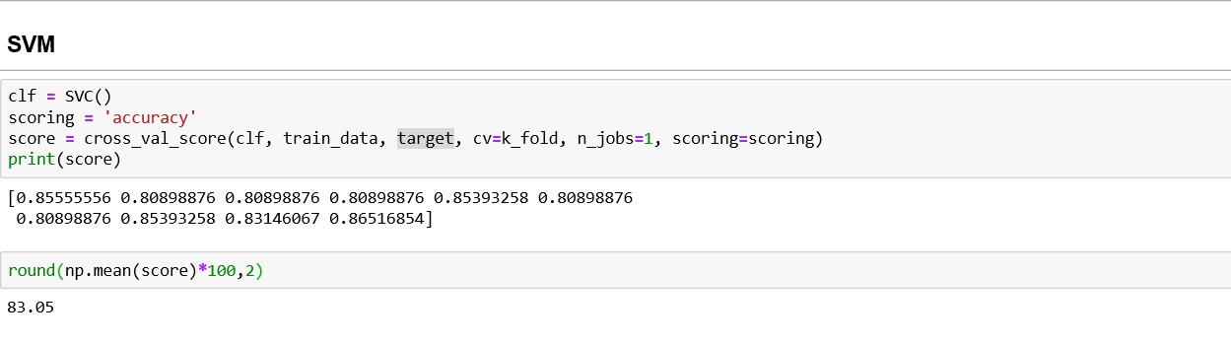
Accuracy of SVM is 83.05

NN
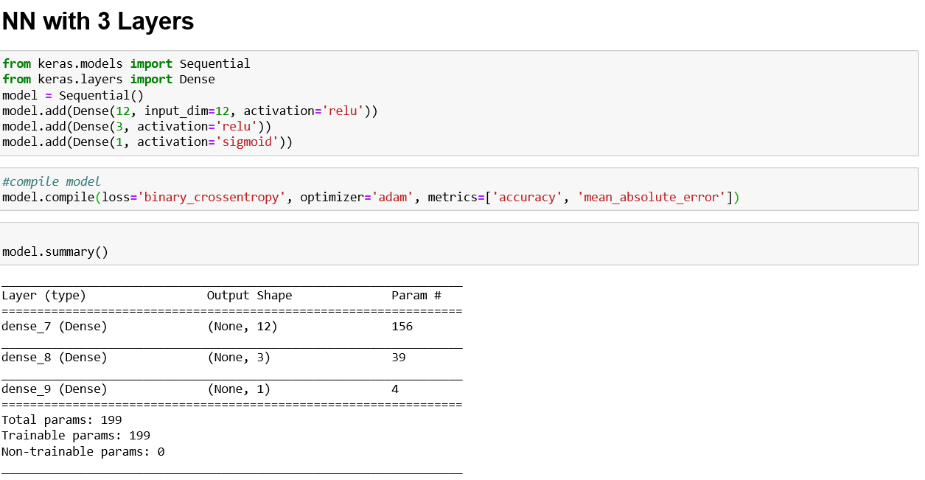

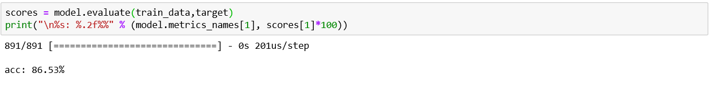

Accuracy of NN with 3 layers is 86.53

NNs are heuristic, while SVMs are theoretically founded. A SVM is guaranteed to converge towards the best solution in the PAC (probably approximately correct) sense. For example, for two linearly separable classes SVM will draw the separating hyperplane directly halfway between the nearest points of the two classes (these become support vectors). A neural network would draw any line which separates the samples, which is correct for the training set, but might not have the best generalization properties.
Accuracy of classifiers or learning algorithms I believe is dependent on the problem at hand in relation to say complexity or quality/integrity of the data. So, I don't think there is a straight answer like saying one is better than the other globally without making reference to the problem at hand. Therefore, the only litmus test is try the classifiers or learning algorithms on your specific data set and you can come out with the best for your data set. Then you would be able to set a reference point for researchers that may be interested in doing further works in relation to data set similar to yours.

Conclusion
The motivation of this study developed from a desire to learn, understand, and apply the CART algorithm. Kaggle’s predictive modeling competition, Titanic: Machine Learning from Disaster, served as a framework for introductory predictive analytic methods. The problem posed in this competition was to build a predictive model to predict the survival of passengers on the RMS Titanic. A great deal of time and effort was spent cleaning, organizing, and redefining variables in the data. So in the large dataset over different permutation and combination NN gives better accuracy.

References
Reference [1] is the data set of Kaggle https://www.kaggle.com/c/titanic
Stephens, T. (2014). Titanic: Getting Started with R. Available from: http://trevorstephens.com/post/72916401642/titanic-getting-started-with-r (accessed 9 February 2015).
Wehrley, C. (2014). Titanic Survival Prediction. Available from: https://github.com/wehrley/wehrley.github.io/blob/master/SOUPTONUTS.md (accessed 9 February 2015).

References

